Q1.1
A^{T}A is called as the structure tensor or a second-moment matrix, and is derived from the gradient of the image by summarizing its dominant directions in a specific neighbourhood of a point.
A^{T}A must be invertible to find the least squares solution, or its eigenvalues should satisfy #todo. The ratio of the eigenvalues (larger to smaller) shouldn't be too large. Also, the eigenvalues shouldn't be close to zero, to avoid numerical errors.

Q1.3
Q1.4 Extra credit template correction
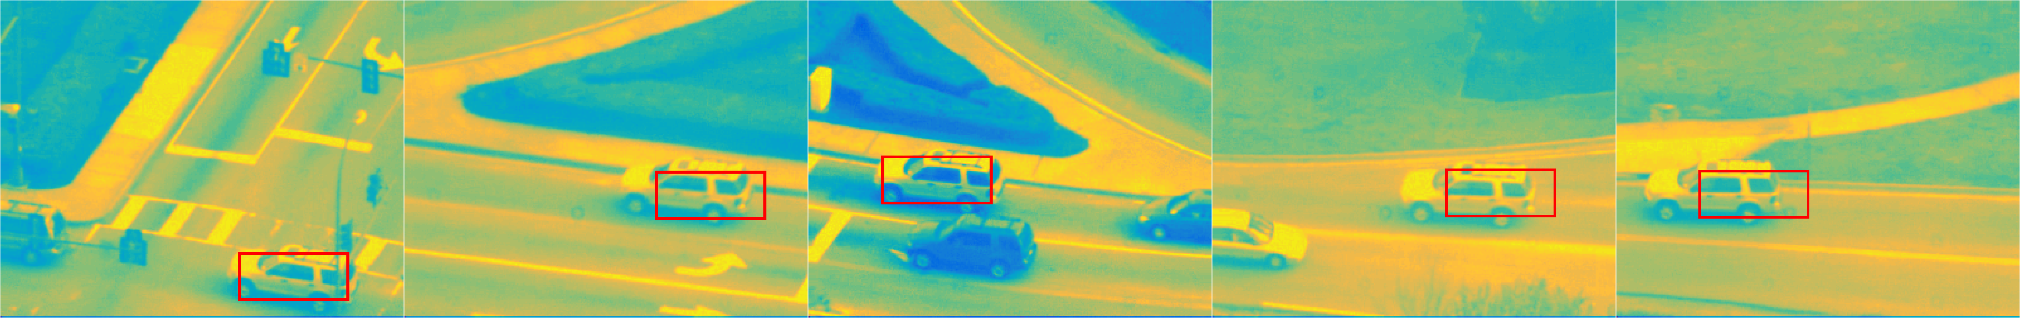Figure 1. Tracking carseq.mat at frames 2, 100, 200, 300 and 400
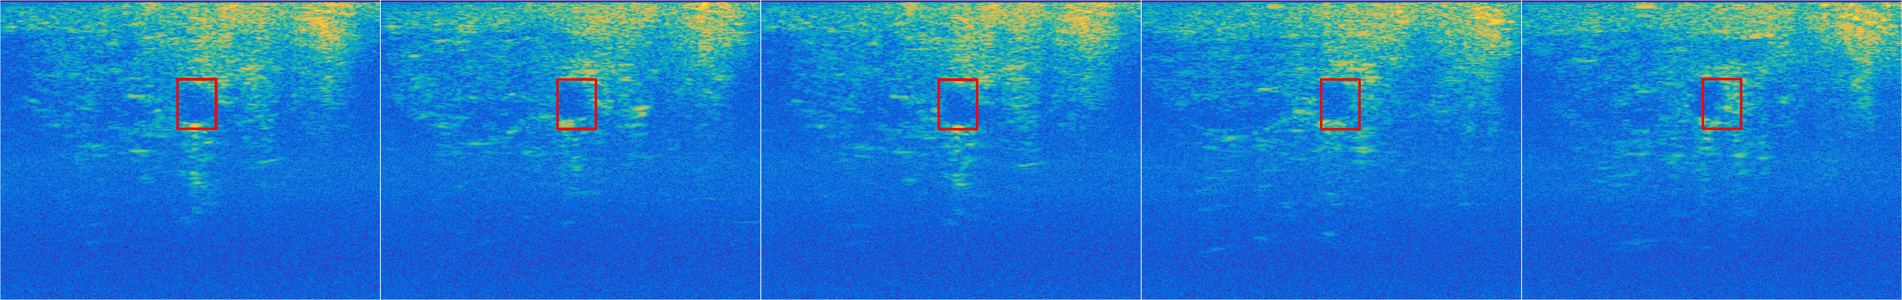Figure 2: Tracking usseq.mat at frames 5, 25, 50, 75 and 100
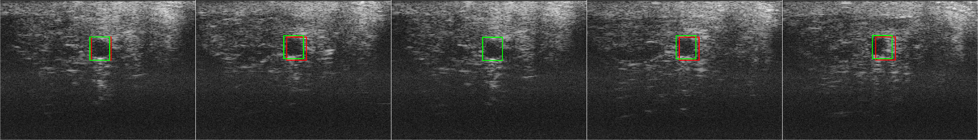Figure 3: Template correction on the ultrasound sequence. Green rectangles are created by the tracker using the corrected template. Red ones are baseline.
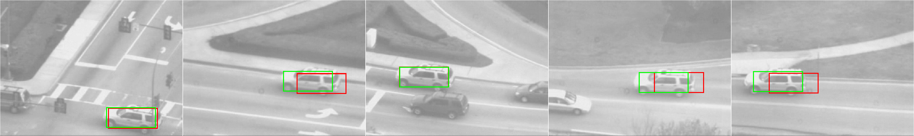Figure 4: Template correction on the car sequence

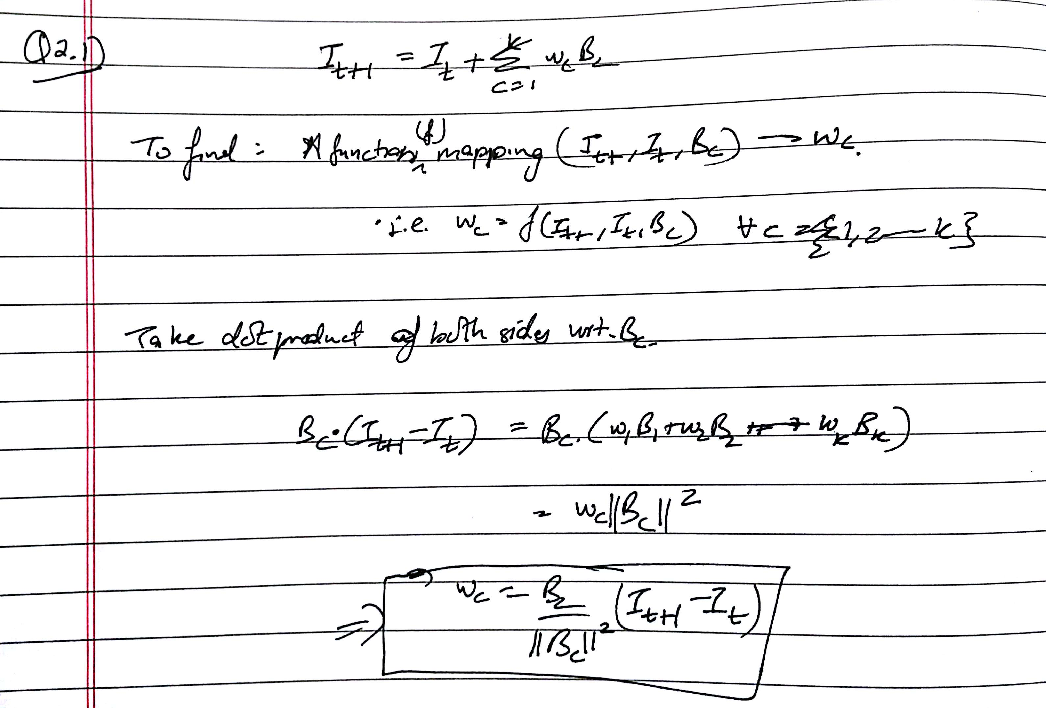
Q2.3
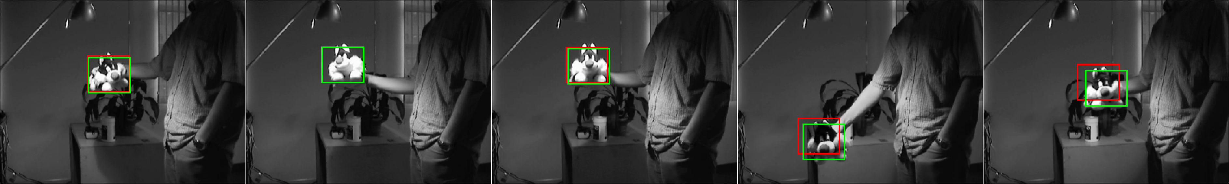Figure 5: Green rectangles show output of Appearance Basis' tracker. Red rectangle shows output of Inverse Compositional tracker.

Q3.3
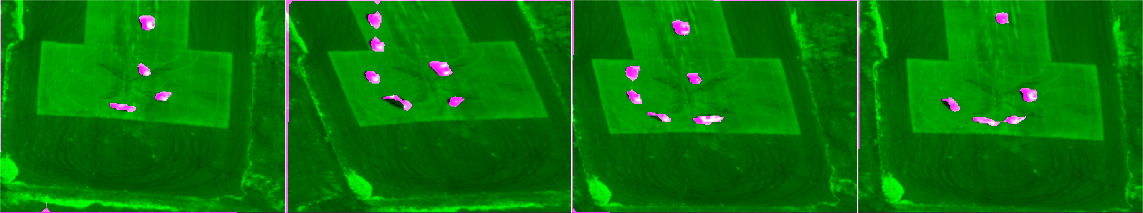Figure 3: Tracking aerialseq.mat at frames 30, 60, 90 and 120 using affine motion

