Problem Statement 1: Multithreading

1. Write a Java program which accepts multiple employees’ details and perform the following:
a. Create thread class.

b. Execute them using frokjoinpool.

c. Make use of runnable interface in it.

Ans:

a) Code:
package assignment_8;

import java.util.concurrent.ForkJoinPool;

public class EmployeeThread implements Runnable {
private String name;
private double salary;

public EmployeeThread(String name, double salary) {
this.name = name;
this.salary = salary;
}

@Override
public void run() {
System.out.println("Employee " + name + " has a salary of $" + salary);
}

public static void main(String[] args) {
// Create an array of EmployeeThread objects
EmployeeThread[] employees = new EmployeeThread[5];
employees[0] = new EmployeeThread("Alice", 45000);
employees[1] = new EmployeeThread("Bob", 50000);
employees[2] = new EmployeeThread("Charlie", 55000);
employees[3] = new EmployeeThread("Dave", 60000);
employees[4] = new EmployeeThread("Eve", 65000);

// Create a ForkJoinPool and execute the EmployeeThreads
ForkJoinPool pool = new ForkJoinPool();
for (EmployeeThread employee : employees) {
pool.execute(employee);
}
pool.close();
}
}

Screenshot:
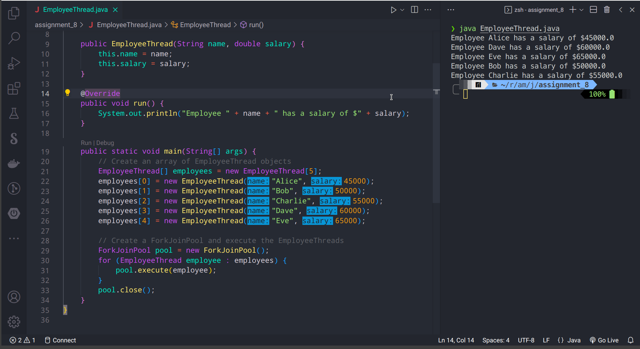

2.

a. Write a program which implements threads with locks by using synchronized keyword.

Ans
a)Code

public class SynchronizedThreads {
private static int counter = 0;

public static void main(String[] args) {
final Object lock = new Object();

Thread t1 = new Thread(new Runnable() {
@Override
public void run() {
for (int i = 0; i < 1000; i++) {
synchronized (lock) {
counter++;
}
}
}
});

Thread t2 = new Thread(new Runnable() {
@Override
public void run() {
for (int i = 0; i < 1000; i++) {
synchronized (lock) {
counter++;
}
}
}
});

t1.start();
t2.start();

try {
t1.join();
t2.join();
} catch (InterruptedException e) {
e.printStackTrace();
}

System.out.println("TotalCount: " + counter);
}
}

b) Screenhot
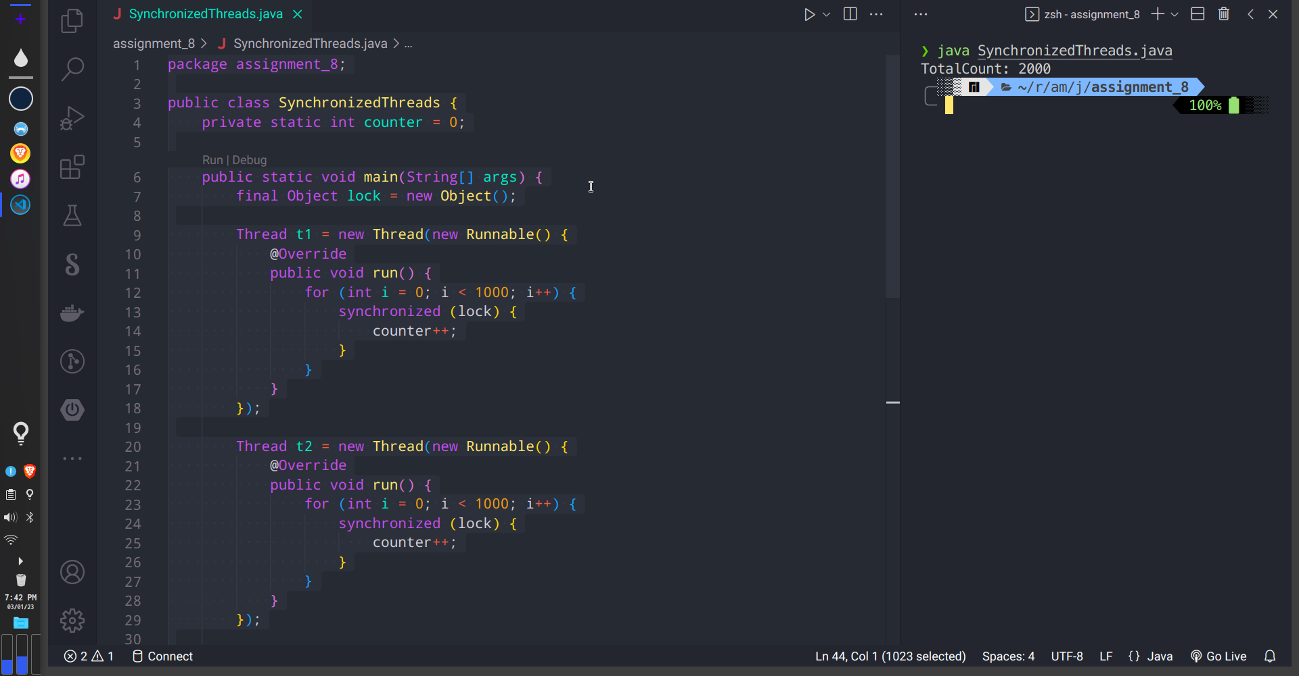

b. Write a program which elaborates the concept of producer consumer problem using wait(), notify() & all required functionalities in it.

Ans:
a) Code
package assignment_8;

import java.util.LinkedList;
import java.util.Queue;

public class ProducerConsumerThreads {
private static class Producer implements Runnable {
private Queue<Integer> queue;
private int maxSize;

public Producer(Queue<Integer> queue, int maxSize) {
this.queue = queue;
this.maxSize = maxSize;
}

@Override
public void run() {
int value = 0;
while (true) {
synchronized (queue) {
while (queue.size() == maxSize) {
try {
queue.wait();
} catch (InterruptedException e) {
e.printStackTrace();
}
}
System.out.println("Produced: " + value);
queue.add(value++);
queue.notifyAll();
}
}
}
}

private static class Consumer implements Runnable {
private Queue<Integer> queue;

public Consumer(Queue<Integer> queue) {
this.queue = queue;
}

@Override
public void run() {
while (true) {
synchronized (queue) {
while (queue.isEmpty()) {
try {
queue.wait();
} catch (InterruptedException e) {
e.printStackTrace();
}
}
int value = queue.poll();
System.out.println("Consumed " + value);
queue.notifyAll();
}
try {
Thread.sleep(1000);
} catch (InterruptedException e) {
e.printStackTrace();
}
}
}
}

public static void main(String[] args) {
Queue<Integer> queue = new LinkedList<>();
int maxSize = 5;

Thread producer = new Thread(new Producer(queue, maxSize));
Thread consumer = new Thread(new Consumer(queue));

producer.start();
consumer.start();
}
}
b) Screenshot
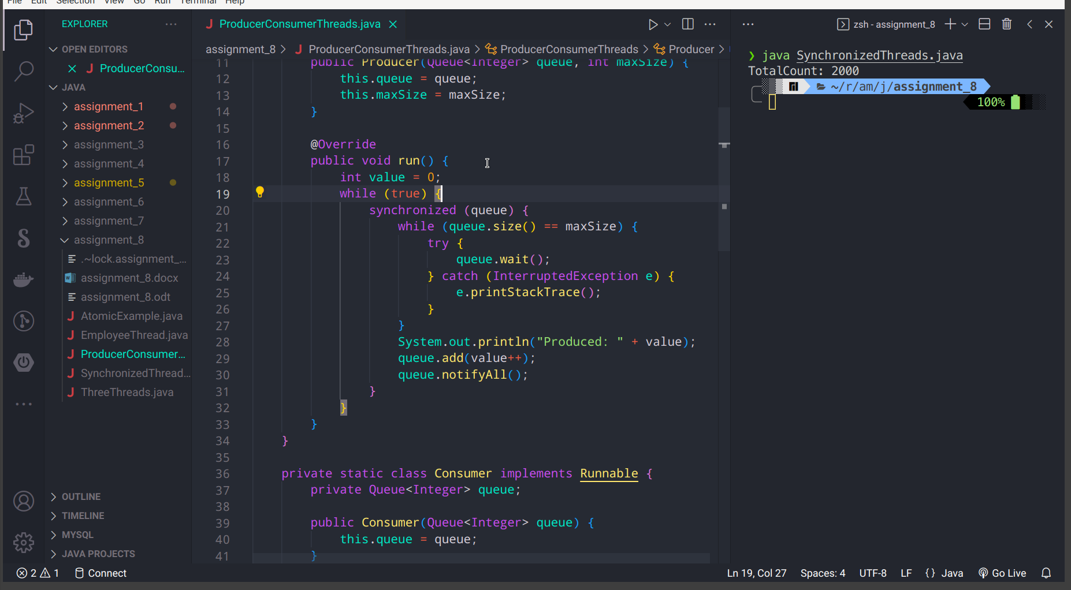

c. Write a program with data structure using atomic methods like get(), incrementAndGet(), decrementAndGet(), compareAndSet(). Also use all other functionalities to make the program more responsive.
a) Code:
package assignment_8;

import java.util.concurrent.atomic.AtomicInteger;

public class AtomicExample {
private static final AtomicInteger counter = new AtomicInteger();

public static void main(String[] args) {
// Increment the counter and get the new value
int newValue = counter.incrementAndGet();
System.out.println("Counter value incremented to: " + newValue);

// Decrement the counter and get the new value
newValue = counter.decrementAndGet();
System.out.println("Counter value decremented to: " + newValue);

// Get the current value of the counter
int currentValue = counter.get();
System.out.println("Current counter value: " + currentValue);

// Compare the current value to a reference value, and set the value to a new
// value if they are equal
boolean success = counter.compareAndSet(0, 5);
if (success) {
System.out.println("Counter value updated from 0 to 5");
} else {
System.out.println("Counter value not updated");
}
}
}
b) Screenshot
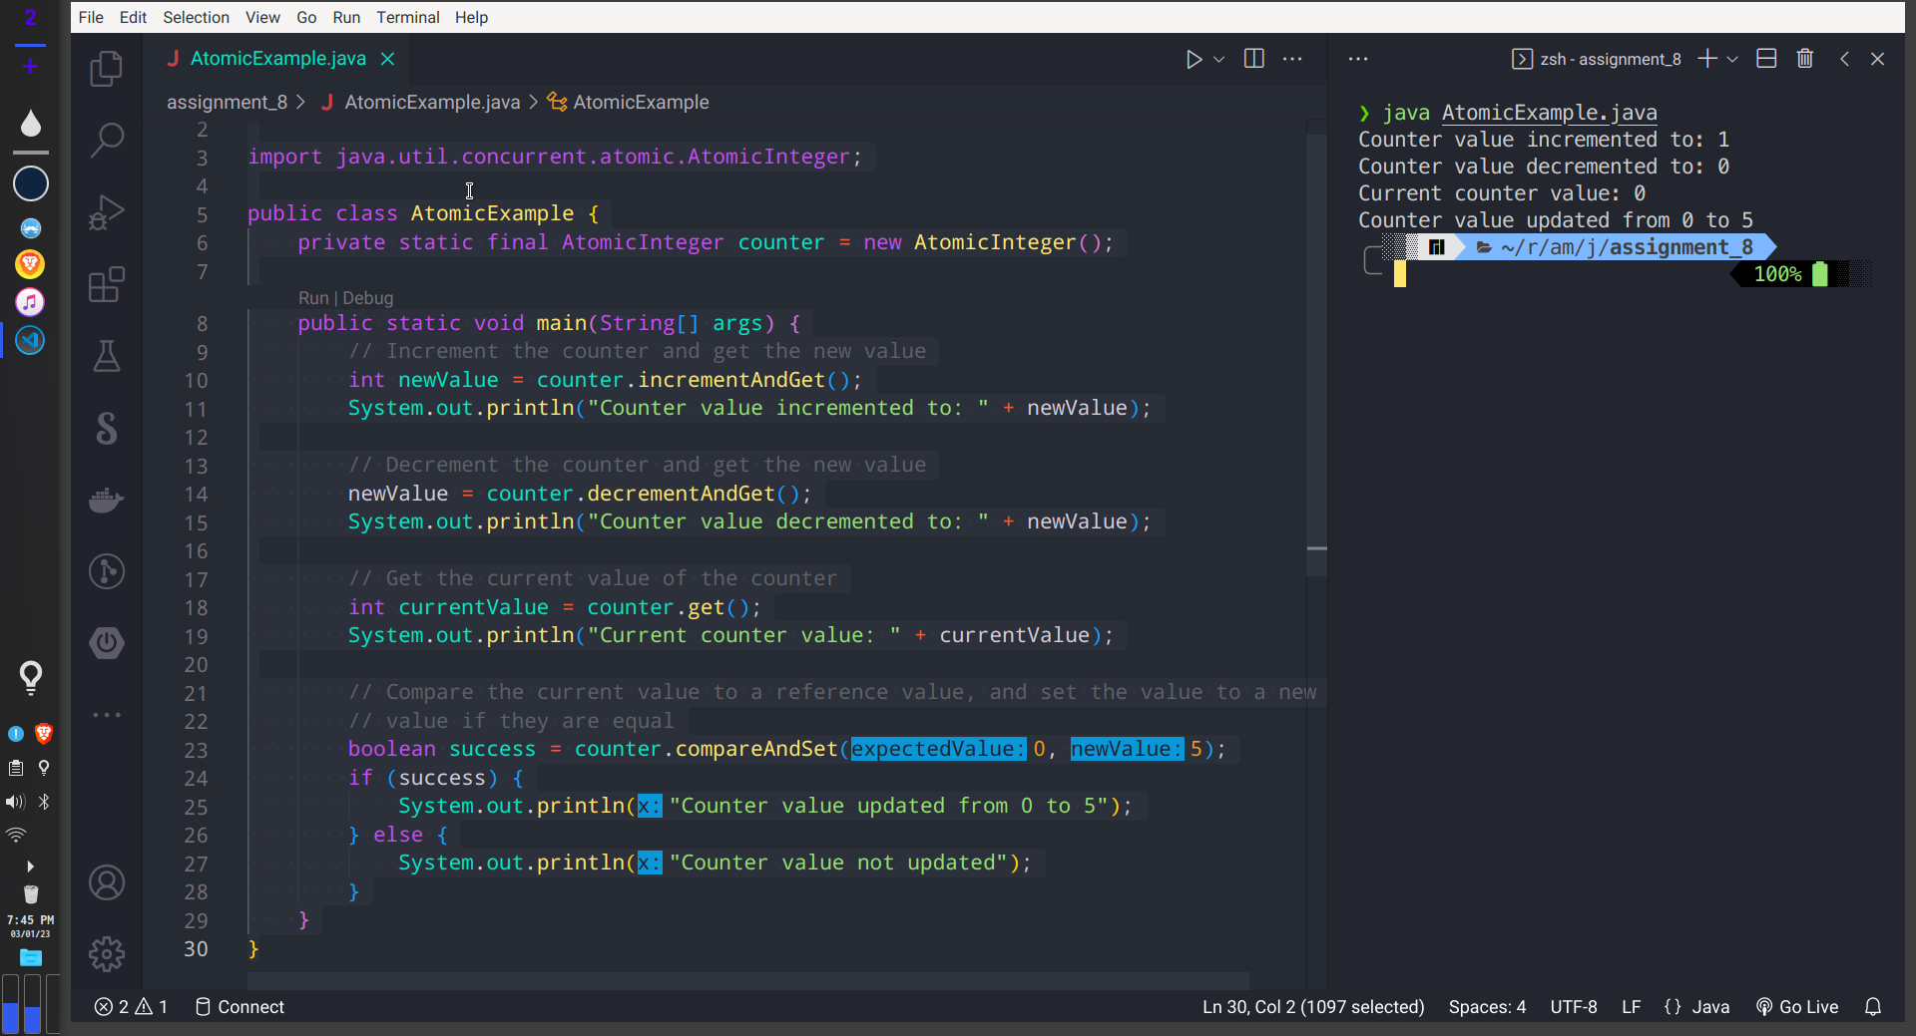

Problem Statement 2: Multithreading

1. Write a Java program to create a thread by using Thread class and also by using

the Runnable interface and display the details of thread like, thread name, id, priority, its phase and other details.

Ans
a) Code
package assignment_8;

public class ThreadInformation {
public static void main(String[] args) {
// Create a thread using the Thread class
Thread thread1 = new Thread() {
public void run() {
System.out.println("Thread 1: Running");
}
};
thread1.setName("Thread 1");
thread1.start();

// Create a thread using the Runnable interface
Runnable runnable = new Runnable() {
public void run() {
System.out.println("Thread 2: Running");
}
};
Thread thread2 = new Thread(runnable);
thread2.setName("Thread 2");
thread2.start();

// Display the details of the threads
System.out.println("Thread 1: Name = " + thread1.getName() + ", ID = " + thread1.threadId() + ", Priority = "
+ thread1.getPriority() + ", Phase = " + thread1.getState());
System.out.println("Thread 2: Name = " + thread2.getName() + ", ID = " + thread2.threadId() + ", Priority = "
+ thread2.getPriority() + ", Phase = " + thread2.getState());
}
}
b) Screenshot
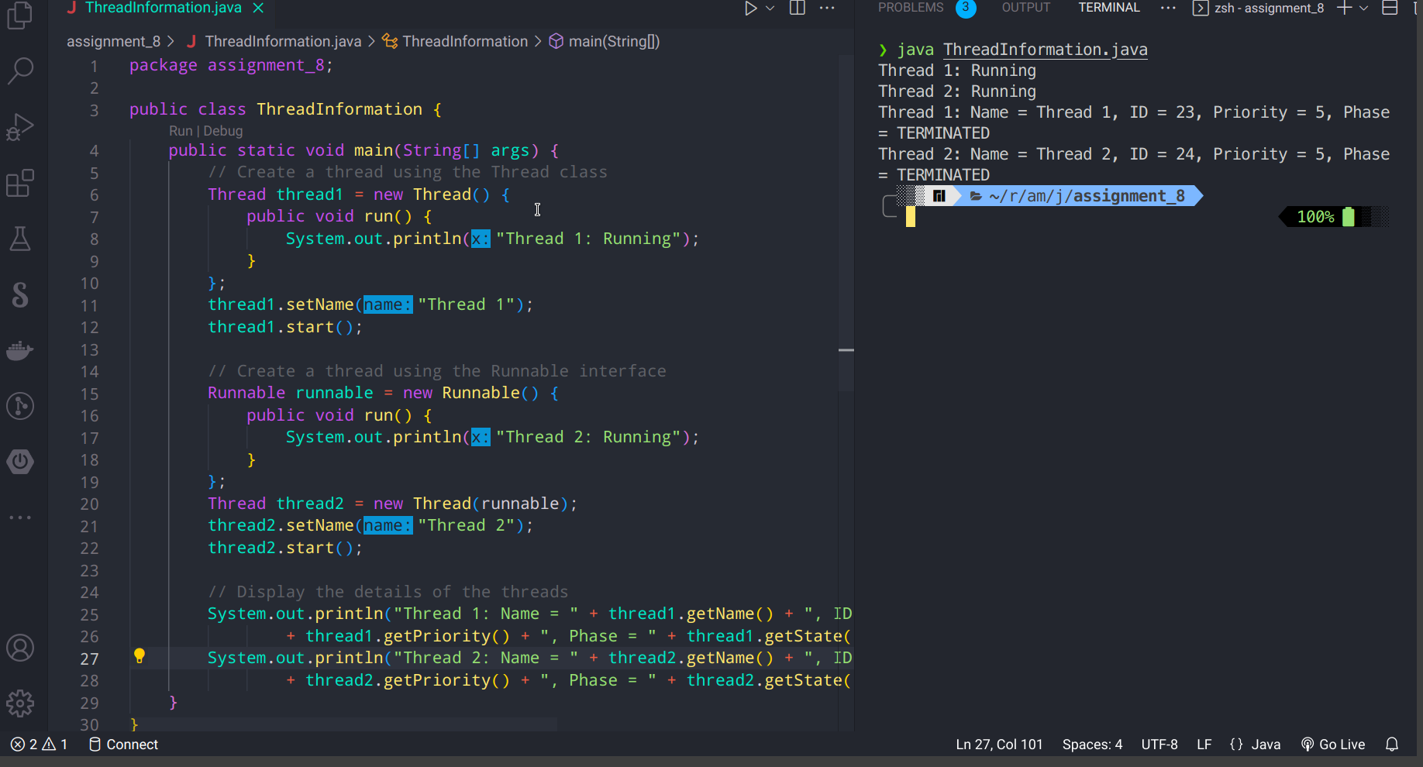

2. Write a Java program to create three different threads, with first thread displaying numbers from 101 to 200, second from 201 to 300 and third from 301 to 400. Verify that all the threads are running simultaneously or not.
Ans
a) Code
package assignment_8;

public class ThreeThreads {
public static void main(String[] args) {
// Create a new thread for displaying numbers from 101 to 200
Thread t1 = new Thread(new Runnable() {
@Override
public void run() {
for (int i = 101; i <= 200; i++) {
System.out.println(i);
}
}
});

// Create a new thread for displaying numbers from 201 to 300
Thread t2 = new Thread(new Runnable() {
@Override
public void run() {
for (int i = 201; i <= 300; i++) {
System.out.println(i);
}
}
});

// Create a new thread for displaying numbers from 301 to 400
Thread t3 = new Thread(new Runnable() {
@Override
public void run() {
for (int i = 301; i <= 400; i++) {
System.out.println(i);
}
}
});

// Start all the threads
t1.start();
t2.start();
t3.start();
}
}

Screenshot:
