Assignment_9

Problem Statement 1: JUnit 5
a. Create a unit test using JUnit 5 to check if the length of the string matches the given length.
b. Create a unit test using Junit 5 to test null pointer exception. Create test using @ParameterizedTest annotation.
c. Create a unit test using JUnit 5 to check the performance of code.
d. Create some tests and group the tests using @Nested annotation.
e. Create unit tests using the JUnit 5 annotations @DisplayName, @BeforeEach, @AfterEach and @Disable. Create a test and use @RepeatedTest annotation.
Screenshot

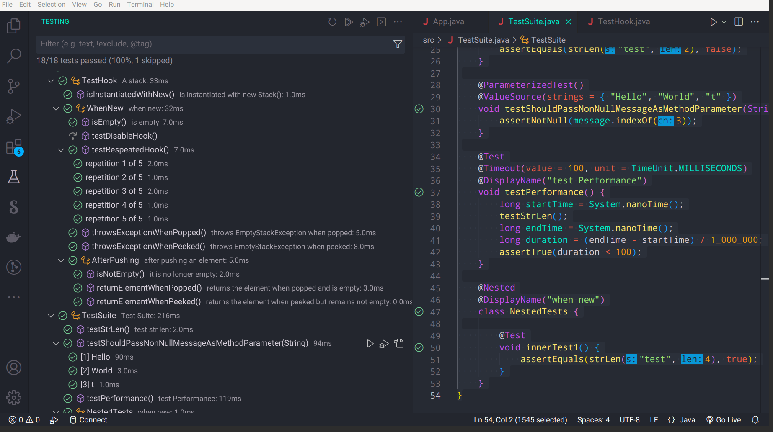
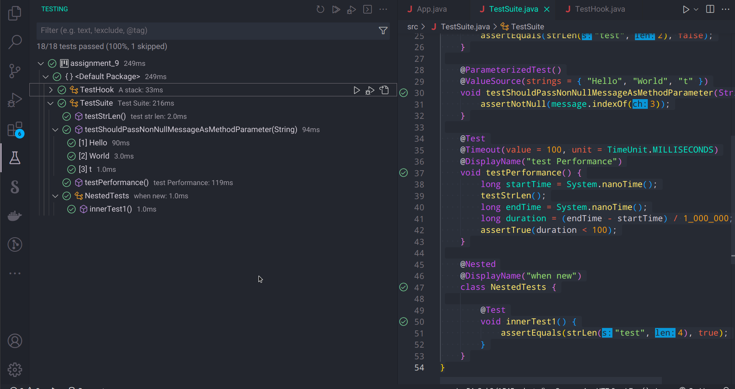
a) Code
PART_1 Test Hook.java
import static org.junit.jupiter.api.Assertions.assertEquals;
import static org.junit.jupiter.api.Assertions.assertFalse;
import static org.junit.jupiter.api.Assertions.assertThrows;
import static org.junit.jupiter.api.Assertions.assertTrue;

import java.util.EmptyStackException;
import java.util.Stack;

import org.junit.jupiter.api.AfterEach;
import org.junit.jupiter.api.BeforeEach;
import org.junit.jupiter.api.Disabled;
import org.junit.jupiter.api.DisplayName;
import org.junit.jupiter.api.Nested;
import org.junit.jupiter.api.RepeatedTest;
import org.junit.jupiter.api.Test;

@DisplayName("A stack")
class TestHook {

Stack<Object> stack;

@Test
@DisplayName("is instantiated with new Stack()")
void isInstantiatedWithNew() {
new Stack<>();
}

@Nested
@DisplayName("when new")
class WhenNew {

@BeforeEach
void createNewStack() {
stack = new Stack<>();
}

@AfterEach
void tearDown() {
// code to be executed after each test
}

@Test
@DisplayName("is empty")
void isEmpty() {
assertTrue(stack.isEmpty());
}

@Test
@Disabled("This test is currently not implemented")
void testDisableHook() {
// test code
}

@RepeatedTest(5)
void testRespeatedHook() {
// test code
}

@Test
@DisplayName("throws EmptyStackException when popped")
void throwsExceptionWhenPopped() {
assertThrows(EmptyStackException.class, stack::pop);
}

@Test
@DisplayName("throws EmptyStackException when peeked")
void throwsExceptionWhenPeeked() {
assertThrows(EmptyStackException.class, stack::peek);
}

@Nested
@DisplayName("after pushing an element")
class AfterPushing {

String anElement = "an element";

@BeforeEach
void pushAnElement() {
stack.push(anElement);
}

@Test
@DisplayName("it is no longer empty")
void isNotEmpty() {
assertFalse(stack.isEmpty());
}

@Test
@DisplayName("returns the element when popped and is empty")
void returnElementWhenPopped() {
assertEquals(anElement, stack.pop());
assertTrue(stack.isEmpty());
}

@Test
@DisplayName("returns the element when peeked but remains not empty")
void returnElementWhenPeeked() {
assertEquals(anElement, stack.peek());
assertFalse(stack.isEmpty());
}
}
}
}
PART 2 TestSuit.java
import static org.junit.jupiter.api.Assertions.assertEquals;
import static org.junit.jupiter.api.Assertions.assertNotNull;
import static org.junit.jupiter.api.Assertions.assertTrue;

import java.util.concurrent.TimeUnit;

import org.junit.jupiter.api.DisplayName;
import org.junit.jupiter.api.Nested;
import org.junit.jupiter.api.Test;
import org.junit.jupiter.api.Timeout;
import org.junit.jupiter.params.ParameterizedTest;
import org.junit.jupiter.params.provider.ValueSource;

@DisplayName("Test Suite")
class TestSuite {
// strLen String,Number -> Bool
public static boolean strLen(String s, int len) {
return s.length() == len;
}

@Test
@DisplayName("test str len")
void testStrLen() {
assertEquals(strLen("test", 4), true);
assertEquals(strLen("test", 2), false);
}

@ParameterizedTest()
@ValueSource(strings = { "Hello", "World", "t" })
void testShouldPassNonNullMessageAsMethodParameter(String message) {
assertNotNull(message.indexOf(3));
}

@Test
@Timeout(value = 100, unit = TimeUnit.MILLISECONDS)
@DisplayName("test Performance")
void testPerformance() {
long startTime = System.nanoTime();
testStrLen();
long endTime = System.nanoTime();
long duration = (endTime - startTime) / 1_000_000;
assertTrue(duration < 100);
}

@Nested
@DisplayName("when new")
class NestedTests {

@Test
void innerTest1() {
assertEquals(strLen("test", 4), true);
}
}
}

