TriSonica

Adjustable pole (0.33 m) ?

iMet XQ-2

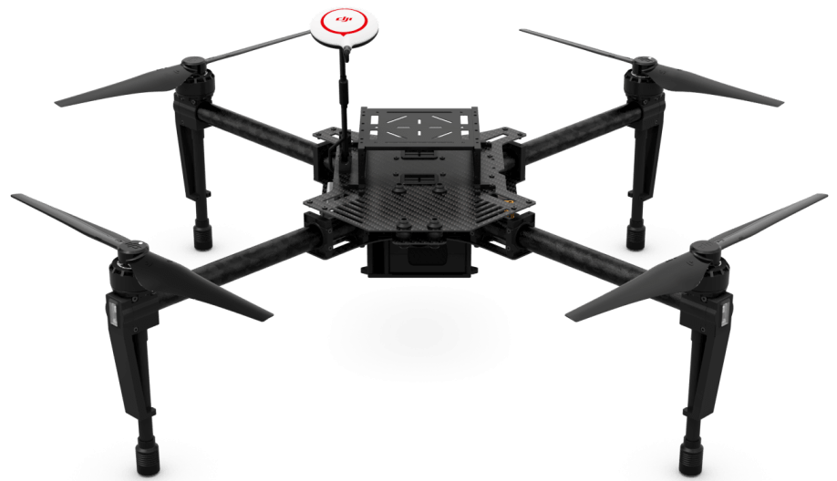

CO2 meter

Raspberry Pi

Mini battery

Diag. wheelbase = 0.65m

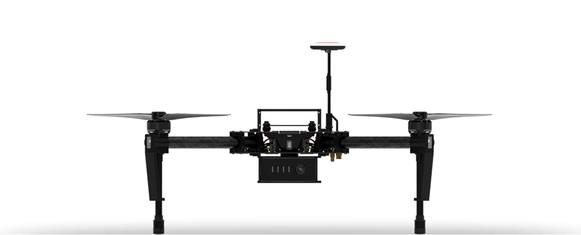

Boom=0.7m from center?

TriSonica

CO2 meter

iMet XQ-2

Extra battery

Raspberry Pi

|  |  |  |  |  |
| --- | --- | --- | --- | --- |
| iMet XQ-2 | T, P, RH | Is T affected by direct sun? RH affected by rotorwash? | Could it go under? | Roldan 2015- underneath center gets higher wind; put on top. BUT shield with some sun cover |
| TriSonica Mini | Wind speed, direxn (H, P) | Avoid rotorwash | Mount on L boom? | Wolf 2017- low interference 0.7m from center  Sucher 2018-1.5 m boom, equal on each side (0.75 each side) |
| K30 CO2 meter | Co2 ppm | Avoid rotorwash | Mount on R boom? |  |
| Raspberry Pi |  |  | flexible |  |
| GPS | Lat, Long, Altitude | On top |  |  |
| External battery |  |  | Near center o |  |