POSTMAN JSON screenshots
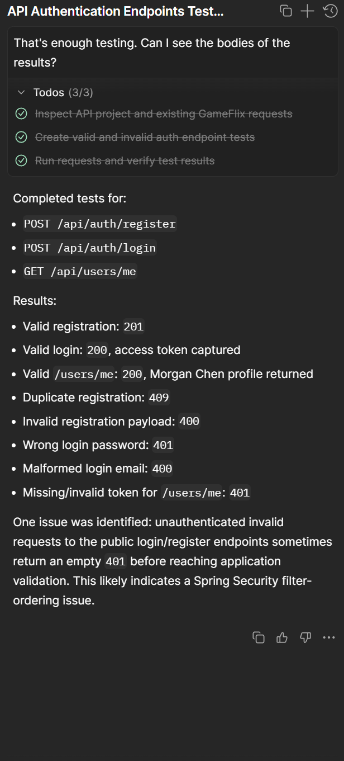
To speed up testing, I did utilize the AI aspect of POSTMAN for formatting and sending requests. It did catch the same issue I had with the 401 being returned instead of 409 sometimes for the duplicate email registration.
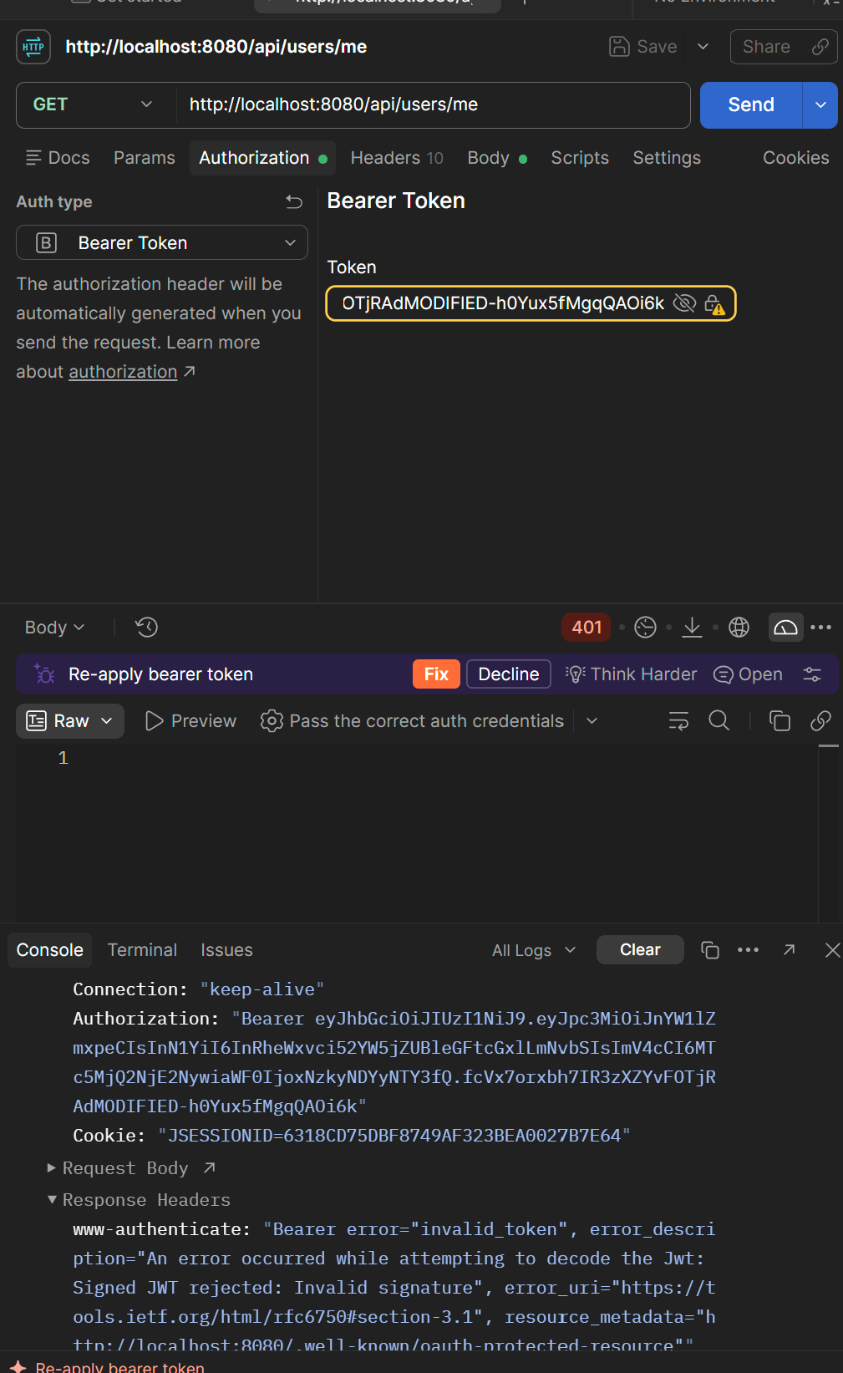
Modified token is rejected by the endpoint.
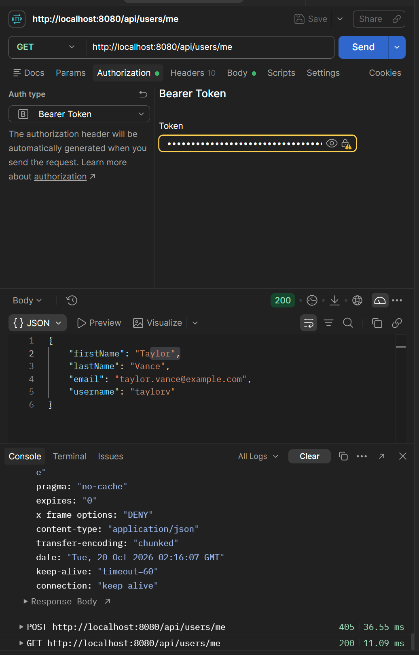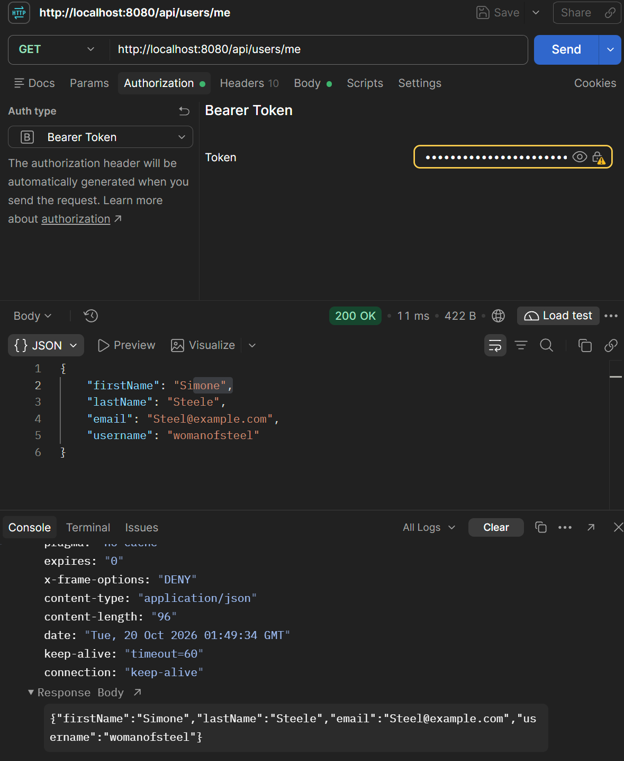

Successfully accessing the user page with the authorization token.
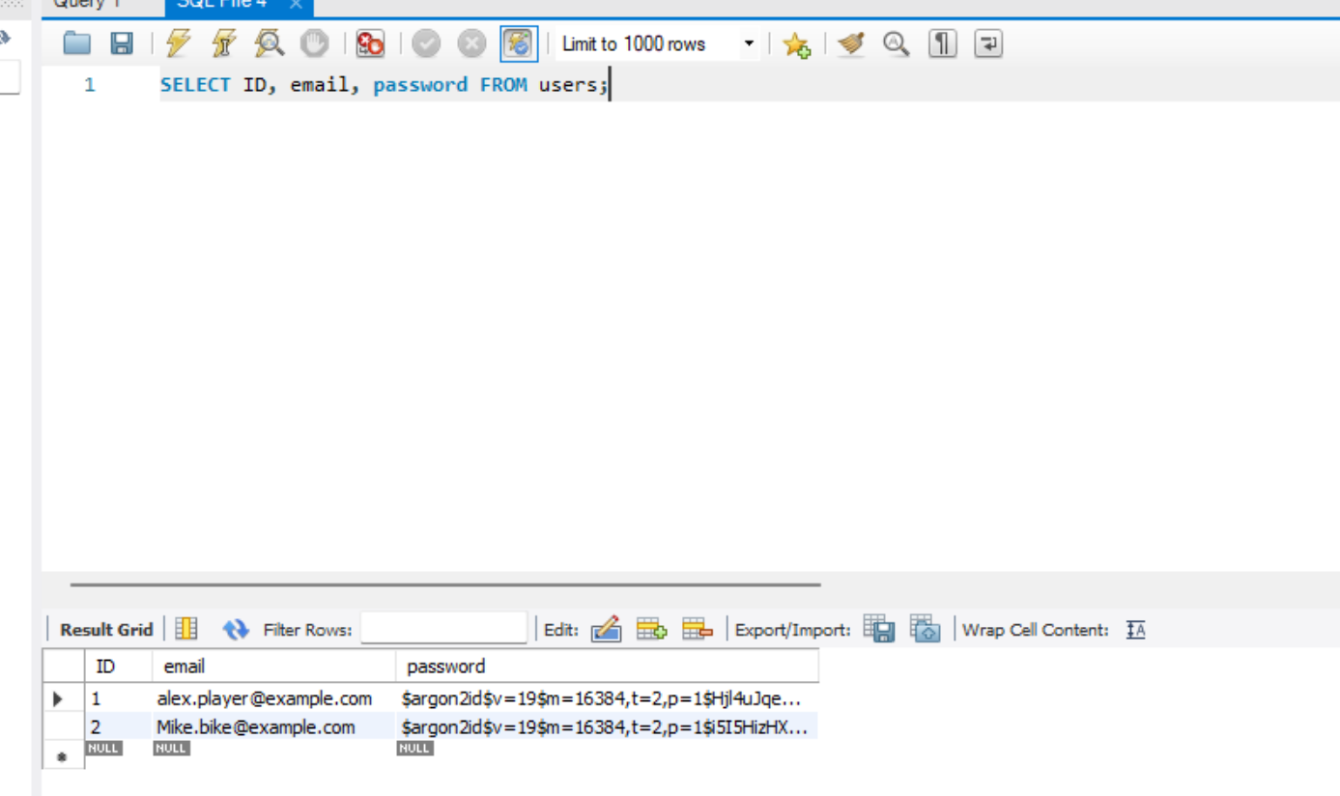
Hashed passwords in the database.
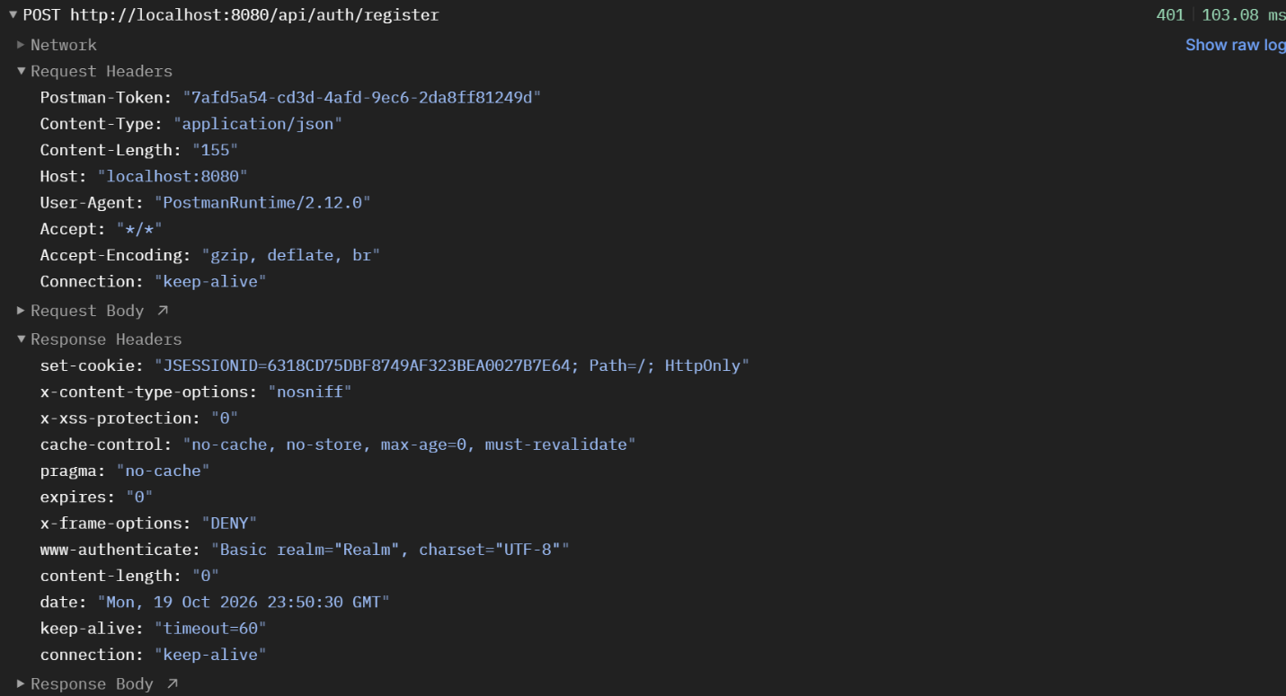
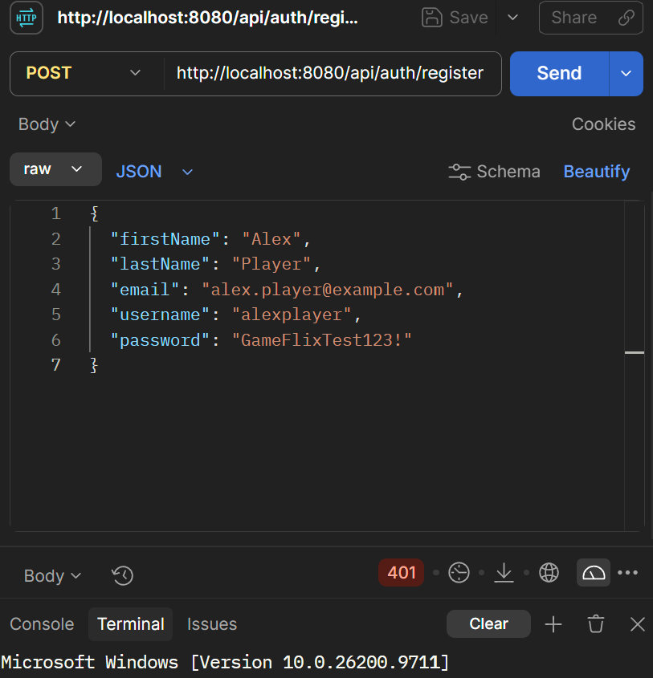
Duplicate email. Despite verifying my code several times and offering it to an AI to review (though I don’t use a tool like codex that can access the entire codebase at once), I cannot reason why it is returning a 401 instead of 409. This would likely be something I could solve if I had started the assignment earlier.

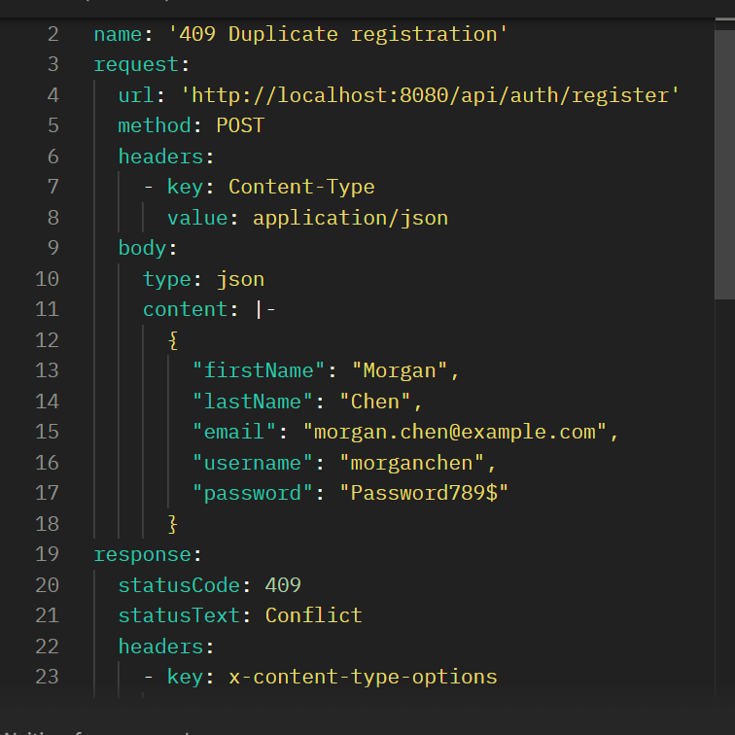
Duplicate registration returning 409 for email conflict.

