# ASSIGNMENT BRIEF AND FEEDBACK FORM

**105-295** & **104-175**

STUDENT No.

**Mr. Sinkala Henry**

LECTURER:

**Software Engineering (Group)**

MODULE:

MODULE CODE:

**COM 413**

ASSIGNMENT NUMBER:

**1**

DATE HANDED OUT:

**20st August, 2025**

DATE DUE IN

**4h September , 2025**

ASSIGNMENT BRIEF

**PROJECT TITLE : CLIMATE CHANGE DASHBOARD**

STUDENT INSTRUCTIONS

1. This form must be attached to the front of your assignment.
2. The assignment must be handed in without fail by submission date (see assessment schedule for your course)
3. Ensure that submission date is date stamped by the reception stuff when you hand it in.
4. Late submission will not be entertained unless with prior agreement with the tutor.
5. All assessable assignments must be word processed.

Table of Contents

ASSIGNMENT BRIEF AND FEEDBACK FORM 1

**CHAPTER ONE: INTRODUCTION** 4

**1.0 Introduction** 4

**1.1 Background** 4

**1.2 Motivation of the Study** 5

**1.3 Significance of the Study** 5

**1.4 Scope of the Study** 6

**1.5 Problem Statement** 6

**1.6 Objectives** 6

**1.7 Research Questions** 7

**1.8 Conceptual/Theoretical Framework** 7

**1.9 Definition of Terms** 7

**1.10 Organization of the Report** 8

**CHAPTER TWO: LITERATURE REVIEW** 8

2.0 Overview 8

2.1 Literature Review 8

2.2 Related Works 9

2.3 Gaps in the Literature 10

**CHAPTER THREE: RESEARCH DESIGN AND SYSTEM DESIGN** 8

3.0 Overview 11

3.1 Research Design 11

3.2 Baseline Study 11

3.3 System Design 12

Development Methodology & Tools 19

Time Frame (5 Weeks Plan) 20

References 21

**CHAPTER ONE: INTRODUCTION**

**1.0 Introduction**

The relationship between climate change and economic development has emerged as one of the most critical global concerns of the 21st century. Rising global temperatures, unpredictable rainfall patterns, and extreme weather events are increasingly impacting agricultural productivity, energy demand, industrial output, and public health. As a result, policymakers, researchers, and organizations worldwide are seeking integrated solutions to better understand the linkages between climate change and economic performance.

In many parts of the world, especially in developing countries, the lack of accessible and interactive platforms for analysing climate-economic data poses a challenge for informed decision-making. While global organizations such as the World Bank and United Nations provide extensive datasets, they are often complex, scattered, and inaccessible to students, researchers, and local policymakers. A simplified digital dashboard can bridge this gap by integrating climate and economic indicators into a visual, interactive system that enhances data-driven analysis and education.

At the local level, Zambia, like many other African nations, is highly vulnerable to climate shocks due to its dependence on agriculture, natural resources, and energy production. Economic growth is often disrupted by droughts, floods, and fluctuating commodity prices. Despite the availability of data, there remains a significant gap in user-friendly tools that can present climate-economic interactions in a clear and actionable format. This study seeks to design and develop a Climate-Economic Data Dashboard that simplifies data interpretation and supports decision-making, academic research, and environmental awareness.

**1.1 Background**

Globally, climate change has been recognized as both an environmental and economic challenge, with reports from the Intergovernmental Panel on Climate Change (Climate Change 2021: The Physical Science Basis, 2021) and the World Bank highlighting the adverse effects on global GDP, food security, and human well-being. Economies across the world are experiencing losses due to natural disasters, reduced agricultural output, and increased healthcare costs. Developed nations are increasingly investing in digital platforms that integrate climate and economic data to enhance resilience planning and policy implementation.

Regionally, African economies are disproportionately affected by climate variability. According to the African Development Bank, up to 50% of agricultural output in Sub-Saharan Africa is highly sensitive to changing climatic conditions. This vulnerability often translates into economic instability, food insecurity, and reduced export earnings. Despite this, most data platforms available remain foreign-based, limiting local ownership, contextualization, and usability.

In Zambia, the Ministry of Green Economy and Environment and the Zambia Statistics Agency collect relevant data; nevertheless, accessing, analysing, and interpreting this data remains a challenge for non-specialists. Academic institutions, policymakers, and students lack simplified tools that present data in a visual, accessible, and interactive way. By introducing a Climate-Economic Data Dashboard, this study aims to address the gap in translating raw datasets into actionable insights that support both academic learning and informed policy decision-making.

**1.2 Motivation of the Study**

The motivation behind this study is to contribute to sustainable development efforts by making climate-economic data more accessible and understandable. Instead of relying solely on static reports, users can engage with dynamic visualizations that reveal trends and correlations. This approach can empower students, policymakers, and researchers at Cavendish University Zambia and beyond to make evidence-based decisions and foster environmental awareness.

**1.3 Significance of the Study**

This study is significant for the following reasons:

1. **Academic Contribution:** Provides students and researchers with a tool for exploring climate and economic linkages in Zambia and globally.
2. **Policy Relevance:** Assists policymakers by providing visual data insights that can support sustainable planning and climate resilience strategies.
3. **Technological Innovation:** Demonstrates the role of digital dashboards in simplifying complex datasets and promoting data-driven decision-making.
4. **Local Relevance:** Creates a platform contextualized for Zambia, aligning with national development and climate change adaptation priorities.

**1.4 Scope of the Study**

The project will focus on designing and developing a web-based Climate-Economic Data Dashboard. The scope will include:

1. Integration of open datasets on climate (temperature, rainfall, emissions) and economy (GDP, agriculture, trade).
2. Development of interactive visualizations using charts and graphs.
3. A user-friendly interface for students, policymakers, and researchers.  
   This study excludes predictive modelling future climate-economic scenarios through machine learning but rather on presenting existing datasets in an accessible format.

**1.5 Problem Statement**

Despite the availability of climate and economic data, there is limited accessibility to user-friendly platforms that can integrate and visualize this information for practical use in Zambia. Existing resources are often fragmented, complex, or inaccessible to non-experts. This gap in accessibility and visualization hinders informed decision-making, academic research, and environmental awareness. Therefore, there is a need to develop a Climate-Economic Data Dashboard that simplifies complex datasets into interactive visualizations, providing users with actionable insights.

**1.6 Objectives**

**1.6.1 General Objective**

To design and develop a Climate-Economic Data Dashboard that integrates and visualizes climate and economic indicators to support academic research, decision-making, and environmental awareness in Zambia.

**1.6.2 Specific Objectives**

1. To identify and collect relevant climate and economic datasets from reliable sources.
2. To design a user-friendly web-based dashboard interface for visualizing the collected data.
3. To implement interactive visualizations (charts, graphs, filters) that highlight key climate-economic trends.
4. To evaluate the usability and effectiveness of the dashboard in supporting academic research and decision-making.

**1.7 Research Questions**

1. What relevant climate and economic datasets can be collected and integrated for Zambia and global analysis?
2. How can a web-based dashboard interface be designed to be user-friendly and accessible to students, researchers, and policymakers?
3. What interactive visualization techniques can effectively present climate-economic data to reveal trends and relationships?
4. How effective is the developed dashboard in supporting academic research, decision-making, and environmental awareness?

**1.8 Conceptual/Theoretical Framework**

This study will be guided by the **Information Visualization Theory**, which emphasizes the transformation of abstract data into interactive visual representations that enhance understanding, pattern recognition, and decision-making. The conceptual framework assumes that the integration of climate and economic data into a single dashboard, when presented visually, can improve comprehension, accessibility, and application of information in academic and policy contexts.

**1.9 Definition of Terms**

1. **Dashboard:** A digital platform that integrates and displays data through visualizations such as charts and graphs.
2. **Climate Data:** Information on temperature, rainfall, emissions, and other weather-related variables.
3. **Economic Data:** Indicators such as GDP, trade, and agricultural output that reflect a country’s economic performance.
4. **Visualization:** The graphical representation of data to enhance interpretation and analysis.

**1.10 Organization of the Report**

This report is organized into five chapters. **Chapter One** introduces the study, including background, motivation, problem statement, and objectives. **Chapter Two** provides a literature review of existing studies and related works, highlighting gaps. **Chapter Three** outlines the research design and system design of the dashboard. **Chapter Four** presents the implementation and results, while **Chapter Five** discusses conclusions, limitations, and recommendations for future work.

# **CHAPTER TWO: LITERATURE REVIEW**

### 2.0 Overview

A literature review is an analysis of scholarly publications, research papers, and project reports related to the subject under investigation. In this study, the literature review explores global, regional, and local perspectives on climate and economic data visualization, the role of dashboards, and existing technological interventions. It highlights what has been done by other researchers, identifies methodological approaches, and points out gaps that justify the need for this study.

### 2.1 Literature Review

**Global Perspective**  
Globally, the integration of climate and economic data has gained attention due to the increasing demand for sustainable development policies. According to the World Bank (climateknowledgeportal, 2025), climate-related shocks such as floods and droughts can reduce GDP growth in developing economies by up to 3%. Various platforms such as the World Bank Data Portal and the Climate Change Knowledge Portal provide access to climate and economic indicators. However, these platforms are often designed for advanced researchers, limiting their usability for non-expert users (Kumar, 2021).

Dashboards have become essential tools in simplifying large datasets. Few (2013) defines a dashboard as a visual display of key information consolidated and arranged on a single screen to support decision-making. Interactive dashboards powered by data visualization libraries such as D3.js and Tableau are widely used in business intelligence and healthcare (Zhang et al., 2020), but limited focus has been placed on climate-economic relationships in an African context.

**Regional Perspective (Africa)**  
In Africa, the African Development Bank (Bank(AfDB), 2021)notes that climate change impacts agriculture, energy, and water resources, with an estimated 30–40% reduction in crop yields in Sub-Saharan Africa due to changing rainfall patterns. Despite the existence of regional data repositories such as ClimDev-Africa and African Climate Policy Centre databases, accessibility challenges persist. Chikozho (Chikozho, 2020) observes that most climate-economic data platforms in Africa are donor-funded and externally managed, which limits local customization and ownership.

Interactive dashboards have been piloted in some African contexts. For example, the South African Weather Service developed climate visualization dashboards for agriculture, while Kenya’s Ministry of Environment has worked on drought-monitoring tools. However, these tools are sector-specific and rarely integrate economic indicators.

**Local Perspective (Zambia)**  
At the national level, Zambia faces recurring droughts, floods, and variable rainfall that significantly impact its economy, particularly in agriculture and hydropower production (Ministry of Green Economy and Environment, 2022). The Zambia Statistics Agency (ZamStats) and Ministry of Finance collect climate and economic data, but the reports are often static and not widely accessible to students or policymakers in a user-friendly form.

Chisanga and Mulenga (B.P Mulenga. and B, 2020) highlight that while Zambia has access to climate data through the Zambia Meteorological Department, translating these datasets into economic terms remains a challenge. No significant platform currently integrates both climate and economic indicators into a single dashboard for decision support. This presents an opportunity for academic and technological innovation.

### 2.2 Related Works

Several studies and projects have attempted to link climate and economic data through visualization platforms:

1. **World Bank Climate Change Knowledge Portal** – Provides global climate data, but is complex for non-specialists (World Bank, 2022).
2. **UNDP Data Futures Platform** – Offers sustainable development data visualizations but does not focus specifically on climate-economic interactions.
3. **Tableau Climate Dashboards** – Used in academic settings to demonstrate climate trends (Zhang et al., 2020), but are proprietary and require subscriptions.
4. **South Africa Agricultural Climate Dashboard** – Focused on climate effects on agriculture, but limited in scope and not integrated with broader economic indicators (SAWS, 2021).

From these examples, it is evident that while dashboards exist, they are either too broad (global platforms) or too narrow (sector-specific African platforms), with little focus on integrated, localized tools tailored for academic use in Zambia.

### 2.3 Gaps in the Literature

From the reviewed studies, the following gaps emerge:

1. **Lack of Integration** – Most platforms either focus on climate or economic data separately, with few integrating the two in a single accessible tool.
2. **Usability Gap** – Existing global dashboards are often too technical and inaccessible to students and local policymakers in Zambia.
3. **Local Context** – Very few dashboards contextualize data for Zambia, making it difficult for local institutions to draw relevant insights.
4. **Educational Utility** – There is limited research on using dashboards as academic tools for teaching and research in environmental economics at the university level.

These gaps justify the need for a **Climate-Economic Data Dashboard tailored for Zambia**, designed to integrate datasets, simplify access, and support academic research and policymaking.

# **CHAPTER THREE: RESEARCH DESIGN AND SYSTEM DESIGN**

### 3.0 Overview

This chapter outlines the research design, data collection approach, and system development methodology adopted for the Climate-Economic Data Dashboard. It also presents the system design framework, including diagrams and modular architecture, to demonstrate how the proposed platform will be developed and implemented.

### 3.1 Research Design

The study will adopt a **design science research design** since it focuses on creating an innovative technological solution to address a practical problem. Design science emphasizes problem identification, artifact development, demonstration, and evaluation. The research process will involve:

1. Identifying the problem (lack of integrated, accessible climate-economic data tools).
2. Designing the dashboard prototype.
3. Developing and implementing the system.
4. Testing the dashboard with end users (students, researchers).
5. Evaluating usability and effectiveness.

This design is appropriate as it aligns with the general objective of creating a functional digital artifact to solve the identified problem.

### 3.2 Baseline Study

#### 3.2.1 Data Collection

The study will rely on **secondary data sources** from reliable organizations such as:

1. World Bank Data Portal
2. Zambia Statistics Agency (ZamStats)
3. Ministry of Green Economy and Environment
4. UN Climate Change Data
5. African Development Bank Reports

The data will include climate variables (temperature, rainfall, emissions) and economic indicators (GDP, agriculture output, trade).

#### 3.2.2 Research Approach

The project will follow a **quantitative research approach**, as it deals with measurable datasets that will be analysed and visualized. The approach allows for statistical representation of trends and correlations between climate and economic factors.

#### 3.2.3 Development of the Application

The dashboard will be developed using a **web-based application approach** with the following technologies:

1. **Frontend:** HTML5, CSS3, JavaScript, Bootstrap (for responsiveness)
2. **Visualization:** Chart.js / D3.js (for interactive charts and graphs)
3. **Backend (optional, if needed):** PHP / Node.js for data integration
4. **Database (optional, if storing local datasets):** MySQL or SQLite

#### 3.2.4 System Design

The system will follow a **modular development strategy**, ensuring each function (data integration, visualization, filtering) is developed and tested independently.

### 3.3 System Design

#### 3.3.1 Context Diagram

The dashboard will receive input from **external data sources** (World Bank, ZamStats, UN data). The system will process the data and output visual dashboards for the **end users** (students, policymakers, researchers).

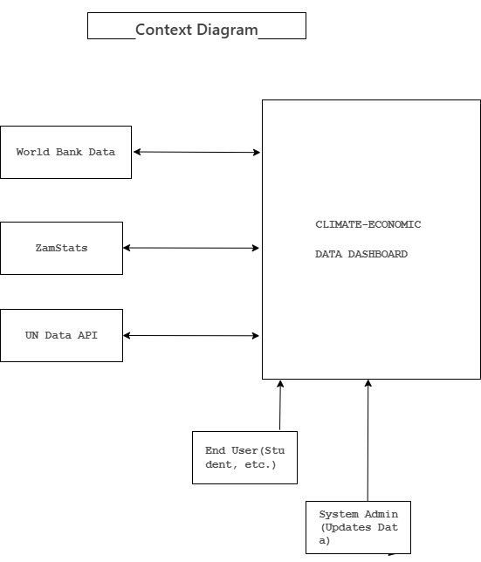

Figure 3.1: Contextual Diagram

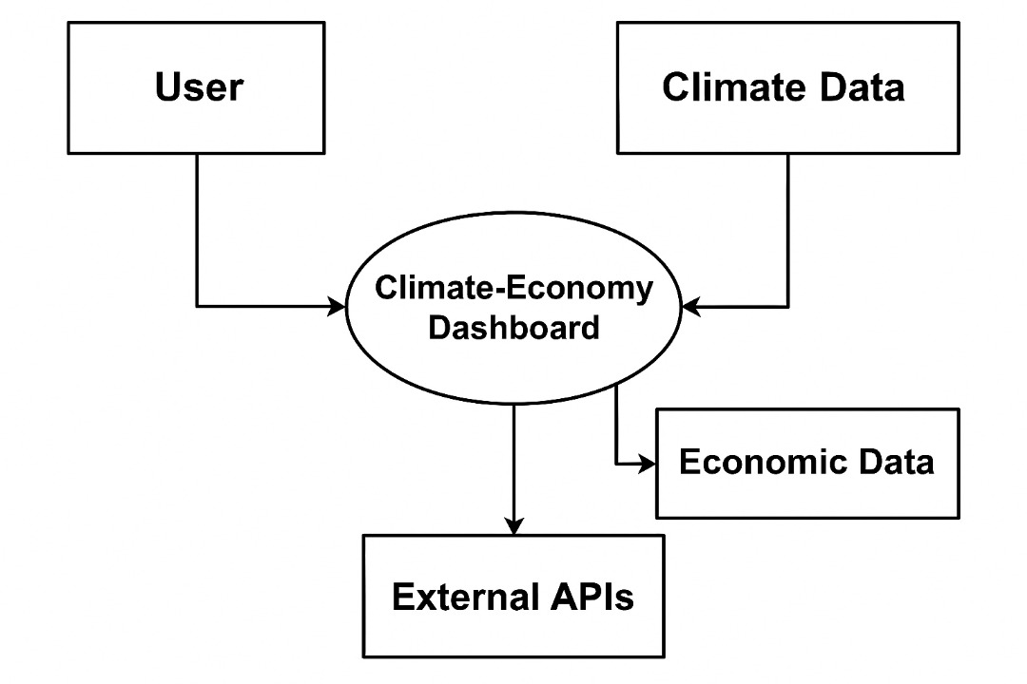

Figure 3.2: Detailed System Architecture Diagram

#### 3.3.2 System Software Level Architectural Design

The architecture will be a **3-tier structure**:

1. **Presentation Layer:** User interface (web browser, dashboard).
2. **Application Layer:** Visualization engine, data processing logic.
3. **Data Layer:** External APIs and/or locally stored datasets.

#### 3.3.3 Modular Design of the System Functions

#### 

Figure 3.3: Modular Design Diagram

#### Figure 3.x: Detailed System Architecture Diagram

* **Module 1: Data Integration** – Fetches datasets from APIs or local CSV/Excel files.
* **Module 2: Data Visualization** – Generates charts, graphs, and tables.
* **Module 3: User Interaction** – Provides filters, search functions, and selection of indicators.
* **Module 4: Export/Reporting (optional)** – Allows users to download graphs or reports.

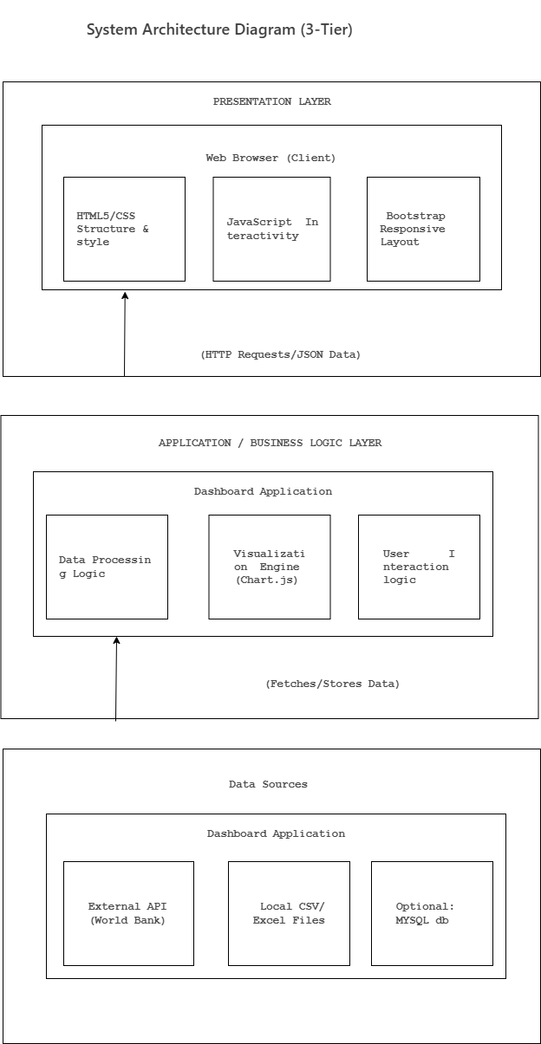

Figure 3.4: Activity Diagram of Dashboard Workflow

#### 3.3.4 System Class Diagram

#### 

Figure 3.5: System Class Diagram*.*

Main classes:

* **Data Source** (attributes: name, type, URL)
* **Dataset** (attributes: indicator, year, value)
* **Visualization** (attributes: chartType, dataset, options)
* **User** (attributes: name, role, preferences)

#### 3.3.5 System Data Model Design

The simplified data model includes:

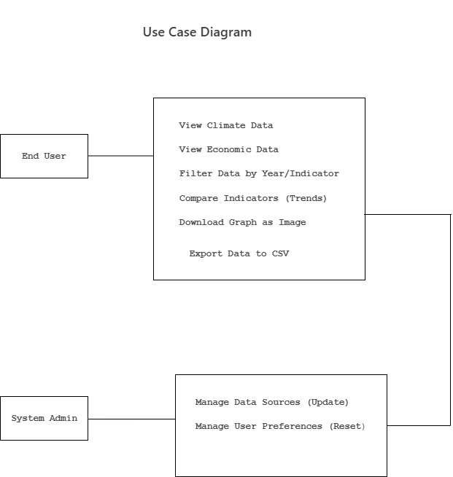

Figure 3.6: USE CASE Diagram

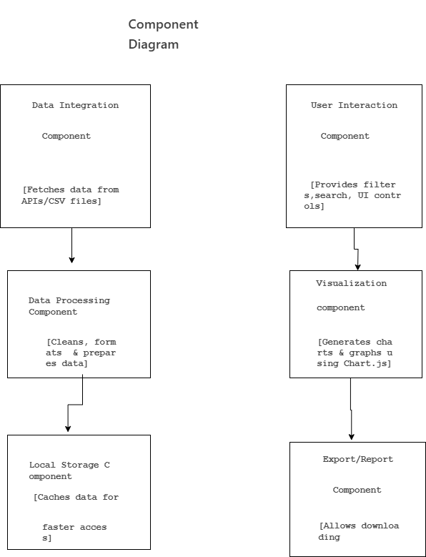

Figure 3.7: Component Diagram

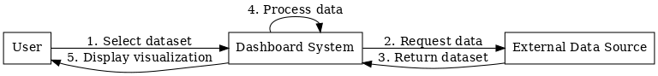

Figure 3.8: Sequence Diagram of User–System–Data Source Interaction



Figure 3.9: State Diagram of Dashboard System States*.*

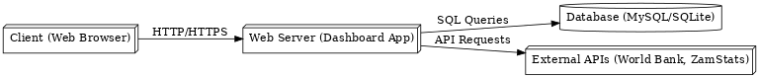

Figure 3.10: Deployment Diagram of Dashboard Infrastructure.

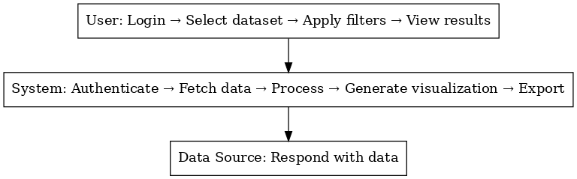

Figure 3.11: Swimlane Diagram of Roles in Dashboard Use*.*

* **Climate_Data (year, temperature, rainfall, emissions)**
* **Economic_Data (year, GDP, agriculture_output, trade_balance)**
* **User_Preferences (user_id, selected_indicators, filters)**

### Development Methodology & Tools

The project will use the **Agile development methodology**, with short iterative cycles to ensure functionality is tested and refined quickly. Tools include:

* Visual Studio Code (coding environment)
* GitHub (version control)
* MySQL Workbench (if database integration is used)
* Tableau Public or Google Data Studio (optional for data exploration)

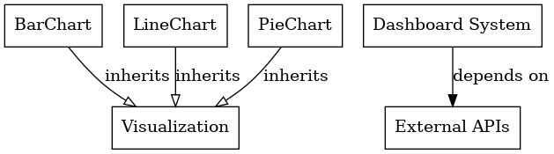

Figure 3.12: Dependency and Generalization Diagram*.*

### Time Frame (5 Weeks Plan)

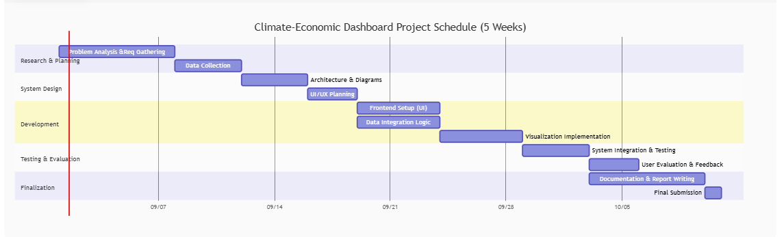

Figure 3.13: Time Frame Diagram

* **Week 1:** Problem analysis, requirements gathering, data collection.
* **Week 2:** System design (diagrams, architecture).
* **Week 3:** Frontend development (UI + visualization setup).
* **Week 4:** Integration of datasets and testing.
* **Week 5:** Evaluation, final testing, documentation, and submission.

# References

(CCKP), W. B. (2O22). https://climateknowledgeportal.worldbank.org/.

B.P Mulenga. and B, C. (2020). Climate Change and agriculture in Zambia: Impact and adaptation options. *Journal of Southern African Studies*, 745-762.

Bank(AfDB), A. D. (2021). *African Economic Outlook.* Abidjan: AfDB.

Bank, W. (2022). *Climate Change Knowledge Portal (CCKP).* Available at: https://climateknowledgeportal.worldbank.org/.

Bank, W. (2025, August 28). *climateknowledgeportal*. From climateknowledgeportal.worldbank: https://climateknowledge.worldbank.org/

Change, I. P. (2021). *Climate Change 2021: The Physical Science Basis.* Cambridge: Cambridge University.

Chikozho, C. (2020). Climate data use in African policy and planning. *African Policy Review*, 211-225.

Intergovernmental Panel on Climate Change (IPCC) (2021) Climate Change 2021: The Physical Science Basis. Cambridge: Cambridge University Press.

International Energy Agency (IEA) (2023) Africa Energy Outlook 2023. Paris: IEA.

Kumar, R. a. (2021). Data visualization for decision support systems. *A review’, Journal of Information Systems, 35(2)*, 45–60.

Smit, B., Burton, I., Klein, R.J.T. and Street, R. (2020) ‘The science of adaptation: A framework for assessing vulnerability’, Mitigation and Adaptation Strategies for Global Change*, 25(1*), pp. 1–22.

United Nations Development Programme (UNDP) (2022) Human Development Report 2022: Uncertain Times, Unsettled Lives*.* New York: UNDP.

United Nations Economic Commission for Africa (UNECA) (2022) Climate Changeand Development in Africa Report 2022. Addis Ababa: UNECA.

Zambia Statistics Agency (ZamStats) (2021) Zambia Environmental and Economic Indicators Report 2021. Lusaka: Government of Zambia.