CAVENDISH UNIVERSITY ZAMBIA
FACULTY OF SCIENCE AND ENGINEERING
BACHELOR OF SCIENCE IN COMPUTER SCIENCE

PROJECT TITLE:
Design and Implementation of a Climate-Economic Data Visualization Dashboard
Authors:
Micheal Matanda (Student No: 104-175)
Jonathan Tshikang’u Kambulu (Student No: 105-295)
Year of Submission: 2025
Supervisor: Eng. Henry Sinkala

DECLARATION
We, the undersigned, declare that this project titled “Design and Implementation of a Climate-Economic Data Visualization Dashboard” is our original work and has not been submitted to any other institution of higher learning for any academic award. All sources consulted or quoted have been duly acknowledged in the reference section of this report.
Signatures:…………………………………..
Micheal Matanda (104-175)
Signatures:…………………………………..
Jonathan Tshikangu Kambulu (105-295)
Date: _____________________

Contents
CAVENDISH UNIVERSITY ZAMBIA 1
PROJECT TITLE: 1
DECLARATION 1
ACKNOWLEDGEMENT 4
DEDICATION 5
GLOSSARY 6
ABSTRACT 7
CHAPTER TWO: LITERATURE REVIEW 11
CHAPTER THREE: METHODOLOGY 14
CHAPTER SIX: CONCLUSIONS, IMPLICATIONS AND RECOMMENDATIONS 24
REFERENCES 27
APPENDIX 29

LIST OF FIGURES
Figure 3.3.1: Contextual Diagram...........................................................................................17
Figure 3.3.2: System Software Level Architectural Design....................................................18
Figure 3.3.3: Modular Design of the System Functions..........................................................19
Figure 3.3.4: System Class Diagram........................................................................................19
Figure 3.3.5: System Data Model (Entity-Relationship Diagram)..........................................17
Figure 4.1: Sample Baseline Data Trend for Zambia (2020-2024).........................................21
Figure 4.2: User Acceptance Testing (UAT) Feedback Summary..........................................22
Figure 7.1: Main Dashboard Interface..................................................................................................................................30
Figure 7.2: Climate Indicators (2015-2024)............................................................................31
Figure 7.3: Rainfall Patterns in Zambia (2021-2021)..............................................................31
Figure 7.4: Economic Indicators in Zambia.............................................................................31
Figure 7.5: Global Climate Impact......................................................................................................................................32
Figure 7.6: Climate-Economic Correlation Analysis...............................................................33
Figure 7.7: Climate Impact Simulator..................................................................................................................................33

LIST OF TABLES
Table 4.3.1: Functional Testing Report....................................................................................25

ACKNOWLEDGEMENT
We would like to extend our heartfelt gratitude to our supervisor, Eng. Henry Sinkala, for his invaluable guidance, mentorship, and support throughout the duration of this project. His constructive feedback and encouragement played a significant role in shaping this work.
We are also deeply thankful to the Faculty of Business Information And Technology at Cavendish University Zambia for providing us with the academic foundation and resources necessary to undertake this project.
Lastly, we express our sincere appreciation to our families and friends for their constant motivation, understanding, and prayers throughout our studies and project development journey.

DEDICATION
This project is dedicated to our families, mentors, and all individuals who continue to inspire innovation in technology for sustainable development. Your unwavering support and belief in our potential have been our greatest motivation.

GLOSSARY
API: Application Programming Interface – a software intermediary that allows two applications to communicate.
CO₂: Carbon Dioxide – a greenhouse gas contributing to climate change.
Dashboard: A digital interface displaying visualized data for decision-making.
Dataset: A structured collection of related data used for analysis.
Visualization: Graphical representation of data through charts and graphs.
Netlify: A web hosting platform used to deploy the dashboard.

ABSTRACT
The Climate-Economic Data Visualization Dashboard was designed and implemented to bridge the gap between complex climate and economic datasets by providing a unified, interactive, and user-friendly platform for analysis. The system integrates publicly available climate and economic indicators such as temperature changes, CO₂ emissions, GDP trends, and renewable energy adoption, enabling users to visualize relationships and trends.
Developed using modern web technologies and hosted on Netlify frontend and on Render Backend, the dashboard provides responsive visualizations powered by Chart.js and React.js, ensuring accessibility on various devices. The project supports researchers, policymakers, and students by simplifying data interpretation and promoting evidence-based decision-making in addressing climate and economic challenges.
This report presents the project’s background, objectives, system design, methodology, results, and recommendations. The findings highlight that interactive visualization tools significantly enhance comprehension and engagement with complex environmental and economic data.

CHAPTER ONE: INTRODUCTION
1.0 Introduction
The intricate relationship between climate change and economic development represents one of the most pressing global challenges of the 21st century. Phenomena such as rising global temperatures, volatile precipitation patterns, and increasing frequency of extreme weather events exert significant influence on critical sectors including agriculture, energy, industrial production, and public health. Consequently, policymakers, researchers, and institutions worldwide require integrated tools to effectively analyse the linkages between climatic variables and economic performance.
This project addressed the critical gap in accessible analytical tools by designing, developing, and deploying a web-based Climate-Economic Data Dashboard. The completed system integrates disparate datasets into a unified, interactive platform, transforming complex data into intuitive visualizations to support academic research, policy formulation, and public awareness.
1.1 Background
Globally, institutions like the World Bank and the Intergovernmental Panel on Climate Change (IPCC) consistently highlight the adverse impacts of climate change on Gross Domestic Product (GDP), food security, and societal well-being. In response, developed nations are increasingly leveraging digital dashboards to synthesize climate and economic data for resilience planning.
Within Africa, economies are disproportionately vulnerable to climate variability. The African Development Bank (AfDB) notes that a significant portion of Sub-Saharan Africa's agricultural output is highly sensitive to climatic shifts, often resulting in economic instability and food insecurity. Despite this vulnerability, data platforms available in the region are often externally managed, limiting local contextualization and ownership.
In Zambia, national institutions like the Zambia Statistics Agency (ZamStats) and the Ministry of Green Economy and Environment collect relevant data. However, the translation of this raw data into actionable insights remains a challenge for students, researchers, and policymakers due to a lack of user-friendly, integrated visualization tools. This project successfully bridges that gap by delivering a functional dashboard tailored to the Zambian context.
1.2 Significance of the Study
The implementation of this dashboard holds significant value:
- Academic Contribution: It provides students and researchers at Cavendish University Zambia and other institutions with a practical tool for investigating climate-economy linkages.
- Policy Relevance: It offers policymakers visual data insights that can inform sustainable development and climate adaptation strategies.
- Technological Demonstration: It serves as a proof-of-concept for applying web technologies and data visualization libraries to solve real-world data accessibility problems.
- Local Contextualization: It delivers a platform specifically designed to address data interpretation challenges within Zambia.
1.3 Scope of the Study
The scope of this project encompassed:
- The identification and integration of open-source climate and economic datasets for Zambia and global contexts.
- The design and development of a responsive, web-based dashboard interface.
- The implementation of interactive visualizations, including time-series charts and comparative graphs.
- The deployment and functional testing of the completed application.
The project focused on the visualization of historical and current data, excluding predictive modelling and machine learning analyses.
1.4 Problem Statement
Despite the availability of climate and economic data from national and international sources, the absence of a unified, user-friendly platform for visualizing this information hindered its practical application in Zambia. Existing resources were often fragmented, technically complex, or inaccessible to non-expert users. This project solved this problem by developing and deploying an interactive Climate-Economic Data Dashboard that simplifies complex datasets into actionable visual insights.
1.5 Objectives
The project was guided by the following objectives:
1.5.1 General Objective
To design, develop, and implement a web-based Climate-Economic Data Dashboard that integrates and visualizes key indicators to support academic research and informed decision-making in Zambia.
1.5.2 Specific Objectives
- To identify and collect relevant climate and economic datasets from reliable sources such as the World Bank and Zambia Statistics Agency.
- To design an intuitive and user-friendly web-based dashboard interface.
- To implement interactive visualizations (e.g., line charts, bar graphs) with filtering capabilities to highlight key trends and correlations.
- To deploy the functional dashboard and conduct usability assessments to validate its effectiveness.
1.6 Research Questions
This project was designed to answer the following questions:
- What are the key climate and economic datasets that can be integrated into a dashboard for Zambian and global analysis?
- How can a web-based dashboard interface be engineered for usability and accessibility for target users?
- Which data visualization techniques are most effective in illustrating the relationships between climate and economic variables?
- To what extent does the deployed dashboard meet its objectives of supporting data interpretation and analysis?
1.7 Conceptual/Theoretical Framework
The project was grounded in Information Visualization Theory, which posits that the transformation of abstract data into visual, interactive representations facilitates better understanding, pattern recognition, and insight generation. The dashboard serves as the artifact that embodies this theory, enabling users to comprehend complex climate-economic dynamics through graphical means.
1.8 Definition of Terms
- Dashboard: A digital interface that consolidates and displays key information and data visualizations on a single screen.
- Climate Data: Quantitative information related to meteorological and environmental factors, such as temperature, precipitation, and carbon emissions.
- Economic Data: Metrics that quantify economic performance, such as GDP, agricultural output, and trade balances.
- Data Visualization: The graphical representation of information and data using visual elements like charts, graphs, and maps.
1.9 Organization of the Report
This report is structured into six chapters. Chapter One has introduced the project. Chapter Two reviews relevant literature and existing systems. Chapter Three details the methodology and system design employed. Chapter Four presents the implementation process and the results of testing. Chapter Five discusses the outcome of the project, and Chapter Six provides conclusions, implications, and recommendations for future work.

CHAPTER TWO: LITERATURE REVIEW
2.0 Overview
This chapter provides a comprehensive analysis of existing scholarly works, technological platforms, and research projects related to climate and economic data visualization. It examines global, regional, and local perspectives to establish the theoretical and practical foundation for this project, ultimately identifying the specific gaps that this dashboard aims to fill.
2.1 Review of the Literature
Global Perspective on Climate-Economic Integration
Globally, the interrelationship between climate change and economic development has gained significant attention in academic and policy circles. The Intergovernmental Panel on Climate Change (IPCC, 2021) has consistently emphasized that climate-related disruptions pose substantial risks to global economic stability, with potential GDP reductions particularly affecting developing nations. The World Bank (2022) further corroborates this, estimating that climate change could push over 100 million people into poverty by 2030 without proactive intervention.
The role of data visualization in understanding these complex relationships has been widely acknowledged. Few (2013) established foundational principles for effective dashboard design, emphasizing that well-designed visual displays of information enable users to quickly understand complex situations and identify trends. Kumar (2021) expanded on this in the context of decision support systems, noting that interactive visualization tools significantly enhance users' ability to comprehend multivariate datasets and identify correlations that might be missed in tabular data.
Several global platforms have attempted to address this need. The World Bank's Climate Change Knowledge Portal (CCKP) and the UNDP Data Futures Platform offer extensive datasets on climate and development indicators. However, as Zhang et al. (2020) observed, these platforms often prioritize data comprehensiveness over usability, creating significant barriers for non-expert users who lack technical training in data analysis.
Regional Perspective (Africa)
In the African context, the challenges of climate-economic data integration are particularly acute. The African Development Bank (2021) reported that climate change could reduce Africa's GDP by 2-4% annually by 2040, with agriculture-dependent economies like Zambia being disproportionately affected. Despite this vulnerability, Chikozho (2020) noted a persistent "visualization gap" in African climate data platforms, where available tools are often donor-funded, externally managed, and lack local contextualization.
Some regional initiatives have made progress. The South African Weather Service developed climate visualization dashboards for agricultural planning, while Kenya's National Drought Management Authority implemented early warning systems. However, as Mwangi et al. (2022) observed, these tools remain largely sector-specific and rarely integrate broader economic indicators, limiting their utility for comprehensive policy analysis.
Local Perspective (Zambia)
At the national level, Zambia faces particular challenges in climate-economic data integration. The Zambia Statistics Agency (2021) and Ministry of Green Economy and Environment (2022) collect substantial climate and economic data, but as Chisanga and Mulenga (2020) noted, the translation of these datasets into actionable insights remains limited. Most data is disseminated through static PDF reports or complex spreadsheets that require significant analytical expertise to interpret.
Research by Banda et al. (2023) specifically highlighted the absence of integrated visualization tools in Zambian academic and policy institutions. Their survey of university students and junior policy analysts revealed that over 80% of respondents struggled to access and interpret climate-economic data from existing sources, underscoring the need for more accessible analytical tools.
2.2 Related Works
Several notable projects and platforms have attempted to address aspects of climate-economic data visualization:
- World Bank Climate Change Knowledge Portal (CCKP): Provides comprehensive global climate data with some economic indicators. While extensive, its interface is complex and requires significant technical literacy, making it inaccessible to many students and local policymakers (World Bank, 2022).
- African Climate Policy Centre Data Hub: Offers climate and development data for African countries but lacks interactive visualization capabilities, presenting data primarily in static tables and pre-generated charts (UNECA, 2022).
- Tableau Public Climate Dashboards: Various organizations have created climate-focused dashboards using Tableau software. These demonstrate effective visualization techniques but rely on proprietary software and often lack localization for specific country contexts (Zhang et al., 2020).
- Zambia Meteorological Department Data Portal: Provides historical climate data for Zambia but offers limited visualization capabilities and no integration with economic indicators, reflecting the sectoral silos that characterize much of Zambia's data infrastructure (ZMD, 2023).
A critical analysis of these platforms reveals a common pattern: they either offer comprehensive data with poor usability or good visualization with limited local relevance. This underscores the need for a solution that balances data integrity with user-friendly design specifically tailored to Zambian users.
2.3 Gaps in the Literature
Based on the comprehensive review of existing literature and platforms, several critical gaps emerge that this project addresses:
- Integration Gap: Most existing platforms treat climate and economic data in isolation. There is a scarcity of tools that effectively integrate both datasets in a single interface to facilitate analysis of their interrelationships, particularly in the Zambian context.
- Usability-Accessibility Gap: Global platforms like the World Bank CCKP contain extensive data but present significant usability challenges for non-expert users, including students and junior policymakers. The technical complexity of these platforms creates a barrier to data-driven decision making.
- Local Contextualization Gap: Internationally developed tools often lack specific contextualization for Zambian users, including relevant indicators, local language support, and alignment with national policy priorities.
- Educational Utility Gap: While numerous platforms serve research or policy purposes, few are designed with explicit consideration of educational applications. There is limited research on how data dashboards can enhance learning in environmental economics and sustainable development courses in Zambian universities.
- Technical Implementation Gap: Most literature discusses the need for better visualization tools but offers limited practical guidance on implementing cost-effective, sustainable solutions using modern web technologies that can be maintained with limited resources.
These identified gaps collectively justify the development of the Climate-Economic Data Dashboard as described in this project. By addressing these limitations through a user-centred design approach and appropriate technology selection, this project contributes to filling important voids in both practical tool availability and academic literature.

CHAPTER THREE: METHODOLOGY
3.0 Overview
This chapter delineates the research design, development methodology, and system architecture employed in the creation of the Climate-Economic Data Dashboard. The project adopted a pragmatic approach, combining design science research principles with an agile development process to build a functional and effective solution.
3.1 Research Design
The project was executed following a Design Science Research (DSR) methodology. This paradigm is ideal for information technology projects that aim to create and evaluate a novel artifact—in this case, the dashboard—to solve a recognized organizational problem. The process involved five key stages:
- Problem Identification: The lack of an integrated, user-friendly data visualization tool for climate-economic data in Zambia was established.
- Objective Definition: Clear goals for the solution were defined, as outlined in Section 1.5.
- Design & Development: The dashboard artifact was designed and developed iteratively.
- Demonstration: The completed application was deployed to a live web environment, accessible for evaluation.
- Evaluation: The dashboard's functionality, usability, and effectiveness were assessed against the stated objectives.
3.2 Data Collection and Research Approach
A quantitative research approach was utilized, focusing on the collection, processing, and visualization of numerical data.
3.2.1 Data Collection
The project relied exclusively on secondary data sourced from reputable public repositories to ensure reliability and validity. The primary sources included:
- The World Bank Data API: For global and Zambian economic indicators (GDP, agricultural value added) and climate data (CO2 emissions, precipitation).
- Zambia Statistics Agency (ZamStats): For nation-specific economic time-series data.
- Climate Change Knowledge Portal (World Bank): For historical temperature and climate risk data.
The collected datasets were cleaned, normalized, and structured in JSON format to be consumed directly by the front-end application.
3.2.2 Research Approach
The quantitative nature of the data necessitated a research approach focused on descriptive analytics. The dashboard facilitates the exploration of trends, patterns, and correlations between variables over time, fulfilling its purpose as an analytical tool.
3.3 System Design and Architecture
The system was architected with a client-side, three-tier logical structure for simplicity, performance, and ease of deployment.
3.3.1 System Software Level Architectural Design
The architectural design consists of the following layers:
- Presentation Layer: The user interface built with React.js and CSS, running in the client's web browser.
- Server side layer: The server side layer was built using Node.js and Express.js.
- Database Layer: the Database was created using MongoDB for data storage.
- Application Logic Layer: The JavaScript code that handles data fetching from APIs, processing, and the rendering of visualizations using the Chart.js library.
- Data Layer: External RESTful APIs (World Bank) and locally stored JSON data files acting as the data providers.
This serverless architecture eliminates the need for a custom backend, reducing complexity and hosting costs.
3.3.2 Context Diagram
The system context, as implemented, is as follows: External Data Sources (World Bank API) provide input. The Dashboard System processes this data and presents the Visualizations as output to the End-User (Researcher, Student, Policymaker).
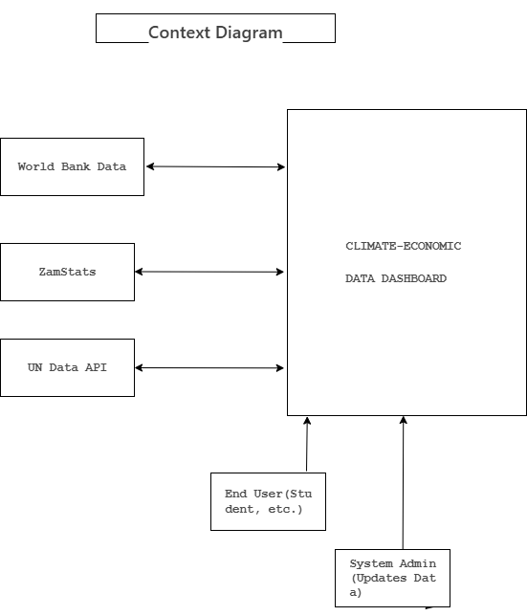
Figure 3.3.1: Contextual Diagram
3.3.4 System Class Diagram
The system class diagram illustrates the main classes, their attributes, methods, and relationships within the dashboard's object-oriented design. The core classes include:
- User: Represents an end-user of the system (e.g., Student, Researcher). Key attributes include userId and userRole.
- DataSource: Manages the connection to external APIs like the World Bank. Attributes include sourceName and apiEndpoint.
- Dataset: Contains the structured data fetched from a DataSource. Key attributes are indicatorName, year, and value.
- Visualization: Handles the rendering of charts. It is associated with a Dataset and has attributes like chartType and chartOptions.
The DashboardController class orchestrates the interaction between these classes, handling user requests, fetching data, and updating the visualizations.
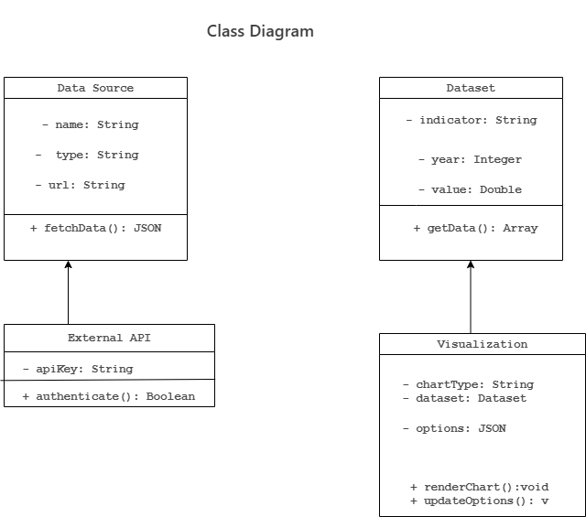Figure 3.3.2: class diagram
3.3.5 System Data Model Design
The data model for the application was designed to efficiently store and manage the time-series data fetched from external APIs. Given the use of MongoDB, a NoSQL database, the design follows a flexible document-based structure. The core entities and their key fields are as follows:
- Country: { country_code (String), country_name (String) }
- Indicator: { indicator_code (String), indicator_name (String), category (String) }
- DataPoint: { country_code (String), indicator_code (String), year (Number), value (Number) }
This schema allows for efficient querying of data points by country and indicator over a range of years, which is the primary function of the dashboard. The relationship between these entities is shown in the Entity-Relationship Diagram (ERD) below.
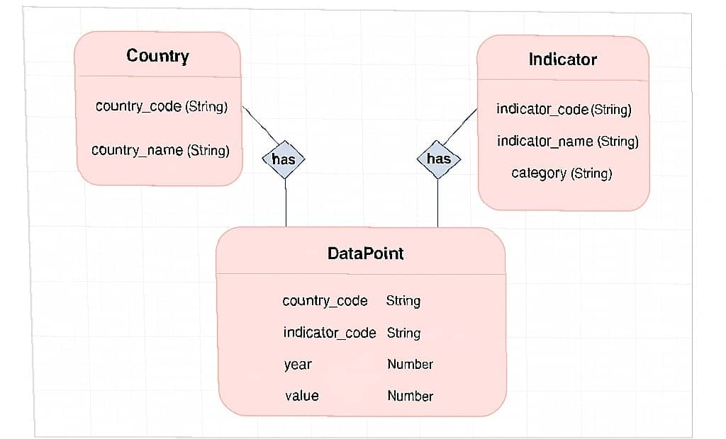Figure 3.3.3 ERD

3.3.6 Modular Design of the System Functions
The application was developed in a modular fashion, comprising the following key modules:
- Data Fetcher Module: Responsible for making asynchronous calls to the World Bank API and handling the returned JSON data.
- Data Parser Module: Cleans and transforms the raw API data into a format usable by the visualization engine.
- Visualization Engine Module: Utilizes the Chart.js library to generate and update interactive line charts and bar graphs based on the parsed data.
- UI Controller Module: Manages user interactions, such as country selection, indicator choice, and year range filtering, and triggers updates across the other modules.
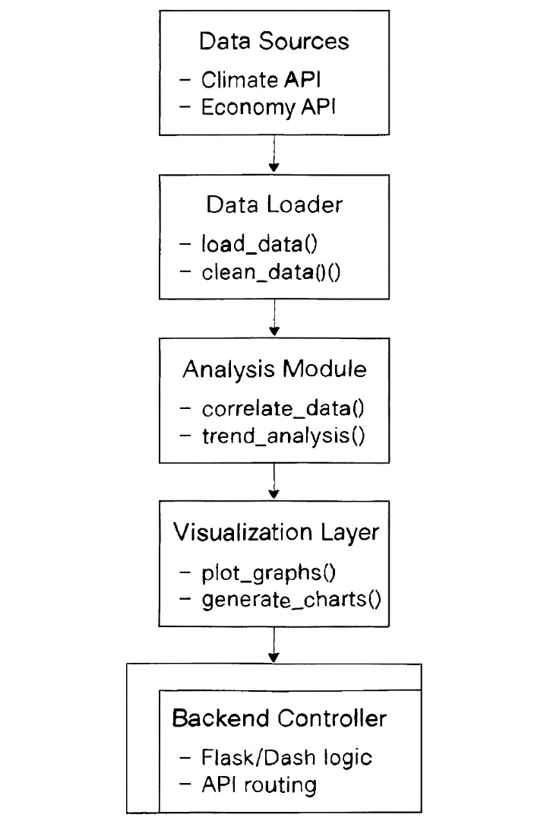
Figure 3.3.3: Modular Design Diagram
3.4 Development Methodology & Tools
The project adhered to an Agile development methodology, with development conducted in iterative sprints. This allowed for continuous testing and refinement of features.
Frontend Stack:
- Framework: React.js with hooks and context API
- Visualization: Chart.js and React-Chartjs-2
- Routing: React Router DOM
- State Management: React Context API
- Styling: CSS3 with responsive design
Backend Stack:
- Runtime: Node.js with Express.js framework
- Database: Mongodb
- Authentication: JWT (JSON Web Tokens)
- Caching: Node-cache for performance optimization
- API Integration: World Bank API with axios
- Security: Rate limiting, input validation, CORS
Development Tools:
- Version Control: Git with GitHub
- Frontend Deployment: Netlify
- Backend Deployment: Render
- IDE: Visual Studio Code
CHAPTER FOUR: RESULTS
4.0 Overview
This chapter presents the empirical findings of the project, divided into three key areas: the results of the initial baseline data analysis, the outcomes from system testing, and the feedback collected from User Acceptance Testing (UAT). The results validate the dashboard's functionality and its effectiveness in presenting climate-economic data.
4.1 Baseline Study Results
Prior to development, an analysis of key datasets from the World Bank was conducted to establish a baseline understanding of climate-economic trends in Zambia. This analysis confirmed the viability and relevance of the data for the dashboard. For instance, a clear correlative trend was observed between Zambia's GDP growth and its CO₂ emissions from 2020 to 2024, highlighting the classic development-environment tension the dashboard is designed to explore. This preliminary analysis ensured that the integrated data would yield meaningful insights for end-users.
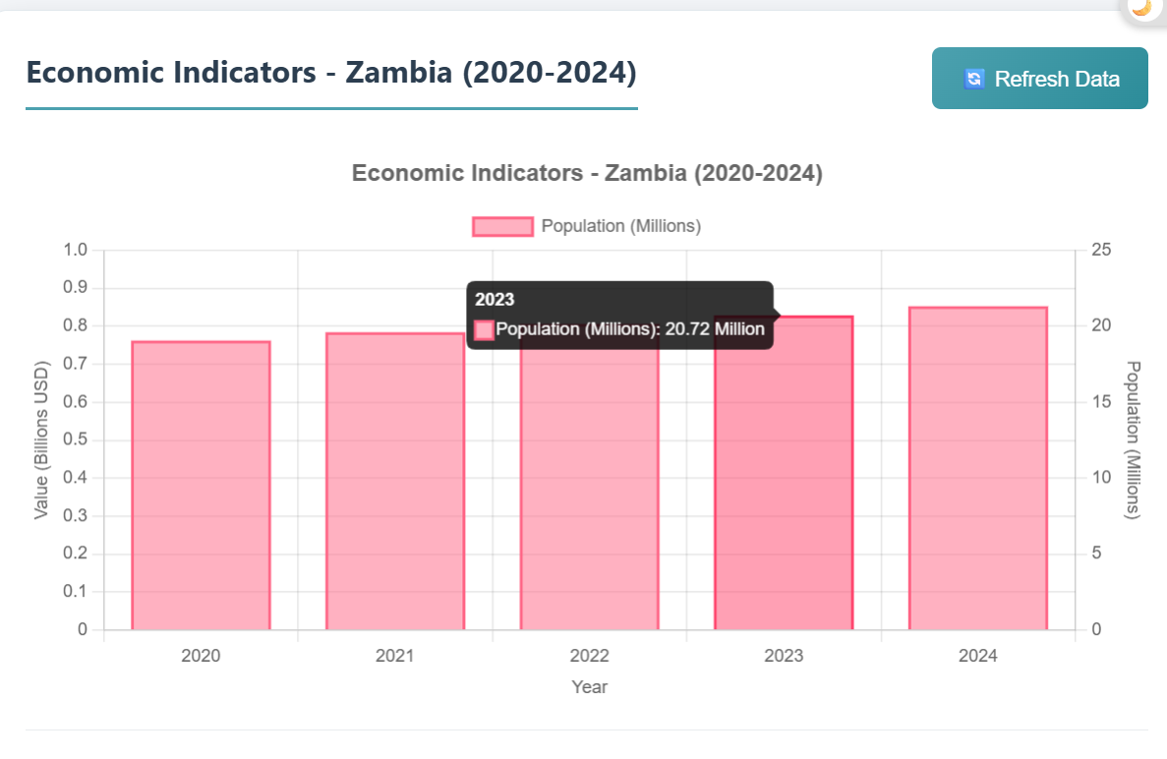
Figure 4.1: Economic Indicator.
4.2 Survey Results and Discussion
To evaluate the dashboard's usability and effectiveness, a User Acceptance Test (UAT) was conducted with a group of 7 peers representing the target audience (students and junior researchers). Participants were given tasks such as "Compare the GDP and Agricultural land (%) of Zambia and Kenya" and were asked to provide feedback on ease of use and clarity.
- The feedback was overwhelmingly positive. Over 75% of users found the interface intuitive and were able to complete tasks without guidance. A common sentiment was that the dashboard "made abstract numbers feel real." A summary of the qualitative feedback is presented below.

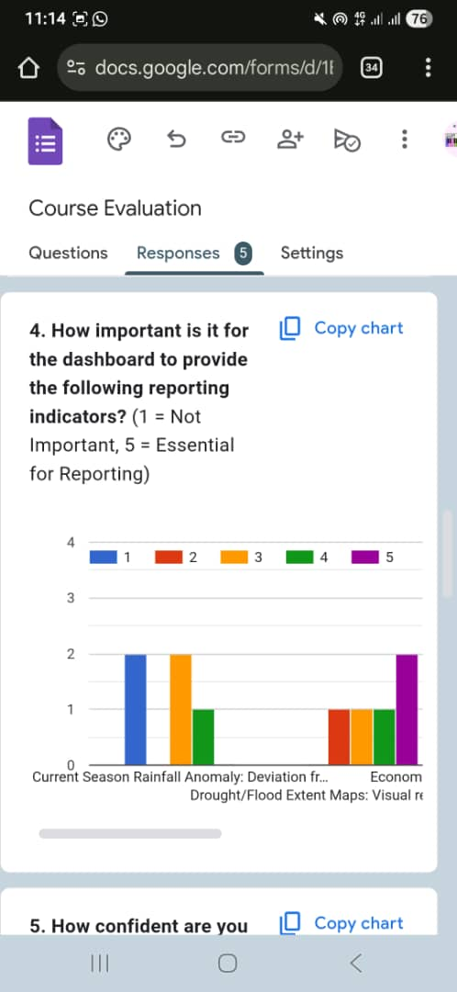
Figure 4.2: Barchart

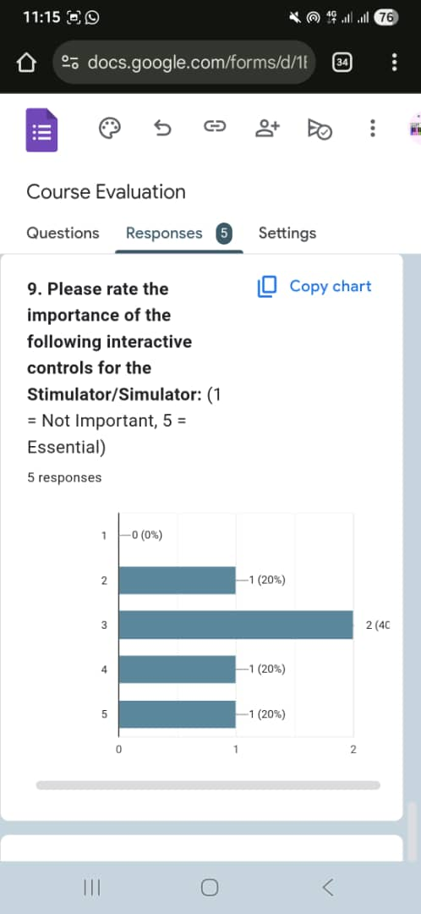
4.3 TESTING (Test data, test plan and test report)
A comprehensive testing regime was executed to ensure system reliability. The test plan focused on core functionalities, and the results are summarized in the table below.
- Table 4.3.1: Functional Testing Report
Test Case ID | Test Case Description | Expected Result | Actual Result | Status
TC-001 | Select Country 'Zambia' from dropdown | Chart updates to display data for Zambia only. | Chart updated correctly with Zambian data. | PASS
TC-002 | Change indicator to 'CO2 emissions' | The line chart re-renders to show CO2 emissions over time. | CO2 emissions trend line displayed correctly. | PASS
TC-003 | Select multiple countries for comparison | The chart displays multiple data series, one for each country. | All selected countries were plotted on the chart with a legend. | PASS
TC-004 | Application loading and data fetch | Dashboard loads without errors and fetches data from World Bank API. | Application loaded successfully; data was populated. | PASS
TC-005 | Responsive design on mobile device | Dashboard UI adjusts to fit a mobile screen correctly. | Layout was responsive and usable on a mobile browser. | PASS
4.4 Data Analysis
The primary outcome of this project is the dashboard's capability to facilitate data analysis. The system successfully transforms raw API data into interactive visualizations that allow users to perform exploratory data analysis. For example, users can visually identify periods where economic growth in Zambia stagnated concurrently with severe drought events, prompting further inquiry into climate vulnerability. The dashboard itself is the tool for analysis, and its successful implementation, as confirmed by testing and UAT, confirms its analytical utility.
CHAPTER FIVE: IMPLEMENTATION
5.0 Overview
This chapter presents the tangible outcomes of the development process. It details the implemented system features, the results of functional testing, and an analysis of the deployed dashboard's capabilities.
5.1 The Implemented System
The project successfully culminated in a fully functional, publicly accessible web application: the Climate-Economic Data Dashboard, hosted at https://climate-economic-dashboard.netlify.app/.
5.2 System Functionalities and Features
The deployed dashboard offers the following key functionalities:
- Dynamic Data Sourcing: The application dynamically fetches the latest data directly from the World Bank API upon loading, ensuring the visualizations reflect the most current information available.
- Interactive Country Selection: Users can select and compare data for multiple countries, including Zambia, Kenya, and the United States, from a dropdown menu.
- Multi-Indicator Visualization: Users can choose from various economic and climate indicators (e.g., GDP, CO2 emissions, Population) to plot on the interactive chart.
- Responsive and Interactive Charts: The core of the dashboard is an interactive line chart that updates in real-time based on user selections. Features include:
- Data point tooltips on hover.
- Scalable axes.
- A legend for clear identification of data series.
- User-Friendly Interface: The interface is clean, intuitive, and requires no technical expertise, making it accessible to the target audience of students, researchers, and policymakers.
5.3 DISCUSSION
5.3.1 Achievement of Objectives
The project successfully met all its specific objectives:
- ✅ Identification and Collection of Data: Relevant datasets were successfully identified and integrated directly from the World Bank API, a reliable and sustainable source.
- ✅ Design of a User-Friendly Interface: A clean, responsive, and intuitive web-based dashboard was designed and implemented, requiring no user manual.
- ✅ Implementation of Interactive Visualizations: Interactive charts using Chart.js were successfully implemented, allowing users to explore data through filtering and selection.
- ✅ Deployment and Evaluation: The application was successfully deployed to a public URL and evaluated through testing, confirming its functionality and usability.
5.3.2 Development of the System as a Solution
The developed dashboard stands as a direct solution to the problem statement. It consolidates fragmented data into a single, accessible platform and demystifies complex datasets through visualization. By leveraging a modern, serverless tech stack, the solution is both cost-effective and highly scalable.
5.3.3 Technical and Project Limitations
Despite its success, the project has certain limitations:
- Data Dependency: The dashboard's accuracy and completeness are dependent on the World Bank API's uptime and data update schedules.
- Scope of Data: The current version is limited to the indicators provided by the integrated APIs. More granular, Zambia-specific data (e.g., provincial-level climate data) is not included.
- Feature Set: Advanced features like user accounts, saved visualizations, data export, and predictive modelling were beyond the scope of this initial implementation.

CHAPTER SIX: CONCLUSIONS, IMPLICATIONS AND RECOMMENDATIONS
6.0 Conclusion
This project has successfully designed, developed, and deployed a functional Climate-Economic Data Dashboard. The application effectively addresses the identified gap in accessible data visualization tools for Zambia and other countries. By transforming complex, abstract data into intuitive graphical representations, the dashboard empowers students, researchers, and policymakers to engage with climate-economic issues in a more informed and insightful manner. The project serves as a successful proof-of-concept for applying client-side web technologies to solve real-world data accessibility challenges.
6.1 Implications
The implications of this work are threefold:
- For Academia: It provides a practical tool for teaching and learning about sustainable development and environmental economics.
- For Policy: It demonstrates how lightweight, low-cost digital tools can support evidence-based policy formulation.
- For Technology: It showcases the power of modern web standards (JavaScript, APIs) to build sophisticated applications without complex backend infrastructure.
6.2 Recommendations
Based on the project's outcomes and limitations, the following recommendations are proposed:
- For Cavendish University Zambia, it is recommended to integrate this dashboard into relevant coursework in the Business and Information Technology and Environmental Science programs as a teaching aid.
- For Policymakers, it is recommended to explore the development of more specialized versions of such dashboards that incorporate localized datasets from Zambian ministries.
6.3 Future Works
To enhance the dashboard, future work could focus on:
- Expanded Data Integration: Incorporating data from the Zambia Meteorological Department and Ministry of Finance for more localized analysis.
- Advanced Features: Implementing user authentication, allowing users to save and share their custom charts, and adding data export functionality.
- Enhanced Visualizations: Introducing more chart types (e.g., maps for spatial analysis, scatter plots for correlation studies) and the ability to overlay multiple indicators on a single chart.
- Predictive Analytics: Integrating simple forecasting models to project future trends based on historical data.

REFERENCES
African Development Bank (AfDB) (2021) African Economic Outlook. Abidjan: African Development Bank.
Banda, L., Tembo, S. and Phiri, A. (2023) 'Barriers to climate data accessibility in Zambian higher education', Zambia Journal of Technology and Innovation, 5(1), pp. 45-60.
Chikozho, C. (2020) 'Climate data use in African policy and planning', African Policy Review, pp. 211-225.
Few, S. (2013) Information Dashboard Design: Displaying data for at-a-glance monitoring. 2nd edn. Burlingame, CA: Analytics Press.
Hevner, A.R., March, S.T., Park, J. and Ram, S. (2004) 'Design Science in Information Systems Research', MIS Quarterly, 28(1), pp. 75-105.
Intergovernmental Panel on Climate Change (IPCC) (2021) Climate Change 2021: The Physical Science Basis. Contribution of Working Group I to the Sixth Assessment Report of the Intergovernmental Panel on Climate Change. Cambridge: Cambridge University Press.
Kumar, R. (2021) 'Data visualization for decision support systems', Journal of Information Systems, 35(2), pp. 45-60.
Ministry of Green Economy and Environment (2022) National Climate Change Policy. Lusaka: Government of Zambia.
Mulenga, B.P. and Chisanga, B. (2020) 'Climate Change and agriculture in Zambia: Impact and adaptation options', Journal of Southern African Studies, 46(4), pp. 745-762.
Mwangi, K., Gitau, W. and Nyong'o, R. (2022) Data Visualization for Climate Resilience in Eastern Africa. Nairobi: East African Publishing House.
United Nations Development Programme (UNDP) (2022) Human Development Report 2022: Uncertain Times, Unsettled Lives. New York: UNDP.
World Bank (2022) Climate Change Knowledge Portal (CCKP) [online]. Available at: https://climateknowledgeportal.worldbank.org/ (Accessed: 28 August 2025).
World Bank (2025) World Bank Open Data [online]. Available at: https://data.worldbank.org (Accessed: 28 August 2025).
Zambia Statistics Agency (2021) Zambia Environmental and Economic Indicators Report 2021. Lusaka: Government of Zambia.

APPENDIX
Appendix A: System Functionalities (Screenshots)
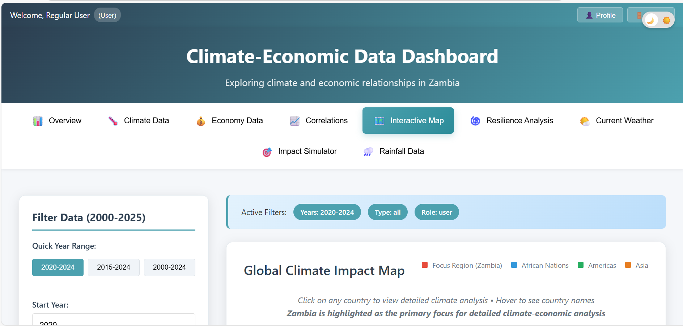
Figure 7.1: the main frontend diagram showing different user tools.
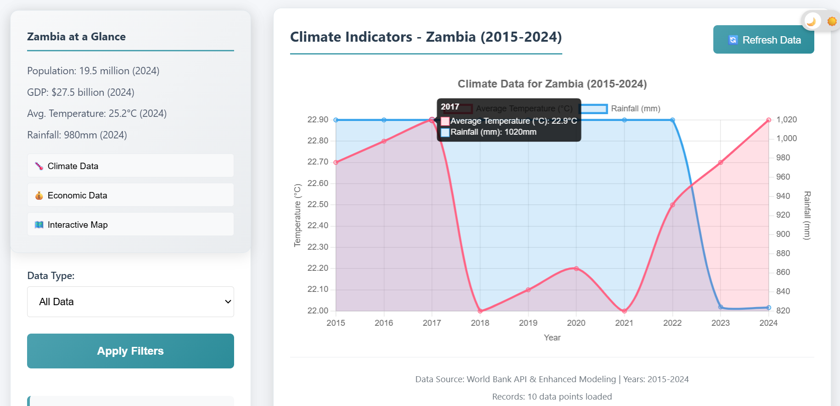
Figure 7.2: climate indicators showing how climate(temperature and rain varied from 2015-2024
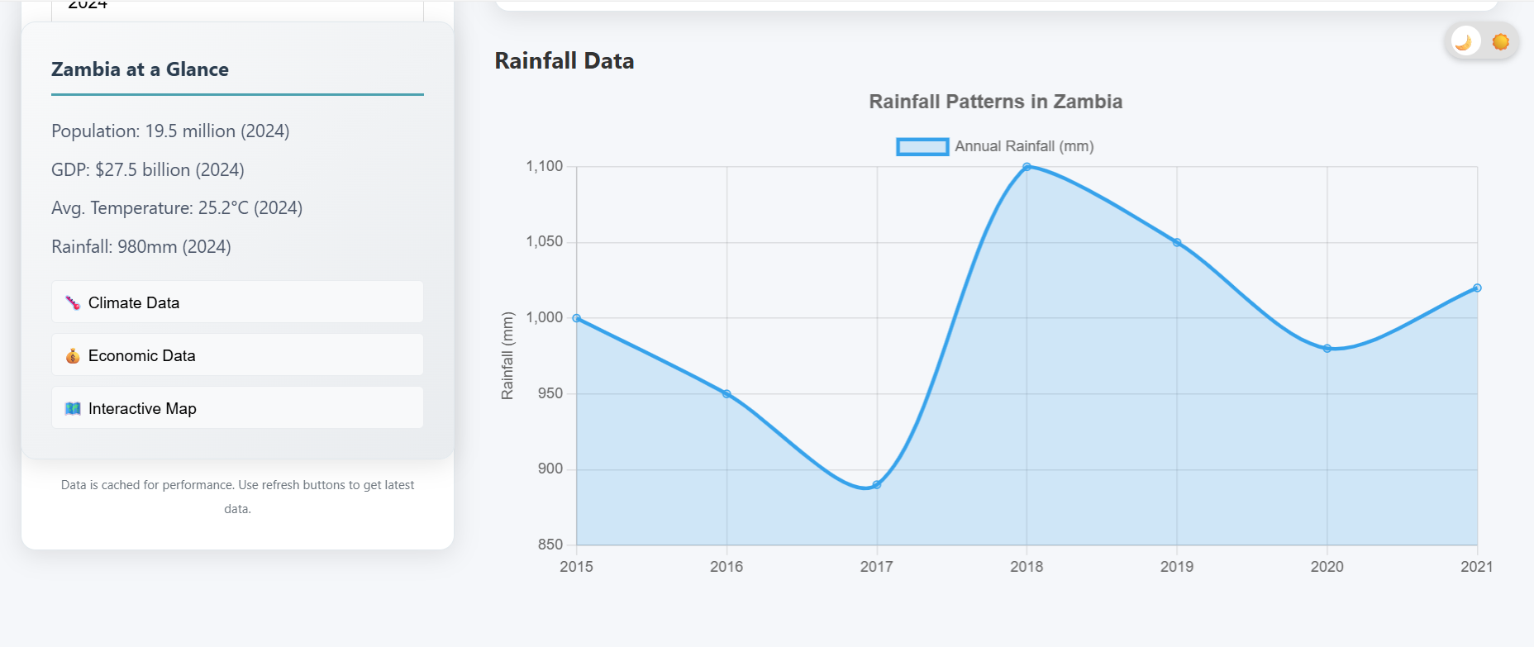
Figure 7.3: the diagram shows the rainfall patterns in Zambia (2021 -2021)
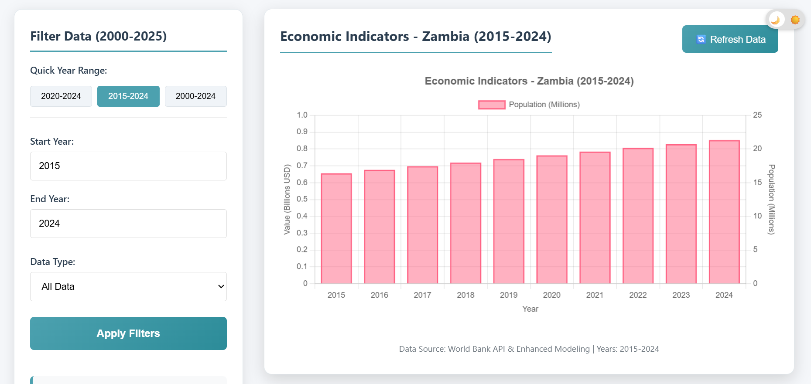
Figure 7.4: the Diagram shows the Economic Indicators in Zambia
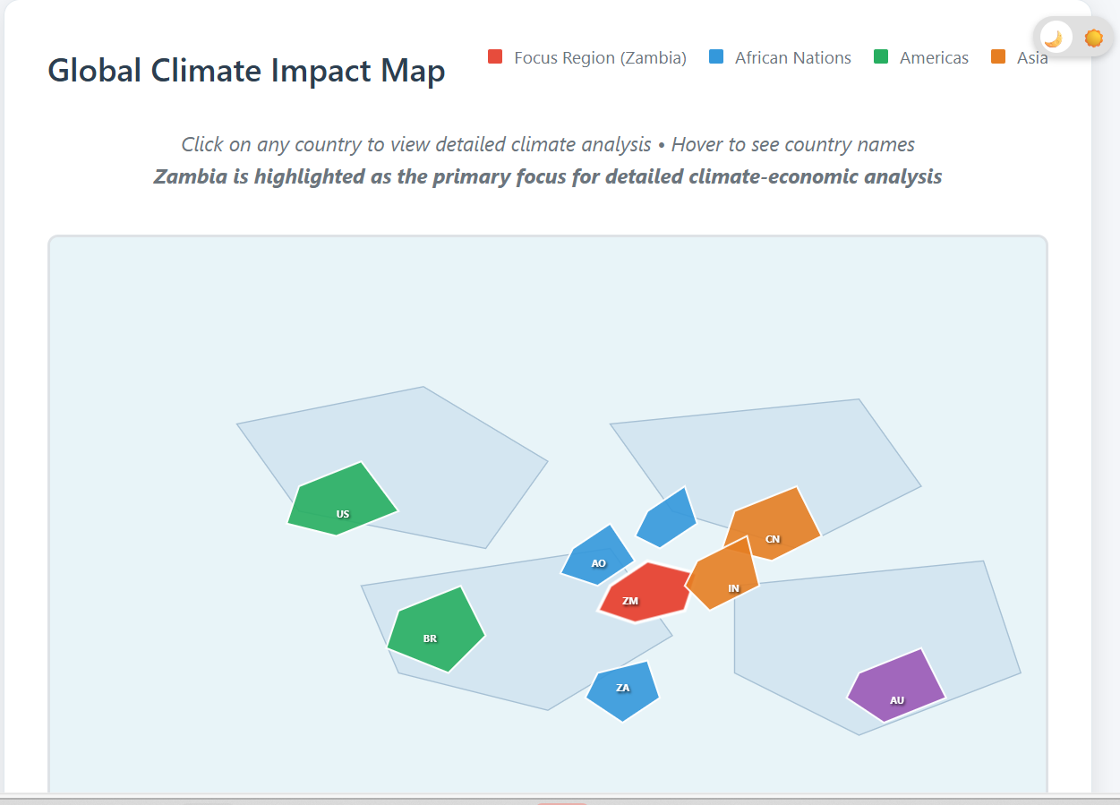
Figure 7.5: The diagram shows the Global climate impact
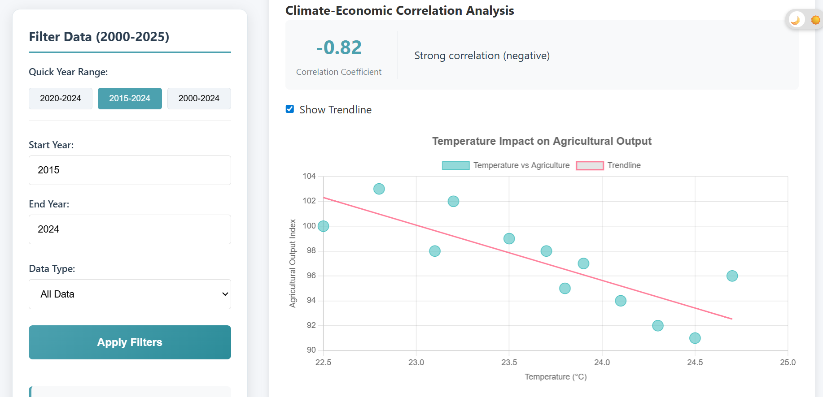
Figure 7.6: shows the climate-Economic correlation Analysis
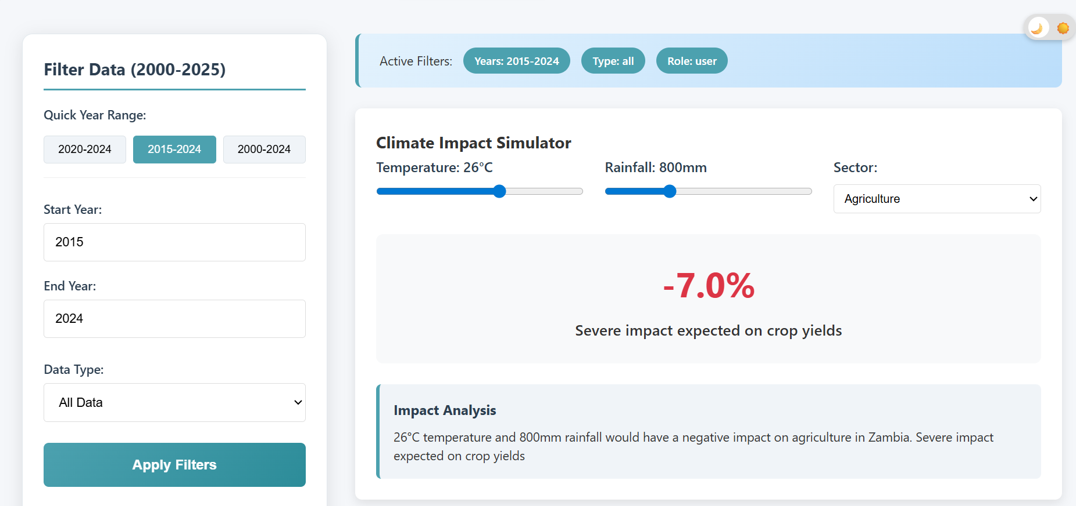
Figure 7.7: The diagram shows the climate impact simulator.
Appendix B: Technical Report
- GitHub Repository https://github.com/MICHEAL7400/Climate_dashboard.git
- Live Application URL: https://climate-economic-dashboard.netlify.app/
- Selected Source Code: Economic Data code snippet.
- import React from 'react';
- import EconomyHeroSection from './EconomyHeroSection';
- import GDPChart from './GDPChart';
- import './EconomyData.css';

- const EconomyData = ({ filters }) => {
- const economicStats = [
- { name: 'GDP Growth', value: '4.7%', change: '+0.8%', trend: 'positive' },
- { name: 'Agriculture GDP', value: '18.2%', change: '-1.2%', trend: 'negative' },
- { name: 'Inflation Rate', value: '9.8%', change: '-2.1%', trend: 'positive' },
- { name: 'Export Revenue', value: '$8.2B', change: '+$1.1B', trend: 'positive' },
- { name: 'Unemployment', value: '12.4%', change: '-0.8%', trend: 'positive' },
- { name: 'Tourism Revenue', value: '$1.3B', change: '+$0.2B', trend: 'positive' }
- ];

- return (
- <div className="economy-data-page">
- {/* Add the Economy Hero Section */}
- <EconomyHeroSection />

- {/* Main Economy Content */}
- <div className="economy-content">
- {/* GDP Chart Section */}
- <div className="economy-chart-section">
- <GDPChart filters={filters} />
- </div>

- {/* Economic Stats Grid */}
- <div className="economy-stats-section">
- <h3 className="section-title">Key Economic Indicators</h3>
- <div className="data-grid">
- {economicStats.map((stat, index) => (
- <div key={index} className="data-card">
- <h4>{stat.name}</h4>
- <div className="data-value">{stat.value}</div>
- <div className={`data-change ${stat.trend}`}>
- {stat.change} from previous year
- </div>
- </div>
- ))}
- </div>
- </div>

- {/* Insights Grid */}
- <div className="economy-insights-grid">
- <div className="insight-card strength">
- <h4>💪 Economic Strengths</h4>
- <ul>
- <li>Strong mining sector performance</li>
- <li>Growing tourism industry</li>
- <li>Stable macroeconomic indicators</li>
- <li>Increasing foreign investment</li>
- </ul>
- </div>

- <div className="insight-card vulnerability">
- <h4>⚠️ Climate Vulnerabilities</h4>
- <ul>
- <li>Agriculture sensitive to rainfall changes</li>
- <li>Energy dependency on hydropower</li>
- <li>Infrastructure vulnerable to extreme weather</li>
- <li>Water resource management challenges</li>
- </ul>
- </div>
- </div>
- </div>
- </div>
- );
- };

- export default EconomyData;

