CpE213 Project 2
Spring Semester 2011

For your project 2, you will interface a 4×4 KEYPAD (included in your project kit or can be purchased from one of department secretaries at 140EECH) to your project 1 board and build a simple calculator. The Putty terminal program, on any desktop, will be your screen. Figure 1 shows what your keypad looks like. The keys labeled 0-9 will remain keys for numbers 0-9. The remaining keys should be relabeled and represent the operations mentioned in Figure 1.
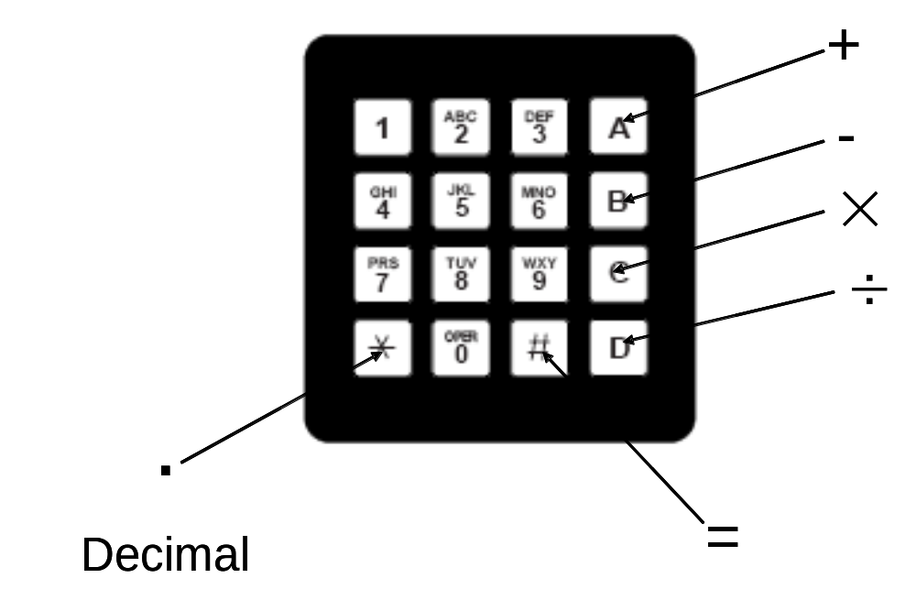

Figure 1: Keypad showing the alternate functions of some of the keys

Functions:
Key ‘A’: ADD (+) operator
Key ‘B’: SUBTRACT (-) operator
Key ‘C’: MULTIPLY (×) operator
Key ‘D’: DIVISION (÷) operator
Key ‘∗’: DECIMAL (.)
Key ‘#’: EQUAL (=)

Your program should allow for the following features:

- Your program should be written in C. If you feel a certain subroutine can be efficiently written in ASM, then you can do so. But the main program has to be in C.
- Only positive values are allowed for the operands. The operands and the answers can be of the largest size possible, but is limited to only 2 decimal places. Please note that microcontrollers are not suited to handle floating point numbers very well. After you have the basic program written, you can experiment on what size of number, your program and, finally, your microcontroller can handle. Also, note you have limited available memory.
- The Putty terminal should display all the operands, operators and the final answer.
- Once the final answer, for a particular operation, is displayed then the program should provide the user with TWO choices.
  - If the user presses a number, then a new computation begins.
  - If the user presses an operator (add, subtract, multiplication, or division), then the first operand should be the previous answer.
- The program should provide error messages for any illegal presses and should restart the operation.
- If the user wishes to cancel an operation, already started: You can decide how to implement this feature. One way is to use a push button and monitor that pin press for a cancellation command. Be Creative!

Communicating with Putty terminal program:
Here are some pointers, from Mr. Roger Younger, on the Putty; that is set up on computers. The Putty shortcut was created and it is set to 9600 8-N-1 with no flow control.

There are a few differences between the standard 8051 and the P89LPC family of processors.

- The P89LPC processors have programmable output pins and they default to input only type pins at reset. These need to be set to bi-directional or set the Txd pin needs to be an output.
- If characters need to be received, the receiver has a separate enable in addition to the serial port enable.
- The standard method of baud rate generation that uses a timer will work, but the P89LPC family has a baud rate generator specifically for the serial port.
- The standard 8051 has one interrupt for when a character is transmitted or received. The P89LPC family can be set up to have separated transmit and receive interrupts.
More on Putty: You should definitely read chapters that are related to serial port communication and keypad interrupt in user’s guide of your target microcontroller. You can, probably, find UART code for the P89LPC microcontrollers on the web.

Keypad interface: You will have to follow the connection method and algorithm explained in Keypad_4x4.pdf document posted along with this description. The P89LPC microcontroller has a separate Keypad interrupt that can be used efficiently. It can be found in the user’s manual of the microcontroller. You can also, find code for Keypad key-detection on the web.

Some advice: First get your serial communication to work. See if you can send characters to the Putty terminal program. Then you develop the Keypad program. Finally perform the mathematical operations.

DELIVERABLES AND DEADLINES: Points are given for the following deliverables. If it is late it is worthless. Note: There are LOTS of things that can go wrong when you start designing your own hardware. Some may require that you order new parts. Start building/debugging your project early!

- Project demonstration (50 points, due during one week before the final week of the semester, demo schedule and sign-up sheet will be posted later). Prove to me that your project works. I’ll post an appointment sheet around the due date to allow you to do so. “Cool” extras will be viewed favorably when grading your project. Note: start debugging your project ahead of time or you seriously risk missing your deadline.
- Project code (due at project demo). During your project demonstration I will ask you to: show me your code, compile your code, email me a copy of your code, download the code to your device, and show me your working device. Your code should be extensively commented at this point.
- Short report (50 points, due during your project presentation). Your report should be a maximum of 5 pages (excluding project code), and should include:
  - Title and team members
  - Summary. Give a quick summary of what you did in your project, what problems you encountered, and how you got around them.
  - Explanation. If your code or circuit did not work, explain what you might do to fix it.
  - Future work. Explain what you might do to improve your project or how you went about completing your project (timeline, etc).
  - Project code. Well documented code is worth more, as is code that makes appropriate use of segments, variables, labels, etc.
  - Work effort distribution. List each person in your group. Tell what their job was and the total percentage effort they contributed to the completion of the project.
- Peer rating of team members (10 points, due during your project demonstration). Each and every student is required to complete the peer rating form (it can be downloaded from Blackboard), sign and submit it during your demo. Email submissions will not be accepted.

