User Manual – Kandu

1. 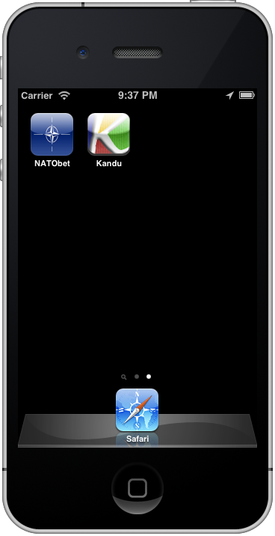Navigate to the page with the *Kandu* app icon and launch the app.
2. Tap the button “Start with Current Location”

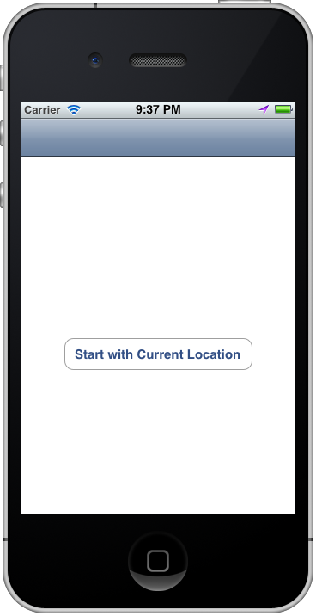

1. When you’ve verified your location, tap the “Continue” button

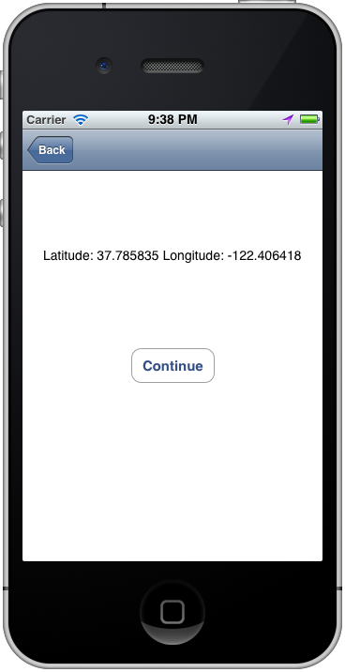

1. Using the picker, select a type of activity

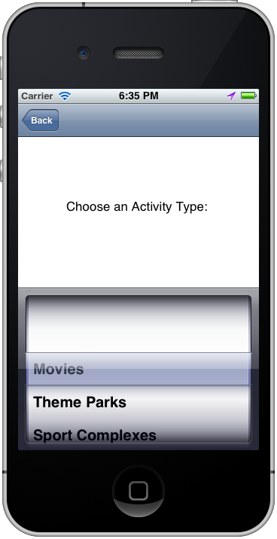

1. 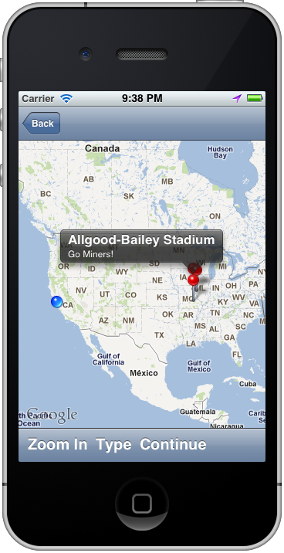On the map, you can examine the locations and then continue on
2. Select the places you wish to visit and then tap the “Email” button.

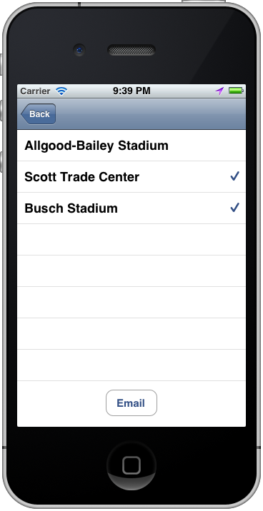

1. Compose your email and then you can exit the app by tapping the home button or start another activity search by tapping the “New” button once your email has been sent.

