LC Technology 2027 HL – Exemplar Folio Sections 1–3
Mr Madden

About this exemplar
This is a worked example of Higher Level folio Sections 1–3 (22 of the 100 folio marks), written as a strong H1 candidate might present them for the 2027 brief.
- 2027 HL theme: a working model of a device, system or technical aid that supports independent living, wellbeing or social participation in an ageing society. It must include an electro-mechanical element and fit within 500 mm.
- Example context used here: ReachEase, a motorised pull-down kitchen shelf that brings items from a high press down to counter height at the touch of a large button.
- HL vs OL: at Higher Level, Section 1 covers the broad context and chosen parameters only. Existing solutions, sub-systems and the final brief move to Section 4 (7 marks), so they are not shown here.
For students: use this to see the depth and layout expected, not as content to reuse. The SEC instructions (points 13–15) treat copied or AI-generated material as plagiarism, and examiners recognise exemplar wording. Your context, research, photos and numbers must be your own.

Section 1 – Analysis of thematic brief (7 marks)
Marks for: evidence of research of the broader context of the theme; specification of chosen parameters.

1.1 Key words of the brief
Key phrase in the brief | What it means for my project
Ageing population | My user is 65+, living at home, possibly with reduced strength, reach, sight or memory
Independent living, wellbeing or social participation | The solution must let the user do something themselves, without waiting for help
Electro-mechanical element | A motor, servo or solenoid must move something, controlled by an electronic circuit
Modern materials and processes | Use CAD/CAM (laser cutting, 3D printing), thermoplastics and a microcontroller
User needs, ease of use, reliability, sustainability | Large controls, safe failure modes, low energy use, repairable design
Working model, max 500 mm | A scale model; every key operating feature visible without dismantling

1.2 The broader context: Ireland's ageing population
Ireland's 65+ population grew by 22% between 2016 and 2022, to 776,315 people (CSO Census 2022). The over-70s were the fastest-growing group, and the number of people aged 85+ rose by 25% (CSO).
This means more people are living at home for longer, often alone. The main challenges I found in my research were:
- Mobility and balance – climbing steps or chairs increases the risk of falls
- Reduced strength and reach – arthritis and stiff shoulders make high presses and heavy doors difficult
- Sensory decline – poorer sight and hearing make small buttons and quiet alarms hard to use
- Memory – forgetting medication, appointments or whether the cooker is off
- Isolation – less contact with family and community, which affects wellbeing
[Student adds: a mind map of these five areas with possible product ideas branching off each, drawn freehand.]

1.3 Primary research
I interviewed my grandmother (78, lives alone) and visited a local day-care centre to speak to two staff members. [Student adds: interview questions, answers and photos, with permission.]
Key findings:
- My grandmother keeps her cups and cereal on the lower shelves only, because she will not stand on a step since a fall last year.
- Staff said reaching into high presses is one of the most common reasons people ask family for help.
- Both said any device must be "obvious to use" – one big button, no app, no small screens.

1.4 Chosen area and parameters
I chose reach and access in the kitchen, because it links directly to falls risk and to the user's independence, and it suits an electro-mechanical solution.
My initial parameters (refined into a full specification in Section 4):
Parameter | Requirement
Function | Lower a shelf from a wall press to counter height and raise it again
Control | One large, high-contrast button; works without reading instructions
Safety | Stops automatically if an obstruction is detected; cannot trap fingers
Load (model) | Carries at least 500 g without stalling
Power | Low-voltage supply (12 V DC), low standby energy use
Size | Model no larger than 500 mm in any direction
Feedback | Light and sound confirm when the shelf is moving and when it has stopped
Sustainability | Repairable with screws; parts separable for recycling
Sources for this section must be listed in the folio bibliography (Section 10).

Section 2 – Overall management of the project (5 marks)
Marks for: analysis of available resources, time and budget constraints; proposed timeframe/Gantt chart.

2.1 Resources available
Resource | Available in school | How I will use it
Laser cutter | Yes, booked through teacher | Acrylic and plywood shelf, housing panels
3D printer | Yes, one shared between class | Gear housings, button cap, cable guides
CAD software | Yes (e.g. Fusion / Onshape, 2D design) | Modelling, laser-cutting files, drawings
Strip heater, pillar drill, hand tools | Yes | Bending acrylic, drilling, finishing
Soldering station | Yes | Control circuit on stripboard
Microcontroller (Arduino Nano) | Must buy | Motor control, sensors, sleep mode
Geared 12 V DC motor + driver | Must buy | Raising and lowering the shelf
Teacher and technician support | Class periods only | Safety checks, machine setup

2.2 Time constraints
- About 4 class periods (roughly 3 hours) per week, plus lunchtime sessions when the room is free.
- All work must be completed in school (SEC instruction 4), so no work at home on the artefact.
- Coursework must be available for assessment by Friday 19 March 2027.
- Breaks and pressure points: Christmas holidays, mock exams, February mid-term, and other subject coursework due in spring.
- The laser cutter and 3D printer are shared, so I must book them a week ahead and print overnight where possible.

2.3 Budget
My budget is €60, agreed with my parents and teacher.
Item | Estimated cost
Arduino Nano (compatible) | €8
12 V geared DC motor | €12
Motor driver module | €4
Limit switches × 2, IR obstruction sensor | €6
Large arcade button, LED ring, buzzer | €7
12 V plug-in power supply | €8
Fixings, bearings, threaded rod | €6
Contingency (about 15%) | €9
Total | €60
Acrylic, plywood, PLA filament and stripboard come from school stock. Full costing is in Section 7.

2.4 Risks to the schedule
Risk | Effect | Plan if it happens
Parts arrive late | Electronics delayed | Order in December; test with school stock motor meanwhile
3D print fails | Lost machine time | Print small test pieces first; keep laser-cut backup design
Mocks take more time than planned | Manufacture falls behind | Two weeks of buffer built in before 19 March
Motor too weak for the load | Shelf stalls | Test load in January before final assembly; gear ratio can change

2.5 Proposed timeframe
The Gantt chart below shows my plan from November to the 19 March deadline. I will compare it with what actually happened in Section 9.
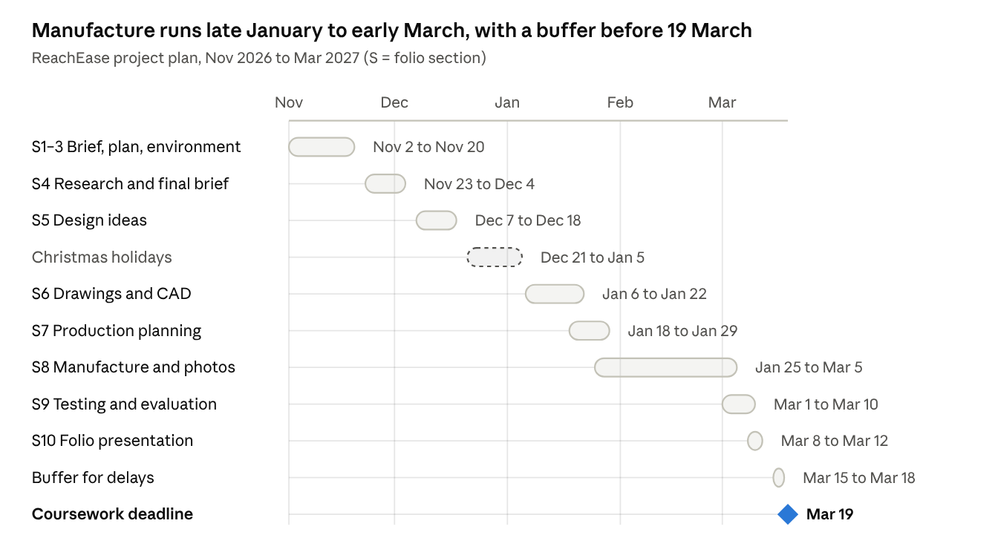
Project Gantt chart · Nov 2026 to 19 Mar 2027
Overlaps are deliberate: production planning starts while drawings are finished, and testing begins in the last week of manufacture. [Student adds: mock exam and mid-term dates from the school calendar.]

Section 3 – Environmental impact of the project (10 marks)
Marks for: environmental awareness during design and realisation; analysis of materials available for manufacture; energy requirements; reuse/recycling.
This is the biggest of the first three sections, so it needs real analysis, not a general paragraph about recycling. I looked at the whole life cycle: materials, manufacture, use and end of life.

3.1 Analysis of materials available
Material | Possible use | Environmental advantages | Environmental disadvantages | Decision
Birch plywood (FSC-certified) | Press housing, shelf base | Renewable; low embodied energy; laser cuts cleanly | Glue in plies makes it harder to recycle | Use for housing
Acrylic (PMMA) | Clear front panel so mechanism is visible | Durable; thermoplastic, so offcuts can be reprocessed | Made from oil; not collected in household recycling | Use only where transparency is needed
PLA filament | Gear housings, button cap | Made from plant starch; low print temperature | Only breaks down in industrial composting; weaker than PETG | Use for low-load parts
PETG filament | Load-bearing brackets | Stronger and tougher than PLA; recyclable (code 1) | Oil-based | Use for brackets
Aluminium angle | Guide rails | Infinitely recyclable; long life | High energy to produce from new ore | Use recycled offcuts from school stock
HIPS sheet | Vacuum-formed cover | Cheap and easy to form | Brittle with age; low recycling rate | Rejected

3.2 Environmental awareness during manufacture
- Nesting laser-cut parts in CAD so the acrylic sheet is used efficiently; offcuts kept for test pieces.
- 3D printing at 15–20% infill for non-load parts, cutting filament use and print time.
- Test prints and test cuts on scrap first, so full parts are not wasted on errors.
- Lead-free solder and a fume extractor at the soldering station.
- Water-based finishes on the plywood instead of solvent-based varnish.
- Recycled aluminium offcuts from the school store instead of buying new stock.

3.3 Energy requirements in use
My estimates, to be measured with a multimeter during testing (Section 9):
Mode | Power | Time per day | Energy per day
Motor moving (12 V × 0.5 A) | 6 W | 80 s (5 uses, up and down, 8 s each way) | 0.13 Wh
Standby, controller always on (about 20 mA) | 0.24 W | 24 h | 5.8 Wh
Standby with sleep mode (about 5 mA) | 0.06 W | 24 h | 1.4 Wh
The most important finding: standby uses over 40 times more energy than the motor itself. So I will programme the Arduino to sleep and wake only when the button is pressed. This cuts yearly use from about 2.1 kWh to about 0.5 kWh.

3.4 Product use, reuse and end of life
- Design for disassembly: parts joined with machine screws and threaded inserts, not glue, so the motor or electronics can be replaced instead of the whole unit.
- Long life: a geared motor with limit switches avoids stalling and burning out.
- Material labelling: plastic parts embossed with their recycling code (e.g. PETG, PMMA) during printing or engraving.
- Electronics: at end of life, the circuit board, motor and power supply go to a WEEE take-back point, not general waste.
- Reuse: the control module is standard, so it could be reused in another product.

3.5 Summary of environmental decisions
- Renewable plywood for the bulk of the structure.
- Plastics used only where their properties are needed.
- Sleep mode, which cuts the product's biggest energy use by about three quarters.
- Screws, not glue, so the product can be repaired and separated for recycling.

What lifts these sections to H1
Section | Typical mid-grade folio | H1 folio
1 – Analysis of brief | Rewrites the brief in own words | Breaks the brief into key phrases and says what each means for the design
1 – Broader context | General statements about older people | Cited statistics plus primary research (interview, visit, survey)
1 – Parameters | Vague aims ("easy to use") | Measurable parameters (load, size, voltage, controls) that Section 4 refines
2 – Resources | A list of tools | Each resource linked to how and when it will be used, including what must be bought
2 – Constraints | "I have limited time" | Hours per week, real dates, shared-machine booking, mocks and holidays named
2 – Budget and timeframe | A total figure; a basic timeline | Itemised budget with contingency; Gantt chart with buffer; risk plan
3 – Materials | Says plastic is bad, wood is good | Compares several materials on both sides and records a decision for each
3 – Energy | Mentions batteries or "low power" | Calculates energy per mode and changes the design because of the result
3 – End of life | "It can be recycled" | Design for disassembly, material coding and WEEE disposal for the electronics
Two habits matter across every section: link forward (Section 1 parameters feed the Section 4 specification; the Section 2 plan is compared in Section 9) and cite every source, including any AI tools used.

