Phase D — Investigation of Historical Fine-Tuning Evidence
This phase reads logs left over from an earlier OpenAI fine-tuning job. They are historical evidence supplied with the project. They are not a new run by the student, and nothing here was re-trained or re-queried.
1. What the two files are (requirement 13)
File | Columns | Size | Contents
fine_tuning_steps.txt | 6 columns: step, elapsed_tokens, elapsed_examples, training_loss, training_sequence_accuracy, training_token_accuracy | 734 steps (final step 734, 34,678 tokens) | Training metrics only. No validation or classification columns.
result.csv | 15 columns: the same 6 training columns plus validation_loss, validation_sequence_accuracy, validation_token_accuracy and classification/accuracy, precision, recall, auroc, auprc, f1.0 | 733 steps (final step 733, 34,661 tokens) | Validation values on 92 of 733 rows; classification metrics on 4 rows.

Important finding: the two files are NOT the same run. They share a format, but their numbers differ at the same step (for example step 1 training loss is 0.3423 in fine_tuning_steps.txt and 0.3613 in result.csv; the largest difference over matching steps is 0.30), and one has 734 steps against 733. They appear to come from two separate fine-tuning jobs. Which job each file belongs to cannot be confirmed from the files alone, and the supplied scripts name a job ID but do not tie it to either file. They should be reported separately and never merged.
Training metrics vs independent holdout performance
- Training loss, training sequence accuracy and training token accuracy are measured on the batch the model is learning from at that step (here one example per step). They show that the model is fitting the training data. They say nothing about unseen data.
- Validation loss and accuracy in result.csv come from a separate validation file, scored periodically (92 times). They are closer to held-out evidence, but the validation values were visible during training, so they are not a final test.
- The classification/* columns are computed by the service on the validation file when classification metrics are requested. The notebook compute_classification_metrics.ipynb shows the job was started with dataset_train.jsonl as training file and dataset_test.jsonl as validation file, so these values are almost certainly measured on the same 46-record test file used in Phase C (inferred from the notebook and from the 45/46 accuracy; the job record itself was not supplied).
- Phase C found that 73.9% of that 46-record file is exact or near-identical to training prompts. So even the classification metrics are not independent holdout performance.
2. Plots (requirement 14)
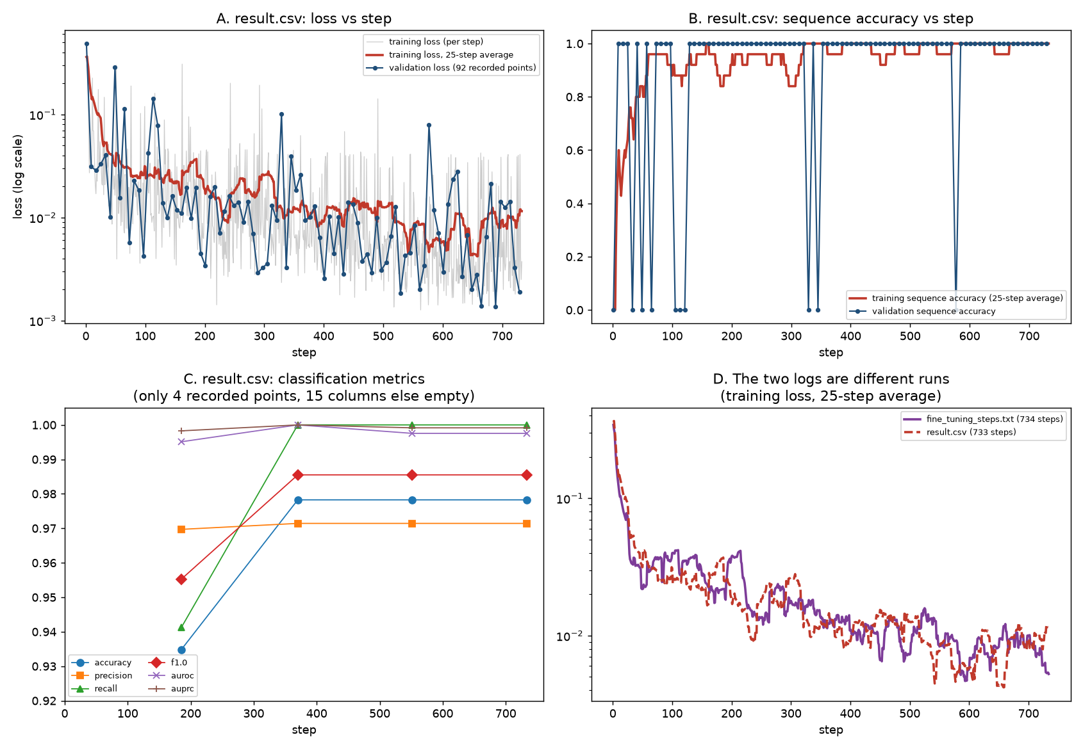
Panel A: training loss falls from about 0.34–0.37 at step 1 to a 25-step average of about 0.01 (first-50-step mean 0.062, last-50-step mean 0.0096 in result.csv; 0.048 and 0.0066 in fine_tuning_steps.txt). Validation loss is noisier but reaches a minimum of 0.00136 at step 689 and ends at 0.00189 at step 729. Panel B: training sequence accuracy averages 0.948 (38 of 733 steps at 0); validation sequence accuracy is 1.0 at the final point, with 10 recorded points below 1 (steps 1, 33, 49, 65, 105, 113, 121, 329, 345, 577). Panel C: only 4 classification points exist. Panel D: the two logs follow a similar overall shape but are different runs.
Missing values and limits
- classification/* columns are empty on 729 of 733 rows; they exist only at steps 185, 370, 551 and 733 (about once per pass over the 183-record training file). A curve of accuracy against step is therefore only 4 points.
- validation_* columns are empty on 641 of 733 rows (92 present, every 8th step).
- Per-step training accuracy on one example per step is very noisy (it can only be 0 or 1); only the moving average is meaningful.
- Falling loss and near-perfect accuracy do not show generalisation. With high train/test overlap, the data cannot separate learning from memorisation.
- No confusion matrix, no predictions, no model ID, and no run configuration (epochs, learning rate, batch size) are included, so the results cannot be independently verified or reproduced.
What can be concluded
- The fine-tuning job(s) converged: loss fell by more than an order of magnitude and training accuracy ended at 1.0.
- The recorded validation metrics were high on a small, overlapping test file.
What cannot be concluded
- That the model generalises to new, unseen data.
- That the model is better than the Phase C TF-IDF classifier or the rule baseline. The Phase C classifier produced a matching accuracy of 0.978, precision of 0.971, recall of 1.000 and F1 of 0.986 on the same 46-record file (confusion matrix [[11,1],[0,34]]), which suggests the file is easy and overlaps training, not that the two models are equivalent.
- That either log belongs to a run by the student, or to which job.
3. Final non-null recorded metrics (requirement 15)
Metric (result.csv, step 733) | Value
Accuracy | 0.978261
Precision | 0.971429
Recall | 1.000000
F1 (classification/f1.0) | 0.985507
AUROC | 0.997549
AUPRC | 0.999147

These are the last non-null values, at step 733, the final row. The four recorded points are shown below. Accuracy 0.978261 equals 45/46, consistent with a 46-record validation file with one error. AUROC and AUPRC reached 1.0 at step 370 and dropped slightly afterwards, a typical sign of small-sample noise. These values come from a historical log. They are not a new student-run model, and no claim is made that they can be reproduced.
Step | Accuracy | Precision | Recall | F1 | AUROC | AUPRC
185 | 0.934783 | 0.969697 | 0.941176 | 0.955224 | 0.995098 | 0.998268
370 | 0.978261 | 0.971429 | 1.000000 | 0.985507 | 1.000000 | 1.000000
551 | 0.978261 | 0.971429 | 1.000000 | 0.985507 | 0.997549 | 0.999147
733 | 0.978261 | 0.971429 | 1.000000 | 0.985507 | 0.997549 | 0.999147

4. Original workflow and why it cannot be assumed usable today (requirement 16)
The original PowerPoint was not among the files supplied, so I have not reviewed it. The workflow below is reconstructed from the scripts in the code folder and should be checked against the slides.
Stage | Script | Legacy call used
1. Upload | upload_dataset_train.py | openai.File.create(purpose="fine-tune")
2. Fine-tuning job | create_fine_tune_job.py | openai.FineTune.create(training_file, model="ada")
3. Status | check_fine_tune_job_status.py | openai.FineTune.retrieve(job id)
4. Prediction | predict_ip_single_line.py | openai.Completion.create(model="ada:ft-...", max_tokens=1)
5. Evaluation | compute_classification_metrics.ipynb | CLI fine_tunes.create with validation file and classification metrics; fine_tunes.results to get result.csv

Why it cannot be assumed to work today
- Retired models and endpoint: OpenAI announced that the ada, babbage, curie and davinci models on the legacy /fine-tunes endpoint would be retired on 4 January 2024, and that fine-tuned models built on those older models would stop working on the same date (OpenAI Developer Community deprecation summary; Portkey deprecation guide, January 2024; OpenAI notice quoted in the community thread "Old models are already gone").
- The model names in the scripts (ada:ft-university-of-baltimore-2023-08-14-12-39-06 and ada:ft-personal-2023-10-09-15-25-25) are legacy fine-tunes created in 2023, and so fall under that retirement. They cannot be assumed to answer a request today; this has not been tested here, since doing so would need a live account.
- Replacement is a new run, not a restore: OpenAI told developers to fine-tune new replacements on newer base models (babbage-002 or davinci-002) through the newer /fine-tuning interface. That would produce a different model with different results.
- The code is also old-style: openai.FineTune, openai.File and openai.Completion belong to the pre-1.0 Python library; current library versions use a client object and different calls, so the scripts would need rewriting.
- Policy now: OpenAI says deprecated models and endpoints stop being accessible at their shutdown date, and that fine-tuned models follow the shutdown schedule of the base model (OpenAI Deprecations page, accessed November 2026).
- Security: several scripts contain a hard-coded API key. Treat it as exposed, revoke it, and never put keys in evidence or reports.
- Reproducibility: the original training file IDs, job IDs and models live in an account the project cannot confirm it still controls, and the logs lack run settings.
Conclusion
The historical logs show that earlier fine-tuning jobs trained successfully and reported high validation metrics on a small, overlapping test file. They are useful as background evidence only. The reproducible results for this project are the offline Phase C models, and any claim about a fine-tuned model would need a fresh, documented run on a currently supported model.
5. Phase D Evidence Integrity Table (Kali run)
Input logs were hashed before analysis, and the script was run read-only on them (no training, no API calls). Outputs were hashed with sha256sum and recorded in PhaseD_manifest.txt. Every figure printed on the analyst machine matched the figures reported above.
File | Description | SHA-256
code/result.csv | Input: historical log, 733 steps, 15 columns | a2985fb577678515c7ca8dad529beec77e91dd1555b4ed515d43000129e0fe58
code/fine_tuning_steps.txt | Input: historical log, 734 steps, 6 columns | 0633c4f1029fbbd6e5408f6e251e08eb740544f4a13ebc315ccf3c88e782bd6d
phase_d_analysis.py | Analysis script | 39e23e2b595d5e607af86bbb7163f0c036f324ac866769a9e6c7a8918d533c6a
phase_d_outputs/classification_rows.csv | The 4 non-null classification rows | e2bc2882530144dbb661eaa65cad8ab509e9895105b41a7d22b850dfe3af941b
phase_d_outputs/phase_d_plots.png | Four-panel plot | 8b40d52b8f28ac2f7b884f03a364726574be9f7dc5c2d72546c3b69b5947bc86
phase_d_outputs/phase_d_summary.json | Summary statistics and missing-value counts | 9503db71f038b7bd37b10cc7ce594efe31ea80602464dfb534b1f994e3e5e452

Forensic integrity statement: the historical logs were read in place and not modified. Hashing shows the files and outputs have not changed since they were produced; it does not show which fine-tuning job produced either log, which remains unconfirmed.

