DEFINITION OF COMPUTER
The word computer is derived from the Latin word ‘computare’, was meaning “arithmetic, accounting”.
The Computer meaning is the digital device that stores information in memory using input devices and manipulate information to produce output according to given instructions.
Components of Computer System
By definition, components of a computer system are the primary elements which make the functioning of an electronic device smooth and faster. There are five basic components which include:
- Input Unit
- Output Unit
- Processing Unit:-
- Arithmetic and Logic Unit
- Control Unit
- Memory Unit

- Input Unit
A computer will only respond when a command is given to the device. These commands can be given using the input unit or the input devices.
For example: Using a keyboard we can type things on a Notepad and the computer processes the entered data and then displays the output of the same of the screen.
The data entered can be in the form of numbers, alphabet, images, etc. We enter the information using an input device, the processing units convert it into computer understandable languages and then the final output is received by a human-understandable language.

Output Unit
When we command a computer to perform a task, it reverts back for the action performed and gives us a result. This result is called output. There are various output devices connected to the computer. The most basic of which is a monitor. Whatever we write using a keyboard or click using a mouse, is all displayed on the monitor.
Thus, the output unit gives us the final result once the entire processing is done within the mechanism of a device.
For example: when we visit an ATM, we enter our details like language, pin, amount to be withdrawn, etc. and then the final money which the cash dispenser releases is our outcome. In this case, the cash dispenser acts as an output unit.

Processing Unit

The Central Processing Unit is the core of any computer devices. These includes:-

Arithmetic & Logical Unit
As the name suggests, all the mathematical calculations or arithmetic operations are performed in the Arithmetic and Logical Unit of the CPU.
It can also perform actions like a comparison of data and decision-making actions. The ALU comprises circuits using which addition, subtraction, multiplication, division and other numerical based calculations can be performed.

Control Unit
This is the core unit which manages the entire functioning of the computer device. It is one of the most essential components of the computer system.
The Control Unit collects the data entered using the input unit leads it on for processing and once that is done, receives the output and presents it to the user. It can be said to the center of all processing actions taking place inside a computer device.
Basically, the instructions taken, interpretation of entered data, issuing signals to execute the data and then finally retrieving the data is all done in the Control Unit.

Memory Unit
When we enter the data into the computer using an input device, the entered information immediately gets saved in the memory unit of the Central Processing Unit (CPU). Because of the presence of some existing programming, the Memory Unit transmits the data further to the other parts of the CPU.
Similarly, when the output of our command is processed by the computer, it is saved in the memory unit before giving the output to the user.

DEVELOPMENT OF COMPUTER
Electronic data processing does not go back more than just half a century i.e. they are in existence merely from early 1940’s. In early days when our ancestor used to reside in cave the counting was a problem. Still it is stated becoming difficult. When they started using stone to count their animals or the possession they never knew that this day will lead to a computer of today. People today started following a set of procedure to perform calculation with these stones, which later led to creation of a digital counting device, which was the predecessor the first calculating device invented, was known as ABACUS.

THE ABACUS
Abacus is known to be the first mechanical calculating device. Which was used to be performed addition and subtraction easily and speedily? This device was a first develop Ed by the Egyptians in the 10th century B.C, but it was given it final shape in the 12th century A.D. by the Chinese educationists. Abacus is made up of wooden frame in which rod where fitted across with rounds beads sliding on the rod. It is dividing into two parts called ‘Heaven’ and ‘Earth’. Heaven was the upper part and Earth was the lower one. Thus any no. can be represented by placing the beads at proper place.
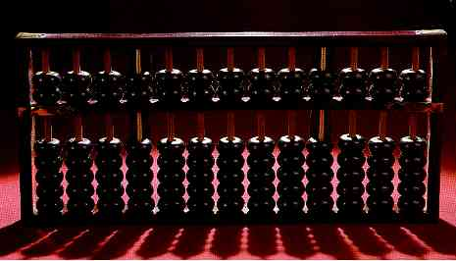

NAPIER’S BONES
As the necessity demanded, scientist started inventing better calculating device. In thus process John Napier’s of Scotland invented a calculating device, in the year 1617 called the Napier Bones. In the device, Napier’s used the bone rods of the counting purpose where some numbers is printed on these rods. You can use these rods to do addition, subtraction, multiplication and division easily.
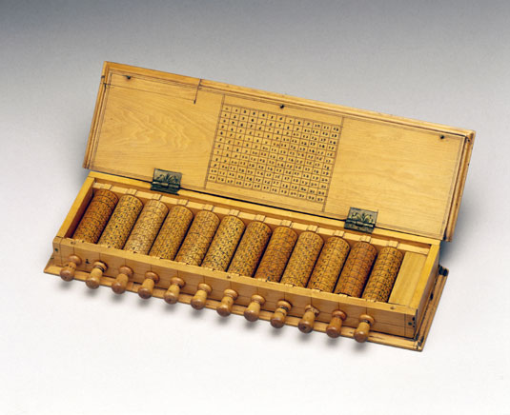

PASCAL’S CALCULATOR
In the year 1642, Blaise Pascal a French scientist invented an adding machine called Pascal’s calculator, which represents the position of digit with the help of gears in it.
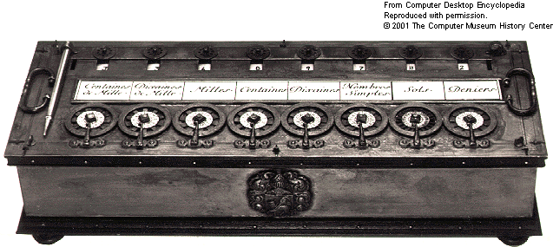

LEIBNZ CALCULATOR
In the year 1671, a German mathematics, Gottfried Leibniz modified the Pascal calculator and he developed a machine which could perform various calculation based on multiplication and division as well.

GENERATION OF COMPUTER
1st Generation - 1950s to 1960s - Vacuum Tubes
The first computer systems used vacuum tubes for circuitry and magnetic drums for memory, and were often enormous, taking up entire rooms. These computers were very expensive to operate and in addition to using a great deal of electricity, the first computers generated a lot of heat, which was often the cause of malfunctions.
First generation computers relied on machine language, the lowest-level programming language understood by computers, to perform operations, and they could only solve one problem at a time. It would take operators days or even weeks to set-up a new problem. Input was based on punched cards and paper tape, and output was displayed on printouts.
The UNIVAC and ENIAC computers are examples of first-generation computing devices. The UNIVAC was the first commercial computer delivered to a business client, the U.S. Census Bureau in 1951.

2nd Generation - 1960s to 1979s - Transistors
The world would see transistors replace vacuum tubes in the second generation of computers. The transistor was invented at Bell Labs in 1947 but did not see widespread use in computers until the late 1950s.
The transistor was far superior to the vacuum tube, allowing computers to become smaller, faster, cheaper, more energy-efficient, and more reliable than their first-generation predecessors. Though the transistor still generated a great deal of heat that subjected the computer to damage, it was a vast improvement over the vacuum tube. Second-generation computers still relied on punched cards for input and printouts for output.

From Binary to Assembly
Second-generation computers moved from cryptic binary machine language to symbolic, or assembly, languages, which allowed programmers to specify instructions in words. High-level programming languages were also being developed at this time, such as early versions of COBOL and FORTRAN. These were also the first computers that stored their instructions in their memory, which moved from a magnetic drum to magnetic core technology.
The first computers of this generation were developed for the atomic energy industry.

3rd Generation - 1970s to 1980s - Integrated Circuit
The development of the integrated circuit was the hallmark of the third generation of computers. Transistors were miniaturized and placed on silicon chips, called semiconductors, which drastically increased the speed and efficiency of computers.
Instead of punched cards and printouts, users interacted with third generation computers through keyboards and monitors and interfaced with an operating system, which allowed the device to run many different applications at one time with a central program that monitored the memory. Computers for the first time became accessible to a mass audience because they were smaller and cheaper than their predecessors.6
Did You Know… ? An integrated circuit (IC) is a small electronic device made out of a semiconductor material. The first integrated circuit was developed in the 1950s by Jack Kilby of Texas Instruments and Robert Noyce of Fairchild Semiconductor.

4th Generation - 1980s to Present - Microprocessor
The microprocessor ushered in the fourth generation of computers, as thousands of integrated circuits were built onto a single silicon chip. What in the first generation filled an entire room could now fit in the palm of the hand. The Intel 4004 chip, developed in 1971, located all the components of the computer from the central processing unit and memory to input/output controls on a single chip.
In 1981, IBM introduced its first computer for the home user, and in 1984 Apple introduced the Macintosh. Microprocessors also moved out of the realm of desktop computers and into many areas of life as more and more everyday products began to use microprocessors.
As these small computers became more powerful, they could be linked together to form networks, which eventually led to the development of the Internet. Fourth generation computers also saw the development of GUIs, the mouse and handheld devices.

5th Generation - Present to Future - Artificial Intelligence
Fifth generation computing devices, based on artificial intelligence, are still in development, though there are some applications, such as voice recognition, that are being used today. The use of parallel processing and superconductors is helping to make artificial intelligence a reality.
Quantum computation and molecular and nanotechnology will radically change the face of computers in years to come. The goal of fifth-generation computing is to develop devices that respond to natural language input and are capable of learning and self-organization.

CLASSIFICATION OF COMPUTER
- By Mode
- By Size
- By Purpose
- By Make
By Mode: Computers by mode are type of computers that are categorize into three namely
- Analog Computers: Clock or wristwatch with hour and a minute hand, speedometer, etc.
- Digital Computers: Electronic clocks and wristwatches, care speedometer showing numbers via screen, etc.
- Hybrid Computers: Is the combination of Analog and Digital Computers like sophisticated wristwatches, etc.
By Size: Computers by size are type of computers that are categorized into four namely
- Super Computers: Mainly used in a military organizations and government.
- Mainframe Computers: Are been used in high level security organizations like the FBI, CIA, CID, NIA, etc.
- Mini Computers: They are computers that are mostly used in offices like the Bank, Standard Chartered, etc.
- Micro Computers: These are computers that we use as personal or general use, like the PCs, Laptops, Phones, etc.

By Purpose: Computers by Purpose are often categorized into two namely
- General Purpose: Which is been use by everyone to satisfy needs, like the Mini and the Micro Computers.
- Special Purpose: These are computers that are been used only in a specialized areas like the Sophisticated Hospital Computer for diagnosing patient illness, like the Super and the Mainframe computers.
By Make: These are computers categorized base on the manufacturer, some of the examples are
- Samsung
- Hp
- Dell
- Compaq, etc.

COMPONENTS OF THE COMPUTER SYSTEM

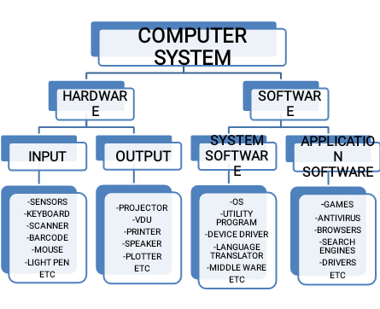

FUNCTIONS OF THE PHERIPHERAL DEVICES
Printer: A printer is an output device that brings out information in a form of a hardcopy, on different kinds of paper. Printer is sub-divided into two namely
- Impact Printer
- Non-Impact Printer

Impact Printer: An impact printer is a printer that makes a lot of noise while in use, and also generate large amount of electricity. Examples are; Dot Matrix, Dairy Wheel, etc.
Non-Impact Printer: A Non-Impact printer is a printer that do not makes noise while in use, and consume small amount of electricity, examples are; Laser Jet, Dane Jet, Ink Jet, etc.
Scanner: A scanner is an electronic device that simply capture image on a paper, then send it to the computer system for processing, the printer don’t change the image, it send it as is, as the original copy, it simply captures what is sees, and converts it into tiny electrical pixels to the computer, whereas the monitor will now displays it after converting the tiny pixels, compressing it at a high density to create a picture on the vdu screen.
Flash: A flash is an external storage device which accept and stores Information from a computer. It is fast but too liable for it contacts virus easily. It is small mobile and flexible to use. Some flash are OTG Flash, meaning they have both USB and Phone type ports.

THE CENTRAL PROCESSING UNIT

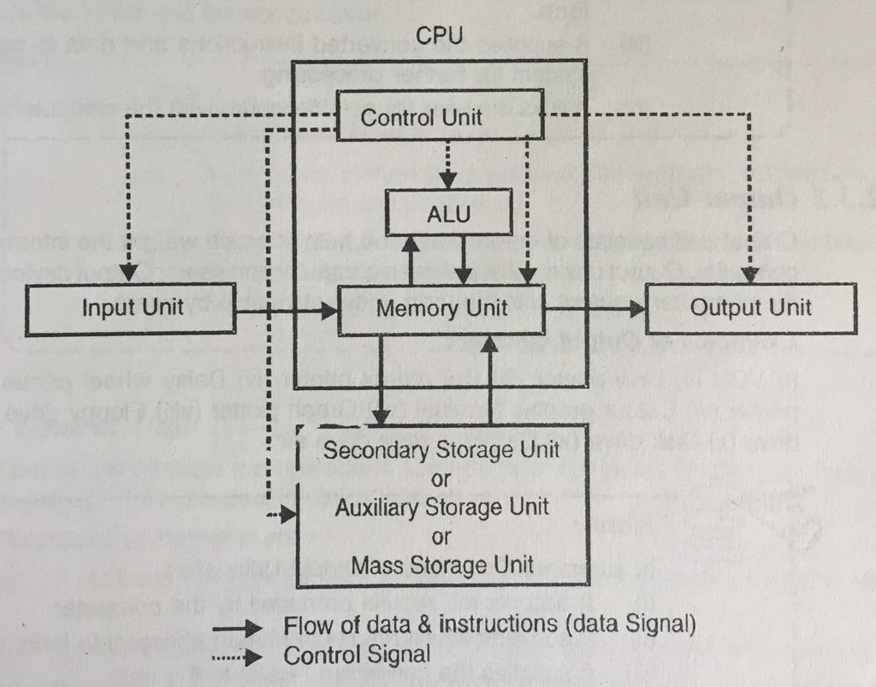

MACHINE LANGUAGE
Sometimes referred to as machine code or object code, machine language is a collection of binary digits or bits that the computer reads and interprets. Machine language is the only language a computer is capable of understanding.
The exact machine language for a program or action can differ by operating system. The specific operating system dictates how a compiler writes a program or action into machine language.
Computer programs are written in one or more programming languages, like C++, Java, or Visual Basic. A computer cannot directly understand the programming languages used to create computer programs, so the program code must be compiled. Once a program's code is compiled, the computer can understand it because the program's code is turned into machine language.

LOW-LEVEL LANGUAGE
A low-level language is a programming language that provides little or no abstraction of programming concepts and is very close to writing actual machine instructions. Two examples of low-level languages are assembly and machine code.

Uses and other information
Low-level languages are useful because programs written in them can be crafted to run very fast and with a very minimal memory footprint. However, they are considered harder to utilize because they require a deeper knowledge of machine language.

HIGH-LEVEL LANGUAGE
A high-level language is a programming language designed to simplify computer programming. It is "high-level" since it is several steps removed from the actual code run on a computer's processor. High-level source code contains easy-to-read syntax that is later converted into a low-level language, which can be recognized and run by a specific CPU.
Most common programming languages are considered high-level languages. Examples include:
- C++  - C#  - Cobol  - Fortran  - Java  - JavaScript | - Objective C  - Pascal  - Perl  - PHP  - Python  - Swift
Each of these languages use different syntax. Some are designed for writing desktop software programs, while others are best-suited for web development. But they all are considered high-level since they must be processed by a compiler or interpreter before the code is executed.
Source code written in languages like C++ and C# must be compiled into machine code in order to run. The compilation process converts the human-readable syntax of the high-level language into low-level code for a specific processor. Source code written in scripting languages like Perl and PHP can be run through an interpreter, which converts the high-level code into a low-level language on-the-fly.

SOUCE PROGRAM
Source program It is a notion that is used as a synonym for source code . This is the instructions that a computer program transmits to a computer So it can run. These instructions are lines of text written in a programming language (a structure capable of delivering computer instructions from a certain semantic and syntactic base).
It can be said that, in the source program, a software details the totality of its operation. A programmer It is he who develops these instructions, respecting the principles of the chosen programming language. The system in question, when accessing the source program, interprets the instructions and starts them up.
It should be noted that the source program is not interpreted directly by the hardware : the instructions are translated into a different language, which the hardware itself is able to execute. The translation process is developed through interpreters , assemblers and compilers , between different translation systems.

TRANSLATOR
A translator or programming language processor is a generic term that can refer to anything that converts code from one computer language into another. A program written in high-level language is called source program. These include translations between high-level and human-readable computer languages such as C++ and Java, intermediate-level languages such as Java bytecode, low-level languages such as the assembly language and machine code, and between similar levels of language on different computing platforms, as well as from any of the above to another.^{[1]}
The term is also used for translators between software implementations and hardware implementations (ASICs microchips) of the same program, and from software descriptions of a microchip to the logic gates needed to build it.
^{Types}

Compiler
A compiler is a translator used to convert high-level programming language to low-level programming language. It converts the whole program in one session and reports errors detected after the conversion. The compiler takes time to do its work as it translates high-level code to lower-level code all at once and then saves it to memory. A compiler is processor-dependent and platform-dependent. It has been addressed by alternate names as the following: special compiler, cross-compiler and, source-to-source compiler.

Interpreter
The interpreter is similar to a compiler, as it is a translator used to convert high-level programming language to low-level programming language. The difference is that it converts the program one line of code at a time and reports errors when detected, while also doing the conversion. An interpreter is faster than a compiler as it immediately executes the code upon reading the code. It is often used as a debugging tool for software development as it can execute a single line of code at a time. An interpreter is also more portable than a compiler as it is processor-independent, you can work between different hardware architectures.

Assembler
An assembler is a translator used to translate assembly language into machine language. It has the same function as a compiler for the assembly language but works like an interpreter. Assembly language is difficult to understand as it is a low-level programming language. An assembler translates a low-level language, such as an assembly language to an even lower-level language, such as the machine code.

BESPOKE
The term "bespoke" comes from England where it originally referred to custom or tailor-made clothing. In recent years, however, the term has been applied to information technology (IT), and refers to custom services or products.
For example, bespoke software is software customized for a specific purpose. Bespoke programs may include custom accounting software for a certain company or a network monitoring tool for a specific network. Because bespoke software is custom-made for a specific purpose, bespoke programs are also considered vertical market software.
Another area where bespoke is used in the computer industry is in reference to websites. A bespoke website is one that is custom-built, often from scratch, to suit the needs of a business or organization. This may include a custom layout, custom database integration, and other extra features the client may require. Because bespoke websites must be individually tailored to a client's needs, they often take longer to develop and are more expensive than websites built from templates.
Finally, bespoke can also be used to refer to hardware. Computer companies, such as Dell, HP, and Apple may provide customers with custom options for the systems they buy. For example, one person may choose to build his system with a high-end graphics card for video production, while another person may choose a basic graphics card, but may add additional RAM so her computer will be able to run several programs at once. These custom configurations are sometimes referred to as bespoke systems.

DATA PROCESSING
Data in its raw form is not useful to any organization.
Data processing is the method of collecting raw data and translating it into usable information. It is usually performed in a step by step process by a team of data scientists and data engineers in an organization. The raw data is collected, filtered, sorted, processed, analyze, stored and then presented in a readable format.
Data Processing is crucial for organizations to create better businesses strategies and increase their competitive edge, by converting the data into a readable format like graph, charts and documents employer through the organization can understand and use the data.

DATA PROCESSING CYCLE
The data processing cycle consist of a series of steps where raw data (Input) is fed into a process (CPU) to produce actionable insights (Output). Each step is taken in a specific order, but the entire process is repeatedly in a cyclic manner. The first data processing cycle’s output can be stored and fed as the input for the next cycle.
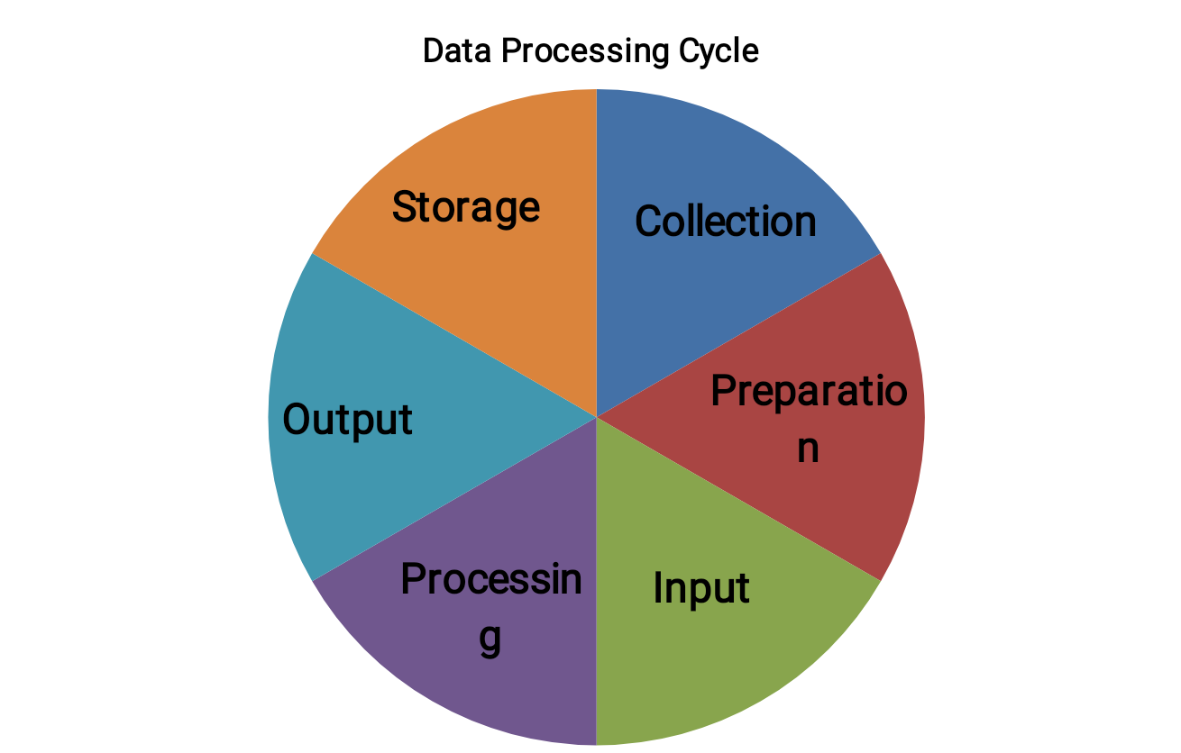

- Collection:- raw data to be collected can include money figures, websites, cookies, profit/loss, statement of a company, user behavior, etc.
- Preparation:- Data preparation or data cleaning is the process of sorting and filtering the raw data to remove un-necessary and in-accurate data. Raw data is checked for errors, duplications, miscalculations of missing data, and transformed into a suitable form further analysis and processing. This is done to ensure the highest quality of data to be fed into the CPU.
- Input:- In this step, the raw data is converted into machine readable form and fed into the processing unit, this can be in a form of data entry through the keyboard, scanner or any other input source.
- Processing:- The raw data is subjected to various data processing methods using the machine learning and A.I. algorithms to generates a desirable output. Process to process depending on data source (Data lakes, Online Databases, connected devices, etc.)
- Output:- The data is finally transmitted and displayed to the user in a readable form like graphs, tables, vectors, files, audio, videos, documents, etc.
- Storage:- Data and meta data is stored for further use. This allows for quick access and retrieval of information whenever needed, and also allows it to be used as input in the next data processing cycle directly.

TYPES OF DATA PROCESSING AND USES
- Batch Processing | Data is collected and processed in batches. Used for large amount of data. Eg, Payroll System like the IPPIS
- Real-Time Processing | Data is processed within seconds when the input is given. Use for small amount of data. Eg, Withdrawing money from ATM
- Online Processing | Data is automatically fed into the CPU as soon as it becomes available. Used for continuous processing of data. Eg, Barcode scanning.
- Multiprocessing | Data is broken down into frames and processed using two or more CPU within a single computer system, Also known as parallel processing. Eg, Weather Forecasting
- Time Sharing | Allocates computer resources and data in time stored to several users simultaneously. Eg, Internet Cafe

DATA PROCESSING METHODS

- Manual:- Data is processed manually, the entire process of data collection; filtering, sorting, calculation and other logical operations are all done with human intervention, without the use of any other electronic device. It is low cost methods requires no tools, but produces high error, high labor cost, and lots of time.
- Mechanical:- Data is processed mechanically through the use of devices and machines. This includes simple devices such as calculators, typewriters, printing press, etc. simple data processing operations can be achieved with these methods. It has such lesser errors than the manual data processing method, but the increase of data has made this process more complex and difficult.
- Electronic:- Data is processed with modern technologies using data processing software and programs. A set of instruction is given to software to process the data and yield output. This method is the most expensive but the fastest processing speeds with the highest reliable and accuracy of output.

EXAMPLE OF DATA PROCESSING

- Stock trading software that converts millions of stock data into a simple graph.
- E-commerce Company uses the search history of customers to recommend their similarities of products and campaign.
- Self-driving car uses Real-Time data from sensors to detect if there are pedestrians and other cars on the road.

DATA PROCESSING IN RESEARCH AREAS

- Questionnaire checking
- Editing
- Coding
- Classification
- Tabulation
- Graphical Representation
- Data Cleaning
- Data Adjustment

ADVANTAGE OF DATA PROCESSING

- High efficient
- Time-sharing
- High speed
- Reduce errors

DISADVANTAGES OF DATA PROCESSING

- Large power consumption
- Occupies large memory
- The cost of installation is high
- Wastage od memory
APPLICATIONS OF DATA PROCESSING
- Bank
- Education
- Application for……
- Logistic tracking area
- Hospital patient details. Etc.

SYSTEM INITIALIZATION

System initialization displays info about configuration parameters that affects the system when it is first powered on, through system boot. Initialization includes boots parameters, startup scripts, and kennel parameters.
Boot Parameters:- This view shows the parameters used on the machines in the active machine group during the initial stages of the boot process.
Startup Scripts:- This view shows the permission and file attributes of the startup scripts invoked during the boot process, arranged by run level.
Multi-value Field:- This view contain at least one value that can have multiple values that on a single machine such as processor on a multi-processor machine.
Kernel Parameters:- This view shows the kernel parameters on machine that belong to the active machine group.

FORMATTING OF A STORAGE MEDIA
Internal Storage/Hard disk Formatting
- Backup any data on the drive you want to save. You can back up installed apps
- Install the hard drive
- Open the computer/my pc/this pc
- Right-click on the drive you want to format
- Select the file system
- Give the drive a name
- Choose whether or not to quick format

Formatting Secondary Storage
- Backup any data on the drive you want to save.
- Install the hard drive
- Open disk utility
- Select your drive from the list on the left.
- Click the erase tab
- Choose your file system
- Give the drive a name
- Start the format process.

COMPUTER SECURITY
Computer security, cybersecurity or information technology security (IT security) is the protection of computer systems and networks from information disclosure, theft of or damage to their hardware, software, or electronic data, as well as from the disruption or misdirection of the services they provide.
The field is becoming increasingly significant due to the increased reliance on computer systems, the Internet and wireless network standards such as Bluetooth and Wi-Fi, and due to the growth of "smart" devices, including smartphones, televisions, and the various devices that constitute the "Internet of things". Owing to its complexity, both in terms of politics and technology, cybersecurity is also one of the major challenges in the contemporary world.

COMPUTER SAFETY MEASURES
Computer safety measures simply refer to ethical and vivid /precise precautionary measures accurately taken in order to ensure safety or protection of the computer system from danger or subsequent attacks. Computer safety measures can also be likened to computer security where users make use of the computer while keeping it absolutely safe from threats and attacks. Computer security can be defined as controls and safety measures that are put in place to provide confidentiality, integrity, and availability for all components of computer systems.
The computing profession, like any other is full of risks. Each peripheral device such as keyboard, monitor, mouse, and printer e.t.c of a computer system has associated injuries. Every computer used either at homes or office must be properly taken care of, most especially certain safety measures must be considered without any error. This article highlights specific and important computer safety measures/tips that will guide every computer users.
When setting a computer room the following must be taken into consideration:
⇒The computer must be space apart
⇒There must be free entry and exit
⇒All wires connecting the system should be properly disposed
⇔A computer library should be closed to computer room.
Dust free environment: Dust should be prevented as often as possible in the computer. The floor must always be kept clean the computer and its peripheral should be covered using the dust cover after use.
Protection from power problems: The surge protectors, the use of stabilizer and UPS must be upheld to prevent any form of damage caused by power fluctuations.
Good Lightening: The computer room should be well illuminated, use of florescent tubes and bulbs to provide light to make the room bright for all the activities carried out by the computer uses is essential.
Computer Security: This involves putting in places a reliable security measures to protect both the physical measures to prevent crime”
⇒Provision of secured guards to control access to the center
⇒Provision of log register to monitor staff
⇒Provision of UPS and generator to prevent accidental loss of data.
⇒Ensuring that waste documents are properly burnt.
⇒Ensuring that equipment’s are switched off when not in use
⇒Solid construction of the computer center with secured windows
Logical Security: This means building software check/control into the system to disallow unauthorized assess. These are achieved through the use of passwords and assess codes.
The following logical measures will assist to prevent crime:
- Provision of passwords for authorized users
- Provision of data encryption method
- Provision of a system to monitor the activities of all login users
- Provision of regular audit to all computing resources
- Provision of security software to restrict the permission of the users to read only ie he cannot modify the data or copy the information
- Provision of an alarm system when an attempt is made to break into the program
- Provision of protection software to limit the user’s activities to specified directory or program
Precautions in the Computer Room : The following rule and regulations must be observed when in the computer room
- There should be no eating
- Do not rest or team
- There should be no noise or fighting in the computer room
- Handle the equipment’s with care
- All computers should be cover after use
- Do not receive visitors in the computer room
- There should be strong security around the computer room to prevent theft
- The system should be shut down or turned off after use.

CARE OF THE COMPUTER
- Computer and related devices are not heat friendly, therefore do not operate
computer in a poorly ventilated environment.
- Never switch off computers but shut down properly to avoid creating irreparable errors on your hard disk.
- Do not leave computer or related devices while they are not being used.
- Always cover computers and other devices with their cover when they are not in use to prevent them form dust
- Always follow the shutdown procedure and never turn off the computer until a
screen massage tells you to do so
- Do not shake the desk or table while the computer and the other related devices are working to interrupt.

MALWARE
Malware, or “malicious software,” is an umbrella term that describes any malicious program or code that is harmful to systems.
Hostile, intrusive, and intentionally nasty, malware seeks to invade, damage, or disable computers, computer systems, networks, tablets, and mobile devices, often by taking partial control over a device’s operations. Like the human flu, it interferes with normal functioning.
The motives behind malware vary. Malware can be about making money off you, sabotaging your ability to get work done, making a political statement, or just bragging rights. Although malware cannot damage the physical hardware of systems or network equipment (with one known exception—see the Google Android section below), it can steal, encrypt, or delete your data, alter or hijack core computer functions, and spy on your computer activity without your knowledge or permission.
Malware can reveal itself with many different aberrant behaviors. Here are a few telltale signs that you have malware on your system:
- Your computer slows down. One of malware’s side effects is to reduce the speed of your operating system (OS), whether you’re navigating the Internet or just using your local applications, usage of your system’s resources appears abnormally high. You might even notice your computer’s fan whirring away at full speed—a good indicator that something is taking up system resources in the background. This tends to happen when your computer has been roped into a botnet; i.e. a network of enslaved computers used to perform DDoS attacks, blast out spam, or mine cryptocurrency.
- Your screen is inundated with annoying ads. Unexpected pop-up ads are a typical sign of a malware infection. They’re especially associated with a form of malware known as adware. What’s more, pop-ups usually come packaged with other hidden malware threats. So if you see something akin to “CONGRATULATIONS, YOU’VE WON A FREE PSYCHIC READING!” in a pop-up, don’t click on it. Whatever free prize the ad promises, it will cost you plenty.
- Your system crashes. This can come as a freeze or a BSOD (Blue Screen of Death), the latter occurs on Windows systems after encountering a fatal error.
- You notice a mysterious loss of disk space. This could be due to a bloated malware squatter, hiding in your hard drive aka bundleware.
- There’s a weird increase in your system’s Internet activity. Take Trojans for example. Once a Trojan lands on a target computer, the next thing it does is reach out to the attacker’s command and control server (C&C) to download a secondary infection, often ransomware. This could explain the spike in Internet activity. The same goes for botnets, spyware, and any other threat that requires back and forth communication with the C&C servers.
- Your browser settings change. If you notice your homepage changed or you have new toolbars, extensions, or plugins installed, then you might have some sort of malware infection. Causes vary, but this usually means you clicked on that “congratulations” pop-up, which downloaded some unwanted software.
- Your antivirus product stops working and you cannot turn it back on, leaving you unprotected against the sneaky malware that disabled it.
- You lose access to your files or your entire computer. This is symptomatic of a ransomware infection. The hackers announce themselves by leaving a ransom note on your desktop or changing your desktop wallpaper itself in to a ransom note (see GandCrab). In the note, the perpetrators typically inform you that your data has been encrypted and demand a ransom payment in exchange for decrypting your files.

What are the most common forms of malware?
Here are the most common offenders in the rogues’ gallery of malware:
- Adware is unwanted software designed to throw advertisements up on your screen, most often within a web browser. Typically, it uses an underhanded method to either disguise itself as legitimate, or piggyback on another program to trick you into installing it on your PC, tablet, or mobile device.
- Spyware is malware that secretly observes the computer user’s activities without permission and reports it to the software’s author.
- A virus is malware that attaches to another program and, when executed—usually inadvertently by the user—replicates itself by modifying other computer programs and infecting them with its own bits of code.
- Worms are a type of malware similar to viruses. Like viruses, worms are self-replicating. The big difference is that worms can spread across systems on their own, whereas viruses need some sort of action from a user in order to initiate the infection.
- A Trojan, or Trojan horse, is one of the most dangerous malware types. It usually represents itself as something useful in order to trick you. Once it’s on your system, the attackers behind the Trojan gain unauthorized access to the affected computer. From there, Trojans can be used to steal financial information or install other forms of malware, often ransomware.
- Ransomware is a form of malware that locks you out of your device and/or encrypts your files, then forces you to pay a ransom to regain access. Ransomware has been called the cybercriminal’s weapon of choice because it demands a quick, profitable payment in hard-to-trace cryptocurrency. The code behind ransomware is easy to obtain through online criminal marketplaces and defending against it is very difficult. While ransomware attacks on individual consumers are down at the moment, attacks on businesses are up 365 percent for 2019. As an example, the Ryuk ransomware specifically targets high-profile organizations that are more likely to pay out large ransoms. For more, check out the Malwarebytes Labs Ransomware Retrospective.
- Rootkit is a form of malware that provides the attacker with administrator privileges on the infected system, also known as “root” access. Typically, it is also designed to stay hidden from the user, other software on the system, and the operating system itself.
- A keylogger is malware that records all the user’s keystrokes on the keyboard, typically storing the gathered information and sending it to the attacker, who is seeking sensitive information like usernames, passwords, or credit card details.
- Malicious cryptomining, also sometimes called drive-by mining or cryptojacking, is an increasingly prevalent malware usually installed by a Trojan. It allows someone else to use your computer to mine cryptocurrency like Bitcoin or Monero. So instead of letting you cash in on your own computer’s horsepower, the cryptominers send the collected coins into their own account and not yours. Essentially, a malicious cryptominer is stealing your resources to make money.
- Exploits are a type of malware that takes advantage of bugs and vulnerabilities in a system in order to give the attacker access to your system. While there, the attacker might steal your data or drop some form of malware. A zero-day exploit refers to a software vulnerability for which there is currently no available defense or fix.

How does malware spread?
Malware can spread in a variety of ways: when you download and install an infected program, when you click an infected link or open a malicious email attachment, or even sometimes when you use corrupted physical media like a USB drive.
Here are some of the most common malware delivery methods to watch out for.
- Email: If your email has been hacked, malware can force your computer to send emails with infected attachments or links to malicious websites. When a recipient opens the attachment or clicks the link, the malware is installed on their computer, and the cycle repeats.
Refusing to open attachments from unknown senders is an important part of good email security.
- Messaging apps: Malware can spread by hijacking messaging clients to send infected attachments or malicious links to a victim’s contacts.
- Infected ads: Hackers can load malware into ads and seed those ads on popular websites. When you click the infected ad, it downloads malware to your computer.
- Pop-up alerts: Scareware uses fake security alerts to trick you into downloading bogus security software, which in some cases can be additional malware.
- Drive-by downloads: A drive-by download happens when a malicious website automatically downloads malware onto your device. This happens as soon as you load the page — no clicks required. Hackers use DNS hijacking to automatically redirect you to these malicious sites.
- Personal installation: People sometimes install parental control software on their partner’s computer or phone. When these apps are used without the victim’s consent, they become spyware.
- Physical media: Hackers can load malware onto USB flash drives and wait for unsuspecting victims to plug them into their computers. This technique is often used in corporate espionage.
- Exploits: Exploits are bits of code designed to take advantage of a vulnerability, or security weakness, in a piece of software or hardware. A blended threat is a specialized type of exploit package that targets multiple vulnerabilities at once.

Who creates malware, and why?
Malware is created by hackers, thieves, blackmailers, scammers, organized crime syndicates, private corporations, and even governments. Typical goals are data theft, file and network damage, and financial gain.
Early computer viruses were created for fun, with no malicious intent beyond a simple prank. But now “prankster” malware is vastly outnumbered by malware that causes real and severe damage.
The who and why of malware are closely related, because all malware is created for a specific purpose. Here are several of the most common reasons why people create and use malware.

Why do people use malware?
Let’s look at why people use malware to get an idea of who’s creating the malware in the first place, and what purposes it serves.
- Data theft: Cybercriminals can steal data and either use it to commit identity theft or sell it on the dark web to other cybercriminals.
Malware-based data theft ranges from redirecting people to pharming websites, to capturing passwords with spyware, to large-scale data breaches.
- Corporate espionage: Data theft on a corporate scale is known as corporate espionage. Companies can steal secrets from their competitors, and governments often target large corporations as well.
- Cyberwarfare and international espionage: Governments around the world are frequently accused of using malware against other countries and large corporations.
- Sabotage: Sometimes, damage is the goal. Attackers can delete files, wipe records, or shut down entire organizations to cause millions of dollars of damage.
- Extortion: Ransomware encrypts a victim’s files or device and demands a payment for the decryption key. The purpose is to get the victim — a person, institution, or government — to pay the ransom.
- Law enforcement: Police and other government authorities can use spyware to monitor suspects and harvest information to use in their investigations.
- Entrepreneurship: Many potent strains of ransomware are available to anyone as ransomware-as-a-service (RaaS), where the developer licenses their malware in exchange for an up-front fee or a cut of every payment.
- DDoS attacks: Hackers can use malware to create botnets — linked networks of “zombie computers” under the attacker’s control. The botnet is then used to overload a server in a distributed denial of service (DDoS) attack.
- Mining cryptocurrency: Cryptominers force a victim’s computer to generate, or mine, bitcoin or other cryptocurrency for the attacker.

How to protect against malware
In no particular order, here’s our tips on protecting against malware.
1. Pay attention to the domain and be wary if the site isn’t a top-level domain, i.e., com, mil, net, org, edu, or biz, to name a few.
2. Use strong passwords with multi-factor authentication. A password manager can be a big help here.
3. Avoid clicking on pop-up ads while browsing the Internet.
4. Avoid opening email attachments from unknown senders.
5. Do not click on strange, unverified links in emails, texts, and social media messages.
6. Don’t download software from untrustworthy websites or peer-to-peer file transfer networks.
7. Stick to official apps from Google Play and Apple’s App Store on Android, OSX, and iOS (and don’t jailbreak your phone). PC users should check the ratings and reviews before installing any software.
8. Make sure your operating system, browsers, and plugins are patched and up to date.
9. Delete any programs you don’t use anymore.
10. Back up your data regularly. If your files become damaged, encrypted, or otherwise inaccessible, you’ll be covered.
11. Download and install a cybersecurity program that actively scans and blocks threats from getting on your device. Malwarebytes, for example, offers proactive cybersecurity programs for Windows, Mac, Android, and Chromebook. Plus, our latest offering, Malwarebytes Browser Guard. It’s free and it’s the only browser extension that can stop tech support scams along with any other unsafe and unwanted content that comes at you through your browser.

How to Install an Antivirus on Windows
- Create an Account
It’s not always necessary to create an account immediately, but it will help you in the long run. Some providers won’t ask you to sign-up straight away but will require it within 30 days of purchase.
Creating an account will give you direct access to updates, and a place where you can manage your licenses and other features, such as remote anti-theft security features for your mobile device, all in one place.
- Download the Antivirus
Click to download the antivirus. It will usually specify how much space is required, so you may have to delete files first to make room for it.
- Authorize Changes
It’s also essential to ensure you have admin privileges for your computer, as you’ll have to authorize the software installation. This step requires you to enter your password via an admin account. It sounds complex, but chances are you’re already the admin and when you try to install it, Windows will allow you. Just give it a try.
- Follow the On-Screen Installation Process
Next, the software will lead you through a short installation process, which usually involves accepting the terms and conditions and establishing where the antivirus will be saved. The installer box will lay out these steps for you.
- Restart your Computer
The version you download might not be the most up-to-date version. Simply restart your computer, which will prompt any updates to load. Once this is complete, run a full scan on your computer

COMPUTER SYSTEM AUDITING
An audit is an examination and evaluation, often in regard to financial records or accounts, which are checked for accuracy. A computer audit generally means an audit of a company’s computer networks and related technology and software, as well as the procedures in place with regard to the use of IT resources. It may be undertaken to check the efficiency of the system and turn up any violations. Less often, the term computer audit is used to refer to a tax audit in which a computer is used as a tool to assist the traditional audit process.
The most basic part of a computer audit is an asset management inventory that identifies all the hardware and software holdings and their connections, and helps determine what is owned and what may need to be updated or replaced. The computer audit information will give a more-or-less detailed analysis of each computer’s processor, current operating system, Service Packs, memory, storage, partitions, size, media capabilities — such as a CD/DVD burner — and any attached peripherals, such as keyboards, printers, scanners, external drives, microphones, speakers, etc. A software inventory provides the name, installation date, and version of all software. This is helpful for a standardization review, especially if a standard operating environment is sought.
In a licensing audit, the serial numbers and product keys for software are collected. The appropriate licenses for individual computers and networks are also reviewed. These steps can help to ensure that everything is up-to-date and examine whether the existing licensing choices are still optimal.
Another aspect of a computer audit is a security review. Knowing and having an appropriate record of assets is only the beginning of this process, which might also involve bar-coding or otherwise tagging holdings. Checking firewalls and security software for consistency and effectiveness is also important. This means a review of anti-virus software and anti-malware, as well as checking systems to make sure they’re clean.

Finally, a computer audit may examine IT procedures, looking for ways in which they could be more efficient. Also under analysis may be any possible instances of misappropriation of resources, improper use of resources, or poor matches between equipment and the demands of individual’s job descriptions. The latter could come from a determination that the employee is underserved by the computer setup he or she has, or that there has been unnecessary IT spending, given the real need.

USERNAME
Alternatively referred to as an account name, login ID, nickname, and user ID, username or user name is the name given to a user on a computer or computer network. This name is commonly an abbreviation of the user's full name or his or her alias. For example, an individual known as John Smith may be assigned the username smitj, the first four letters of the last name followed by the first letter of the first name. The picture shown on this page shows the username as root.
Usernames allow multiple users to use the same computer or online service with their personal settings and files. When used on a website, a username enables you to maintain personal settings and identification with that website or service.
USER PASSWORD
A password is a string of characters used for authenticating a user on a computer system. For example, you may have an account on your computer that requires you to log in. In order to successfully access your account, you must provide a valid username and password. This combination is often referred to as a login. While usernames are generally public information, passwords are private to each user.
Most passwords are comprised of several characters, which can typically include letters, numbers, and most symbols, but not spaces. While it is good to choose a password that is easy to remember, you should not make it so simple that others can guess it. The most secure passwords use a combination of letters and numbers and do not contain actual words.
COMPUTER ERGONOMICS
Ergonomics is a science that studies the design and arrangement of items people use and interact with most efficiently and safely. It is also referred to as human engineering.
Computer ergonomics is the study of how we interact with our computers. Scientists that study computer ergonomics, attempt to find solutions to strain, fatigue, and injuries caused by poor product design or workplace arrangement. Their goal is to create an overall comfortable and relaxed workplace environment.
Sitting at a computer for many hours a day, many people find themselves looking for a better way to work. Personally, my back hurts, my neck gets tight, and I often find that my legs fall asleep. So what can you do when your workstation is ergonomically wrong?
Setting Up Your Workstation
According to the ergonomic experts at the University of Michigan, your workstation should
- Be adjusted to allow your arms to rest at a 90-degree angle to the keyboard
- Allow for the monitor and keyboard to be separated
- Have a chair that supports your back in an upright seated position with a slight arch that may or may not contain a lumbar roll for the lower back
- Position the monitor to be directly in front of you (at least 18 inches) and at eye level
- Keep feet flat on the floor with the legs in a parallel position, and for the vertically challenged, a footrest may be needed
- If using a hard-copy document, use a document holder to keep it at eye level
Since laptops are not designed for use over long periods of time, if possible, separate the monitor and keyboard. Place the laptop on top of books or some other device to raise it to eye level. Then, use an external keyboard that allows the elbows to retain their 90-degree angle while typing.
Other Factors to Consider

Other factors such as body position, working for shorter periods of time before moving around, and moving every 10 minutes, will help keep your back and neck from becoming stiff and sore. One study reported that workers who moved every seven minutes avoided computer-related pain, even with extended computer use. Every 30 minutes to an hour, take a short break to get up out of your chair and stretch or walk around.

Keeping physically fit can also help to avoid, and even treat, problems and pains related to extended computer use. Build up core muscles to support the lower back while seated.
If you have constant pain, numbness, or any other symptoms that are persistent and do not go away, seek medical care immediately. A delay in seeking care may cause the problems to develop into serious medical conditions related to the back and joints.

COMPUTER NETWORKS
A network is a set of devices (often referred to as nodes) connected by communication links. A node can be a computer, printer, or any other device capable of sending and/or receiving data generated by other nodes on the network.
A Computer Network consists of two or more independent computers that are linked (connected) together in order to share data & resources (files, printers, modems, fax machines), share application software (MS Office), allow electronic communication, and increase productivity (makes it easier to share data amongst users. This connection is twofold: (a) physical, through wires, cables, and wireless media (cell phones), and (b) logical, through the transport of data across the physical media. A Computer network includes, the network operating system in the client and server machines, the cables, which connect different computers and all supporting hardware between such as bridges, routers and switches. In wireless systems, satellites, antennas and towers are also part of the network.
Network Characteristics
A network must be able to meet a certain number of criteria. The most important of these are performance, reliability, and security.
Performance
Performance can be measured in many ways, including transit time and response time. Transit time is the amount of time required for a message to travel from one device to another. Response time is the elapsed time between an inquiry and a response. The performance of a network depends on a number of factors, including the number of users, the type of transmission medium, the capabilities of the connected hardware, and the efficiency of the software. Performance is often evaluated by two networking metrics: output and delay. We often need more outputs and less delay. However, these two criteria are often contradictory. If we try to send more data to the network, we may increase throughput but we increase the delay because of traffic congestion in the network.
Reliability
In addition to accuracy of delivery, network reliability is measured by the frequency of failure, the time it takes a link to recover from a failure, and the network's robustness in a catastrophe.
Security
Network security issues include protecting data from unauthorized access, protecting data from damage and development, and implementing policies and procedures for recovery from breaches and data losses.

A protocol is a set of rules that governs how networks communicate. It represents an agreement between the communicating devices and standards for communication between network devices. A protocol defines the format and the order of messages exchanged between two or more communicating entities, as well as the actions taken on the transmission and/or receipt of a message. A protocol defines what is communicated, how it is communicated, and when it is communicated. Without protocols, two devices may be connected but not communicating i.e. devices would not be able interpret the signals sent by other devices, and data would go nowhere. When choosing protocols, characteristics such as purpose, speed, transmission efficiency, utilization of resources, and ease of setup, compatibility, network interconnection, data security requirements, and ability to travel between different LANs should be considered.

Types of Connection
A network consists of two or more devices connected through links. A link is a communications pathway that transfers data from one device to another. For visualization purposes, it is simplest to imagine any link as a line drawn between two points. For communication to occur, two devices must be connected in some way to the same link at the same time. There are two possible types of connections: point-to-point and multipoint.

- Point-to-Point:
A point-to-point connection provides a dedicated link between two devices. The entire capacity of the link is reserved for transmission between those two devices. Most point- to-point connections use an actual length of wire or cable to connect the two ends, but other options, such as microwave or satellite links, are also possible. When you change television channels by infrared remote control, you are establishing a point-to-point connection between the remote control and the television's control system.
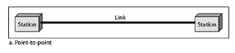

- Multipoint:
A multipoint (also called multidrop) connection is one in which more than two specific devices share a single link. In a multipoint environment, the capacity of the channel is shared, either spatially or temporally. If several devices can use the link simultaneously, it is a spatially (space) shared connection. If users must take turns, it is a timeshared connection.
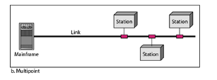

Point-to-Point/Switched Networks
Point-to-point or switched, networks are those in which there are many connections between individual pairs of machines. In these networks, when a packet travels from source to destination it may have to first visit one or more intermediate machines. Routing algorithms play an important role in Point-to-point or Switched networks because often multiple routes of different lengths are available. An example of switched network is the international dial-up telephone system. The different types of Point- to-point or Switched networks are: Circuit Switched Networks and Packet Switched Networks.
In Switched network, the temporary connection is established from one point to another for either the duration of the session (circuit switching) or for the transmission of one or more packets of data (packet switching).

Circuit Switched Networks
Circuit Switched networks use a networking technology that provides a temporary, but dedicated connection between two stations no matter how many switching devices are used in the data transfer route. Circuit switching was originally developed for the analog based telephone system in order to guarantee steady and consistent service for two people engaged in a phone conversation. Analog circuit switching has given way to digital circuit switching, and the digital counterpart still maintains the connection until broken (one side hangs up). This means bandwidth is continuously reserved and “silence is transmitted” just the same as digital audio in voice conversation.

Packet Switched Networks
Packet switched Networks use a networking technology that breaks up a message into smaller packets for transmission and switches them to their required destination. Unlike circuit switching, which requires a constant point-to-point circuit to be established, each packet in a packet- switched network contains a destination address. Thus, all packets in a single message do not have to travel the same path. They can be dynamically routed over the network as lines become available or unavailable. The destination computer reassembles the packets back into their proper sequence.
Packet switching efficiently handles messages of different lengths and priorities. By accounting for packets sent, a public network can charge customers for only the data they transmit. Packet switching has been widely used for data, but not for real-time voice and video.
Benefits:
- More than one user stream of data can be sent over a link during a given window of time.
- Packet-switching does not set up a connection through a network. Thus, it does not require dedicated end-to-end channels. If problems occur in one part of network, user data can be dynamically rerouted to those switches that are operating satisfactorily. In the past, a failed circuit switch required the tedious and time-consuming job of reestablishing a dedicated end-to-end connection.
- Because many user sessions (such as email and text messaging) entail a slow introduction of data into the network, packet-switching “packages” this data into small bundles and sends it on its way to the destination. (By the way, even “faster” sessions, such as file transfer, do not fully utilize a high-capacity communications link.) While the packet switching software is waiting for more data to spring forth from our cumbersome fingers and thumbs, it shifts its attention to an active user and for a brief time, it allots network resources to this user. Later, when we are keying in data, it turns its attention back to us.

NETWORK ARCHITECTURE

- PEER – TO – PEER NETWORKS
In this type of network, every computer communicates with each other directly with no computer having more authority than another. In a peer-to-peer network, networked computers act as equal partners, or peers. As peers, each computer can take on the client function or the server function. In a peer-to-peer network, individual users control their own resources. The users may decide to share certain files with other users. The users may also require passwords before they allow others to access their resources. Since individual users make these decisions, there is no central point of control or administration in the network. In addition, individual users must back up their own systems to be able to recover from data loss in case of failures. When a computer acts as a server, the user of that machine may experience reduced performance as the machine serves the requests made by other systems.

ADVANTAGES OF PEER – TO – PEER NETWORK
1. They are simple to configure.
2. They are less expensive to set up and to maintain.
DISADVANTAGES
1. They are not very flexible to change in network growth.
2. They are not practical for connecting more than a handful of computer.
A common way to share resources on a peer-to-peer network is by modifying the file – sharing controls via the computer’s operating system.
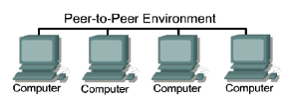

- CLIENT/SERVER NETWORKS
Another way of designing a network is to use a central computer, known as a server, to facilitate communication and resource sharing between other computers on the network, which are known as clients also known as work stations. In a client/server arrangement, network services are located on a dedicated computer called a server. The server responds to the requests of clients. The server is a central computer that is continuously available to respond to requests from clients for file, print, application, and other services. Typically, desktop computers function as clients and one or more computers with additional processing power, memory, and specialized software function as servers. Servers are designed to handle requests from many clients simultaneously. Before a client can access the server resources, the client must be identified and be authorized to use the resource. Each client is assigned an account name and password that is verified by an authentication service. The authentication service guards access to the network. With the centralization of user accounts, security, and access control, server-based networks simplify the administration of large networks. The concentration of network resources such as files, printers, and applications on servers also makes it easier to back-up and maintain the data. Resources can be located on specialized, dedicated servers for easier access. Most client/server systems also include ways to enhance the network with new services that extend the usefulness of the network.
Advantages of a Peer-to-Peer Network | Advantages of a client-server Network
Less Expensive to implementation | Provides of better security.
Does not require additional specialized network administration softwares. | Easier to administer when the network is large because administration is centralized.
Does not require a dedicated network administrator. | All date can be backed up on one central location.
Disadvantages of a Peer-to-Peer Network | Disadvantage of a Client-server Network
Does not scale well to large network and administration become unmanageable. | Requires expensive, specialized network administrative and operational software.
Less Secure | Requires a professional administrator.
All machine sharing the resources negatively impact the performance. | Has a single point of failure. User data is unavailable if the server is down.
Each user must be trained to perform administrative tasks. | Requires more expensive, more powerful hardware for the server machine.

TOPOLOGY
Topology is the graphical arrangement or physical layout of computer systems in a network. Two or more devices connect to a link; two or more links form a topology. It defines the way in which computers devices are connected to a network, and the main types include:

- BUS:
A bus topology is a multipoint connection. Each computer or networking components connects along a single, long and common cable (backbone), only one computer can transmit data at a time or frames will collide and be destroyed. It can also connect networking components using a series of cable segments that are connected linearly. Nodes are connected to the bus cable by drop lines and taps. A drop line is a connection running between the device and the main cable. A tap is a connector that either splices into the main cable or punctures the sheathing of a cable to create a contact with the metallic core. As a signal travels along the backbone, some of its energy is transformed into heat. Therefore, it becomes weaker and weaker as it travels farther and farther. For this reason there is a limit on the number of taps a bus can support and on the distance between those taps.
Advantages:
- Easy to install
- Costs are usually low; uses less cables than mesh and star
- Easy to add systems to network
- Great for small networks

Disadvantages:
- Out of date technology.
- Include difficult reconnection and fault isolation; hard to add new devices.
- Can be difficult to troubleshoot.
- Unmanageable in a large network
- If cable breaks, whole network is down

- RING
This topology connects hosts in a physical ring or circle. In ring topology, there are no collisions. Each device has a dedicated point-to-point connection with only the two devices on either side of it. A signal is passed along the ring in only one direction, with one single node receiving the transmission and relaying it to the next node in the ring, until it reaches its destination. Each device in the ring incorporates a repeater. When a device receives a signal intended for another device, its repeater regenerates the bits and passes them along. The ring topology is attractive because it is rarely subjected to the jams associated with hierarchical and star configurations.
A ring is relatively easy to install and reconfigure. Each device is linked to only its immediate neighbors. To add or delete a device requires changing only two connections. The only constraints are media and traffic considerations (maximum ring length and number of devices). In addition, fault isolation is simplified. Generally in a ring, a signal is circulating at all times. If one device does not receive a signal within a specified period, it can issue an alarm. The alarm alerts the network operator to the problem and its location. However, unidirectional traffic can be a disadvantage. In a simple ring, a break in the ring (such as a disabled station) can disable the entire network. Using a dual ring or a switch capable of closing off the break can solve this weakness.
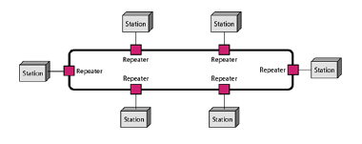
Advantages:
- It is easy to install and reconfigure.
- Very orderly network where every device has access to the token and the opportunity to transmit.
- Performs better than a bus topology under heavy network load
- Does not require network server to manage the connectivity between the computers

Disadvantage
- One malfunctioning workstation or bad port in the MAU can create problems for the entire network,
- Moves, adds and changes of devices can affect the network
- Network adapter cards and MAU's a Multistation Access Unit are much more expensive than Ethernet cards and hubs,
- Much slower than an Ethernet network under normal load

- STAR:
In a star topology, each device has a dedicated point-to-point link only to a central controller or connection point, usually called a hub/switch/router. The devices are not directly linked to one another. Each device connects directly to the central point with a cable, which makes it easy to troubleshoot. Unlike a mesh topology, a star topology does not allow direct traffic between devices. The controller acts as an exchange: If one device wants to send data to another, it sends the data to the controller, which then relays the data to the other connected device.
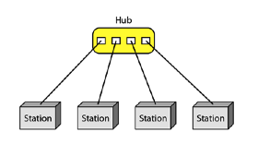
Advantages:
- Less Expensive than Mesh topology.
- Each device needs only one link and one I/O port to connect it to any number of other devices. This factor also makes it easy to install and reconfigure.
- Less Cabling, Addition and Deletion involves only one connection between the devices and the Hub or Switch.
- Easy for Fault identification and fault isolation. If one link fails, only that link is affected. All other links remain active.

Disadvantage:
- One big disadvantage of a star topology is the dependency of the whole topology on one single point, the hub. If the hub goes down, the whole system is dead.
- Although a star requires far less cable than a mesh, each node must be linked to a central hub. For this reason, often more cabling is required in a star than in some other topologies (such as ring or bus).

- MESH TOPOLOGY
In a mesh topology, every device has a dedicated point-to-point link to every other device. The term dedicated means that the link carries traffic only between the two devices it connects. It connects all devices to each other; failure of any cable will not affect the network, often used in WANs that interconnect LANs. To connect n nodes in Mesh topology, we require n(n-1)/2 duplex mode links.
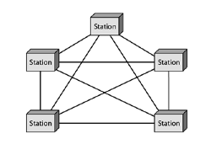
Advantages:
- The use of dedicated links guarantees that each connection can carry its own data load, thus eliminating the traffic problems that can occur when links must be shared by multiple devices.
- Robust, If one link becomes unusable, it does not incapacitate the entire system.
- Advantage of privacy or security.
- Point-to-point links make fault identification and fault isolation easy, Traffic can be routed to avoid links with suspected problems.

Disadvantage:
- Requires high amount of cabling and the number of I/O ports
- The sheer bulk of the wiring can be greater than the available space (in walls, ceilings, or floors) can accommodate.
- The hardware required to connect each link (I/O ports and cable) can be prohibitively expensive.
One practical example of a mesh topology is the connection of telephone regional offices in which each regional office needs to be connected to every other regional office.

NETWORKING CONCEPTS
REPEATERS
A repeater is a device that operates only in the physical layer of the OSI model. Signals that carry information within a network can travel a fixed distance before weakening endangers the integrity of the data. A repeater is an electronic device that receives a signal and retransmits it at a higher level or higher power, or onto the other side of an obstruction, so that the signal can cover longer distances. A repeater receives a signal and, before it becomes too weak or corrupted, regenerates the original bit pattern. The repeater then sends the refreshed signal. A repeater can extend the physical length of a LAN. A repeater does not actually connect two LANs; it connects two segments of the same LAN. The segments connected are still part of one single LAN. A repeater is not a device that can connect two LANs of different protocols.
A repeater forwards every frame; it has no filtering capability. A repeater does not amplify the signal; it regenerates the signal. When it receives a weakened or corrupted signal, it creates a copy, bit for bit, at the original strength. A repeater is a regenerator, not an amplifier.
The location of a repeater on a link is vital. A repeater must be placed so that a signal reaches it before any noise changes the meaning of any of its bits. A little noise can alter the precision of a bit's voltage without destroying its identity. If the corrupted bit travels much farther, however, accumulated noise can change its meaning completely. At that point, the original voltage is not recoverable, and the error needs to be corrected.

SWITCHES
A network switch is a computer networking device that connects devices together on a computer network, by using packet switching to receive, process and forward data to the destination device. Unlike less advanced network hubs, a network switch forwards data only to one or multiple devices that need to receive it, rather than broadcasting the same data out of each of its ports. A network switch is a multiport network bridge that uses hardware addresses to process and forward data at the data link layer (layer 2) of the OSI model. Switches can also process data at the network layer (layer 3) by additionally incorporating routing functionality that most commonly uses IP addresses to perform packet forwarding; such switches are commonly known as layer-3 switches or multilayer switches.
A switch electrically and logically connects together devices in a network. Multiple data cables are plugged into a switch to enable communication between different networked devices. Switches manage the flow of data across a network by transmitting a received message only to the one or more devices for which the message was intended. Each networked device connected to a switch can be identified using a MAC address, allowing the switch to regulate the flow of
traffic. This maximizes the security and efficiency of the network. Essentially, when replacing a repeater hub with an Ethernet switch, the single large collision domain is split up into smaller ones, reducing the probability and scope of collisions and, as a result, increasing the potential throughput. A switch may be seen as more "intelligent" than a repeater hub, which simply retransmits messages out of every port of the hub but the receiving one, unable to distinguish different recipients, and greatly degrading the overall efficiency of the network.

BRIDGES
A bridge is a device that provides a means for logically separating a physically connected network. It connects different segment of the same network just like a repeater does but it has the additional capability of Filtering. Filtering is the process whereby the bridge allows only packets whose source and destination address are on different segments of the network to cross over. When a packet is allowed to cross over, it is said to be Forwarded otherwise it is said to be Filtered.
Bridges can gradually learn the position of nodes on a network from packet movements. To do this, the bridge inspects both the destination and the source addresses. The destination address is used for the forwarding decision; the source address is used for adding entries to the table and for updating purposes.
Network bridging is the action taken by network equipment to create an aggregate network from either two or more communication networks, or two or more network segments. Bridging is distinct from routing, which allows multiple different networks to communicate independently while remaining separate.
A network bridge connects multiple network segments. In the OSI model, bridging is performed in the first two layers, below the network layer.

Hub
An Ethernet hub is a network hardware device for connecting multiple Ethernet devices together and making them act as a single network segment. It has multiple input/output (I/O) ports, in which a signal introduced at the input of any port appears at the output of every port except the original incoming. A hub works at the physical layer (layer 1) of the OSI model. Repeater hubs also
participate in collision detection, forwarding a jam signal to all ports if it detects a collision. Hubs are now largely obsolete, having been replaced by network switches except in very old installations or specialized applications.
Hub connect network stations to form a local area network (LAN). Hubs can be used for connecting about a dozen computers to form a work-group or departmental LAN and for connecting other hubs in a cascaded star topology to form a larger LAN of up to roughly a hundred computers.
How It Works
Hubs are the foundation of traditional 10BaseT Ethernet networks. The hub receives signals from each station and repeats the signals to all other stations connected to the hub. In active hubs (which all of today’s hubs are), the signal received from one port is regenerated (amplified) and retransmitted to the other ports on the hub. Hubs thus perform the function of a repeater and are sometimes called multiport repeaters. From a logical cabling point of view, stations wired into a hub form a star topology.
Hubs generally have RJ-45 ports for unshielded twisted-pair (UTP) cabling, and they range in size from 4 to 24 or more ports for connecting stations to the hub, plus one or more uplink ports for connecting the hub to other hubs in a cascaded star topology. Hubs generally have various light-emitting diode (LED) indicator lights to indicate the status of each port, link status, collisions, and so on. Hubs with several different types of LAN connectors such as RJ-45, BNC, and AUI are commonly called combo hubs.
Router
A router is a networking device that forwards data packets between computer networks. Routers perform the "traffic directing" functions on the Internet. A data packet is typically forwarded from one router to another through the networks that constitute the internetwork until it reaches its destination node.
A router is connected to two or more data lines from different networks (as opposed to a network switch, which connects data lines from one single network). When a data packet comes in on one of the lines, the router reads the address information in the packet to determine its ultimate destination. Then, using information in its routing table or routing policy, it directs the packet to the next network on its journey. This creates an overlay internetwork.
The most familiar type of routers are home and small office routers that simply pass data, such as web pages, email, IM, and videos between the home computers and the Internet. An example of a router would be the owner's cable or DSL router, which connects to the Internet through an ISP. More sophisticated routers, such as enterprise routers, connect large business or ISP networks up to the powerful core routers that forward data at high speed along the optical fiber lines of the Internet backbone. Though routers are typically dedicated hardware devices, use of software-based routers has grown increasingly common.
Applications
When multiple routers are used in interconnected networks, the routers exchange information about destination addresses using a dynamic routing protocol. Each router builds up a table listing the preferred routes between any two systems on the interconnected networks. A router has interfaces for different physical types of network connections, such as copper cables, fibre optic, or wireless transmission. It also contains firmware for different networking communications protocol standards. Each network interface uses this specialized computer software to enable data packets to be forwarded from one protocol transmission system to another.
Routers may also be used to connect two or more logical groups of computer devices known as subnets, each with a different sub- network address. The subnet addresses recorded in the router do not necessarily map directly to the physical interface connections.

TYPES OF NETWORK
Computer Networks are mostly classified on the basis of the geographical area that the network covers, the topology used, the transmission media used and the computing model used.
- Local Area Network (LAN)
The term LAN refers to a local network or a group of interconnected network that are under the same administrative control. In the early days of networking, LANS are defined as small networks that exist in a single physical location; can be a building or campus. While LANs can be a single network installed in a home or small office, it has evolved to include interconnected local networks consisting of many hundreds of hosts, installed in multiple buildings and locations. They are privately-owned networks within a single building or campus of up to a few kilometres in size. They are widely used to connect personal computers and workstations in company offices and factories to share resources (e.g., printers) and exchange information. LANs are distinguished from other kinds of networks by three characteristics:
- Their size,
- Their transmission technology, and
- Their topology.
The Typical Characteristics of a LAN are:
- They operate within a limited geographic are and allow Multi-access to high bandwidth media.
- LANs are restricted in size, which means that the worst-case transmission time is bounded and known in advance. Knowing this bound makes it possible to use certain kinds of designs that would not otherwise be possible.
- It also simplifies network management. LANs may use a transmission technology consisting of a cable to which all the machines are attached, like the telephone company party lines once used in rural areas.
- They run at speeds of 10 Mbps to 100 Mbps, have low delay (microseconds or nanoseconds), and make very few errors. Newer LANs operate at up to 10 Gbps.
- Various topologies are possible for broadcast LANs.
- LANs consist of the following components: Computers, Network interface cards, Peripheral devices, Networking media, and Network devices.
- LANs allow businesses to locally share computer files and printers efficiently and make internal communications possible. A good example of this technology is e- mail.
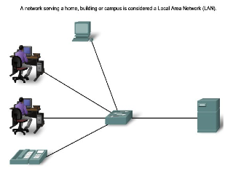

- Metropolitan Area Network (MAN)
A metropolitan area network (MAN) is a large computer network that usually spans a city or a large campus usually interconnects a number of local area networks (LANs) using a high-capacity backbone technology, such as fiber-optical links, and provides up-link services to wide area networks (or WAN) and the Internet. The network consists of various buildings interconnected via either wireless or fiber optics backbones.
The best-known example of a MAN is the cable television network available in many cities. In terms of geographic area MAN’s are larger than local-area networks (LANs), but smaller than wide-area networks (WANs). MAN’s are usually characterized by very high-speed connections using fiber optical cable or other digital media.

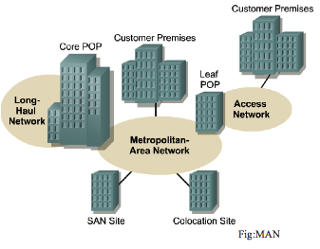

The Typical Characteristics of a MAN are:
- Confined to a larger area than a LAN and can range from 10km to a few 100km in length.
- Slower than a LAN but faster than a WAN.
- Operates at a speed of 1.5 to 150 Mbps.
- Expensive equipment.
- Moderate error rates.

- Wide Area Network (WAN)
WAN spans broader in geographical area than a local area network over public communication network. WANs interconnect LANs, which then provide access to computers or file servers in other locations. Because WANs connect user networks over a large geographical area, they make it possible for businesses to communicate across great distances. WANs allow computers, printers, and other devices on a LAN to be shared from distant locations. WANs provide instant communications across large geographic areas. Collaboration software provides access to real-time information and resources and allows meetings to be held remotely (skype).
It contains a collection of machines intended for running user (i.e., application) programs. These machines are called as hosts. The hosts are connected by a communication subnet. The hosts are owned by the customers (e.g., people's personal computers), whereas the communication subnet is typically owned and operated by a telephone company or Internet service provider. The job of the subnet is to carry messages from host to host, just as the telephone system carries words from speaker to listener. Separation of the pure communication aspects of the network (the subnet) from the application aspects (the hosts), greatly simplifies the complete network design. In most wide area networks, the subnet consists of two distinct components: transmission lines and switching elements. Transmission lines move bits between machines. They can be made of copper wire, optical fiber, or even radio links. In most WANs, the network contains numerous transmission lines, each one connecting a pair of routers. If two routers that do not share a transmission line wish to communicate, they must do this indirectly, via other routers. When a packet is sent from one router to another via one or more intermediate routers, the packet is received at each intermediate router in its entirety, stored there until the required output line is free, and then forwarded. A subnet organized according to this principle is called a store-and-forward or packet-switched subnet. Nearly all wide area networks (except those using satellites) have store-and-forward subnets. When the packets are small and all the same size, they are often called cells. The principle of a packet-switched WAN is so important. Generally, when a process on some host has a message to be sent to a process on some other host, the sending host first cuts the message into packets, each one bearing its number in the sequence. These packets are then injected into the network one at a time in quick succession. The packets are transported individually over the network and deposited at the receiving host, where they are reassembled into the original message and delivered to the receiving process.
WANs are designed to do the following:
- Operate over a large and geographically separated area
- Allow users to have real-time communication capabilities with other users
- Provide full-time remote resources connected to local services
- Provide e-mail, Internet, file transfer, and e-commerce service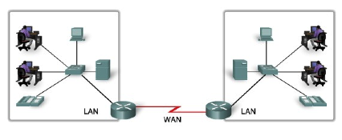
The Typical Characteristics of a WAN are:
- A WAN can range from 100km to 1000km and the speed between cities can vary from l.5 Mbps to 2.4 Gbps.
- WAN supports large number of computers and multiple host machines. Various segments of network are interconnected using sophisticated support devices like routers and gateways.
- Usually the speed is much slower than LAN speed.
- Highest possible error rate compared to LAN & MAN.

- Internet
The network formed by the co-operative interconnection of a large number of computer networks.
- Network of Networks
- No one owns the Internet
- Every person who makes a connection owns a slice of the Internet.
- There is no central administration of the Internet.
Internet is comprising of:
- A community of people: who use and develop the network.
- A collection of resources: that can be reached from those networks.
- A setup to facilitate collaboration: Among the members of the research and educational communities world wide.
- The connected networks use the TCP/IP protocols:
Important Internet applications:
- world wide web(WWW)
- File Transfer Protocol(FTP)
- Electronic Mail
- Internet Relay Chat
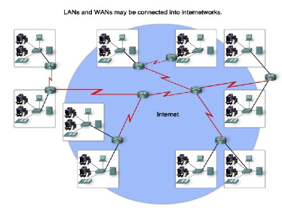

Comparison between LAN, MAN, and WAN
NETWORK | SIZE | TRANSMISSION MEDIA | MAXIMUM DISTANCE
Local Area Network | Confined to building or campus | Cable used | Covers up to 10km
Metropolitan Area Network | Network confined to city or town | Different hardware & transmission media are used | Covers the area of a city or town
Wide Area Network | Larger than MAN | Telephone lines, radio waves, leased lines or satellites. | Covers a number of cities or countries

LAN vs WAN vs MAN
LAN | WAN | MAN
Connects host within a relatively small geographical area.  - Same Building  - Same room  - Same Campus | Hosts may be widely dispersed.  - Across Campuses  - Across Cities/countries/continent | Confined to a larger area than a LAN and can range from 10km to a few 100km in length.  - Across cities
Faster | Slower | Slower than a LAN but faster than a WAN
Cheaper | Expensive | More expensive than LAN but cheaper than WAN
Under a control of single ownership. | Not under a control of a single person. | Not under a control of a single person.
Typical Speeds: 10 Mbps to 10 Gbps | Typical Speed: l.5 Mbps to 2.4 Gbps | Operates at a speed of 1.5 to 150 Mbps.

THE INTERNET
The Internet (or internet) is the global system of interconnected computer networks that uses the internet protocol suits (TCP/IP) to communicate between networks and devices.
HOME PAGE
A home page is a webpage that serves as the starting point of website. It is the default webpage that loads when you visit a web address that only contains a domain name. For example, visiting https://techterms.com will display the Tech Terms home page.

WEB PAGE
Web pages are what make up the World Wide Web. These documents are written in HTML (hypertext markup language) and are translated by your Web browser. Web pages can either be static or dynamic. Static pages show the same content each time they are viewed. Dynamic pages have content that can change each time they are accessed. These pages are typically written in scripting languages such as PHP, Perl, ASP, or JSP. The scripts in the pages run functions on the server that return things like the date and time, and database information. All the information is returned as HTML code, so when the page gets to your browser, all the browser has to do is translate the HTML.
Please note that a Web page is not the same thing as a Web site. A Web site is a collection of pages. A Web page is an individual HTML document. This is a good distinction to know, as most techies have little tolerance for people who mix up the two terms.

WEBSITE
A website, or Web site, is not the same thing as a Web page. Though the two terms are often used interchangeably, they should not be. So what's the difference? To put it simply, a Web site is a collection of Web pages. For example, Amazon.com is a Web site, but there are millions of Web pages that make up the site.
DOMAIN NAME
A domain name is a unique name that identifies a website. For example, the domain name of the Tech Terms Computer Dictionary is "techterms.com." Each website has a domain name that serves as an address, which is used to access the website.

EMAIL
Email, short for "electronic mail," is one of the most widely used features of the Internet, along with the web. It allows you to send and receive messages to and from anyone with an email address, anywhere in the world.
Email uses multiple protocols within the TCP/IP suite. For example, SMTP is used to send messages, while the POP or IMAP protocols are used to retrieve messages from a mail server. When you configure an email account, you must define your email address, password, and the mail servers used to send and receive messages. Fortunately, most webmail services configure your account automatically, so you only need to enter your email address and password. However, if you use an email client like Microsoft Outlook or Apple Mail, you may need to manually configure each account. Besides the email address and password, you may also have to enter the incoming and outgoing mail servers and enter the correct port numbers for each one.
WWW
Stands for "World Wide Web." It is important to know that this is not a synonym for the Internet. The World Wide Web, or just "the Web," as ordinary people call it, is a subset of the Internet. The Web consists of pages that can be accessed using a Web browser. The Internet is the actual network of networks where all the information resides. Things like Telnet, FTP, Internet gaming, Internet Relay Chat (IRC), and e-mail are all part of the Internet, but are not part of the World Wide Web. The Hyper-Text Transfer Protocol (HTTP) is the method used to transfer Web pages to your computer. With hypertext, a word or phrase can contain a link to another Web site. All Web pages are written in the hyper-text markup language (HTML), which works in conjunction with HTTP.

URL
Stands for "Uniform Resource Locator." A URL is the address of a specific webpage or file on the Internet. For example, the URL of the TechTerms website is "http://techterms.com." The address of this page is "http://techterms.com/definition/url" and includes the following elements:
- http:// – the URL prefix, which specifies the protocol used to access the location
- techterms.com – the server name or IP address of the server
- /definition/url – the path to the directory or file
While all website URLs begin with "http," several other prefixes exist. Below is a list of various URL prefixes:
- http – a webpage, website directory, or other file available over HTTP
- ftp – a file or directory of files available to download from an FTP server
- news – a discussion located within a specific newsgroup
- telnet – a Unix-based computer system that supports remote client connections
- gopher – a document or menu located on a gopher server
- wais - a document or search results from a WAIS database
- mailto - an email address (often used to redirect browsers to an email client)
- file - a file located on a local storage device (though not technically a URL because it does not refer to an Internet-based location)
You can manually enter a URL by typing it in the address bar of your web browser. For example, you might enter a website URL printed on a business card to visit the company's website. Most URLs, however appear automatically when you click on a link or open a bookmark. If the server name in the URL is not valid, your browser may display a "Server not found" error. If the path in the URL is incorrect, the server may respond with a 404 error.
NOTE: URLs use forward slashes to denote different directories and cannot contain spaces. Therefore, dashes and underscores are often used to separate words within a web address. If your browser produces an error when you visit a specific webpage, you can double-check the URL for typos or other errors. If you find an error, you can manually edit the URL and press Enter to see if it works.
ISP
Stands for "Internet Service Provider." An ISP provides access to the Internet. Whether you're at home or work, each time you connect to the Internet, your connection is routed through an ISP.
Early ISPs provided Internet access through dial-up modems. This type of connection took place over regular phone lines and was limited to 56 Kbps. In the late 1990s, ISPs began offering faster broadband Internet access via DSL and cable modems. Some ISPs now offer high-speed fiber connections, which provide Internet access through fiber optic cables. Companies like Comcast and Time Warner provide cable connections while companies like AT&T and Verizon provide DSL Internet access.
To connect to an ISP, you need a modem and an active account. When you connect a modem to the telephone or cable outlet in your house, it communicates with your ISP. The ISP verifies your account and assigns your modem an IP address. Once you have an IP address, you are connected to the Internet. You can use a router (which may a separate device or built into the modem) to connect multiple devices to the Internet. Since each device is routed through the same modem, they will all share the same public IP address assigned by the ISP.

The role of ISP in internet access among others:
- As a medium that provides services to connect to the internet.
- Connect customers to the nearest Internet gateway.
- Provides a modem for dial-up.
- Connecting an information service to a user of the World Wide Web (www).
- Allows a user to use the services of electronic mail (e-mail).
- Allows a user voice conversations via the internet.
- Gave place to the homepage.
- ISP do protection from the spread of the virus by applying antivirus systems for his customers.

CLOUD COMPUTING

Definition of Cloud Computing
Cloud computing is the use of off-site systems to help computers store, manage, process, and/or communicate information. These off-site systems are hosted on the cloud (or the internet) instead of on your computer or other local storage. They can encompass anything from email servers to software programs, data storage, or even increasing your computer’s processing power.
The “cloud” is a term that simply means “the internet.” Computing involves the infrastructures and systems that allow a computer to run and build, deploy, or interact with information. In cloud computing, this means that instead of hosting infrastructure, systems, or applications on your hard drive or an on-site server, you’re hosting it on virtual/online servers that connect to your computer through secure networks.

Examples of Cloud Computing
Cloud computing is the use of hardware or software off-site that is accessed over networks for computing needs. Examples of cloud computing depend on the type of cloud computing services being provided.
The main types of cloud computing include software as a service, platform as a service, and infrastructure as a service. Serverless computing, also known as function as a service (FaaS), is also a popular method of cloud computing for businesses.
- SaaS or Software as a Service. SaaS means instead of installing software on your computer, you access the platform online. Examples would include:
  - Square, which processes payments online
  - Google Apps such as Google Drive or Calendar
  - Slack, which allows collaboration and chat between other users
- IaaS or Infrastructure as a Service. IaaS provides infrastructure components such as servers, storage, networking, security, and moreover the cloud. Examples would include:
  - Dropbox, a file storage and sharing system
  - Microsoft Azure, which offers backup and disaster recovery services, hosting, and more
  - Rackspace, which offers data, security, and infrastructure services.
- PaaS or Platform as a Service. PaaS provides computing platforms such as operating systems, programming language execution environments, databases, and web servers. Examples would include:
  - Google App Engine and Heroku, which allow developers to develop and serve apps
- Serverless Computing. Serverless computing (also called simply “Serverless”) is simply using a server on the cloud. This offers more elasticity, easier maintenance, and is often more price effective than hosting servers on-site.
However, for many companies, additional examples of cloud computing services include:
- Virtual Machines
- Data Storage
- Backup & Disaster Recovery
- Increasing Bandwidth
- App Development Platforms
- Cloud-Based Servers
- Infrastructure Monitoring & Management
- Build, Host, & Deploy SaaS Services
IoT
The Internet of Things (IOT) describes the network of physical objects that are embedded with sensors, software and other technologies for the purpose of connecting and exchanging data with other devices and systems over the internet. These devices range from ordinary houhold objects to sophisticated industrial tools. With more than 7 billion connected IoT Devices today, experts are expecting this number to grow to 10 billion by 2020 and 22 billion by 2025. Oracle has a network of device partners.
What Technologies have made IoT possible?
- Access to low-cost power sensor technology
- Connectivity
- Cloud computing platforms
- Machine learning and analytics
- Conversational Artificial Intelligence (AI)

INDUSTRIAL IOT
Industrial IoT (IIoT) refers to the application of IoT technology in industrial settings, expecially with respect to instrumentation and control of sensors and devices that engage cloud technologies. Industries can achieve a new automation layer with it create new revenue and business models. IIoT is sometimes called the fourth wave of the industrial revolution, or industry 4.0.
The following are some common uses of IIoT
- Smart manufacturing
- Connected assets and preventive and predictive maintenance
- Smart power grids
- Smart cities
- Connected logistics
- Smart digital supply chains
The Industries that can benefit from IoT
- Manufacturing
- Automotive
- Transportation and logistics
- Retail
- Public sector
- Healthcare
- General safety across all industries

