Types of Annuities
Annuities can be classified according to how premiums are paid into the annuity, how premiums are invested, and when and how benefits are paid out.
KNOW THIS
Classification of annuities:
- Premium payment method: single premium vs. periodic
- When income payments begin: immediate vs. deferred
- How premiums are invested: fixed vs. variable
- Disposing of proceeds: pure life, annuity certain, or life refund annuity

1. Premium Payment Options
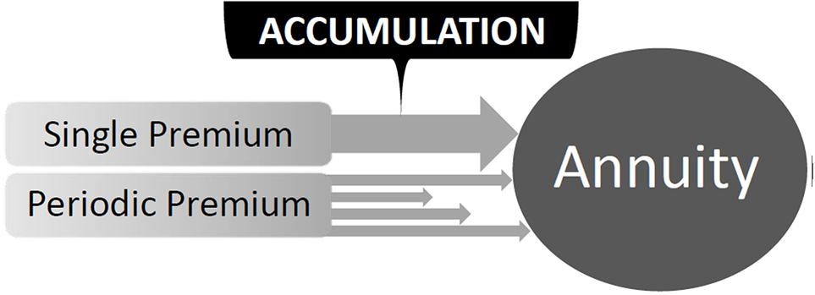
The first way to classify annuities can be based on how they can be funded (paid for). There are 2 options: a single premium (one-time lump-sum payment) or through periodic payments in which the premiums are paid in installments over a period of time. Periodic payment annuities can be either level premium, in which the annuitant/owner pays a fixed installment, or flexible premium, in which the amount and frequency of each installment varies.

2. When Benefits Begin - Immediate vs. Deferred Annuities
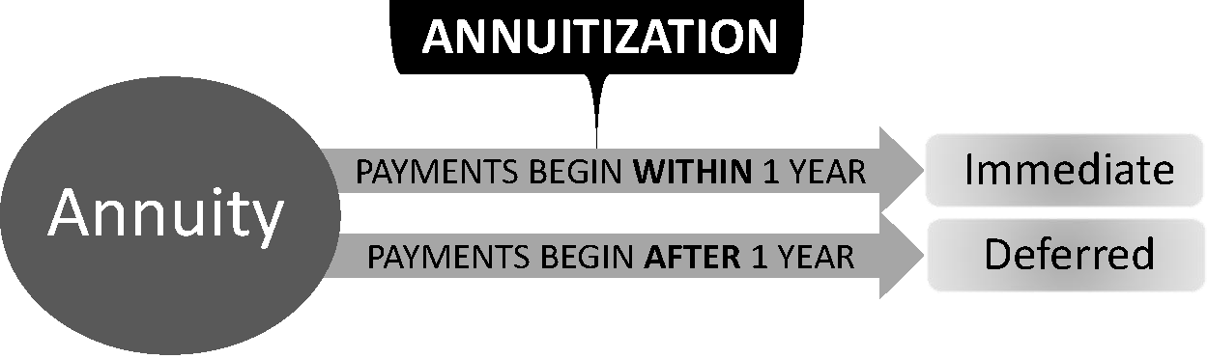
Annuities can also be classified according to when the income payments from the annuity begin. An immediate annuity is one that is purchased with a single, lump-sum payment and provides income payments that start within one year from the date of purchase. Typically, an immediate annuity will make the first payment as early as one month from the purchase date. Most commonly, this type of annuity is known as a Single Premium Immediate Annuity (SPIA).
A deferred annuity is an annuity in which the income payments begin sometime after one year from the date of purchase. Deferred annuities can be funded with either a single lump sum (Single Premium Deferred Annuities — SPDAs) or through periodic payments (Flexible Premium Deferred Annuities — FPDAs). Periodic payments can vary from year to year. The longer the annuity is deferred, the more flexibility for payment of premiums it allows.
KNOW THIS
An immediate annuity is purchased with a single premium. Income payments from a deferred annuity begin sometime after 1 year from the date of purchase.

Nonforfeiture
The nonforfeiture law stipulates that a deferred annuity must have a guaranteed surrender value that is available if the owner decides to surrender the annuity prior to annuitization (e.g., 100% of the premium paid, less any prior withdrawals and related surrender charges). However, a 10% penalty will be applied for early withdrawals (prior to age 59 ½).

Surrender Charges
The purpose of the surrender charge is to help compensate the company for loss of the investment value due to an early surrender of a deferred annuity.
A surrender charge is levied against the cash value, and is generally a percentage that reduces over time. A common surrender charge might be 7% the first year, 6% the second year, and 5%, 4%, 3%, 2%, 1%, and 0% respectively thereafter. Therefore, if the annuity is surrendered in the 8th year or after there would be no further surrender charge. At surrender, the owner gets the premium, plus interest (the value of the annuity), minus the surrender charge.
Example:
Assume that the annuity owner paid $700 in premium, which accumulated a total of $35 of interest, and a surrender charge is $70. If the annuity is surrendered prematurely, what will the annuity value be at surrender? The answer is $665.
($700 Premium + $35 Interest) - $70 Surrender Charge = $665 Value of the Annuity

3. Annuity Investment Options
Annuities may be classified as fixed or variable based on how the premium payments are invested.

Fixed Annuities
A fixed annuity provides the following features:
- Guaranteed minimum rate of interest to be credited to the purchase payment(s);
- Income (annuity) payments that do not vary from one payment to the next; and
- The insurance company guarantees the specified dollar amount for each payment and the length of the period of payments as determined by the settlement option chosen by the annuitant.
With fixed annuities, the annuitant knows the exact amount of each payment received from the annuity during the annuity period. This is called level benefit payment amount. A disadvantage to fixed annuities is that the purchasing power that they afford may be eroded over time due to inflation.

General Account Assets
Fixed annuity premiums are deposited into the life insurance company's general account. The general account is comprised mostly of conservative investments like bonds. These investments are secure enough to allow the insurance company to guarantee a specified rate of interest, as well as assure the future income payments that the annuity will provide.
KNOW THIS
In fixed annuities, the premiums are deposited in the company’s general account.

Interest Rate Guarantees (Minimum vs. Current)
In fixed annuities, the insurer bears the investment risk. Future interest rates actually paid by an insurer are based upon the performance of the insurance company's general account. However, the rate may not drop below a policy's guaranteed minimum (typically 3%). Should interest rates drop below this guaranteed rate, the insurer is obligated to pay the guaranteed rate amount.
During the accumulation phase, the insurer will invest the principal, or accumulation, and give the annuitant a guaranteed interest rate based on a minimum rate as specified in the annuity, or the current interest rate, whichever is higher. The minimum rate is the lowest rate that the principal can contractually earn.

Equity Indexed Annuities
Indexed (or equity indexed) annuities are fixed annuities that invest on a relatively aggressive basis to aim for higher returns. Like a fixed annuity, the indexed annuity has a guaranteed minimum interest rate (typically, 3 or 4%), which provides a guarantee for a certain rate of growth. At the end of the contract term, the annuity will be credited with the greater of the guaranteed minimum value or the current (indexed) value. The current interest rate that is actually credited is often tied to a familiar index like the Standard and Poor's 500.
Generally, the insurance companies reserve the initial returns for themselves but pay the excess to the annuitant. For example, the company may keep the first 4% earned for itself, but any accumulation in excess of 4% is credited to the annuitant's account. So if the interest earned is 12%, the company keeps 4% and credits the client’s account with 8%.
Equity indexed annuities are less risky than a variable annuity or mutual fund but are expected to earn a higher interest rate than a fixed annuity.

Variable Annuities
A variable annuity serves as a hedge against inflation, and is variable from the standpoint that the annuitant may receive different rates of return on the funds that are paid into the annuity. Listed below are the 3 main characteristics of variable annuities:
- Underlying Investment — the payments that the annuitant makes into the variable annuity are invested in the insurer's separate account, not their general account. The separate account is not part of the insurance company's own investment portfolio, and is not subject to the restrictions that are applicable to the insurer's own general account.
- Interest Rate — the issuing insurance company does not guarantee a minimum interest rate.
- License Requirements — a variable annuity is considered a security and is regulated by the Securities Exchange Commission (SEC) in addition to state insurance regulations. An agent selling variable annuities must hold a securities license in addition to a life insurance license. Agents or companies that sell variable annuities must also be properly registered with FINRA.
Variable premiums purchase accumulation units in the fund, which is similar to buying shares in a Mutual Fund. Accumulation units represent ownership interest in the separate account. Upon annuitization, the accumulation units are converted to annuity units. The income is then paid to the annuitant based on the value of the annuity units. The number of annuity units received remains level, but the unit values will fluctuate until actually paid out to the annuitant.
FEATURES | FIXED ANNUITY | VARIABLE ANNUITY
Interest Rate | Guaranteed by insurer | No guarantee
Underlying Investment | General account  (safe, conservative) | Separate account  (equities, no guarantee)
License Needed | Life insurance | Life insurance PLUS securities
Expenses | Guaranteed | Guaranteed
Income Payment | Guaranteed | No guarantee

4. Life Contingency Options - Pure Life vs. Life with Guaranteed Minimum
The life annuity will pay a specific amount for the remainder of the annuitant’s life. With pure life, also known as life-only or straight life, this payment ceases at the annuitant's death (no matter how soon in the annuitization period that occurs). This option provides the highest monthly benefits for an individual annuitant. Under this option, while the annuity payments are guaranteed for the lifetime of the annuitant, there is no guarantee that all the proceeds will be fully paid out.
Under the life with guaranteed minimum settlement option, if the annuitant dies before the principal amount has been paid out, the remainder of the principal amount will be refunded to the beneficiary. This option is also called refund life. It guarantees that the entire principal amount will be paid out.
KNOW THIS
Pure life annuity provides the highest monthly benefit, but there is no guarantee that the entire principal will be paid out.
There are two types of refund life annuities:
- Cash refund — when the annuitant dies, the beneficiary receives a lump-sum refund of the principal minus benefit payments already made to the annuitant. The cash refund option does not guarantee to pay any interest.
- Installment refund — when the annuitant dies, the beneficiary will continue to receive guaranteed installments until the entire principal amount has been paid out.
Note, however, that any unpaid annuity benefits following the death of an annuitant are taxable when paid to the beneficiary.
Life with period (term) certain is another life contingency payout option. Under this option, the annuity payments are guaranteed for the lifetime of the annuitant, and for a specified period of time for the beneficiary. For example, a life income with a 20-year period certain option would provide the annuitant with an income while the annuitant is living (for the entire life). If, however, the annuitant dies shortly after payments begin, the payments will be continued to a beneficiary for the remainder of the 20-year period.

Single Life vs. Multiple Life
Single life annuities cover one life, and annuity payments are made with reference to one life only. Contributions can be made with a single premium or on a periodic premium basis with subsequent values accumulating until the contract is annuitized.
Multiple life annuities cover 2 or more lives. The most common multiple life annuities are joint life, and joint and survivor.

Joint Life
Joint life is a payout arrangement where two or more annuitants receive payments until the first death among the annuitants, and then payments stop.

Joint and Survivor
The joint and survivor arrangement is a modification of the life income option in that it guarantees an income for two recipients that neither can outlive. Although it is possible for the surviving recipient(s) to receive payments in the same amount as the first recipient to die, most contracts provide that the surviving recipients will receive a reduced payment after the first recipient dies. Most commonly, this option is written as “joint and ½ survivor” or "joint and ²/₃ survivor,” in which the surviving beneficiary receives ½ or ²/₃ of what was received when both beneficiaries were alive. This option is commonly selected by a couple in retirement. As with the life income option, there is no guarantee that all the proceeds will be paid out if both beneficiaries die shortly after the installments begin.

5. Guarantee of Minimum Total Benefit
Annuity payment options specify how annuity funds are to be paid out. They are very similar to the settlement options used in life insurance that determine how the policy proceeds are distributed to the beneficiaries.

Annuity with Period Certain
In contrast with life contingency benefit payment options, annuities certain are short-term annuities that limit the amounts paid to a certain fixed period or until a certain fixed amount is liquidated.

Fixed Period
With fixed-period installments, the annuitant selects the time period for the benefits, and the insurer determines how much each payment will be, based on the value of the account and future earnings projections. This option pays for a specified amount of time only, whether or not the annuitant is living.
KNOW THIS
The fixed-period option pays for a specific time only, whether or not the annuitant is living.

Fixed Amount
With fixed-amount installments, the annuitant selects how much each payment will be, and the insurer determines how long the benefits will be paid by analyzing the value of the account and future earnings. This option pays a specific amount until funds are exhausted, whether or not the annuitant is living.

