Combination Policies and Variations in the Basic Forms
In addition to the traditional forms of life insurance and the interest-sensitive policies, insurers have developed a variety of other policies or insurance plans which are primarily the result of combining or packaging two or more coverages. Most of these plans use a combination of permanent insurance and term insurance to fill the insurance needs of an individual or multiple individuals.

1. Family Policy
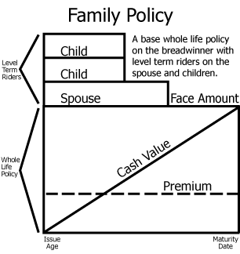
A family protection or family policy combines whole life with term insurance to cover family members in a single policy, providing coverage on every member of a family. The family policy typically provides whole life insurance on the breadwinner of the family and convertible term insurance on the other family members. The spouse has the opportunity to convert their term coverage to permanent coverage up until age 65. Children are automatically covered after birth for a specified period of time, usually 30 or 31 days. To continue coverage for the newborn after the initial period, the parents must inform the insurer of the birth within that time period. The children may convert their term coverage to permanent coverage when they turn the age of 21, or the maximum age for coverage as a dependent that is stated in the policy, without evidence of insurability.

2. Family Income Policy
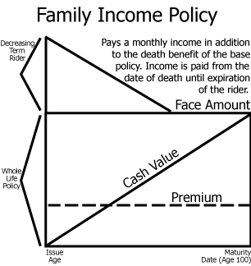
The Family Income Policy is a combination of decreasing term insurance and whole life insurance on the breadwinner of the family. The policy is designed to provide an income period which begins from the effective date of the policy and commonly runs for twenty years, but it is also issued for ten years or even to age 65. This income period is funded with decreasing term insurance. If the insured should die any time during the income period, the term coverage will provide the surviving family with a monthly income for the remainder of the income period. At the end of the income period, the face amount of the whole life coverage is paid to the beneficiary. If the insured dies after the income period, only the whole life portion will be paid to the beneficiary. This type of policy provides a family with a monthly income upon the death of the insured while maintaining permanent coverage until the end of the income payments.
For example, if one purchases a 20-year family income policy and dies five years after the policy is issued, the decreasing term portion of the plan would provide his or her surviving family with a monthly income for 15 years. At the end of the 15-year period, the whole life death benefit would then be paid to the family.

3. Joint Life
Joint life is a single policy that is designed to insure two or more lives. Joint life policies can be in the form of term insurance or permanent insurance. The premium for joint life would be less than for the same type and amount of coverage on the same individuals. It is more commonly found as joint whole life, which functions similarly to an individual whole life policy with two major exceptions:
- The premium is based on a joint average age that is between the ages of the insureds; and
- The death benefit is paid upon the first death only.
A premium based on joint age is less than the sum of 2 premiums based on individual age, so it is common to find joint life policies issued on spouses. This is particularly so if the need for insurance is such that it does not extend beyond the first death. Joint life policies are used when there is a need for two or more persons to be protected; however, the need for the insurance is no longer present after the first of the insureds dies.
For example, a married couple purchasing a house may use a Joint Life policy for mortgage protection if both spouses work and earn close to the same amount of income. If one spouse dies, the insurance pays the mortgage for the surviving spouse.
Joint Life is also used to insure the lives of business partners in the funding of a buy-sell agreement and other business life needs. A buy-sell is a business continuation agreement that determines what will be done with the business in the event that an owner dies or becomes disabled.
KNOW THIS
Premium rates on a joint life policy are determined by averaging the ages of both insureds.

4. Survivorship Life (Second to Die)
Survivorship life (also referred to as "second-to-die" or "last survivor" policy) is much the same as joint life in that it insures two or more lives for a premium that is based on a joint age. The major difference is that survivorship life pays on the last death rather than upon the first death. Since the death benefit is not paid until the last death, the joint life expectancy in a sense is extended, resulting in a lower premium than that which is typically charged for joint life, which pays upon the first death. This type of policy is often used to offset the liability of the estate tax upon the death of the last insured.
KNOW THIS
Joint life = first to die; survivorship life = second to die (last survivor).

5. Jumping Juvenile Life
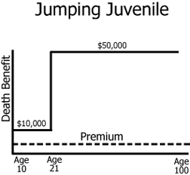
Juvenile life insurance is, as the name implies, any life insurance written on the life of a minor. A common juvenile policy is known as the “jumping juvenile” policy because the face amount increases at a predetermined age, often age 21. The face amount jumps, but the premium remains level.

6. Double or Triple (Multiple) Protection
Multiple protection policies combine permanent insurance with level term insurance for the multiple protection period. These policies pay double or triple the face amount if the insured dies during a specified period, which is usually determined as a number of years (such as 10 or 20) or to a specified age (such as to age 65). If the insured dies after the specified period, the policy only pays the face amount. For example, a double protection policy of $100,000 written to age 65 would decrease the face amount to $50,000 after the insured's age 65.

7. Term Riders
Term riders allow for an additional amount of temporary insurance to be provided on the insured, without the need to issue another policy. They are usually attached to a whole life policy to provide greater protection at a reduced cost.

8. Limited Benefit
These policies cover certain expenses from specifically named illnesses, injuries or circumstances. As an example, cancer policies pay benefits for the actual treatment of cancer and cover no other illness. Some also pay benefits for conditions or diseases caused or aggravated by cancer and/or its treatment.

