Policy Provisions
While there is no "standard" policy form in life insurance, the standard policy provisions adopted by the National Association of Insurance Commissioners (NAIC) create uniformity among life insurance policies.

1. Entire Contract
The entire contract provision stipulates that the policy and a copy of the application, along with any riders or amendments, constitute the entire contract. No statements made before the contract was written can be used to alter the contract. Neither the insurer nor the insured may change policy provisions once the policy is in effect without both parties agreeing to it and the change being affixed to the contract.
KNOW THIS
Entire contract = policy + copy of application + any riders or amendments

2. Insuring Clause
The insuring clause (or insuring agreement) sets forth the basic agreement between the insurer and the insured. It states the insurer’s promise to pay the death benefit upon the insured’s death. The insuring clause usually is located on the policy face page, and also defines who the parties to the contract are, how long coverage is in force, and the type of loss insured against.

3. Free Look
This provision allows the policyowner 10 days from receipt to look over the policy and if dissatisfied for any reason, return it for a full refund of premium. The free-look period starts when the policyowner receives the policy (policy delivery), not when the insurer issues the policy. Certain life insurance transactions, such as replacement, may require a longer free-look period.
Example:
Life insurance agent Bob delivers a policy to his new client Marie on December 10th. Bob will tell Marie that she has 10 days to look over the policy and return it to the company for a full refund if she is dissatisfied. On the 17th, Marie decides to return the policy and mails it to the insurance company. The company must then refund her Marie her premium since it was within the 10 day free-look period.

4. Owner's Rights
The parties to the insurance contract are the insurer, the policyowner, the insured, and the beneficiary. The policyowner and the insured may be the same person or different persons. Regardless, only the policyowner has the ownership rights under the policy, and not the insured or the beneficiary. Among the ownership rights are naming and changing the beneficiary, receiving the policy's living benefits, selecting a benefit payment option, and assigning the policy.
The policyowner has the responsibility of paying the policy premiums, and is also the person who must have an insurable interest in the insured at the time of application for the insurance. When the owner and the insured are not the same person, the insurance arrangement is referred to as the third-party ownership.
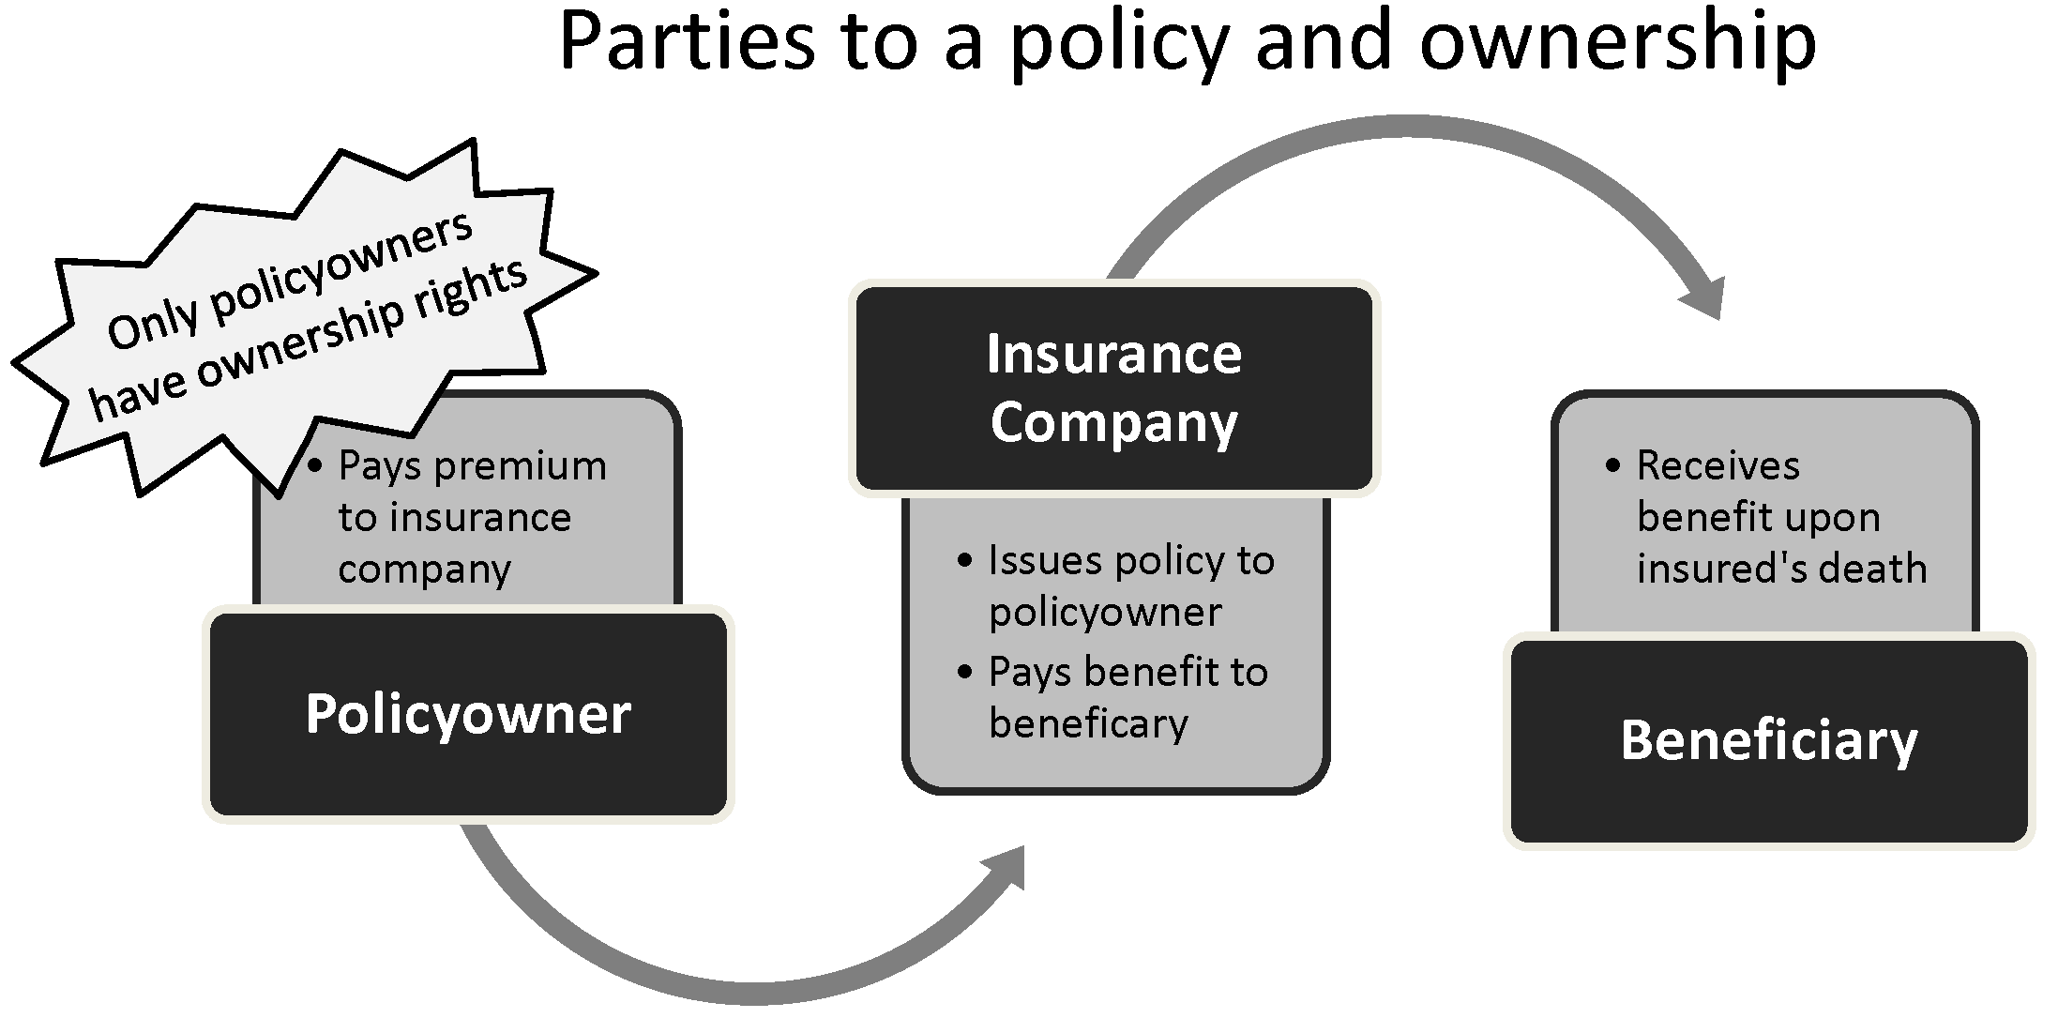

5. Assignment
The policyowner of a life insurance policy has the right to transfer partial or complete ownership of the policy to another person without the consent of the insurer. However, the owner must notify the insurer in writing of the assignment. Without a written notice, the insurer may not recognize the assignment and would not assume responsibility for its validity. The company's major concern is paying the claim twice. Transfer of the life insurance policy does not change the insured or amount of coverage; it only changes who has the policy ownership rights.
The assignment provision specifies the policyowner's right to assign (transfer rights of ownership) the policy. The policyowner must advise the insurer in writing of the assignment. There are 2 types of policy assignment:
- Absolute Assignment – involves transferring all rights of ownership to another person or entity. This is a permanent and total transfer of all the policy rights. The new policyowner does not need to have an insurable interest in the insured.
- Collateral Assignment – involves a transfer of partial rights to another person. It is usually done in order to secure a loan or some other transaction. A collateral assignment is a partial and temporary assignment of some of the policy rights. Once the debt or loan is repaid, the assigned rights are returned to the policyowner.
- KNOW THIS
- Absolute assignment is the complete and permanent transfer of ownership rights; collateral assignment is the partial and temporary transfer of rights.
- Example:
- Aunt Edna was just diagnosed with having the beginning stages of Alzheimer's disease. Aunt Edna makes a decision to assign the ownership rights of her life insurance policy over to her nephew, Robert, permanently. This is called absolute assignment, and gives her nephew all rights to the policy as the owner.

6. Beneficiaries
- The beneficiary is the person or interest to which the policy proceeds will be paid upon the death of the insured. The beneficiary may be a person, class of persons (sometimes used with children of the insured), the insured's estate, or an institution or other entity such as a foundation, charity, corporation or trustee of a trust. Trusts are commonly used in conjunction with beneficiary designations to manage life insurance proceeds for a minor or for estate tax purposes (although naming a trust as beneficiary does not avoid estate taxes).
- The beneficiary does not have to have an insurable interest in the insured. In addition, the policyowner does not have to name a beneficiary in order for the policy to be valid.

Designations

Individuals
- The owner of a life insurance policy may name any individual as a beneficiary for the policy proceeds. The owner may name more than one individual, in which case the individual beneficiaries will split the benefit by the percentage specified in the policy.
- Benefits designated to a minor will either be paid to the minor's guardian, or paid to the trustee of the minor if the trust is the named beneficiary, or paid as directed by a court. The guardian and trustee can be the same person. It is generally accepted not to be a good practice to have life insurance benefits payable to a minor.

Classes
- A class of beneficiary is using a designation such as "my children." This term can be vague if the insured has been married more than once, has adopted children, or has children out of wedlock. An example of a class that is less vague is "children of the union of Jane Smith and James Smith." Many insurers encourage the insured to name each child specifically and to state the percentage of benefit they are to receive.
- When naming beneficiaries, it is most prudent to be specific by naming each individual and by designating the exact amount to be given for that individual. Two class designations are available for use when an insured chooses to "group" the beneficiaries: per capita and per stirpes. Per capita, meaning by the head, evenly distributes benefits among the living named beneficiaries. Per stirpes, meaning by the bloodline, distributes the benefits of a beneficiary who died before the insured to that beneficiary's heirs.
- For example, Bryan purchased a $90,000 life insurance policy. He named his three sons, Quentin, Steve, and Patrick, as beneficiaries for equal shares. Quentin has two children of his own, Bob and Lou. Steve and Patrick are both married but have no children. Unfortunately, Quentin predeceases Bryan.
- If Bryan selected the per capita designation, which means "by the head," with Quentin gone, only 2 named beneficiaries remain. Steve & Patrick each will receive $45,000 ($90,000 divided by 2). Quentin's children would not receive any benefits, since they were not named as beneficiaries.
- If Bryan selected the per stirpes designation, which means "by the bloodline," Steve and Patrick would receive $30,000 each and Quentin's sons would share his allotment equally at $15,000 each.

Estates
- If none of the beneficiaries is alive at the time of the insured’s death, or if no beneficiary has been named, the insured’s estate will automatically receive the proceeds of a life insurance policy. The death benefit of the policy may be included in the insured's taxable estate if this occurs.
- KNOW THIS
- If NO beneficiary is named, policy proceeds go to the insured’s estate.

Trusts
- Trusts are commonly established for minors, or to create a scholarship fund. Trusts can be used for estate planning purposes, and when used properly, can keep life insurance death proceeds out of the insured’s taxable estate. They are, however, expensive to administer.

Succession - Primary and Contingent
- The beneficiary designation can provide for three levels of priority or choice. In the event that the first beneficiary predeceases the insured, the second (or sometimes third) level in the succession of beneficiaries will be entitled to the death proceeds. Each level in the succession of beneficiaries is only eligible for the death benefit if the beneficiary(s) in the level(s) above them has died before the insured.
- The primary beneficiary has first claim to the policy proceeds following the death of the insured. The policyowner may name more than one primary beneficiary, as well as how the proceeds are to be divided.
- The contingent beneficiary (also referred to as secondary or tertiary beneficiary) has second claim in the event that the primary beneficiary dies before the insured. Contingent beneficiaries do not receive anything if the primary beneficiary is still living at the time of the insured’s death.
- 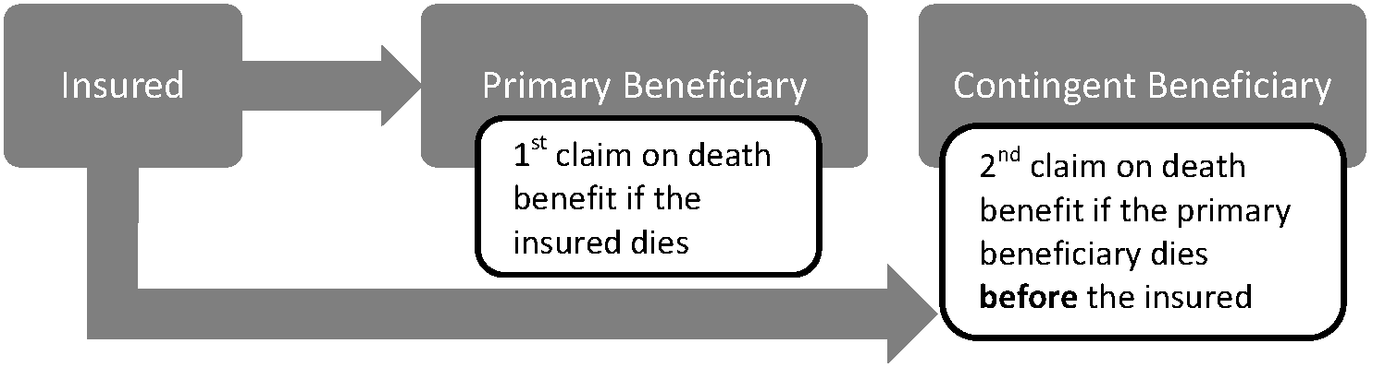

Revocable and Irrevocable
- Beneficiary designations may be either revocable or irrevocable. The policyowner, without the consent or knowledge of the beneficiary, may change a revocable designation at any time. An irrevocable designation may not be changed without the written consent of the beneficiary. Irrevocable beneficiaries have a vested interest in the policy; therefore, the policyowner may not exercise certain rights without the consent of the beneficiary. In addition to being unable to change the beneficiary designation, the policyowner cannot borrow against the policy’s cash value (as this would decrease the policy face value until repaid) or assign the policy to another person without the beneficiary's agreement.
- Example:
- John names his wife Michele as a revocable beneficiary on his policy; therefore, John can remove his wife as the beneficiary if he chooses to do so. He also retains the ability to apply all of his ownership rights as normal. If John had named his wife Michele as an irrevocable beneficiary, John would not be able to remove her as the beneficiary without her permission. Also, if John wants to enforce any of his ownership rights such as taking out a loan or assigning his policy, he needs to get Michele's permission for that too. It is only at the time of Michele's death that John will be able to have complete control over his policy again.

Methods of Changing the Beneficiary
- While changing the beneficiary through the recording or filing method, the policyowner completes a form with the change and submits it to the insurance company. In the endorsement method, the policyowner is required to send the request for change with the contract to the home office of the insurer. The home office will have to approve and make the change.

Common Disaster
- If the insured and the primary beneficiary die at approximately the same time from a common accident with no clear evidence as to who died first, a problem may arise in identifying which party is eligible for the death benefit. The Uniform Simultaneous Death Law has been adopted by most states to address this problem, and to protect the policyowner's original intent, as well as to protect the contingent beneficiary. This law stipulates that if the insured and the primary beneficiary died in the same accident and there is no sufficient evidence to show who died first, the policy proceeds are to be distributed as if the primary beneficiary died first.
- The Common Disaster Clause, when added to a policy, provides that if the insured and the primary beneficiary died in a common disaster (even if the beneficiary outlived the insured by a specified number of days), it is presumed that the primary beneficiary died first, so the proceeds will be paid to either the contingent beneficiary or to the insured's estate, if no contingent beneficiary is designated. Most insurers specify a certain period of time, usually 14 to 30 days, in which the primary beneficiary's death must occur in order for the Common Disaster Clause to apply. As long as the beneficiary dies within this specified period of time following the death of the insured, it will still be interpreted that the beneficiary died first. The intent is to fulfill the wishes of the policyowner in regard to payment of proceeds to beneficiaries.
- Example:
- James had a life insurance policy that included a Common Disaster Clause. James was the insured; his wife Maggie was named the primary beneficiary, and his son Ben was named the contingent beneficiary. James and Maggie got in a terrible car accident, and James died immediately, but Maggie died 4 days later from her injuries from the same accident. Because the policy included the Common Disaster Clause, the death benefit would be paid to Ben, the contingent beneficiary, as if Maggie, the primary beneficiary, had died before James, the insured.
- KNOW THIS
- Common disaster clause protects the contingent beneficiary.

7. Premium Payment
The policy stipulates when the premiums are due, how often they are to be paid (monthly, quarterly, semiannually, or annually) and to whom. If the insured dies during a period of time for which the premium has been paid, the insurer must refund any unearned premium along with the policy proceeds. The payment of premium provision also stipulates that premiums must be paid in advance.

Modes
The policy stipulates when the premiums are due, how often they are to be paid (monthly, quarterly, semiannually, or annually) and to whom.
The premium mode is the manner or frequency that the policyowner pays the policy premium. Most policies allow for annual, semi-annual, quarterly, or monthly payments. If the insured selects a premium mode other than annual, there will be an additional charge to offset the loss of earnings since the company does not have the entire premium at once, and there are additional administrative costs associated with more frequent billing.
If the insured dies during a period of time for which the premium has been paid, the insurer must refund any unearned premium along with the policy proceeds.

Effect of Nonpayment
A policy may be terminated because of nonpayment of premiums. This is known as a lapsed policy.

Level or Flexible
Most life insurance policies have a level premium, which means that the premium remains the same throughout the duration of the contract. Flexible premium policies allow the policyowner to increase or decrease the premium during the policy period.

Expense Charge

Mortality
Mortality is the ratio of the number of deaths in a specific population over a certain amount of time versus the number of living people in that population. Mortality tables, used by insurers, indicate the number of individuals within a specified group of individuals (e.g., males, females, smokers, nonsmokers) starting at a certain age, who are expected to be alive at a succeeding age. In other words, these tables help the insurers predict the expectation of life and the probability of death for a given group.

Interest
Because premiums are paid before claims are incurred, insurance companies invest a large portion of the premiums in an effort to earn interest on these funds (invested in bonds, stocks, or mortgages). The interest earnings help insurers reduce the premium rates for policyowners.

Expense
The insurer collects the mortality charge to pay the policy face amount if an insured dies. Since the insurer earns interest on the premiums it collects, the expected interest is subtracted from the mortality cost to arrive at the net premium. Then, the insurer adds its expected operating costs (underwriting, overhead and commissions) to calculate the gross premium that the insured pays.
Another way to view this formula is net premium plus expenses (loading) equals the gross premium.
- Mortality - Interest = Net Premium
- Net Premium + Expense (loading) = Gross Premium
- Mortality – Interest + Expense (loading) = Gross Premium
Calculation Example:
Assume that
$500 Mortality cost |  | $400 Net premium
- $100 Interest |  | + $200 Operating cost
$400 Net Premium | therefore, | $600 Gross Premium
Front-end load refers to commissions or sales charges that apply at the time of the initial purchase of an insurance policy or annuity. Rear-end (or back-end) load is a sales charge applied at the time of a sale, transfer or withdrawal from an annuity, a life insurance policy, or a security.

8. Grace Period
The grace period is the period of time after the premium due date that the policyowner has to pay the premium before the policy lapses (usually 30 or 31 days, or one month). The purpose of the grace period is to protect the policyholder against an unintentional lapse of the policy. If the insured dies during this period, the death benefit is payable; however, any unpaid premium will be deducted from the death benefit.
KNOW THIS
Grace periods protect policyholders from losing insurance coverage if they are late on a premium payment.

9. Misstatement of Age or Gender
Because the age and gender of an insured are important for determining the premium that will be charged for a life insurance policy, a provision which allows the insurer to adjust the policy at any time due to a misstatement of age or gender is included in the policy. If the applicant's age or gender was misstated on the application, in the event of a claim, the insurer is allowed to adjust the benefits to an amount that the premium at the correct age or gender would have purchased. The proceeds calculations should be based on the insurer's rate at the date of policy issue.
KNOW THIS
Misstatement of age on the application will result in adjustment of premiums or benefits.
Example:
Mark said he was age 30 on a life insurance policy, but his true age was 40. At the time of Mark's death the insurance company learned of Mark's true age. Therefore, when the insurance paid the death benefit to his beneficiary, the company adjusted the benefit that was due because of the age difference.

10. Reinstatement
The reinstatement provision allows a lapsed policy to be put back in force if reinstated within a specified maximum time limit after the policy has lapsed. Evidence of insurability is usually required. The policyowner is also required to pay all back premiums plus interest, and any outstanding loans with interest. The advantage of reinstating a lapsed policy, as opposed to purchasing a new one, is that the policy will be restored to its original status, and retain all the values that were established at the insured's issue age.
Note that a policy that has been surrendered cannot be reinstated.

11. Incontestability
The incontestability clause prevents an insurer from denying a claim due to statements in the application after the policy has been in force for 2 years, even if there has been a material misstatement of facts or concealment of a material fact. During the first 2 years of the policy, an insurer may contest a claim if the insurer feels that inaccurate or misleading information was provided in the application. The incontestability period does not apply in the event of nonpayment of premiums; it also does not usually apply to statements relating to age, sex or identity.

12. Conversion and Change of Plan
Conversion privilege in individual life insurance policies allows the policyowner to elect to have a new policy issued prior to the expiration of an existing policy. Most commonly, a conversion right is exercised when the policyowner converts the term policy to a cash-value permanent policy.
Change of plan provision allows the policyowner to change the policy form, usually at a higher premium rate. Proof of insurability is not required. Some policies permit a change to a lower premium rate plan, in which case the insurer will require proof of insurability.

13. Excess Interest
The term excess interest refers to the difference between the interest rate guaranteed by the insurance contract and the actual interest rate paid on the proceeds by the insurance company. This provision is very important to a policyowner since it will directly affect the size of the cash value. Excess interest will vary from year to year depending on the financial market conditions and the returns on the investment.

14. Policy Loans
The policy loan option is found only in policies that contain cash value. The policyowner is entitled to borrow an amount equal to the available cash value. Any outstanding loans, and accrued interest, will be deducted from the policy proceeds upon the insured’s death. The policy will not lapse with an outstanding policy loan unless the amount of the loan and accrued interest exceeds the available cash value. However, the insurer must provide 30 days' written notice to the policyowner that the policy is going to lapse. Insurance companies may defer a policy loan request for up to 6 months, unless the reason for the loan is to pay the policy premium. Policy loans are not subject to income taxation.
KNOW THIS
Policy loans are ONLY available in policies that have cash value (whole life).
Interest rates for policy loans may be either fixed or variable. A fixed interest rate is usually a set percentage per year, and will not change during the policy period. A variable interest rate will fluctuate based on changes in an underlying interest rate index (such as Published Monthly Average), and must be calculated at regular intervals.

Automatic Premium Loans
The automatic premium loan provision is not required, but is commonly added to contracts with a cash value at no additional charge. This is a special type of loan that prevents the unintentional lapse of a policy due to nonpayment of the premium. For example, a loan against the policy cash value for the amount of premium due is automatically generated by the insurer when the policyowner has not paid the premium by the end of the premium-paying grace period. It is a loan for which the insurer will charge interest. If the loan and interest are not repaid and the insured dies, then it will be subtracted from the death benefit. While the insurer may defer requests for other loans for a period of up to 6 months, loan requests for payment of due premiums must be honored immediately.
Usually, the policyowner must specifically elect this provision in writing to make it effective.

15. Exclusions
Exclusions are the types of risks the policy will not cover. Certain exclusions are standard for all policies, while others are attached to the policy as an exclusion rider. The most common exclusions found in life insurance policies are aviation, hazardous occupation, and war and military service.
Aviation — Most life insurance will cover an insured as a fare-paying passenger or a pilot on a regularly scheduled airline, but will exclude coverage for noncommercial pilots, or require an additional premium for the coverage.
Hazardous Occupations or Hobbies — If the insured is engaged in a hazardous occupation or participates in hazardous hobbies (such as skydiving or auto racing), death that results from the hazardous occupation or hobby may be excluded from coverage. The underwriter also has the option of charging a higher premium for insuring these risks.
War or Military Service — Most life insurance policies issued today do not exclude military service. However, there are actually two different types of exclusions that may be used to limit the death benefit if the insured dies as a result of war, or while serving in the military. The status clause excludes all causes of death while the insured is on active duty in the military. The results clause only excludes the death benefit if the insured is killed as a result of an act of war (declared or undeclared).

Suicide Exclusion
The suicide provision in life insurance policies protects the insurers from individuals who purchase life insurance with the intention of committing suicide. Insurance policies usually stipulate a period of time during which the death benefit will not be paid if the insured dies by suicide. If the insured dies by suicide within 2 years following the policy effective date (issue date), the insurer's liability is limited to a refund of premium. If the insured dies by suicide after the 2-year period, the policy will pay the death proceeds to the designated beneficiary the same as if the insured had died of natural causes.
LIFE POLICY  STANDARD PROVISIONS | CHARACTERISTICS
Entire Contract | Policy (with riders and amendments) + copy of the application
Insuring Agreement | Basic agreement between the insurer and the insured
Ownership | Policyowner has ownership rights
Assignment | Absolute or collateral
Right to Examine/Free Look | 10 days to return the policy for a full refund of premium
Grace Period | 31 days after premium is due to prevent policy lapsing
Misstatement of Age or Gender | Death benefit is adjusted to the amount according to the right age or gender at policy issue
Reinstatement | Specified number of years to reinstate a lapsed policy with proof of insurability
Incontestability | 2 years for the company to contest misstatements of the application
Conversion | Policyowner may elect to have a new policy issued prior to the expiration of an existing policy
Excess Interest | Difference between the interest rate guaranteed by the insurance contract and the actual interest rate paid on the proceeds by the insurer
Exclusions/Suicide | Aviation, hazardous occupation/hobbies, and war or military service; suicide is excluded within a specified time period

