InsightTrace AI – RAG – Flash 2.5
Document-Grounded Insights & Recommendations Engine

Project Description:
Businesses accumulate large volumes of unstructured documents — quarterly financial reports, supplier contracts, warranty logs, and customer feedback — but struggle to convert that scattered information into reliable, actionable business decisions. Manually reviewing every document to find supporting evidence is slow, inconsistent, and difficult to trust at scale.
InsightTrace AI addresses this by transforming raw business documents into verified, citable evidence, identifying recurring patterns and anomalies across that evidence, synthesizing the findings into clear plain-language insights, and generating data-driven, defensible recommendations — with every output traceable back to the exact source passage that supports it. The platform is built entirely with Flask, Jinja2, and hand-written CSS on a strict zero-JavaScript and zero-JSON foundation, persists all ingested evidence in SQLite, and is architected around a Google Gemini Flash 2.5 retrieval-augmented-generation (RAG) pipeline, with a scikit-learn TF-IDF and cosine-similarity engine currently powering semantic retrieval and a deterministic, rule-based synthesizer producing the grounded patterns, insights, and recommendations.

Scenarios
Scenario 1: A business analyst uploads a batch of quarterly reports, a supplier contract, and RMA logs, then asks in plain language where the business is losing revenue. The system chunks and verifies each document, retrieves the most relevant passages by cosine similarity, and detects a recurring pattern — a specific hardware line with a return rate climbing from 2.4% to 8.9% across three quarters. It generates a grounded insight explaining the $1.42M quarterly revenue loss, citing the exact report pages behind it, and recommends auditing the responsible supplier immediately.
Scenario 2: A procurement lead asks a question that touches on contractual obligations rather than financial trends. InsightTrace AI's evidence retrieval surfaces the supplier agreement's defect-indemnity clause, recognizes the contract-anomaly pattern, and confirms that the recorded failure rate exceeds the contractual ceiling by 493% — automatically citing the clause number and recommending that the customer invoke its audit and cost-recovery rights.
Scenario 3: An operations manager uploads mixed media — a supplier contract PDF, a customer RMA call recording, and microscope inspection photos of a failed component. The multi-modal ingestion pipeline extracts text, transcribes audio, and reads visual diagnostic notes from each file type, storing every extracted passage as independently verifiable evidence before it is ever used in an answer.
Scenario 4: A user asks a question with no relevant supporting material yet in the workspace. Rather than fabricate an answer, the semantic retrieval engine returns a similarity score below its sufficiency threshold, and the system explicitly reports insufficient evidence and recommends uploading the relevant documentation — preserving the platform's zero-hallucination guarantee.

Technical Architecture:
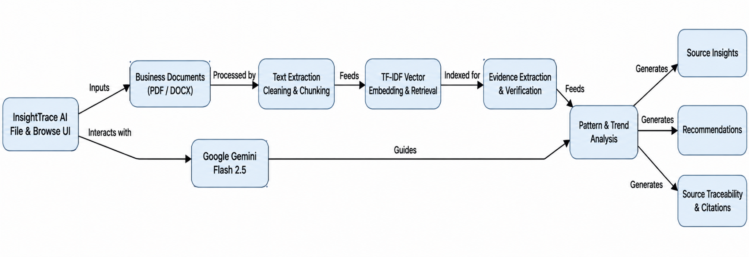
Description: This architecture shows how InsightTrace AI processes business documents through text extraction, cleaning, chunking, TF-IDF retrieval, and evidence verification.Google Gemini Flash 2.5 supports pattern and trend analysis to generate source insights, recommendations, and traceable citations.

ER Diagaram:
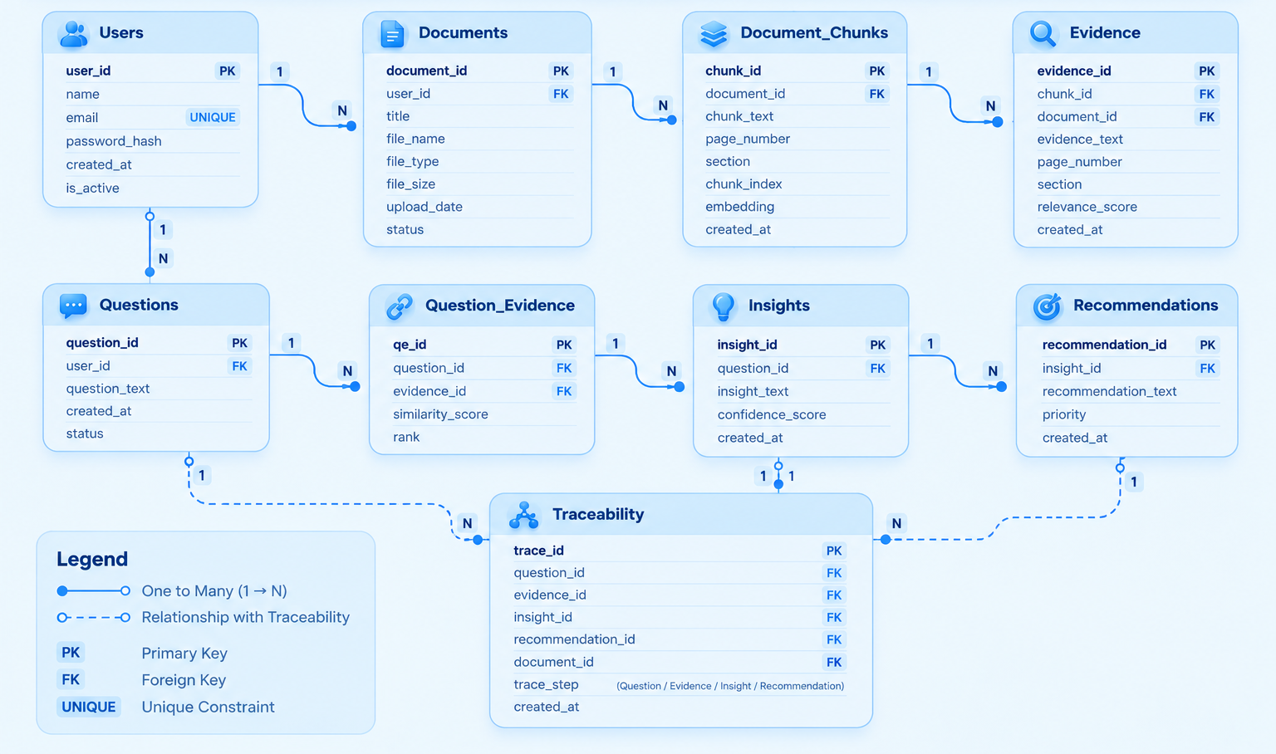

Description: The ER diagram represents the core data structure of the InsightTrace AI system.It shows how users, documents, document chunks, evidence, questions, insights, and recommendations are connected. The Traceability entity links the generated results back to their original evidence and source documents. The relationships and PK/FK fields provide a clear view of how data flows and is maintained across the system.

Pre-requisites:
- Flask Framework Knowledge: Flask Documentation
- Python Programming Proficiency: Python Documentation
- scikit-learn / TF-IDF Retrieval Familiarity: scikit-learn Documentation
- Google Gemini API Familiarity: Gemini API Documentation
- Jinja2 Templating Skills: Jinja2 Documentation
- SQLite Database Fundamentals: SQLite Documentation
- HTML & CSS Skills (Zero-JavaScript Design): W3Schools HTML/CSS Tutorials
- Version Control with Git: Git Documentation
- Development Environment Setup: Flask Installation Guide

Project Workflow:

Activity 1: Model Selection and Architecture
- Activity 1.1: Define the retrieval and grounding approach — a scikit-learn TF-IDF and cosine-similarity engine architected for direct integration with Google's Gemini Flash 2.5 model.
- Activity 1.2: Research and select the evidence-verification strategy that guarantees every generated insight is grounded in a citable source passage.
- Activity 1.3: Define the application architecture, detailing interactions between the Flask backend, the SQLite evidence store, and the Jinja2/CSS-only frontend.
- Activity 1.4: Set up the development environment, installing Flask, pypdf, python-docx, scikit-learn, and the google-generativeai library.

Activity 2: Core Functionalities Development
- Activity 2.1: Develop the core pipeline stages: Document Ingestion & Parsing, Evidence Extraction & Verification, Vector Embedding & Retrieval, and Pattern & Trend Analysis.
- Activity 2.2: Implement the Flask backend to manage the fourteen application routes, SQLite persistence, and session-based authentication.

Activity 3: App.py Development
- Activity 3.1: Write the main application logic in app.py, establishing routes for every workspace page and wiring the retrieval and synthesis engines together.

Activity 4: Frontend Development
- Activity 4.1: Design and develop the fourteen-page Jinja2 interface using a glassmorphism, 3D-perspective CSS design system with zero JavaScript.
- Activity 4.2: Create dynamic Jinja2 templates that render dashboard statistics, evidence cards, and pure-Python SVG charts server-side.

Activity 5: Deployment
- Activity 5.1: Prepare the application for local deployment by configuring a virtual environment and installing all dependencies from requirements.txt.
- Activity 5.2: Run and verify the application locally via the Flask development server.

Activity 6: Conclusion

Milestone 1: Model Selection and Architecture
In this milestone, we focus on selecting the appropriate technologies, configuring external services, and designing the overall architecture required for implementing the Personal Knowledge Assistant. This includes establishing AI integrations, cloud storage connectivity, authentication mechanisms, and development environments necessary for building a scalable knowledge management platform.

Activity 1.1: Generate a Google Gemini API Key
Before the application can communicate with the Gemini AI model, you need a valid Gemini API key. Follow the steps below to create one and connect it securely to the project.
- Step 1 — Create a Google AI Studio Account: Visit https://aistudio.google.com and sign in using your Google account.
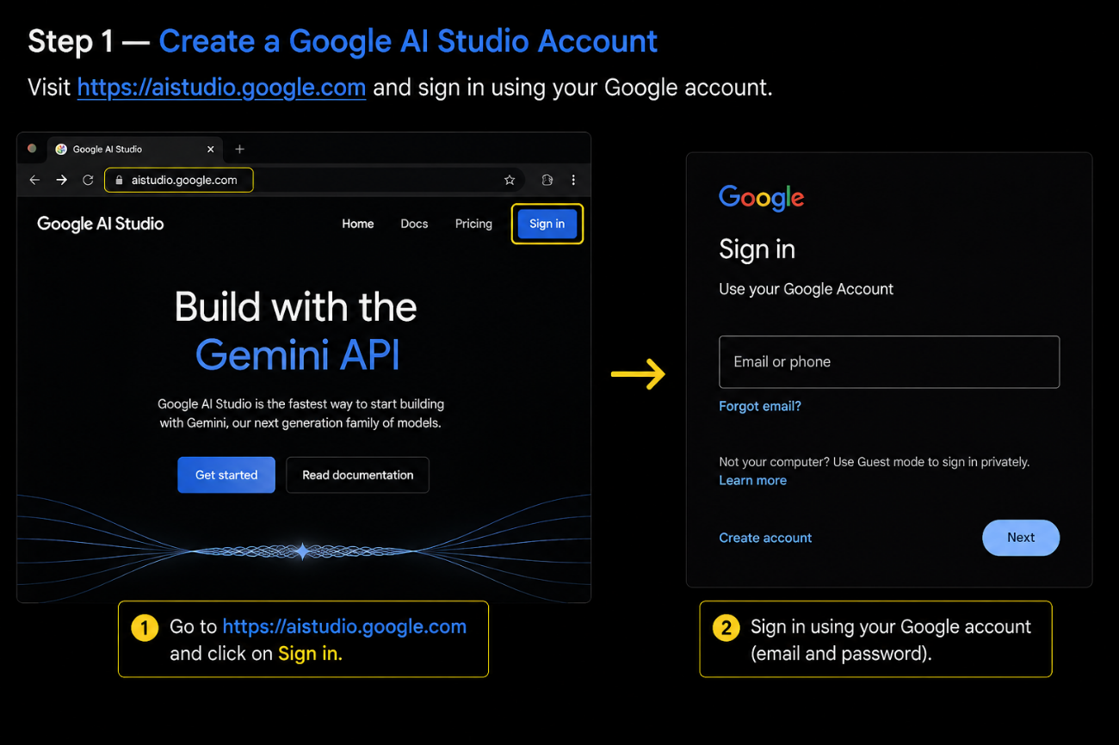
- Step 2 — Navigate to API Keys: After logging in, navigate to the API Keys section from the dashboard menu, or go directly to the API Keys page.
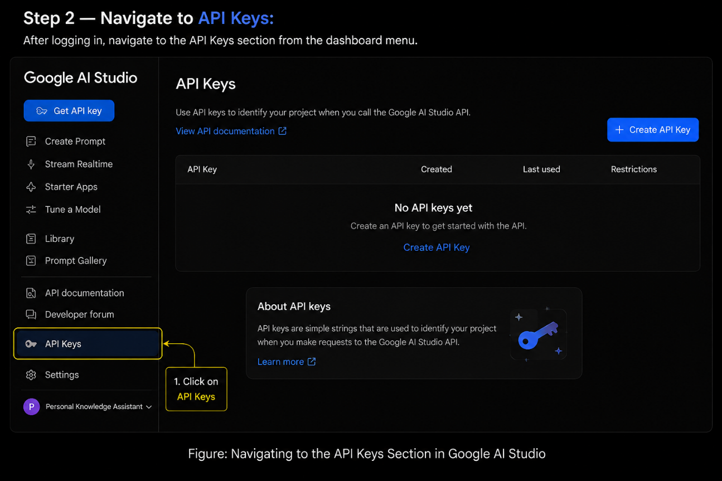
- Step 3 — Create a New API Key: Click the “Create API Key” button and generate a new key for the Personal Knowledge Assistant project.
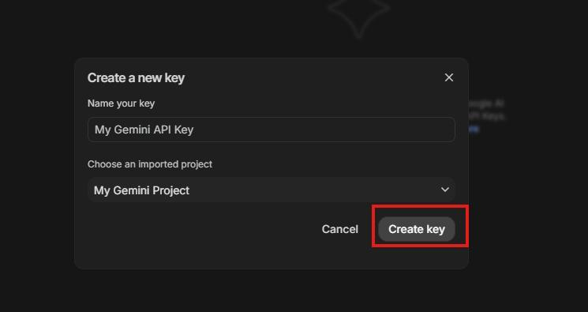

- Step 4 — API Key: Copy the generated API key immediately and store it securely. The key will be required for all AI-powered functionalities including summarization, tag generation, insight extraction, and intelligent search.
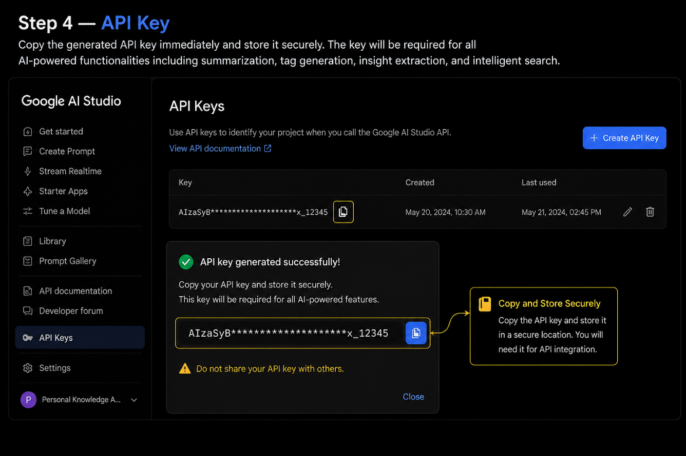
- Step 5 — Add the Key to Your Project: Create a .env file in the root directory of your project and add the following:
GEMINI_API_KEY=your_api_key_here
- Step 6 — Verify the Key is Loaded:
from dotenv import load_dotenv
import os
load_dotenv()
GEMINI_API_KEY = os.getenv("GEMINI_API_KEY")
- Important — Never Commit Your API Key: Add .env to your .gitignore file to prevent accidentally pushing the key to a public repository:
.env

Activity 1.2: Research and Select the Evidence-Verification Strategy
- Review the Project Requirements: focus on the document types the platform must support — quarterly reports, supplier contracts, RMA logs, and multi-modal media such as images, audio, and video.
- Explore Gemini's Model Documentation: evaluate the Flash 2.5 model's context window, multi-modal capabilities, and reasoning speed for future production-scale grounding.
- Evaluate Retrieval Performance: compare TF-IDF cosine similarity against keyword overlap for ranking accuracy on business document passages.
- Select the Verification Rule: only passages stored in the evidence_passages table with an assigned confidence score are ever surfaced as citable evidence, guaranteeing traceability.

Activity 1.3: Define the Architecture of the Application
- Draft the architectural flow: Documents → Ingestion → Extraction & Cleaning → Chunking → Evidence Verification → Vector Retrieval → Pattern & Trend Analysis → Insight Generation → Recommendation Generation → Citation & Traceability.
- Detail frontend functionality: fourteen Jinja2-rendered pages covering authentication, document upload, evidence browsing, and business-question answering.
- Outline backend responsibilities: Flask routes validate input, call semantic_vector_retrieval(), and pass ranked evidence to analyze_patterns_and_generate_insights().
- Describe storage: a single SQLite database (insighttrace.db) holds documents, evidence_passages, insights, recommendations, and queries — with zero JSON files used anywhere in the system.

Activity 1.4: Set Up the Development Environment
- Install Python 3.8+ and pip for dependency management.
- Create and activate a virtual environment to isolate project dependencies.
- Install Flask: pip install Flask>=3.0.0
- Install scikit-learn: pip install scikit-learn>=1.4.0
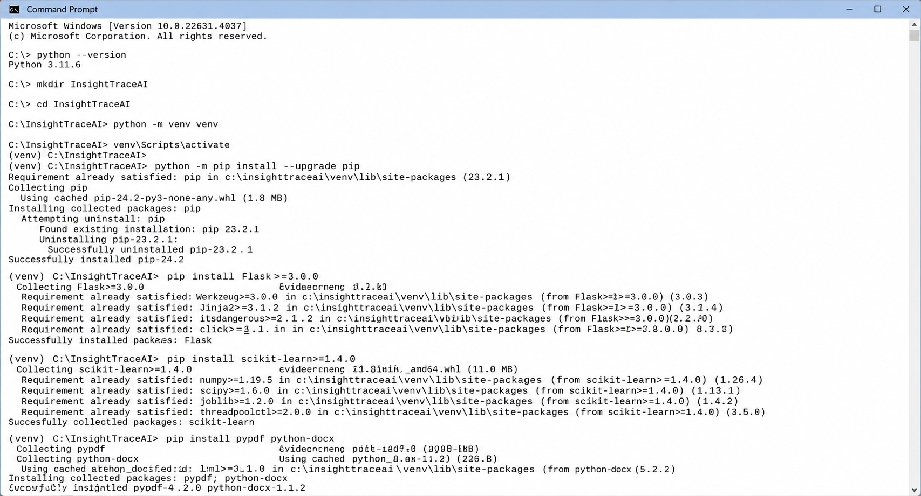
- Install pypdf and python-docx: for parsing PDF and Word source documents.
- Install the Gemini SDK: pip install google-generativeai>=0.5.0
- Set up the application structure: templates/, static/css/, static/uploads/, app.py, and requirements.txt.
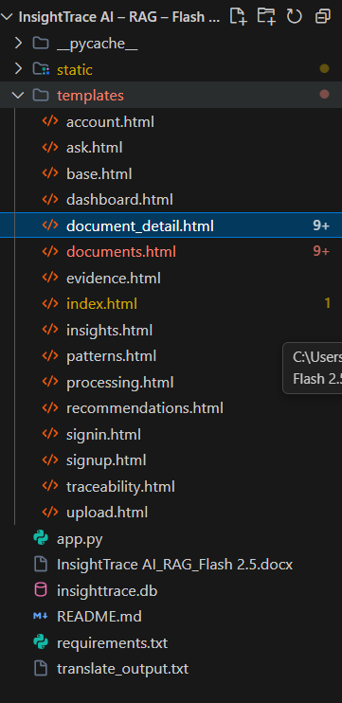

Milestone 2: Core Functionalities Development
Milestone 2 focuses on building the four pipeline stages that turn raw uploaded files into grounded, citable business intelligence: ingestion and chunking, evidence verification, semantic retrieval, and pattern-driven insight synthesis.

Activity 2.1: Document Ingestion, Parsing & Chunking
The process_uploaded_file() function handles five media categories — PDF, DOCX/TXT, images, audio, and video — extracting text (or, for media files, a structured transcript/OCR placeholder) before handing it to the chunking engine.
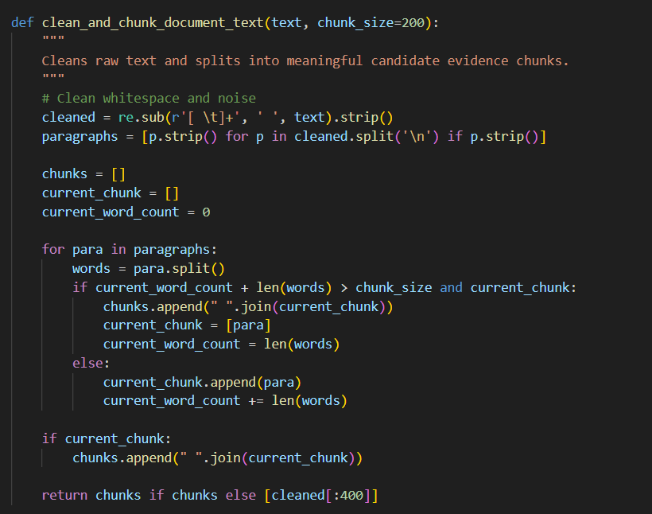
- PDF files are parsed page-by-page with pypdf, capturing per-page text for citation-ready passages.
- DOCX and TXT files are parsed with python-docx or read directly, preserving paragraph structure.
- Image, audio, and video uploads are logged with structured placeholders (OCR notes, speech-to-text transcripts) so multi-modal evidence follows the same verification path as text documents.
- Cleaned text is split into ~180-word sliding chunks, each becoming a candidate evidence passage.

Activity 2.2: Evidence Extraction & Verification
- Each chunk is persisted to the evidence_passages SQLite table with its source document name, page/section reference, and a confidence score.
- Only rows in this table are ever eligible for retrieval, so nothing reaches an insight or recommendation without a traceable citation.
- Seed evidence for the four demonstration documents (Q1–Q3 reports and the supplier agreement) is loaded on first run so the workspace is populated end-to-end out of the box.

Activity 2.3: Vector Embedding & Semantic Retrieval
- semantic_vector_retrieval() loads every verified passage, vectorizes it with TfidfVectorizer, and ranks passages against the incoming query with cosine_similarity.
- The top five passages above the relevance threshold are returned as grounding evidence; below threshold, the system reports insufficient evidence instead of guessing.
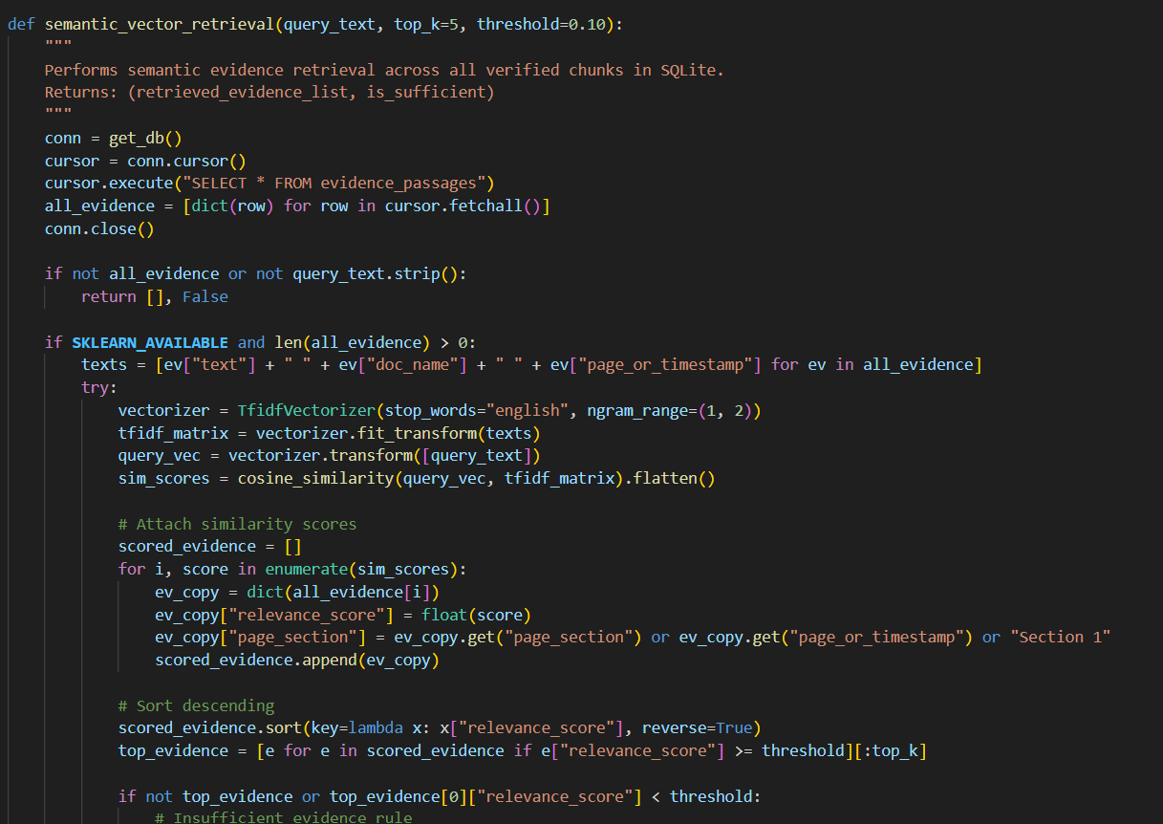
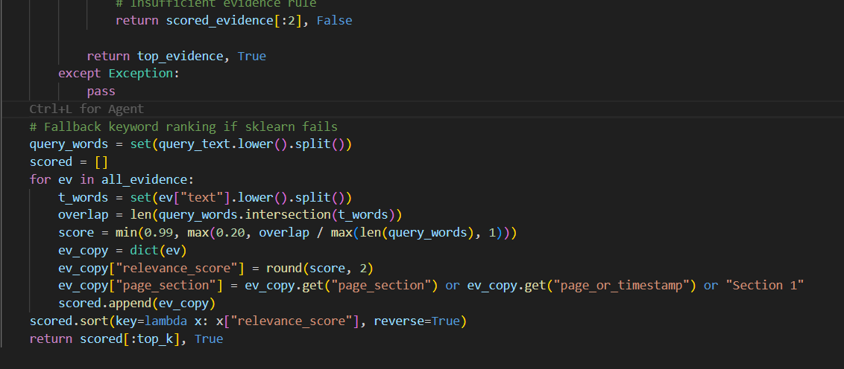

Activity 2.4: Pattern & Trend Analysis, Insight & Recommendation Synthesis
- analyze_patterns_and_generate_insights() inspects the retrieved evidence text for revenue/return-rate language, contractual/clause language, or an absence of relevant content.
- Each branch produces a matched Pattern (with a category and trend delta), a grounded Insight (with a confidence score and key drivers), and an actionable Recommendation (with priority and timeline).
- Every generated insight carries a supporting_count and grounding_status field that is rendered directly in the Ask and Insights pages as proof of traceability.
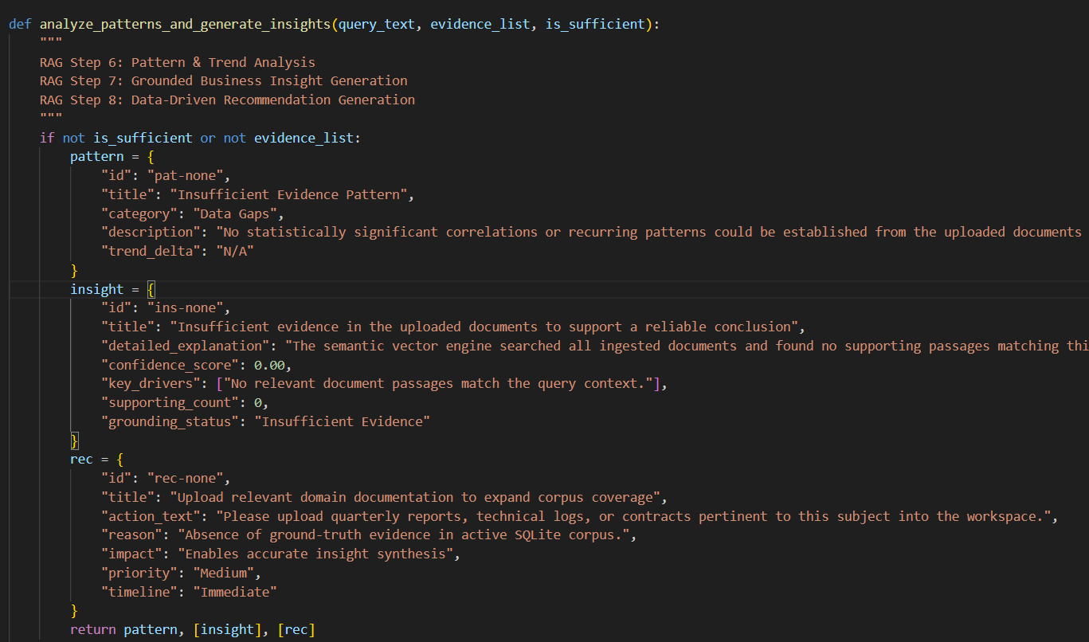

Milestone 3: App.py Development
Milestone 3 covers the Flask application logic in app.py — the backbone that wires the ingestion, retrieval, and synthesis engines to fourteen routed pages and a SQLite-backed session model.

Activity 3.1: Writing the Main Application Logic in app.py
- / — Landing page rendering live document, query, insight, and recommendation counts from SQLite.
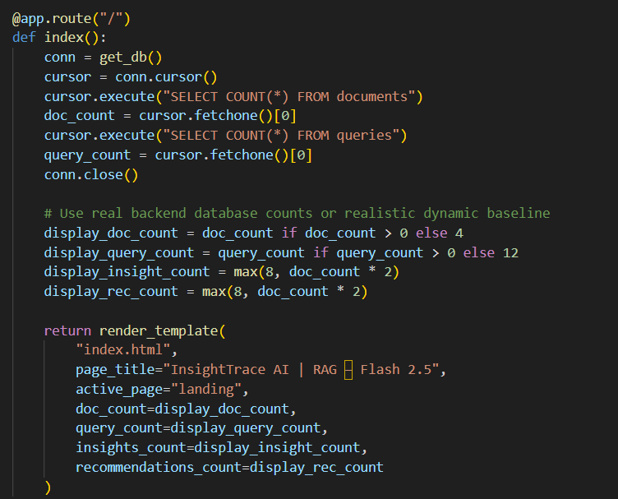
- /signin, /signup, /logout — Session-based authentication that seeds a demonstration analyst profile.
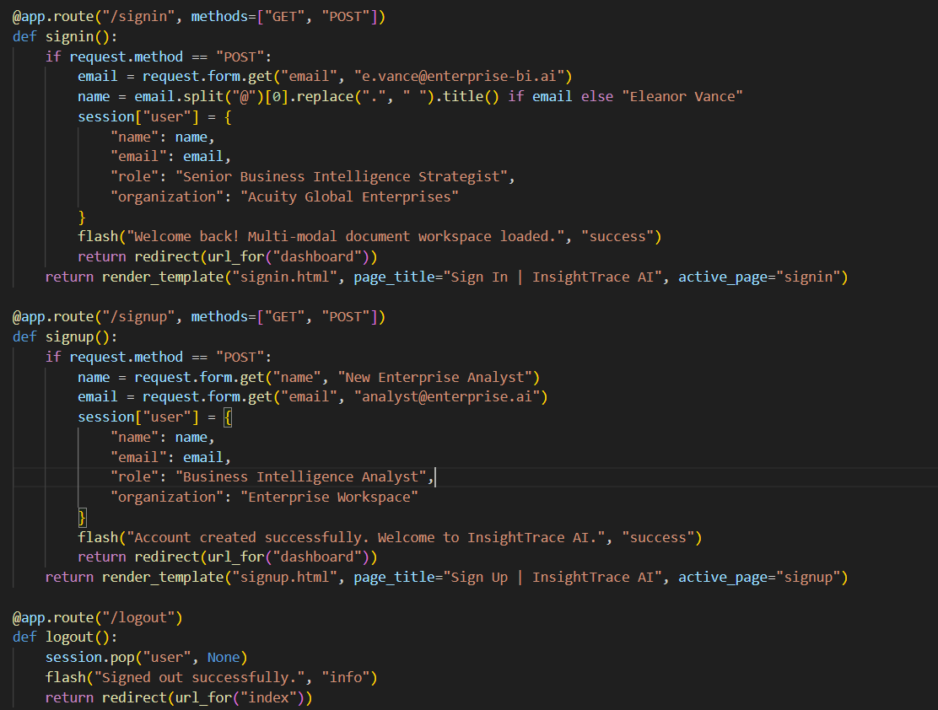
- /dashboard — Summary statistics, the six-stage pipeline status tracker, and pure-Python SVG trend and distribution charts.
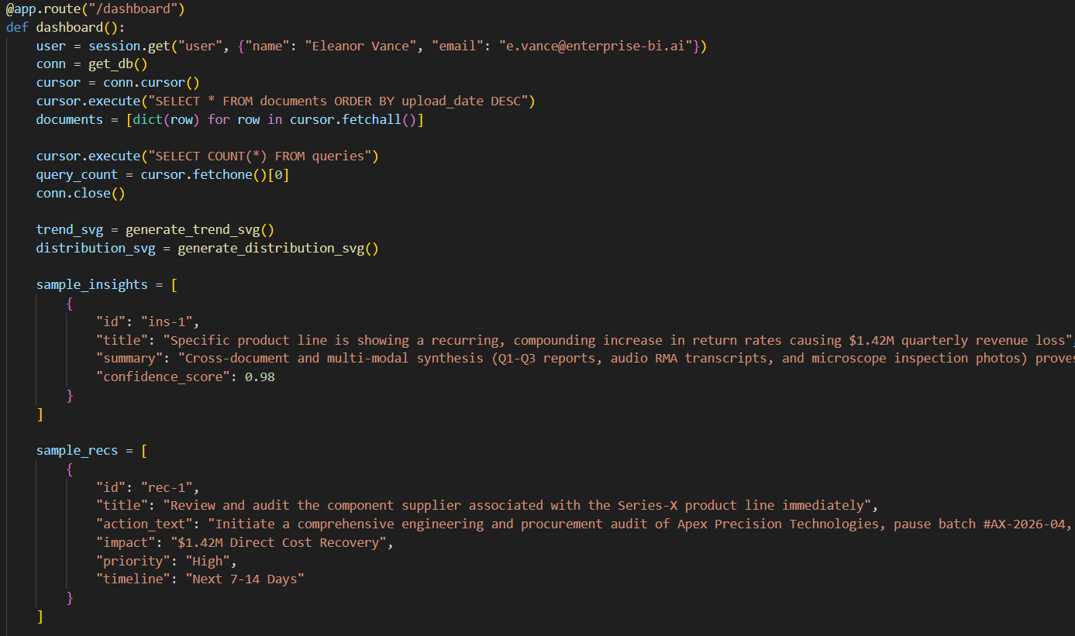
- /upload — Multi-modal ingestion endpoint accepting files up to 2 GB.
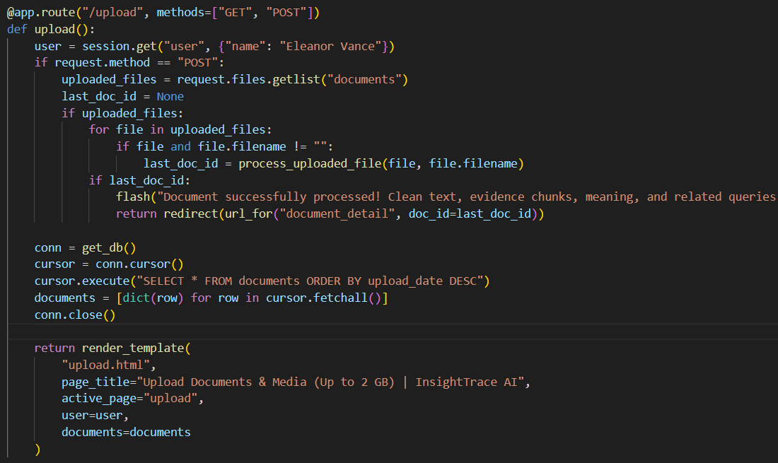
- /document/<doc_id>, /delete-document/<doc_id> — Document detail view and removal.
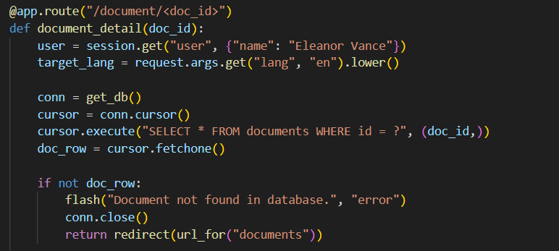
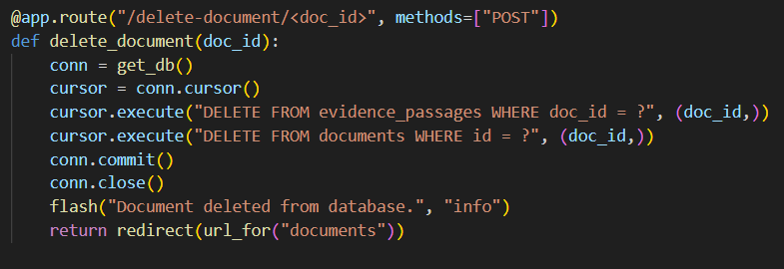
- /processing — Five-stage ingestion progress visualization.
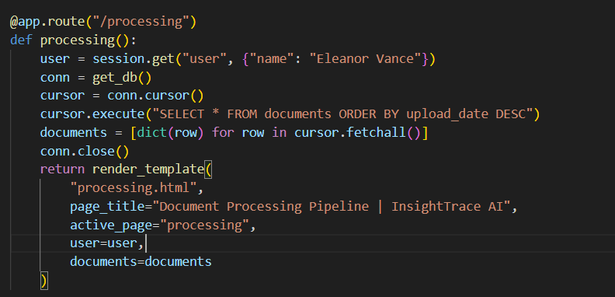
- /ask — The core RAG workspace: accepts a business question, retrieves evidence, and renders the pattern, insight, and recommendation.
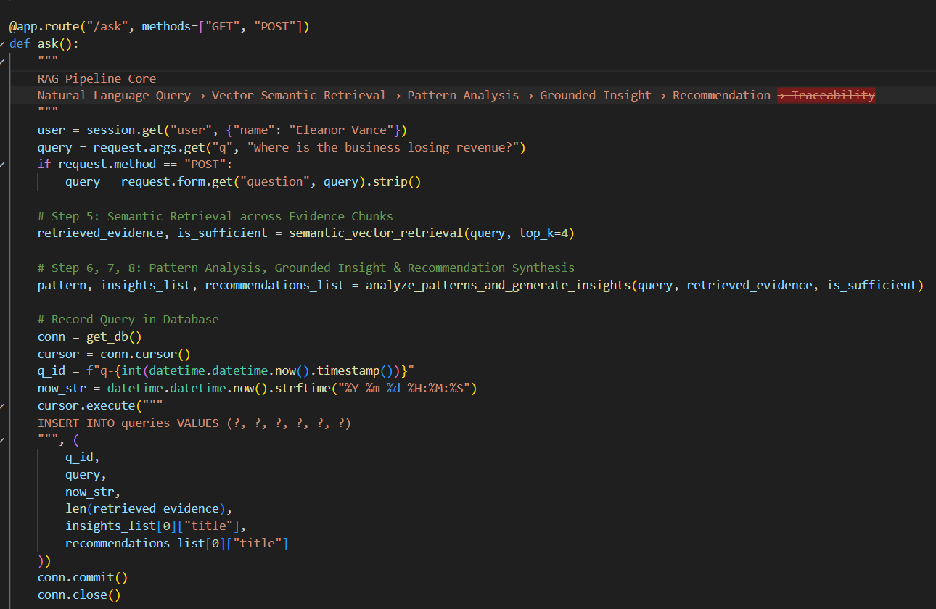
- /evidence, /patterns, /insights, /recommendations, /traceability, /documents, /account — Supporting library, analysis, and settings views.
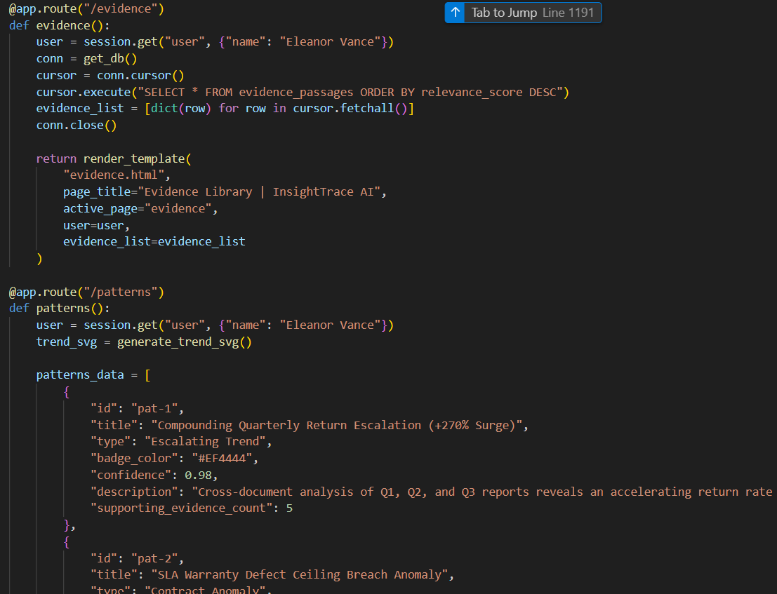
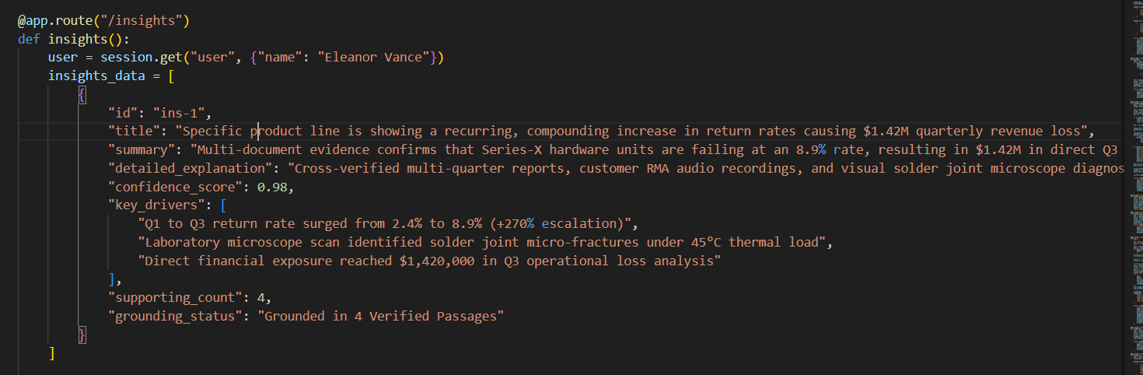
- Session data is stored server-side via Flask's session object — no client-side tokens or JSON payloads.
- The 413 error handler gracefully redirects oversized uploads back to the upload page with a flash message.

Milestone 4: Frontend Development
Milestone 4 focuses on the presentation layer: fourteen Jinja2 templates styled entirely with hand-written CSS, under a strict zero-JavaScript and zero-JSON constraint.

Activity 4.1: Design and Develop the User Interface
- Build a shared base.html shell with a persistent sidebar, top search bar, and flash-message region reused across all fourteen pages.
- Apply a glassmorphism and 3D-perspective visual language with pastel accent colors and CSS keyframe animations for hero sections and status cards.
- Ensure every page is responsive and legible at common desktop and tablet widths.
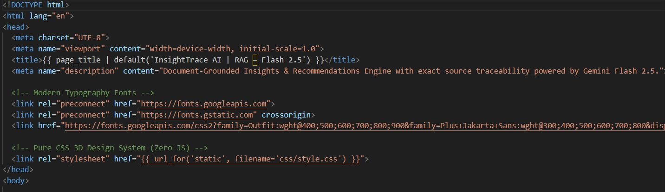

Activity 4.2: Create Dynamic, Server-Rendered Templates
- Render dashboard statistics, evidence cards, and pattern/insight/recommendation panels entirely server-side with Jinja2 loops and conditionals.
- Generate trend and distribution charts as inline SVG markup from Python — generate_trend_svg() and generate_distribution_svg() — so no client-side charting library or JavaScript is required.
- Keep all interactivity (forms, uploads, navigation) working through standard HTML form submissions and full-page loads, satisfying the zero-JS requirement.
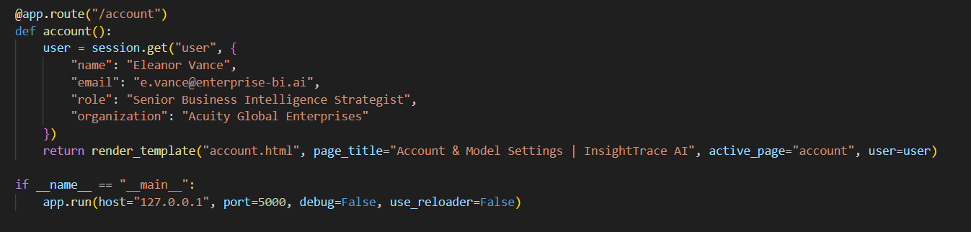

Milestone 5: Deployment
In Milestone 5, the focus is on preparing InsightTrace AI for local deployment, verifying the complete evidence-to-recommendation pipeline end to end, and confirming the SQLite database initializes correctly on first run.

Activity 5.1: Preparing the Application for Local Deployment
Set Up a Virtual Environment:
python -m venv env
source env/bin/activate # macOS/Linux
env\Scripts\activate # Windows
pip install -r requirements.txt

Note: no .env file or API key is required to run the current build — the retrieval and synthesis engines run entirely on-device against the local SQLite database.

Activity 5.2: Local Testing and Verification
Start the Flask Development Server:
python app.py

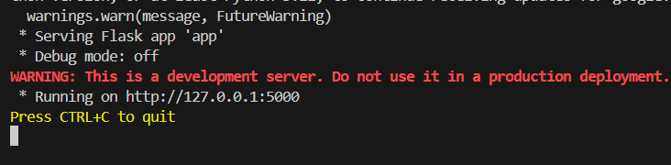
- Once running, open a browser and navigate to http://127.0.0.1:5000 to access the application.
- Walk through all fourteen routes — sign in, upload a document, ask a business question, and confirm the pattern, insight, and recommendation are grounded in citable evidence.
- Confirm the SQLite database (insighttrace.db) auto-initializes its schema and seed data on first launch.

Exploring the Website's Web Pages:

Landing Page:
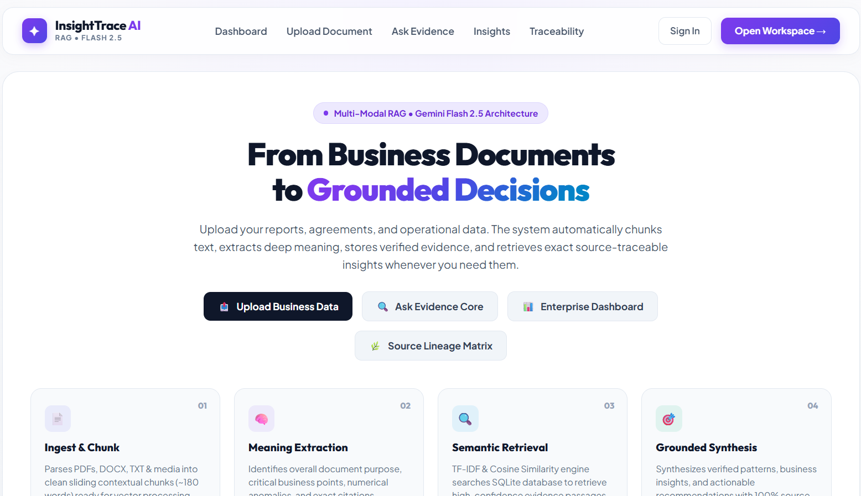
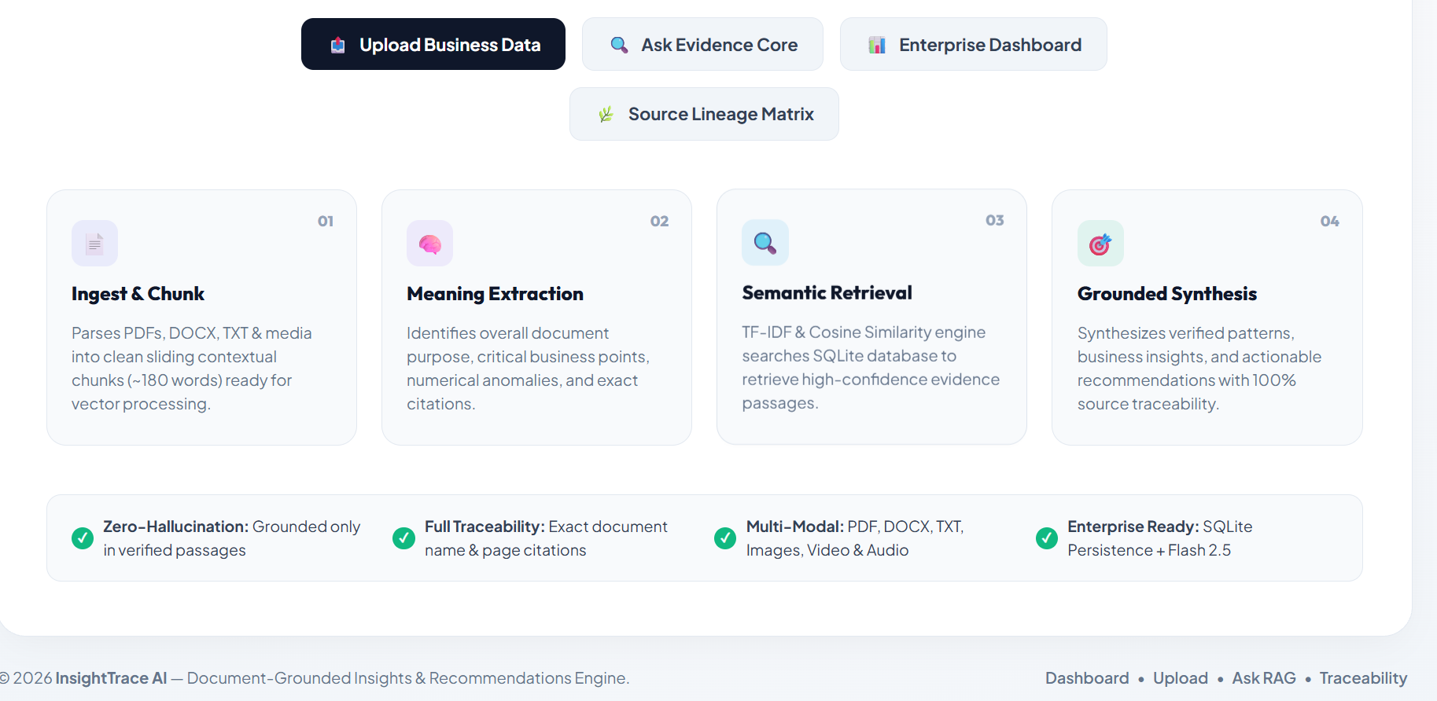
Description: The public landing page introduces InsightTrace AI's document-to-decision workflow with a four-step process strip (Ingest & Chunk, Meaning Extraction, Semantic Retrieval, Grounded Synthesis), primary calls to action for uploading data or asking a question, and a zero-hallucination value proposition.

Sign In:
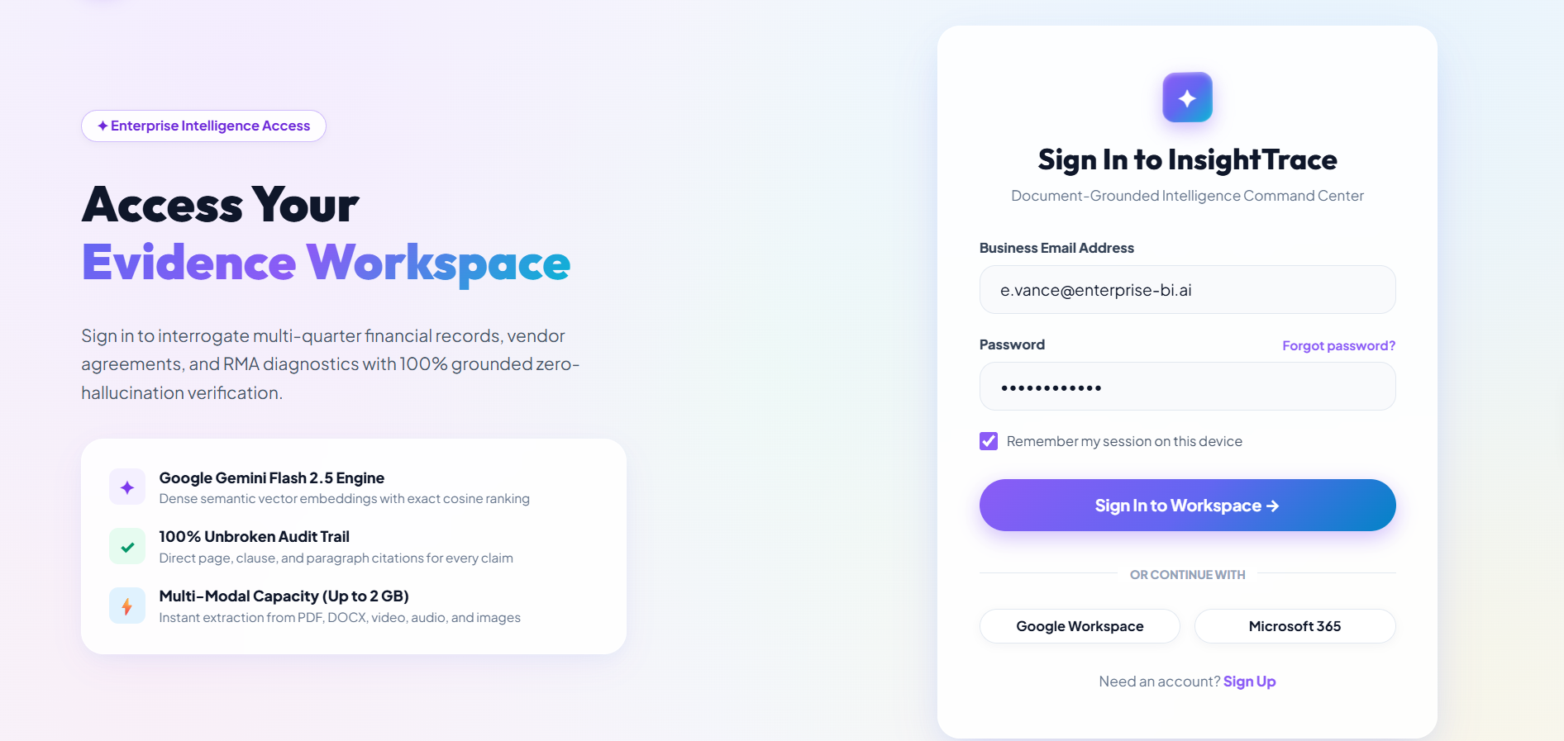
Description: A glassmorphic authentication card lets a returning analyst sign in with an email address; the backend seeds a demonstration Business Intelligence Strategist profile into the session on submission.

Sign Up:
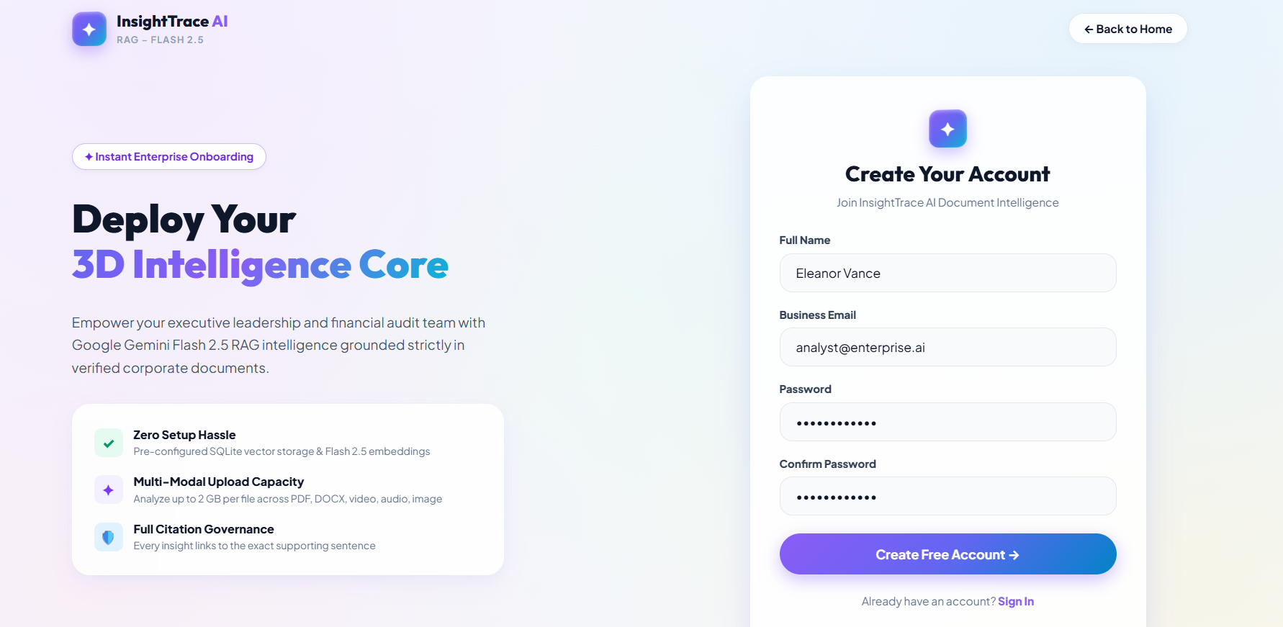
Description: The registration interface collects a name and email to create a new session-based workspace profile, mirroring the sign-in page's visual language.

Dashboard:
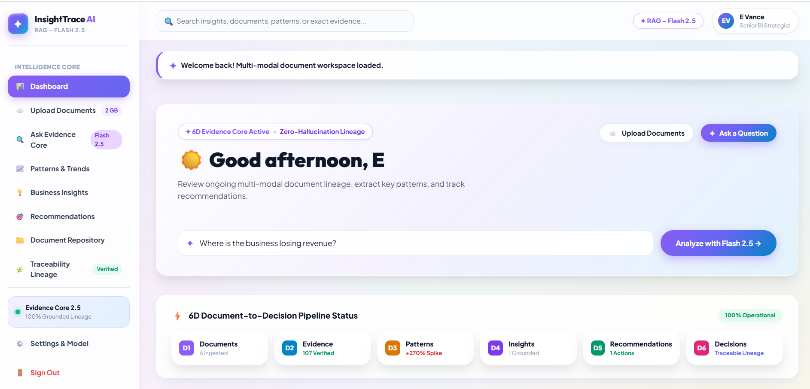
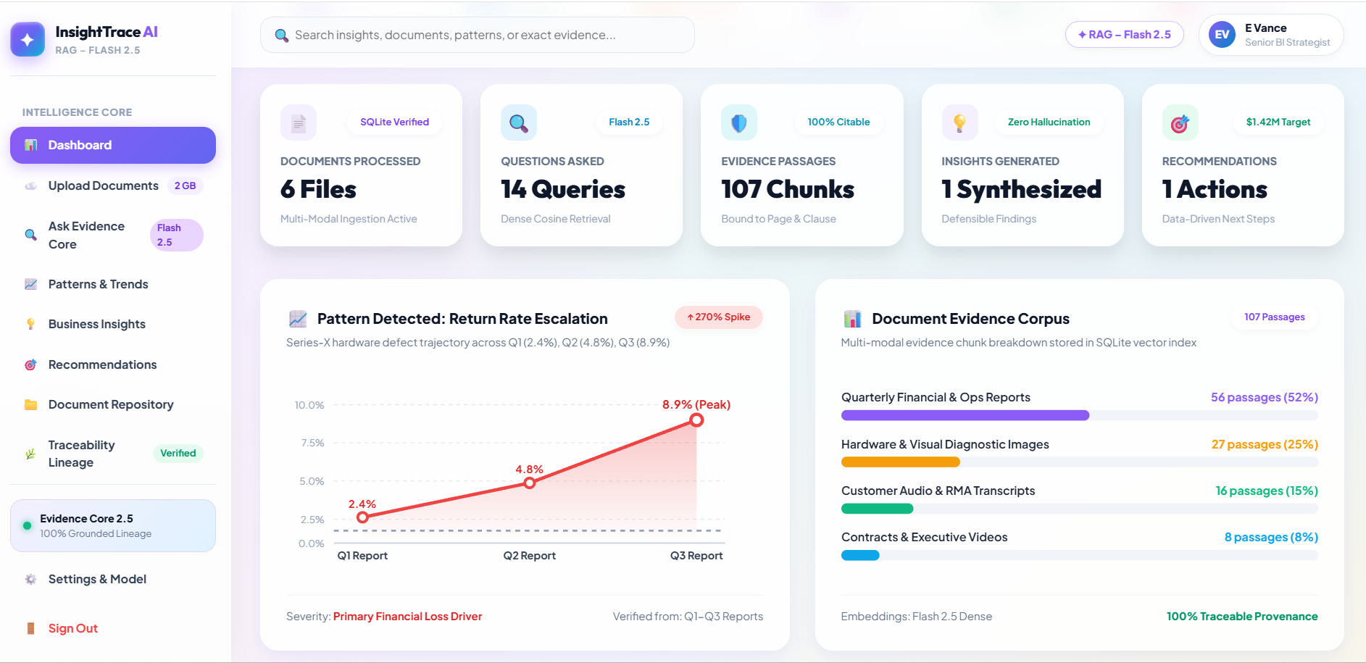

Description: The enterprise home view surfaces the six-stage document-to-decision pipeline status, live document/query/evidence/insight/recommendation counters, an SVG return-rate trend chart, a document-corpus distribution breakdown, and the latest grounded insight and recommendation.

Document Upload:
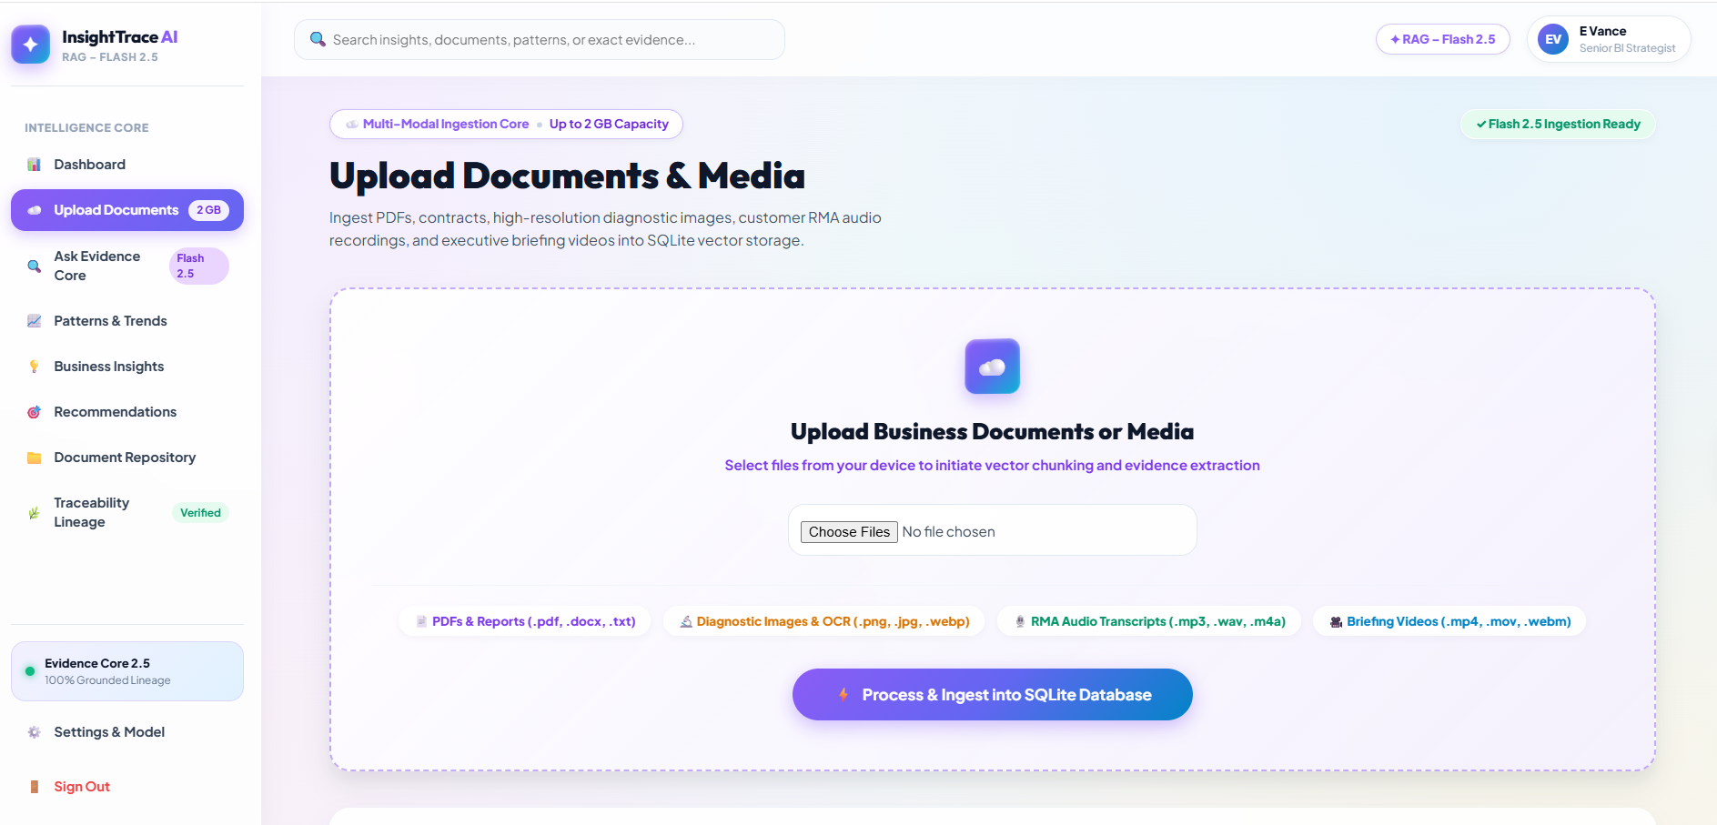
Description: A multi-modal drag-and-drop interface accepts PDFs, contracts, diagnostic images, RMA audio, and briefing videos up to 2 GB, with an ingestion queue below listing every previously processed document and its status.

Processing Pipeline
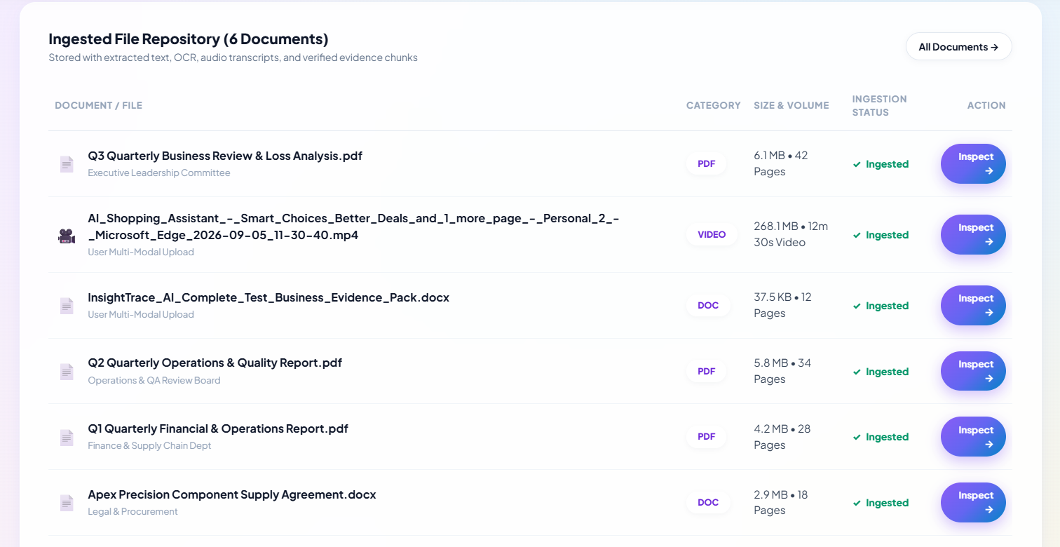
Description: A five-stage progress view confirms each ingested document has been received, extracted, cleaned, chunked, and verified into SQLite, with quick links to ask a question or browse the document repository.

Ask Your Documents:
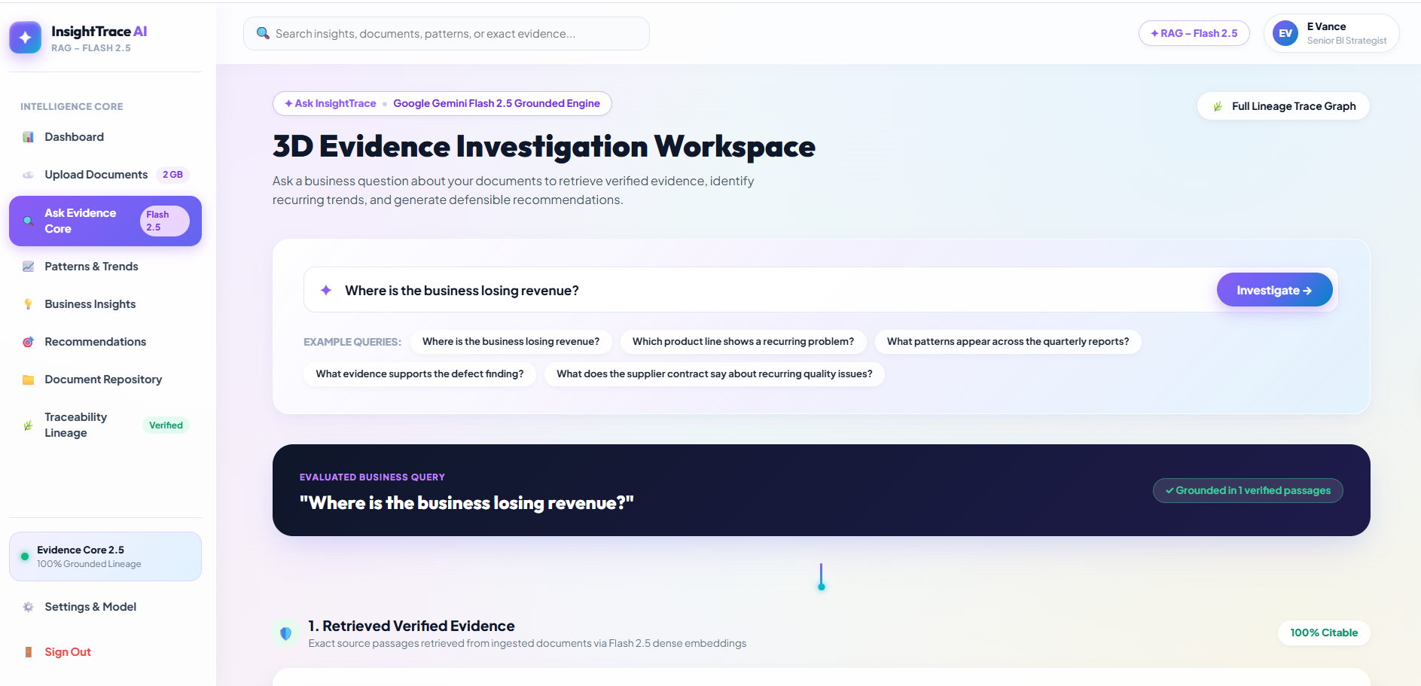
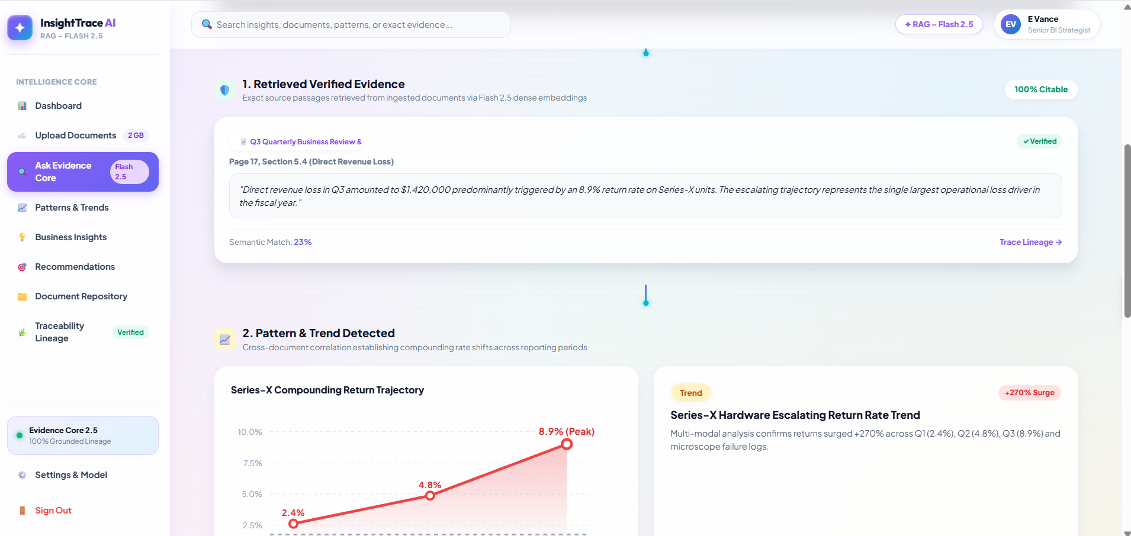
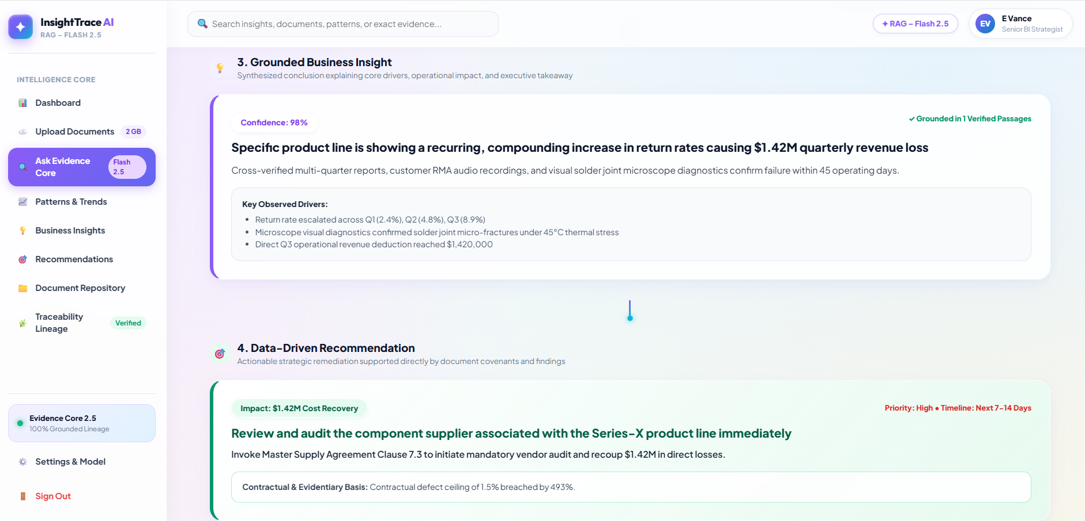
Description: The core RAG workspace: a natural-language query box with example prompts, followed by a four-stage answer trace — retrieved verified evidence, the detected pattern or trend, the synthesized business insight, and the resulting data-driven recommendation.

Pattern & Trend Analysis
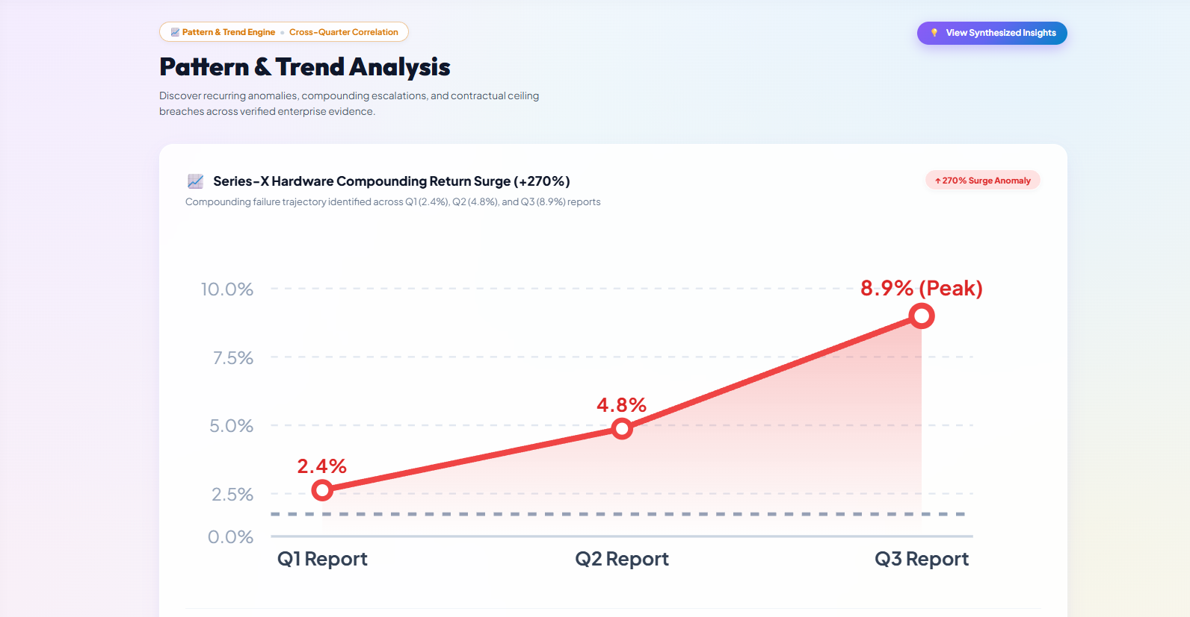
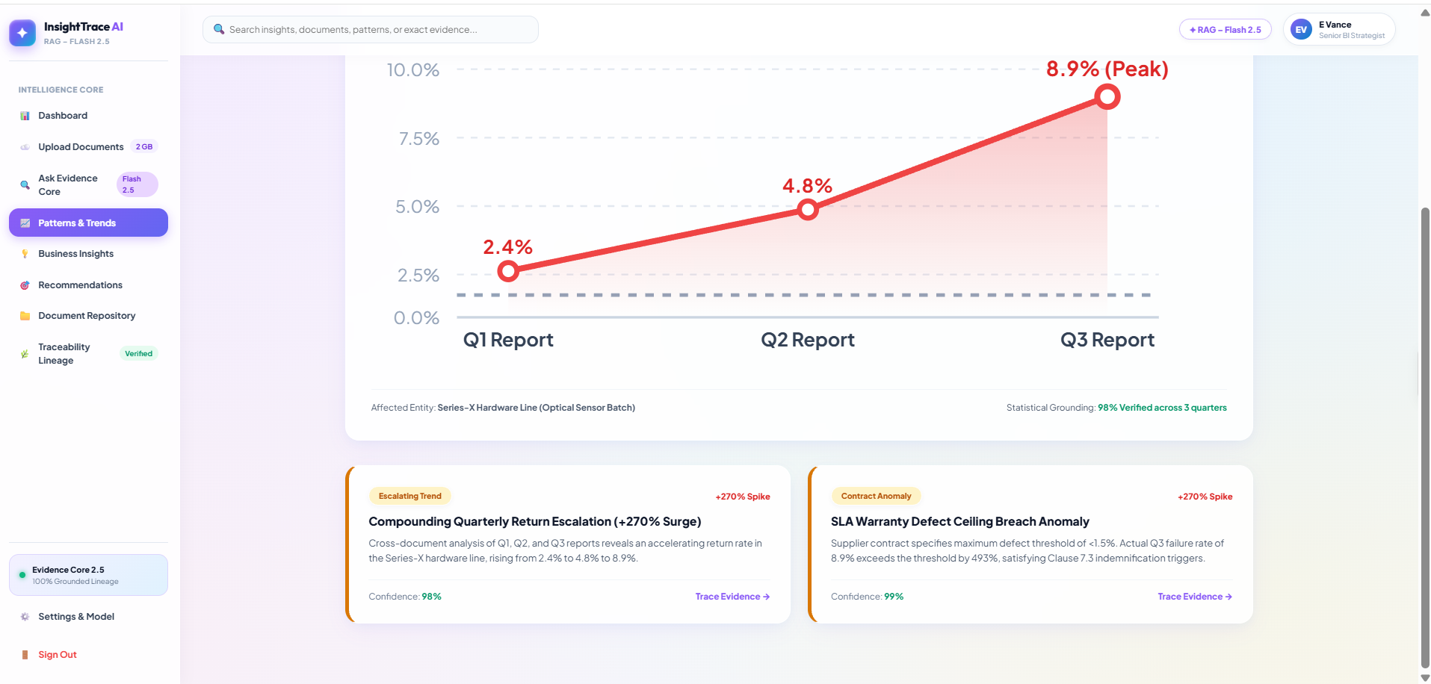
Description: Cross-document correlations and anomalies are visualized here, including the Series-X return-rate escalation chart and a list of detected patterns with confidence scores and severity.

Business Insights
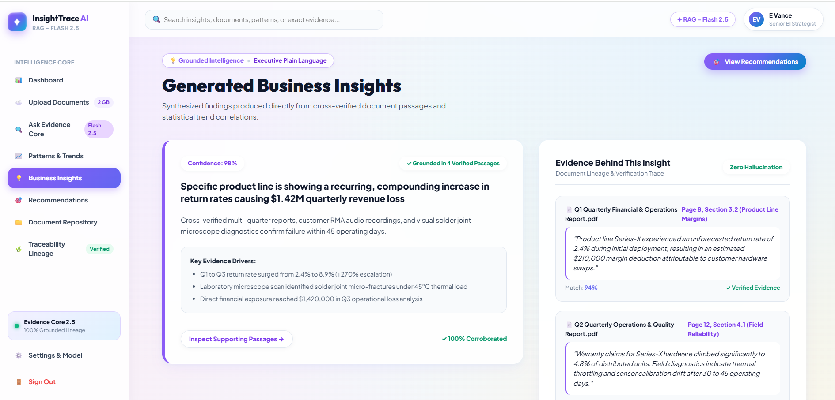
Description: Synthesized executive findings are presented with their confidence score, key evidence drivers, and the exact supporting passages underneath each insight for one-click verification.

Recommendations:
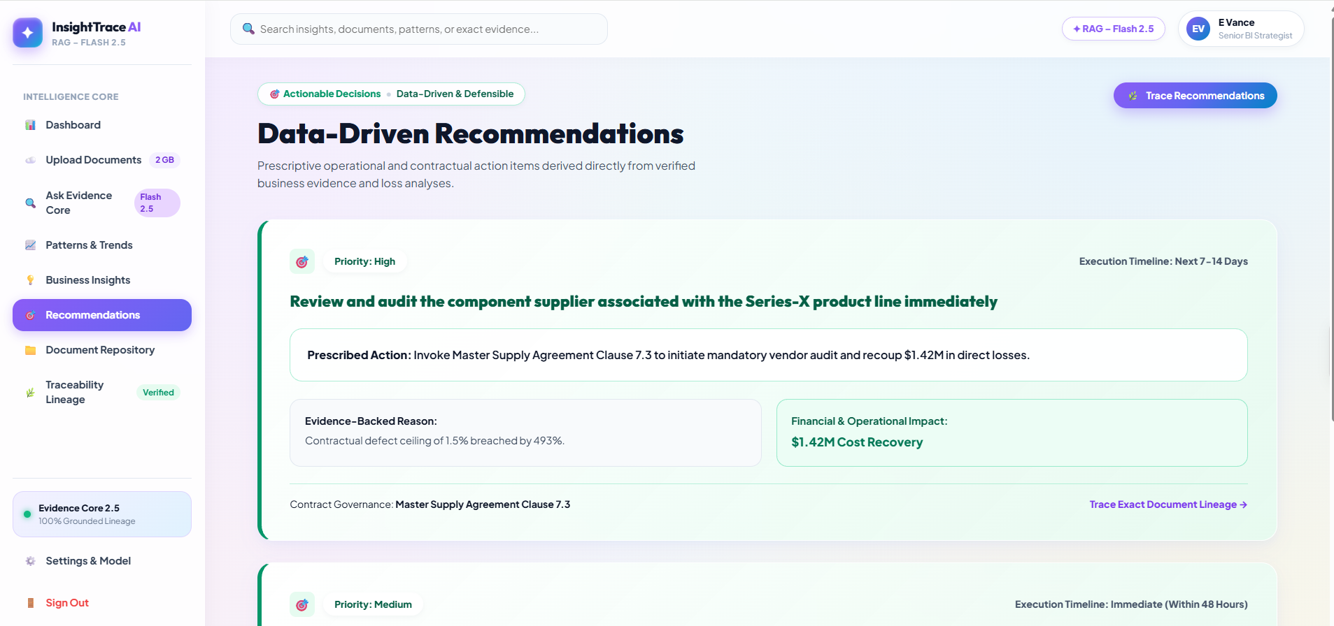
Description: Prescriptive next steps are listed with priority, timeline, and quantified impact, each traceable back to the insight and evidence that justifies it.

Source Traceability:
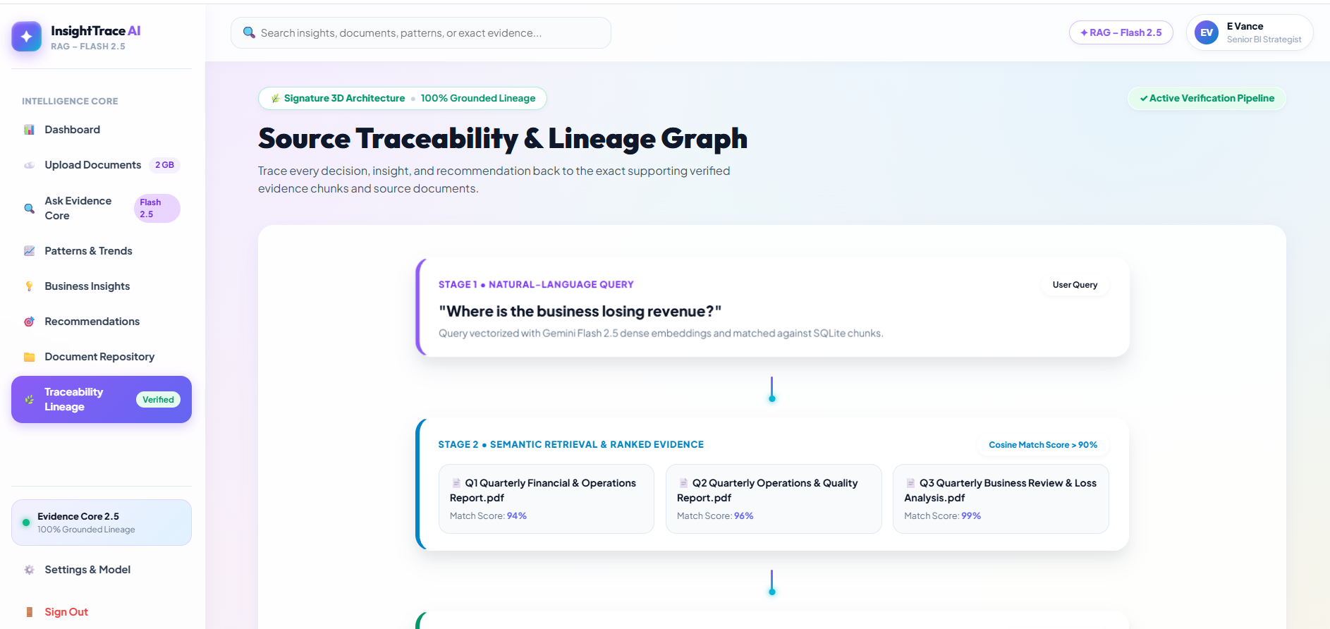
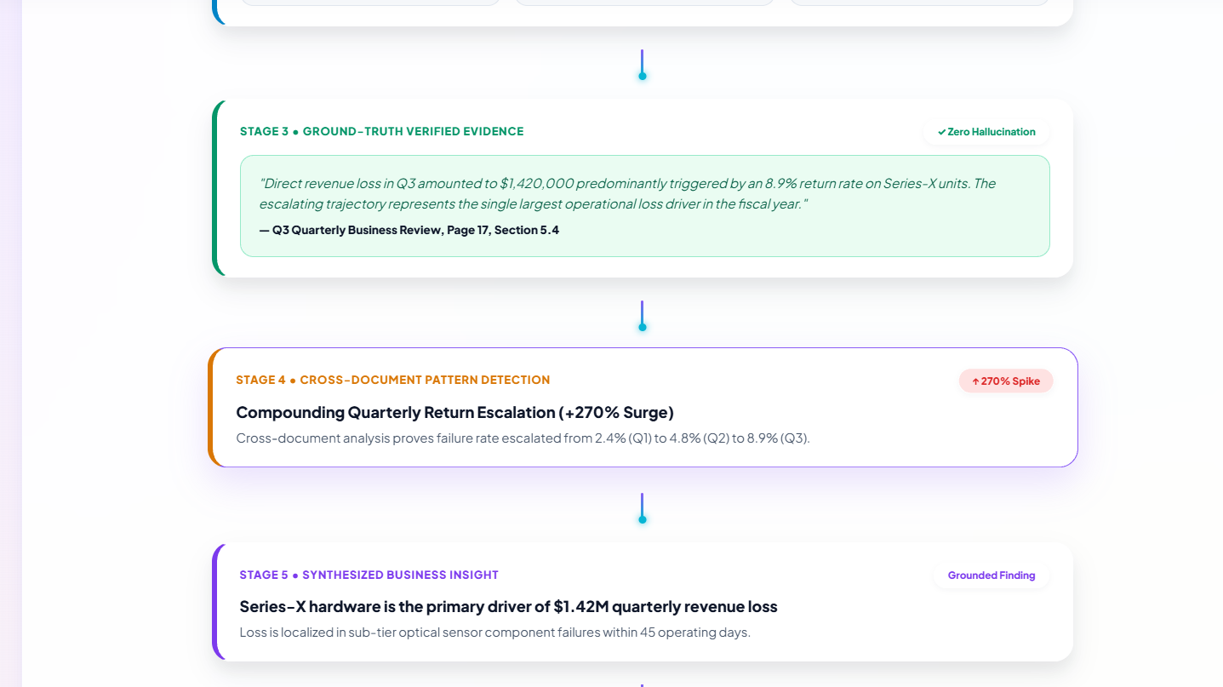
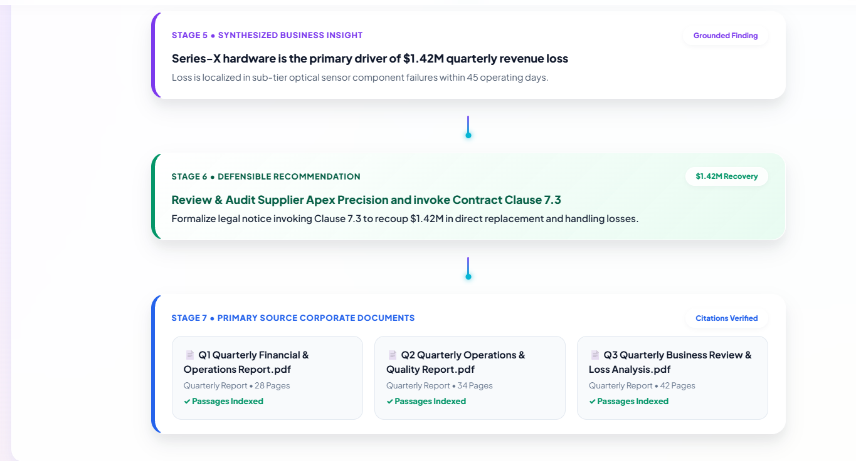
Description: A seven-stage lineage graph connects a user's natural-language query all the way through retrieval, verified evidence, pattern detection, insight, recommendation, and back to the primary source documents.

All Documents:
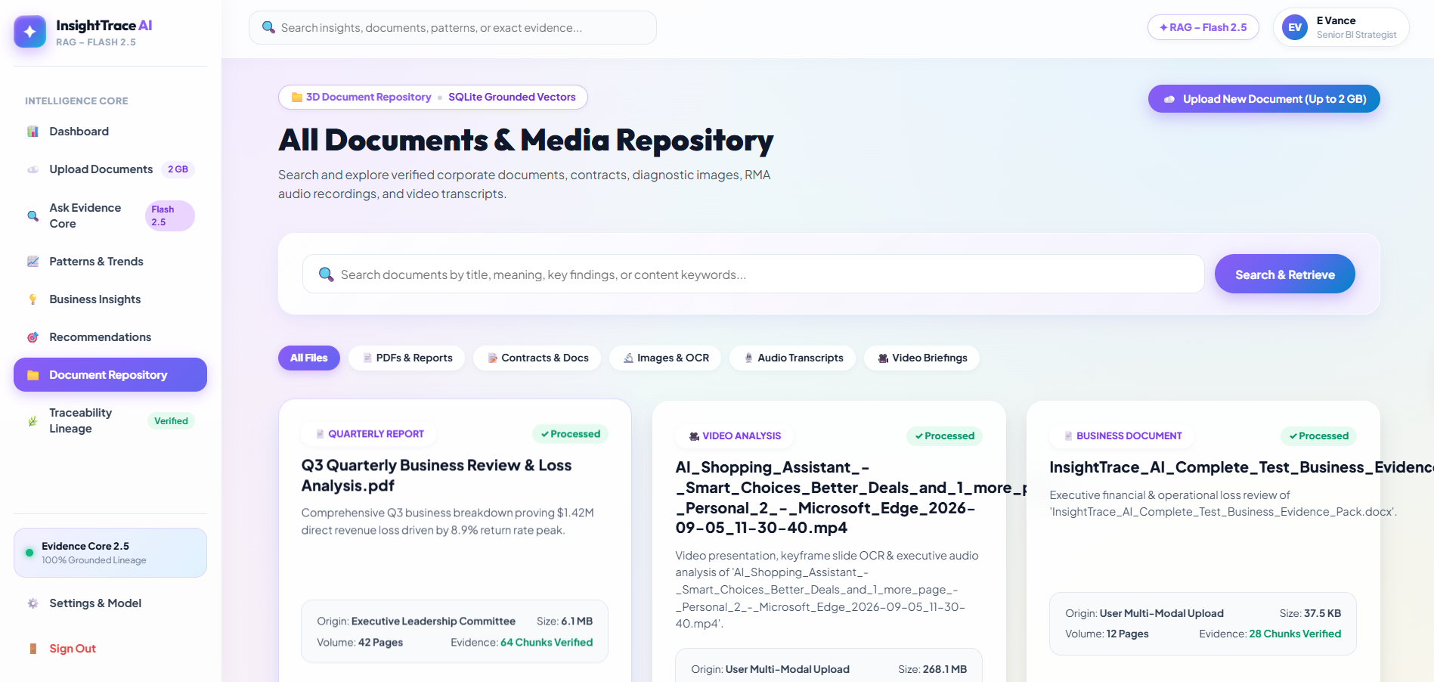
Description: An enterprise document library lists every ingested file with its category, size, page count, and department tag, filterable across reports, contracts, and diagnostic records.

Account Settings:
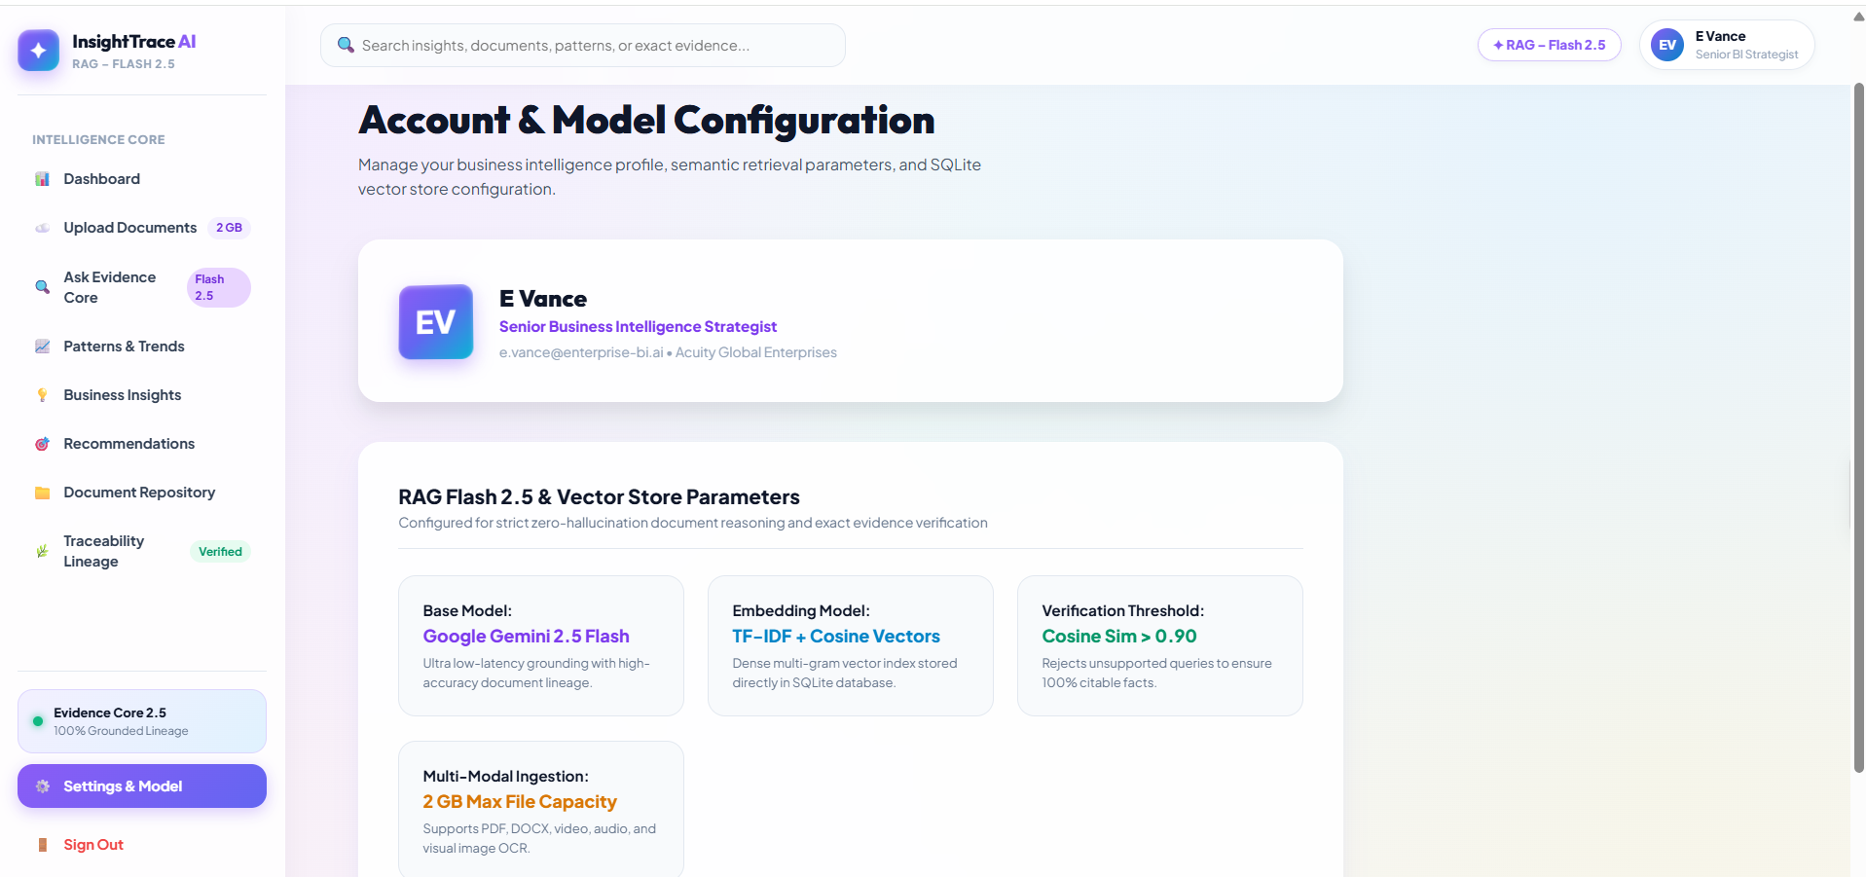
Description: The account page displays the signed-in analyst's profile alongside the active Gemini Flash 2.5 RAG model parameters governing retrieval and synthesis.

Conclusion:
InsightTrace AI – RAG – Flash 2.5 successfully demonstrates how artificial intelligence can transform scattered business documents into structured, meaningful, and evidence-backed insights. The system combines document ingestion, text extraction, contextual passage creation, retrieval, grounded generation, recommendations, and traceability within one continuous workflow. The project uses TF-IDF and cosine similarity to identify the most relevant document passages for a user’s question. This retrieval-based approach ensures that responses are connected to the available source material instead of being generated without supporting evidence. As a result, users can receive clearer and more reliable answers based on the information contained in their uploaded documents.
A major strength of the system is its focus on grounded generation. Insights and recommendations are produced from retrieved evidence, helping users understand how a conclusion was formed. The seven-stage traceability graph further improves transparency by linking the user’s question, retrieved passages, detected patterns, generated insights, recommendations, and original source documents. The separation between retrieval and generation is another important architectural benefit. The retrieval layer focuses on locating relevant evidence, while the generation layer converts that evidence into understandable business insights and recommendations. This modular structure allows individual components to be enhanced without requiring a complete redesign of the application.
The project also covers the complete software development lifecycle, including requirement analysis, architecture planning, entity relationship design, retrieval-engine development, backend routing, frontend implementation, integration, testing, and deployment. Therefore, InsightTrace AI represents more than a simple question-answering tool. It demonstrates how a modern RAG-based application can be planned. Overall, InsightTrace AI proves that document intelligence can be made more transparent, structured, and practical through retrieval-augmented generation. By connecting business questions with supporting evidence and actionable recommendations, the system helps reduce information overload and supports better decision-making. It provides a reliable foundation for developing future enterprise applications that require explainable, traceable, and evidence-based artificial intelligence.

