Mentora_AI_Flash_Gemini_2.5
Intelligent Mentor–Intern Project Management & Evaluation Platform

Project Description:
Mentora AI is an enterprise-grade, AI-powered mentor–intern project management and evaluation platform that automates every stage of a technical internship lifecycle. Built with Flask, Jinja2, SQLAlchemy, and a zero-JavaScript pastel UI, it gives mentors a single workspace to generate production-grade project blueprints, recommend technology stacks, match interns by semantic skill fit, track task velocity, diagnose project health, and evaluate submitted deliverables — while interns get a dedicated portal to receive assignments, submit work, and grow their skills through a self-learning hub.
The platform is powered by the Google Gemini 2.5 Flash API, orchestrated through a LangGraph-inspired multi-agent routing engine (MentoraOrchestrator) that dispatches every request — project generation, matching, tracking, health scoring, evaluation, feedback, and copilot conversation — to a dedicated specialized agent. Submission evaluation is additionally augmented with a lightweight Retrieval-Augmented Generation (RAG) pipeline that chunks and vectorizes mentor-supplied reference documents so the AI grades each submission against the exact standard the mentor expects, and the platform persists all state — users, projects, assignments, tasks, submissions, and evaluations — through SQLAlchemy models backed by SQLite in development and PostgreSQL in production.

Scenarios :
Scenario 1: A mentor types a one-line prompt, “I need a project on climate risk analytics using agentic AI,” into the AI Project Generator. The Multi-Project Generation Agent calls Gemini 2.5 Flash to draft five distinct, production-grade project blueprints in parallel — an autonomous multi-agent workflow, a RAG knowledge base, a real-time predictive analytics dashboard, a full-stack AI copilot, and a streaming alert engine — each pre-populated with a problem statement, abstract, objectives, functional and non-functional requirements, and a recommended skill set. The mentor reviews the five flashcards and saves one to the project repository.
Scenario 2: With the project saved, the mentor opens the AI Intern Matching page. The Matching Agent compares the project's required skills against every registered intern's profile — skills, technologies, workload, and availability — and returns a ranked list with 0–100% semantic match scores, missing-skill diagnostics, and workload-risk flags, letting the mentor assign the project to the best-fit intern in a single click.
Scenario 3: An intern uploads a completed deliverable (DOCX) ahead of a deadline. The Pre-Submission Review Agent extracts and previews the document text before the intern confirms submission. The Evaluation Agent then runs the RAG pipeline — chunking and vectorizing the mentor's reference/sample document and retrieving the sections most semantically relevant to the evaluation criteria — before asking Gemini to score the submission section-by-section, flag missing sections and technical errors, and hand the result to the Feedback Agent, which produces an executive summary, prioritized corrections, and a final approval recommendation.
Scenario 4: A mentor asks the Mentor AI Copilot, “Who's overloaded this week and what's overdue?” The Copilot Agent pulls a live snapshot of every project, assignment, task, intern, and submission directly from the database, and Gemini composes a context-aware natural-language answer that cites specific assignments and deadlines — without the mentor writing a single query or leaving the chat panel.

Technical Architecture:

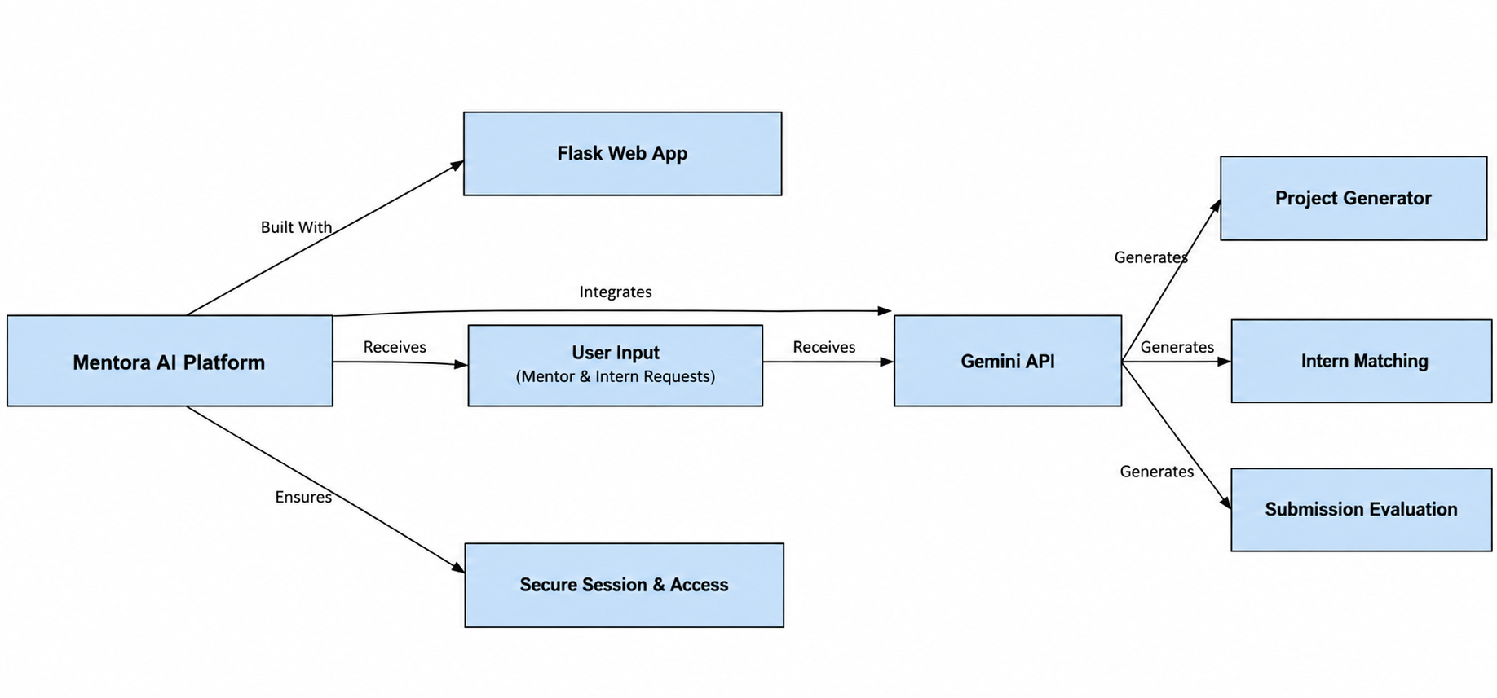

Description:
Mentora AI is a Flask-based web application that connects mentors and interns through a centralized platform. The Flask Web App receives mentor and intern requests and securely manages user sessions and access. These requests are processed through the Gemini API for AI-powered capabilities such as project generation, intern matching, and submission evaluation. The platform uses the generated AI results to support project planning, suitable intern allocation, and evaluation of submissions. Overall, the architecture integrates the Flask application, secure access, user inputs, and Gemini AI services into a unified workflow.

ER_Diagram:
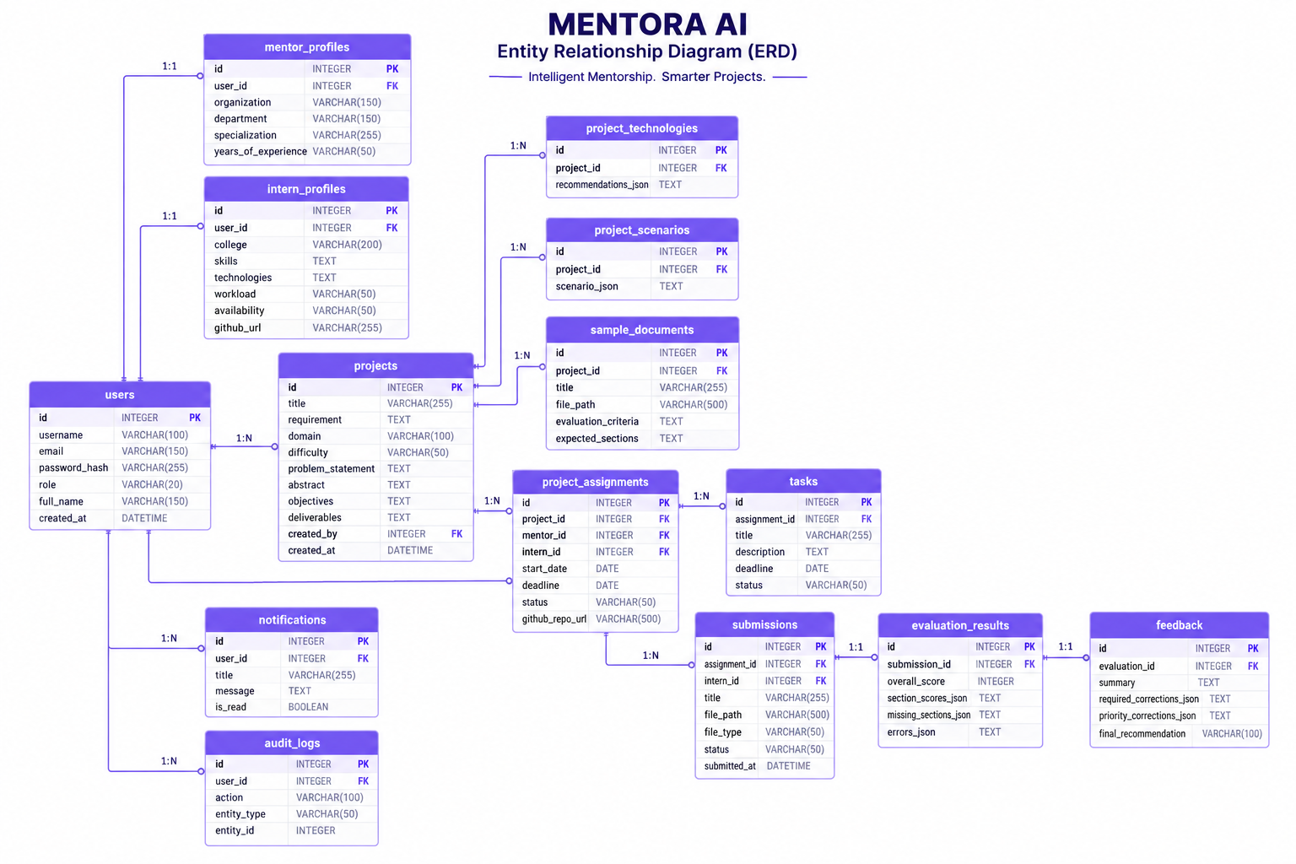

Description:
The ER diagram represents the core data structure of the Mentora AI platform, including entities such as Users, Mentors, Interns, Projects, Assignments, Tasks, Submissions, Evaluations, Feedback, Notifications, and Audit Logs. These entities are connected through relationships that support mentor–intern collaboration and project management. Users provide the foundation for mentor and intern profiles, while projects are associated with assignments and tasks. Intern submissions are evaluated through evaluations and feedback, while notifications support important platform updates. Audit logs maintain records of significant system activities. Together, these entities and relationships represent the complete data flow of the Mentora AI platform.

Pre-requisites:
- Flask Documentation: https://flask.palletsprojects.com/
- Flask-SQLAlchemy Documentation: https://flask-sqlalchemy.palletsprojects.com/
- Gemini API Documentation: https://ai.google.dev/gemini-api/docs
- Jinja2 Documentation: https://jinja.palletsprojects.com/
- MDN HTML & CSS Documentation: https://developer.mozilla.org/
- Python Documentation: https://docs.python.org/3/
- SQLAlchemy Documentation: https://docs.sqlalchemy.org/
- SQLite Documentation: https://www.sqlite.org/docs.html
- PostgreSQL Documentation: https://www.postgresql.org/docs/
- Git Documentation: https://git-scm.com/doc
- RAG Overview: Google Cloud RAG Overview

Project Workflow:

Activity 1: AI Model Selection and Multi-Agent Architecture
Activity 1.1: Generate a Google Gemini API key and configure it securely in the project environment.
Activity 1.2: Research and select the appropriate Gemini model tier for structured JSON generation across nine specialized agents.
Activity 1.3: Define the multi-agent orchestration architecture, detailing how MentoraOrchestrator routes intents to specialized agents and services.
Activity 1.4: Set up the development environment, installing Flask, SQLAlchemy, and the Gemini SDK dependencies.

Activity 2: Core AI Agent Functionalities Development
Activity 2.1: Develop the nine specialized agents — Project, Technology, Scenario, Matching, Tracking, Health, Evaluation, Feedback, and Copilot.
Activity 2.2: Implement the RAG-augmented evaluation pipeline that grades intern submissions against mentor reference documents.

Activity 3: App.py & Service Layer Development
Activity 3.1: Write the main application logic in app.py, establishing role-guarded routes, session authentication, and the SQLAlchemy service layer.

Activity 4: Frontend Development
Activity 4.1: Design and develop the zero-JavaScript pastel user interface using semantic HTML5 and pure CSS.
Activity 4.2: Build server-side dynamic rendering with Jinja2 templates, forms, and flash-message feedback.

Activity 5: Deployment
Activity 5.1: Prepare the application for local deployment by configuring the virtual environment and dependencies.
Activity 5.2: Test and verify the application locally across mentor and intern workflows.
Activity 5.3: Deploy the application to a production WSGI server and managed database.

Activity 6: Conclusion

Milestone 1: AI Model Selection and Multi-Agent Architecture
In this milestone, we focus on selecting Google's Gemini 2.5 Flash as the reasoning engine for Mentora AI and designing the multi-agent orchestration layer that routes every mentor and intern action — project generation, matching, tracking, health scoring, evaluation, feedback, and copilot conversation — to a dedicated specialized agent.

Activity 1.1: Generate a Google Gemini API Key
Before the application can communicate with the Gemini LLM, you need a valid Gemini API key. Follow the steps below to create one and connect it securely to the project.
Step 1 — Open Google AI Studio: Visit https://aistudio.google.com and sign in with your Google account.
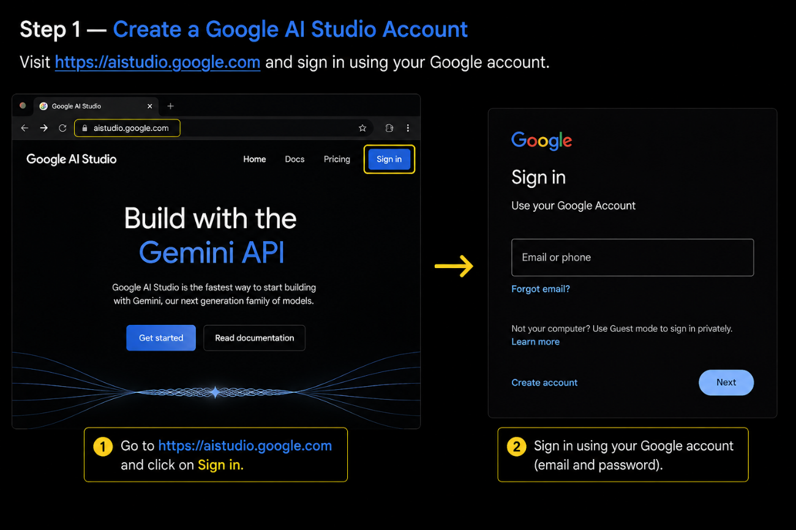

Step 2 — Create an API Key: Navigate to the “Get API key” section and click “Create API key,” selecting or creating a Google Cloud project to associate it with.
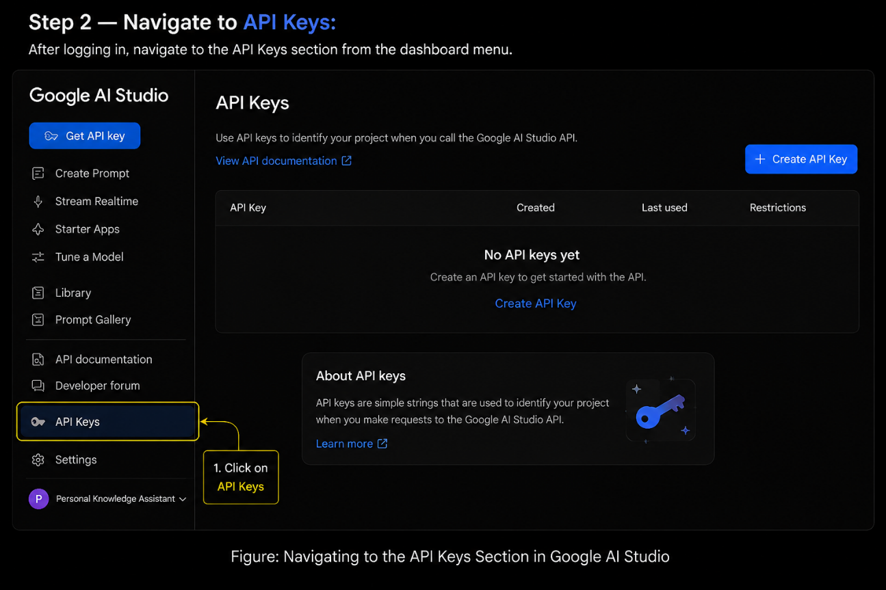
Step 3 — Copy the Key Immediately: Google AI Studio displays the key once. Copy it and store it somewhere safe before navigating away.
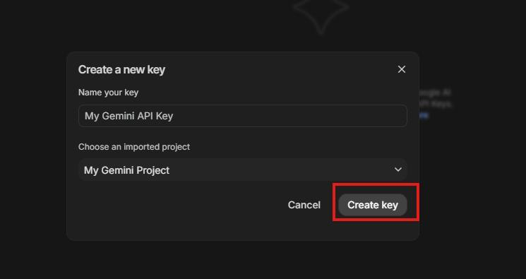
Step 4 — Add the Key to Your Project: Create a .env file in the project root (if it does not already exist) and paste the key as shown below:
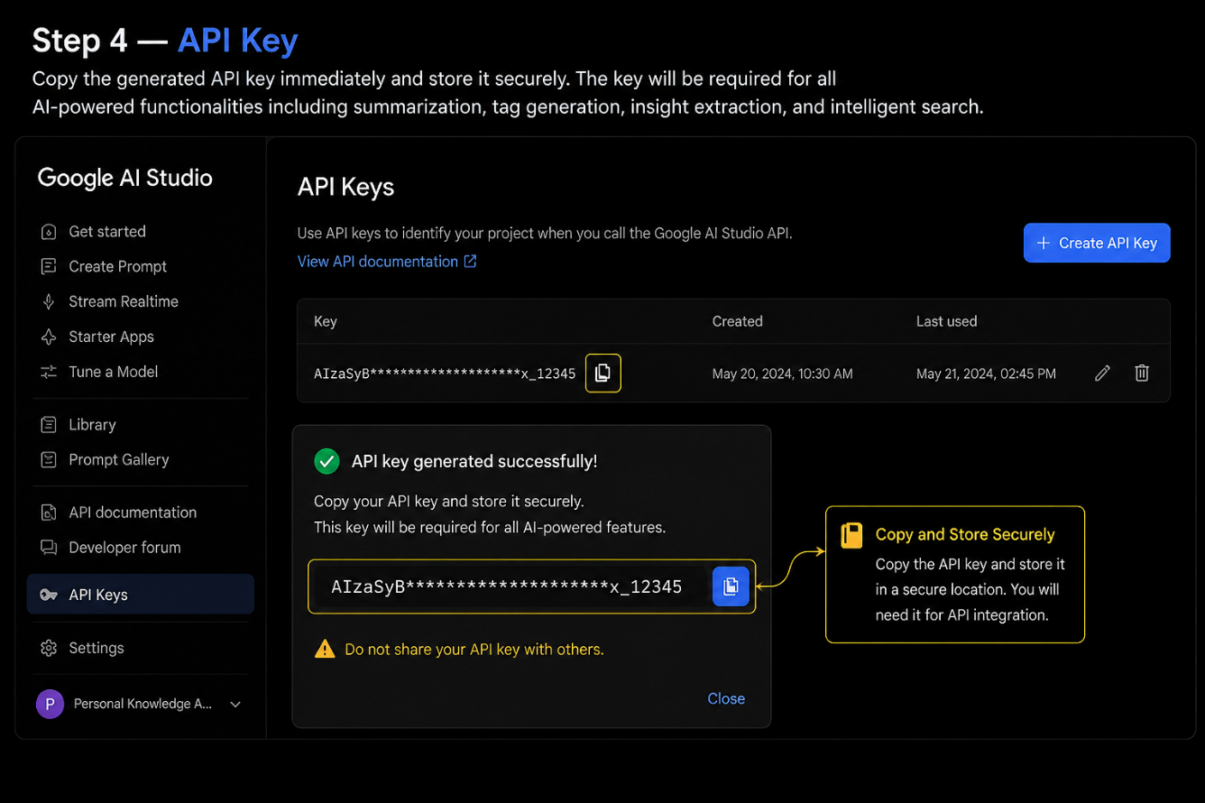
Step 5 — Verify the Key is Loaded: config.py loads this key automatically at startup using python-dotenv:
from dotenv import load_dotenv
BASE_DIR = Path(__file__).resolve().parent
load_dotenv(BASE_DIR / '.env')
a
class Config:
GEMINI_API_KEY = os.getenv('GEMINI_API_KEY', '')
Important — Never Commit Your API Key: Add .env to your .gitignore file to prevent accidentally pushing the key to a public repository.

Activity 1.2: Research and Select the Appropriate Generative AI Model
Understand the Project Requirements: Review Mentora AI's need to generate structured JSON across nine distinct agent workflows — from multi-project blueprints to submission evaluation — each requiring fast, deterministic, schema-consistent output.
Explore Gemini's Model Documentation: Examine Google's available Gemini model families, comparing context window, latency, and JSON-mode reliability.
Evaluate Model Performance: Compare candidate models on structured-output consistency, reasoning depth for multi-section evaluation, and response latency for a responsive mentor workspace.
Select the Optimal Model and Build a Resilient Fallback Chain: gemini_service.py initializes the google-genai client and tries a prioritized list of model identifiers per call, silently falling forward to the next candidate if one is unavailable, so the platform stays functional across API tier changes:
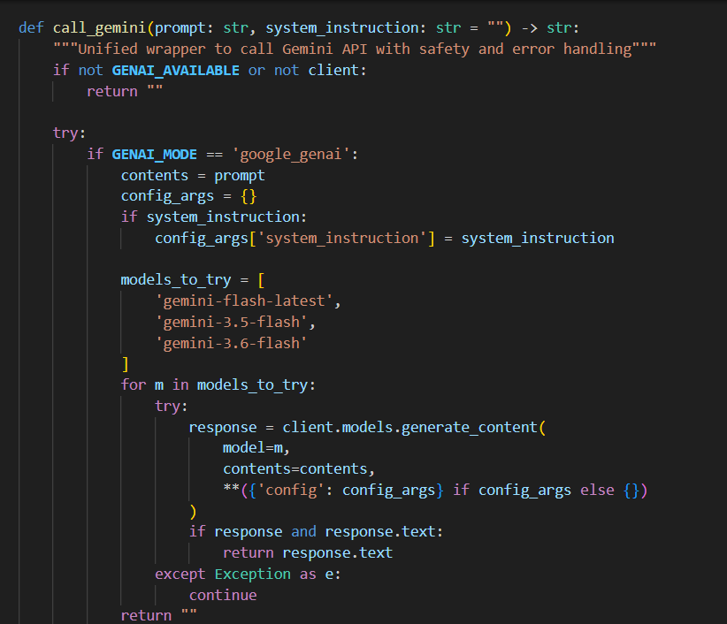

Activity 1.3: Define the Multi-Agent Orchestration Architecture
Draft an Architectural Diagram: Create a visual representation of the application architecture — the Jinja2/CSS browser client, the Flask routing layer, the eight-module service layer, the MentoraOrchestrator intent router, the specialized agents, the Gemini API, the RAG vector store, and the SQLAlchemy data layer.
Detail the Intent-Routing Contract: MentoraOrchestrator.route_request(intent, payload) inspects a lowercased intent string and dispatches to the matching agent function, keeping every call-site in app.py decoupled from the underlying Gemini prompt engineering:
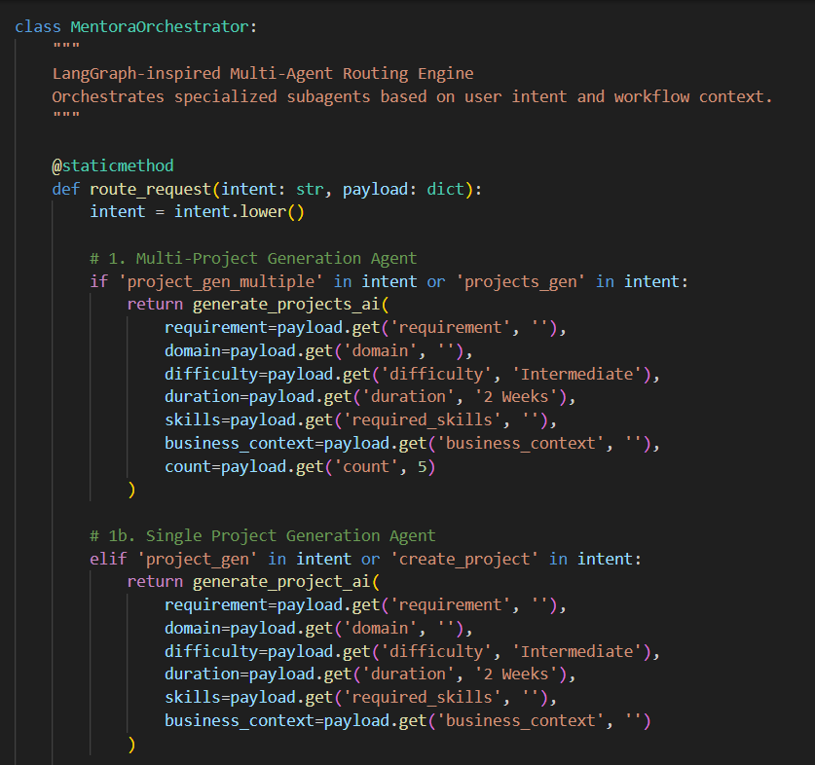
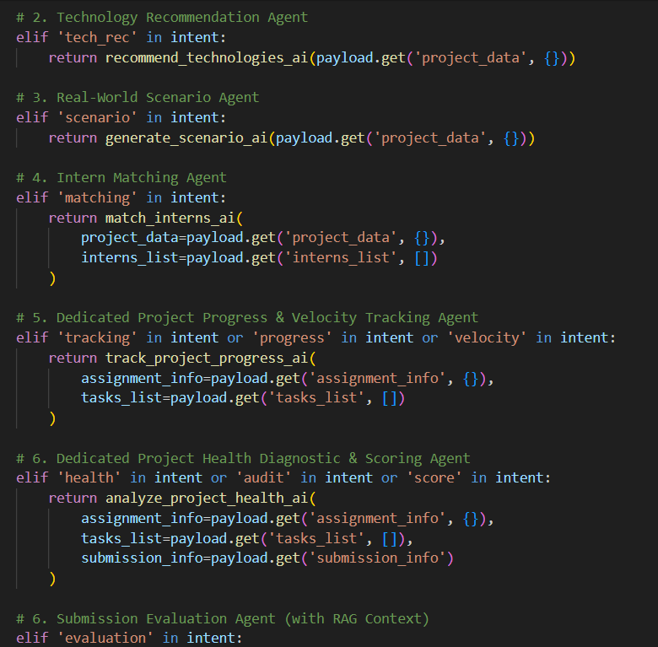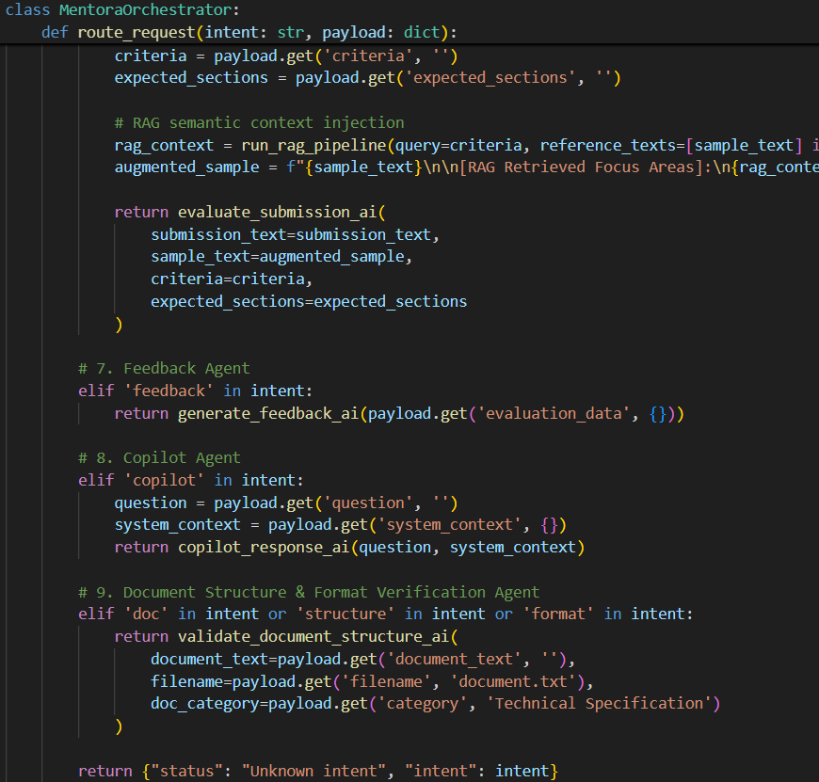
Map Every Agent to Its Module: The orchestrator fans out to nine agent-facing functions in gemini_service.py, each backed by a thin wrapper class in agents/*.py (project_agent.py, technology_agent.py, scenario_agent.py, matching_agent.py, tracking_agent.py, health_agent.py, evaluation_agent.py, feedback_agent.py, and the standalone pre_submission_agent.py used for document pre-checks).

Activity 1.4: Set Up the Development Environment
Install Python and Pip: Ensure Python 3.9+ is installed on your machine along with pip for dependency management.
Create a Virtual Environment: Set up a virtual environment using venv to isolate project dependencies:
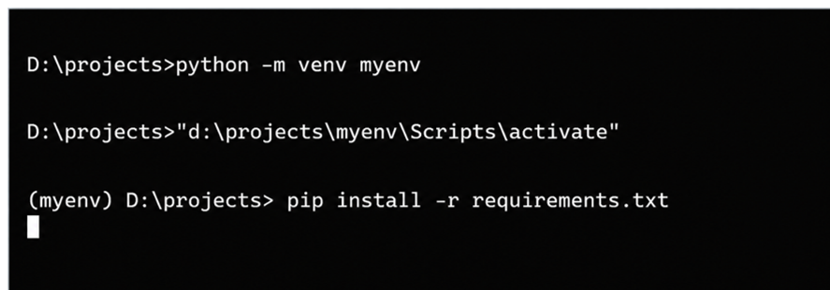
Install Project Dependencies: Install every dependency listed in requirements.txt in one step:
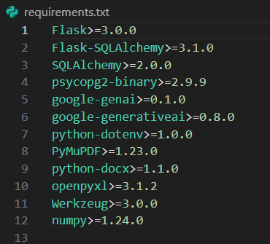

Configure the API Key: Create the .env file in the project root and add your Gemini API key, secret key, and database URL as shown in Activity 1.1.
Set Up the Application Structure: Config.py auto-creates the uploads/ directory tree (samples/, submissions/, templates/, upskilling/) used for sample documents, intern submissions, and self-learning material on first run.
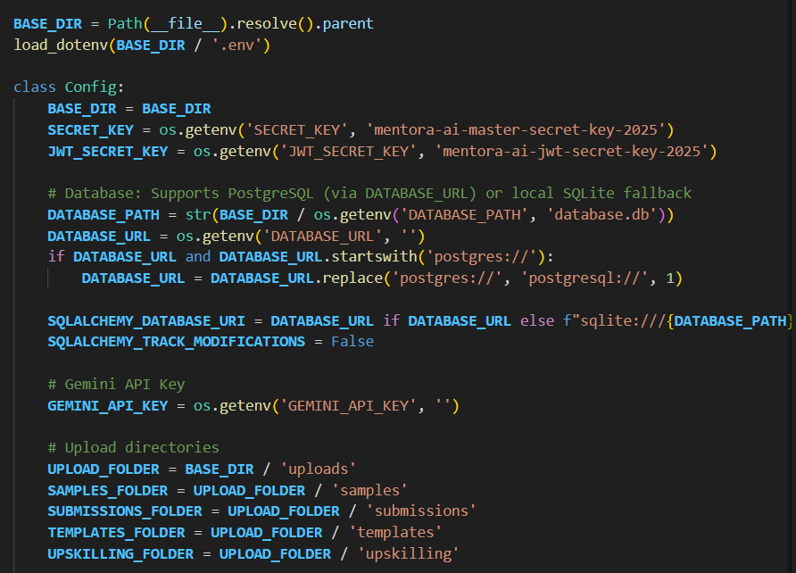
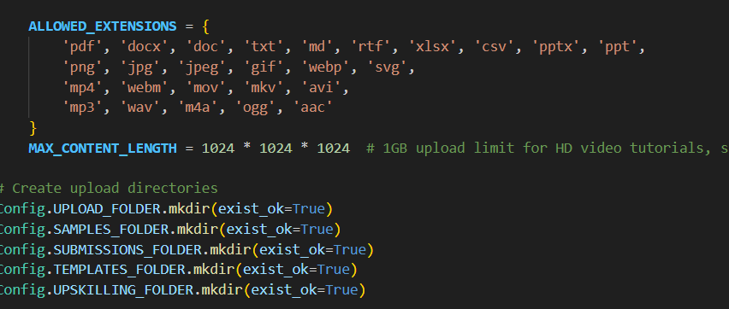

Milestone 2: Core AI Agent Functionalities Development
Milestone 2 builds the nine specialized AI agents that give Mentora AI its intelligence — from generating full project blueprints to grading a submitted deliverable against a mentor's own reference document using Retrieval-Augmented Generation.

Activity 2.1: Develop the Specialized AI Agents

Project Generation Agent: generate_projects_ai() drives the AI Project Generator, instructing Gemini to produce five distinct, production-grade project blueprints for a single mentor prompt — each with a unique architectural angle (multi-agent automation, RAG knowledge base, predictive analytics, full-stack copilot, or real-time streaming) and a complete problem statement, abstract, objectives, and requirements set:
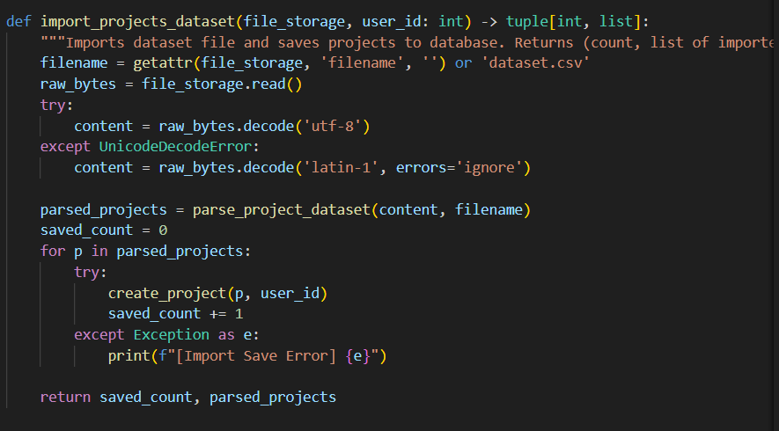
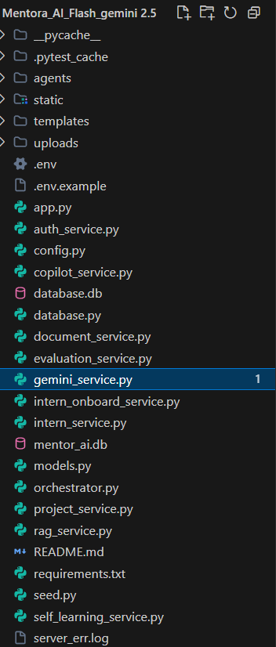
Technology & Scenario Agents: recommend_technologies_ai() maps each saved project to a tailored stack of languages, frameworks, databases, AI tools, and testing tooling (e.g. Google Gemini API — gemini-2.5-flash for structured JSON reasoning); generate_scenario_ai() synthesizes a real-world enterprise business scenario, user personas, and ROI benefits for the same project.
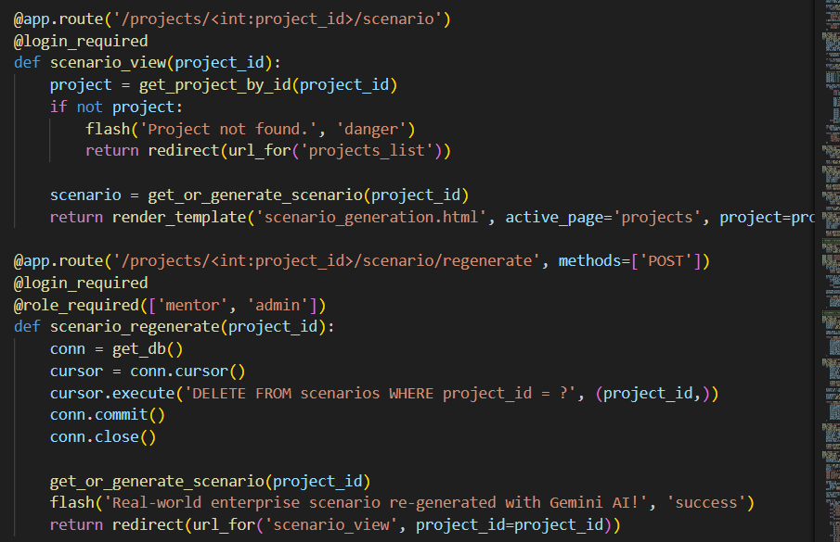

Matching Agent: match_interns_ai() compares a project's required_skills against every intern's skills, technologies, workload, and availability fields, returning a ranked, semantically-scored shortlist with missing-skill diagnostics that powers the AI Intern Matching page.
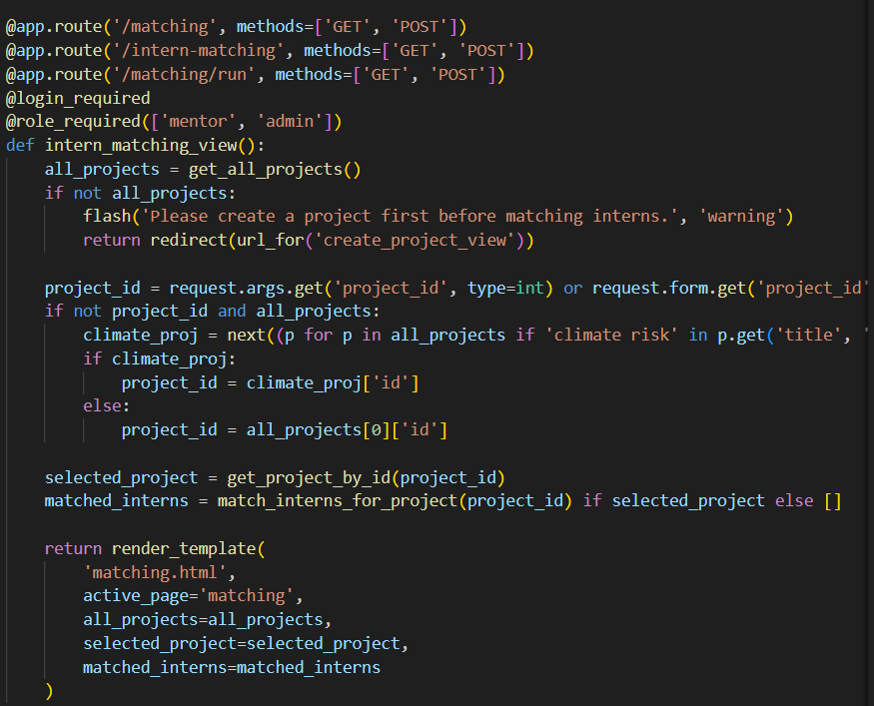
Tracking & Health Agents: track_project_progress_ai() analyzes an assignment's task list to estimate completion velocity, while analyze_project_health_ai() produces a HEALTHY / NEEDS ATTENTION / CRITICAL diagnostic badge from deadline proximity, task status distribution, and submission state.
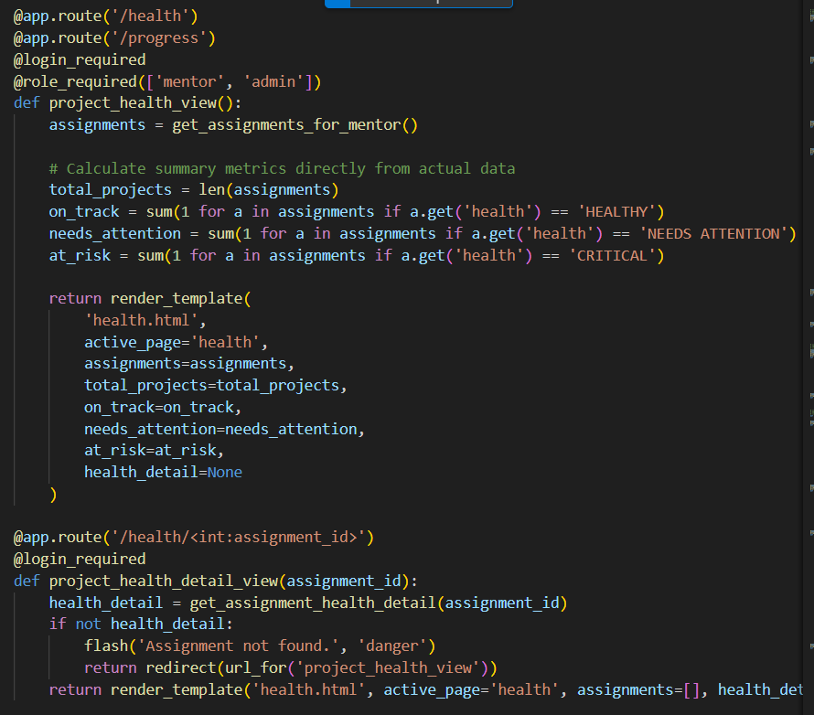
Evaluation & Feedback Agents: evaluate_submission_ai() scores an intern's submission section-by-section against a sample/reference document and criteria; generate_feedback_ai() converts that raw evaluation into an executive summary, prioritized corrections, and a final approval recommendation for the mentor.
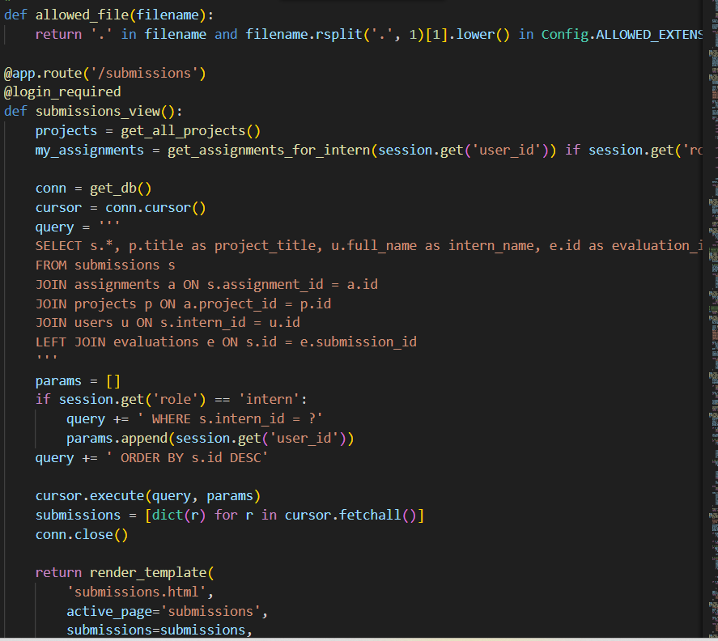
Pre-Submission Review Agent: agents/pre_submission_agent.py extracts and previews document text (including fetching shared Google Docs via fetch_google_doc_text) before an intern formally submits, catching empty or malformed uploads early.
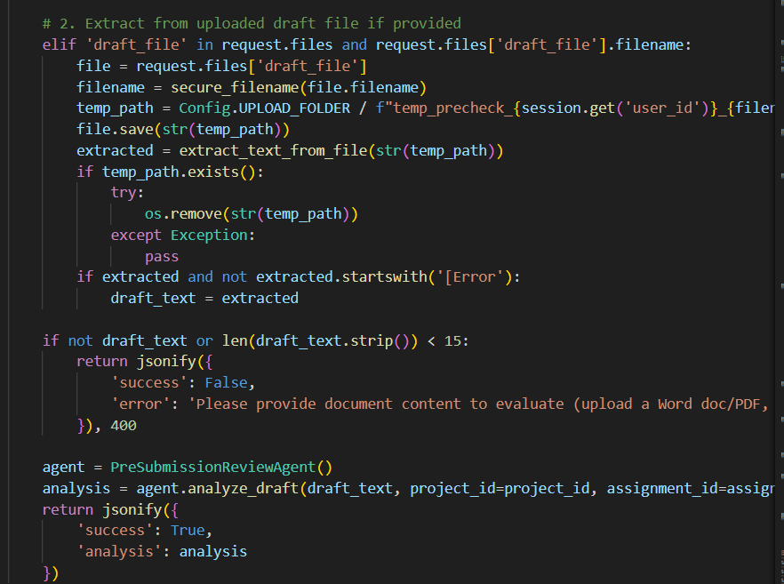
Copilot Agent: copilot_response_ai() answers free-form mentor questions using a live database snapshot as grounding context, and can additionally trigger intern-provisioning actions when the question expresses onboarding intent.
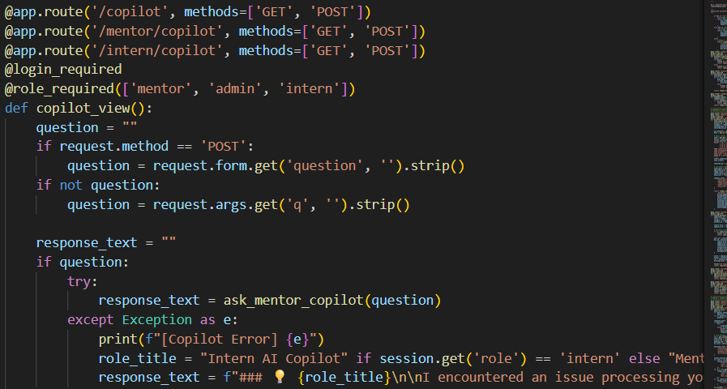

Activity 2.2: Implement the RAG-Augmented Evaluation Pipeline
Chunk and Vectorize Reference Documents: rag_service.py implements a lightweight, dependency-free SimpleVectorStore that splits mentor reference documents into overlapping word chunks and builds TF-IDF style vectors over a shared vocabulary:
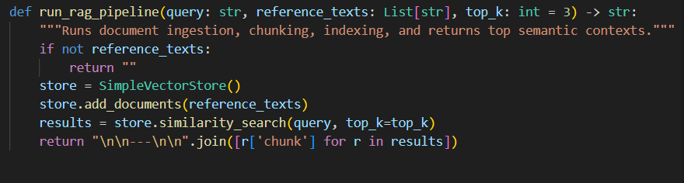
Retrieve by Cosine Similarity: similarity_search() vectorizes the evaluation criteria as a query and ranks every chunk by dot-product similarity against the normalized document vectors, returning the top-k most relevant passages:

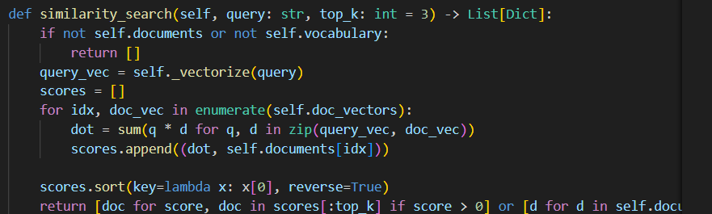
Fall Back to a Generated Blueprint Standard: When a mentor hasn't uploaded a sample document, run_submission_evaluation() in evaluation_service.py builds an authoritative specification from the project's own abstract, problem statement, objectives, scope, and deliverables so every submission is still graded against a concrete standard.
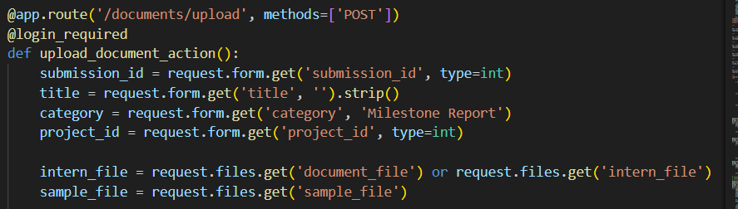

Milestone 3: App.py & Service Layer Development
Milestone 3 focuses on the application backbone — app.py, which wires together 90+ routes, session-based authentication, role-based access control, and eight service-layer modules that each own a distinct slice of the domain model.

Activity 3.1: Writing the Main Application Logic in app.py
Define Session Authentication & Role Guards: Two decorators gate every protected route — login_required() verifies an active session and that the user still exists in the database, while role_required() further restricts access to specific roles (mentor, intern, admin):
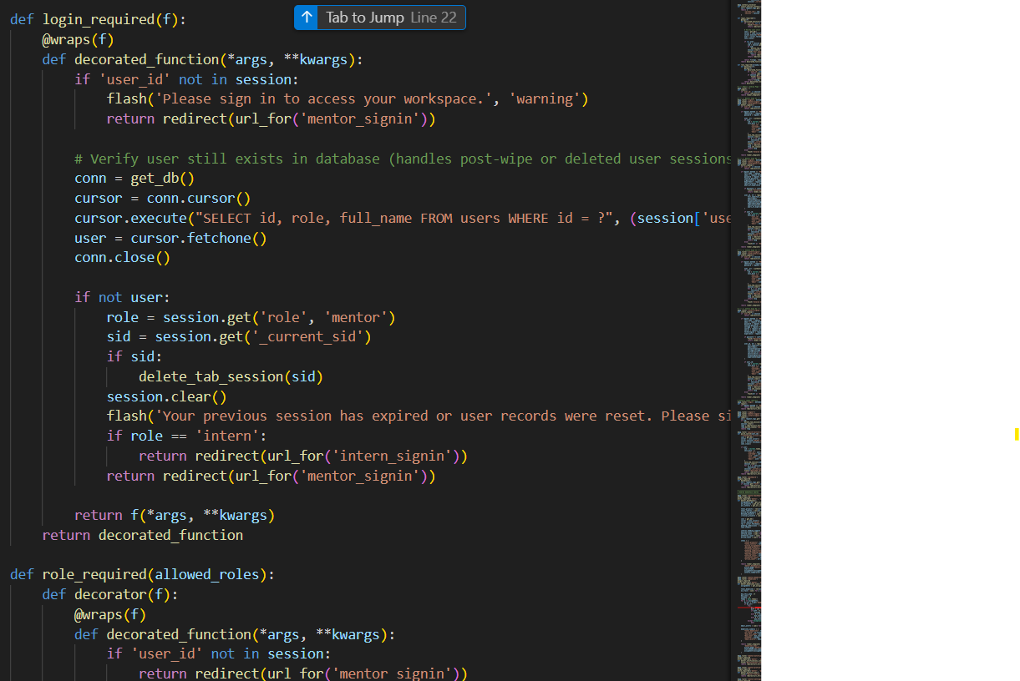
Drive AI Project Generation Through the Orchestrator: The create_project_view() route reads the mentor's free-text requirement and delegates directly to MentoraOrchestrator.route_request(), normalizing metadata on every generated blueprint before rendering the flashcard selection screen:
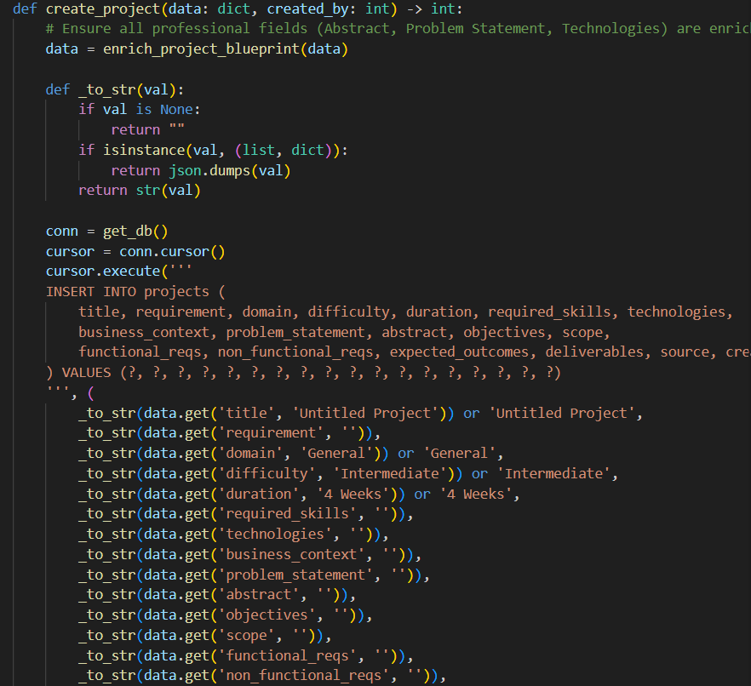
Wire the Matching Workflow: intern_matching_view() loads every project, resolves the selected one, and calls the intern service layer, which in turn calls the Matching Agent through the orchestrator:
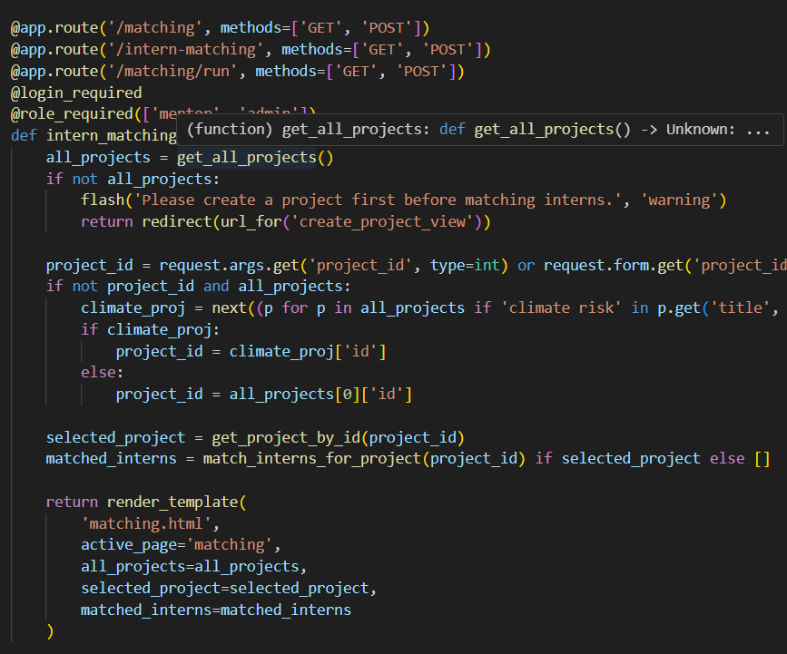

Activity 3.2: Service Layer & SQLAlchemy Data Models

Authenticate Users Securely: auth_service.py hashes passwords with Werkzeug and derives the username from the email address on registration:
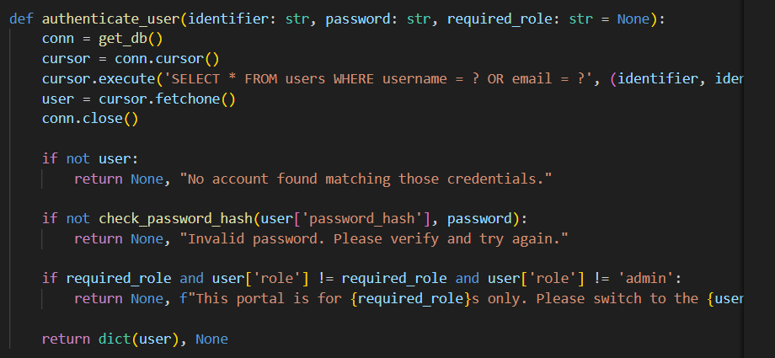
Model the Domain with SQLAlchemy: models.py defines thirteen related tables — User, MentorProfile, InternProfile, Project, ProjectTechnology, ProjectScenario, ProjectAssignment, Task, SampleDocument, Submission, EvaluationResult, Feedback, Notification, and AuditLog — with cascading deletes so that removing a project cleans up its technologies, scenarios, assignments, and sample documents automatically:
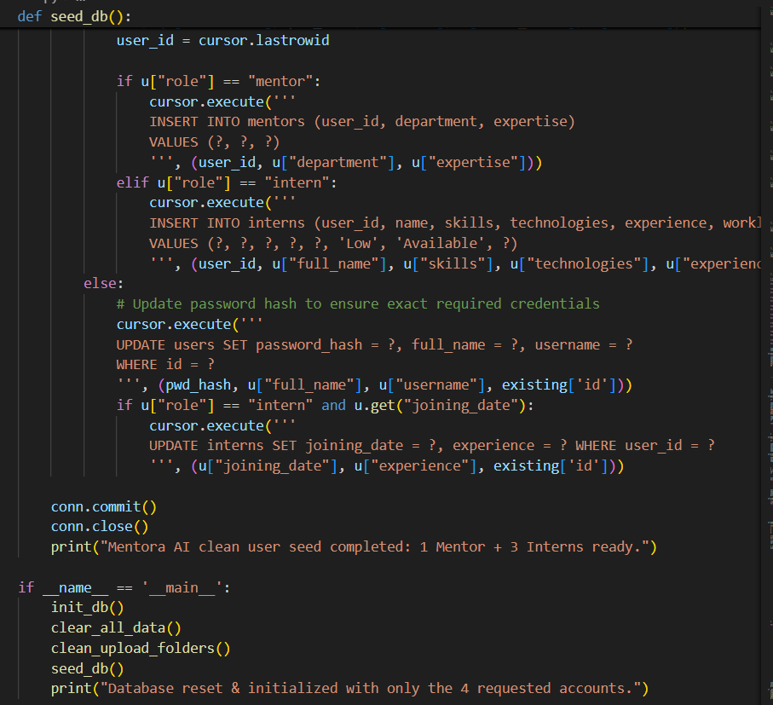
Support SQLite and PostgreSQL Interchangeably: config.py builds SQLALCHEMY_DATABASE_URI from a DATABASE_URL environment variable when present (auto-correcting the legacy postgres:// scheme to postgresql://), and falls back to a local SQLite file for development.
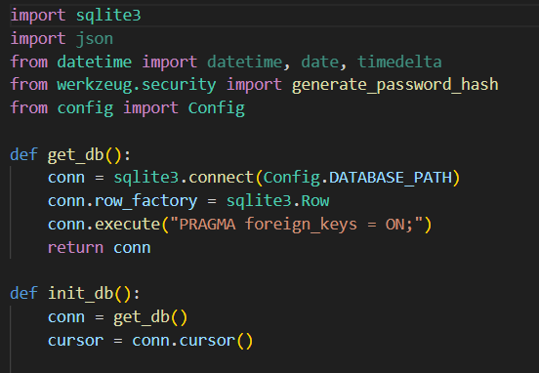

Milestone 4: Frontend Development
Milestone 4 focuses on building a calm, professional, zero-JavaScript interface for Mentora AI. Every interaction — form submission, filtering, navigation — is handled through standard HTML5 forms and server-side redirects, styled entirely with a hand-built pastel CSS design system.

Activity 4.1: Designing the Zero-JavaScript Pastel UI
Define the Design Token System: static/style.css declares the full Mentora pastel palette, radii, and shadow tokens as CSS custom properties, giving every template a single, consistent source of truth for color and spacing:
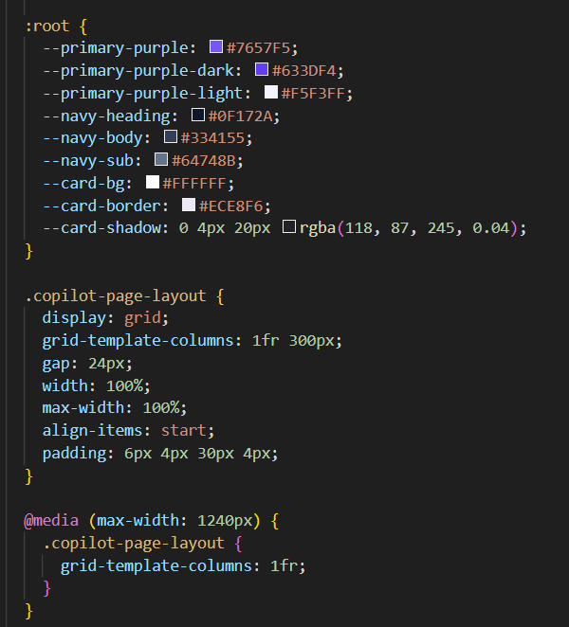
Establish the Layout Language: The design uses split-screen authentication panels, rounded 20–24px cards, soft ambient shadows, and Plus Jakarta Sans typography, imported once via Google Fonts and reused across every mentor and intern surface.
Compose Feature-Specific Templates: Each module owns a dedicated Jinja2 template under templates/ — create_project.html (AI generator flashcards), matching.html (ranked intern cards), assignments.html and tasks.html (Kanban-style status boards), health.html (HEALTHY / NEEDS ATTENTION / CRITICAL badges), submissions.html and evaluation.html (RAG scoring breakdown), and copilot.html (conversational history panel).

Activity 4.2: Server-Side Dynamic Rendering with Jinja2
Extend a Shared Base Layout: Every page extends templates/base.html, which renders the sidebar navigation, the active-page highlight, and a flash-message region so success and error banners appear consistently across the app.
Render AI Output Without a Single Fetch Call: Because there is no client-side JavaScript, every AI-generated result — project blueprints, match scores, evaluation breakdowns — is rendered directly into HTML by Flask on the same request/response cycle that triggered the Gemini call, keeping the architecture simple to reason about and easy to test.
Handle Both Form Posts and AJAX-style JSON: Several routes, such as create_project_view(), detect an X-Requested-With: XMLHttpRequest header or an explicit request.is_json check and branch between returning a full rendered page or a JSON payload — allowing the same endpoint to serve a classic form post or a lightweight fetch from a future client without duplicating logic.
Surface Contextual Feedback: Every mutating action ends with flash(message, category) followed by a redirect, so the pastel banner system (success, warning, danger) gives the mentor or intern immediate, readable confirmation of what happened.

Milestone 5: Deployment
In Milestone 5, the focus shifts to deploying Mentora AI first locally to verify correct operation across both the mentor and intern workspaces, and then to a production-grade host behind a WSGI server and a managed PostgreSQL database.

Activity 5.1: Preparing the Application for Local Deployment
Set Up a Virtual Environment: Create and activate a virtual environment, then install all required dependencies from requirements.txt:
Configure Environment Variables: Create a .env file in the project root with your Gemini API key, Flask secret key, and database URL. The app loads these automatically using python-dotenv at startup:
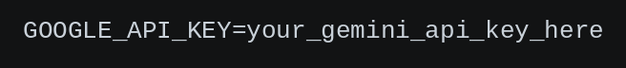

Activity 5.2: Local Testing and Verification
Start the Flask Development Server: Run the application locally using:
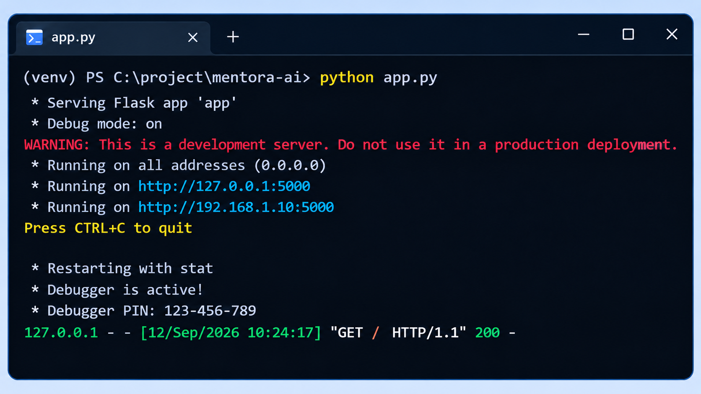
Once running, open a browser and navigate to http://127.0.0.1:5000 to access the public landing page.
Sign In with the Seeded Demo Accounts: database.py's seed_db() provisions a mentor (mentor1 / sarah.jenkins@mentora.ai) and two interns (intern_alex, intern_priya), all with the password password123, so every workflow can be exercised end-to-end immediately after first launch.
Exercise the Full Workflow: Generate a project on /mentor/projects/create, run AI matching on /matching, assign it to an intern, have the intern submit a deliverable, and confirm the RAG evaluation and feedback pipeline completes on /evaluations/<id>.
Run the Automated Test Suite: The project ships with a pytest-based test suite covering the core flows — test_app.py, test_intern_signup.py, test_create_project_page.py, test_multi_project_creator.py, test_projects_page.py, test_import_dataset.py, and test_chai_gen.py:
pytest -v

Activity 5.3: Public Deployment via Ngrok
Ngrok creates a secure tunnel from a public URL to your local Streamlit server, making the app accessible from anywhere without a cloud hosting provider.

Install Ngrok and pyngrok:
- Install the pyngrok Python wrapper, which manages Ngrok programmatically within your Python project:
pip install pyngrok
- Download and install the Ngrok client from https://ngrok.com/download.
- Click on “Microsoft Store Installer”.
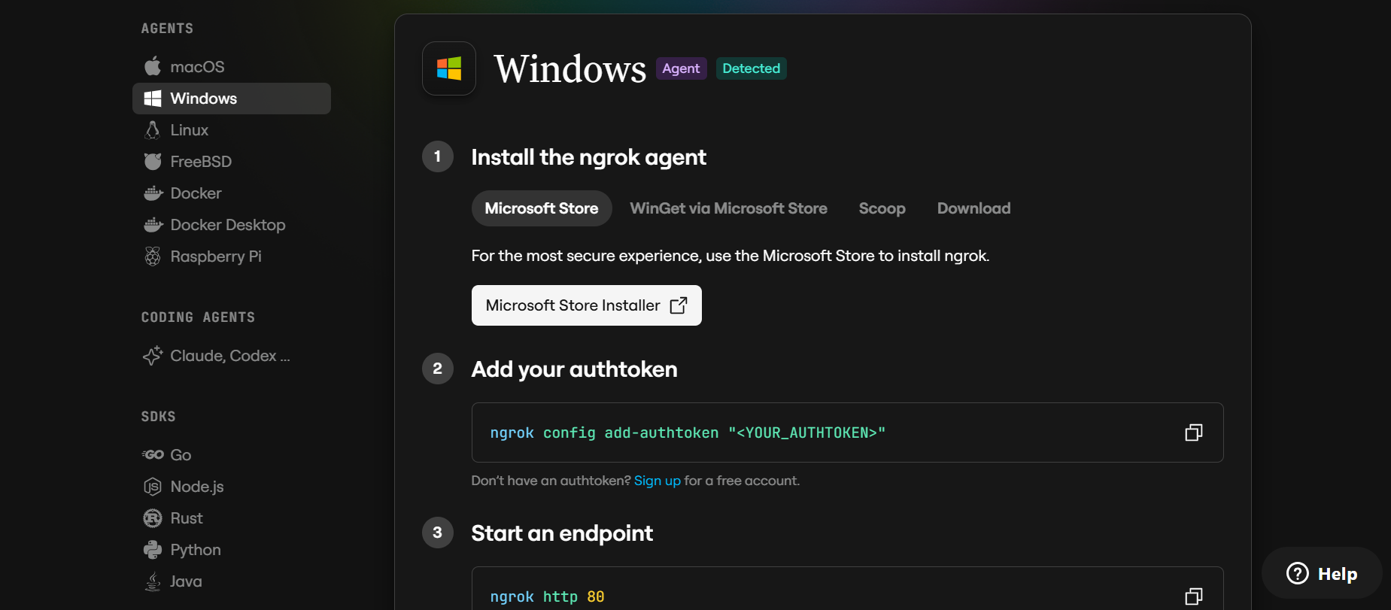
Configure Your Ngrok Authtoken:
- Sign up at ngrok.com and copy your authtoken from the Ngrok dashboard.
- The run_public.py script sets the authtoken automatically using:
ngrok.set_auth_token("YOUR_NGROK_AUTHTOKEN")
- Replace the TOKEN value in run_public.py with your own Ngrok authtoken before running.

Run the Public Deployment Script:
- Instead of running app.py directly, launch run_public.py to start both the Ngrok tunnel and the Streamlit server:
python run_public.py
- The script opens an HTTP tunnel on port 5000 and prints the live public URL in the terminal:
======================================================
YOUR PUBLIC WEBSITE URL IS LIVE!
URL: https://xxxx-xx-xx-xxx-xx.ngrok-free.app
======================================================

Important Notes:
- debug=False is required in run_public.py to prevent Streamlit from spawning a reloader process, which would interfere with Ngrok’s tunnel management.
- The public URL changes each time you restart run_public.py (on the free Ngrok plan). For a persistent URL, upgrade to a paid Ngrok plan and configure a reserved domain.
- Ngrok free tier sessions expire after a few hours of inactivity. Restart run_public.py to get a new URL when this happens.

Exploring the Website’s Web Pages:

Home / Landing Page:
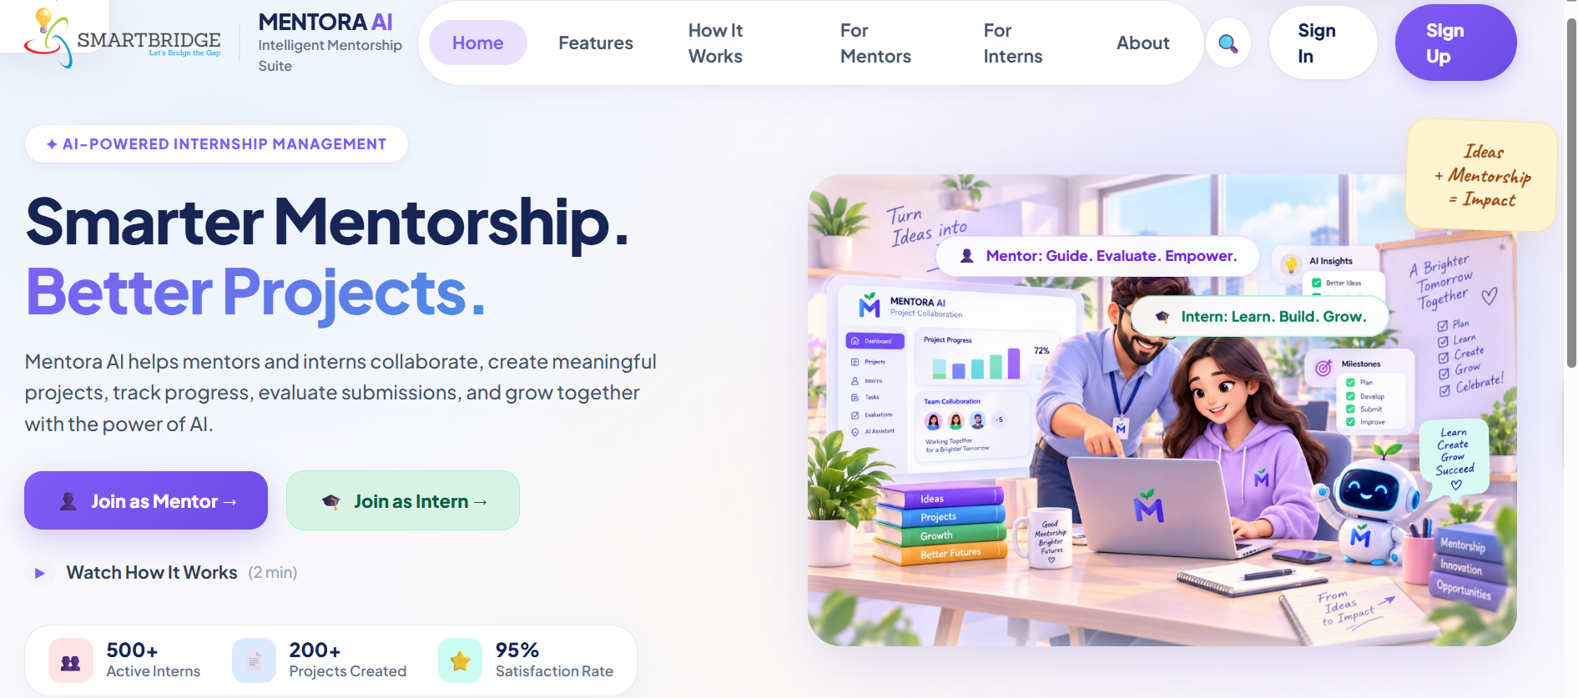
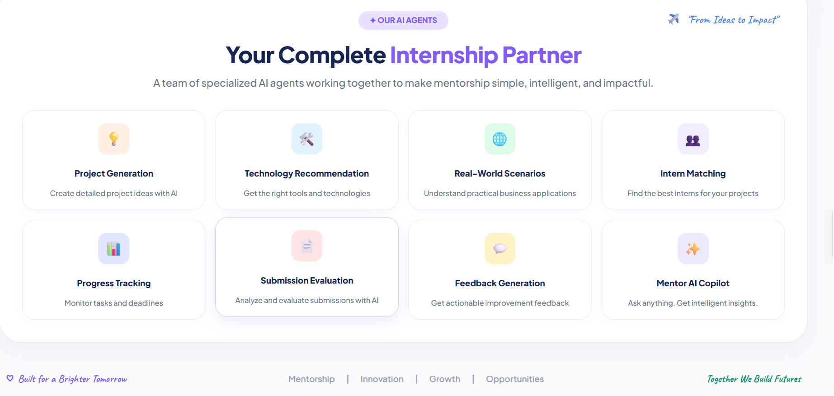
Description: The public landing page (/) introduces Mentora AI with a hero section, a feature overview of the eight key modules, and dedicated call-to-action buttons that route visitors to the separate Mentor and Intern authentication portals, keeping the two workspaces cleanly distinguished from the very first screen.

Mentor Sign Up / Sign In:
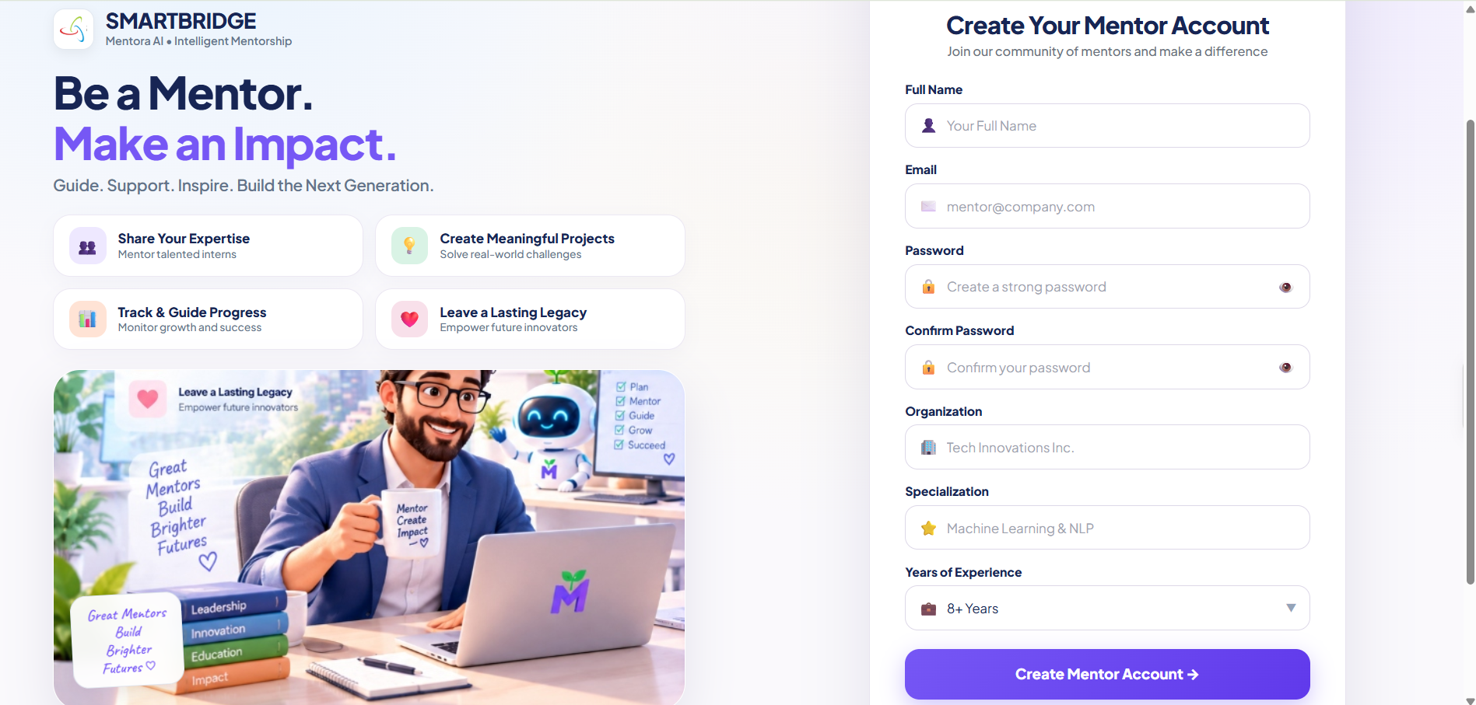
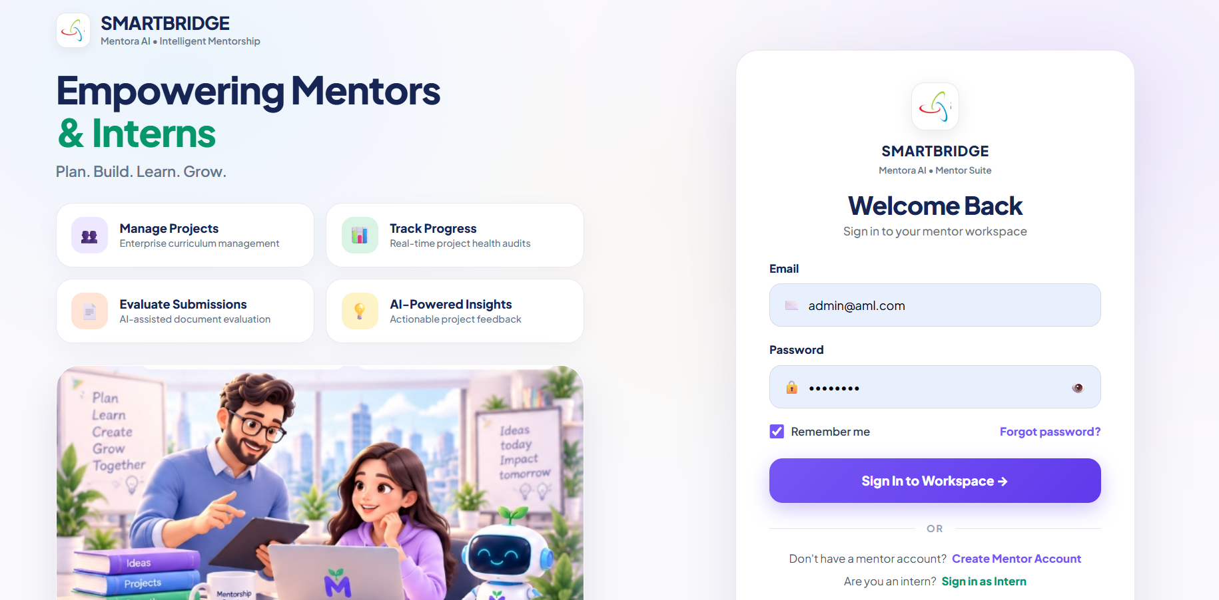

Description:
Mentor Sign Up / Sign In: Mentors can securely create an account or sign in using their registered credentials to access the Mentora AI dashboard and manage interns, projects, tasks, evaluations, and AI-powered features.

Mentor Dashboard:
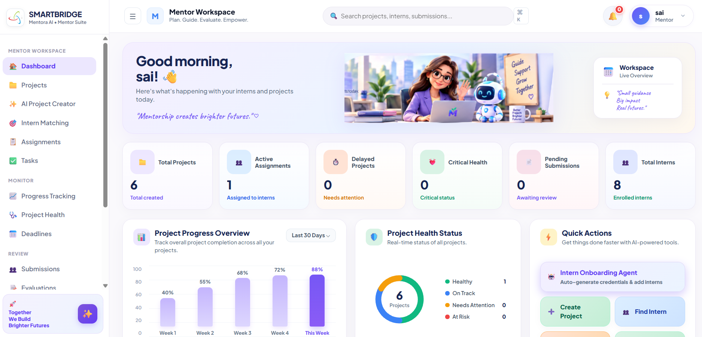
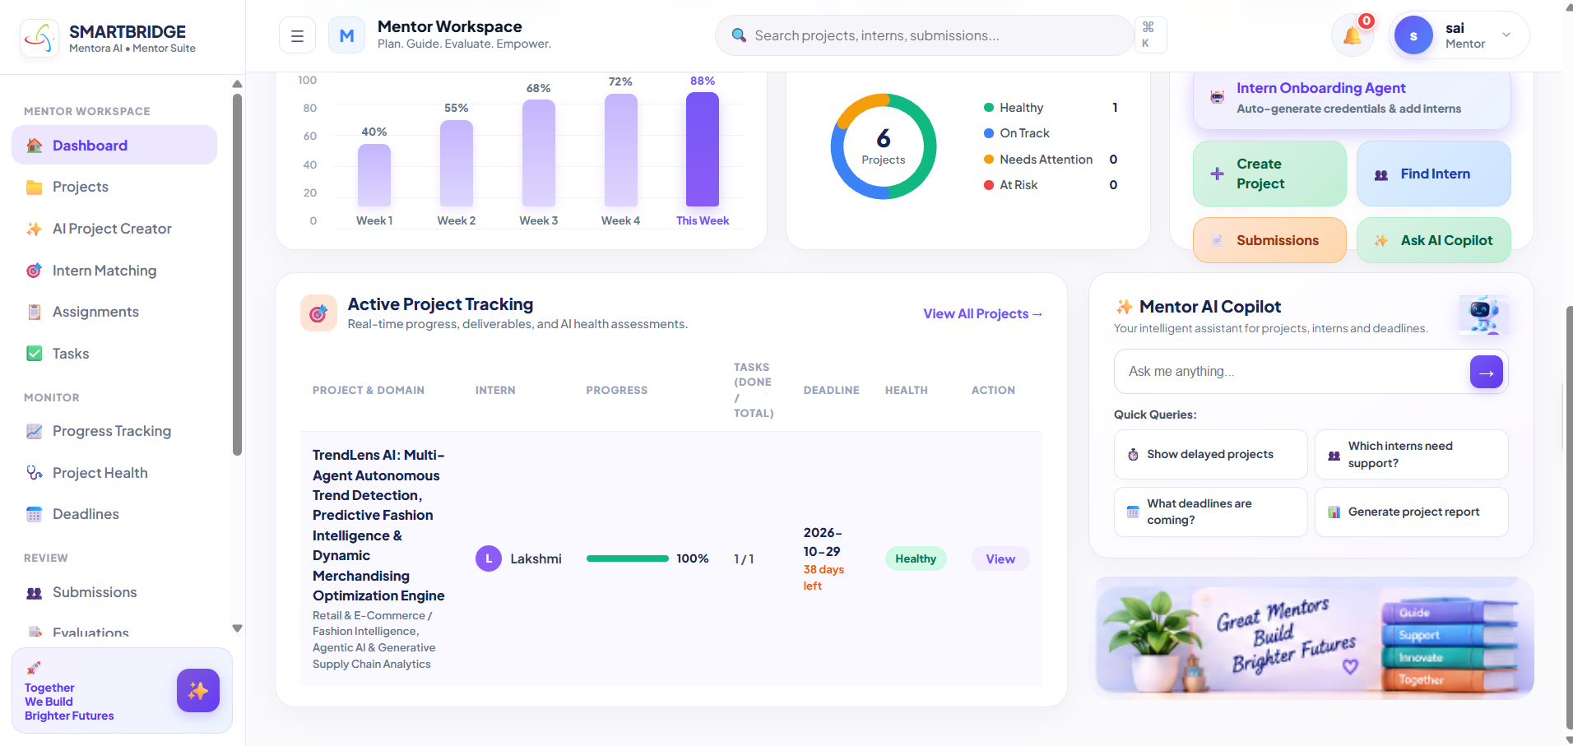

Description: /mentor/dashboard aggregates the mentor's active projects, assignments nearing their deadline, and a project-health snapshot into pastel summary cards, giving a single at-a-glance view before drilling into project generation, matching, or submissions.

AI Project Generator:
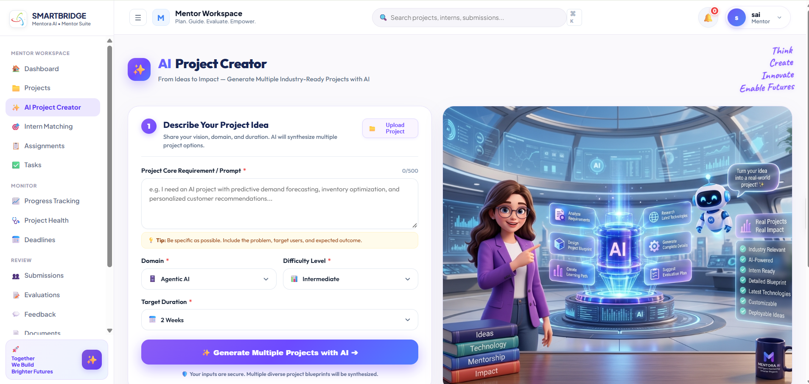

Description: /projects/create is where the Multi-Project Generation Agent turns a one-line requirement into five distinct, production-grade project blueprints, rendered as selectable flashcards with problem statement, abstract, objectives, and required skills — one click saves the chosen blueprint to the project repository.

AI Intern Matching:
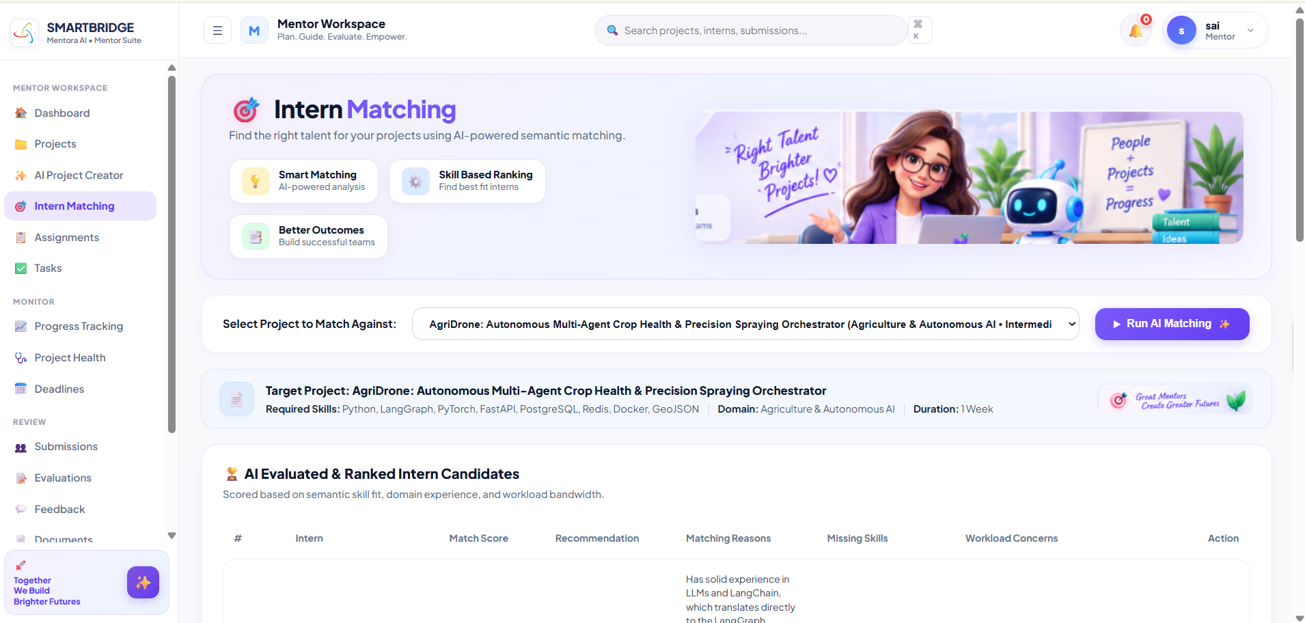
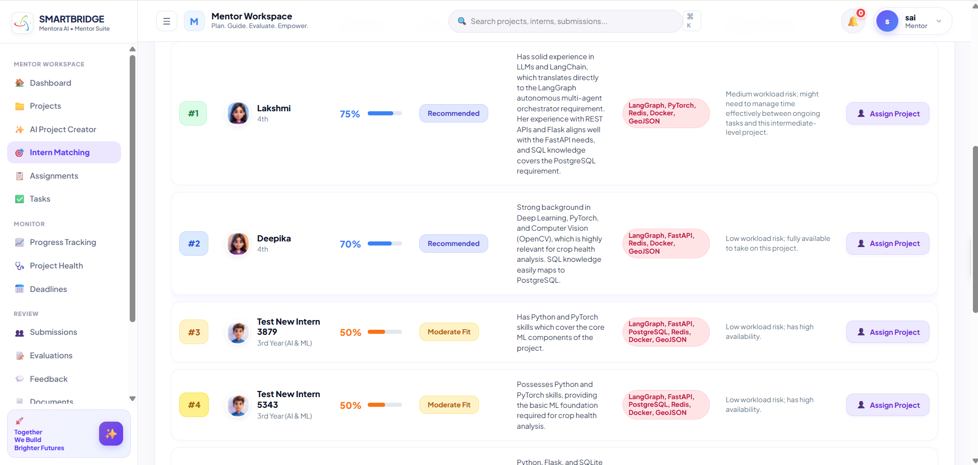

Description: /matching lets a mentor pick a saved project and see every registered intern ranked by a 0–100% semantic match score against that project's required skills, with missing-skill diagnostics and workload-risk flags surfaced directly on each intern's card.

Submissions & RAG Evaluation:
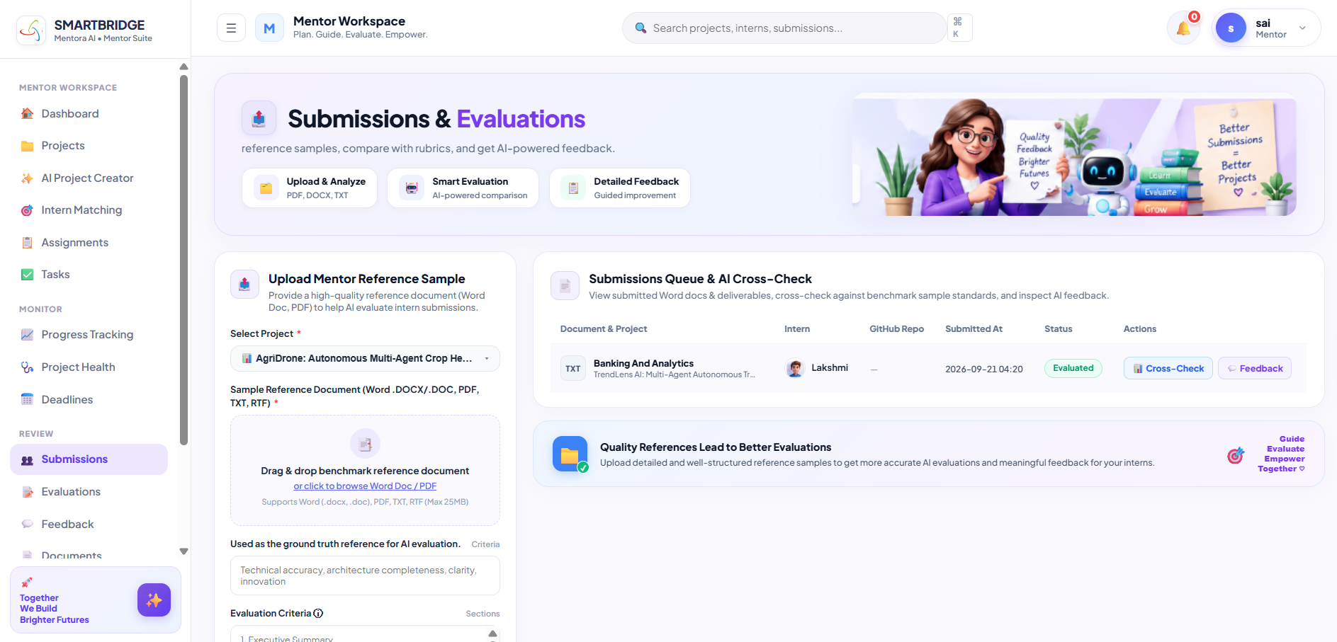
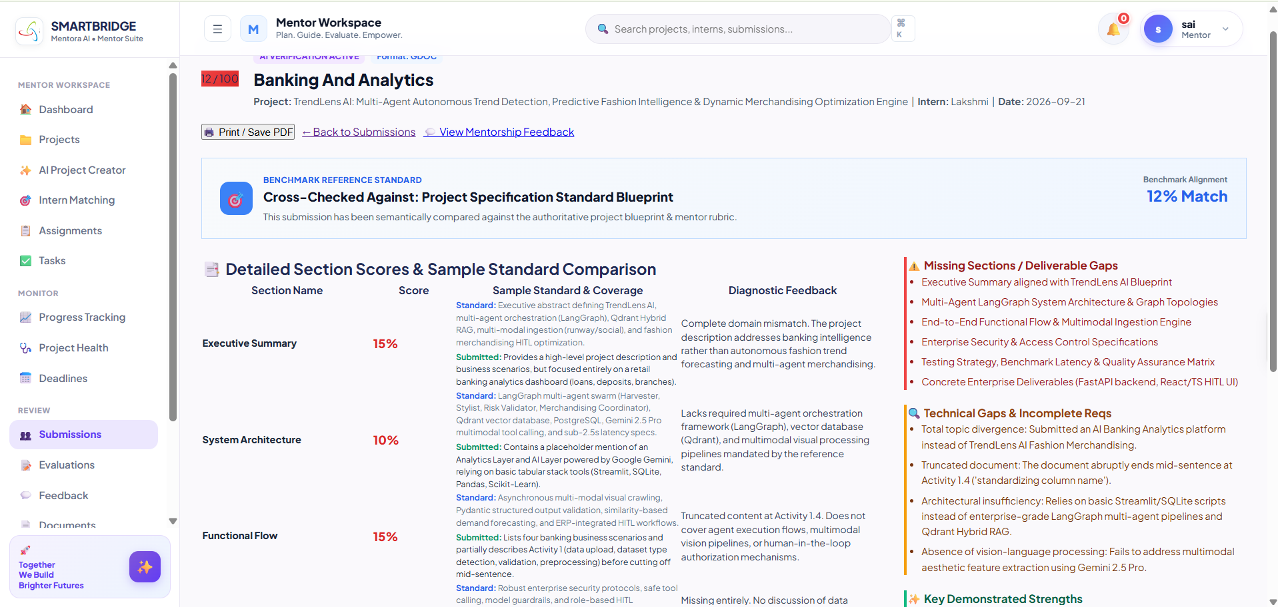
Description: /submissions lists every intern deliverable with its review status, and each evaluation page (/evaluations/<id>) shows the RAG-grounded, section-by-section score breakdown, missing sections, flagged errors, and the Feedback Agent's executive summary and final recommendation.

Mentor AI Copilot:
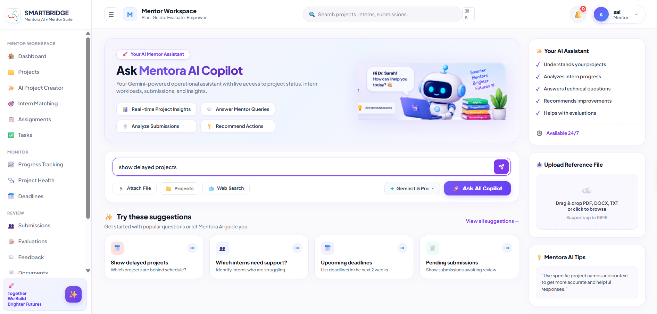
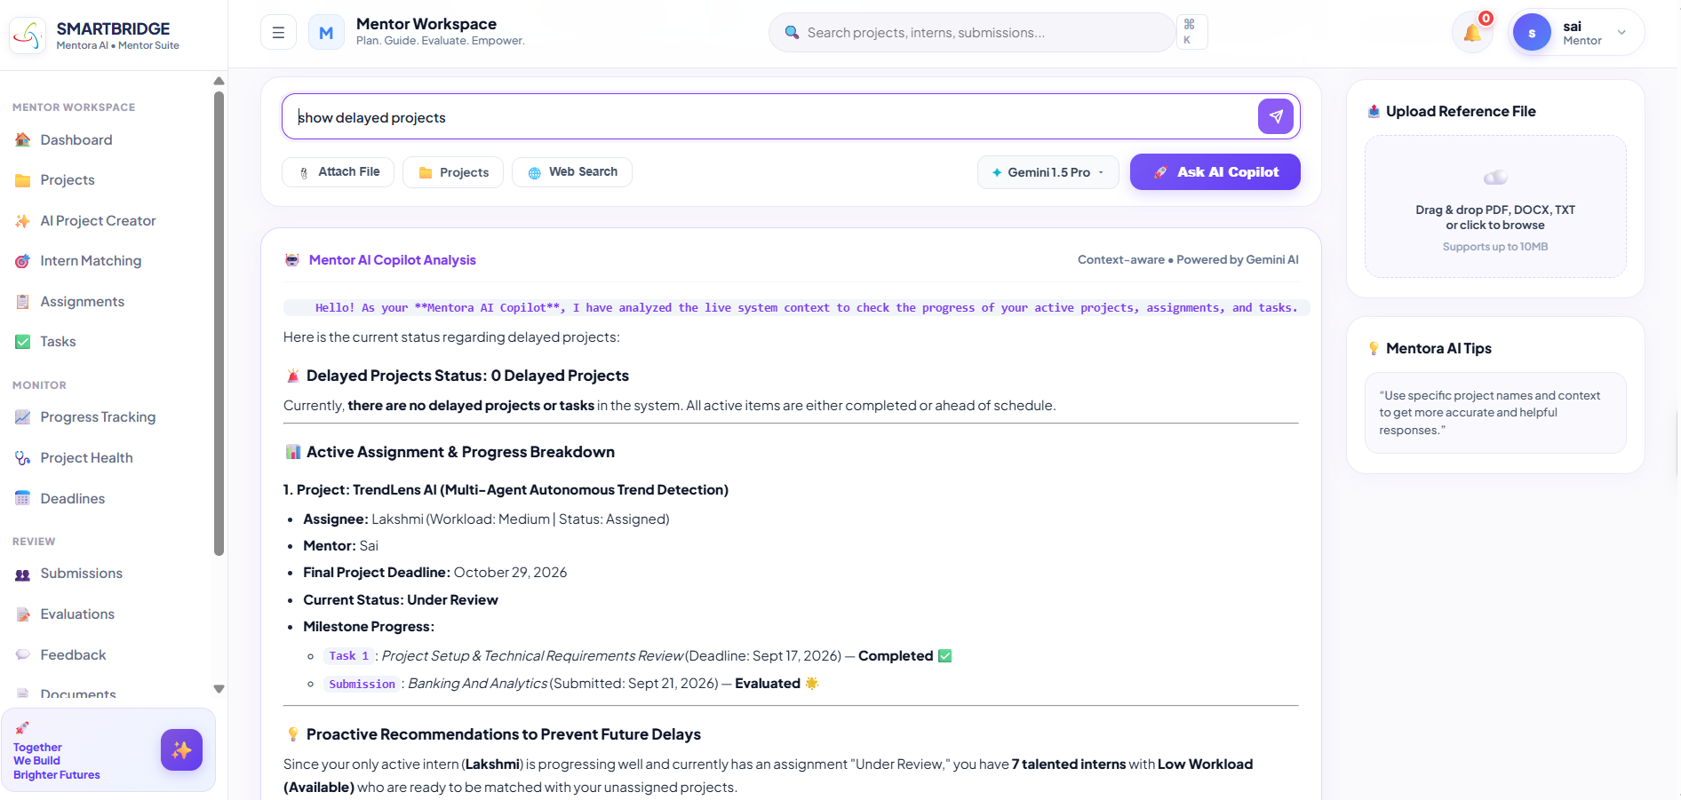

Description: /copilot is a persistent, context-aware conversational panel where a mentor can ask free-form questions about workload, deadlines, or intern status, and the Copilot Agent answers using a live snapshot of the mentor's own project, assignment, task, and submission data.

Interns Dashboard:
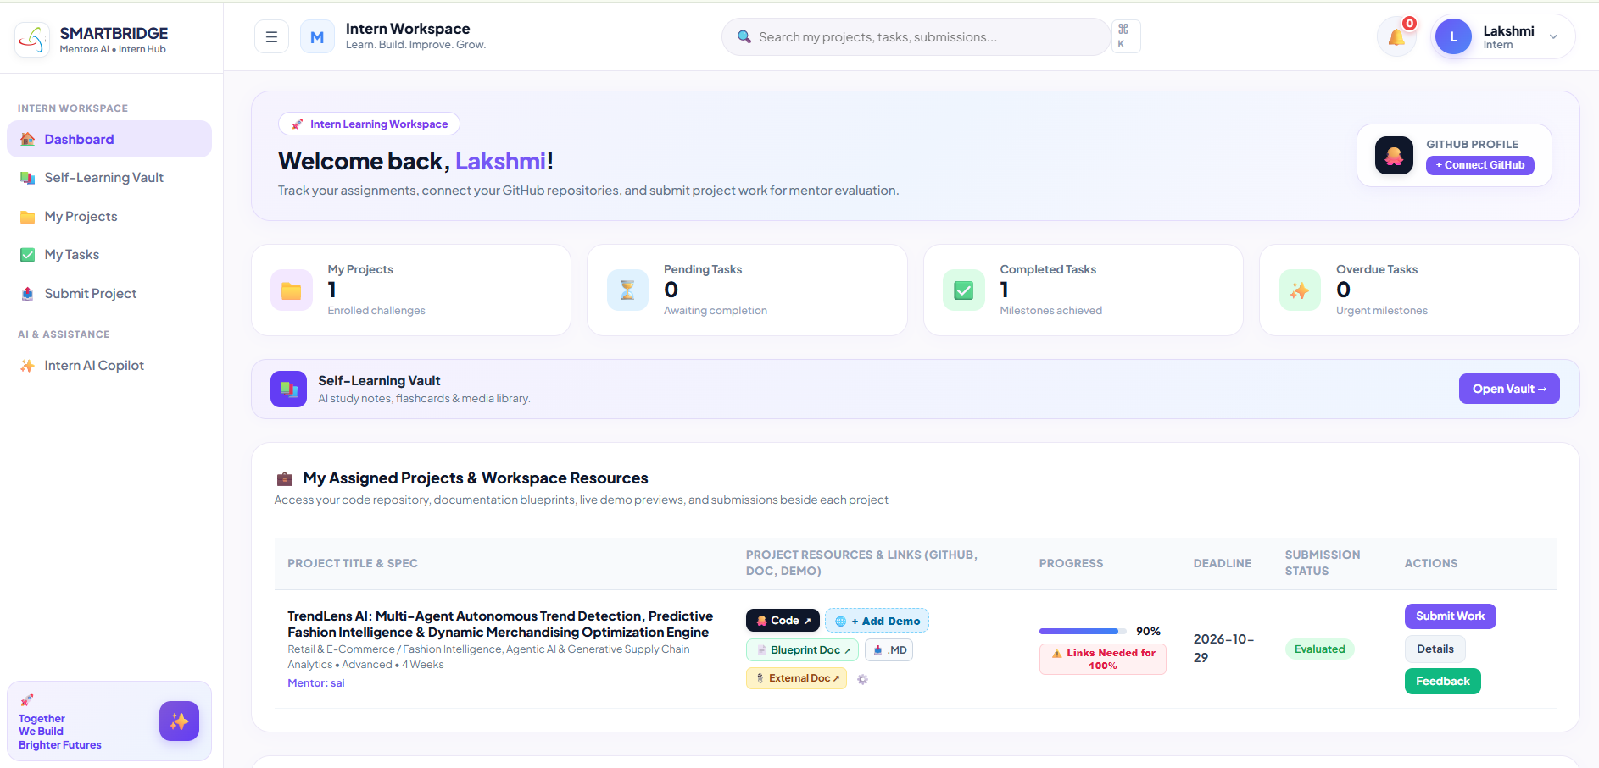
Description:
The Intern Dashboard provides a centralized overview of assigned projects, pending tasks, upcoming deadlines, submission status, evaluation results, and mentor feedback. It helps interns monitor their progress, manage responsibilities, access learning resources, and stay updated throughout their internship.

Self-Learning & AI Study Hub:
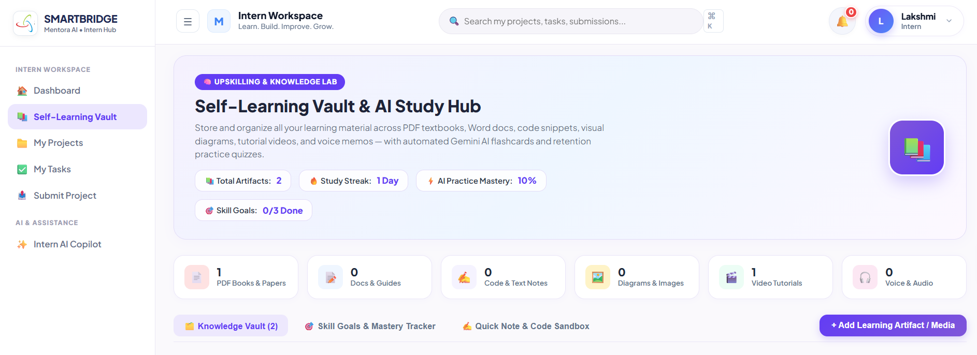
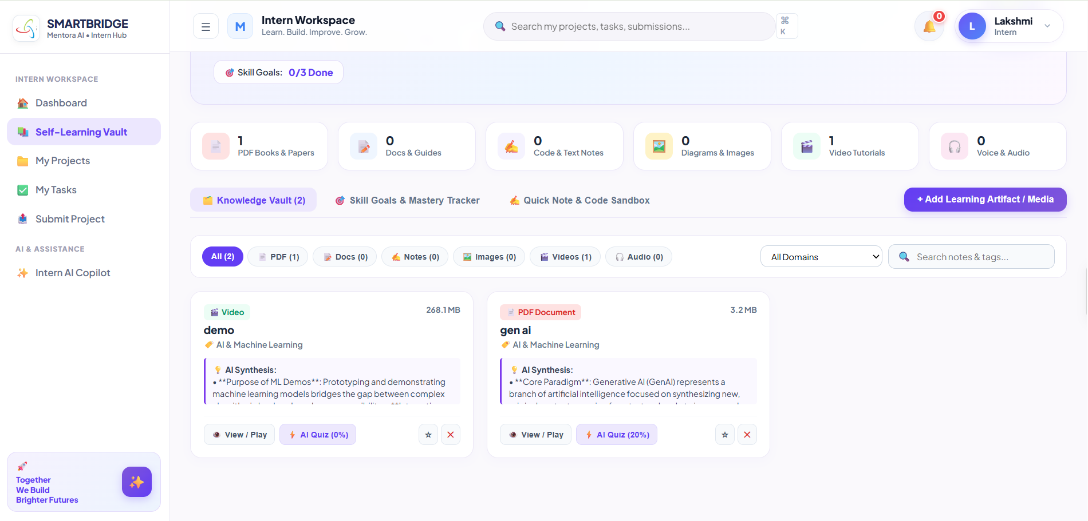
Description:
The Intern Self-Learning and AI Study Hub enables interns to set learning goals, track their progress, and access personalized AI guidance. Interns can upload documents, demos, videos, and images related to their studies, organize learning materials, and write notes for future reference. This centralized hub supports independent learning, skill development, and effective knowledge management.

Intern Projects:
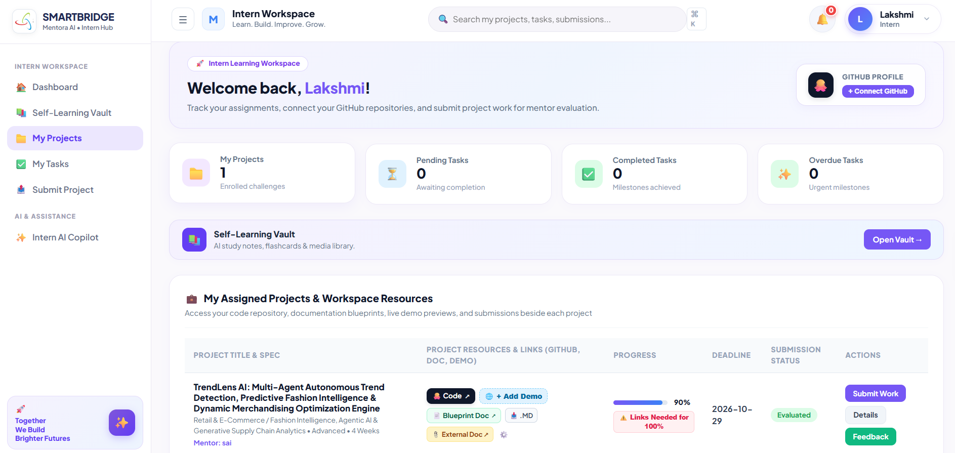
Description:
The Intern Projects module allows interns to view projects assigned by their mentors, including project objectives, requirements, deadlines, and current status. Interns can monitor progress, access project details, complete deliverables, and stay organized throughout the project lifecycle.

Intern’s Task:
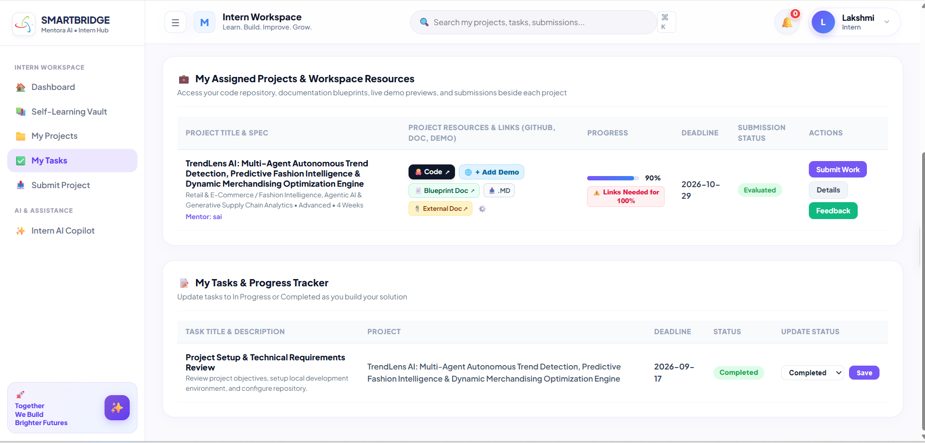
Description:
The Intern Tasks module allows interns to view tasks and projects assigned by their mentors, including requirements, priorities, deadlines, and current status. Interns can track their responsibilities, monitor project progress, and complete assigned work efficiently.

Project Submission:
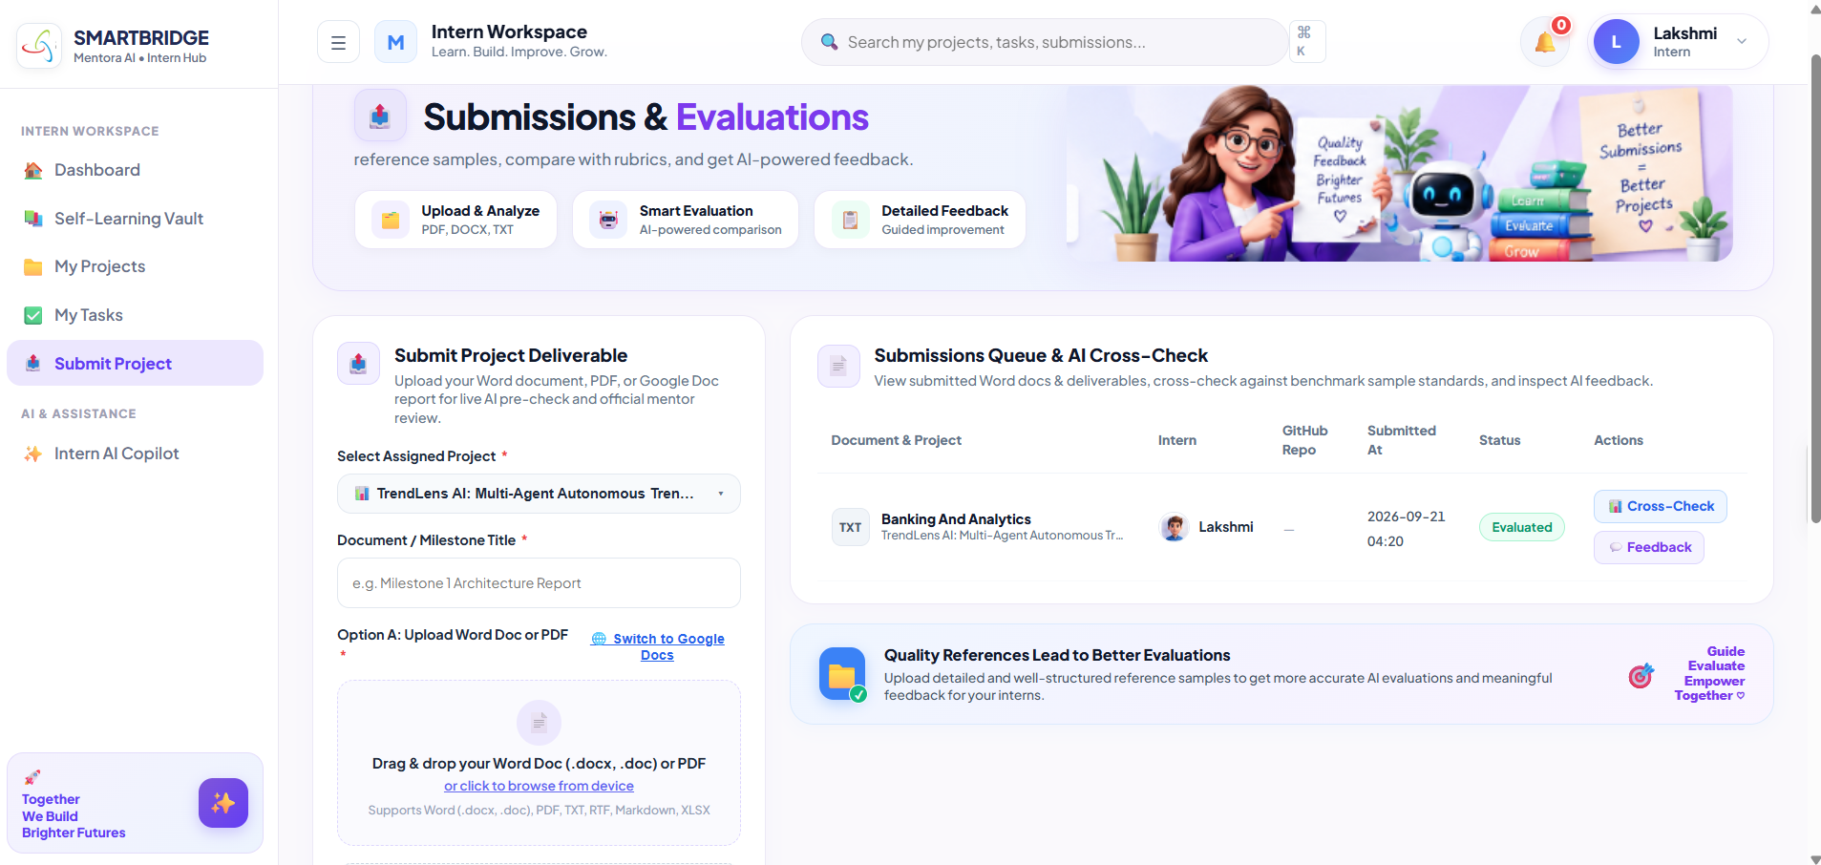
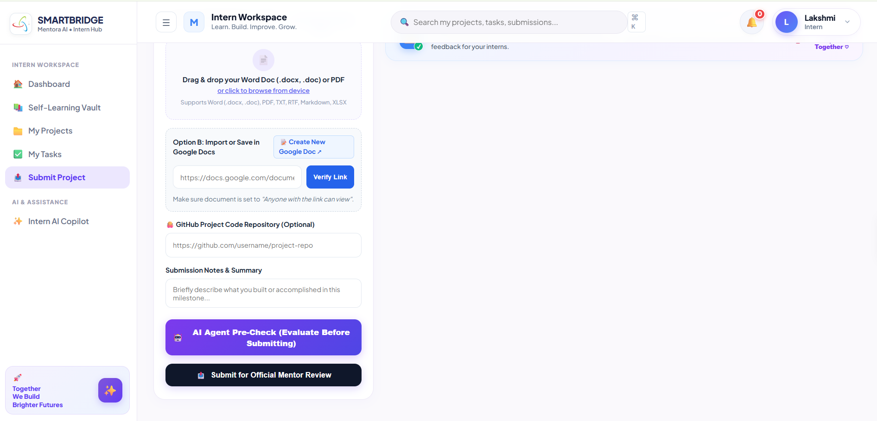
Description:
The Intern Project Submission and Evaluation module allows interns to upload completed project deliverables for mentor review. Mentors can evaluate submissions based on predefined criteria, assign scores, and provide constructive feedback. Interns can view their evaluation results, understand areas for improvement, and use the feedback to enhance future project work.

Intern’s Copilot:
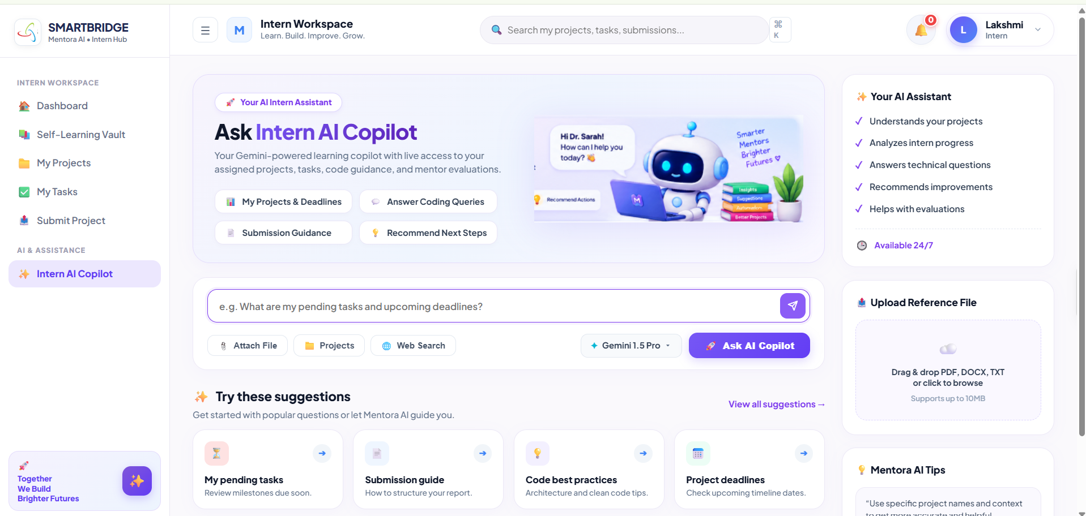
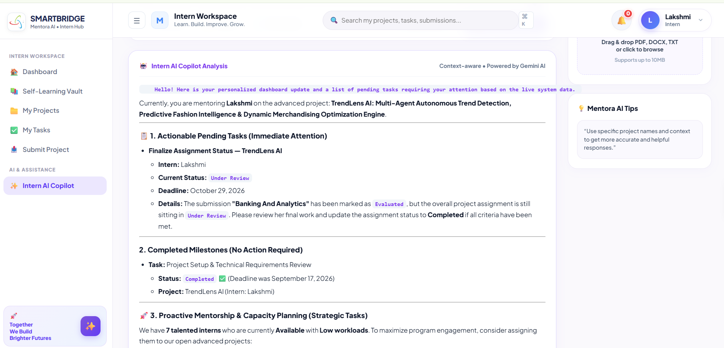
Description:
The Intern AI Copilot is an intelligent assistant that helps interns understand assigned projects, clarify requirements, manage tasks and deadlines, resolve technical questions, and receive personalized guidance throughout the project lifecycle. Powered by Gemini 2.5 Flash, it uses real-time project data to provide context-aware support, recommend learning resources, review progress, and help interns complete deliverables efficiently.

Conclusion:
Mentora AI successfully demonstrates how generative AI can be woven into the everyday mechanics of running a technical internship program — not as a bolt-on chatbot, but as the reasoning layer behind every core workflow a mentor or intern touches. Built on Flask with a fully server-rendered, zero-JavaScript pastel UI, the platform proves that a thoughtful design system and disciplined Jinja2 templating can deliver a polished, modern experience without any client-side framework overhead.
At the heart of the system is a nine-agent, LangGraph-inspired orchestration layer (MentoraOrchestrator) that cleanly separates what the platform does from how Gemini is prompted to do it. This design gives the project three concrete strengths:
- Automation across the full internship lifecycle — from a single-line prompt generating five distinct, production-grade project blueprints, to semantic skill-based intern matching, task-velocity tracking, and project-health diagnostics, mentors go from idea to assigned, monitored project in minutes rather than hours of manual coordination.
- Grounded, trustworthy evaluation — rather than letting Gemini grade submissions from general knowledge, the Retrieval-Augmented Generation pipeline chunks and vectorizes each mentor's own reference documents, so every score, missing-section flag, and correction is anchored to the actual standard the mentor expects, not a generic rubric.
- Resilience and maintainability — a prioritized model fallback chain in gemini_service.py, a clean eight-module service layer, and thirteen well-normalized SQLAlchemy tables mean the platform degrades gracefully under API changes and stays easy to extend with new agents or routes.
The result is a single, coherent workspace where mentors spend their time reviewing and deciding rather than drafting and chasing status updates, and interns get clear assignments, fast feedback, and a self-learning hub to close their own skill gaps. Looking ahead, the same orchestration pattern leaves clear room to grow — richer analytics dashboards, real-time notifications, deeper GitHub/CI integration for automated code review, and expanding the RAG evaluation pipeline with proper embedding-based retrieval as the platform scales beyond its current TF-IDF implementation.

