# Citrix XenServer Action Pack

Author: Tim Kennedy (Automic Software)

## Change Log

|  |  |  |
| --- | --- | --- |
| Version | Date | Description |
| 1.1.0 | July 2016 | * Updated actions to confirm to Package Manager format and naming conventions. * Get Parameter Value action can now return a list of all parameters for an object * Get Parameter Value action bug removed * The following actions removed as they are superseded by Get Parameter Value action:   + List Host Attributes   + List Network Bonds * Additional promptset tooltips provided. * Provided Map VARA object for use with ARA dynamic property mapping. * Required login type changed from "XEN" to "XENSERVER" * Moved example workflows from templates folder to resources. |
| 1.0.0 | Dec 2015 | Initial Release |

## Overview

Objects are provide to provision and manage Citrix Xen Server virtual environments.

It uses the ‘xe’ command line utility to interact with Citrix Xen hosts. For complete details on xe, please refer to the Citrix XenServer Administration Guide which may be obtained here: http://support.citrix.com/article/CTX141500

## Pre-Requisites

* Automic Engine 11.2 or above
* Tested against Citrix XenServer 6.5.0
* Automic Windows / Unix agent
* Citrix XenServer ‘xe’ utility

## Installation

1. Install the ‘xe’ command line utility on your agent machine (it can be found on the XenServer media, or installed via rpm on Linux).
2. Update your PATH environment variable to include the location of xe.
3. Ensure you can connect to XenServer from the command-line, e.g.

xe -s 192.168.59.138 -u root -pw password host-list

uuid ( RO) : d63d7bbd-593c-4fd3-9f19-a38193f6f1e6

name-label ( RW): xenserver

name-description ( RW): Default install of XenServer

1. In client 0, open UC_LOGIN_TYPES and define an entry for XENSERVER.

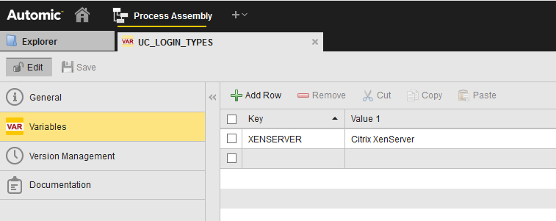

1. In your client, create a LOGIN object containing the username and password required to connect to XenServer. XEN should now be a valid type.

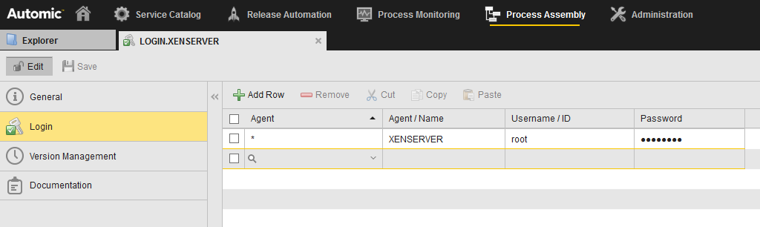

The LOGIN object can now be used to configure each job.

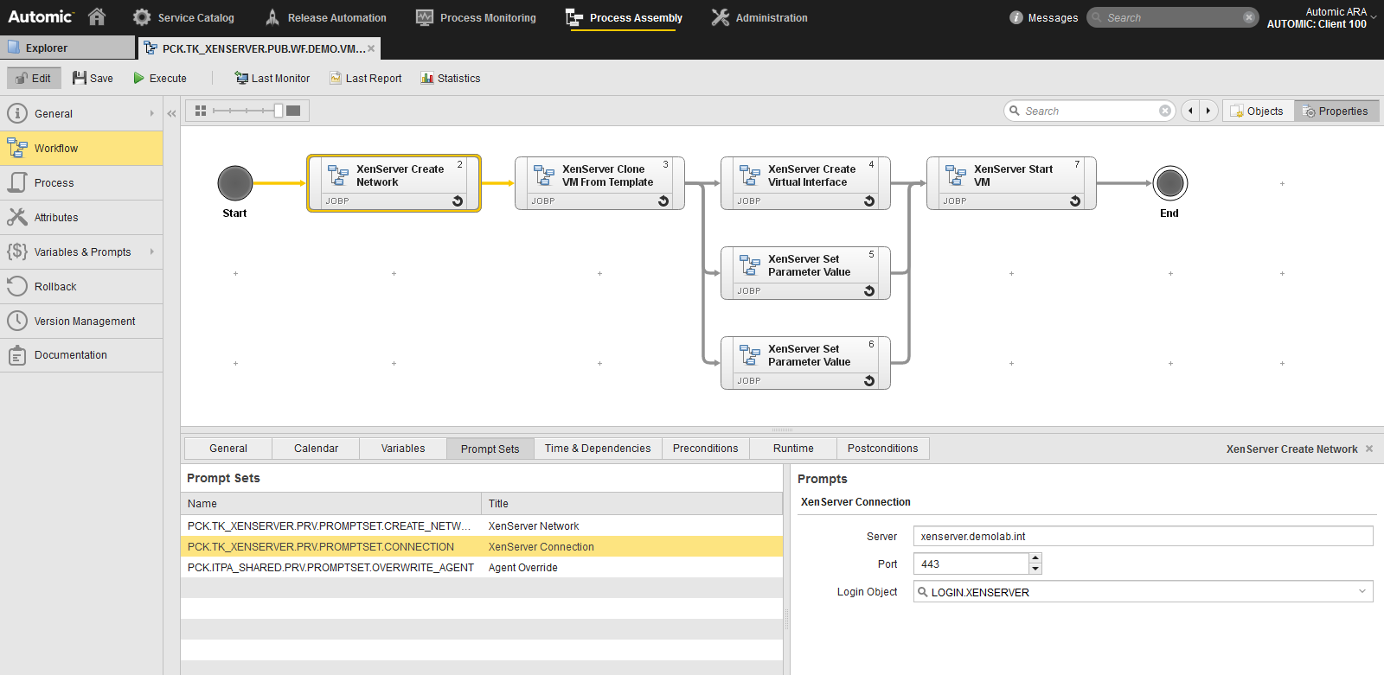

Jobs can be validated via the job report or from Citrix XenCenter

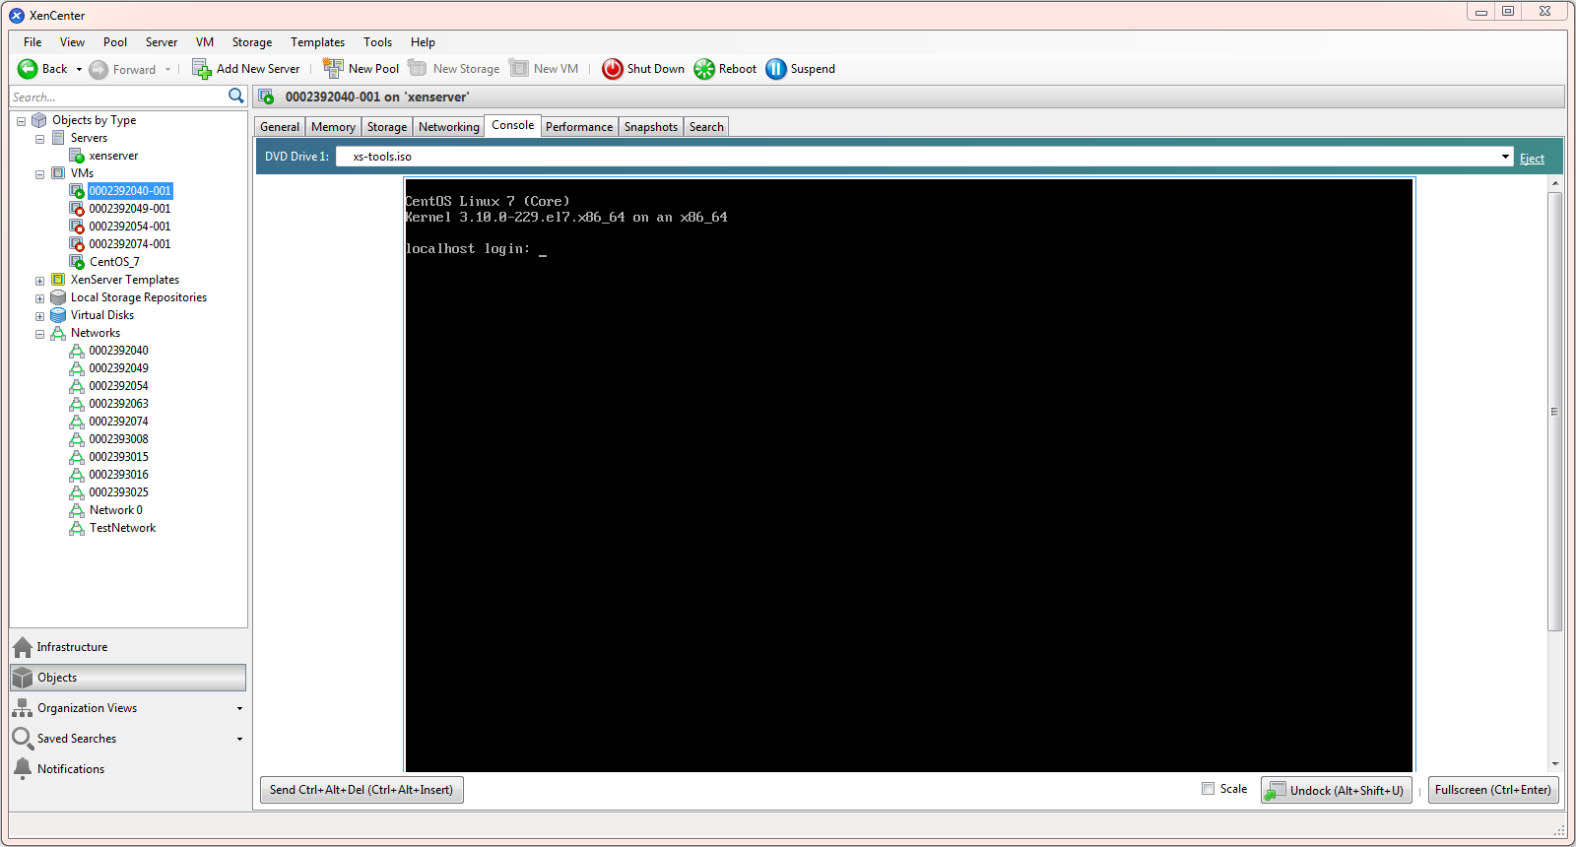

### Jobs

The following jobs are provided:

* Appliance
  + Add VM
  + Create
  + Destroy
  + Shutdown
  + Start
* Bond
  + Create
  + Destroy
* General
  + Set Parameter
  + Get Parameter Value
  + Wait For Event
* Host
  + Disable
  + Enable
  + Evacuate
  + Power On
  + Reboot
  + Shutdown
* Network
  + Create
  + Destroy
* Physical Block Device
  + Create
  + Destroy
  + Plug
  + Unplug
* Physical Interface
  + Forget
  + Introduce
  + Plug
  + Reconfigure
  + Scan
  + Unplug
* Storage Repository
  + Create
  + Destroy
  + Forget
  + Disable XAPI Database Replication
  + Enable XAPI Database Replication
* Virtual Block Device
  + Create
  + Destroy
  + Eject Media
  + Insert Media
  + Plug
  + Unplug
* Virtual Disk Interface
  + Clone
  + Copy
  + Create
  + Destroy
  + Forget
  + Resize
  + Snapshot
  + Unlock
* Virtual Interface
  + Create
  + Destroy
  + Plug
  + Unplug
* Virtual Network (VLAN)
  + Create
  + Destroy
* Virtual Machine (VM)
  + Clone
  + Destroy
  + Export
  + Import
  + List Attached CD images
  + List Attached Network Interfaces
  + List Attached Disks
  + Migrate
  + Reboot
  + Restart
  + Resume
  + Shutdown
  + Start
  + Suspend
  + Uninstall

### Workflows

The following sample workflows are provided in the RESOURCES/DEMO folder:

* PCK.TK_XENSERVER.PUB.WF.DEMO.VM.ADD - Create Network Container and VM
* PCK.TK_XENSERVER.PUB.WF.DEMO.VM.DELETE- Delete VM

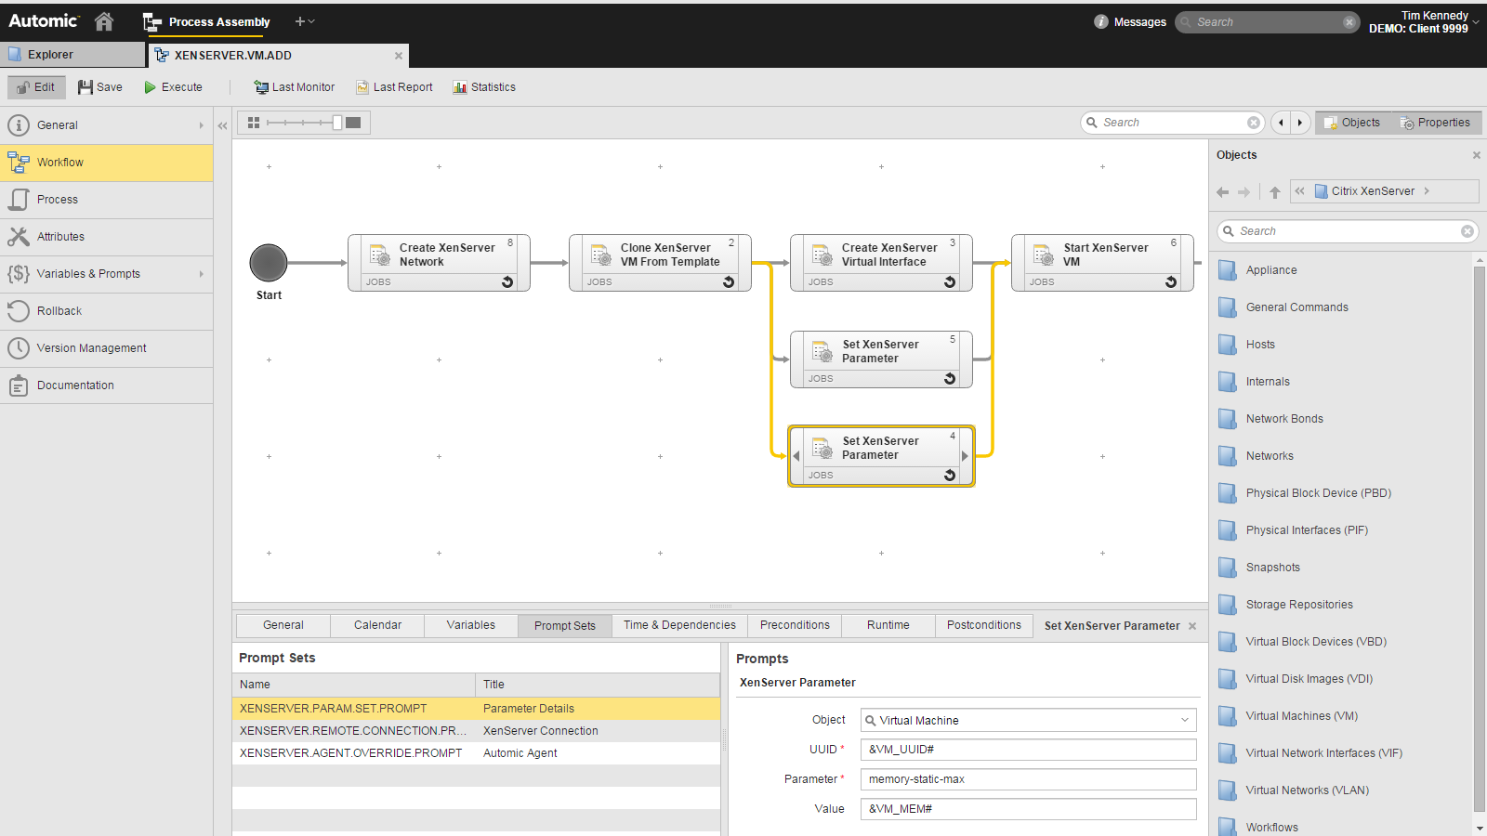

### Creating Additional Commands

The majority of commands described in the Citrix XenServer Administration Guide have been provided as Automic jobs.

The full list of commands available with xe can be obtained by running the following command:

xe –s *server* -u *user* -pw *password* help –all