listenaddress = ‘*’
CATALINA_PID=$CATALINA_HOME/catalina.pid
GEOSERVER_DATA_DIR=/home/tomcat/GEOSERVER_DATA_DIR
JAVA_OPTS="-server -Xms512m -Xmx1024m -XX:MaxPermSize=128m -XX:PermSize=64m -XX:+UseConcMarkSweepGC -XX:NewSize=48m -Dorg.geotools.shapefile.datetime=true -DGEOSERVER_DATA_DIR=$GEOSERVER_DATA_DIR"
ServerName"csn.e-geos.it server"
…
ServerAdmin root@csn.e-geos.it
DefaultRoot /emsa/in/ftp/
…
#AuthPAMConfig proftpd
#AuthOrder mod_auth_pam.c* mod_auth_unix.c
AuthOrder mod_ldap.c
…
Umask000
…
UseReverseDNS on
…

# Load config files from the conf.d directory
Include /etc/proftpd.d/*.conf


Contents

Table of Contents

Introduction 5
Preliminary installation and machine preparation 7
Keyboard and keyboard layout 7
Network 7
Locale 7
GeoSolutions S.A.S 2
File limits 8
J2SE JDK 8
Apache ANT 8
Apache Maven2 9
Installing OpenLDAP 10
The OWS server configuration 11
Apache HTTPD 11
Apache HTTPD – LDAP Auth 12
NFS v.3 12
DataBase configuration: PostgreSQL/PostGIS 13
PROJ4 / GEOS / PostGIS 13
PostgreSQL configuration 14
IPTABLES 14
Tomcat configuration 15
The CSW server configuration 17
ProFTPd 17
ProFTPd – LDAP Auth 17
NFS V.3 18
Tomcat configuration 18
Buddata Registry configuration and deployment 20
GeoServer configuration and deployment 22
GeoBatch configuration and deployment 29
Services Summary Table 31
Use Case and Test 32
TestCase using ssh: 32
TestCase using ftp: 32
Check Web Deployer Service Data 33
Check OGC Web Services 34
Check CSW Registry Service 36

Illustration Index

Illustration 1: Deployment Architecture Schema 6
Illustration 2: GeoServer Welcome page 27
Illustration 3: GeoServer Status 28
Illustration 4: GeoServer Users 29
Illustration 5: GeoServer Global Settings 30
Illustration 6: GeoBatch Flow Manager page 33

Introduction
This document guides the system administrator to the deployment and configuration of E-GEOS/EMSA system architecture.
The whole architecture is composed by several core modules and distributed as an Enterprise Service Oriented architecture in two machines actually. The components could be deployed independently though and distributed in more machines both physical or virtual in order to enhance the resources allocation.
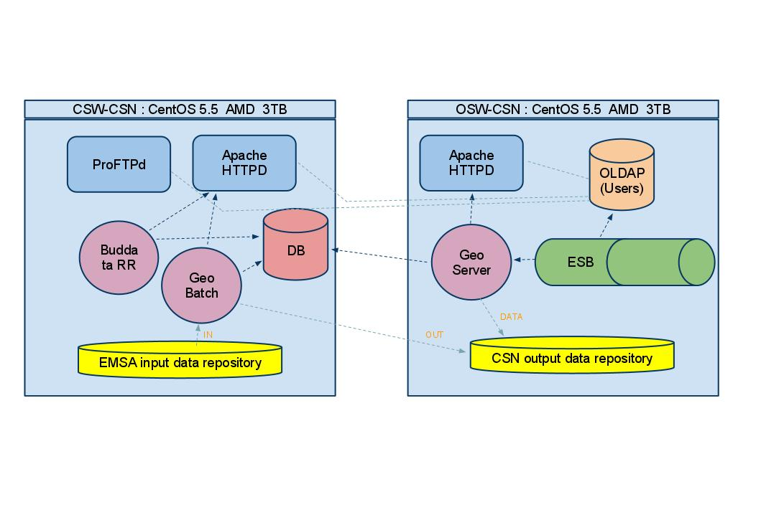Illustration 1: Deployment Architecture Schema

The diagram shows a reference deployment diagram we will threat in this context.
The components we are going to describe on the next chapters are the following:
- Preliminary installation and machine preparation: basics necessary steps to achieve in order to prepare the machine to host every one of the next components/services.
- CSW Registry Service: service implementing CSW specs, containing metadata and allowing to perform advanced searches on it. We will use BuddataRR with EO profile.
- OGC Web Services: implementation of standard OGC Web Services (WMS, WCS and WFS). Those services will be used to describe with a minimum metadata set and distribute data in a standard way on the web. The services will be provided by GeoServer.
- Batch and processing system: running services delegated to data processing and ingestion. The components used here is GeoBatch, a modulae J2EE SOA able to process data throught several plug-ins and automatically prepare and configure datasets and metadata-sets for other components.
- Enterprise Service Bus: an enterprise infrastructure that combines Service Oriented Architecture (SOA) and Event Driven Architecture (EDA) to create an agile enterprise bus. We have choosen as implementation Apache ServiceMIX since it is the most compliant with JBI specification JSR-208.

Preliminary installation and machine preparation
Notice that the steps described below are valid for a CentOS 5.5 based machine. Other OS may require heavy revision of the steps below.

Keyboard and keyboard layout
$> nano /etc/sysconfig/keyboard
KEYBOARDTYPE = “pc”
KEYTABLE = “it”

Network
Notice that this procedure is necessary only for not managed/independent machines. Otherwise please refer to your local network administrators.
$> nano /etc/resolv.conf
domain <your_domain_here>
search <your_domain_here>
nameserver <your_dns_or_gateway_address_here>
$> nano /etc/hosts
<your_ip_address_here> <full_server_name>

Locale
$> yum install ntp
$> chkconfig ntpd on
$> ntpdate –b 0.it.pool.ntp.org
$> /etc/init.d/ntpd start

- Special groups and users
It is highly recommended to reboot the server at this stage

File limits
$> nano /etc/security/limits.conf
#at the end of file
* soft nofile 4096
* hard nofile 4096
#Important!: must login with tomcat user in order to apply limits. “su” command won’t work.

J2SE JDK
#get the rpm.bin of J2SE JDK 6 from http://java.sun.com
$> wget http://<link_to>/java-jdk-sun-1.6...rpm.bin
$> ./java-jdk-sun-1.6...rpm.bin #follow the instructions
$> update-alternatives --install /usr/bin/java java /usr/java/jdk1.6.0_22/bin/java 1
$> update-alternatives --config java #choose SUN-JDK
$> echo “export JAVA_HOME=/usr/java/jdk1.6.0_22” >> /home/tomcat/.bashrc
$> echo “export PATH=$JAVA_HOME/bin:$PATH” >> /home/tomcat/.bashrc
$> echo “export MALLOC_CHECK_=0” >> /home/tomcat/.bashrc

Apache ANT
#as root
$> wget http://mirror.nohup.it/apache//ant/binaries/apache-ant-1.8.1-bin.tar.gz
$> tar -xzvf apache-ant-1.8.1-bin.tar.gz
$> mv -f apache-ant-1.8.1 /opt/apache-ant-1.8.1
$> echo “export ANT_HOME=/opt/apache-ant-1.8.1” >> /home/tomcat/.bashrc
$> update-alternatives --install /usr/bin/ant ant /opt/apache-ant-1.8.1/bin/ant 1

Apache Maven2
#as root
$> wget http://apache.fastbull.org//maven/binaries/apache-maven-2.2.1-bin.tar.gz
$> tar -xzvf apache-maven-2.2.1-bin.tar.gz
$> mv -f apache-maven-2.2.1 /opt/apache-maven-2.2.1
$> echo “export MAVEN_HOME=/opt/apache-maven-2.2.1” >> /home/tomcat/.bashrc
$> update-alternatives --install /usr/bin/mvn mvn /opt/apache-maven-2.2.1/bin/mvn 1

Installing OpenLDAP
#as root
$> yum install -v openldap openldap-servers openldap-clients
$> wget http://demo.geo-solutions.it/share/E-GEOS/LDAP/e-geos.schema
$> cp e-geos.schema /etc/openldap/schema/
$> cp /etc/openldap/slapd.conf /etc/openldap/slapd.conf.orig
$> nano /etc/openldap/slapd.conf
# Load custom schema
include /etc/openldap/schema/e-geos.schema
...
suffix "dc=csn,dc=egeos,dc=it"
rootdn "uid=admin,ou=people,dc=csn,dc=egeos,dc=it"
rootpw {SHA}SzNOehBlpvMBVVx9ddMKcUpUmmM=
...
NOTE: rootpw generated with command →
$> slappasswd -h {SHA} -s ldap-e-geos_matera
$> cp /etc/openldap/DB_CONFIG.example /var/lib/ldap/DB_CONFIG
$> chown ldap:ldap /var/lib/ldap/DB_CONFIG
$> chkconfig --level 35 ldap on
$> service ldap restart
$> mkdir base
$> cd base
$> wget http://demo.geo-solutions.it/share/E-GEOS/LDAP/base/create_base.sh
$> wget http://demo.geo-solutions.it/share/E-GEOS/LDAP/base/e-geos_base.ldif
$> chmod +x create_base.sh
$> nano e-geos_base.ldif
- Change the password ->
  - e1NIQX1Tek5PZWhCbHB2TUJWVng5ZGRNS2NVcFVtbU09 is the base64 encode of {SHA}SzNOehBlpvMBVVx9ddMKcUpUmmM= → slappasswd {SHA} ldap-e-geos_matera
$> ./create_base.sh
$> wget http://demo.geo-solutions.it/share/E-GEOS/LDAP/base/create_global.sh
$> wget http://demo.geo-solutions.it/share/E-GEOS/LDAP/base/template_global.ldif
$> chmod +x create_global.sh
$> ./create_global.sh
$> wget http://demo.geo-solutions.it/share/E-GEOS/LDAP/base/create_user.sh
$> wget http://demo.geo-solutions.it/share/E-GEOS/LDAP/base/template_user.ldif
$> chmod +x create_user.sh
$> ./create_user.sh
- FOLLOW instructions.
  - NOTE: remember that ‘create_user.sh’ uses the default password ‘ldap-e-geos_matera’
Default values:
USER: emsa
NAME: EMSA
SURNAME: E-GEOS Matera
EMAIL: emsa@csn.e-geos.it
PASSWORD: 3-g30s!

The OWS server configuration

Apache HTTPD
# as root
$> yum -v install httpd httpd-devel openssl-devel mod_authz_ldap
$> chkconfig httpd on
$> service httpd restart
NOTE: check the ‘/etc/httpd/http.conf’ contains →
LoadModule proxy_ajp_module modules/mod_proxy_ajp.so
$> nano /etc/httpd/conf.d/proxy_ajp.conf
LoadModule proxy_ajp_module modules/mod_proxy_ajp.so
#
# When loaded, the mod_proxy_ajp module adds support for
# proxying to an AJP/1.3 backend server (such as Tomcat).
# To proxy to an AJP backend, use the "ajp://" URI scheme;
# Tomcat is configured to listen on port 8009 for AJP requests
# by default.
#
# Uncomment the following lines to serve the ROOT webapp
# under the /tomcat/ location, and the jsp-examples webapp
# under the /examples/ location.
#
# always keep the host header
ProxyPreserveHost On
ProxyPass /tomcat/ ajp://localhost:8009/

Apache HTTPD – LDAP Auth
Make a symbolic link to the output data dir:
$> ln -s /emsa/out/nfs/ /var/www/html/emsa

Build the configuration file and place it into the right dir:
NOTE: modify ldap admin password here if necessary
$> nano /etc/httpd/conf.d/ldap.conf
Restart the service:
$> service httpd restart
LoadModule ldap_module modules/mod_ldap.so
LoadModule authnz_ldap_module /modules/mod_authnz_ldap.so
Alias /emsa "/var/www/html/emsa"
<Directory "/var/www/html/emsa">
AllowOverride None
# Possible values for the Options directive are "None", "All", or any combination of:
# Indexes Includes FollowSymLinks SymLinksifOwnerMatch ExecCGI MultiViews
Options +Indexes +Includes +FollowSymLinks -IncludesNOEXEC
IndexIgnore *.ht* *.php .??* *.bak *.swp *# HEADER* README* ^.ht* *.conf
#DirectoryIndex none
AddOutputFilter Includes html
AddHandler type-map var
Order allow,deny
#Allow from $LOCAL_NET
LanguagePriority en cs de es fr it ja ko nl pl pt-br ro sv tr
ForceLanguagePriority Prefer Fallback
AuthName "E-GEOS LDAP Auth"
AuthType Basic
AuthBasicProvider ldap
AuthzLDAPAuthoritative on
AuthLDAPURL ldap://ows-csn.e-geos.it:389/dc=csn,dc=egeos,dc=it??sub?(objectClass=*)
AuthLDAPBindDN uid=admin,ou=people,dc=csn,dc=egeos,dc=it
AuthLDAPBindPassword ldap-e-geos_matera
AuthLDAPGroupAttributeIsDN off
AuthLDAPGroupAttribute memberUid
require ldap-group cn=GLOBAL_WRITER,ou=groups,dc=csn,dc=egeos,dc=it
require ldap-group cn=GLOBAL_READER,ou=groups,dc=csn,dc=egeos,dc=it
Satisfy any
</Directory>

NFS v.3
#on OWS server as root
$> mkdir /emsa/
$> mkdir /emsa/out
$> mkdir /emsa/out/nfs # will be used as output/exchange data dir
$> chown -R nobody:nobody /emsa
$> chmod -R 777 /emsa
$> yum –v install nfs-utils nfs-utils-lib
$> nano /etc/exports
/emsa/out/nfs/ 10.20.2.0/24(rw,sync,no_subtree_check)
$> exportfs –a
$> nano /etc/sysconfig/nfs
# Number of nfs server processes to be started.
# The default is 8.
RPCNFSDCOUNT=16
...
# Optional arguments passed to rpc.mountd. See rpc.mountd(8)
RPCMOUNTDOPTS="-p 32767"
# Port rpc.mountd should listen on.
MOUNTD_PORT=892
...
$> chkconfig nfs on
$> service nfs start
$> chkconfig portmap on
$> service portmap start

DataBase configuration: PostgreSQL/PostGIS
- Preliminary packages installation
$> yum install postgresql postgresql-server postgresql-devel gcc \ gcc++ libxp flex libXtst make bzip2 flex

PROJ4 / GEOS / PostGIS
#PROJ4
$> wget http://download.osgeo.org/proj/proj-4.7.0.tar.gz
$> tar –xzvf proj-4.7.0.tar.gz
$> cd proj-4.7.0
$> ./configure
$> make
$> make install
#GEOS
$> wget http://download.osgeo.org/geos/geos-3.2.2.tar.bz2
$> tar -xjvf geos-3.2.2.tar.bz2
$> cd geos-3.2.2
$> ./configure
$> make
$> make install
#PostGIS
$> wget http://postgis.refractions.net/download/postgis-1.3.6.tar.gz
$> tar -xzvf postgis-1.3.6.tar.gz
$> cd postgis-1.3.6
$> ./configure --with-geos --prefix=/usr/local
$> make
$> make install

PostgreSQL configuration
$> nano /var/lib/pgsql/data/pg_hba.conf
local all postgres trust
host all all 0.0.0.0/0 md5 #provide your network here
$> chkconfig postgresql on
$> service postgresql restart
$> nano /var/lib/pgsql/data/postgresql.conf
listenaddress = ‘*’

IPTABLES
$> iptables -A INPUT -p udp -s 0/0 --sport 5432 -d 0/0 --dport 1024:65535 -m state --state ESTABLISHED -j ACCEPT
$> iptables -A INPUT -p udp -s 0/0 --sport 1024:65535 -d 0/0 --dport 5432 -m state --state NEW,ESTABLISHED -j ACCEPT
#as root
$> su – postgres
$> psql postgres
#default: postgres_matera
psql> ALTER USER postgres WITH PASSWORD ‘<your_pwd_here>’;
psql> \q
#as root 32-bit system
$> ln –s /usr/local/lib/libgeos_c.so.1.6.2 /usr/lib/libgeos_c.so.1
$> ln –s /usr/local/lib/libproj.so.0.6.6 /usr/lib/libproj.so.0
#as root 64-bit system
$> ln -s /usr/local/lib/libgeos_c.so /usr/lib64/libgeos_c.so
$> ln -s /usr/local/lib/libgeos_c.so.1.6.2 /usr/lib64/libgeos_c.so.1
$> ln -s /usr/local/lib/libproj.so.0.6.6 /usr/lib64/libproj.so.0
#as postgres
$> createdb –Upostgres –EUTF8 template_postgis
$> createlang –Upostgres plpgsql template_postgis
$> psql –Upostgres –d template_postgis –f /usr/local/share/lwpostgis.sql
$> psql –Upostgres –d template_postgis –f /usr/local/share/spatial_ref_sys.sql

Tomcat configuration
#as tomcat user
$> wget http://apache.fastbull.org/tomcat/tomcat-6/v6.0.29/bin/apache-tomcat-6.0.29.tar.gz
$> tar -xzvf apache-tomcat-6.0.29.tar.gz
$> mv -f apache-tomcat-6.0.29 /home/tomcat/tomcat-6.0.29
$> echo “export CATALINA_HOME=/home/tomcat/tomcat-6.0.29” >> /home/tomcat/.bashrc
$> source /home/tomcat/.bashrc
$> nano $CATALINA_HOME/bin/setenv.sh
CATALINA_PID=$CATALINA_HOME/catalina.pid
GEOSERVER_DATA_DIR=/home/tomcat/GEOSERVER_DATA_DIR
JAVA_OPTS="-server -Xms512m -Xmx1024m -XX:MaxPermSize=128m -XX:PermSize=64m -XX:+UseConcMarkSweepGC -XX:NewSize=48m -Dorg.geotools.shapefile.datetime=true -DGEOSERVER_DATA_DIR=$GEOSERVER_DATA_DIR"
$> chmod +x $CATALINA_HOME/bin/setenv.sh
$> nano $CATALINA_HOME/conf/server.xml
<Listener className="org.apache.catalina.core.JreMemoryLeakPreventionListener" appContextProtection="false" />

The CSW server configuration

ProFTPd
#as root
$> wget http://apt.sw.be/redhat/el5/en/i386/rpmforge/RPMS/rpmforge-release-0.3.6-1.el5.rf.i386.rpm
$> rpm -ivH rpmforge-release-0.3.6-1.el5.rf.i386.rpm
$> yum -v install proftpd proftpd-ldap proftpd-devel
$> chkconfig --level 35 proftpd on

ProFTPd – LDAP Auth
$> cp /etc/proftpd.conf /etc/proftpd.conf.orig
$> mkdir /etc/proftpd.d
$> chown -R nobody:nobody /etc/proftpd.d/
$> nano /etc/proftpd.conf
ServerName"csn.e-geos.it server"
…
ServerAdmin root@csn.e-geos.it
DefaultRoot /emsa/in/ftp/
…
#AuthPAMConfig proftpd
#AuthOrder mod_auth_pam.c* mod_auth_unix.c
AuthOrder mod_ldap.c
…
Umask000
…
UseReverseDNS on
…

# Load config files from the conf.d directory
Include /etc/proftpd.d/*.conf

$> wget http://demo.geo-solutions.it/share/E-GEOS/FTP/global.conf
$> wget http://demo.geo-solutions.it/share/E-GEOS/FTP/ldap.conf
$> cp *.conf /etc/proftpd.d/
$> service proftpd restart

NFS V.3
#on CSW server as root
$> mkdir /emsa/
$> mkdir /emsa/in/
$> mkdir /emsa/in/ftp # will be used as input data dir
$> mkdir /emsa/out
$> mkdir /emsa/out/nfs # will be used as output/exchange data dir
$> chown -R nobody:nobody /emsa/
$> chmod -R 777 /emsa/
$> yum –v install nfs-utils nfs-utils-lib
$> chkconfig nfs on
$> service nfs start
$> chkconfig portmap on
$> service portmap start
$> nano /etc/fstab

#end of file
10.20.2.5:/emsa/out/nfs /emsa/out/nfs/ nfs rw,sync,hard,intr 0 0

Be shure to start the service on the OWS server before run mount:
$> mount /emsa/out/nfs

Tomcat configuration
#as tomcat user
$> wget http://apache.fastbull.org/tomcat/tomcat-6/v6.0.29/bin/apache-tomcat-6.0.29.tar.gz
$> tar -xzvf apache-tomcat-6.0.29.tar.gz
$> mv -f apache-tomcat-6.0.29 /home/tomcat/tomcat-6.0.29
$> echo “export CATALINA_HOME=/home/tomcat/tomcat-6.0.29” >> /home/tomcat/.bashrc
$> source /home/tomcat/.bashrc
$> mkdir $CATALINA_HOME/server_2/
# Buddata
$> cp $CATALINA_HOME/work $CATALINA_HOME/server_1/
$> cp $CATALINA_HOME/conf $CATALINA_HOME/server_1/
$> cp $CATALINA_HOME/webapps $CATALINA_HOME/server_1/
$> cp $CATALINA_HOME/logs $CATALINA_HOME/server_1/
# GeoBatch
$> mv $CATALINA_HOME/work $CATALINA_HOME/server_2/
$> mv $CATALINA_HOME/conf $CATALINA_HOME/server_2/
$> mv $CATALINA_HOME/webapps $CATALINA_HOME/server_2/
$> mv $CATALINA_HOME/logs $CATALINA_HOME/server_2/
$> nano $CATALINA_HOME/bin/setenv.sh
if [ -z "$CATALINA_SERVER" ]; then
CATALINA_SERVER="./";
fi
CATALINA_BASE=$CATALINA_HOME/$CATALINA_SERVER/
CATALINA_PID=$CATALINA_HOME/$CATALINA_SERVER.pid
CATALINA_OUT=$CATALINA_BASE/logs/catalina.out
CATALINA_TMPDIR=$CATALINA_BASE/temp/
GEOBATCH_DATA_DIR=/home/tomcat/GEOBATCH_DATA_DIR
JAVA_OPTS="-server -Xms512m -Xmx1024m -XX:MaxPermSize=128m -XX:PermSize=64m -XX:+UseConcMarkSweepGC -XX:NewSize=48m -Dorg.geotools.shapefile.datetime=true -DGEOBATCH_DATA_DIR=$GEOBATCH_DATA_DIR"

$> chmod +x $CATALINA_HOME/bin/setenv.sh
$> nano $CATALINA_HOME/conf/server.xml
<Listener className="org.apache.catalina.core.JreMemoryLeakPreventionListener" appContextProtection="false" />
# To manage the server 1
# start
$> CATALINA_SERVER="server_1" bin/startup.sh
# check logs
$> tail -f server_1/logs/catalina.out
# stop
$> CATALINA_SERVER="server_1" bin/shutdown.sh -force

# To manage the server 2
# start
$> CATALINA_SERVER="server_2" bin/startup.sh
# check logs
$> tail -f server_1/logs/catalina.out
# stop
$> CATALINA_SERVER="server_2" bin/shutdown.sh -force

Buddata Registry configuration and deployment
#as tomcat user
$> wget http://demo.geo-solutions.it/share/E-GEOS/BuddataRR.tar
$> tar -xvf BuddataRR.tar
$> nano /home/tomcat/BuddataRR/trunk/ErgoRR/conf/ergorr.properties
# database connections parameters
db.url=<host_name>:5432
db.user=postgres
db.password=postgres_matera
...
repository.root=/home/tomcat/BuddataRR/ERGO/
...
# database template name which is initialized with postgis data.
# Used while setting up instance database.
db.templatePostgis=template_postgis
$> cd /home/tomcat/BuddataRR/trunk/ErgoRR
$> echo “export ERGO_HOME=/home/tomcat/BuddataRR/trunk” >> /home/tomcat/.bashrc
$> source /home/tomcat/.bashrc
$> cd $ERGO_HOME/ErgoRR
$> nano ErgoRR-web/pom.xml
<plugin>
<groupId>org.codehaus.mojo</groupId>
<artifactId>properties-maven-plugin</artifactId>
<version>1.0-alpha-2</version>
<executions>
<execution>
<phase>initialize</phase>
<goals>
<goal>read-project-properties</goal>
</goals>
<configuration>
<files>
<file>/home/tomcat/BuddataRR/trunk/ErgoRR/conf/ergorr.properties</file>
...
$> mvn clean install
$> ant tomcat-setup
$> ant db-drop
$> ant db-build
$> ant deploy
#start/restart tomcat before next step
$> ant db-load-model
$> nano conf.d/proxy_ajp.conf
#as root
...
$> ProxyPass /ergorr/ ajp://localhost:8009/ergorr/
$> service httpd restart

GeoServer configuration and deployment
#as tomcat user
$> wget http://demo.geo-solutions.it/share/E-GEOS/geoserver.war
$> chown tomcat:tomcat geoserver.war
$> mv geoserver.war $CATALINA_HOME/webapps
$> nano $CATALINA_HOME/bin/setenv.sh
GEOSERVER_DATA_DIR=/home/tomcat/GEOSERVER_DATA_DIR
$> cd
$> wget http://demo.geo-solutions.it/share/E-GEOS/GEOSERVER_DATA_DIR.tar
$> tar -xvf GEOSERVER_DATA_DIR.tar
#start/restart tomcat...
$> nano /home/tomcat/GEOSERVER_DATA_DIR/workspaces/emsa/egeos/datastore.xml
<dataStore>
<id>DataStoreInfoImpl--35a92d22:12ba4fe29f4:-7ffe</id>
<name>egeos</name>
<type>PostGIS</type>
<enabled>true</enabled>
<workspace>
<id>WorkspaceInfoImpl--35a92d22:12ba4fe29f4:-8000</id>
</workspace>
<connectionParameters>
<entry key="Connection timeout">20</entry>
<entry key="port">5432</entry>
<entry key="passwd">postgres_matera</entry>
<entry key="dbtype">postgis</entry>
<entry key="host">10.20.2.4</entry>
<entry key="validate connections">true</entry>
<entry key="max connections">10</entry>
<entry key="database">egeos</entry>
<entry key="namespace">http://www.e-geos.it/emsa</entry>
...
<entry key="preparedStatements">true</entry>
<entry key="user">postgres</entry>
</connectionParameters>
<__default>false</__default>
</dataStore>
$> nano /home/tomcat/GEOSERVER_DATA_DIR/workspaces/csndc/csndc/mappings.xml
...
<sourceDataStores>
<DataStore>
<id>egeos-emsa-pg</id>
<parameters>
<Parameter>
<name>dbtype</name>
<value>postgisng</value>
</Parameter>
<Parameter>
<name>host</name>
<value>10.20.2.4</value>
</Parameter>
<Parameter>
<name>port</name>
<value>5432</value>
</Parameter>
<Parameter>
<name>database</name>
<value>egeos</value>
</Parameter>
<Parameter>
<name>user</name>
<value>postgres</value>
</Parameter>
<Parameter>
<name>passwd</name>
<value>postgres_matera</value>
</Parameter>
</parameters>
</DataStore>
</sourceDataStores>
...

$> nano /home/tomcat/GEOSERVER_DATA_DIR/workspaces/csndc/csndc/datastore.xml
<dataStore>
<id>csndc_datastore</id>
<name>csndc_datastore</name>
<enabled>true</enabled>
<workspace>
<id>csndc_workspace</id>
</workspace>
<connectionParameters>
<entry key="namespace">http://www.emsa.europa.eu/csndc</entry>
<entry key="url">file:workspaces/csndc/csndc/mappings.xml</entry>
<entry key="dbtype">app-schema</entry>
</connectionParameters>
</dataStore>
IMPORTANT: On “CSW” Server create the Database ‘egeos’ as ‘postgres’ user using the following command
$> createdb egeos -T template_postgis
- Reload GeoServer catalog
http://ows-csn.e-geos.it/geoserver/
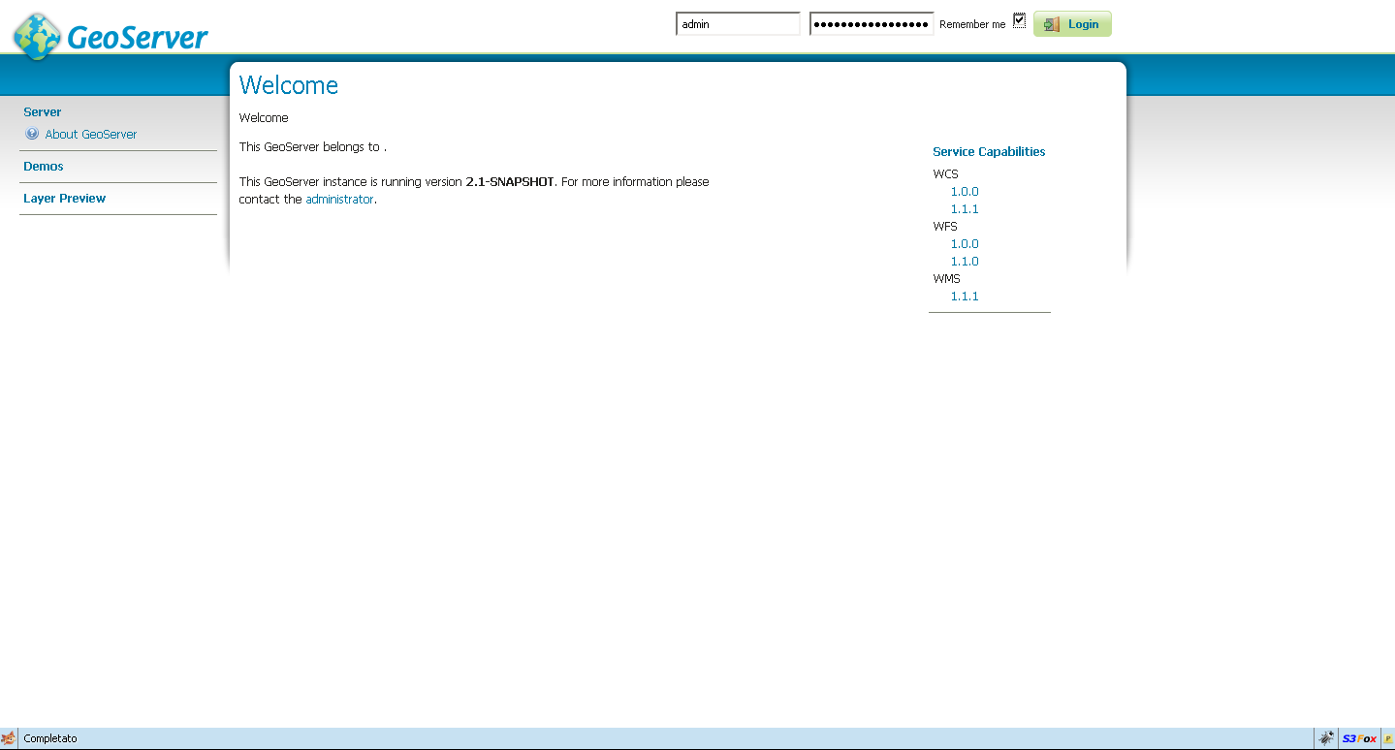Illustration 2: GeoServer Welcome page
  - Login the first time as : admin/geoserver
  - Goto “Server Status” page, and click on “Reload” button
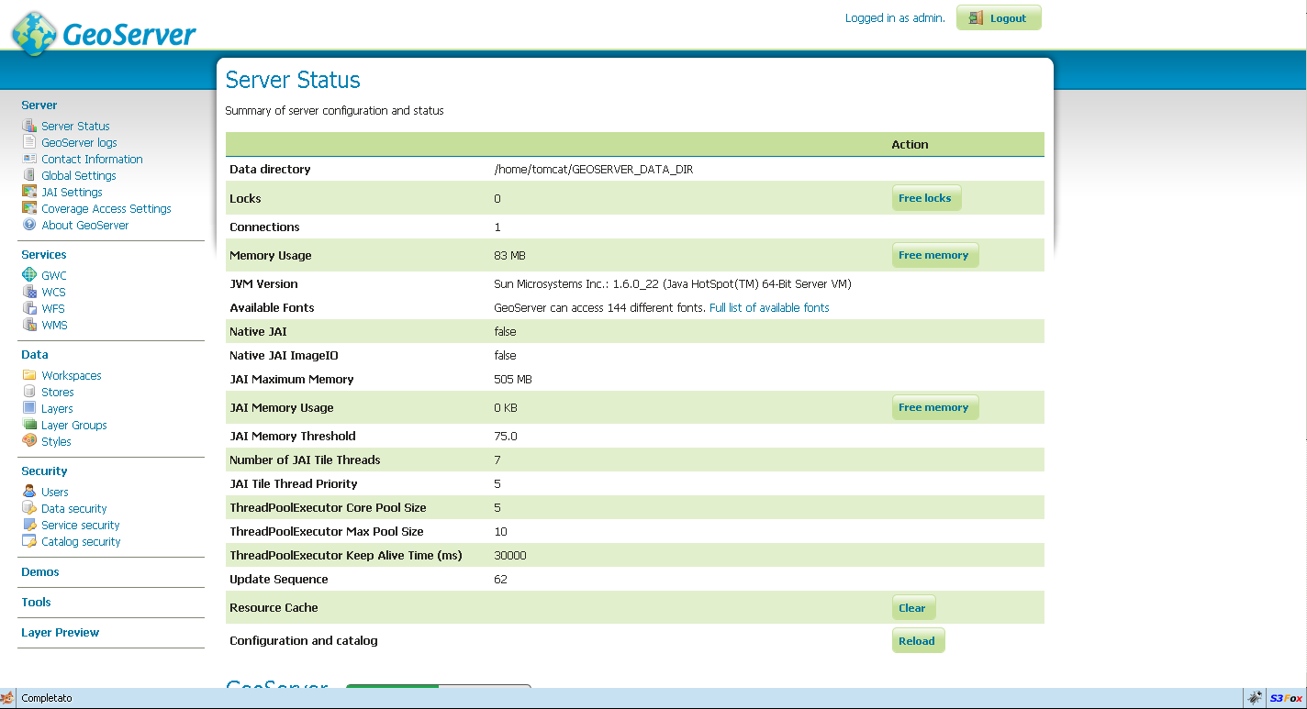Illustration 3: GeoServer Status
- From the “Users” menu, change the “admin” password to ‘geoserver-e-geos_matera’
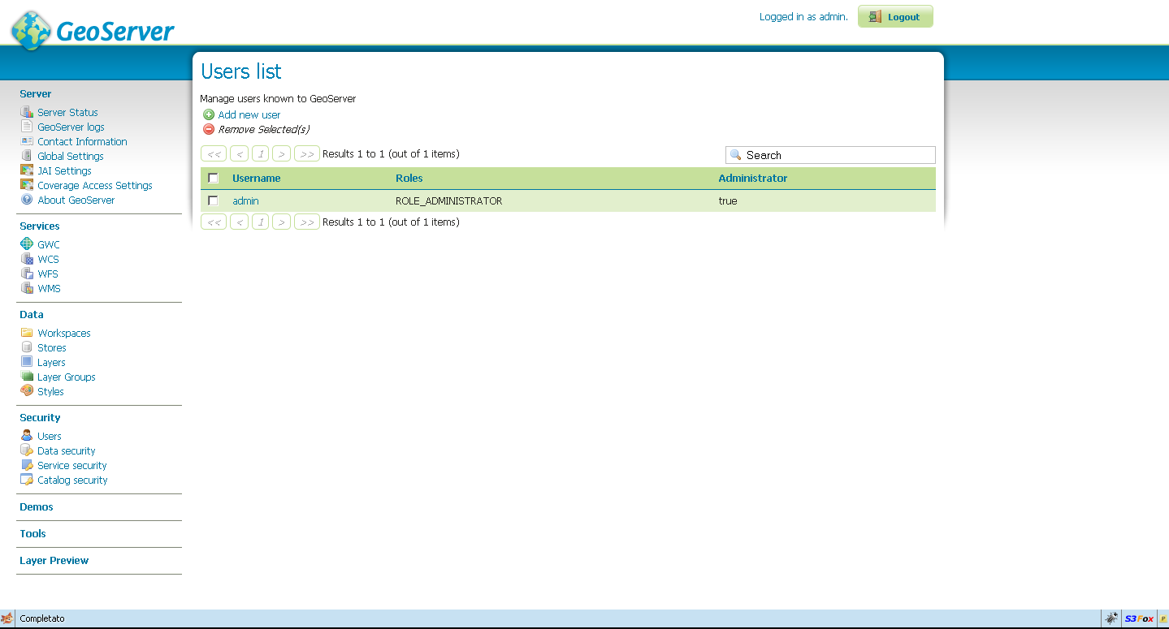Illustration 4: GeoServer Users
- In order to perform some GeoServer optimization, goto “Global Settings” panel and change setting like depicted below
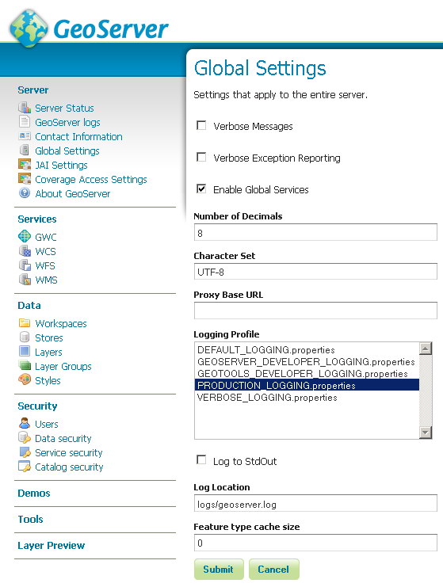Illustration 5: GeoServer Global Settings
- Restart tomcat
$> nano conf.d/proxy_ajp.conf
#as root
...
$> ProxyPass /ergorr/ ajp://localhost:8009/geoserver/
$> service httpd restart

GeoBatch configuration and deployment
#as tomcat user
$> cd /home/tomcat
$> chown tomcat:tomcat INSTALL/geobatch.war
$> mv INSTALL/geobatch.war $CATALINA_HOME/server_2/webapps
$> nano $CATALINA_HOME/bin/setenv.sh
GEOBATCH_DATA_DIR=/home/tomcat/GEOBATCH_DATA_DIR
$> cd /home/tomcat/
$> tar -xvjf INSTALL/GEOBATCH_DATA_DIR.tar.bz2
#start/restart tomcat...
NOTE: Actually you have to remove 2 jaxb libs which conflicts with the servlet-api.jar.
Do as follow:
$> rm $CATALINA_HOME/server_2/webapps/geobatch/WEB-INF/lib/jaxb-*
#start/restart tomcat...
- Check that all flows are up and running
http://csw-csn.e-geos.it/geobatch/
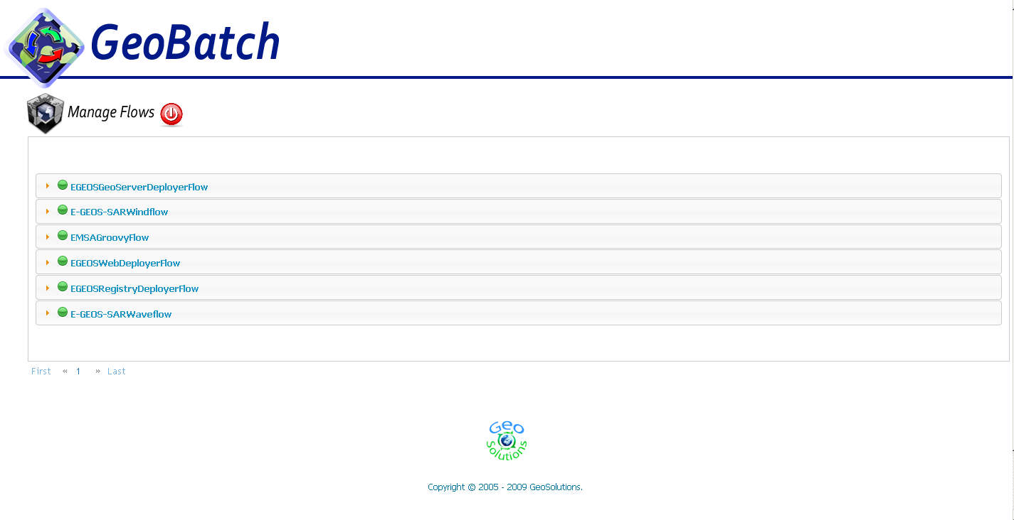Illustration 6: GeoBatch Flow Manager page
  - NOTE: Login as admin/admin
$> nano conf.d/proxy_ajp.conf
#as root
...
$> ProxyPass /ergorr/ ajp://localhost:8009/geobatch/
$> service httpd restart

Services Summary Table
Service | URL | Description
EMSA Input Data Directory | http://csw-csn.e-geos.it/emsa/  ftp://csw-csn.e-geos.it | Folder where to push ‘.tar’ package files and ‘PackageReady.txt’ in order to start automatic processing.  NOTE: the folder is LDAP protected
E-GEOS Output Data Directory | http://ows-csn.e-geos.it/e-geos/  ftp://ows-csn.e-geos.it | Folder where original data is deployed in order to allow retrieve from web gml and detections files.  NOTE: the folder is LDAP protected
OpenLDAP | ldap://ows-csn.e-geos.it:389 | LDAP user and groups repository server.
PostgreSQL/PostGIS | ows-csn.e-geos.it:5432/egeos | Application DataBase
GeoBatch | http://csw-csn.e-geos.it/geobatch/ | Automatic processing and deploying service.
Apache ServiceMIX | http://ows-csn.e-geos.it/servicemix/ | Enterprise Service Bus
Buddata CSW Registry Service | http://csw-csn.e-geos.it/ergorr/webservice?wsdl | CSW Service  “Service delegated to deliver metadata in OGC std protocol”
OGC WMS | http://ows-csn.e-geos.it/geoserver/wms | WMS Service  “Service delegated to deliver maps and portrayals in OGC std protocol”
OGC WFS | http://ows-csn.e-geos.it/geoserver/wfs | WFS Service  “Service delegated to deliver vectorial datasets in OGC std protocol”
OGC WCS | http://ows-csn.e-geos.it/geoserver/wcs | WCS Service  “Service delegated to deliver raster datasets in OGC std protocol”

