Illustration 2: GeoServer Welcome page
<wcs:Capabilities ...>
<ows:ServiceType>WCS</ows:ServiceType>
…
<ows:Operation name="GetCapabilities">
...
<wcs:CoverageSummary>
<ows:Title>sarImages</ows:Title>
<ows:Abstract>Generated from ImageMosaic</ows:Abstract>
<ows:Keywords>
<ows:Keyword>WCS</ows:Keyword>
<ows:Keyword>ImageMosaic</ows:Keyword>
<ows:Keyword>sarImages</ows:Keyword>
</ows:Keywords>
<ows:WGS84BoundingBox>
<ows:LowerCorner>17.6784973144531 59.8959579467773</ows:LowerCorner>
<ows:UpperCorner>25.4646759033203 63.3412437438965</ows:UpperCorner>
</ows:WGS84BoundingBox>
<wcs:Identifier>sarImages</wcs:Identifier>
</wcs:CoverageSummary>
...
</wcs:Capabilities>
...
<FeatureType>
<Name>csndc:OilSpill</Name>
<Title>OilSpill</Title>
<Abstract>Oil spill warnings and notifications</Abstract>
<DefaultSRS>urn:x-ogc:def:crs:EPSG:4326</DefaultSRS>
<ows:WGS84BoundingBox>
<ows:LowerCorner>-180.0 -90.0</ows:LowerCorner>
<ows:UpperCorner>180.0 90.0</ows:UpperCorner>
</ows:WGS84BoundingBox>
</FeatureType>
<FeatureType>
<Name>csndc:Ship</Name>
<Title>Ship</Title>
<Abstract/>
<DefaultSRS>urn:x-ogc:def:crs:EPSG:4326</DefaultSRS>
<ows:WGS84BoundingBox>
<ows:LowerCorner>-180.0 -90.0</ows:LowerCorner>
<ows:UpperCorner>180.0 90.0</ows:UpperCorner>
</ows:WGS84BoundingBox>
</FeatureType>
<FeatureType>
<Name>emsa:oilspill</Name>
<Title>oilspill</Title>
<Abstract/>
<DefaultSRS>urn:x-ogc:def:crs:EPSG:4326</DefaultSRS>
<ows:WGS84BoundingBox>
<ows:LowerCorner>-180.0 -90.0</ows:LowerCorner>
<ows:UpperCorner>180.0 90.0</ows:UpperCorner>
</ows:WGS84BoundingBox>
</FeatureType>
...


Contents

Table of Contents

GeoSolutions S.A.S 2
Introduction 3
Services Summary Table 4
Use Case and Test 5
TestCase using ssh: 5
TestCase using ftp: 6
Check Web Deployer Service Data: 7
Check Web Deployer Service Data: 7
Check OGC Web Services 9
WCS: 9
WFS: 10
WMS: 11
Layer preview 13
Check CSW Registry Service 16
GetCapabilities 16
DescribeRecord 17
GetRecordById 18

Illustration Index

OWS httpd service page 7
GeoServer Welcome page 8
GeoServer Layer preview page 13
GeoServer Layer preview for a GeiTiff SAR Image 13
GeoServer Layer preview OilSpill preview 14
GeoServer Layer preview for Ship 15

Introduction
This document guides the system administrator to perform deep tests using the installed platform (ref. Deployment Guide).
Service | URL
OpenLDAP | Pass: ldap-e-geos_matera
User:emsa
Pass:3-g30s!
Postgres Database | Database: egeos User:postgres  Pass:postgres_matera
GeoServer (first time) | User:admin  Pass:geoserver
GeoServer (configured) | User:admin  Pass:geoserver-e-geos_matera
FTP | User:admin  Pass:ldap-e-geos_matera
GeoBatch | User:admin  Pass:admin
OWS  ssh | User:root  Pass:e-geos_matera
CSW  ssh | User:root  Pass:e-geos_matera

Services Summary Table
Service | URL | Description
EMSA  Input Data Directory | http://csw-csn.e-geos.it/emsa/  ftp://csw-csn.e-geos.it | Folder where to push ‘.tar’ package files and ‘PackageReady.txt’ in order to start automatic processing.  NOTE: the folder is LDAP protected
E-GEOS Output Data Directory | http://ows-csn.e-geos.it/e-geos/  ftp://ows-csn.e-geos.it | Folder where original data is deployed in order to allow retrieve from web gml and detections files.  NOTE: the folder is LDAP protected
OpenLDAP | ldap://ows-csn.e-geos.it:389 | LDAP user and groups repository server.
PostgreSQL PostGIS | ows-csn.e-geos.it:5432/egeos | Application DataBase
GeoBatch | http://csw-csn.e-geos.it/geobatch/ | Automatic processing and deploying service.
Apache ServiceMIX | http://ows-csn.e-geos.it/servicemix/ | Enterprise Service Bus
Buddata CSW Registry Service | http://csw-csn.e-geos.it/ergorr/webservice?wsdl | CSW Service  “Service delegated to deliver metadata in OGC std protocol”
OGC WMS | http://ows-csn.e-geos.it/geoserver/wms | WMS Service  “Service delegated to deliver maps and portrayals in OGC std protocol”
OGC WFS | http://ows-csn.e-geos.it/geoserver/wfs | WFS Service  “Service delegated to deliver vectorial datasets in OGC std protocol”
OGC WCS | http://ows-csn.e-geos.it/geoserver/wcs | WCS Service  “Service delegated to deliver raster datasets in OGC std protocol”

Use Case and Test
During all the following test cases you can see services metadata growing up while processing or follow the ingestion process looking at:
On ows-csn.e-geos.it:
$> tail -f /home/tomcat/tomcat-6.0.29/logs/catalina.out
On csw-csn.e-geos.it:
$> tail -f /home/tomcat/tomcat-6.0.29/server_1/logs/catalina.out
$> tail -f /home/tomcat/tomcat-6.0.29/server_2/logs/catalina.out
Note that the example package can be used only once, if you want to perform more tests you need to rename the folder as test_case_${N} before passing it to GeoBatch.

TestCase using ssh:
- Log in as root on the CSW server and switch to tomcat user:
# ssh root@csw-csn.e-geos.it
# su – tomcat
$ ...
- Get sample dataset from the INSTALL dir:
$ cd /ho me/tomcat/
$ tar -xvjf INSTALL/test_case_1.tar.bz2
- move it to the input data dir:
Note: remember to rename to test_case_${N}
$ mv /home/tomcat/test_case_1 /emsa/in/ftp/test_case_N
- Check the server_2 (GeoBatch) log to be shure that the file system monitor is active on that directory.
- Once the packages have been uploaded, push (or touch) the ‘PackagesReady.txt’ into:
$ touch /emsa/in/ftp/test_case_1/PackagesReady.txt
- The automatic processing starts to ingest all data into the several services.

TestCase using ftp:
- FTP to
ftp://admin@csw-csn.e-geos.it
- Log-in as
admin/ldap-e-geos_matera
- Put the folder test_case_N into the input folder /emsa/in/ftp/
- Check the server_2 (GeoBatch) log to be shure that the file system monitor is active on that directory.
- Once the packages have been uploaded, push (or touch) the ‘PackagesReady.txt’ into:
$ touch /emsa/in/ftp/test_case_1/PackagesReady.txt
NOTE: once the files have been uploaded you need to be sure they have WRITE permission to ‘tomcat’ user, otherwise the processing system will be stuck on that files.

Check Web Deployer Service Data:
Check that packages have been correctly decompressed and deployed on E-GEOS Output Data Directory HTTP.
- Redirecting your browser to:
http://ows-csn.e-geos.it/emsa/
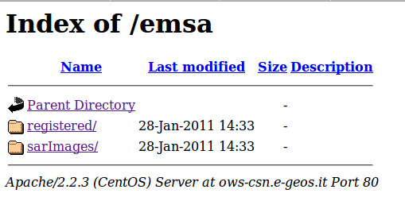Illustration 1: OWS httpd service page
- Or checking manually (via ssh) the content of the output dir:
/emsa/out/nfs/

Check Web Deployer Service Data:
- In order to get the GetCapabilities documents just query HTTP-GET on the OGC Services URLs or looking at the figure click on relatives links in the right frame ('Service Capabilities').
Illustration 2: GeoServer Welcome page
- Obtain ship-detections WMS layer at the URL:
http://ows-csn.e-geos.it/geoserver/ows?service=wms&version=1.1.1&request=GetCapabilities
- Specific detections can be filtered by adding TIME parameter at the ‘GetMap’ request, e.g.:
http://ows-csn.e-geos.it/geoserver/ows?service=wms&version=1.1.1&request=GetCapabilities&TIME=2010-05-27T03:56:58.000Z
NOTE: The timestamps list for the layer can be obtained from ‘GetCapabilieits’ XML document (see above)

Check OGC Web Services
- Query the WMS, WFS and WCS Services in order to get the “GetCapabilities” XML document and make sure the layers, featureTypes and coverages are present on those document with updated TimeStamps.
<wcs:Capabilities ...>
<ows:ServiceType>WCS</ows:ServiceType>
…
<ows:Operation name="GetCapabilities">
...
<wcs:CoverageSummary>
<ows:Title>sarImages</ows:Title>
<ows:Abstract>Generated from ImageMosaic</ows:Abstract>
<ows:Keywords>
<ows:Keyword>WCS</ows:Keyword>
<ows:Keyword>ImageMosaic</ows:Keyword>
<ows:Keyword>sarImages</ows:Keyword>
</ows:Keywords>
<ows:WGS84BoundingBox>
<ows:LowerCorner>17.6784973144531 59.8959579467773</ows:LowerCorner>
<ows:UpperCorner>25.4646759033203 63.3412437438965</ows:UpperCorner>
</ows:WGS84BoundingBox>
<wcs:Identifier>sarImages</wcs:Identifier>
</wcs:CoverageSummary>
...
</wcs:Capabilities>

WCS:

WFS:
...
<FeatureType>
<Name>csndc:OilSpill</Name>
<Title>OilSpill</Title>
<Abstract>Oil spill warnings and notifications</Abstract>
<DefaultSRS>urn:x-ogc:def:crs:EPSG:4326</DefaultSRS>
<ows:WGS84BoundingBox>
<ows:LowerCorner>-180.0 -90.0</ows:LowerCorner>
<ows:UpperCorner>180.0 90.0</ows:UpperCorner>
</ows:WGS84BoundingBox>
</FeatureType>
<FeatureType>
<Name>csndc:Ship</Name>
<Title>Ship</Title>
<Abstract/>
<DefaultSRS>urn:x-ogc:def:crs:EPSG:4326</DefaultSRS>
<ows:WGS84BoundingBox>
<ows:LowerCorner>-180.0 -90.0</ows:LowerCorner>
<ows:UpperCorner>180.0 90.0</ows:UpperCorner>
</ows:WGS84BoundingBox>
</FeatureType>
<FeatureType>
<Name>emsa:oilspill</Name>
<Title>oilspill</Title>
<Abstract/>
<DefaultSRS>urn:x-ogc:def:crs:EPSG:4326</DefaultSRS>
<ows:WGS84BoundingBox>
<ows:LowerCorner>-180.0 -90.0</ows:LowerCorner>
<ows:UpperCorner>180.0 90.0</ows:UpperCorner>
</ows:WGS84BoundingBox>
</FeatureType>
...

WMS:

<Layer queryable="1">
<Name>emsa:sarImages</Name>
<Title>sarImages</Title>
...
<Keyword>WCS</Keyword>
<Keyword>ImageMosaic</Keyword>
<Keyword>sarImages</Keyword>
</KeywordList>
<SRS>EPSG:4326</SRS>
<LatLonBoundingBox minx="17.6784973144531" miny="59.8959579467773" maxx="25.4646759033203" maxy="63.3412437438965"/>
<BoundingBox SRS="EPSG:4326" minx="17.6784973144531" miny="59.8959579467773" maxx="25.4646759033203" maxy="63.3412437438965"/>
<Dimension name="time" units="ISO8601"/>
<Extent name="time" default="current">2010-07-07T05:04:41.854Z</Extent>
<Style>...</Style>
</Layer>
<LatLonBoundingBox minx="-180.0" miny="-90.0" maxx="180.0" maxy="90.0"/>
<Layer queryable="1">
<Name>emsa:oilspill</Name>
...
<SRS>EPSG:4326</SRS>
<LatLonBoundingBox minx="-180.0" miny="-90.0" maxx="180.0" maxy="90.0"/>
<BoundingBox SRS="EPSG:4326" minx="-180.0" miny="-90.0" maxx="180.0" maxy="90.0"/>
<Dimension name="time" units="ISO8601"/>
<Extent name="time" default="current">2010-05-27T03:56:13.000Z</Extent>
<Style> …</Style>
</Layer>

<Layer queryable="1">
<Name>emsa:ship</Name>
<Title>ship</Title>
<SRS>EPSG:4326</SRS>
<LatLonBoundingBox minx="-180.0" miny="-90.0" maxx="180.0" maxy="90.0"/>
<BoundingBox SRS="EPSG:4326" minx="-180.0" miny="-90.0" maxx="180.0" maxy="90.0"/>
<Dimension name="time" units="ISO8601"/
<Extent name="time" default="current">
2010-10-13T19:30:47.000Z,2010-10-13T19:30:46.000Z,2010-10-13T19:30:45.000Z,2010-10- 13T19:30:44.000Z,2010-10-13T19:30:43.000Z,2010-10-13T19:30:42.000Z,2010-10- 13T19:30:40.000Z,2010-10-13T19:30:39.000Z,2010-10-13T19:30:38.000Z,2010-10-
...
27T03:56:20.000Z,2010-05-27T03:56:19.000Z,2010-05-27T03:56:18.000Z,2010-05- 27T03:56:17.000Z,2010-05-27T03:56:16.000Z,2010-05-27T03:56:15.000Z,2010-05-27T03:56:14.000Z
</Extent>
<Style>...</Style>
</Layer>
...

Layer preview
- You can view ingested data using the 'Layer preview' page:
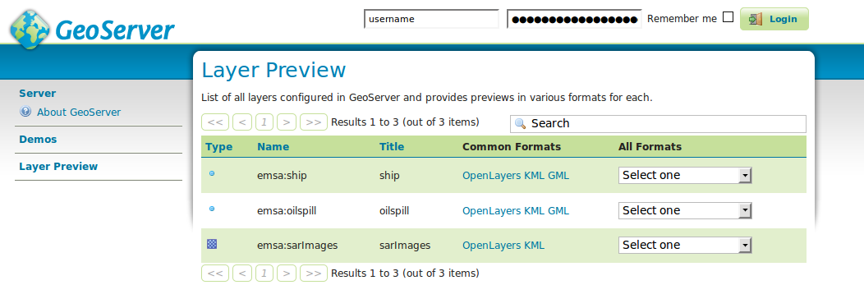Illustration 2: GeoServer Layer preview page
- This is the SAR Image preview using OpenLayers link (under 'Common formats')
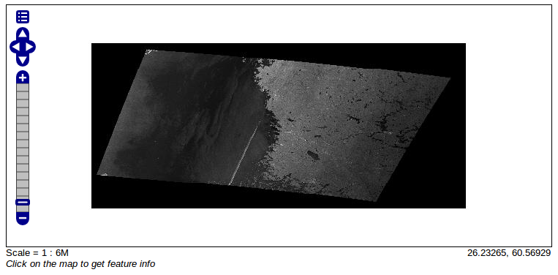Illustration 3: GeoServer Layer preview for a GeiTiff SAR Image
- The following image represent the set of ingested oil spill points. The table showed below is related to a single point (selected using the mouse)
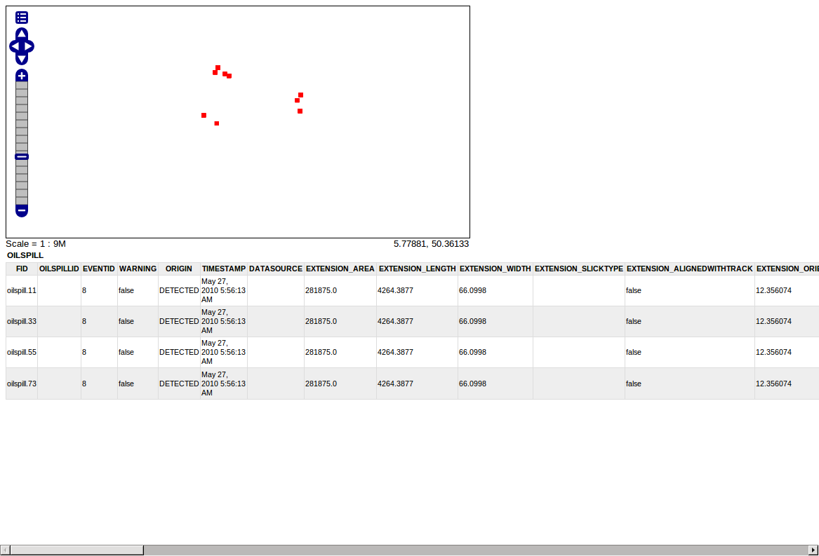Illustration 4: GeoServer Layer preview OilSpill preview

- The group of ingested data points related to 'ship':
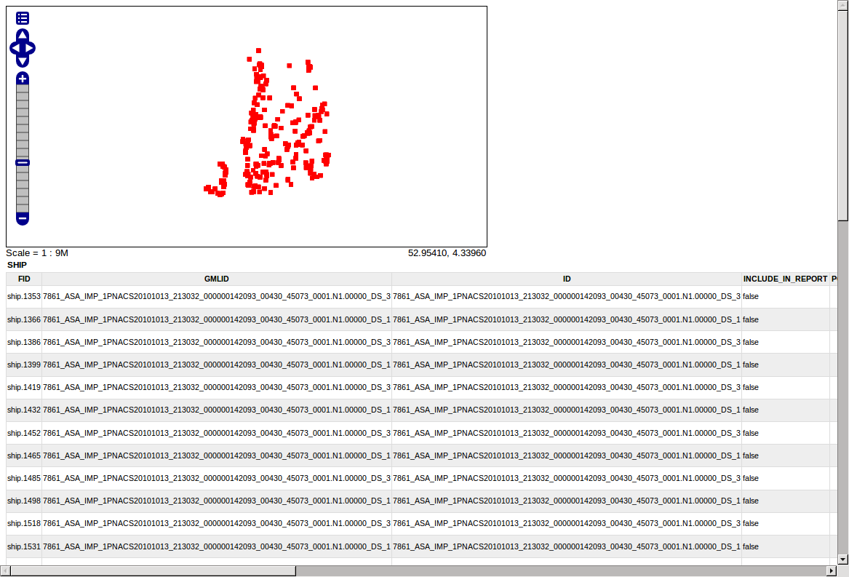Illustration 5: GeoServer Layer preview for Ship

Check CSW Registry Service

GetCapabilities
SOAP Request
URL:
http://csw-csn.e-geos.it/ergorr/webservice?wsdl
Mime-type:
text/xml
Post data:
<?xml version="1.0" encoding="UTF-8"?>
<env:Envelope xmlns:env="http://schemas.xmlsoap.org/soap/envelope/">
<env:Body>
<csw:GetCapabilities xmlns:csw="http://www.opengis.net/cat/csw/2.0.2" service="CSW">
<ows:AcceptVersions xmlns:ows="http://www.opengis.net/ows">
<ows:Version>2.0.2</ows:Version>
</ows:AcceptVersions>
<ows:AcceptFormats xmlns:ows="http://www.opengis.net/ows">
<ows:OutputFormat>application/xml</ows:OutputFormat>
</ows:AcceptFormats>
</csw:GetCapabilities>
</env:Body>
</env:Envelope>

DescribeRecord
SOAP Request
URL:
http://csw-csn.e-geos.it/ergorr/webservice?wsdl
Mime-type:
text/xml
Post data:
<?xml version="1.0" encoding="UTF-8"?>
<env:Envelope xmlns:env="http://schemas.xmlsoap.org/soap/envelope/">
<env:Body>
<csw:DescribeRecord xmlns:csw="http://www.opengis.net/cat/csw/2.0.2" service="CSW" version="2.0.2" outputFormat="application/xml" schemaLanguage="http://www.w3.org/XML/Schema" />
</env:Body>
</env:Envelope>

GetRecordById
SOAP Request
URL:
http://csw-csn.e-geos.it/ergorr/webservice?wsdl
Mime-type:
text/xml
Post data:
<?xml version="1.0" encoding="UTF-8"?>
<env:Envelope xmlns:env="http://schemas.xmlsoap.org/soap/envelope/">
<env:Body>
<csw:GetRecordById xmlns:csw="http://www.opengis.net/cat/csw/2.0.2" service="CSW" version="2.0.2"> <csw:Id>urn:OILSPILL:7922_RS2_20100527_055613_0045_SCNA_VV_SCN_83076_0000_0000000_OS_1_OSW</csw:Id>
<csw:ElementSetName>full</csw:ElementSetName>
</csw:GetRecordById>
</env:Body>
</env:Envelope>
<?xml version="1.0" encoding="UTF-8"?>
<env:Envelope xmlns:env="http://schemas.xmlsoap.org/soap/envelope/">
<env:Body>
<csw:GetRecordById xmlns:csw="http://www.opengis.net/cat/csw/2.0.2" service="CSW" version="2.0.2"> <csw:Id>urn:OILSPILL:7922_RS2_20100527_055613_0045_SCNA_VV_SCN_83076_0000_0000000_OS_1_OSW:GML:FILE:LINK</csw:Id>
<csw:ElementSetName>full</csw:ElementSetName>
</csw:GetRecordById>
</env:Body>
</env:Envelope>

