**GeoRepository – Model**

**06/jan/2011**

**2011**

**Ing. Alessio Fabiani**

**GeoSolutions S.A.S.**

**TechRep #2/2011**



Contents

Introduction 4

Object Model 5

Class Diagram 5

Future Improvements 8

Mltiple Profiles for Users 8

Caching Filters on GeoServer 9

**Non è stata trovata alcuna voce dell'indice delle figure.**

# Introduction

This document presents a proposal for the GeoRepository internal model with few observation for future improvements and directions.

It is worth to point out that the proposal is based on the concept that GeoRepository is strictly related to GeoServer.

Therefore the model and the way GeoRepository will handle and manage filter rules, will be oriented not to a generic rule system but to GeoServer one instead.

# Object Model

## Class Diagram

The picture below represents the class diagram for the GeoRepository Object Model.

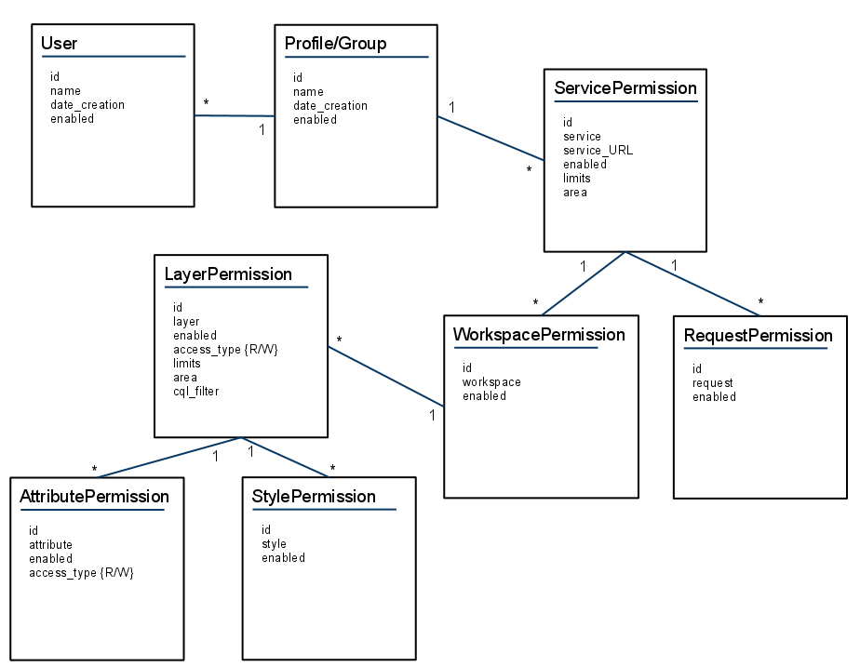

As depicted on the figure above, each User can be associated to a Profile. Therefore its filters’ definitions will be retrieved only through its own Profile. If a group of Users need some specific filter rules, a new Profile must be created. We assume here that won’t be the necessity of defining rights for single users and that all GeoReposiotry/GeoServer users will be logically grouped together.

Since GeoRepository is strictly related to GeoServer structure and model as pointed out on the introduction, to a Profile are directly associated Services rules.

At this stage is **very important** to underline an assumption GeoRepository makes:

* The default behavior of GeoRepository rule management is not conservative, i.e. if a *rule is NOT present than the permission is ALLOWED*.

For instance if WCS service permissions or filter rules are NOT present for a Profile, that means that the WCS service is ALLOWED and FULLY open to that Profile users.

This choice is mainly adopted for performance reasons. If a rule is not present, no further checks will be made not data will be stored anywhere for the rule and all sub-rules depenending on that.

For the reasons above:

1. If a Service is not attached to a Profile, the Service, Requests, Workspaces and Layers are open to all Profile Users.
2. If a Service is presents but no area or limits are specificed for the former, the full world and any image size dimensions will be allowed for Profile Users. On the counter side, if area or limits are specified for the Service, will be applied to all sub-rules unless specific ones are defined for the sub-rule itself (see LayersPermissions).

Taking in mind the assumptions above, lets examine the model proposed in details.

To a Profile can be associated filters on one or more Services (WCS, WMS, WFS, WPS, …).

A Service can be disabled at all, or can force limits on image/memory dimensions and the available/allowed data area.

Optionally a Service can define restriction to its specific Requests (GetMap, GetCapabilities, …). The Requests can be only disabled or not for a certain Profile.

For a Service can be enabled only some Workspaces and for each Workspace can be allowed only specific Layers.

Similarly for a Layer can be allowed only certain Styles or Attributes. Moreover for a Layer can be also defined more specific optional rules on:

* Layer access type, wich can be **R**ead or **W**rite.
* Layer size/memory limits, which if specified will override the Service ones.
* Layer area, which if specified will override the Service one.

# Future Improvements

## Mltiple Profiles for Users

As a future improvement to GeoRepository model, a multiple profile for Users can be introduced.

This improvement would be not so straightforward though, due to the complexity that will be introduced into the filter generation business logic.

Specific rules in fact on Profile priorities and Filters definition must be defined in order to avoid as much as possible rules clashes.

One possible solution would be to introduce a mechanism similar to the Apache Directory one with order and allow/deny definitions.

As an instance the example here below

<Directory /storage/www/TSS08>

<Limit ALL>

AllowGroup TSS08_WEBMASTER

DenyAll

</Limit>

<Limit READ DIRS >

AllowGroup TSS08_WRITER

AllowGroup TSS08_READER

AllowGroup TSS08_METEOAM

AllowGroup TSS08_NRL

AllowGroup TSS08_NURC

AllowGroup TSS08_OGS

DenyAll

</Limit>

</Directory>

defines for the Directory TSS08 some rules based on Groups:

* TSS08_WEBMASTER can execute any command on the Directory. The others are denied instead.
* Other groups can only Read and List directory content.

Of course a deeper study and analysis must be performed to find a suitable method for Profile Filters and Rules handling.

## Caching Filters on GeoServer

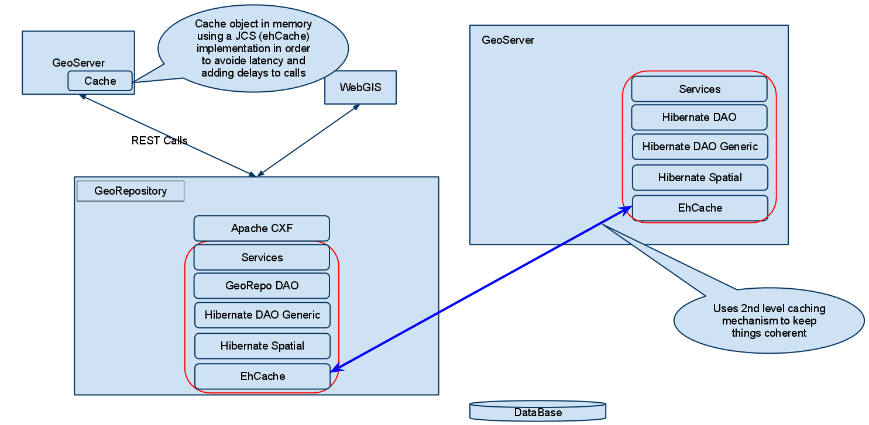

The picture above depicts a useful improvement for the GeoServer/GeoRepository communication.

For sure always asking filters’ constraints remotely to GeoRepository can be very time consuming especially for Tiled requests.

Considering that in most cases consecutive requests will be made on the same layer and restricted areas for a single user, the idea would be to cache filters requested to GeoRepository internally so that is not necessary to perform a remote request to GeoRepository for every tile or dataset to retrieve the constraint.

A relatively easy solution to achieve this objective would be to replicate the GeoRepository Object Model tier into the GeoServer implementation of the DataAccess Request, by introducing a JCS like ehCache in order to store locally objects and queries for a limited amount of time.

Moreover a mechanism to invalidate the cache on GeoServer should also be envisaged. GeoServer should be able to check if the cache objects are valid or not somehow. This could be done by introducing a specific method into the GeoRepository Service interface.