**Menu Item Name : Sales Order (Unit)**

**Menu Structure : Sales\Sales Order (Unit)**

1. **Bug Description**
   1. Click Button Save & Close, Save & New no reaction: Form Sales Order (Unit), Order Lines – Add an Item, Select Product (Unit)
   2. Cannot Add Unit, error field Accessories Id
2. **Bug Fix & Additional Solution**
   1. Add Filter: Form Sales Order (Unit) – Order Lines – Add an Item, Filter Field for Type Unit and Accessories
3. **Bug Reference**
   1. 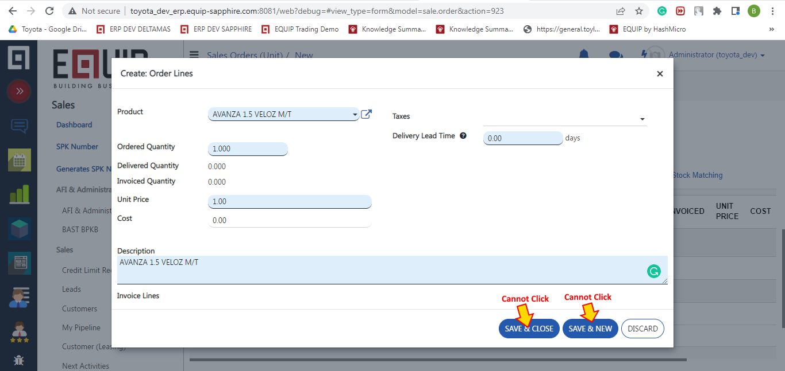Print Screen Order Lines – Add an Item
   2. Graphical user interface, text, application

      Description automatically generatedPrint Screen Error Accessories Id