
UNITY WARRIORS EMPIRE
COMMERCIAL BUSINESS PROPOSAL & TECHNICAL SYSTEM WHITE-PAPER
CONFIDENTIAL & PROPRIETARY COMMERCIAL PROPOSAL
This document details the complete operational capabilities, dual-tier software architecture, automated student enrollment pipeline, and defense-grade security matrix of the Unity Warriors Empire training & academy platform. Ready for immediate enterprise operation, commercial licensing, or white-label acquisition.

Author: UWE Systems Architecture & Engineering Division
Document Release: Version 2.4 (Production Validated)
Deployment Target: Vercel Cloud Serverless + PostgreSQL Supabase
Quality Assurance: 32 / 32 Automated Test Suites Passing (100%)

1. Executive Overview & Commercial Value Proposition
Modern high-ticket coaching, subconscious mind optimization, and executive leadership academies require a digital infrastructure that conveys elite operational excellence. Generic educational templates and bloated third-party platforms (such as Teachable or Kajabi) introduce heavy monthly recurring SaaS costs, high latency, and fragmented workflows.
Unity Warriors Empire (UWE) was engineered from the ground up to solve these challenges by unifying a cinematic student-facing academy with a centralized 12-in-1 Command HQ.
KEY COMMERCIAL ADVANTAGES
• 100% Owned IP & Zero Recurring Platform Fees: Self-hosted serverless architecture eliminates monthly SaaS licensing overhead.
• Frictionless Bank Transfer Monetization: Custom canvas-compressed slip submission and 1-click admin auto-enrolment.
• Integrated Student Command Center: Personalized progress tracking, live Zoom links, and official credential vaults.
• Granular Access Protection: Public free previews paired with strict token-gated masterclass content.

2. Visual Platform Showcase & Live Production Screenshots
The screenshots below demonstrate the live, fully responsive user experience across both the student learning environment and the back-office administrative command suite:
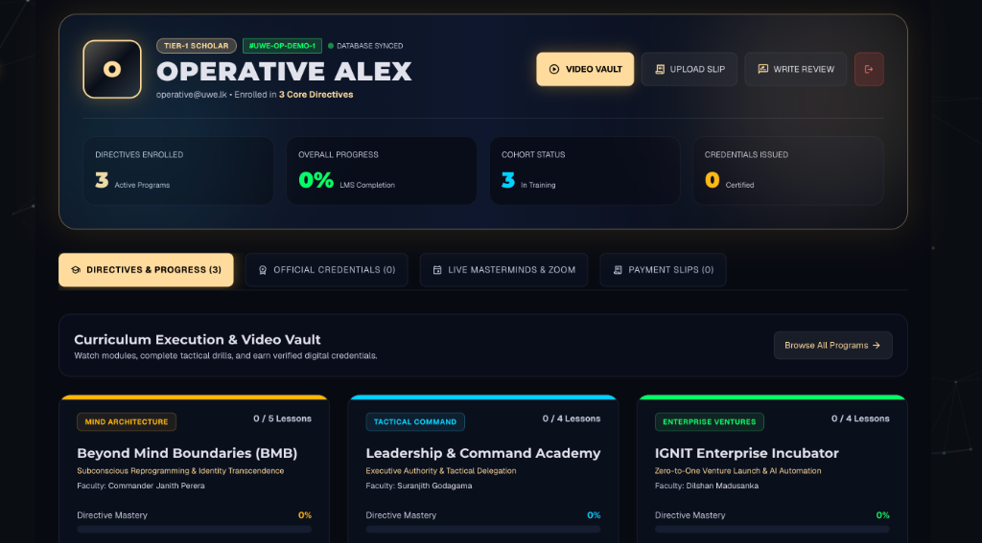
📸 Figure 1: Operative Student Command Dashboard — Live Program Directives, KPI Progress Counters, and Direct Zoom Mastermind Launchpad
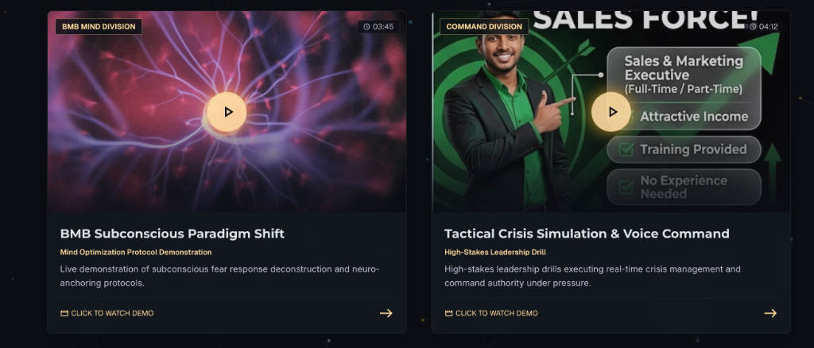
📸 Figure 2: Tactical Video Masterclass Vault — High-Fidelity Custom Thumbnails, Video Duration Timers, and Interactive Modal Player
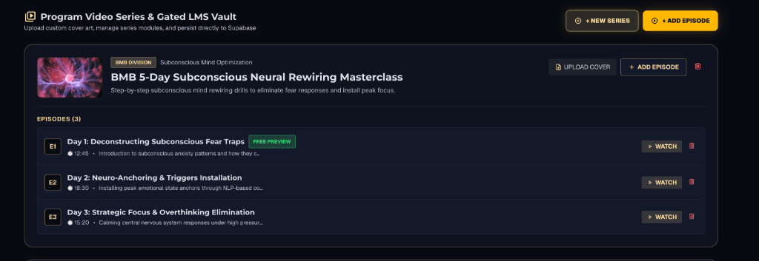
📸 Figure 3: Admin Command HQ: Video Series & Gated LMS Vault — Drag-and-Drop Thumbnail Cover Uploader with Direct PostgreSQL Persistence
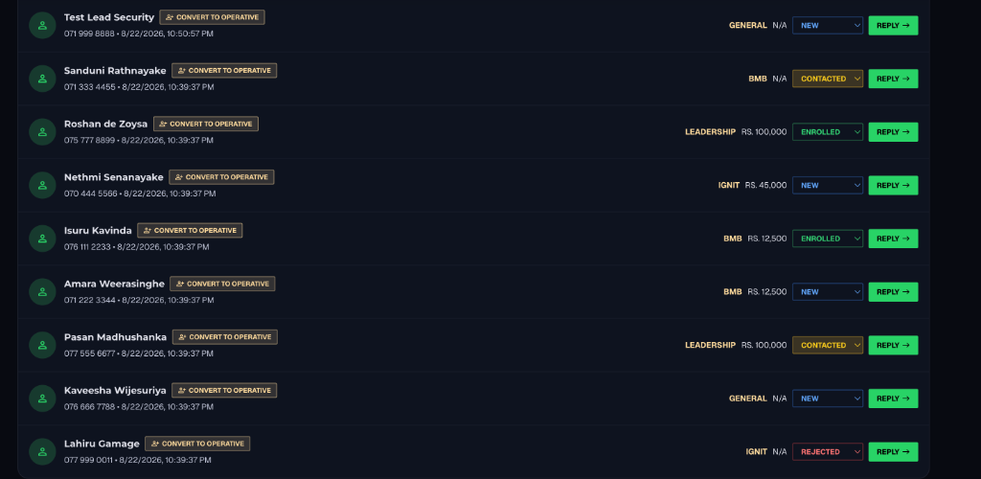
📸 Figure 4: Admin Inbound Leads CRM — WhatsApp Ingestion Pipeline, Status Lifecycle Management (NEW, CONTACTED, ENROLLED), and 1-Click Operative Conversion
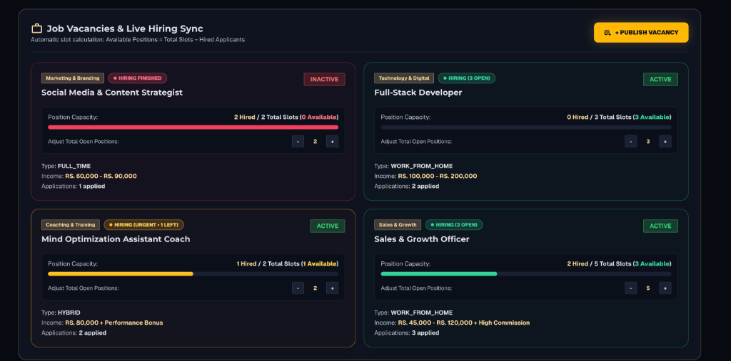
📸 Figure 5: Talent Acquisition & Live Capacity Sync — Visual Open Position Capacity Bars, Hiring Statuses, and Applicant Tracking

3. Comprehensive Frontend Capabilities & User Experience
Built using React 19 and Framer Motion with tailored dark-mode ergonomics, the frontend delivers sub-second responsiveness and high-ticket perceived value.
Module / Area | Key Functional Features | Business / UX Impact
Home Portal | Spring-physics cursor lighting, tactical hero cards, dynamic stats ticker, and animated value propositions. | Commands immediate attention and authority upon first page load.
Program Catalog | Real-time pricing, seat scarcity countdowns, and upcoming batch dates fetched dynamically from Supabase. | Drives conversion urgency with real-time seat availability.
Course Detail View | Modular day-by-day syllabuses, faculty credentials, interactive FAQs, and verified student feedback. | Addresses prospective student objections with transparent curriculum data.
Student Dashboard | Personalized enrolled directives, module watch meters, schedule calendars, and direct Zoom launch buttons. | Provides an organized central command center for paying students.
Gated LMS Video Vault | Category-wise series playlists (BMB, Leadership, IGNIT) with public Episode 1 Free Previews and token gating. | Nurtures free leads while strictly protecting premium intellectual property.
Bank Slip Uploader | Client-side HTML5 Canvas image optimization (PNG, JPG, WebP) with live status tracking (PENDING, VERIFIED). | Enables frictionless local payments with zero payment gateway fees.
Careers Portal | Live open position listings with department filters, income ranges, and instant application forms. | Automates recruitment and talent acquisition for internal growth.
Global SEO Engine | Pre-configured Open Graph, canonical links, and dynamic meta descriptions via React Helmet Async. | Maximizes organic search visibility across search engines and social sharing.

4. Centralized Admin Command HQ & Operations Matrix
Command HQ serves as the complete operational cockpit for business owners, training coordinators, and recruitment staff. All changes synchronize with the PostgreSQL database in real time.
HQ Control Tab | Administrative Capability | Operational Benefit
Batches, Fees & Zoom Links | Edit tuition fees, available seats, commencement dates, and live Mastermind Zoom meeting URLs per batch. | Instant scheduling updates reflected immediately on student portals.
Bank Slips Hub | Visual inspection of uploaded payment receipts with 1-click verification that automatically enrolls students. | Eliminates manual bookkeeping and accelerates student onboarding.
WhatsApp CRM Leads | Live lead ingestion pipeline with statuses (NEW, CONTACTED, ENROLLED, REJECTED) and 1-click conversion to user accounts. | Maximizes sales follow-up velocity and tracks marketing ROI.
Coupons & Promos | Create discount vouchers with percentage or fixed deductions, max uses, expiry dates, and program restrictions. | Empowers flexible promotional campaigns and affiliate marketing.
Video & Media CMS | Publish and edit video reels and masterclasses with drag-and-drop thumbnail uploads and canvas compression. | Zero developer dependencies for curriculum updates.
User Accounts Registry | Manage student profiles, grant special course clearances, and perform instant security password resets. | Complete governance over enrolled user records.
Ticker Announcement Bar | Global emergency or promotional alert banner editor with dirty-state change detection. | Instantly broadcast critical deadlines or final seat callouts.
Job Vacancies Sync | Create and adjust open career slots with visual progress bars and applicant review tables. | Streamlines hiring of sales specialists and coaches.

5. Enterprise Security & Defense Architecture
Security has been built with defense-in-depth principles across every network boundary, authentication handshake, and database interaction.
🔐 Dual-Token Authentication Protocol
Short-lived 15-minute Access Tokens (JWT) paired with cryptographic 7-day Refresh Tokens. If an access token is intercepted, it expires rapidly, while refresh tokens are rotated safely.

🛡️ Granular Role-Based Access Control (RBAC)
Hierarchical authorization enforcing four discrete clearance roles: SUPER_ADMIN, COMMANDER, COACH, and RECRUITER. Financial and credentialing endpoints strictly reject unauthorized staff.

🚦 3-Tier Layered Rate Limiting
Dedicated express-rate-limiters: Auth (12 attempts/15min for brute-force defense), Submissions (20/hr for lead spam defense), and Global API (300/15min), with Vercel 'trust proxy' client IP identification.

🔍 Schema Enforcement & Payload Sanitization (Zod)
Every API mutation passes through strict Zod validators, automatically stripping unexpected keys and rejecting malformed payloads before database execution.

🔑 Bcrypt Salted Password Hashing
All administrative and student passwords are encrypted with Bcrypt using 12 salt rounds, ensuring protection against rainbow table attacks.

🗄️ PgBouncer Database Connection Pooling
Supabase PostgreSQL transactions communicate via PgBouncer on port 6543, providing elasticity against serverless concurrency surges.

6. Automated Student Lifecycle & Technical QA Metrics
The platform powers a continuous, automated 6-stage monetization pipeline:
▶ 1. Inbound Lead Acquisition
Prospective students review dynamic curriculum breakdowns and submit direct WhatsApp inquiries captured automatically into the Admin CRM.
▶ 2. Account Creation & Batch Selection
Students create an operative account with encrypted credentials and select their targeted training cohort.
▶ 3. Bank Transfer & Receipt Upload
Students submit bank payment receipts using the in-browser canvas-compressed image uploader.
▶ 4. Admin 1-Click Verification
Staff inspect receipt details in Command HQ and execute a 1-click verification action.
▶ 5. Automated Batch Enrolment
The database automatically deducts an available seat and unlocks the enrolled program directive on the student's profile.
▶ 6. LMS Video Vault & Zoom Launch
Student dashboard immediately transitions to active training status, unlocking live Zoom Masterminds and gated lessons.

Technical Topology & Quality Assurance
Frontend Technology | React 19, TypeScript, Vite, Vanilla CSS, Framer Motion 13, Lucide
Backend Technology | Node.js (ESM), Express 5, esbuild Serverless Bundle, Helmet, Zod
Database Infrastructure | PostgreSQL (Supabase) via Prisma ORM 6.19 with PgBouncer Pooling
Cloud Deployment Target | Vercel Edge & Serverless Functions (Single unified mono-repo build)
Automated Test Suite | Vitest — 32/32 Passed (100% Pass Rate across Security & Phase 7 APIs)
API Documentation | OpenAPI 3.0 / Swagger UI integrated at /api/docs

PROPOSAL PREPARED BY:  Unity Warriors Empire Technical Team  System Architecture & Engineering Division | DEPLOYMENT STATUS:  Production-Ready (Passed 32/32 Tests)  Status: Live on Vercel Edge Cloud

