# Setting up the Nginx Proxy

## Base install

* Setup the nginx repo /etc/yum.repos.d/nginx.repo and enable it
* Install Nginx using the yum package

*sudo yum install nginx -y*

## Install Add-ons and Depdencies:

* Enable the EPEL release packages and repo
* Install add-on packages and Development Tools to help compile the dynamic modules

*sudo yum groupinstall "Development tools" -y*

* + Install libraries like libjansson,libjwt, libz, etc for the complete list of libraries Please refer to the [Docker file](https://github.com/TeslaGov/ngx-http-auth-jwt-module/blob/master/Dockerfile) used on the github link <https://github.com/TeslaGov/ngx-http-auth-jwt-module>
* Install and build the missing libraries using the commands in the Docker file

## Building the Module:

* Download the nginx source version corresponding to the release installed using yum (ex: 1.18.0 ; nginx -v ) Can be downloaded from <http://nginx.org/download/>
* Download the source for ngx-http-auth-jwt-module module using https://github.com/TeslaGov/ngx-http-auth-jwt-module
* Compile the ngx_http_auth_jwt_module

*./configure --with-compat --add-dynamic-module=../ngx-http-auth-jwt-module --without-http_gzip_module --with-http_ssl_module --without-http_rewrite_module $(nginx -V)*

* Build the module

*make modules*

* Copy the required modules to the right directories

*sudo cp /data/nginx-1.18.0/objs/ngx_http_auth_jwt_module.so /etc/nginx/modules/ngx_http_auth_jwt_module.so*

* Verify the installed module permissions (Installed module and permissions below)

ls -altr /etc/nginx/modules/

total 524

-rwxr-xr-x. 1 root root 174848 Jun 7 12:30 ngx_stream_module.so

-rwxr-xr-x. 1 root root 101376 Jun 7 12:30 ngx_mail_module.so

-rwxr-xr-x. 1 root root 24576 Jun 7 12:30 ngx_http_xslt_filter_module.so

-rwxr-xr-x. 1 root root 24528 Jun 7 12:30 ngx_http_perl_module.so

-rwxr-xr-x. 1 root root 24600 Jun 7 12:30 ngx_http_image_filter_module.so

drwxr-xr-x. 3 root root 20 Nov 12 11:55 ..

drwxr-xr-x. 2 root root 4096 Nov 13 11:47 .

-rwxr-xr-x. 1 root root 172688 Nov 13 19:14 ngx_http_auth_jwt_module.so

## Extracting the Authorization JWT file from Okta:

* Fetch the Okta keys using the Okta tenant using the endpoint <https://uspto-dev.oktapreview.com/oauth2/default/v1/keys>
* Make sure to use the **CURRENT** KEY from the authorization server
* Identify the Kid being used by the authorization server from okta tenant

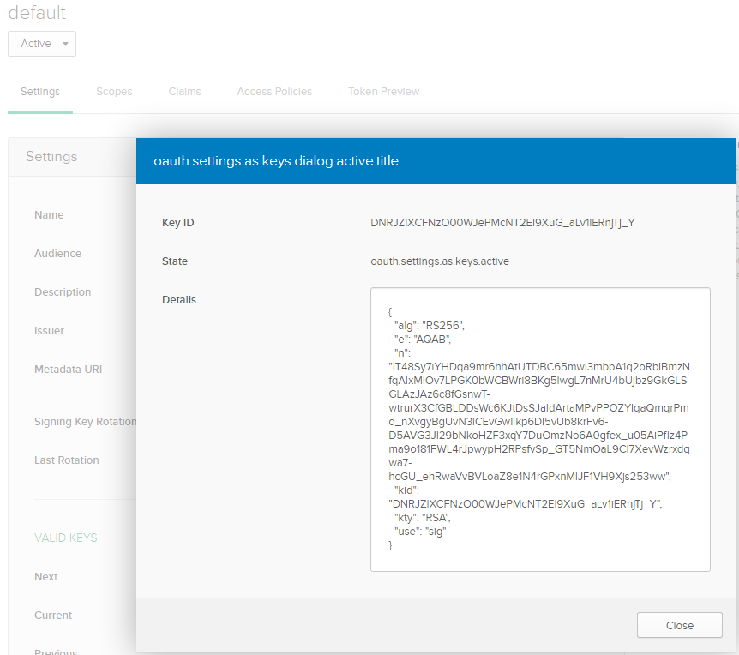

* Convert the jwks to pem file to extract the public key
* Sample of a public key is below

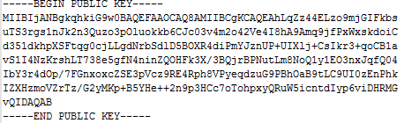

## Configuring Nginx

* Update /etc/nginx/nginx.conf to use the jwt keys and proxy to the back end services
* Load the ngx_http_auth_jwt_module dynamic module built earlier

load_module modules/ngx_http_auth_jwt_module.so;

* Configure the proxy in the servers
  + Services for Image Server
  + Services to Design Code
  + Services for Goods and Services
* Sample Configuration for Trademark Image servers

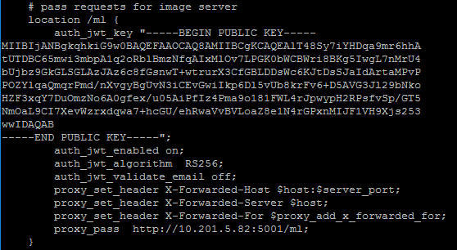

location /ml2 {

auth_jwt_key "-----BEGIN PUBLIC KEY-----XABSDLSDFSDXSDSDSDSD -----END PUBLIC KEY-----";

auth_jwt_enabled on;

auth_jwt_algorithm RS256;

auth_jwt_validate_email off;

proxy_set_header X-Forwarded-Host $host:$server_port;

proxy_set_header X-Forwarded-Server $host;

proxy_set_header X-Forwarded-For $proxy_add_x_forwarded_for;

proxy_pass http://10.201.5.4:5001/ml2;

}

Goods and Services(ml2) and Design Codes (ml1) and Trademark Image server (ml)

*/ml2 🡪* <http://10.201.5.4:5001/ml2>

*/ml1 🡪* [*http://10.201.5.42:5001/ml1*](http://10.201.5.42:5001/ml1)

*/ml 🡪* [*http://10.201.5.82:5001/ml*](http://10.201.5.82:5001/ml)

## Starting the services

* Stop the nginx service
* Start the nginx service
* Verify the Nginx startup is good

sudo systemctl status nginx

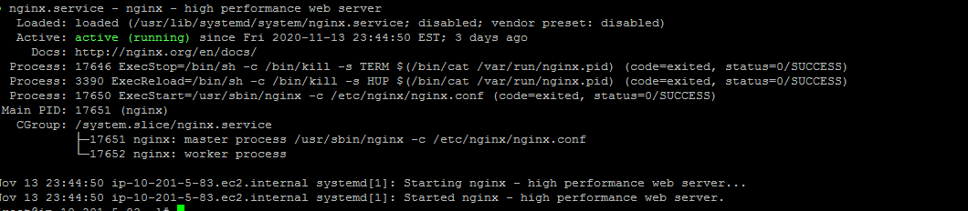

## Log Location:

* Logs are present /var/log/nginx directory the access.log and error.log

[root@ip-10-201-5-83 nginx]# tail -f error.log

2020/11/16 09:59:30 [error] 17652#17652: *14357 failed to find a jwt, client: 10.201.5.234, server: _, request: "GET /ml/serve/85789070 HTTP/1.1", host: "pvt-tmimagesearch.app.uspto.gov", referrer: "https://pvt-tmimagesearch.app.uspto.gov/gallery-select"

2020/11/16 09:59:30 [error] 17652#17652: *14353 failed to find a jwt, client: 10.201.5.234, server: _, request: "GET /ml/serve/79199155 HTTP/1.1", host: "pvt-tmimagesearch.app.uspto.gov", referrer: "https://pvt-tmimagesearch.app.uspto.gov/gallery-select"

2020/11/16 09:59:30 [error] 17652#17652: *14354 failed to find a jwt, client: 10.201.5.234, server: _, request: "GET /ml/serve/75033182 HTTP/1.1", ho

tail -f access.log

10.201.5.119 - - [17/Nov/2020:09:22:12 -0500] "GET / HTTP/1.1" 200 612 "-" "ELB-HealthChecker/2.0" "-"

10.201.5.234 - - [17/Nov/2020:09:22:12 -0500] "GET / HTTP/1.1" 200 612 "-" "ELB-HealthChecker/2.0" "-"

10.201.5.119 - - [17/Nov/2020:09:22:42 -0500] "GET / HTTP/1.1" 200 612 "-" "ELB-HealthChecker/2.0" "-"

10.201.5.234 - - [17/Nov/2020:09:22:42 -0500] "GET / HTTP/1.1" 200 612 "-" "ELB-HealthChecker/2.0" "-"