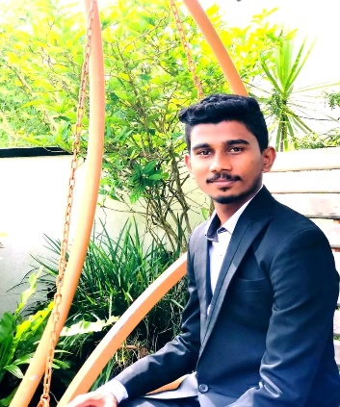

|  |
| --- |
| D.S.Maduranga Sandaruwan  **17th of August 2002.**  **147/F1, Adadola Road, Wathugedara.**  **madurangasadaruwan393@gmail.com**  **Mobile Number +94 765591043** |

# Career Objective

* To enhance my knowledge and capabilities by working in a dynamic organization that prides itself in giving substantial responsibility to new talent.

# Acadamic Qualification

* Curruntly following and studying for a Software Engineer diploma at the Institute of Software Engineering (IJSE) and also studying other subjects.
* I am currently studying Java computer language as a master in IJSE Institute.
* My Git hub link -: <https://github.com/maduranga1234>

• First Semester Final Results at IJSE Campas

|  |  |
| --- | --- |
| Subjects | Grade |
| Object oriented programming(Oop) | -A |
| Programming fundamentals(Prf) | C |
| Database management system(Dbms) | +C |
| Software Engineering(Swe) | -C |
| Layered architecture | A |
| Java socket Programming | A |
| First semester final project | B |

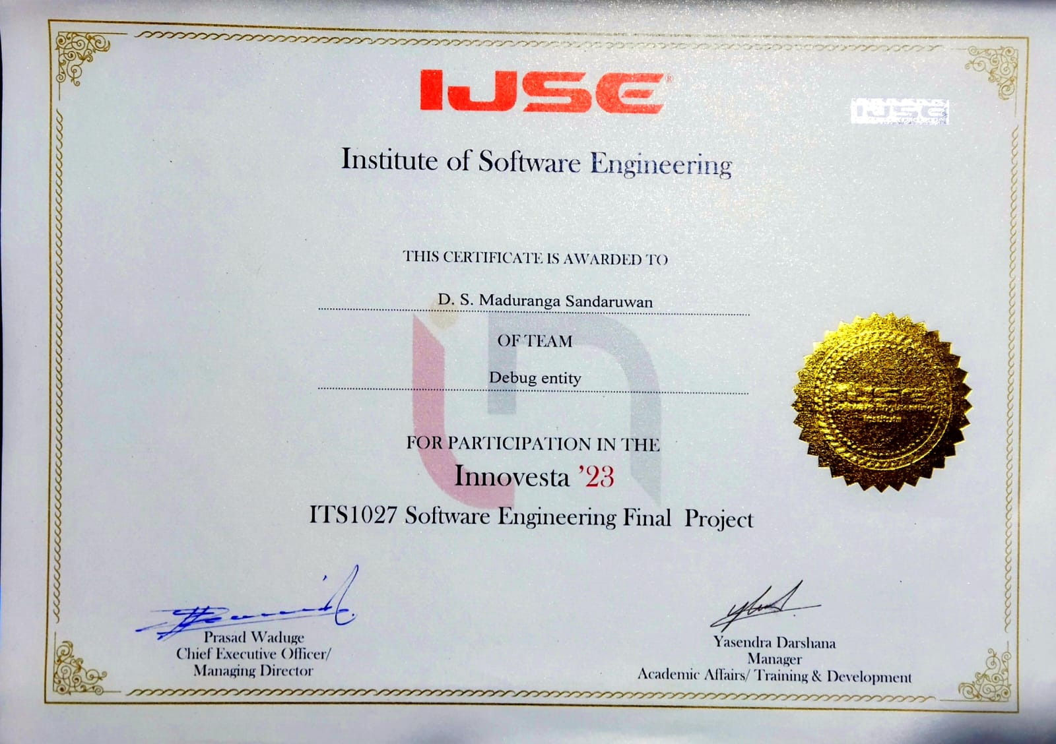

# Working Experience

* Two years working experience as a Software Data Entry executive at Softlogic Company.
* Working as a software data executive in a softlogic company.(Jan 2021 -Present)

# Skills

* Created presentations and reports in every module of advanced diploma and higher diploma in Software Engineering at IJSE.
* Fluent in MS Office

# Presentation Skills

* + Delivered presentations in every module of advanced diploma and higher diploma in Software Engineering at IJSE.

Non-Related Referees.

* I.G. Jayathilaka
* 0777606375
* Softlogic Showroom Maneger Hikkaduwa Branch

I do hereby declare that the particulars given above are true and correct to the best of my knowledge.

D.S.Maduranga Sandaruwan .