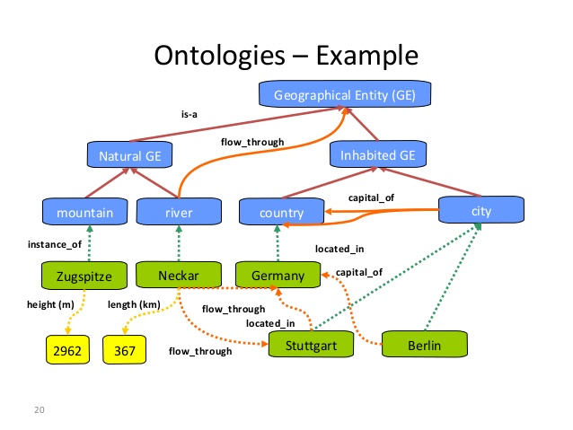

Questions:

1. Berlin is capital of what country?
2. What is length of river Neckar?
3. Where is located Stuttgart?
4. What is a mountain?
5. Neckar flow through which city?