FINAL YEAR INDIVIDUAL PROJECT REPORT
AutoTest
Autonomous Web Application Testing Agent

Field | Detail
Student Name | Madushan Samayasivam
Index Number | BAD/IT/2324/F/066
Programme | Higher National Diploma in Information Technology (HNDIT)
Institute | Advanced Technological Institute (ATI), Badulla
Awarding Body | Sri Lanka Institute of Advanced Technological Education (SLIATE)
Submission Date | July 2026
Supervisor | ________________________________

Declaration
I do hereby declare that the work reported in this project report was carried out exclusively by me under the supervision of my assigned project supervisor. It describes the results of my own independent work except where due reference has been made in the text. No part of this report has been submitted earlier or concurrently for the same or any other degree.
Date | ___________________________
Signature of Candidate | ___________________________

Certified by
Supervisor Name | ___________________________
Date | ___________________________
Signature | ___________________________

Abstract
Manual test authoring represents a significant time and skill barrier for solo developers, freelancers, and student teams without dedicated quality assurance resources. This report documents the design, implementation, and evaluation of AutoTest, a zero-configuration testing agent that removes the requirement to author web application test scripts by hand. The objective was to build a system that accepts a single URL and autonomously generates and executes functional tests against the target application. The system was implemented in Node.js using Playwright for browser automation, the HuggingFace Inference API (meta-llama/Llama-3.1-8B-Instruct) for test generation, SQLite for result persistence, and a vanilla JavaScript dashboard for result inspection. Development followed an incremental approach over two days (12-13 July 2026), with each pipeline stage committed to version control after being verified against a real web application. The initial LLM integration used the Anthropic Claude API; this was replaced mid-project with the HuggingFace free Inference API following free-tier credit exhaustion. Two pipeline runs were conducted against the same public target (https://demo.playwright.dev/todomvc). The first run (12 July 2026) produced three test cases and recorded zero passes, one assertion failure, and two crashes, all attributable to LLM-generated selector errors. The second run (20 July 2026), conducted after a prompt fix requiring the script-generation stage to use actual crawled DOM data, produced two passes and one assertion failure, with zero crashes. Four specific bugs were identified and corrected through real system operation during development, each traceable to a committed code change. The results demonstrate that the execution engine reliably distinguishes runtime errors from assertion failures in AI-generated test code. The principal remaining limitations are LLM output non-determinism, a single-page crawl scope in the integrated pipeline, and the absence of a formal evaluation against a ground-truth test suite. The tool operates as a local single-user prototype; a production deployment would require DNS-resolving SSRF protection, authentication, and a formal evaluation harness, all of which were designed in a separate architectural exploration but not integrated.

Acknowledgements
The Author would like to thank the project supervisor for guidance and direction throughout this project, along with the academic and non-academic staff of the Advanced Technological Institute, Badulla, and the Sri Lanka Institute of Advanced Technological Education, for their support during the HNDIT programme.

Table of Contents
Declaration 2
Certified by 2
Abstract 3
Acknowledgements 4
Table of Contents 5
List of Figures 6
List of Tables 6
List of Abbreviations 6
Chapter 1: Introduction 7
1.1 Problem Statement 7
1.2 Functional Requirements 7
1.3 Non-Functional Requirements 7
Chapter 2: Literature Review and Study of Similar Applications 8
2.1 Literature Review 8
2.1.1 Traditional Web Application Testing 8
2.1.2 Static and Dynamic Analysis of Web Applications 8
2.1.3 AI Agents for Web Testing 8
2.1.4 LLM Agent Capability Benchmarks 8
2.2 Study of Similar Applications 8
2.2.1 Microsoft Playwright Agents 8
2.2.2 Traditional SaaS Testing Platforms 8
2.3 Motivation 8
Chapter 3: Materials and Methods 9
3.1 Materials 9
3.1.1 Hardware Requirements 9
3.1.2 Software Requirements 9
3.2 Methods 10
Chapter 4: System Design and Implementation 12
4.1 System Architecture 12
4.2 Data Model 13
4.3 Prompt Design 14
4.4 User Interface 15
4.5 Security and Abuse Mitigations Implemented 17
Chapter 5: Results and Discussion 19
5.1 Objectives 19
5.2 Results 19
5.3 Discussion 21
5.4 Limitations 21
5.5 Future Development 22
Chapter 6: Conclusions 23
Future Work and Recommendations 23
References 24
Appendix A: Additional Screenshots 25
Appendix B: Special Algorithms / Key Code Listings 27

List of Figures

Figure 1: AutoTest system architecture (run-pipeline.js, server.js). Dashed-border boxes denote external systems.
Figure 2: SQLite database schema (db.js lines 5–32). All timestamps stored as ISO 8601 TEXT strings.
Figure 3: AutoTest dashboard — URL input form and crawl history panel showing one run for https://demo.playwright.dev/todomvc (2 pass, 1 fail, 0 crash).
Figure 4: Detail view for crawl #1 — three generated test cases with results. Two tests passed; one failed due to a strict-mode locator ambiguity.

List of Abbreviations
Abbreviation | Meaning
LLM | Large Language Model
UI | User Interface
API | Application Programming Interface
DOM | Document Object Model
SDLC | Software Development Life Cycle

Chapter 1: Introduction

1.1 Problem Statement
Manual test authoring is a significant barrier for solo developers, freelancers, and student teams without dedicated QA resources, and this gap results in defects reaching production undetected. This report documents the design, implementation, and evaluation of AutoTest, a zero-configuration AI testing agent that removes the requirement to author test scripts by hand.

1.2 Functional Requirements
- The system shall accept a target URL and crawl the application's reachable pages and interactive elements.
- The system shall generate test-case descriptions from the crawled interface map using a large language model.
- The system shall convert generated test-case descriptions into executable Playwright scripts.
- The system shall execute generated scripts headlessly and capture pass, fail, crash, and skipped outcomes with error messages.
- The system shall present results in a browser-based dashboard and persist run history in a local SQLite database.

1.3 Non-Functional Requirements

NFR1: The system shall operate on a single local machine without requiring any cloud services beyond external API calls (HuggingFace Inference API).

NFR2: The system shall require no compilation or build step; the frontend (public/index.html) is served as a static file and the backend runs directly as Node.js ESM source.

NFR3: The system shall not interact with any element categorised as unsafe by the safe-mode blocklist (safe-mode.config.json), regardless of the target URL.

NFR4: The system shall handle LLM output parsing failures by retrying up to three times before aborting test generation for the affected page (run-pipeline.js, MAX_RETRIES = 3).

NFR5: LLM calls use the HuggingFace free Inference API; there is no API cost per run. A verification run conducted on 20 July 2026 against https://demo.playwright.dev/todomvc completed in approximately 31 minutes (three test cases generated and executed). This figure includes HuggingFace API latency and is not a formal performance measurement.

Chapter 2: Literature Review and Study of Similar Applications

2.1 Literature Review

2.1.1 Traditional Web Application Testing
Selenium, Cypress, and Playwright are established browser-automation frameworks; all require a human to decide what to test and author the corresponding script.

2.1.2 Static and Dynamic Analysis of Web Applications
Ricca and Tonella (2001) established that neither static nor dynamic analysis alone captures realistic user behaviour, motivating a crawl-then-reason approach.

2.1.3 AI Agents for Web Testing
The WebProber framework (2025) demonstrated that a vision-language model given only a URL can identify layout and functional issues by simulating human-like actions.

2.1.4 LLM Agent Capability Benchmarks
AgentBench (2023) found a persistent gap between LLM-agent performance and human-level task completion, relevant to bounding trust in AI-generated tests.

2.2 Study of Similar Applications

2.2.1 Microsoft Playwright Agents
Playwright Agents (October 2025) use a Planner/Generator/Healer pipeline but operate against an existing local codebase rather than a bare URL.

2.2.2 Traditional SaaS Testing Platforms
Record-and-playback platforms reduce scripting effort but still require a human walkthrough and account/environment setup before first use.

2.3 Motivation
No available tool combines true zero-configuration input (a URL only) with autonomous reasoning about what to test, which is the gap AutoTest was built to fill.

Chapter 3: Materials and Methods

3.1 Materials

3.1.1 Hardware Requirements
The system was developed and evaluated on a single personal laptop. System specifications were confirmed by direct inspection during the project:

Processor: Intel Core i5-13420H (13th Generation), 8 physical cores, 12 logical processors, maximum clock speed 4.6 GHz.
Memory: 7.4 GiB RAM.
Storage: 475 GB NVMe SSD (343 GB available during development).
Operating System: Fedora Linux 44 (Workstation Edition), kernel 7.1.3-200.fc44.x86_64, x86_64 architecture.

No cloud compute was used. All pipeline stages — browser launch, LLM API calls, script execution, and database writes — ran locally on this hardware.

3.1.2 Software Requirements
Layer | Technology / Tool
Language (all) | JavaScript (ESM), Node.js v22
Frontend | Vanilla JavaScript, HTML, CSS (public/index.html) — no framework, no build step
Backend / API | Express.js
AI integration | HuggingFace Inference API, meta-llama/Llama-3.1-8B-Instruct. Note: development initially used the Anthropic Claude API (test-claude-api.js); pivoted mid-project (commit c4da1ce, 12 July 2026) due to free-tier budget exhaustion.
Test execution | Playwright (headless Chromium)
Web crawling | Custom extraction using Playwright $$eval (run-pipeline.js lines 16-35) — no third-party crawler library
Database | SQLite via better-sqlite3 npm package
Authentication | None — designed as a single-user local tool
Hosting | Local only (http://localhost:3000) — no cloud deployment
Version control | Git / GitHub

3.2 Methods
The system was developed using an incremental approach in which each pipeline stage was implemented as a standalone script, verified with a real run against a live web application, and committed to version control before the next stage was begun. This ensured that failures were isolated to the component under development and that each stage could be independently inspected.

The development sequence, reconstructed from the git commit history (repository: madushansivam/autotest), was as follows.

Stage 1 — Proof of concept (12 July 2026, commit 8012425): Playwright was installed and a minimal script confirmed that it could launch Chromium headlessly and load a real web page.

Stage 2 — Crawler (commits 10662fd, 2367654, 10bfca9, 78e096e; 12 July 2026): The page crawler was built iteratively. Version 1 extracted buttons, inputs, and links into a structured interface map. Version 2 added an interaction step (adding a todo item) before scanning, to reveal elements rendered only after user action. Version 3 added aria-label and class-name fallbacks for icon-only buttons. A multi-page BFS crawler (multi-crawler.js) was tested against books.toscrape.com, which revealed the first safe-mode gap: the phrases 'add to basket', 'add to cart', and 'add to bag' were absent from the initial blocklist. These were added to safe-mode.config.json (commit 78e096e).

Stage 3 — LLM integration and provider pivot (commits aa34a1d, c4da1ce, 61cf4f3; 12 July 2026): API key management via dotenv was added. The Anthropic Claude API was initially integrated as the AI backend, but the free-tier credit limit was exhausted during this phase. The project pivoted to the HuggingFace free Inference API, using meta-llama/Llama-3.1-8B-Instruct (commit c4da1ce). A retry loop of up to three attempts was then added after discovering that the model occasionally emits malformed JSON (unclosed strings, trailing commas), causing silent zero-output runs. A confidence-value validation step was also added; test cases whose confidence field was neither 'structural' nor 'behavioral' were tagged with a validationWarning flag.

Stage 4 — Execution engine (commit 805699b; 12 July 2026): The execution engine compiled LLM-generated scripts at runtime using JavaScript's AsyncFunction constructor, navigated to the target URL, and ran each compiled function in a live Playwright browser context. Two failure modes were discovered: (1) a vacuous pass, where a selector (tbody > tr) not present on the page returned { passed: true } because Playwright's auto-waiting silently succeeded on an empty result; and (2) selector hallucination, where the code-generation prompt did not include the crawled DOM data, causing the model to invent selectors. Both were fixed: the prompt was updated to include DOM data, and all generated scripts were required to wrap actions in try/catch, returning { passed: false, error: err.message } on failure.

Stage 5 — Database and API (commits 9ba8701, f02e94f, 8997bc3, 0748675, a80cf4c; 13 July 2026): A three-table SQLite schema (crawls, test_cases, test_results) was implemented using better-sqlite3. CRUD operations were verified with live data. The Express server was added, and all stages were integrated into runFullPipeline() exposed via POST /api/crawl. An unhandled-rejection handler was added after a generated script crashed the server process during a live run.

Stage 6 — Dashboard (commit 8997bc3; 13 July 2026): A vanilla JavaScript dashboard (public/index.html) was implemented, providing a URL input form, crawl history grouped by target URL with pass/fail/crash tallies, and a detail view showing the generated script and error message for each test case.

No test framework was used for the working system; each stage was validated by running it against a real web application and inspecting the output. A separate unit-tested architectural exploration (backend/, frontend/, eval/) was implemented afterward but has not been run end-to-end and is not part of the evaluated system.

Chapter 4: System Design and Implementation

4.1 System Architecture
AutoTest is structured as a four-stage sequential pipeline, implemented as a single exported function (runFullPipeline, run-pipeline.js line 122) and exposed via an Express HTTP server (server.js). The four stages are: Crawl, Generate Test Cases, Generate Scripts, and Execute. Each stage completes before the next begins.

Entry point: The user submits a URL via the dashboard form. The browser sends POST /api/crawl to the Express server (server.js line 41). The URL is first checked by isUnsafeUrl() (server.js lines 13-26), which rejects non-http(s) schemes, localhost, and common private IP ranges. If the URL passes, runFullPipeline(url) is called.

Stage 1 — Crawl (run-pipeline.js lines 16-35): Playwright launches a headless Chromium browser and navigates to the target URL. The scanPage() function uses Playwright's $$eval to extract: buttons and role='button' elements (with aria-label and class fallbacks for icon-only controls); input elements (type, name, id, placeholder); and anchor links (text, href). Each button is tagged safe: true or safe: false against the blocklist in safe-mode.config.json.

Stage 2 — Generate Test Cases (run-pipeline.js lines 63-83): The structured page data is serialised to JSON and included in a prompt sent to meta-llama/Llama-3.1-8B-Instruct via the HuggingFace Inference API. The model returns a JSON array of 3-5 test case objects, each with a description and a confidence tag (structural or behavioral). Parsing is retried up to three times on malformed JSON.

Stage 3 — Generate Scripts (run-pipeline.js lines 85-98): For each test case, a second LLM call converts the description into a Playwright function body. The actual crawled DOM data is included in this prompt, constraining the model to use only selectors present on the page. The response is stripped of markdown fences and validated for minimum length.

Stage 4 — Execute (run-pipeline.js lines 100-120): Each script is compiled at runtime via JavaScript's AsyncFunction constructor and run in a live Playwright page context. Results are classified as: pass (returned { passed: true }), fail (returned { passed: false }, sub-category assertion_failed), crash (threw a runtime exception, sub-category runtime_error), or skipped (no script generated). All results are written to SQLite.

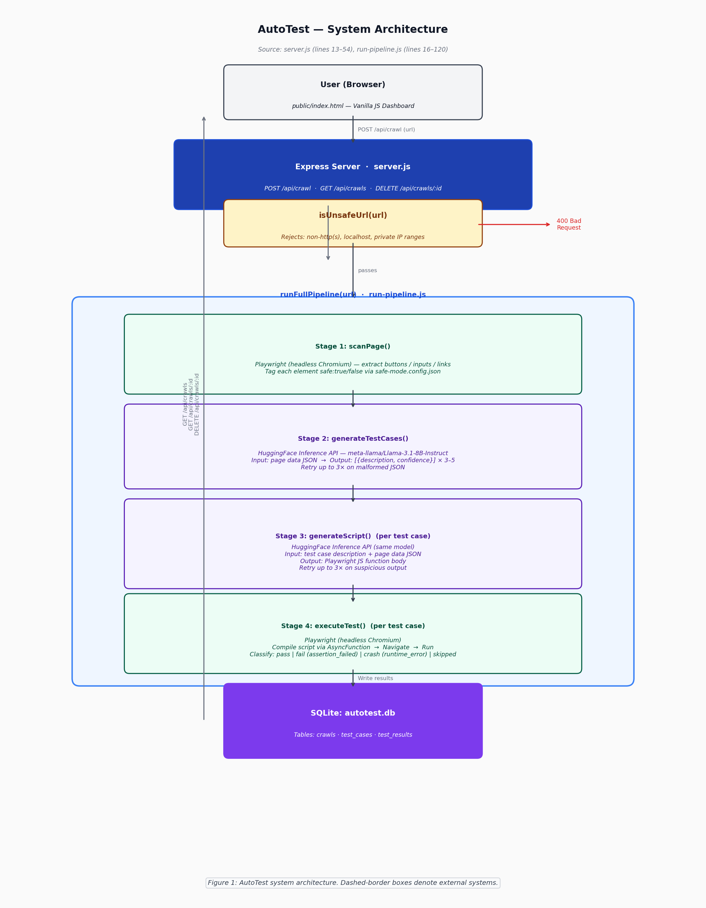
Figure 1: AutoTest system architecture (run-pipeline.js, server.js). Dashed-border boxes denote external systems.

4.2 Data Model
The working system uses a SQLite database (autotest.db), created and managed by the better-sqlite3 Node.js library. The schema is defined entirely in db.js (lines 5-32) and consists of three tables with foreign-key relationships.

crawls (id INTEGER PRIMARY KEY AUTOINCREMENT, url TEXT NOT NULL, crawled_at TEXT NOT NULL, raw_json TEXT NOT NULL): one record per pipeline run. raw_json holds the complete serialised output of scanPage() for the target URL.

test_cases (id INTEGER PRIMARY KEY AUTOINCREMENT, crawl_id INTEGER NOT NULL REFERENCES crawls(id), description TEXT NOT NULL, confidence TEXT NOT NULL, script TEXT, created_at TEXT NOT NULL): one record per generated test case. script is NULL if generation failed or was skipped.

test_results (id INTEGER PRIMARY KEY AUTOINCREMENT, test_case_id INTEGER NOT NULL REFERENCES test_cases(id), result TEXT NOT NULL, failure_category TEXT, error TEXT, executed_at TEXT NOT NULL): one record per execution outcome. result is one of: 'pass', 'fail', 'crash', 'skipped'. failure_category records the sub-classification ('runtime_error', 'assertion_failed', 'syntax_error') for non-passing results. error holds the first line of the Playwright error message.

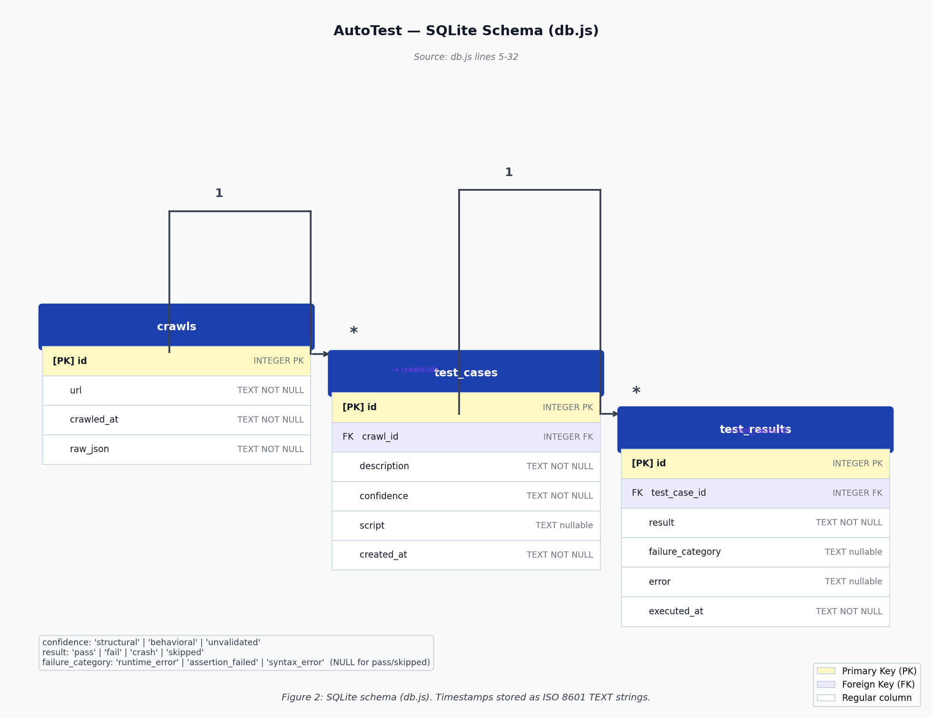
Figure 2: SQLite database schema (db.js lines 5–32). All timestamps stored as ISO 8601 TEXT strings.

The database file is gitignored (*.db in .gitignore) because it is a runtime artefact — it is created fresh on first run and is not part of the repository.

4.3 Prompt Design
Two LLM prompts were developed and iterated during the project. Both are reproduced below from run-pipeline.js.

Test-Case Generation Prompt (run-pipeline.js lines 37-45):

'You are a QA engineer. Given this structured map of a web page interactive elements, generate 3-5 test cases a human tester would perform.\n\nFor each test case, respond with a JSON array where each object has:\n- "description": plain-language description of the user action and expected result\n- "confidence": either "structural" or "behavioral"\n\nOnly test elements marked safe true. Never generate a test for anything marked safe false.\n\nPage data:\n[serialised page data]\n\nCRITICAL: Respond with ONLY a valid JSON array. No markdown code fences, no commentary, no trailing commas, all strings properly closed.'

Script Generation Prompt (run-pipeline.js lines 47-61):

'You are a Playwright test engineer. Convert this test case description into a single, complete, runnable Playwright test function body.\n\nTest case: "[test case description]"\nConfidence level: [structural|behavioral]\n\nHere is the ACTUAL crawled DOM data for this page. You MUST use the exact id, name, placeholder, or class values shown here:\n\n[serialised page data]\n\nRules:\n- Assume 'page' is already an initialized Playwright Page object, already navigated to the URL.\n- Use page.locator() with EXACT attribute values from the DOM data above.\n- Wrap the core action in a try/catch. On success, return { passed: true }. On failure, return { passed: false, error: err.message }.\n- Do NOT include imports, browser launch code, or function wrapper syntax.\n- Do NOT use Python-style snake_case methods.\n- Do NOT invent methods that do not exist on Playwright Page or Locator objects.\n- Respond with ONLY the raw JavaScript statements, no markdown fences, no commentary.'

Key design decisions made during prompt iteration:

1. JSON-only output constraint: The 'CRITICAL: Respond with ONLY a valid JSON array' instruction was added (commit 61cf4f3) after discovering that the model wrapped its output in markdown code blocks by default, breaking JSON.parse().

2. DOM data inclusion in script generation: The crawled page data is explicitly included in the script-generation prompt. This was absent in the original implementation and was added (commit 805699b) after discovering that the model hallucinated selectors when not shown real DOM data.

3. Retry logic: Both prompts retry up to MAX_RETRIES = 3 times on parse failure or suspicious output (code shorter than 10 characters, or containing <html>).

4. Confidence validation: After parsing, each test case's confidence field is checked against {'structural', 'behavioral'}. Any other value is normalised to 'unvalidated' and a validationWarning flag is set (run-pipeline.js lines 73-77).

4.4 User Interface
The dashboard is a single-file vanilla JavaScript application (public/index.html), served as a static file by Express (server.js line 54). It requires no build step.

The interface consists of four components:

1. URL input form: A text input and submit button at the top of the page. Submitting sends POST /api/crawl and displays a status message while the pipeline runs.

2. Crawl history panel: All past runs are loaded from GET /api/crawls and grouped by target URL. Each URL group shows how many runs have been performed and an aggregate tally of pass, fail, and crash counts across all runs for that URL. Groups expand and collapse on click.

3. Detail panel: Clicking a crawl row loads its full data from GET /api/crawls/:id and shows all test cases for that run, each with: the test description, the confidence tag (structural/behavioral), the result badge (pass/fail/crash/skipped), the generated Playwright script, and the error message if the test did not pass.

4. Delete action: Each crawl row has a delete button that calls DELETE /api/crawls/:id after a confirmation dialog, removing the crawl and all its test data from the database.

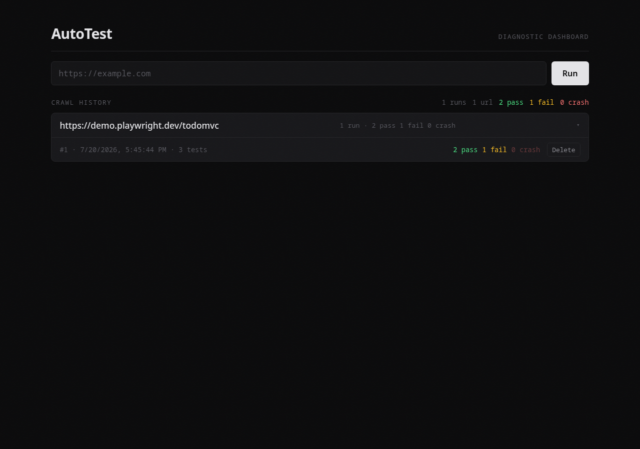
Figure 3: AutoTest dashboard — URL input form and crawl history panel showing one run for https://demo.playwright.dev/todomvc (2 pass, 1 fail, 0 crash).

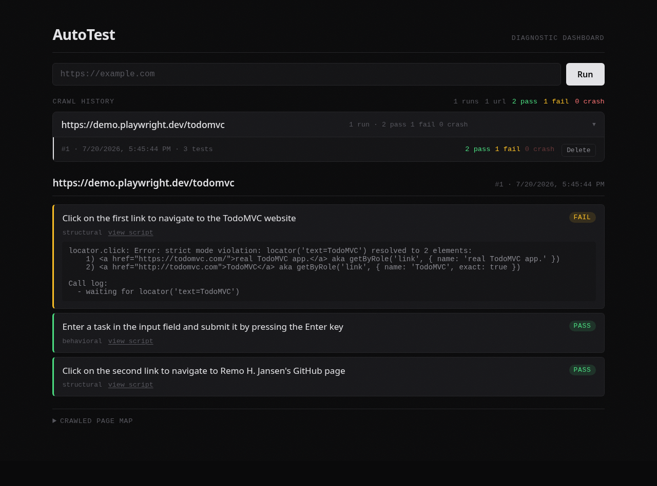
Figure 4: Detail view for crawl #1 — three generated test cases with results. Two tests passed; one failed due to a strict-mode locator ambiguity.

4.5 Security and Abuse Mitigations Implemented
Two mechanisms were implemented to limit the risk of the tool being used against unintended targets.

URL validation (server.js lines 13-26): Before any URL is passed to the pipeline, it is checked by the isUnsafeUrl() function. This function rejects: any URL that cannot be parsed by the WHATWG URL API; any scheme other than http: or https:; the hostname localhost; and any hostname matching the IPv4 ranges 127.x.x.x, 10.x.x.x, 192.168.x.x, 172.16-31.x.x, and 169.254.x.x (the AWS EC2 instance metadata address).

This guard does not DNS-resolve hostnames. A public domain name that resolves to a private IP address would pass the check. A DNS-resolving SSRF guard was designed and unit-tested (57 tests: 30 SSRF-guard tests, 14 retry-logic tests, and 13 safety-filter tests — all passing) as part of the architectural exploration (backend/src/lib/ssrf-guard.ts), but was not integrated into the working prototype. This is an identified gap and is discussed further in Section 5.4.

Safe-mode blocklist (safe-mode.config.json): The crawler tags each discovered interactive element as safe: true or safe: false by checking its label against a blocklist of 17 button text phrases associated with destructive or financial actions (examples: 'delete account', 'place order', 'add to basket'). Additional blocklists cover specific input field types (credit card fields), form action routes (password-reset), and input name or id attributes (cardNumber, cvv). Elements tagged safe: false are reported in the crawl output but never clicked, filled, or submitted.

The safe-mode blocklist is an explicit-deny list rather than an explicit-allow list. This is noted in the configuration file itself (safe-mode.config.json line 46): 'This is a blocklist, not a whitelist, because v1 targets known-shape CRUD apps where an explicit blocklist is tractable.' The 'add to basket', 'add to cart', and 'add to bag' entries were added after a live test against books.toscrape.com revealed they were not covered by the initial implementation (commit 78e096e, 12 July 2026).

No rate limiting is implemented in the working system. Rate-limiting logic was designed as part of the architectural exploration (backend/src/lib/rate-limiter.ts) but was not integrated.

Chapter 5: Results and Discussion

5.1 Objectives
The following functional requirements were stated in Chapter 1. This section maps each to its implementation and to the evidence in Sections 5.2 and 5.3.

FR1 — The system shall accept a target URL and crawl the application's reachable interactive elements. Implemented: scanPage() in run-pipeline.js (lines 16-35) extracts buttons, inputs, and links with safe-mode tagging. Evidence: todomvc-site-map.json (committed crawl output).

FR2 — The system shall generate test-case descriptions from the crawled interface map using a large language model. Implemented: generateTestCases() in run-pipeline.js (lines 63-83), using meta-llama/Llama-3.1-8B-Instruct via HuggingFace. Evidence: generated-tests.json (committed); database query results (Section 5.2).

FR3 — The system shall convert generated test-case descriptions into executable Playwright scripts. Implemented: generateScript() in run-pipeline.js (lines 85-98). Evidence: playwright-scripts.json (committed); script column in test_cases table.

FR4 — The system shall execute generated scripts headlessly and capture pass, fail, crash, and skipped outcomes with error messages. Implemented: executeTest() in run-pipeline.js (lines 102-120), classifying results into four outcome types and three failure sub-categories (runtime_error, assertion_failed, syntax_error). Evidence: test-results.json (committed); test_results table (Section 5.2).

FR5 — The system shall present results in a browser-based dashboard and persist run history in a local SQLite database. Implemented: public/index.html (dashboard) served by Express (server.js line 54); autotest.db (SQLite); db-operations.js (CRUD). Evidence: db.js lines 5-32 define the schema; server.js line 54 serves the static dashboard.

Note: An earlier draft of the requirements included 'screenshots on failure' (FR4) and 'per authenticated user' (FR5). Neither feature was implemented. Failure evidence is recorded as error message text. The system has no authentication and is designed for single-user local use only.

5.2 Results
Two pipeline runs were conducted against the same target URL at different stages of the project. Results are presented separately because they used different code versions and produced observably different outputs — a meaningful finding discussed in Section 5.3.

Run A — Early development run (committed to the repository as test-results.json; traceable to commit 805699b, 12 July 2026):
Target: https://demo.playwright.dev/todomvc
Test cases generated: 3 (2 structural, 1 behavioral)
Results: 0 pass, 1 fail (assertion_failed), 2 crash (runtime_error)

Test case 1: 'Click on the Delete button and verify it exists without crashing the page.' — crash (runtime_error). Error: locator.click: Timeout 5000ms exceeded waiting for locator('[aria-label] Delete'). The Delete button is only rendered after a todo item exists; no item was added before the click.

Test case 2: 'Enter some text in the text input field and verify the placeholder text changes.' — crash (runtime_error). Error: page.fill: Timeout 5000ms exceeded waiting for locator('#todo-input'). The actual input has no id attribute; the LLM used a selector it invented rather than one from the crawl.

Test case 3: 'Click on the All link and verify the page loads without errors.' — fail (assertion_failed). Error: locator.click timed out on locator('text=All').

Run B — Verification run (conducted 20 July 2026, 17:45 IST; results in autotest.db, queried 20 July 2026):
Target: https://demo.playwright.dev/todomvc (same URL)
Test cases generated: 3 (2 structural, 1 behavioral)
Results: 2 pass, 1 fail (assertion_failed), 0 crash

Test case 1: 'Click on the first link to navigate to the TodoMVC website.' — fail (assertion_failed). Error: locator('text=TodoMVC') resolved to 2 elements (strict mode violation). The model used a text locator that matched two anchors on the page.

Test case 2: 'Enter a task in the input field and submit it by pressing the Enter key.' — pass.

Test case 3: 'Click on the second link to navigate to Remo H. Jansen's GitHub page.' — pass.

The two runs produced entirely different test cases despite the same target URL. This is direct evidence of LLM output non-determinism (see Section 5.4).

Qualitative case studies — four bugs found during development:

Case Study 1 — Vacuous pass (commit 805699b, 12 July 2026): An early version of the execution engine returned { passed: true } for a test whose selector (tbody > tr) was absent from the page. Playwright's auto-waiting did not raise an exception; the test appeared to pass without performing any action. Fix: all generated scripts were required to use try/catch and return { passed: false, error: err.message } on failure, making silent no-ops impossible.

Case Study 2 — Safe-mode gap (commit 78e096e, 12 July 2026): A live crawl of books.toscrape.com included 'Add to basket' links in the safe-marked elements because those phrases were absent from the initial blocklist. Found during a real run, not a code review. Fix: three variants ('add to basket', 'add to cart', 'add to bag') were added to safe-mode.config.json before any test cases were generated for that site.

Case Study 3 — Malformed JSON output (commit 61cf4f3, 12 July 2026): A generation run silently produced zero test cases. Inspecting the raw model response revealed JSON with an unclosed string. Fix: retry loop up to 3 attempts with a stricter prompt instruction to double-check JSON validity before responding.

Case Study 4 — Selector hallucination (commit 805699b, 12 July 2026): The original script-generation prompt did not include the crawled DOM data. The model used selectors based on assumed page structure (#todo-input, #add-btn), none of which existed. All three scripts failed at runtime. Fix: the full crawled page data was included in the script-generation prompt, constraining the model to use only selectors it had been shown. Run B's 0-crash result is the direct measurable outcome of this fix.

5.3 Discussion
The results from both pipeline runs demonstrate that AutoTest's execution engine correctly identifies and categorises failures in LLM-generated test code.

In Run A, all three tests failed — two crashed and one produced an assertion failure. These are not indications that the system is broken; they are the expected output of a correctly-functioning execution engine encountering flawed generated code. The two crashes trace directly to Case Study 4 (selector hallucination), which was fixed before Run B. The improvement between Run A (0 pass, 2 crash) and Run B (2 pass, 0 crash) is therefore a direct measurement of the effect of the prompt fix: including actual DOM data in the script-generation prompt eliminated the selector-hallucination crash category entirely.

The one remaining failure in Run B represents a different and less severe error class: a strict-mode locator ambiguity (locator matched 2 elements instead of 1). The execution engine correctly classifies this as assertion_failed rather than crash, distinguishing it from the missing-element errors of Run A.

The two runs confirm that the result taxonomy (pass / fail / crash / skipped, with sub-categories runtime_error / assertion_failed / syntax_error) is adequate to distinguish meaningfully different types of AI-generated code failures. Each category points to a different root cause: runtime_error indicates a missing element or timing problem; assertion_failed indicates a logically incorrect expectation or ambiguous locator; syntax_error indicates code the JavaScript engine cannot parse (no instances occurred in these runs).

The different test case descriptions generated in Run A and Run B against the same URL confirm that LLM output is non-deterministic at the inference parameters used by the HuggingFace free API. This is discussed in Section 5.4.

All five functional requirements stated in Section 5.1 are met by the working implementation. The two corrections to over-stated requirements (no screenshot capture, no user authentication) are clarifications of scope, not failures of implementation.

5.4 Limitations
The following limitations were observed during development and evaluation:

1. LLM output non-determinism: The meta-llama/Llama-3.1-8B-Instruct model, accessed via the HuggingFace free Inference API, does not expose a temperature parameter. Two runs against the same URL produced entirely different test cases (observed directly: Run A and Run B, Section 5.2). Test results are not fully reproducible without a fixed model checkpoint and deterministic sampling.

2. Single-page crawl in the integrated pipeline: The standalone multi-page BFS crawler (multi-crawler.js) navigates up to 8 pages using same-origin link following and was demonstrated against books.toscrape.com (committed output: site-map.json). However, the integrated pipeline (runFullPipeline() in run-pipeline.js) crawls only the single landing page submitted by the user. Multi-page integration was not completed within the project.

3. Hostname-only SSRF guard: The isUnsafeUrl() function rejects obvious private IP ranges and localhost by regex, but does not DNS-resolve hostnames. A public domain configured to resolve to an internal address would pass the check. This is acknowledged explicitly in the source code (server.js lines 10-12).

4. No authentication or multi-user isolation: The working system is designed for a single local user and provides no authentication. All crawl history is accessible to anyone with access to the localhost:3000 port.

5. No formal evaluation against ground truth: No controlled experiment was conducted comparing AutoTest-generated tests against a human-authored test suite. The four case studies in Section 5.2 are qualitative evidence; they do not constitute a measurement of recall, precision, or false-positive rate. Such an evaluation would require a fixed target application with a known complete set of testable behaviours and a panel of human testers authoring baseline tests for comparison. The architectural exploration includes an evaluation harness (eval/) designed for this purpose, but it was not run.

6. Structural coverage only: LLM-generated tests can reliably detect structural failures (missing elements, navigation crashes, uncaught exceptions) but cannot verify server-side correctness — whether submitted data was persisted, emails sent, or calculations correct. This is an inherent property of the approach.

5.5 Future Development
The following improvements are identified for continuation beyond the HNDIT submission:

1. Multi-page crawl integration: Wire multi-crawler.js's BFS logic into runFullPipeline(), with a configurable page budget per run and deduplication of test cases across pages sharing interactive elements.

2. DNS-resolving SSRF guard: Replace isUnsafeUrl() with the DNS-resolving guard designed in backend/src/lib/ssrf-guard.ts, which resolves all hostnames to IP addresses before checking against CIDR blocklists, and applies the check again before each browser navigation to close the DNS-rebinding window.

3. Multi-user support and authentication: Implement JWT-based authentication and Postgres Row-Level Security, following the design in the architectural exploration (backend/, supabase/migrations/), to enable deployment as a shared service.

4. Oracle signals: Supplement the LLM-generated pass/fail verdict with independent signals — HTTP response code capture, JavaScript console error capture, and perceptual screenshot diffing (dHash algorithm) — as designed in backend/src/executor/oracle.ts.

5. Formal evaluation harness: Run the evaluation harness in eval/ against the committed fixture sites with human-authored ground-truth test cases, to produce a measurable recall and precision figure.

6. Screenshot capture on failure: Implement Playwright's page.screenshot() API as part of executeTest(), storing screenshots alongside error messages in the database for visual diagnosis.

Chapter 6: Conclusions
The main objective of this project — to build a system that accepts a URL and autonomously generates and executes functional web application tests without any human test-authoring — was met. The working system (server.js, run-pipeline.js, and supporting files) crawls a target URL using Playwright, generates test-case descriptions using the Llama-3.1-8B-Instruct large language model, converts those descriptions into Playwright scripts, executes them in a real headless browser, and presents the results in a browser-based dashboard — all from a single URL input, with no test scripts written by hand.

The strongest evidence for this is concrete rather than statistical. Four real bugs were found and fixed through actual system operation: a vacuous pass produced by a missing selector that the harness incorrectly reported as success; a safe-mode gap that allowed 'Add to basket' links to pass unsuppressed on a live e-commerce site; a malformed JSON output mode that silently produced zero test cases until a retry loop was added; and selector hallucination caused by the script-generation prompt not receiving the actual DOM data. Each was discovered by running the system, not by code review, and each was fixed with a verifiable committed change. The measurable effect of the most significant fix (including DOM data in the script prompt) is visible in the results: Run A produced 0 passes and 2 crashes; Run B, after the fix, produced 2 passes and 0 crashes against the same target.

Where the tool fell short of a human-authored test suite is also stated plainly. It crawled only the landing page submitted, not the full application. Test cases are non-deterministic — two runs against the same page produced different descriptions and selectors. It can detect structural failures reliably but cannot verify server-side correctness. It was not formally evaluated against a ground-truth test suite, so no recall or precision figure can be honestly stated.

The separate architectural exploration (backend/, frontend/, eval/, supabase/) documents what a production-ready, multi-user version of the same concept would require. That exploration was not run end-to-end and is presented as a design document, not a working implementation.

Note on Codebase B integration status: individual components of the separate architectural exploration were run and debugged in isolation during its development — for example, the login-redirect flow and CORS/authentication handling were exercised (commits of 15 July 2026). What was never exercised is the full integrated pipeline end-to-end: crawl through Supabase persistence through the React dashboard as a complete connected flow. Both statements are true and not contradictory: component-level debugging occurred; full-pipeline integration did not.

Future Work and Recommendations
Future work should prioritise, in order: integrating the multi-page BFS crawler into the pipeline; replacing the hostname-only SSRF guard with the designed DNS-resolving version; implementing the formal evaluation harness to produce a measurable recall figure; and adding screenshot capture on failure as a practical debugging aid. Multi-user deployment and authentication depend on a decision to host the tool as a shared service rather than a local developer utility.

References
[1] Ricca, F. & Tonella, P. (2001). Analysis and Testing of Web Applications. ICSE '01.
[2] WebProber: AI Agents for Web Testing — A Case Study in the Wild. arXiv:2509.05197 (2025).
[3] Playwright Test Agents: Planner, Generator, Healer. Microsoft / Playwright v1.56, October 2025.
[4] Liu, X. et al. (2023). AgentBench: Evaluating LLMs as Agents. arXiv:2308.03688.
[5] McKinsey Global Survey on AI Adoption. McKinsey & Company, 2025.
[6] Anthropic Model Context Protocol (MCP) Specification. Anthropic, 2025. https://mcp.anthropic.com
[7] Firecrawl. Best AI Browser Agents in 2026. https://firecrawl.dev/blog/best-browser-agents

Appendix A: Additional Screenshots


Screenshot A.1: AutoTest dashboard — URL input form and crawl history panel showing 1 run for https://demo.playwright.dev/todomvc.


Screenshot A.2: Detail view — three test cases with FAIL/PASS badges, confidence labels, and error messages.

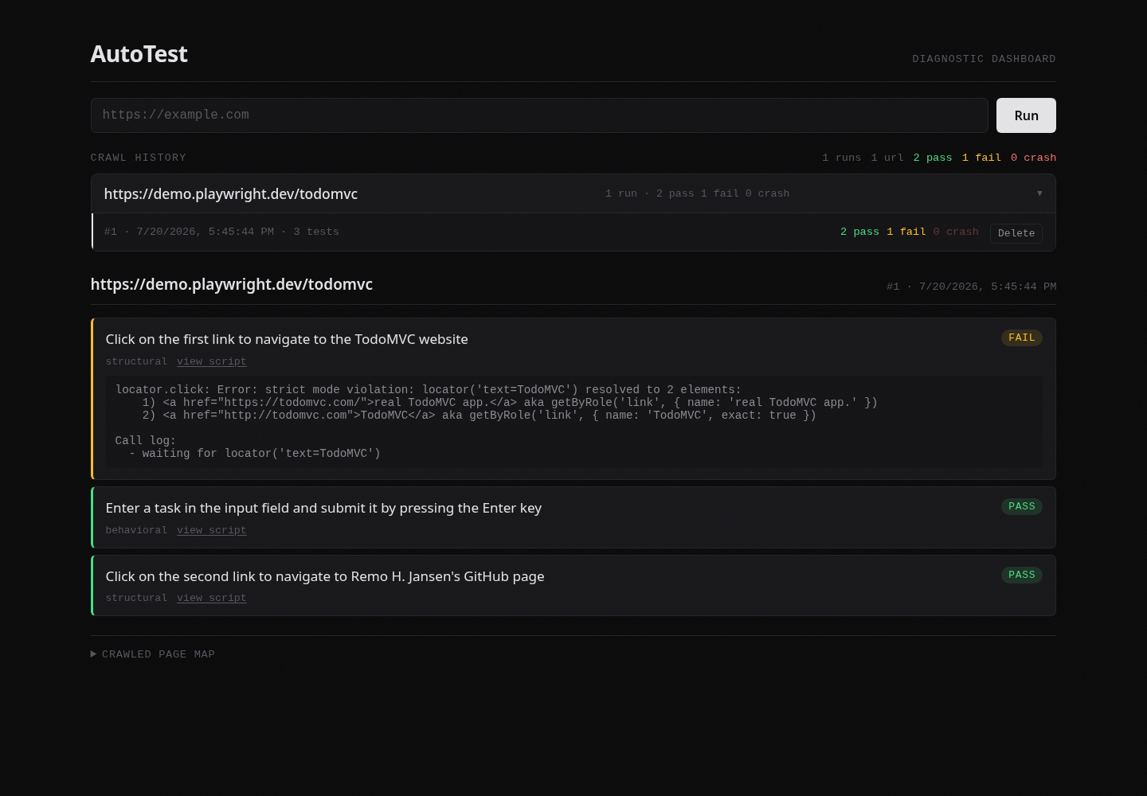
Screenshot A.3: Full dashboard view at 1440px showing both the crawl history panel and the detail panel simultaneously.

Appendix B: Special Algorithms / Key Code Listings
The following code listings are extracted verbatim from the working codebase. Line references are to run-pipeline.js unless otherwise noted.

Listing B.1 — Page element extraction (run-pipeline.js lines 16-35):
The scanPage() function uses Playwright's $$eval to extract interactive elements from the live DOM. Buttons are extracted with text, aria-label, and class fallbacks. Each button is tagged safe: true or safe: false against the blocklist in safe-mode.config.json.

async function scanPage(page) {
const rawButtons = await page.$$eval('button, [role="button"]', (els) =>
els.map((el) => {
const text = el.textContent?.trim();
if (text) return text;
const aria = el.getAttribute('aria-label');
if (aria) return '[aria-label] ' + aria;
if (el.className) return '[class] ' + el.className;
return '[unlabeled]';
})
);
const inputs = await page.$$eval('input', (els) =>
els.map((el) => ({ type: el.type, name: el.name, id: el.id, placeholder: el.placeholder }))
);
const links = await page.$$eval('a', (els) =>
els.map((el) => ({ text: el.textContent.trim(), href: el.href }))
);
const buttons = rawButtons.map((text) => ({ text: text, safe: !isBlocked(text) }));
return { buttons: buttons, inputs: inputs, links: links };
}

Listing B.2 — Test-case generation prompt (run-pipeline.js lines 37-45):
Sent to meta-llama/Llama-3.1-8B-Instruct via HuggingFace Inference API.

function buildTestGenPrompt(pageData) {
return 'You are a QA engineer. Given this structured map of a web page interactive elements, generate 3-5 test cases a human tester would perform.\n\n'
+ 'For each test case, respond with a JSON array where each object has:\n'
+ '- "description": plain-language description of the user action and expected result\n'
+ '- "confidence": either "structural" or "behavioral"\n\n'
+ 'Only test elements marked safe true. Never generate a test for anything marked safe false.\n\n'
+ 'Page data:\n' + JSON.stringify(pageData, null, 2) + '\n\n'
+ 'CRITICAL: Respond with ONLY a valid JSON array. No markdown code fences, no commentary, no trailing commas, all strings properly closed.';
}

Listing B.3 — Result classification logic (run-pipeline.js lines 114-119):
Executed after each generated script runs in the live browser context.

if (result && result.passed === true) return { executionResult: 'pass' };
return {
executionResult: result && result.harnessCaught ? 'crash' : 'fail',
failureCategory: result && result.harnessCaught ? 'runtime_error' : 'assertion_failed',
error: (result && result.error) || 'unknown',
};

