**Name: Sarthak S. Tamhankar Roll No: 53 Batch: B4**

# EXPERIMENT NO 6

**Aim:** To implement a network topology with respect to a routing protocol and observe graphical simulation in NAM with data transfer through TCP protocol.

**Theory:**

**Code:**

set ns [new Simulator]

$ns color 1 Blue

$ns color 2 Red

set nf [open out.nam w]

$ns namtrace-all $nf

proc finish {} {

global ns nf

$ns flush-trace

close $nf

exec nam out.nam &

exit 0

}

set n0 [$ns node]

set n1 [$ns node]

set n2 [$ns node]

set n3 [$ns node]

$ns duplex-link $n0 $n2 2Mb 10ms DropTail

$ns duplex-link $n1 $n2 2Mb 10ms DropTail

$ns duplex-link $n2 $n3 1.8Mb 20ms DropTail

set tcp [new Agent/TCP]

$ns attach-agent $n0 $tcp

set sink [new Agent/TCPSink]

$ns attach-agent $n3 $sink

$ns connect $tcp $sink

set ftp [new Application/FTP]

$ftp attach-agent $tcp

set udp [new Agent/UDP]

$ns attach-agent $n1 $udp

set null [new Agent/Null]

$ns attach-agent $n3 $null

$ns connect $udp $null

set cbr [new Application/Traffic/CBR]

$cbr attach-agent $udp

$ns at 0.1 "$cbr start"

$ns at 1.0 "$ftp start"

$ns at 4.0 "$ftp stop"

$ns at 4.5 "$cbr stop"

$ns at 5.0 "finish"

$ns run

**Output:**

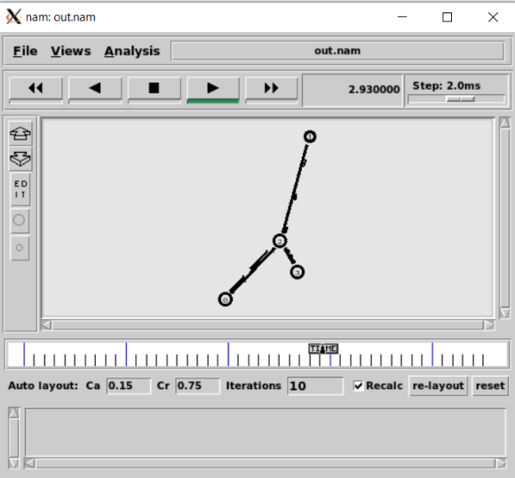

**Conclusion:** Thus, we have successfully implemented