# Summary of the TMS/X interface

## Working page organization

The application screen of the TMS/X consists of the following main elements:

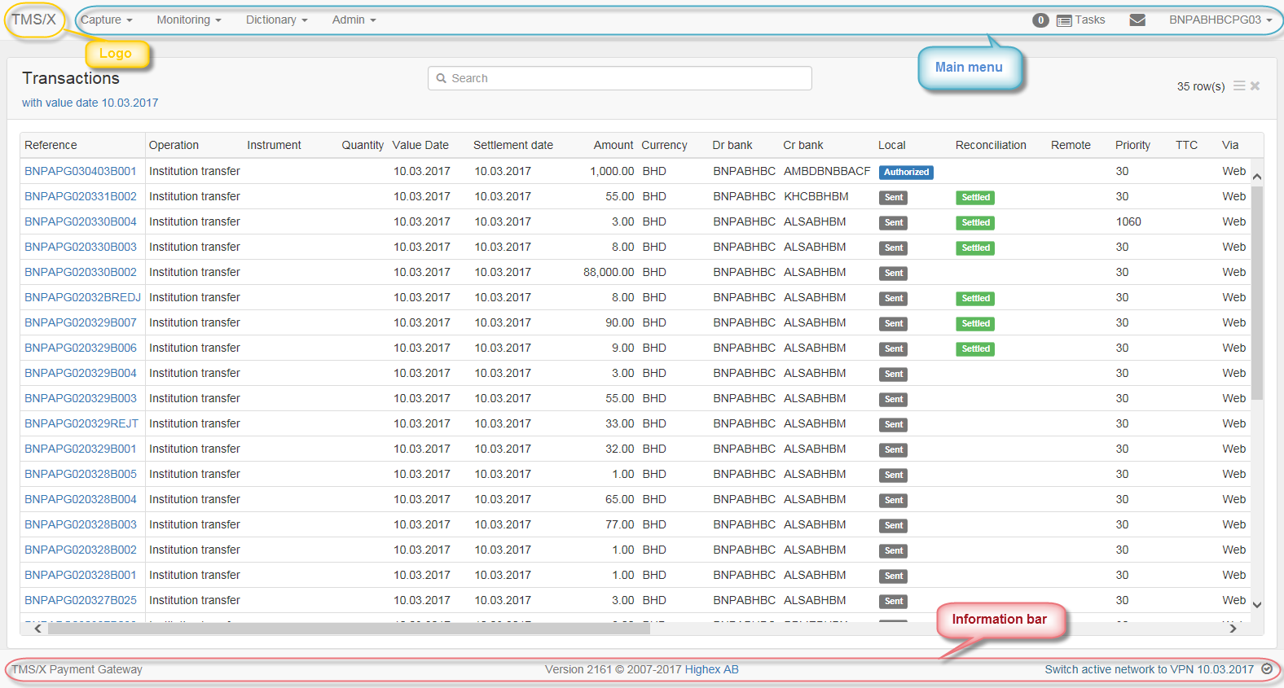

* Logo and horizontal main menu bar at the header;
* Screen body that usually reflects currently opened table or object detail form;
* Information bar that is located in the footer

## The TMS/X main menu

The TMS/X main menu is a horizontal bar at the top of the application page. The main menu contains top-level items that correspond to separate application’s sections. The top-level items may contain sub-items that are opened automatically, when you click the parent menu item. Each sub-item itself may contain one or few sub-items, etc. (multi-level hierarchy):



The user’s main menu contains the following submenus:

* **TMS/X** – closes currently opened page and returns to the home blank page;
* **Capture** – allows users to create a new operation (instruction) of selected type. See the section Ошибка: источник перекрёстной ссылки не найден below for details;
* **Monitoring** – allows users to monitor base objects and operations (such as transactions and messages) registered in the Central node system. See the section Ошибка: источник перекрёстной ссылки не найден below for details;
* **Dictionary** - displays dictionaries of correspondents, accounts, operation types and other accessory data that are used in payment preparation and processing. Operators can view, and Administrators can manage the dictionaries. See the section Ошибка: источник перекрёстной ссылки не найден below for details;
* **Reports** – allows users to view and print custom reports on monitoring transactions and user activity. See the section Ошибка: источник перекрёстной ссылки не найден below;
* **User tools** (shown as the user name’s icon with a drop down menu ) – allows user to login on/off and change their password (See the section Ошибка: источник перекрёстной ссылки не найден below for details). Also displays the user login information.

## Informational bar

The following information is indicated at the bottom of the TMS/X page:



* The workplace registered name;
* The workplace software current version and copyrights;
* The name of current period and date of the business day (to see more details about a schedule of the day, just click the period name hyperlink. The schedule will be displayed in a separate window):

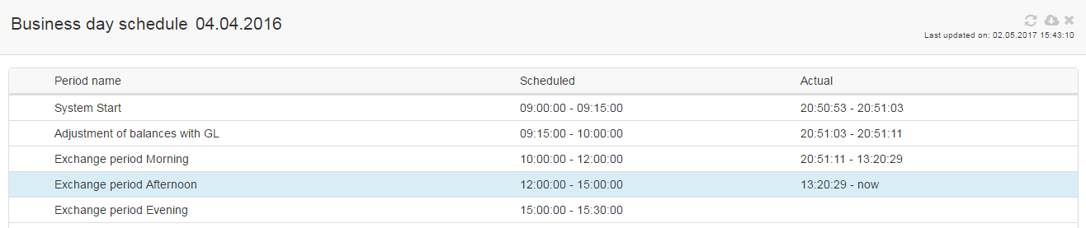

* The signs of active/inactive connection (to see more details, just click the sign hyperlink):

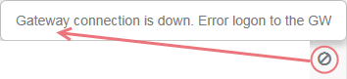

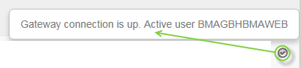

## The TMS/X tables

### TMS/X table layout

The following interface elements present in the TMS/X tables (dependently on the table data, some of them may be absent in a concrete table):

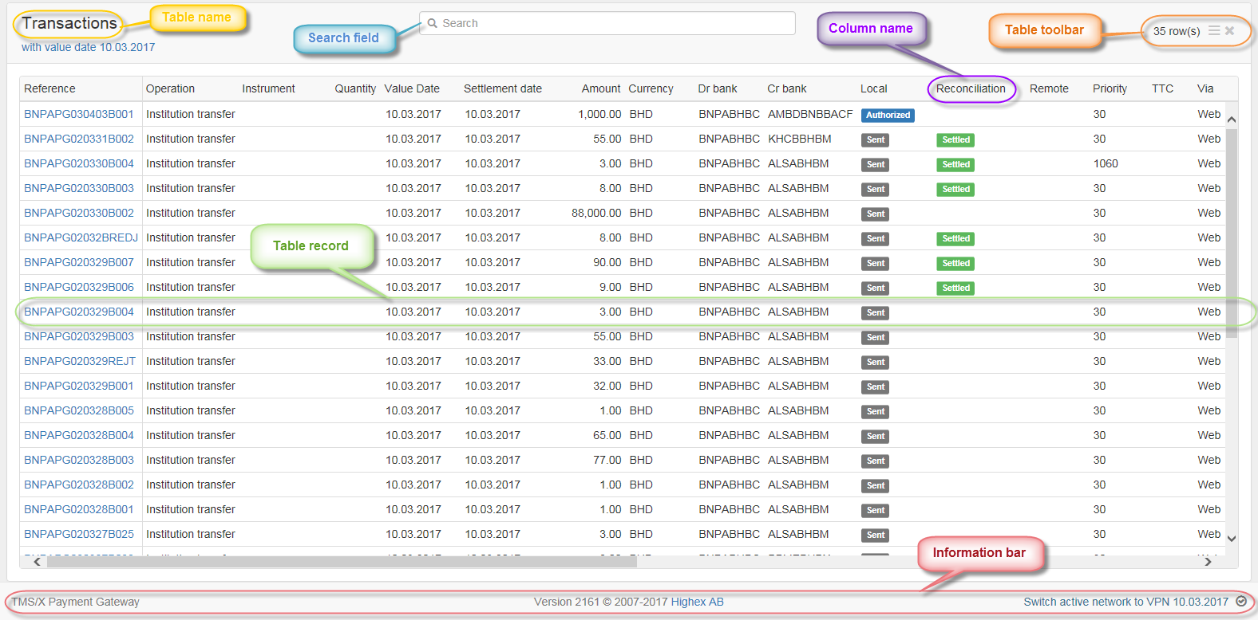

* A name of the opened table,
* The table’s toolbar with the buttons for calling actions, which will affect the table or manipulate its record. The toolbar is placed just above the table. The number of buttons may be various for specific tables (some buttons may absent in some tables). Typical actions are:

 - refreshes the table data (some tables (Transactions, Sustem events, etc.) are refreshed automatically and user can refresh other tables manually anytime via pressing the button);

 - adds a new record into the table (correspondent entry form will be opened in a separate window);

- pops up a context menu (see the description of its items in sections 1.4.2, 1.8 and 1.7 below):

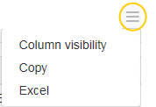

- closes the table and returns to the home page of the TMS/X.

The row local toolbar with icons of actions, which only affect the record, may be displayed in the last column of the table:



Description of such actions will be given in sections, referred to concrete tables.

* Line of table header contains a set of descriptive names of the table's columns. You can sort the table's data in both ascending and descending order. Use the down-arrow icon, which becomes visible when the mouse pointer is over a column name: . You can also sort the table by the column's data by simply clicking on a column header. When the table is sorted by the column's data, it is indicated by an up-arrow () or down-arrow () in the column header.
* The selected line is highlighted with a light grey color in the table.
* When the screen window cannot hold the entire table, the scrollbar(s) will be displayed to make table data scrolling available.
* Use the Search field for fast searching records in large tables. Type any fragment of value, which you intend to find among the table records, in the field. The table will immediately be filtered, so that the records, containing the specified fragment in their columns, will only remain:

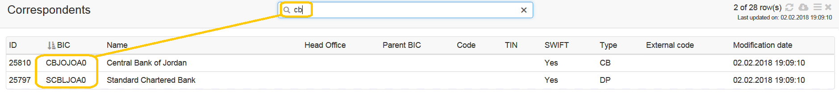

To return to the full table, just clear the Search field.

### Displaying/hiding table's columns

You can display or hide any table column, depending on what information is more important. Call the table context menu and press the Column visibility button from there:

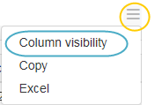

A list of the table column’s names will drop down:

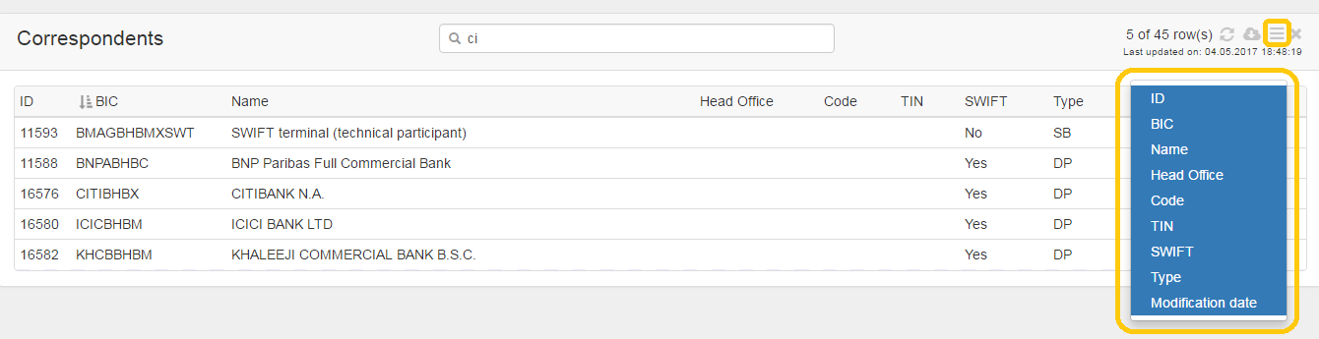

Click the column names in the list, which are not to be displayed (their background color will change from blue to white):

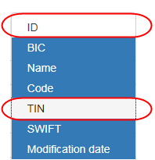

Selected columns will immediately abandon the table:

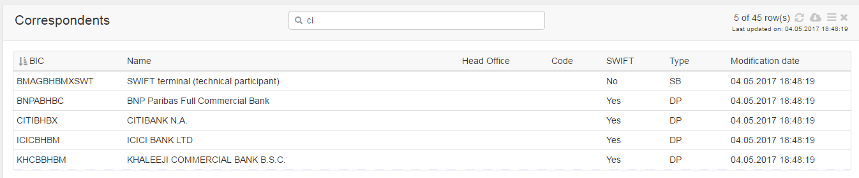

To return the hidden columns into the table, call the ‘Column visibility’ option again and click the names of the hidden columns once more (their background color will change to blue):

 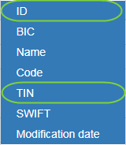

Selected columns will immediately appear in the table.

### Filters in tables

You can apply filtering to the data, displayed in the most of the tables. When the filtering options are available, the filter bar is placed above the table. To set the filter, click the bar. Fill in the necessary fields in the pop-up filter dialog box, then press the Filter button inside:

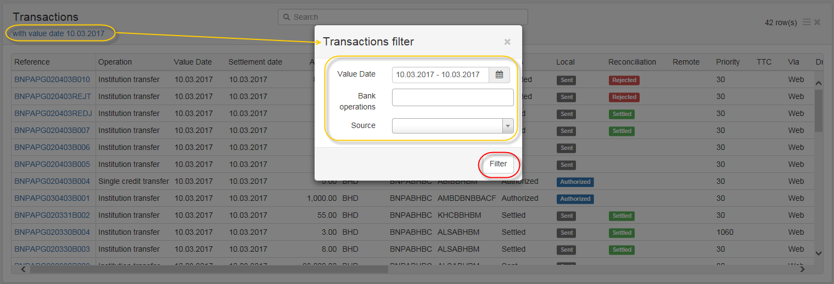

The table will be updated, so that only the records, which meet the criteria, will remain. If filter field is a list, you can specify any numbers of possible values from it in some filters:

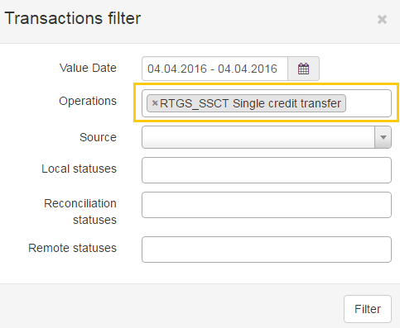

The content of the filter depends on the table’s matter.

## Viewing/editing table record details

If the row record in the opened table has one or more fields that are colored in blue, it means that you can view or edit the data from the record in a separate form by simply clicking the hyperlink:

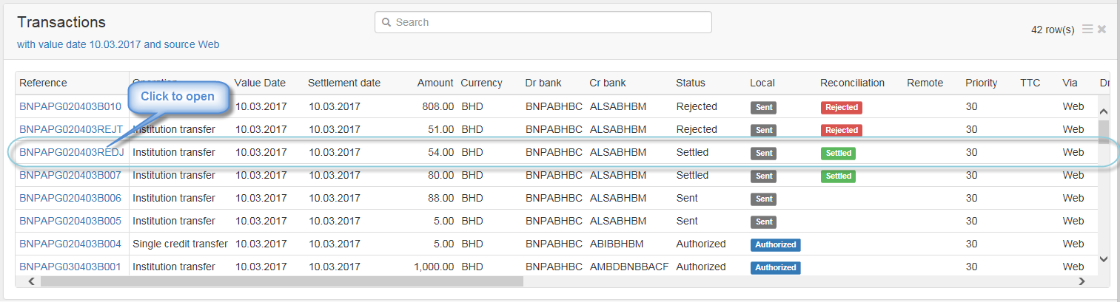

A special multi-tab form with details of the record will pop-up, where you can view or edit them:

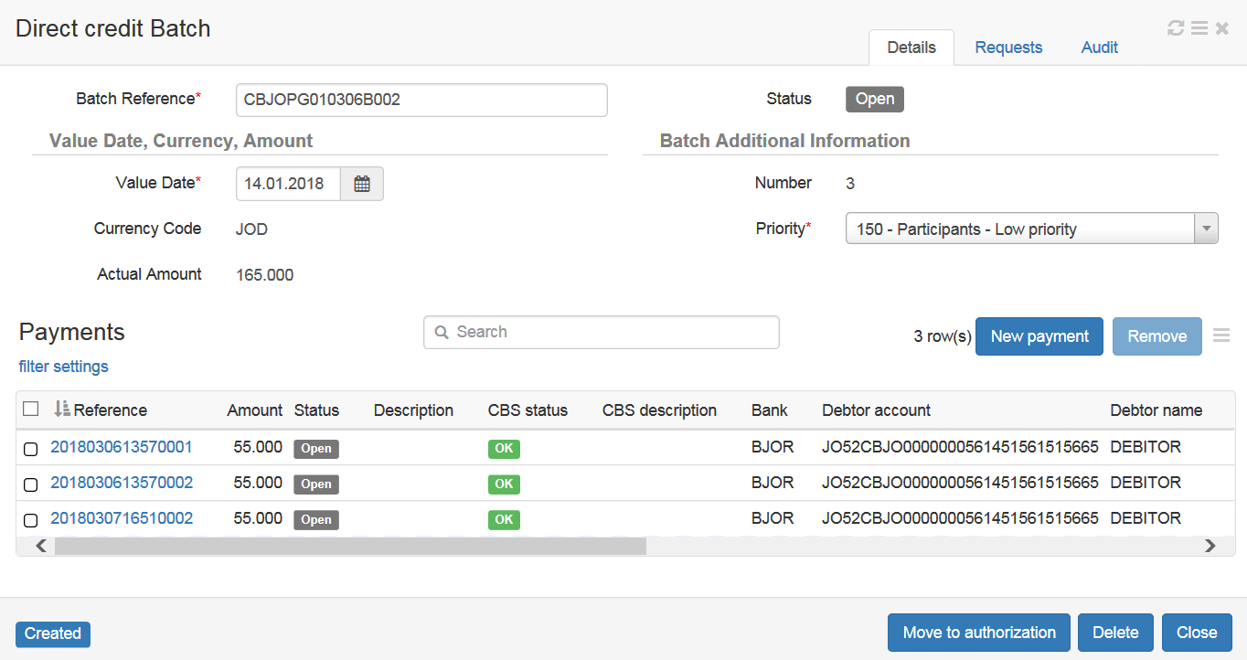

## Printing table data

To print the content of any table, call the table context menu and press the Print button from there.

The printing page layout and standard printer manager dialog box will be shown in a separate window. Make settings there and press its own Print button to send the page to the selected printer.

## Copying table data

To copy a content of any table into a clipboard, call the table context menu and press the Copy button from there. The information message will be shown:

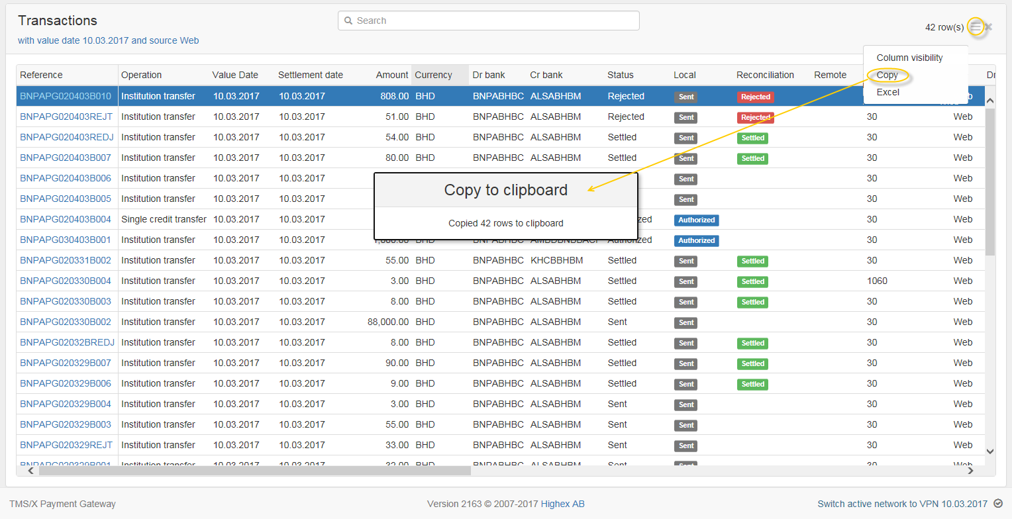

Then you can paste the clipboard content into any textual editor or other application, supporting OLE-technology

## Exporting table data

To convert the content of any table to the MS Excel file, call the table context menu and press the Excel button from there:

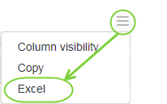

Confirm the operation in the pop up message box by pressing the Open or Save button inside it. The name of the file will be generated automatically, but you can change it by choosing the Save As option instead of the Save.

Specify new file name and location and press the Save button in the pop-up standard dialog box.

The table data will be opened or saved in the correspondent application’s format:

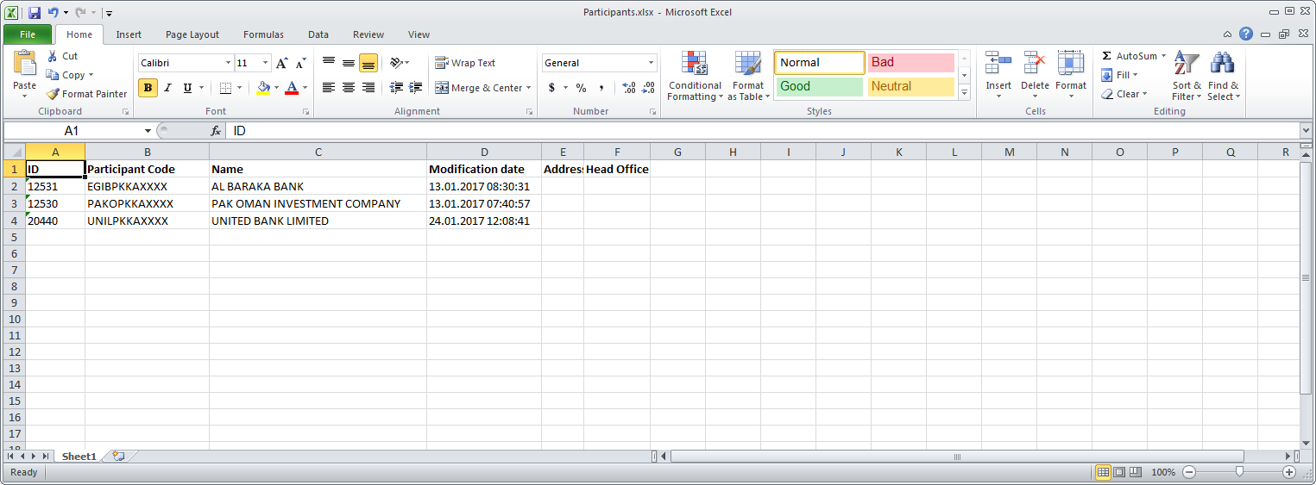

Then you can edit the file by using standard tools of the application (e.g., in order to prepare a report).

Note: I*n the case a filtering was applied to the table, the filtered data will only be exported, but not the whole table.*

# 