# Main tables and actions

## User session operations

The login form appears on the screen automatically every time the TMS/X is started (see the section Ошибка: источник перекрёстной ссылки не найден). When the user is logged-on, the following session operations are available from the separate menu that will pop-up, as the user clicks its name in the TMS/X main menu:

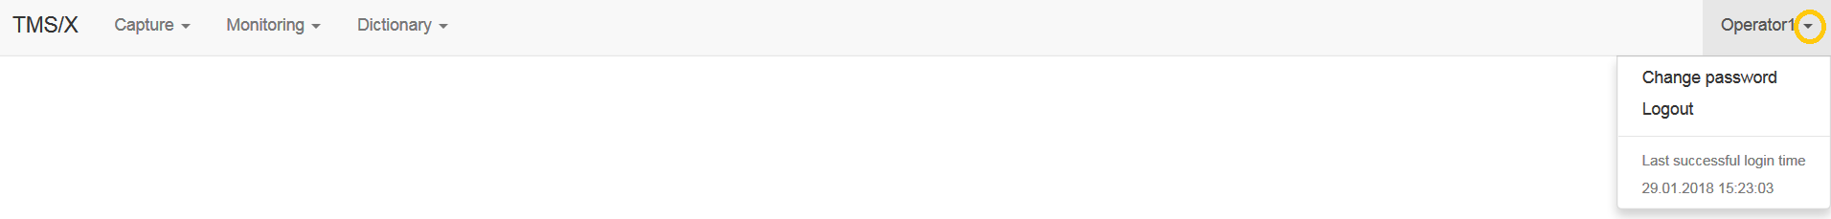

TheSessionmenu contains the following items:

* **Logout** — logs off the user from the TMS/X and suggest new session;
* **Change password** — allows changing user's password (availability of the item depends on whether this functionality is provided in the current version of the software and cryptography settings).

### Logging out

The process of logging out of the software just invokes the logout function and redirects you to the login page, where you can enter credential of another user (e.g., in order to make an authorization of entered payment).

### Changing own user password

Changing user’s password might be disabled depending on user's permissions and cryptographic methods that are used in the current version of the TMS/X.

When this option is able, call the **Session** > **Change password** menu item. The dialog form will open:

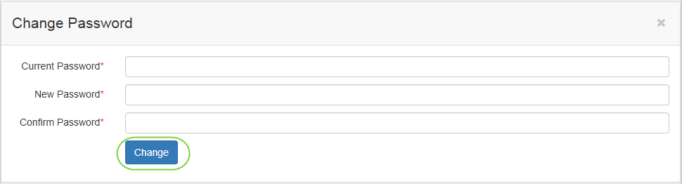

To change the password, type in your old password, the new one and retype the new password once again, in the correspondent fields of the form. The new password should be complex enough (from a security viewpoint); otherwise, the TMS/X wouldn't accept it. Then press the Change button to confirm the action. In the case of mistake, the error message will be issued:



Close the message box and try to fill in the fields of the password changing form correctly. In case of success, you will immediately be redirected to the login page. Enter your login and **new** password, as usual:

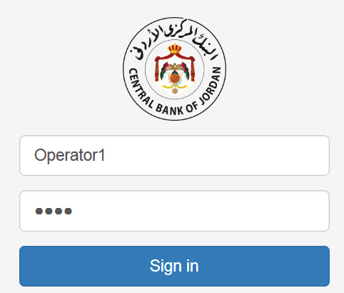

After successful connection, the TMS/X will inform you about new password’s validity term:



## Dictionaries

Call the **Dictionary** item of the mainmenu to get a list of the TMS/X dictionary:

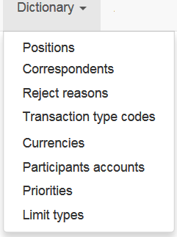

Choose the necessary item from drop down list. Details of the dictionaries are described below in correspondent sections.

### Correspondents

Call the **Dictionary > Correspondents** item to open the table of participants (institutions) registered the in the Central node:

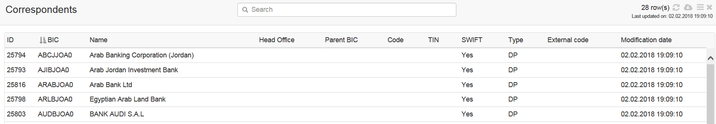

The table contains the following columns:

* **ID** – system internal identifier of the correspondent;
* **BIC** – bank identification code (BIC) of the correspondent;
* **Name** – name of the correspondent;
* **Head office** – name of the correspondents’ head office;
* **Code** – internal 6-symbols code of the correspondent (if exists);
* **TIN –** tax identification number of the correspondent (if exists);
* **SWIFT –** a flag (Yes/No) that defines, whether the correspondent is registered in the SWIFT BIC Directory;
* **Type –** code of the correspondent type (the DP – direct participant is default);
* **Modification date** – date and time, when the record was created or last modified.

### Currencies

Call the **Dictionary > Currencies** menu item to open the table with a list and attributes of currencies:

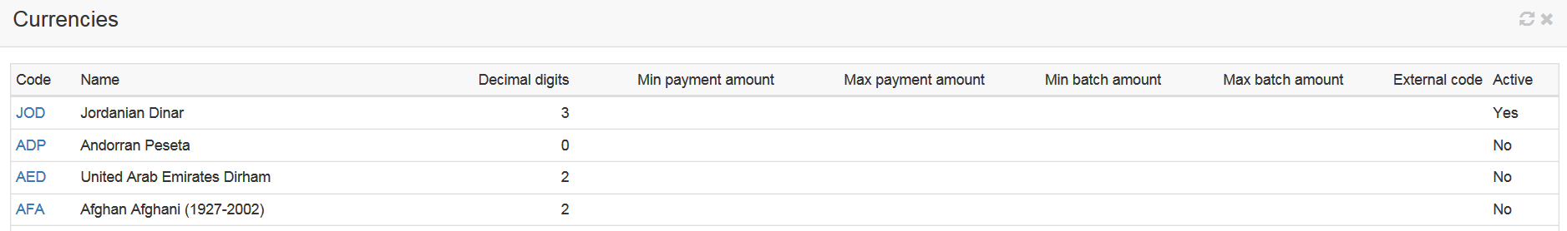

The table contains the following columns:

* **Code** – system code of the currency;
* **Name** – system name of the currency;
* **Decimal digits** – number of decimal digits in amount values that are expressed in the currency;

### Participant accounts

Call the **Dictionary > Participant Accounts** item to open the table of accounts, registered in the in the Central node:

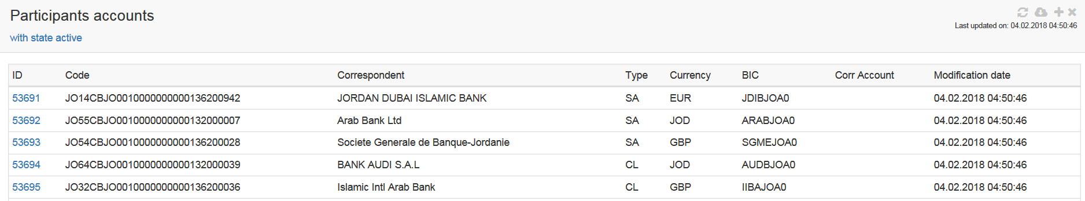

The table contains the following columns:

* **ID** – system internal (numeric) identifier of the account;
* **Code** - code of the account;
* **Correspondent** - name of the correspondent of the participant, the account is referred to;
* **Type** - a type of the account;
* **Currency** - code of the currency (ISO) of the account;
* **BIC** – bank identification code (BIC) of the participant the account belongs to
* **Corr Account** - code of the correspondent account (if exists);
* **Modification date** – date and time, when the record was created or last modified.

### Priorities

Call the **Dictionary > Priorities** item to open the table of priorities that are registered in the in the Central node:

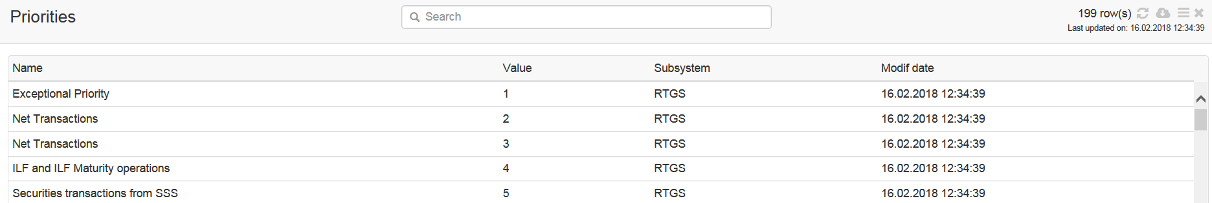

The table contains the following columns:

* **Name** – name of the group, the priority is included into;
* **Value –** numberof the priority;
* **Modification date** – date and time, when the record was created or last modified.

### Reject reasons

Call the **Dictionary > Reject reasons** menu item to open the table with a list of rejection reasonsthat are registered in the Central node:

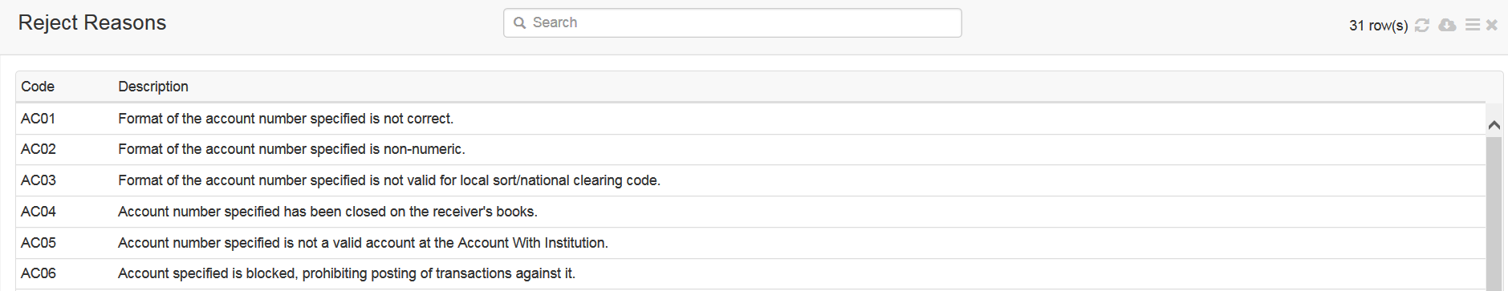

The table contains the following columns:

* **Code** – rejection reason code;
* **Description** –rejection reason description.

### Transaction type codes

Call the **Dictionary > Transaction type codes** item to open the table of priorities that are registered in the Central node:

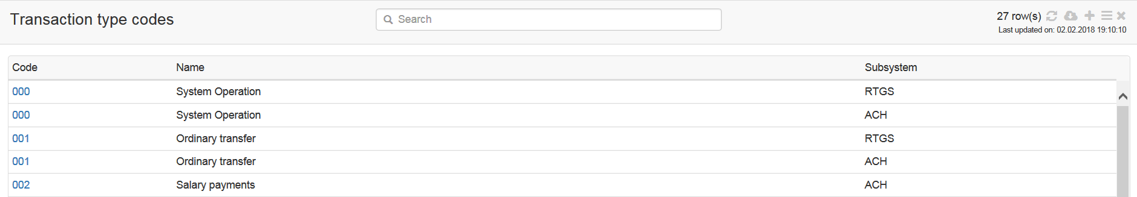

The table contains the following columns:

* **Code** – transaction type code;
* **Name** – transaction type code name;
* **Subsystem** – subsystem (RTGS or ACH) TTC used.

### Limit types

Call the **Dictionary > Limit types** item to open the table of limits that are set in the Central node:

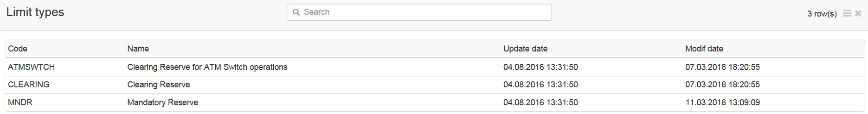

### Positions

Call the **Dictionary > Positions** menu item allows to open the table of Bank’s accounts to request account reports:

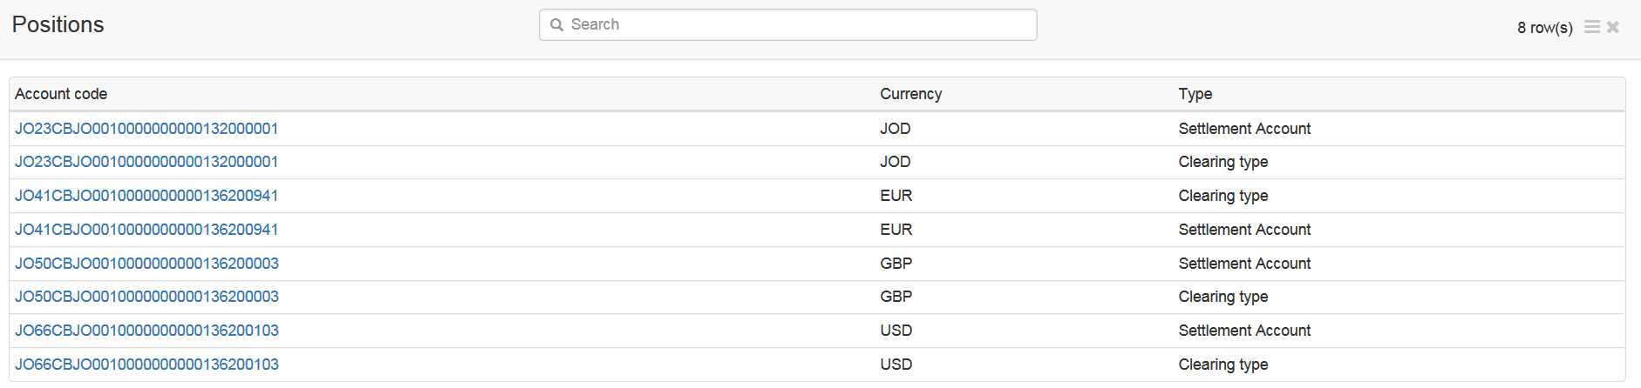

The table contains the following columns:

* **Account code** – number of account;
* **Currency** – account currency;
* **Type** – account type.

To get access to account details and related reports and actions click the blue link of the account code.

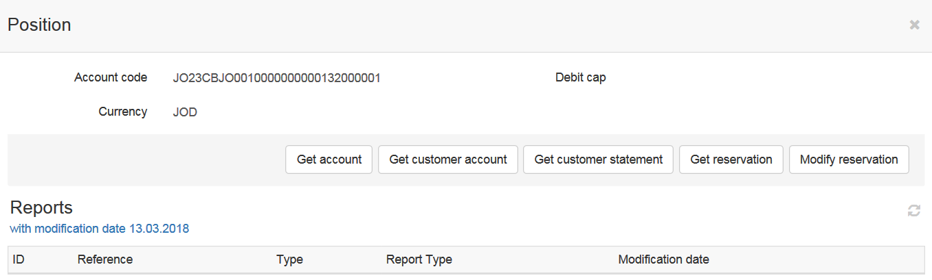

Following actions with Settlement account available on corresponding buttons:

* **Get account**– to send request for account report click the button and confirm sending;
* **Get customer account** – to send request for balance report click the button and confirm sending;
* **Get customer statement** – to send request for statement report click the button and confirm sending;
* **Get reservations** – to send limit request click the button and confirm sending;
* **Modify reservations** – to send request for set limit click the button and confirm sending.

Following actions with Clearing account available on corresponding buttons on **Position** form:

* **Get Debit Cap** – to send request for the last value of debit cup click the button and confirm sending;
* **Set Debit Cap** – to send request for to defining a value of debit cup click the button and confirm sending:
* **Get account** – to send request for account report click the button and confirm sending.

Select the report in the table and click the ID hyperlink to get access to the report, message details and related objects. The report **Details** tab will be opened in a separate window (the message type, direction and reference will be put into the header of the window):

