Class04.R

ITSloaner

2022-10-06

#This is a comment  
x <- 1:50  
plot(x, sin(x))

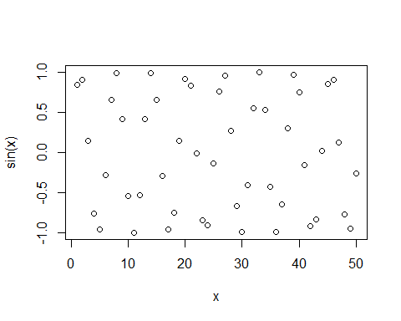

#Add more input arguments to get this how we want it  
plot(x, sin(x), type="l", col="yellow", lwd=3)

