TECHNOLOGICAL INSTITUTE OF THE PHILIPPINES
COLLEGE OF COMPUTER STUDIES

IT 009 - Systems Integration and Architecture 1
MIDTERM

Name: Leader: ALI, MOHAMED RADWAN T. /BSIT  Members:  BAGNAS, MITCHELL DANIEL C. /BSIT  BUENAVENTURA, RONIN S. /BSIT  DELA CRUZ, CHRISTIAN DAVE C. /BSIT  MARBELLA, AELOUS MATHEW B. /BSIT  MESA, ADRIEL JOHN T. /BSIT | Date: Sep 21, 2026
Program/Section: BSIT/IT31S1 | Instructor:

Assessment Task: Stress Testing Simulation

Instructions: ( every section , stress test different website)
- Perform the activity Stress Testing Simulation in the website application
  - Website Stress Testing
    - IT31S9 - youtube.com
  - Project Stress Testing

- Download Apache JMeter - Download Apache JMeter
- 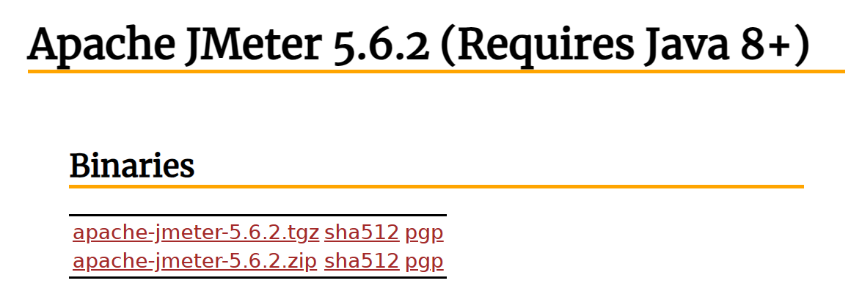
- Extract the file.
- Click ApacheJMetter inside the bin folder
- Update Java jdk to version 8 up
- 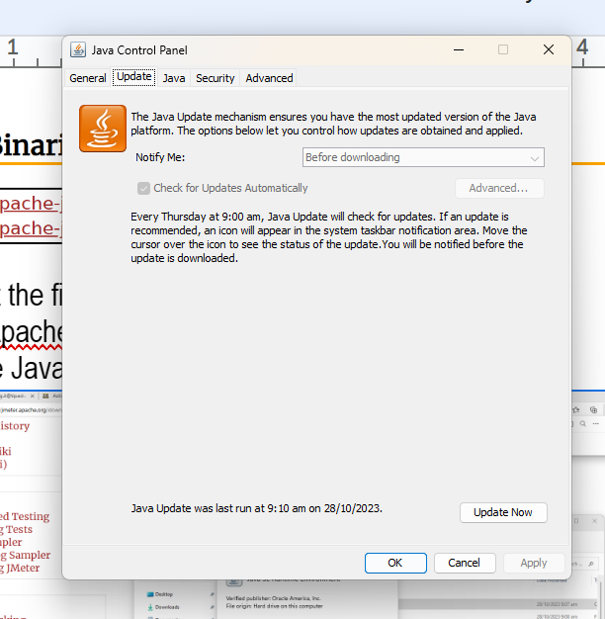

- Submit your work by uploading the file.

STEPS OF STRESS TESTING in Website Application ( Screenshot your output for every step)
- WEBSITE STRESS TESTING

Step 1. Create the Test Plan and Save:Create a Test Plan and run it multiple times to gather reliable data . NOTE: Include your name in the test plan name.

Step 2. Set up Threads –

Right Click -> Add-> Threads (Users)->Thread Group -> Rename: Set up Threads with the proper number of users, ramp-up period and loop count

NOTE: Include your name in the thread group name.

- Right Click -> Add-> Sampler -> HTTP Request -> Rename
  - Add sampler to specify the HTTP request details

NOTE: Include your name in the HTTP request name.

Step 3. Analyze data – Results: Save as to Document folder, Run Tests and generate Report
- Right Click -> Add->Listener-> View Result in Table / View result Tree/ Summary Report
    - Add a Listener to collect and display the test results

- View Results Tree

- View Result in Table

- Summary Result

100 USERS
- View Results Tree

- View Result in Table

- Summary Result

(2) PROJECT WEBSITE STRESS TESTING

Honor Pledge
"I affirm that I have not given or received any unauthorized help on this assignment and that this work is my own".

