*REACT CONCEPTS*

ReactJS is a popular JavaScript library for building user interfaces. To get started with ReactJS, you need to have a good understanding of the following concepts:

1. JSX: JSX is a syntax extension for JavaScript that allows you to write HTML-like code in your JavaScript files. It makes it easy to write and maintain complex UI components.
2. Components: React components are reusable building blocks that can be used to create UI elements. Components can be either class components or functional components.
3. State: State is a JavaScript object that represents the current state of a component. When the state changes, React re-renders the component with the updated data.
4. Props: Props are short for "properties" and are used to pass data from one component to another.
5. Lifecycle methods: React components have a lifecycle that consists of different phases. You can use lifecycle methods to perform actions during these different phases.
6. Virtual DOM: React uses a virtual DOM to efficiently update the UI when changes are made. The virtual DOM is a lightweight copy of the actual DOM and is used to determine what needs to be updated.
7. React Router: React Router is a library that allows you to handle routing in your React application. It provides a way to navigate between different components without refreshing the page.
8. Redux: Redux is a state management library that provides a predictable way to manage application state. It allows you to store and update the application state in a single place.

*JSX SYNTAX*

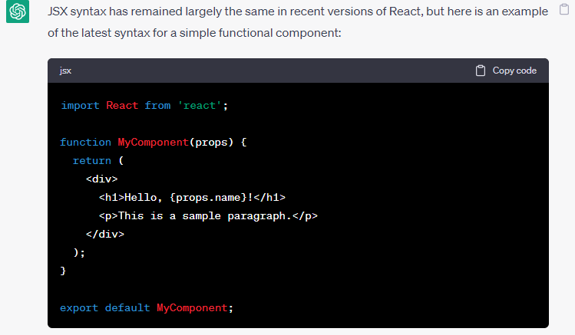

PASSSING COMPONENTS OF *PARENT TO CHILD*

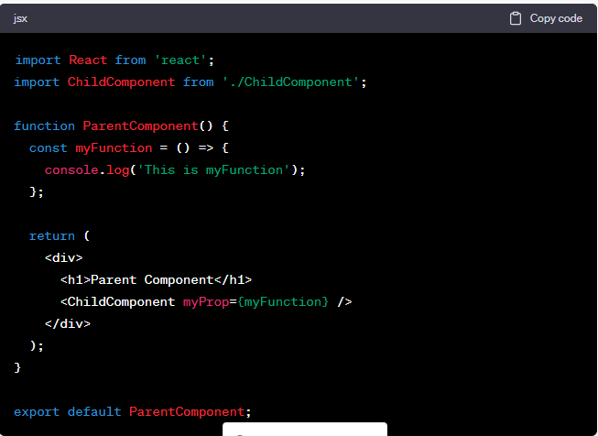

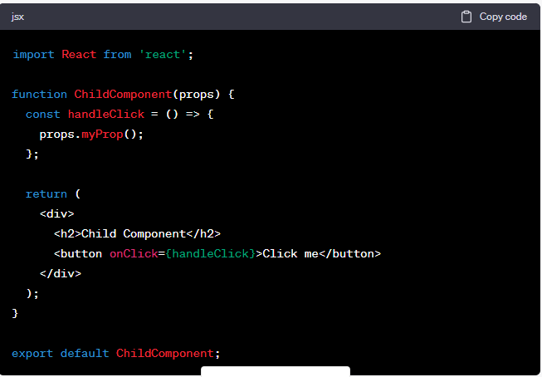

1ST- WAY OF PASSING COMPONENT IN REACT

PARENT TO CHILD SYNTAX EXAMPLE USING PROPS

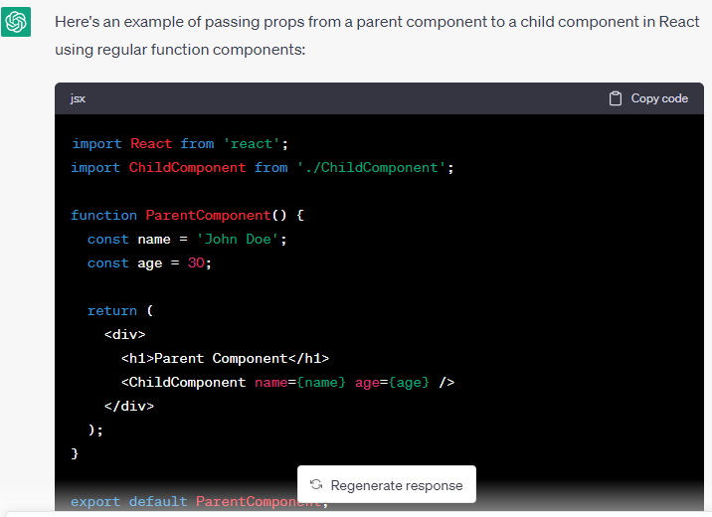

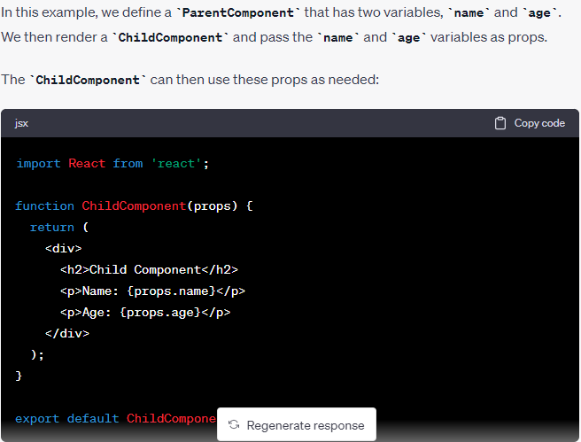

1ST- WAY OF PASSING COMPONENT IN REACT

PARENT TO CHILD SYNTAX EXAMPLE USING PROPS

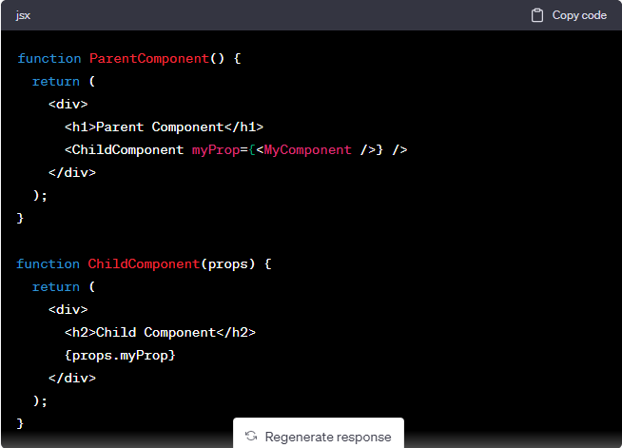

2nd - WAY OF PASSING COMPONENT IN REACT

PARENT TO CHILD SYNTAX EXAMPLE USING JSX

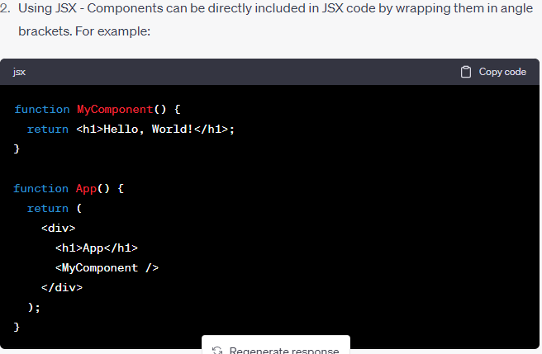

3rd - WAY OF PASSING COMPONENT IN REACT

PARENT TO CHILD SYNTAX EXAMPLE USING RENDER PROP

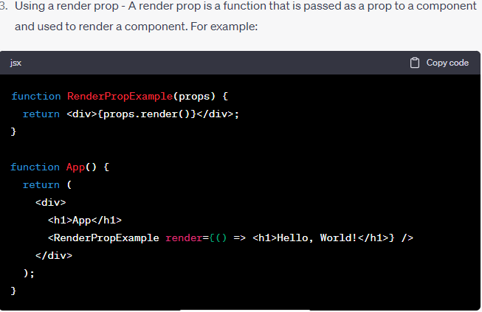

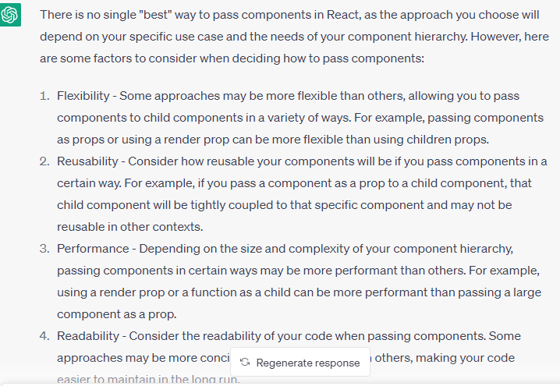

REACT HOOKS

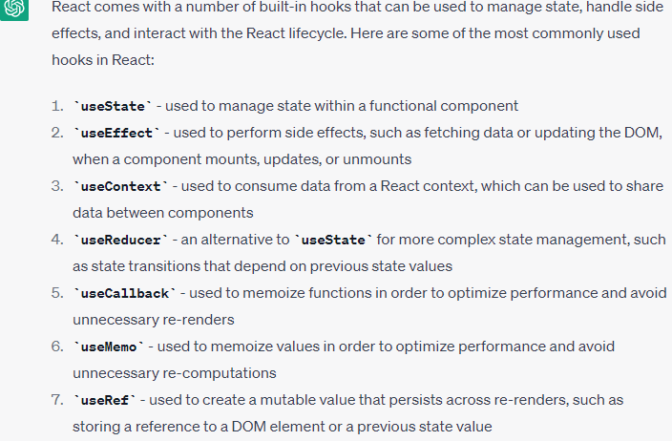

useState Syntax using arrow function

