Code testing plan

This test plan is here to help validate the functionality and reliability of my Voting Analysis program. This includes testing user options and edge cases as well as seeing how the code handles unexpected inputs.

The test will cover the following:
- Analysing valid voters per party
- Listing constituencies
- Calculating gender percentages
- Listing MPs and parties
- Searching constituencies by region
- Displaying detailed constituency information
- Menu navigation and input test

Test 1.1 functional test

Test number ID | Option | Input | Expected output
T1.1 | Analyse the number of valid votes per party | 1 | Correct count of valid votes per party
T1.2 | List constituencies | 2 | All constituencies displayed
T1.3 | Calculate % of male and female members | 3 | Male and female percentages displayed
T1.4 | List MPs | 4 | MPs listed
T1.5 | List parties | 5 | List of all parties
T1.6 | List constituencies by region | 6 and enter “Wales” | List constituencies in Wales
T1.7 | Show constituency details | 7 and enter “Newport East” | List details about Newport east

T1.1
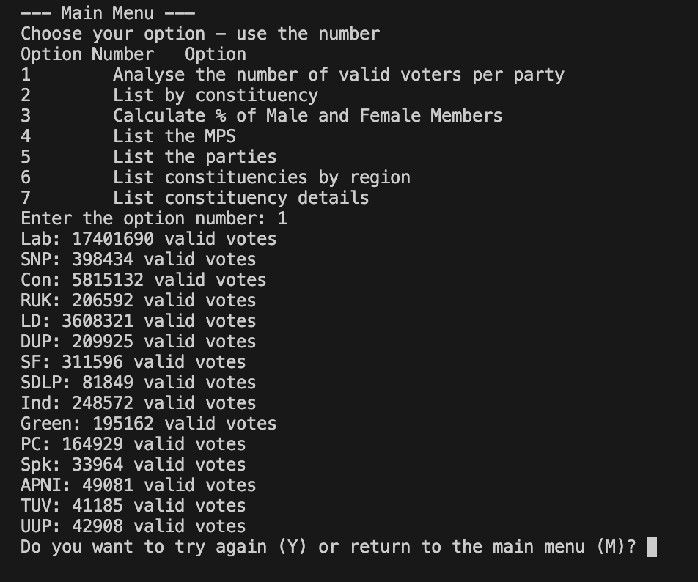

T1.2
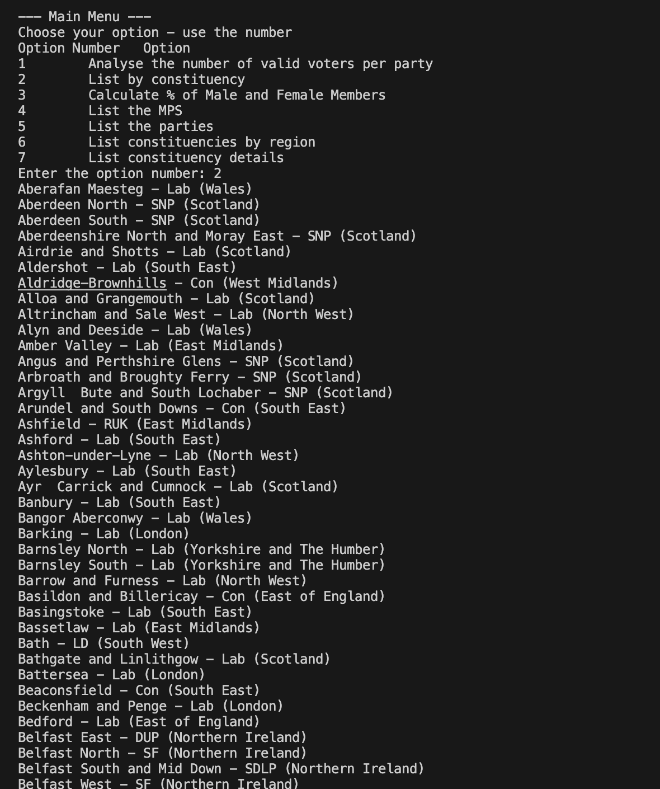

T.3
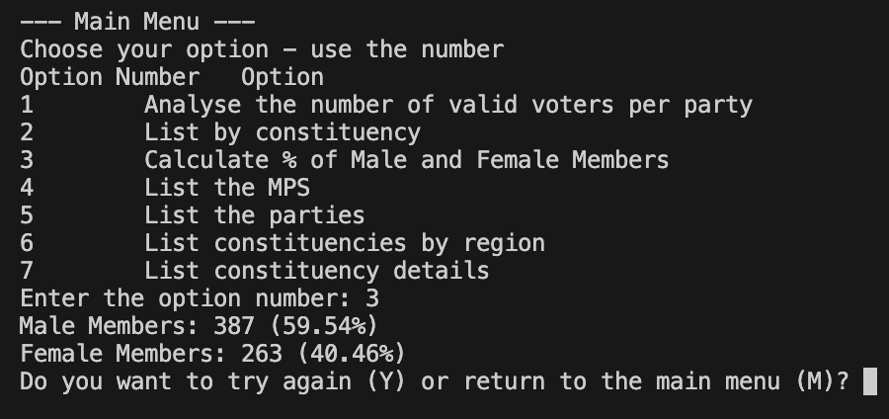

T1.4
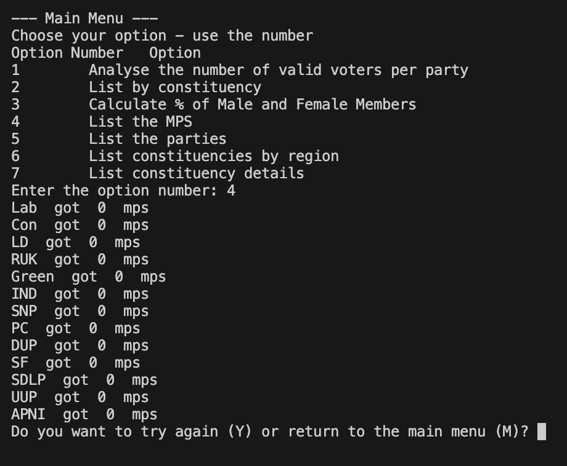

T1.5
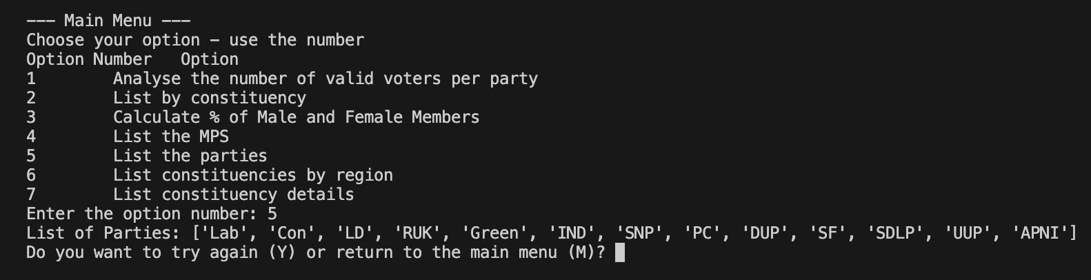

T.6
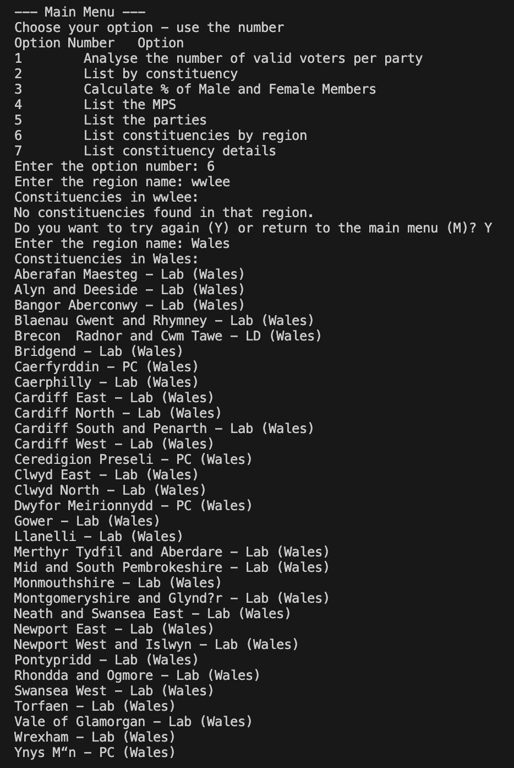

T1.7
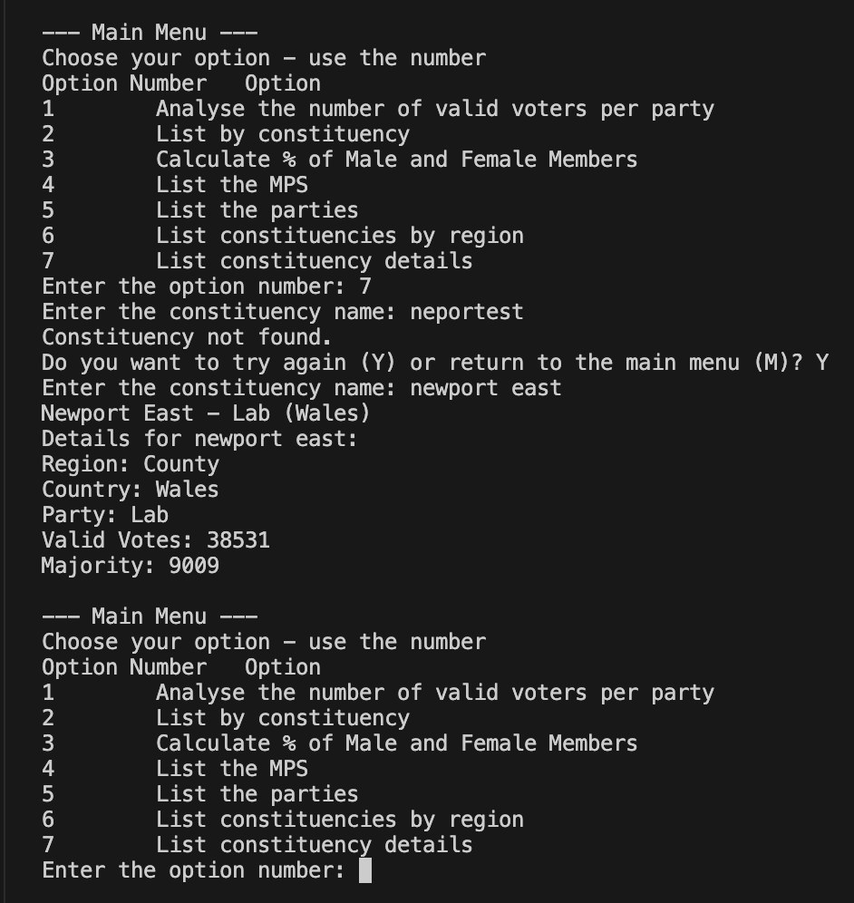

Test 2.1 Negative tests
Test number ID | Feature | Input | Expected output
T2.1 | Invalid menu option | “8” | “Invalid option. Please try again”. Re prints main menu
T2.2 | Search invalid region | “Ireland” | When invalid region entered it should prompt for user to try again.
T2.3 | Search Invalid constituency | “Dublin” | When invalid constituency is entered it should prompt user to retry.

T2.1
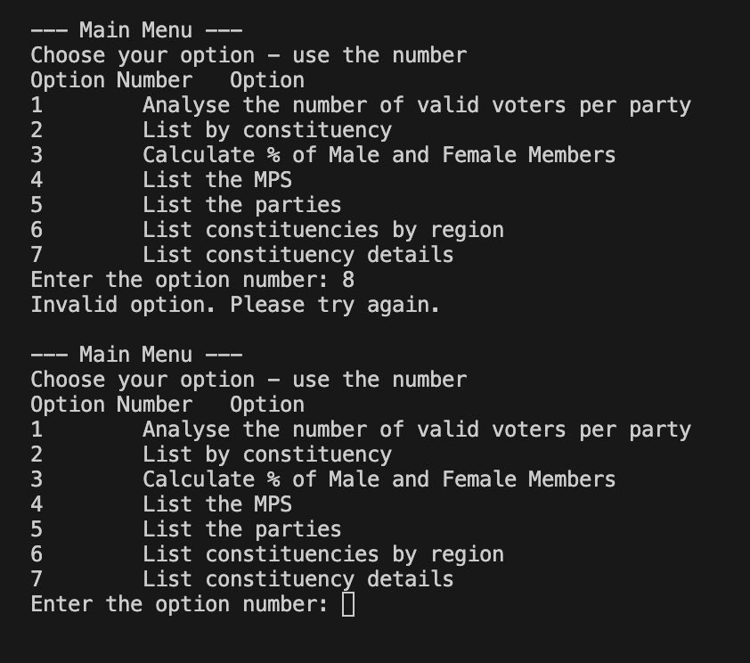

T2.2
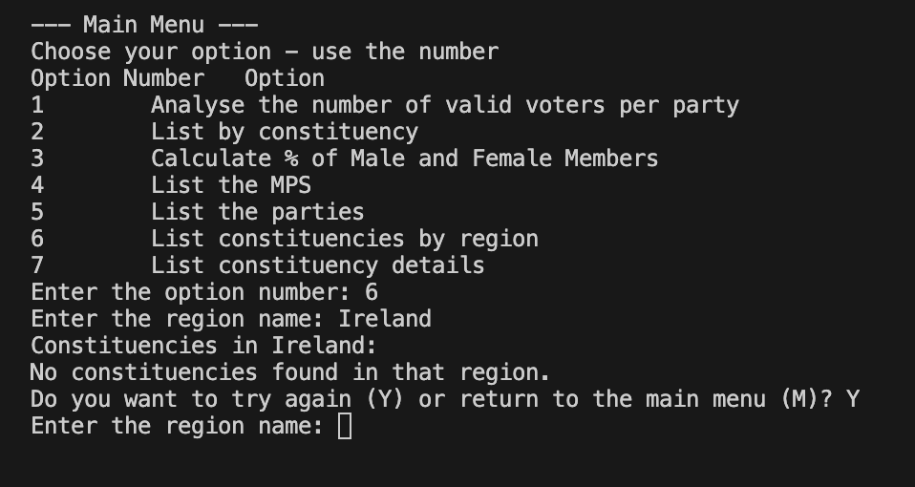

T2.3
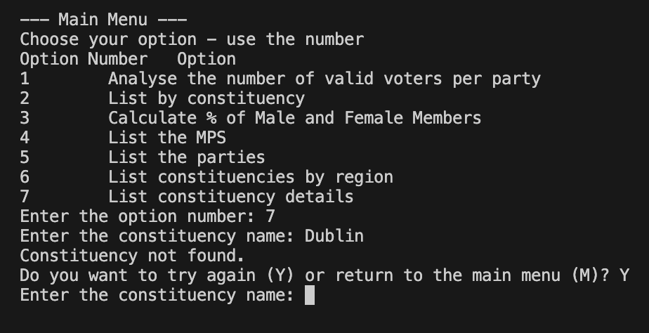

Test 3.1 edge cases

Test number ID | Feature | Input | Expected output
T3.1 | Empty constituency file | Run program with no data | Appropriate error message
T3.2 | Mixed case input | Input regon constituency in mixed case. E.g wAlEs | Case mismatching autocorrection. Info should still be outputted.

3.1
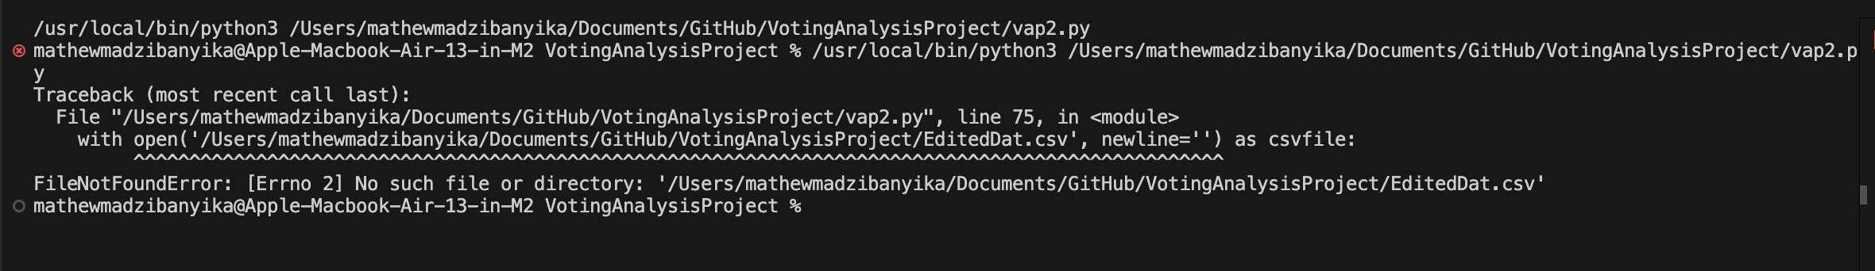
3.2
