Leo's Auto Database Project

Report 1
Group: Mae Beeman, Marquise Grant, Marcel Langdon, Dashaun Townsend Course and section: COSC 457 - 001
Instructor: Sung-Chul Hong Submission date: October 6, 2026

Contents

1 Introduction | 2
2 Interview and target business | 3
3 Business process | 4
4 Data and application requirements | 5
5 ERD schema and screen examples | 6-9
6 Project schedule and meeting log | 10-12
Appendix A Confirmed ERD and schema | 13-14
Appendix B Completed interview form and signature | 15-17

Manager ownership and progress
Colors identify the manager; labels show progress. Done means completed in this revision. To do means a manager still needs to review, provide or assemble the work.

Manager | Status | Responsibility
Interview Manager  Mae | Done | Introduction, interview record, business process and interview answers in section 4. Completed form and signature attached as Appendix B.
Database Manager  Marquise | Done | Review data requirements, Chen ERD and schema against the interview; document corrections and attach the design as Appendix A.
Application Manager  Marcel | Done | Review application behavior and query priorities; provide two or three screens, confirm tools and setup, and record required changes.
Report Manager  Dashaun | Done | Combine the pieces, fill actual dates and contribution log, finalize contents and page numbers, check the assembled report and submit.

All major Report 1 components have been completed and assembled, including the interview evidence, updated database design, application screenshots, project schedule, and meeting log. The report is ready for final review and submission.

1 Introduction

Our project is a small database application informed by an interview with Leo's Auto Inc., the confirmed business at 14 Willow Ave, Towson, MD 21286. The project focuses on the information needed to connect a customer, a vehicle, a repair visit, the work performed, and the resulting bill. We want to understand that process well enough to explain the data model and demonstrate a complete example using fictional records.
Mae Beeman interviewed Brooke Maenner, whose role was recorded as Daughter / Front Desk Manager, in person at the shop on September 29, 2026, at 4:45 PM. The shop uses digital management software for estimates and paper repair orders for mechanics. Finding older paper records for warranty checks and tracking wrong-part returns are difficult. Brooke selected repair-history searches by customer phone number and an open-jobs dashboard, including waiting for parts and ready for pickup, as the prototype's priorities.
Our proposed scope covers customer and vehicle records, repair orders, labor and parts used on a job, invoices, and payments. The interview prioritizes customer repair history and open repair jobs; unpaid bills were not selected as a priority. Customers pay in full by cash or card at pickup, and closed, paid invoices remain unchanged, with corrections handled by a separate credit or refund. Appointments, payroll, online payments, supplier ordering, and a customer portal remain outside the proposed scope.
The design phase will turn the interview answers into data and process requirements. A Chen entity relationship diagram will show the types of information and how they connect. A matching schema will identify the tables, primary keys and foreign keys. We will check rules such as whether a vehicle has one current customer, whether a repair can involve several mechanics, and whether one visit can produce more than one bill. Any difference between the interview and our starting design will be recorded and addressed.
The implementation phase will connect those tables to a small application using Python and SQLite. We will use fictional records to test customer entry, a repair with labor and parts, invoicing, payment, and the selected reports. We will also check invalid entries and confirm that saved information remains available after restarting the application.
Work is divided among interview and requirements, database design, application development, and report assembly. Each member will review and explain their own contribution. The final project package will include source code, database setup instructions, a functional guide, a step-by-step tutorial, and a demonstration. Our aim is a manageable application whose design, implemented behavior and documentation agree.

2 Interview and target business

Interview Manager: Mae Beeman

Interview record
Date and time: September 29, 2026, 4:45 PM Location or mode: In person at the shop
Interviewee and role: Brooke Maenner, Daughter / Front Desk Manager Students present: Mae Beeman
Signed proof: Completed form attached as Appendix B; dated September 29, 2026.
The supplied form includes an electronic signature. It confirms that the interview occurred; it does not mean that the interviewee approved the report or application.

Business profile

Item | Interview answer
Business name and address | Confirmed: Leo's Auto Inc., 14 Willow Ave, Towson, MD 21286.
History and branches | Family-owned and operated; founded by Leo in 1978. One location.
Size and staff | About 5-6 staff. Family members run the front desk; mechanics handle repairs.
Activities and services | General auto repair and maintenance, A/C, brakes and tire repair. Service only; no car sales.
Customers and service area | Towson and the surrounding area. Mainly personal/family vehicles; few fleet accounts.
Total sales | Revenue was not disclosed.
Current tools | Digital shop management software for estimates and invoicing; printed paper repair orders (ROs) for mechanics.
Questions, answers, and evidence
Appendix B contains the supplied three-page completed interview form, including all questions, answers and the signature. Section 4 identifies the source question for each answer.
Main findings:
- Brooke prices estimates and records verbal phone approval before ordering parts.
- Older paper repair histories and physical returns of wrong parts to NAPA are difficult to track.
- Phone-number history searches and job status are the two selected priorities.
Permissions: Business name use and note-taking allowed. Exterior/front desk photos discouraged; no plates or personally identifying information.

3 Business process

Confirmed workflow from interview question 3; approval and payment rules from question 7.

Mechanic
Diagnose and note labor/parts

Front desk manager Check in and print RO

Front desk manager and customer Price estimate and approve

Customer  Pay in full and collect keys |  | Front desk manager Finalize invoice |  | Front desk manager and mechanic Order parts and repair

One ordinary visit
- The front desk manager checks in the customer, records contact and vehicle details, the complaint and exact arrival mileage, and prints an RO.
- A mechanic takes the car and RO to a bay, diagnoses the problem, and writes the required parts and labor on the RO.
- The front desk manager prices the estimate and calls the customer for approval. Approval is verbal; the name and time are written on the RO.
- After approval, the front desk manager orders parts and the mechanic completes the repair.
- The front desk manager finalizes the invoice in the shop system.
- The customer pays the full amount by cash or card at pickup and receives the keys.

Other activities in scope
Catalog and staff records: The interview did not identify a specific person responsible for maintaining these records. The front desk manager handles estimates, parts ordering, and invoices; mechanics record diagnoses and work details.
Stock: Most parts are bought per job from local suppliers. Oil, filters and bulbs are stocked; counts are reduced manually when used. Unused parts are returned for credit (Q6). Receipt-entry procedures were not described.

Reports: The front desk manager selected repair-history searches by phone number and an open-jobs dashboard showing waiting for parts and ready for pickup (Q8). Report frequency was not specified.

When something changes

Situation | Shop response and requirement for review
Work not approved or cancelled | Work proceeds after approval. Declined-work/cancellation handling and stock adjustments were not described; no further rule is confirmed.
A part is unavailable | No separate missing-part procedure was given. The requested dashboard must show waiting for parts; the visit remains visible as an open job (Q8).
Partial payment or billing correction | No deposits or partial payments. Full cash/card payment at pickup. Closed, paid invoices cannot change; a separate credit/refund records a correction (Q7).
Wrong part delivered | Mechanic reports the error. The front desk manager requests a vendor exchange, notes the delay on the RO and, if needed, moves the car off the lift and calls with a revised pickup time. Record the delay and waiting status for review (Q9).

Interview: Mae | Done Database: Marquise | Done Application: Marcel | Done

4 Data and application requirements

Interview answers are confirmed below. The database and application designs were reviewed against these requirements and updated where needed.

Interview topic and source  Mae - Done | Data needed  Marquise - Done | Application behavior  Marcel - Done
Customer / vehicle fields (Q4)  Name, phone, optional email; VIN, plate, make/model/year, exact arrival mileage. | customer, vehicle Name/contact; VIN, year, make, model | Add/find customer and vehicle; avoid repeated VINs.
Job information / workflow (Q3, Q4, Q7, Q8)  Complaint, diagnosis/notes, approval and mechanic; approver name/time on RO. Show waiting for parts and ready for pickup. | repair_order  Complaint, diagnosis, odometer, authorization, status | Open a visit, authorize work, show open jobs, close or cancel. Show ‘waiting for parts’ and ‘ready for pickup’. Record approver name and time.
Labor and parts (Q6)  Guide hours x hourly rate; diagnostics use flat hours/hourly pricing. Most parts bought per job. | employee, service, labor_line, part, part_line | Record mechanic, service, hours, quantity and prices charged.
Stock handling (Q6, Q9)  Oil, filters, bulbs stocked; counts reduced manually on use. Unused parts returned for credit; wrong parts exchanged. | inventory_movement  Part, quantity change, reason, optional job | Receive/use/return stock; prevent negative stock.
Billing rules (Q7)  Parts, labor, shop supplies, state tax. Full cash/card payment at pickup; no deposits/partial payments. Paid, closed invoice unchanged; separate credit/refund. | invoice, payment  Bill amounts, payment amount, date and method | Issue bill; record allowed payments; calculate remaining balance.
Relationships (Q5)  Customer can have several family vehicles; one current owner per vehicle. Relink on sale, retaining history. Usually one mechanic, rarely several. Invoice count not specified. | Vehicle ownership; mechanic per line; invoice per visit | Vehicles must be under one owner. Can assign one, or more, mechanics to a line. Invoice must be paid in full

Three proposed queries

Question  Marcel - Done | Input and expected result
What repair history does this customer have? | Filter by customer phone number; show the customer’s linked vehicles, repair dates, complaints, statuses, and billed totals when available.
Which jobs are still open? | No input; show open or in-progress repair orders with customer, vehicle, opening date, and status, including waiting for parts and ready for pickup.
Which bills are still unpaid? | No input; show invoices with total, amount paid and positive remaining balance.
Interviewee priorities (Q8): The first two queries reflect the interviewee’s selected priorities: customer repair history searched by phone number and an open-jobs dashboard that includes waiting for parts and ready for pickup. The unpaid-bills query is an additional proposed database query, not an interviewee-selected priority; customers normally pay in full at pickup.
Other required fields/functions: Review optional email, plate, exact arrival mileage, approval name/time, shop supplies and tax, vehicle history on owner change, and separate credits/refunds. These requirements were reviewed during the database and application design process.

Unanswered questions: Brooke stated none (Q10). Cancellation handling, catalog/staff maintenance, and invoice counts per visit were not covered in the interview. These remain design assumptions or follow-up items if clarification becomes necessary.
Database: Marquise | Done Application: Marcel | Done

5 ERD schema and screen examples

Conceptual design and schema
The conceptual ERD and matching schema were reviewed against the interview requirements. The completed ERD and schema are included in Appendix A.
Our proposed design contains 11 entities. A customer can have several vehicles, and each vehicle can have several repair visits. Each visit records its bill-to customer separately. Labor and parts are stored as individual lines so a visit can include several services or parts. Each line records what was charged at the time. An invoice belongs to one repair visit, and several payments may apply to that invoice.
Changes made after the interview: The design was reviewed and updated to reflect the interview requirements for customer phone information, vehicle ownership, exact arrival mileage, approval information, job status, labor and part lines, and inventory movements. The application requirements were also updated to include customer repair-history searches by phone number and open-job statuses such as waiting for parts and ready for pickup.
Confirmed rules and design assumptions: The interview confirmed that a customer may have several vehicles, while each vehicle has one current owner. A vehicle may be relinked to a new customer after a sale while retaining its repair history. Repairs usually involve one mechanic but may involve several. The interview did not specify the number of invoices per repair visit, so the current one-invoice-per-visit structure remains a project design assumption.

Keys constraints and normalization
Primary keys identify individual records. Foreign keys connect records without copying the full customer, vehicle or part into each row. A unique VIN avoids duplicate vehicle records, and a unique order link allows at most one invoice per visit in the proposed model. Stock and payment checks prevent negative stock and overpayment. Historical job prices and invoice labels are preserved so later catalog changes do not rewrite old bills.

The prototype uses Python and SQLite. The current schema enforces unique VINs, links tables through primary and foreign keys, prevents negative stock, and restricts payments according to the outstanding invoice balance. One remaining design item is support for a separate credit/refund record for billing corrections. The interview specifies that closed, paid invoices should remain unchanged and that corrections should be handled separately.

Application: Marcel | Done

Application screens
The following screenshots show examples of customer and vehicle records, repair and billing functions, and report output.
Marcel | Done

Screen | Input and output to show
Customer and vehicle | Input: name/contact and VIN/car details. Output: saved linked records or an error.  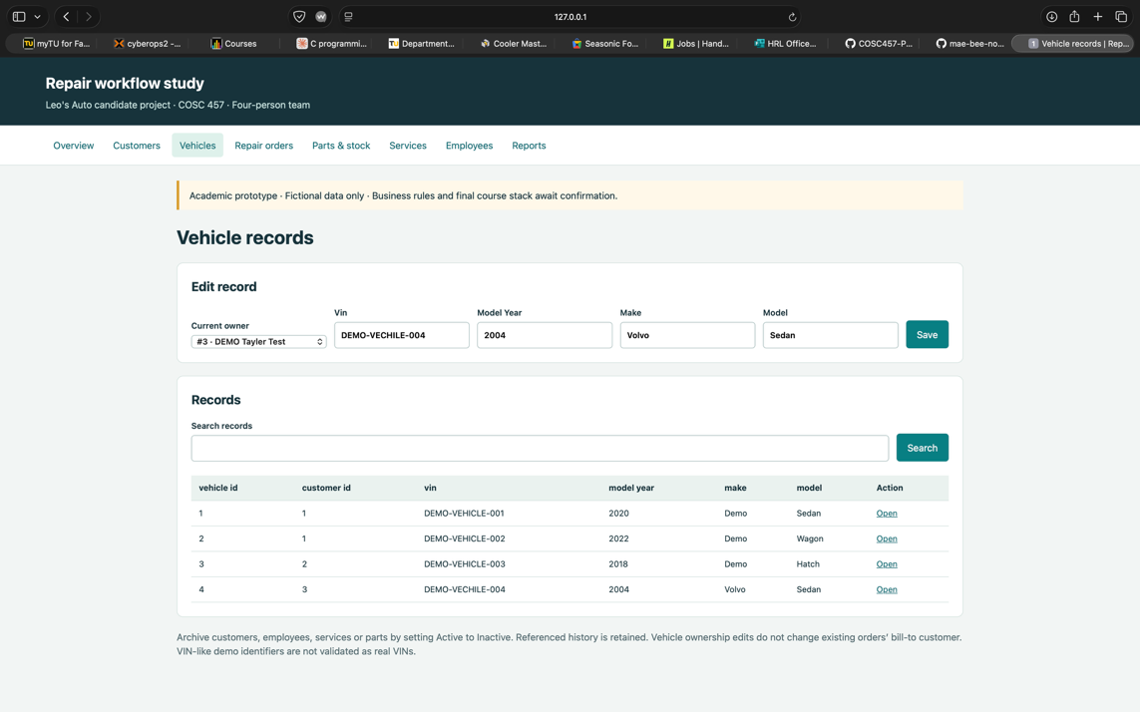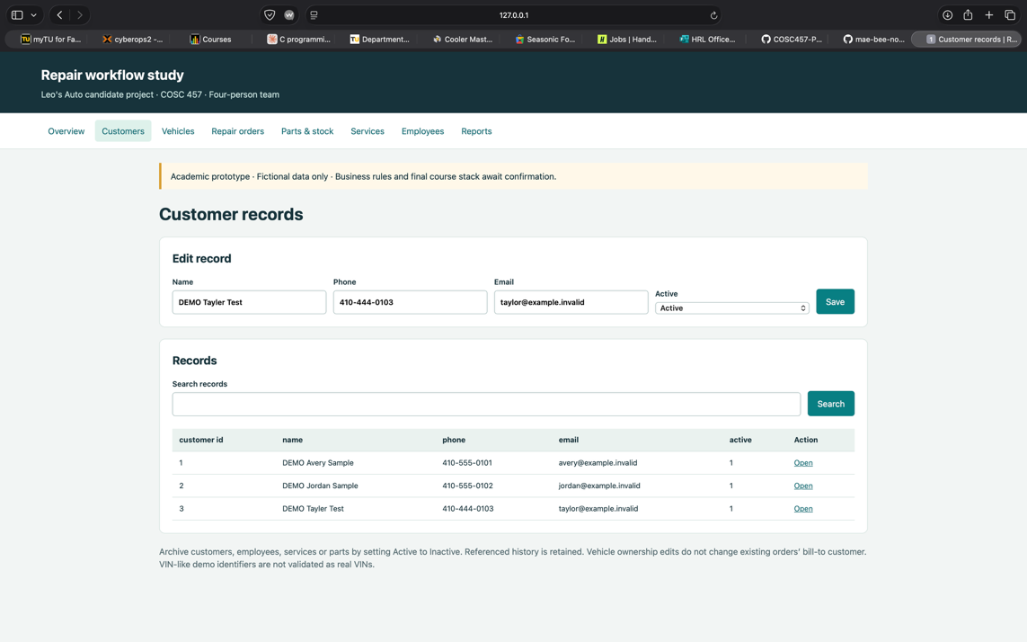
Repair and billing | Input: complaint, authorization, labor and parts. Output: repair lines, invoice total and payment balance.  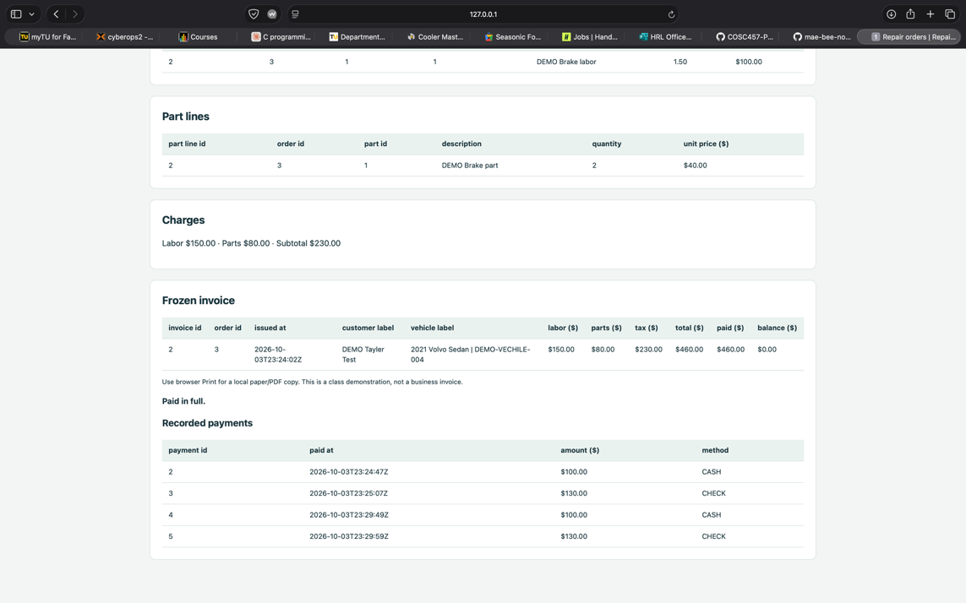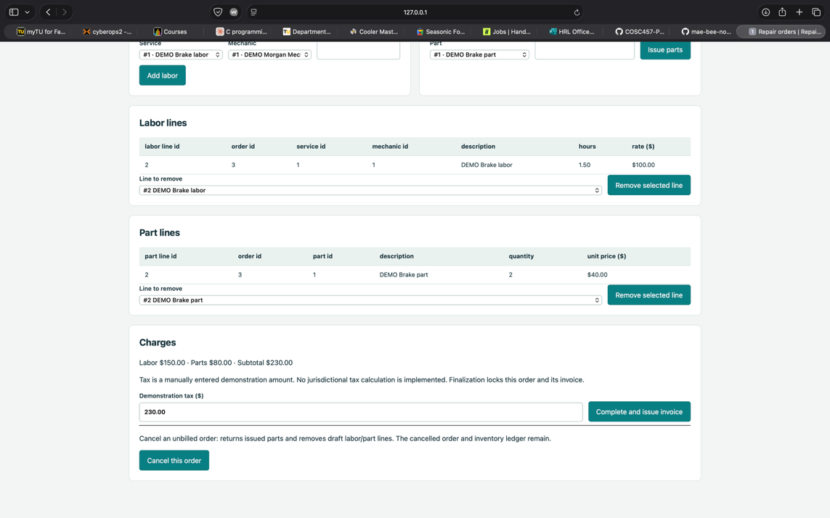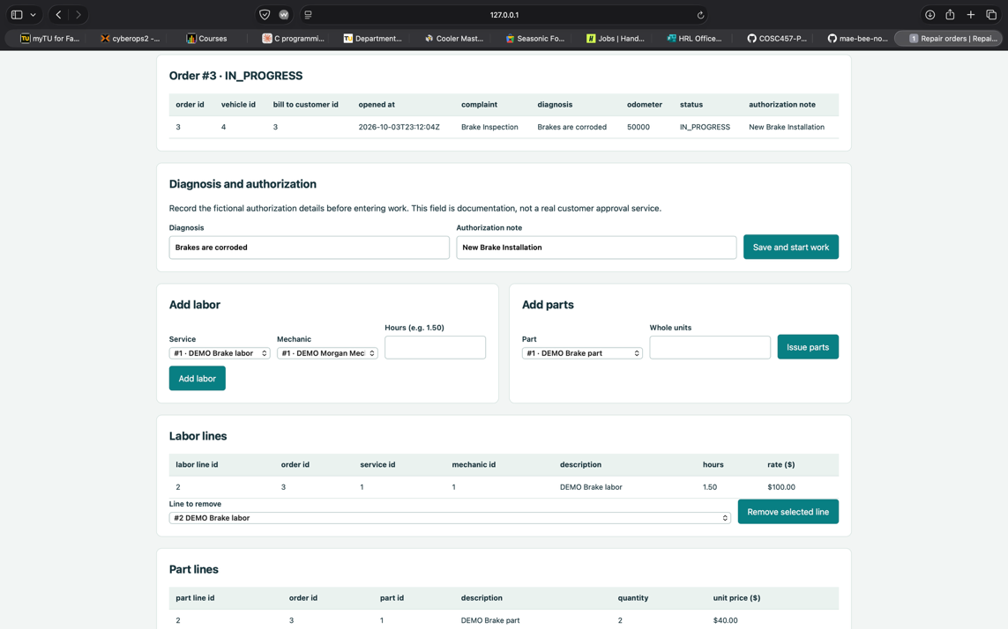
Report | Input: report choice / vehicle filter. Output: readable results for one of the three queries.  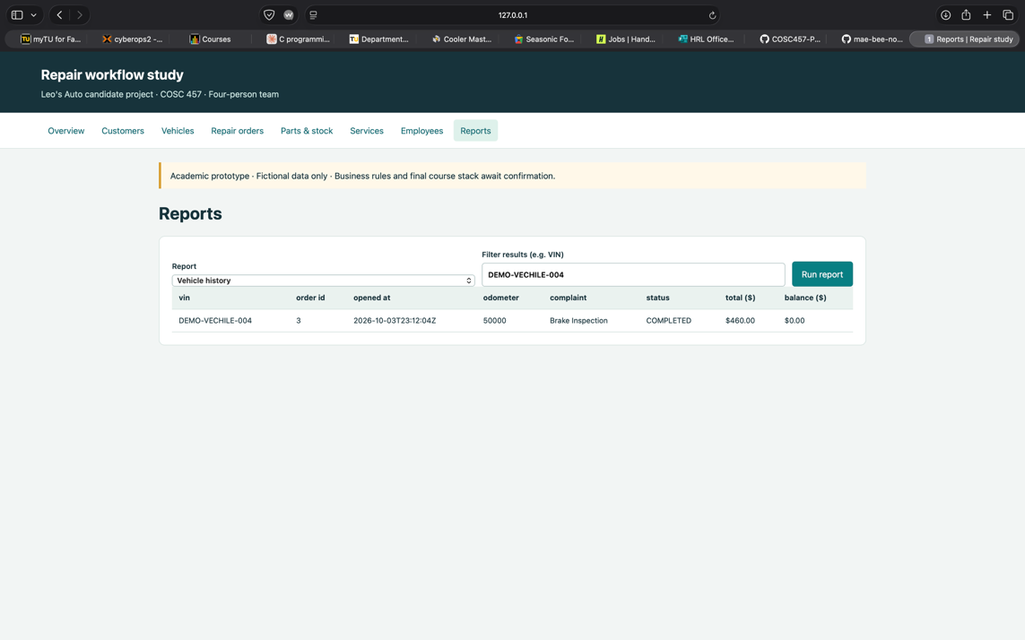  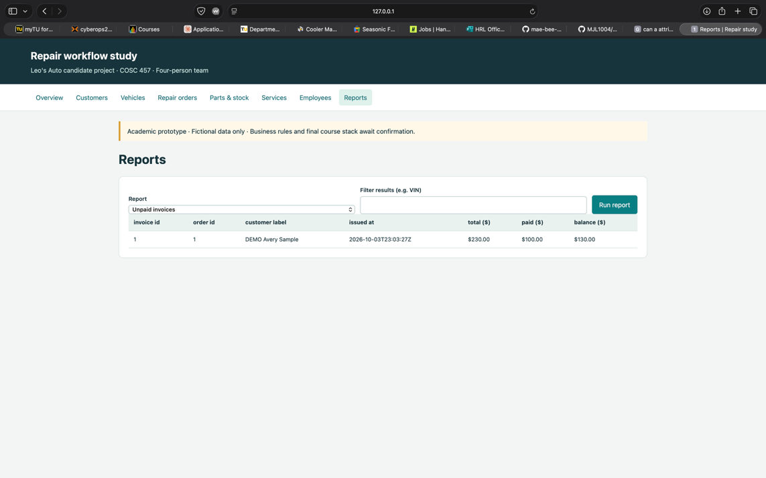

Implementation tools: Python and SQLite
Report: Dashaun | Done

6 Project schedule and meeting log
The project schedule below summarizes the major phases of work, assigned responsibilities, and planned deadlines for Report 1 and the final project.
Report 1 due: October 6, 2026
A: September 15–29 — topic selection, initial setup, role assignment, and interview
B: September 30–October 6 — Report 1
C: October 7–November 20 — build and integration
D: November 21–December 1 — final testing, documentation, and presentation
Final due: December 1, 2026

Task | Owner | A | B | C | D
Interview and report content | Mae | X | X
ERD schema and report assembly | DB + Report |  | X
Database and app integration | DB + App |  |  | X
Full checks and fixes | Everyone |  |  | X | X
Manuals slides and rehearsal | Report + all |  |  |  | X

Concrete handoffs
Interview Manager posts the completed form and report sections by September 29, 2026
Database Manager posts the checked diagram/schema by October 2, 2026.
Application Manager posts screens and setup notes by October 5, 2026.
Report Manager posts the assembled draft for everyone to review by October 6, 2026.

Actual meeting and contribution log
Record real meetings or group-chat work: date, place/channel, each person’s contribution and next task.

Date / Channel | Member | Contribution | Decision / Next Step
 | Mae | Proposed Leo’s Auto, created the GitHub repository, and created the initial mock project materials.
September 15, 2026 — iMessage | Marquise | Participated in the initial project discussion. | Leo’s Auto was selected as the proposed target business and initial project setup began.
 | Marcel | Participated in the initial project discussion.
 | Dashaun | Participated in the initial project discussion.

Date / Channel | Member | Contribution | Decision / Next Step
 | Mae | Assigned Interview Manager role.
September 22, 2026 — iMessage | Marquise | Assigned Database Manager role. | Project roles were finalized. Each member proceeded with their assigned responsibilities.
 | Marcel | Assigned Application Manager role.
 | Dashaun | Assigned Report Manager role.

Date / Channel | Member | Contribution | Decision / Next Step
September 29, 2026 | Mae | Conducted the interview with Brooke Maenner and obtained the completed interview form/signature. | Interview findings would be used to review and update the requirements, ERD/schema, application, and Report 1.
 | Dashaun | Created discord group for communication

Date / Channel | Member | Contribution | Decision / Next Step
 | Mae | Created the meeting log, helped coordinate the group, and reviewed the report/ERD updates.
October 2, 2026 — Discord | Marquise | Finished updating the schema and ERD and shared both with the group. | Reviewed the updated schema and ERD, confirmed remaining Report 1 work, and continued assembling the final report.
 | Marcel | Participated in the group review and report planning.
 | Dashaun | Participated in the group review and report planning.

Date / Channel | Member | Contribution | Decision / Next Step
October 5, 2026 | Marcel | Uploaded prototype screenshots and confirmed that the sample application worked correctly during testing. | Complete final report assembly, review the application section and other project materials, and perform final checks before submitting Report 1 on October 6, 2026.
 | Dashaun | Combined the completed Report 1 materials, updated formatting, and prepared the report for final submission.

Appendix A — Confirmed ERD and Schema

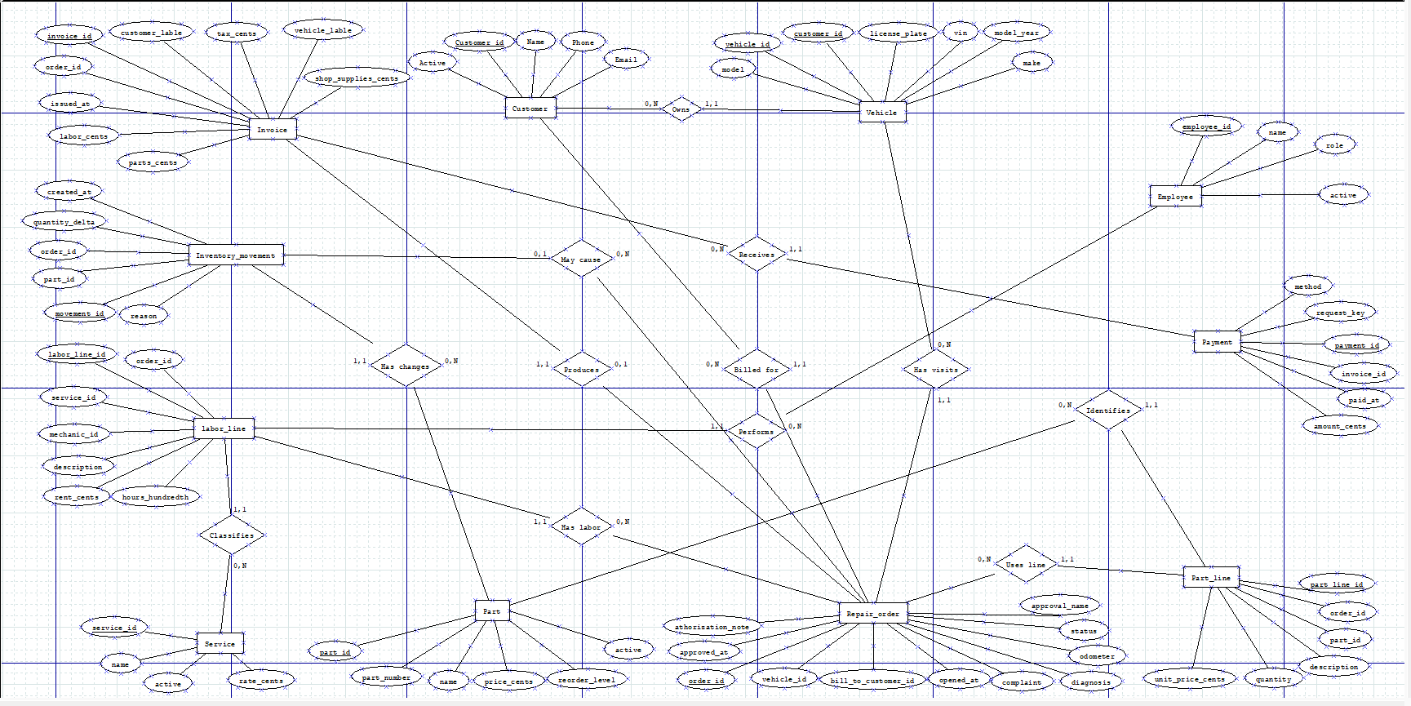

Matching Schema
PK = unique row ID. FK = link to another table. Every table has one integer PK. The ERD relationships supply the FKs below.

customer — Contact details for a customer.
PK customer_id; name, phone, email, active

vehicle — A vehicle and its current customer.
PK vehicle_id, FK customer_id, vin, license_plate, model_year, make, model
customer_id links to customer.customer_id.
Also unique: VIN.

repair_order — One visit; bill-to customer is recorded separately from current ownership.
PK order_id, FK vehicle_id, FK bill_to_customer_id, opened_at, complaint, diagnosis, odometer, status, approval_name, approved_at, authorization_note
bill_to_customer_id links to customer.customer_id; vehicle_id links to vehicle.vehicle_id

employee — Staff; only an active mechanic can be selected for a labor line.
PK employee_id, name, role, active

service — Catalog of labor types and current rates.
PK service_id, name, rate_cents, active

labor_line — A service performed on a job, by one mechanic, at the rate charged.
PK labor_line_id, FK order_id, FK service_id, FK mechanic_id, description, hours_hundredths, rate_cents
mechanic_id links to employee.employee_id; service_id links to service.service_id; order_id links to repair_order.order_id

Converting Chen to tables
An entity becomes a table; its ovals become columns. For one-to-many links, put the FK on the many side. For the optional one-to-one order/invoice link, invoice.order_id is a unique FK. LaborLine and PartLine are separate line entities, so each use can store its own quantity, hours, and price.
Schema and simple rules

part — Part catalog; stock is calculated from inventory movements.
PK part_id, part_number, name, price_cents, reorder_level, active
Also unique: part_number.

part_line — Parts used on a job, at the price charged.
PK part_line_id, FK order_id, FK part_id, description, quantity, unit_price_cents
part_id links to part.part_id; order_id links to repair_order.order_id

inventory_movement — Each stock increase or decrease; a repair link is optional.
PK movement_id, FK part_id, FK order_id, quantity_delta, reason, created_at
order_id links to repair_order.order_id (optional); part_id links to part.part_id

invoice — One final bill per order, with labels and amounts preserved.
PK invoice_id, FK order_id, issued_at, customer_label, vehicle_label, labor_cents, parts_cents, shop_supplies_cents, tax_cents
order_id links to repair_order.order_id
Also unique: order_id.

payment — A payment that settles the outstanding balance of an invoice.
PK payment_id, FK invoice_id, paid_at, amount_cents, method, request_key
invoice_id links to invoice.invoice_id
Also unique: request_key.

Rules already in the sample
Money is stored as integer cents; hours as hundredths. Stock cannot go below zero. Payments must be positive and must equal the outstanding balance. VINs cannot repeat. Only authorized, in-progress orders accept work lines. Final orders and issued bills are locked.

Confirm before keeping these choices
One current customer per vehicle; one mechanic per labor line; at most one final invoice per visit. No deposits before invoicing, refunds, invoice corrections or shared vehicle ownership yet. Tax is a manually entered demo amount. Change the model if the interview requires it.

Why separate tables?
Customer details, service rates and part prices each have one home. Job lines preserve the rate actually charged; invoice labels preserve the billed details. These are historical facts, not copies to keep synchronized. Stock = sum of movements; balance = invoice total minus payments.
Appendix B Completed interview form and signature
Interview: Mae | Done

Leo's Auto: quick interview

Opening:
"We're doing a small Towson University database class project. Could you explain how you track a repair from arrival to payment? We only need general information, not customer records. May I take notes?"

Date / time Place or call/video Student(s) present
09/29/2026 / 4:45 PM
In-person at the shop
Mae Beeman

Person interviewed Their role
Brooke Maenner
Daughter / Front Desk Manager

Quick business profile
Proposed site: Leo's Auto Inc., 14 Willow Ave, Towson, MD 21286. Confirm or correct the name/address below. Approximate answers are fine; sales can be "not disclosed."

History, location(s), staff/size, service area, main services, optional sales
Confirmed: Leo's Auto Inc., 14 Willow Ave, Towson, MD 21286.
Family-owned and operated; founded by Leo. One location, about 5-6 staff. Family runs the front desk; mechanics handle repairs. Serves Towson and the surrounding area. General auto repair, maintenance, A/C, brakes and tire repair. No car sales; service only.

What tools do you use now? Anything hard to track?
Software / paper / other; one issue or improvement (or "works fine")
Digital shop management software for estimates, plus paper Repair Orders (ROs) for mechanics. Difficulties: finding older paper records for warranty checks
and tracking physical part returns to NAPA when the wrong item is delivered.

Walk me through a normal repair, from arrival to pickup.
Who does each step? What is written down or entered? Include estimate/approval and payment.
Actual steps, in order
- Brooke checks in the customer, records details/complaint and prints an RO.
- Mechanic takes car/RO to bay, diagnoses and writes parts/labor on the RO.
- Brooke prices parts/labor and calls the customer for estimate approval.
- After approval, Brooke orders parts; the mechanic completes the repair.
- Brooke finalizes the invoice in the system.
- Customer pays in full by cash/card at pickup and receives the keys.

COSC 457 | Leo's Auto candidate project

What information do we need?

What details do you record?
Customer details (e.g., name, phone, business/fleet account)
Name, phone number and sometimes email. Mainly personal/family vehicles; few fleet accounts.
Vehicle details (e.g., VIN, plate, make/model/year, mileage)
VIN, license plate, make, model, year and exact mileage at arrival.
Repair/job details (e.g., complaint, diagnosis, approval, status, mechanic)
Initial complaint, mechanic diagnosis/notes, customer approval status and assigned mechanic.

How do these records connect?
Can one customer have several vehicles? Can a vehicle have several owners/contacts? Can several mechanics work on one job? What happens when a vehicle changes owners?
Answers / exceptions (yes, no, unsure + a short explanation)
One customer may have several vehicles under a family profile. One vehicle is linked to one owner; on sale, create the new customer profile and relink
the vehicle, preserving its history. Usually one mechanic per job; rarely several.

How do you record labor and parts?
Labor: hours, flat price, or both? Parts: stocked or bought per job? When does stock go down, and what happens to unused/returned parts?
Labor pricing and parts/stock rules
Labor: flat-rate guide hours x hourly rate; diagnostics use flat hours/hourly pricing. Parts usually bought per job from local suppliers. Oil, filters and
bulbs stocked; counts reduced manually when used. Unused parts returned for credit.

How do approval, bills and payments work?
How is approval recorded? What makes up the total (labor, parts, tax/fees)? Any partial payments, deposits or refunds? Can an old invoice change?
Short answers; note anything we should ask about later
Approval: verbal by phone; name/time written on RO. Total: parts, labor, shop supplies and state tax. No deposits or partial payments; cash/card in full
at pickup. Closed, paid invoices cannot change; issue a separate credit/refund.

Finish with priorities and proof

What should a small class prototype do first?
Which 2-3 tasks, searches or reports are useful? For example, finding repair history, viewing open jobs or checking unpaid bills. Ask them to choose.
Top tasks / reports
- Search customer repair history by phone number.
- Open Jobs dashboard showing status, including waiting for parts and ready for pickup.

What happens when something goes wrong?
Ask about a cancellation, declined work, wrong entry or missing part. One common example is enough.
Example and what the shop does
Wrong part delivered: mechanic reports it; Brooke requests a vendor exchange and notes the delay on the RO. If needed, move the car off the lift and call the customer with the revised pickup time.

Anything to correct, or a question we should follow up on?
No corrections or additional follow-up questions stated.
Brooke agreed to note-taking for the Towson University class project.

Business name / blank form / photo use permitted? Any restrictions?
Business name use allowed. Exterior/front desk photos discouraged; no plates or PII.


Interview confirmation
This signature confirms that the interview above took place. It does not approve our report, commit the business to using our software, or endorse the project.
Interviewee signature (sign by hand):
Signed electronically
Date signed: 09/29/2026

