COMP2411 Project: Banquet Management System (BMS)

STAGE 1 (2/11)

Member info:
Group member1: Au Tsz Kin 23085232d
Group member2: Chong Zhi Yi 23078028d
Group member3: Lau Ming Yin 23087882d
Group member4: Lee Yin Lam Elaine 23082545d

ER Diagram:
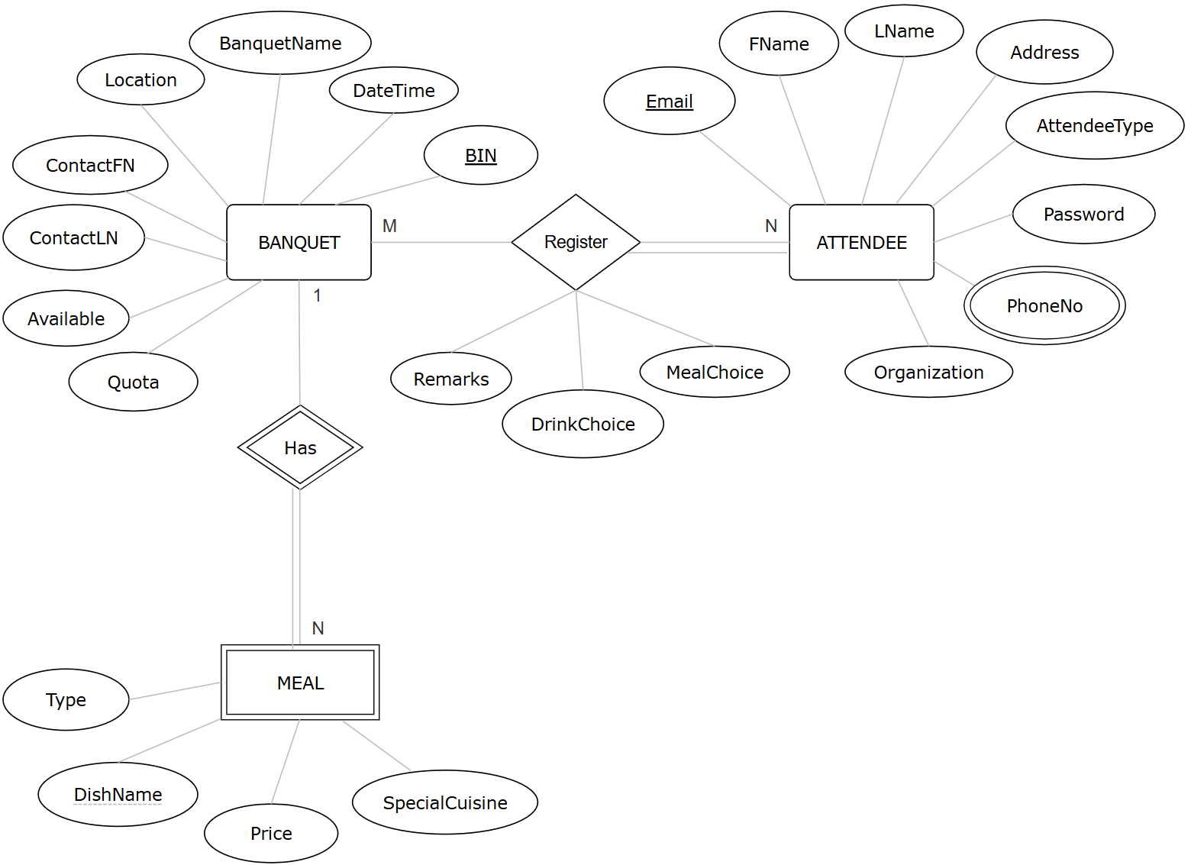

Assumptions:
Least number of attendees in a banquet: 1
Attendee can make account but don’t join any banquet

Relational Schema:
BANQUET (BIN, BanquetName, DateTime, Address, Location, ContactFN, ContactLN, Available, Quota)

MEAL (BIN, DishName, Price, Type, SpecialCuisine)
MEAL (BIN) —> BANQUET (BIN)

ATTENDEE (Email, FName, LName, Address, AttendeeType, Password, PhoneNo, Organization)

REGISTRATION (BIN, Email, Remarks, DrinkChoice, MealChoice)
REGISTRATION (BIN) —> BANQUET (BIN)
REGISTRATION (Email) —> ATTENDEE (Email)

Project plan:
- User guide 19/11
- Source code 14/11
- Testing data 15/11
- Analysis report(s) 19/11
- Presentation file 22/11
- Five min video 27/11
- Contribution of work 28/11
- Peer evaluation form 28/11

