Notes from the TVB-Usability Workshop

5th April 2012 in Gemenos

Participants: Viktor Jirsa  
Randy McIntosh  
Petra Ritter  
Cathy Price  
Thomas Hope  
Paula Sanz Leon  
Stuart Knock  
Jean-Luc Blanc  
Lia Domide  
Bogdan Neacsa  
Jochen Mersmann

# Reports from using TVB

## Tom’s-Run

Initialize it:

* IE as a default-browers: can there something to be done to fire a compatible browser…
* Problems with Firefox -> switch to chrome
* Login was not intuive (especially to use an own user).

General usage:

* You can get used to it
* Project-page during longer operation need a bit of feedback to the user (maybe auto refresh)
* Better explanation (tooltip or maybe wiki)
* Visualizations not always appropriate (timeseries view with a moving bar on a node-level makes no sense)

Simulation:

* Default-selection of the channels is a bit odd. Especially not having the names, but only channel-number was not helpful
* Changing the region of interest needs to be reworked. Having a user-set name to such a set would be good
* Selecting multiple nodes in something like a batch-mode would be nice.
* Comparing of output would be good

## Petra’s-Run

Initialize it:

* Screen-size for login…
* Low contrast on things (everywhere)
* List-length calculation: lots of space, but multiple pages…
* Context-sensitivity of buttons (deactivate if not applicable)
* Loading (or reloading) of data not consistent in all situations. Sometimes it just does not reload at all and needs to be restarted
* Mouse-ways are quite long in some situation.
* “Launch” is a bit difficult as a word

Overall Observations:

* Operations-screen could be more helpful (lot of unneeded info, important ones hidden)
* Export is not intuitive. Export everything is not appropriate
* File-exchange is missing some information (units etc.)
* We need a lot better “help-system” for the simulation. E.g. help-popup with a link to a more broad-help

## Randy’s Run

* No major additions but see attached protocol…

# Decisions from the workshop-part

We will change the bottom-tabs from the current state a bit in terms, that we will have

* User
* Project
* Connectivity
* Bursting
* Simulation
* Results (?)

All of these should be designed a cockpits, which means, that you instantly have a good overview of the relevant information and either can circle in short circles and tweak params, or jump to detail-views of special interest. Each of these Cockpits will have different designs, where by now we only have discussed on 3 of them.

**User-Cockpit:** Not discussed, however necessary for quite some settings. Least important

**Project-Cockpit:** discussed, but with no feasible result. Common understanding, that it will change from the current state. Will continue the discussion in Toronto based on the sketch, which was produced during a workshop of the technical team in Cluj.

**Connectivity Cockpit:** Multi-Selection in a Way, that you easily (e.g. typing on nodes in the matrix or on the 3D visualizer while holding down a modifier-Key e.g. STRG) select a set, which you then can persist (under a name) to reselect it. With that selection you need to do a set of different operation (excite, calm down, cut out etc.) which will be applied similarly to the whole selection of nodes. A given selection needs to be inversed (so select the rest of the nodes).

A selection always works on nodes. That implies that the connections fall into 4 groups:

* Connections between selected nodes
* Connections between unselected nodes
* Incoming connections from an unselected to a selected node
* Outgoing connection from an unselected to a selected node

To these connection-sets, also operations can be applied. To distinct between these, it is planned to have a distinct operation for each subgroup (maybe we come up with a better solution to also manage the connection-sets and not only the region-sets).

A rough sketch would be like this:

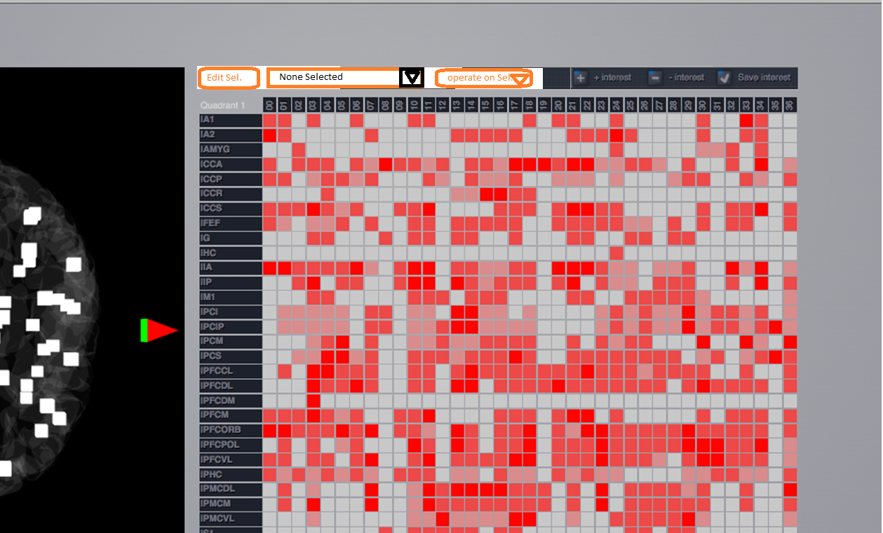

Additionally the regions will be identified by names (instead of numbers) also on the x-axis of the matrix with the text rotated by 90 degrees.

**Bursting-Cockpit:** This cockpit is desired, to poke around in the param-space of a simulation, to get a clue, where a param-exploration might make sense. The workflow is, that the system should give an (more or less) immediate response to freshly set parameters and a result-inspection should be possible instantly. That is the reason, why we have a split screen, where the left side is similar to the “Simulation-Cockpit” and the right side is similar to the “Visualization-Cockpit”. A rough outline of that screen looks like the following (thanks Paula):

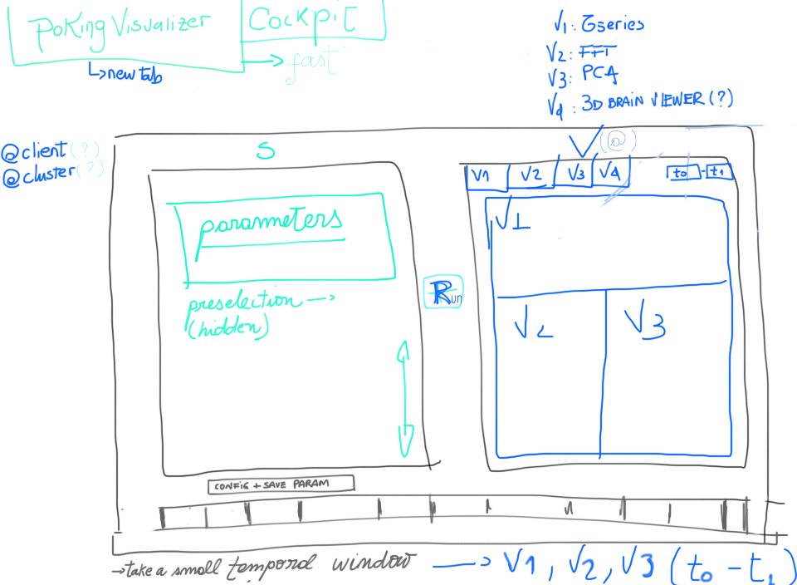

The left screen resembles the Simulation-params. Most important here is, that the Connectivity-Matrix to work on and the Node-Model can be choosen. The latter also distinguishes, which other parameters can be worked on. If the param-list is too long, a scrollbar will appear in this section. There is a button “param-config”, which enables to set, if a parameter is to be shown on the main-screen and what the default value for a simulation run should be used (independent whether it is shown or not).

When a simulation is submitted, a small rectangle is added to the band below the two window-sections. This rectangle serves as a handle to recall the burst (on the left and right pane) and also serves as a progress indicator, if a simulation-run takes longer then some seconds. The simulation-results are not persisted, it is only foreseen, that the parameter-set of a given burst can be persisted to work as a preset for the simulation-cockpit (details there to be defined). However it is necessary, that you can move off this screen and return to your work later on. Thus there is a technical need for a persistence. Thus a “clear bursts” button needs to be there.

For a burst-run, you need to define, which visualizations you want to see (thus implicitly defining the Monitors, which cannot be defined explicitly in the simulation-section). These visualizations should be presented as “tiles” on the visualization-page and serves as a sanity-check with showing data for the full time-period of the simulation. You can (by clicking on a tile) go to the detail-view of that visualizer with full control (e.g. zooming, time-selection etc.). The image above indicates, that you might to that image also via a tab-control, but the details here are left to a first mock-implementation which is the basis of further discussions. In the details-view of a visualization you can further narrow a region of inspection (may it be in time or space) and go back to the overview-page of the visualization-pane. That is then recalculated on the narrowed params and so on. This will lead you to another set of parameters, you submit your next burst upon.

By now it cannot be guaranteed, that the processing speed will be sufficient with the web-interface and the cluster in the processing-chain. We need an evaluation, how we can present a technical solution, which works fast enough for that work-mode but is still maintainable (given the fact, that by now we do not have a fat client, where we could executed some simulation-tasks on the client-side)

**Simulation-Cockpit:** not to be changed at this point in time. Technical team will make an attempt, to integrate the controls for parameter-exploration (which need an own visualization-type)

**Results-Cockpit (?):** discussed on this, however with moving results. Still has to be discussed and decided, if this is necessary and how it will work, or if that might be integrated with the Project-Cockpit.