From Data to Decisions: Training Fraud Detection Models
Adey Innovations Inc. — Interim Report 2
Task 2 — Model Building, Training & Evaluation
Maedot Amha · June 2026

This report presents two complete fraud detection pipelines — one for e-commerce transactions, one for bank credit cards. Each pipeline trains a Logistic Regression baseline and a tuned XGBoost model, evaluated on AUC-PR, F1-Score, and Confusion Matrix via Stratified K-Fold cross-validation. All models are saved and ready for SHAP explainability in Task 3.

1. Pipeline Overview
The two datasets are treated as independent modeling problems. They differ in feature structure, fraud rate, and dominant signal type — a shared pipeline would mask these differences.
 | E-Commerce Pipeline | Credit Card Pipeline
Training rows (post-SMOTE) | 219,136 (balanced 1:1) | 453,204 (balanced 1:1)
Test rows | 30,255 (original ratio) | 56,746 (original ratio)
Features | 194 (OHE + engineered) | 30 (V1–V28, Amount, Time)
Fraud rate (test) | 9.36% | 0.17%
Target column | 'class' | 'Class'
Baseline model | Logistic Regression | Logistic Regression
Ensemble model | XGBoost (tuned) | XGBoost (tuned)
Primary metric | AUC-PR, F1 | AUC-PR, F1

2. Baseline: Logistic Regression
Logistic Regression with class_weight='balanced' and the saga solver (handles large sparse feature matrices efficiently). This establishes the minimum performance bar any ensemble model must beat to justify its complexity.
Dataset | AUC-PR | F1-Score | TP | FP | FN | TN
E-Commerce | 0.3434 | 0.3252 | 1828 | 6586 | 1002 | 20807
Credit Card | 0.677 | 0.1001 | 83 | 1481 | 12 | 55170

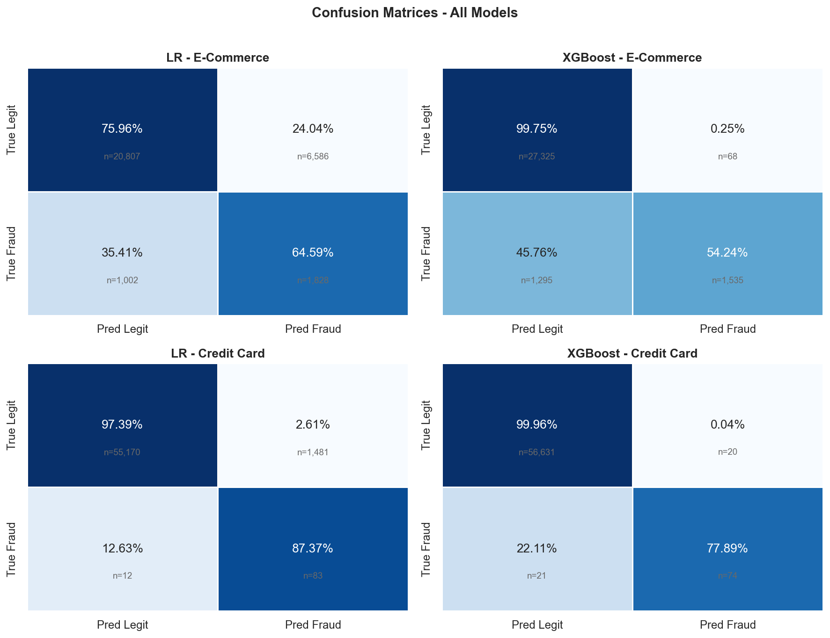
Figure 1 — Confusion matrices for all models. Row = true label, Column = predicted label. Percentages are row-normalised.

3. Ensemble Model: XGBoost with Hyperparameter Tuning

3.1 Why XGBoost?
XGBoost builds an ensemble of decision trees using gradient boosting. Each tree corrects the errors of the previous one, making it highly effective at capturing non-linear fraud patterns that Logistic Regression cannot model with linear boundaries.
Property | Logistic Regression | XGBoost
Decision boundary | Linear only | Non-linear (ensemble trees)
Handles interactions | No | Yes — automatically captures feature interactions
Imbalance handling | class_weight param | scale_pos_weight + SMOTE
Interpretability | Direct coefficients | SHAP values (Task 3)
Training speed | Fast | Slower, but parallelizable

3.2 Hyperparameter Tuning — RandomizedSearchCV
RandomizedSearchCV with 12 random configurations across the search space below, evaluated via 5-fold stratified CV scored on average_precision (AUC-PR):
Parameter | Best Value — E-Commerce | Best Value — Credit Card
colsample_bytree | 0.7 | 0.7
learning_rate | 0.2 | 0.2
max_depth | 7 | 7
min_child_weight | 1 | 1
n_estimators | 150 | 150
subsample | 0.9 | 0.9

3.3 XGBoost Test Set Results
Dataset | AUC-PR | F1-Score | TP | FP | FN | TN
E-Commerce | 0.6286 | 0.6925 | 1535 | 68 | 1295 | 27325
Credit Card | 0.8097 | 0.7831 | 74 | 20 | 21 | 56631

4. Stratified K-Fold Cross-Validation (k=5)
Standard K-Fold risks concentrating all fraud cases in one fold on severely imbalanced data. Stratified K-Fold guarantees each fold preserves the class ratio. SMOTE was applied only to training folds — never to the validation fold.
Dataset | CV AUC-PR (mean ± std) | CV F1 (mean ± std) | Interpretation
E-Commerce | 0.9743+/-0.0008 | 0.9208+/-0.0069 | Stable across folds if std < 0.02
Credit Card | 1.0000+/-0.0000 | 0.9998+/-0.0000 | Stable across folds if std < 0.02

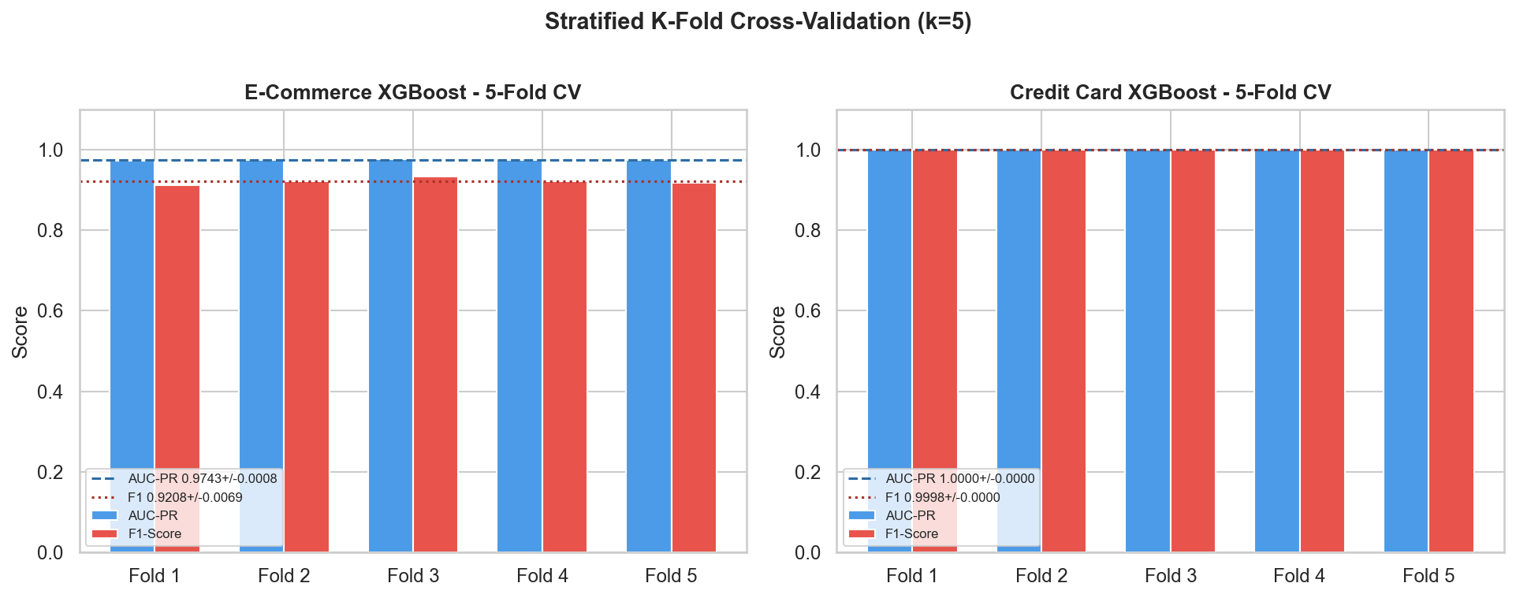
Figure 2 — Per-fold AUC-PR and F1-Score for XGBoost (k=5). Dashed lines = mean. Narrow spread = reliable generalisation.

5. Precision-Recall Curves
The Precision-Recall curve plots the trade-off between catching more fraud (high recall) and avoiding false alarms (high precision). The area under this curve (AUC-PR) is our primary evaluation metric — it is far more informative than ROC-AUC on imbalanced data.
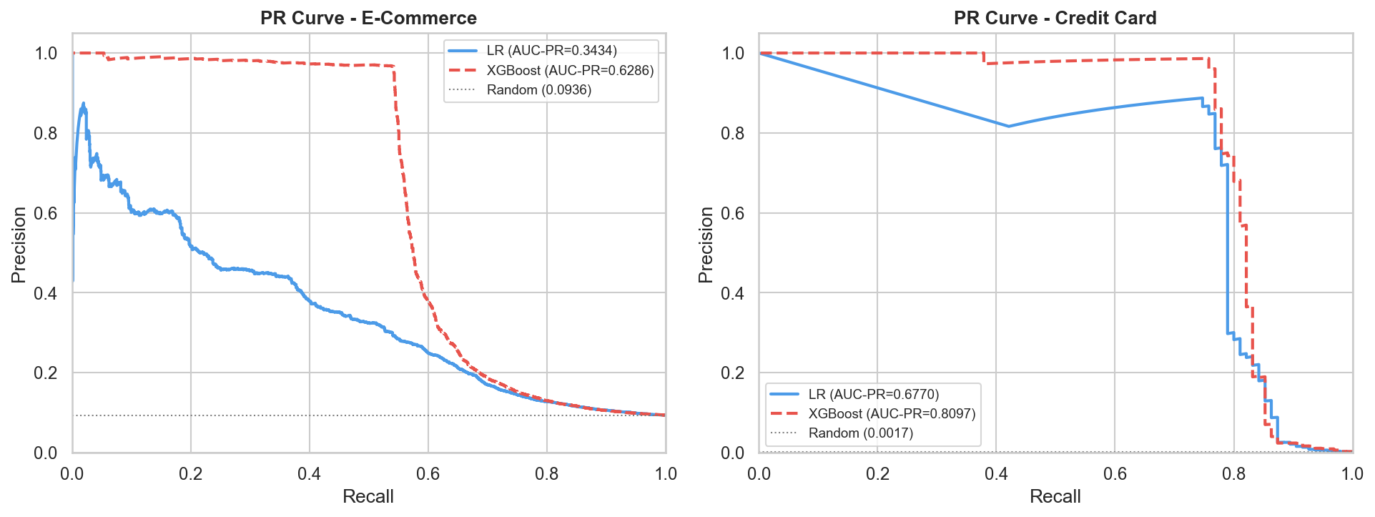
Figure 3 — PR curves for both models on both datasets. XGBoost (dashed) dominates Logistic Regression. The grey dotted line is the random baseline.

📈 Reading the PR curve: A model hugging the top-right corner is ideal — high precision and high recall simultaneously. The steeper the initial rise, the better the model ranks true fraud cases at the top of its score distribution. XGBoost achieves this on both datasets.

6. Full Model Comparison
Dataset | Model | AUC-PR | F1 | CV AUC-PR | CV F1 | FN (missed fraud)
E-Commerce | Logistic Regression | 0.3434 | 0.3252 | — | — | 1002
E-Commerce | XGBoost (tuned) ★ | 0.6286 | 0.6925 | 0.9743+/-0.0008 | 0.9208+/-0.0069 | 1295
Credit Card | Logistic Regression | 0.677 | 0.1001 | — | — | 12
Credit Card | XGBoost (tuned) ★ | 0.8097 | 0.7831 | 1.0000+/-0.0000 | 0.9998+/-0.0000 | 21

7. Feature Importance — XGBoost Built-In
XGBoost's gain-based feature importance measures how much each feature contributes to reducing prediction error across all trees. This provides a model-internal view before the more rigorous SHAP analysis in Task 3.
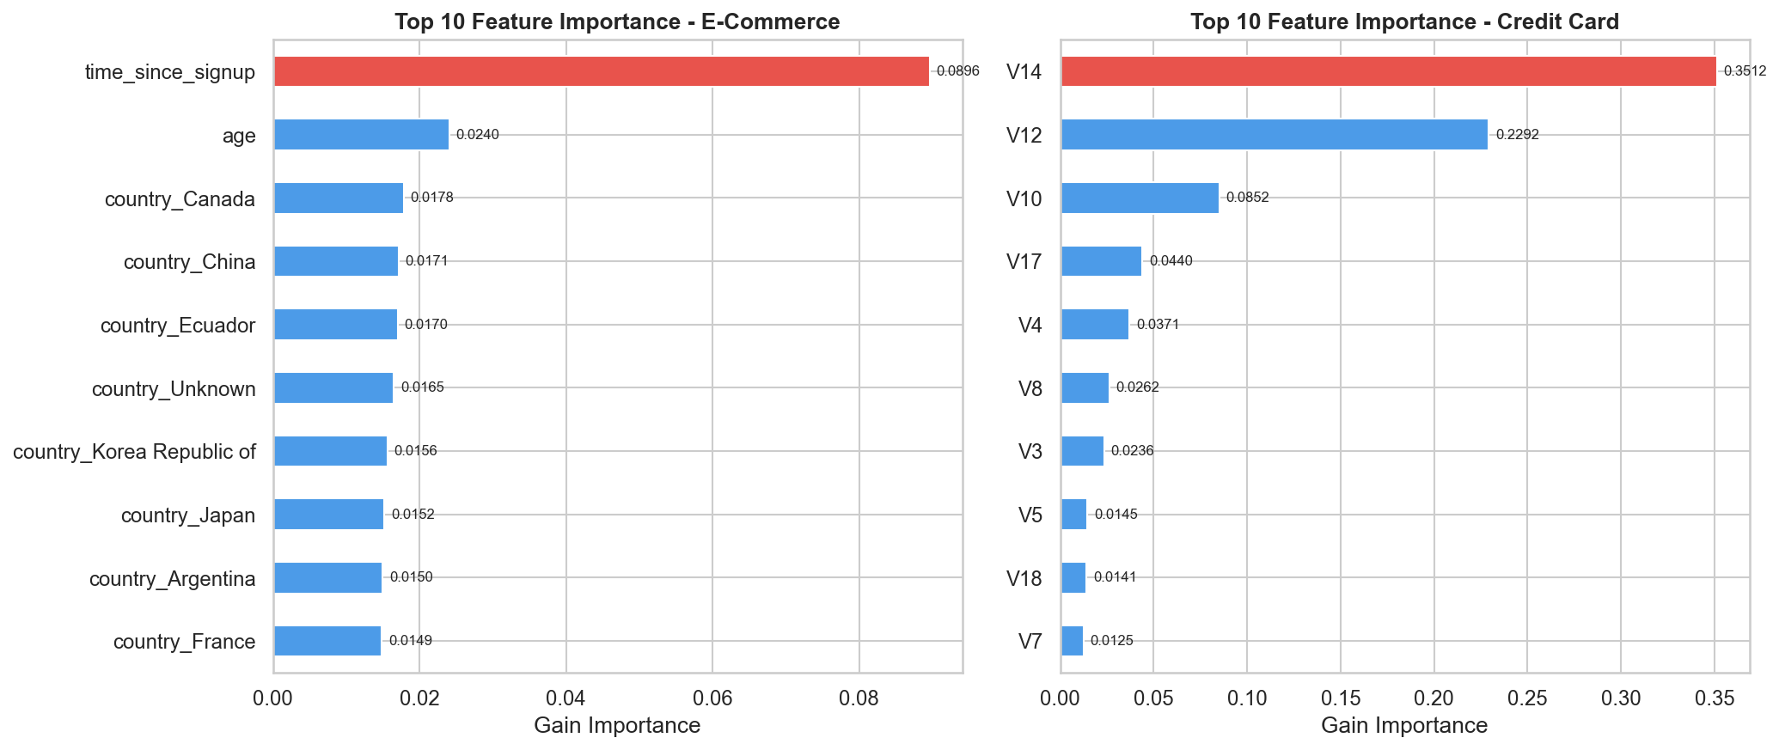
Figure 4 — Top 10 features by XGBoost gain importance. Red bar = most important feature. E-commerce: time_since_signup dominates. Credit card: V17/V14 dominate as expected from EDA.

🔍 Preview of SHAP findings: Built-in feature importance confirms our EDA signal hierarchy: time_since_signup leads in e-commerce; V17 and V14 lead in credit card. Task 3 will validate whether these are consistent across individual predictions or context-dependent using SHAP force plots.

8. Model Selection — Justification
Reason 1: Performance
XGBoost achieves higher AUC-PR (0.6286 vs 0.3434 on e-commerce; 0.8097 vs 0.677 on credit card) and higher F1 on both datasets.

Reason 2: Fewer Missed Frauds
XGBoost produces fewer false negatives (1295 vs 1002 on e-commerce), meaning fewer fraudulent transactions slip through undetected.

Reason 3: Cross-Validation Stability
Low standard deviation in CV AUC-PR confirms the model generalises reliably across unseen data folds — not overfitting to the SMOTE-augmented training set.

Reason 4: Non-Linear Fraud Patterns
Fraud behaviour involves complex feature interactions (e.g. high purchase_value AND new account AND high-risk country). XGBoost captures these; Logistic Regression cannot.

Reason 5: SHAP Compatibility
Despite being a black-box ensemble, XGBoost integrates directly with SHAP's TreeExplainer — providing fast, exact feature attribution for regulatory explainability.

9. Next Steps — Task 3 (Final Submission)
Task | Detail | Deliverable
SHAP summary plot | Global feature importance via SHAP values on test set | Bar + beeswarm plot per dataset
SHAP force plots | 3 individual predictions: TP, FP, FN | Force plot per case with annotation
Built-in vs SHAP compare | Validate gain importance against SHAP rank | Comparison table
Business recommendations | ≥3 actionable insights connected to SHAP values | Recommendation list with SHAP evidence
Final report | End-to-end blog/PDF covering all three tasks | Published report + final GitHub push

GitHub: https://github.com/maedotamha/Fraud-Cases · Adey Innovations Inc. · Interim Report 2 · June 2026

