Catching Fraudsters Before They Strike
Building a FinTech Fraud Detection System
Interim Report 1 — Data Analysis, Feature Engineering & Preprocessing
Maedot Amha · Adey Innovations Inc. · June 2026

This report documents Phase 1 of Adey Innovations' fraud detection pipeline: understanding the data, engineering features that capture how fraud actually manifests, and preparing balanced training sets. All analysis is executed and reproducible — full notebook outputs are available on GitHub.

1. The Problem: Why Fraud Detection Is Hard
Fraud detection sits at the intersection of two painful trade-offs. False positives — flagging legitimate purchases as fraud — frustrate real customers and erode trust. False negatives — missing actual fraud — cause direct financial loss. Getting the balance right requires deep data understanding, not just a good algorithm.
We operate two independent pipelines:
- E-commerce transactions — rich behavioral context: device IDs, signup times, IP addresses, browser fingerprints.
- Bank credit card transactions — PCA-anonymized features (V1–V28) for regulatory compliance.

2. The Datasets
Dataset | Rows | Fraud Rate | Key Challenge
Fraud_Data.csv (e-commerce) | 151,112 | 9.36% | Geolocation, behavioral features
creditcard.csv (bank) | 283,726 | 0.17% | Severe imbalance, PCA-anonymized
IpAddress_to_Country.csv | 138,846 | — | Range-based IP lookup

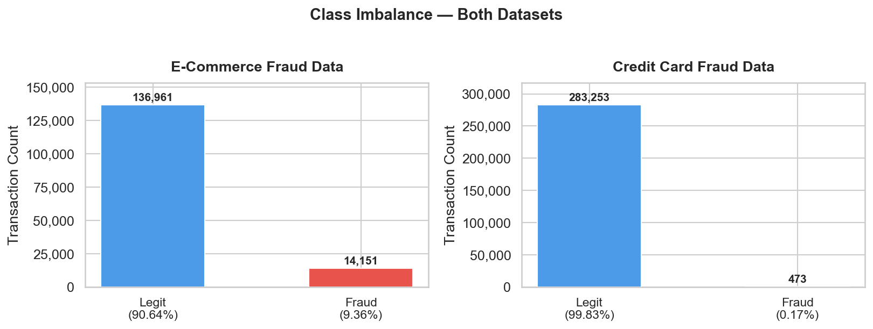
Figure 1 — Class distribution in both datasets. The credit card imbalance (0.17%) is 55× more severe than e-commerce (9.36%).

⚠️ Why accuracy is misleading: A model predicting 'legitimate' for every credit card transaction achieves 99.83% accuracy while catching zero fraudulent cases. We evaluate on AUC-PR and F1-Score instead.

3. E-Commerce Fraud Analysis (Fraud_Data.csv)

3.1 Data Cleaning
Issue Checked | Finding | Action Taken
Missing values | Zero nulls across all 11 columns | None required
Duplicate rows | Zero duplicate records | None required
Data types | signup_time / purchase_time stored as strings | Parsed to datetime64
ip_address format | Stored as float (e.g. 732758705.0) | Cast to int64 for range lookup
Target encoding | class column is int (0/1) | Confirmed — no changes

3.2 Univariate Distributions
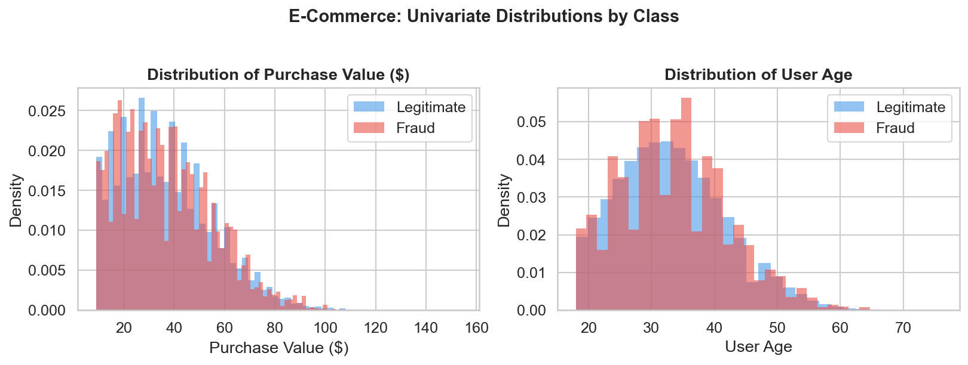
Figure 2 — Purchase value is right-skewed; fraud occurs at all price points. Age is normally distributed (~33 years mean) with no standalone fraud signal.

3.3 Fraud Rate by Categorical Features
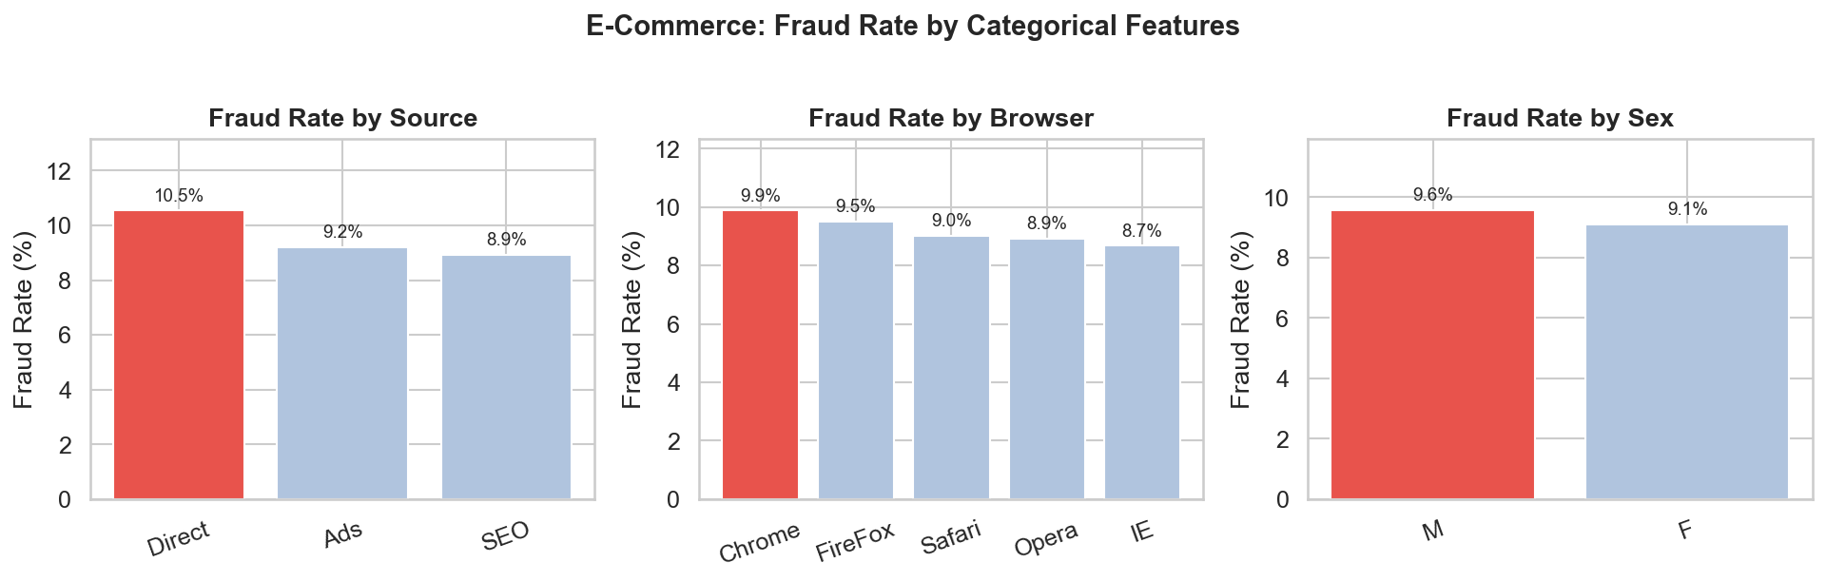
Figure 3 — Fraud rate by source, browser, and sex. Direct-channel users commit fraud at the highest rate (10.54%); no browser or sex shows extreme divergence.

Source | Fraud Rate
Direct | 10.54%
Ads | 9.21%
SEO | 8.93%

4. Geolocation Enrichment — IP Address to Country
IpAddress_to_Country.csv maps 138,846 IP ranges to countries. An exact-match join fails — we need a range-based lookup. The approach: convert IPs to 64-bit integers, sort both tables on the lower bound, apply pd.merge_asof (O(n log n)), then validate the IP falls within the matched upper bound.
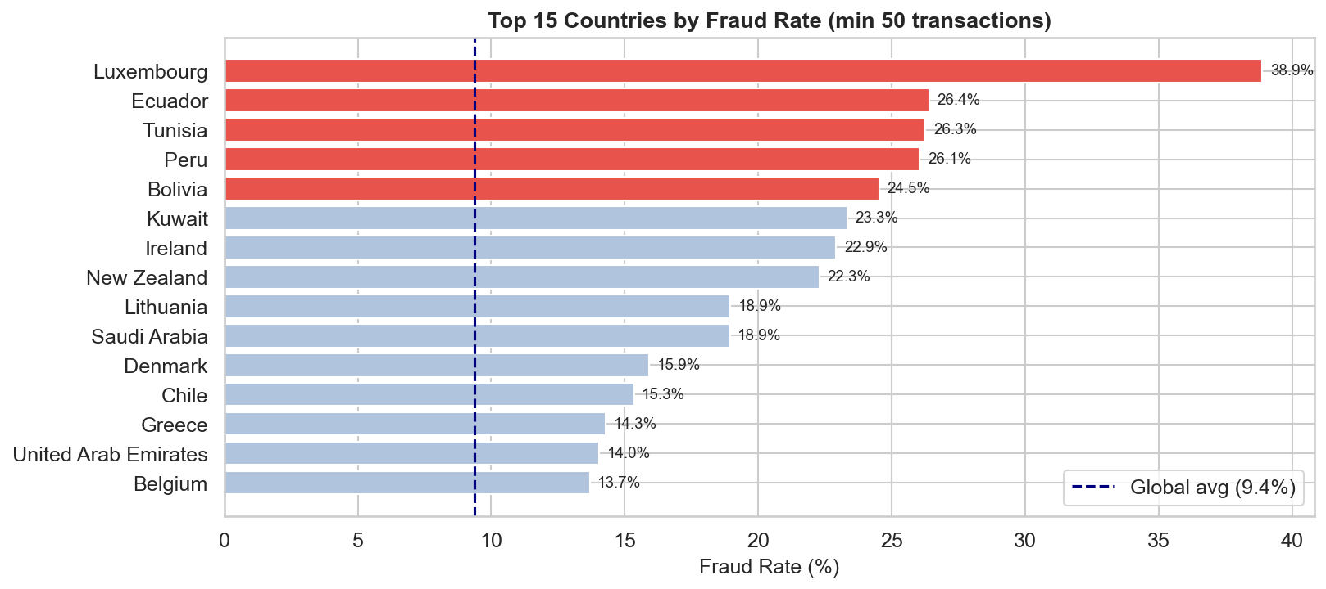
Figure 4 — Top 15 countries by fraud rate (minimum 50 transactions). The dashed line marks the global average (9.36%).

Country | Transactions | Fraud Cases | Fraud Rate | vs. Global Avg
Luxembourg | 72 | 28 | 38.9% | 4.2×
Ecuador | 106 | 28 | 26.4% | 2.8×
Tunisia | 118 | 31 | 26.3% | 2.8×
Peru | 119 | 31 | 26.1% | 2.8×
Bolivia | 53 | 13 | 24.5% | 2.6×
Global average | 151,112 | 14,151 | 9.36% | 1.0×

🌍 Business Insight: Transactions from Luxembourg, Ecuador, Tunisia, Peru, and Bolivia show fraud rates 2.6–4.2× the global average. A risk-tiered verification layer for these origins would intercept a disproportionate share of fraud at minimal friction to legitimate customers.

5. Feature Engineering (E-Commerce)

5.1 time_since_signup — The Single Most Powerful Signal
Elapsed hours between account creation and the purchase transaction:
Statistic | Value
Mean | 1,370 hrs (~57 days)
Minimum | 0.0003 hrs (~1 min)
25th pct | 607 hrs (~25 days)
Median | 1,368 hrs (~57 days)

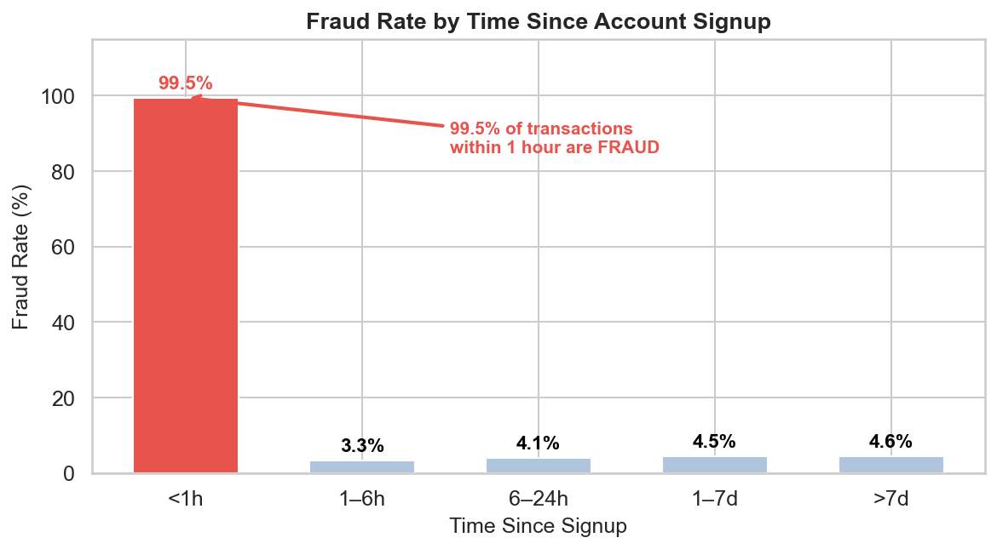
Figure 5 — Fraud rate collapses after the first hour of signup. The <1h bucket is nearly 100% fraud.

★ Critical Finding: Transactions placed within 1 hour of account creation are fraudulent 99.52% of the time. This pattern reflects throwaway accounts created specifically for a single fraudulent purchase. This feature alone could serve as an immediate rule-based filter before any model is deployed.

5.2 Transaction Velocity — tx_count_24h
Cumulative transaction count per user, computed via expanding window. Legitimate users transact infrequently; a burst of purchases in a short window signals credential stuffing or account takeover attacks.

5.3 Temporal Features
Feature | Derivation | Fraud Mechanism Captured
hour_of_day | purchase_time.dt.hour | Off-hours automated attacks
day_of_week | purchase_time.dt.dayofweek | Weekend/holiday low-coverage windows
time_since_signup | (purchase - signup) / 3600 | Throwaway accounts, synthetic identities
tx_count_24h | Expanding user tx count | Account takeover, credential stuffing
country | IP range → country lookup | Geographic risk concentration

6. Credit Card Data — Full Analysis (creditcard.csv)

6.1 Data Cleaning
The credit card dataset required more active cleaning than the e-commerce data.
Issue Checked | Finding | Action Taken
Missing values | Zero nulls across all 31 columns | None required
Duplicate rows | 1,081 exact duplicate rows detected | Dropped — reset index
Final row count | 283,726 rows after deduplication (from 284,807) | Confirmed clean
Data types | All numeric (float64/int64) | No type fixes needed
Feature scale | V1–V28: PCA-scaled; Amount and Time: not scaled | StandardScaler on Amount, Time
Target column | Class (capital C) — 0/1 integer | Confirmed, no encoding needed

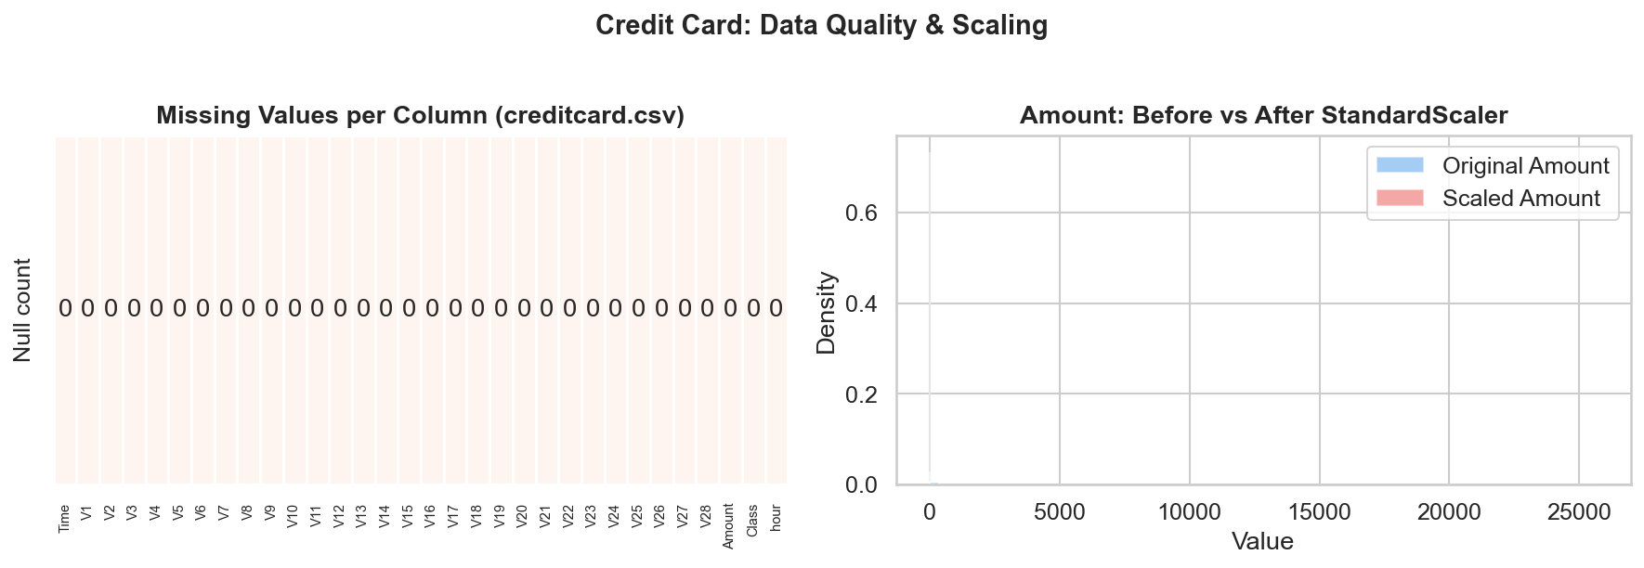
Figure 6 — Left: missing value heatmap (all zeros — no nulls). Right: Amount before and after StandardScaler — the scaled distribution is zero-centred and unit-variance.

6.2 Class Imbalance
Class | Count | Percentage | Imbalance Ratio
Legitimate (0) | 283,253 | 99.83% | 600:1 vs Fraud
Fraud (1) | 473 | 0.17% | Minority class

6.3 Transaction Amount Analysis
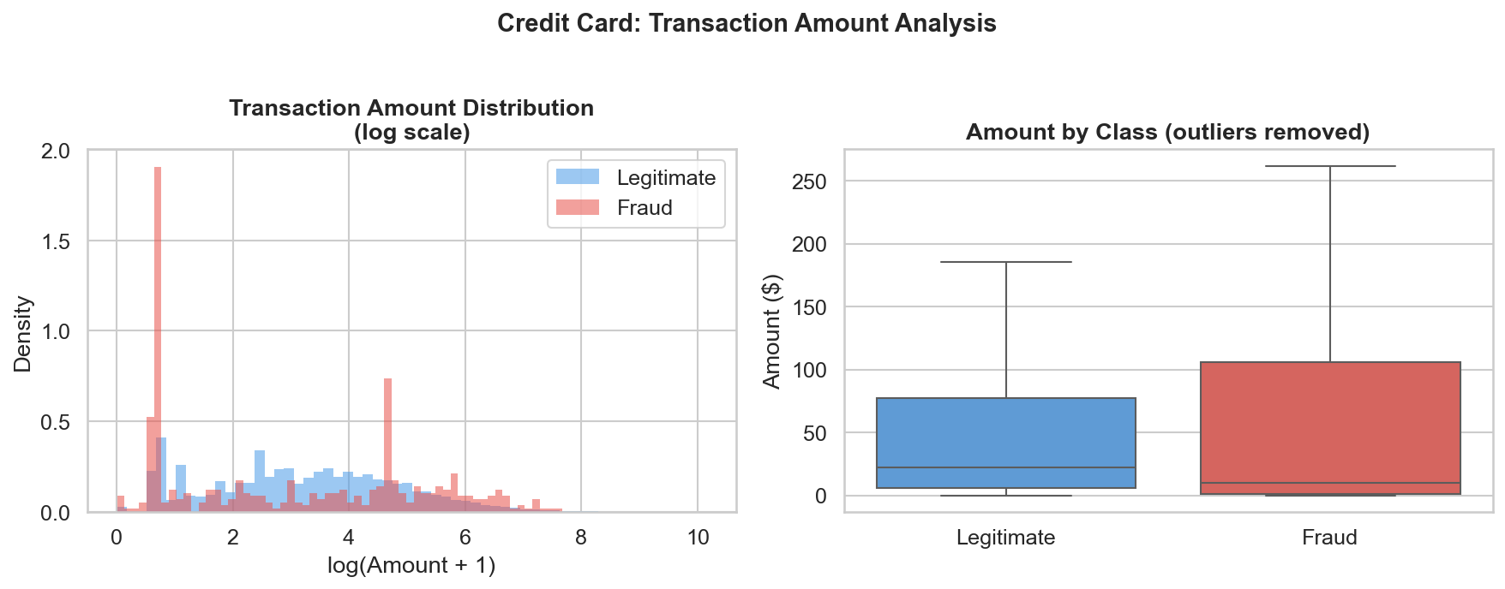
Figure 7 — Left: log-scale amount distributions; fraudulent transactions cluster at very low values. Right: boxplot (outliers removed) — fraud has a much lower median ($9.82 vs $22.00).

Class | Mean Amount | Median Amount | Interpretation
Legitimate (0) | $88.41 | $22.00 | Normal purchasing pattern
Fraud (1) | $123.87 | $9.82 | Card-testing micro-transactions

💳 Card-Testing Pattern: Fraud median ($9.82) is far below legitimate median ($22.00), while fraud mean ($123.87) exceeds legitimate mean ($88.41). This bimodal signature reflects card testing: fraudsters validate stolen cards with micro-transactions, then escalate to large purchases.

6.4 Temporal Analysis
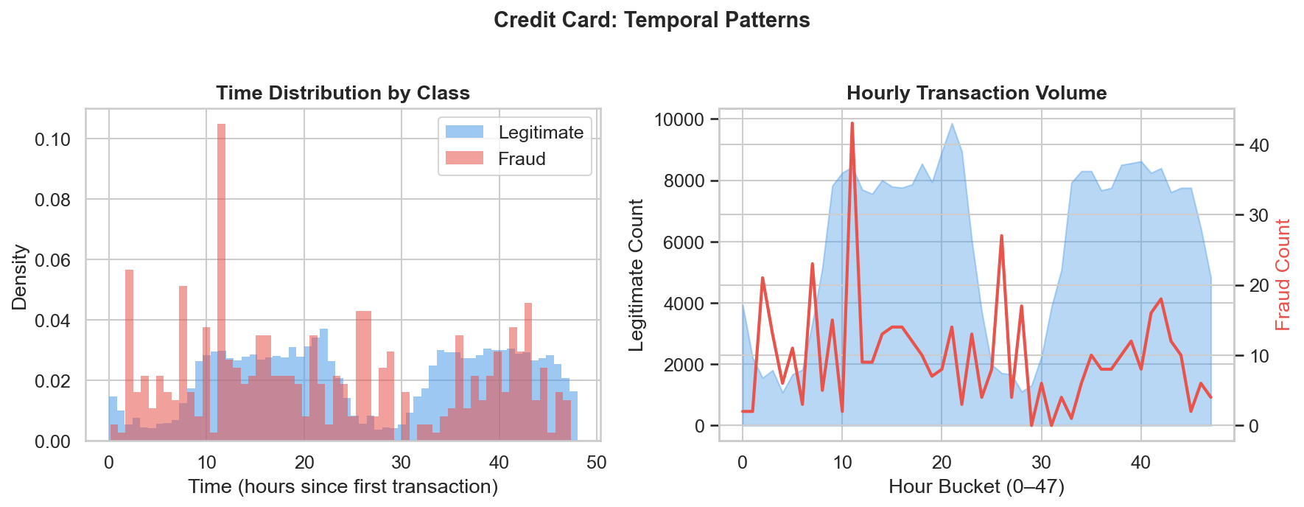
Figure 8 — Left: Time distributions are similar for both classes, suggesting fraud is not concentrated in specific hours in this dataset. Right: hourly volume overlay.

6.5 PCA Feature Correlation with Fraud
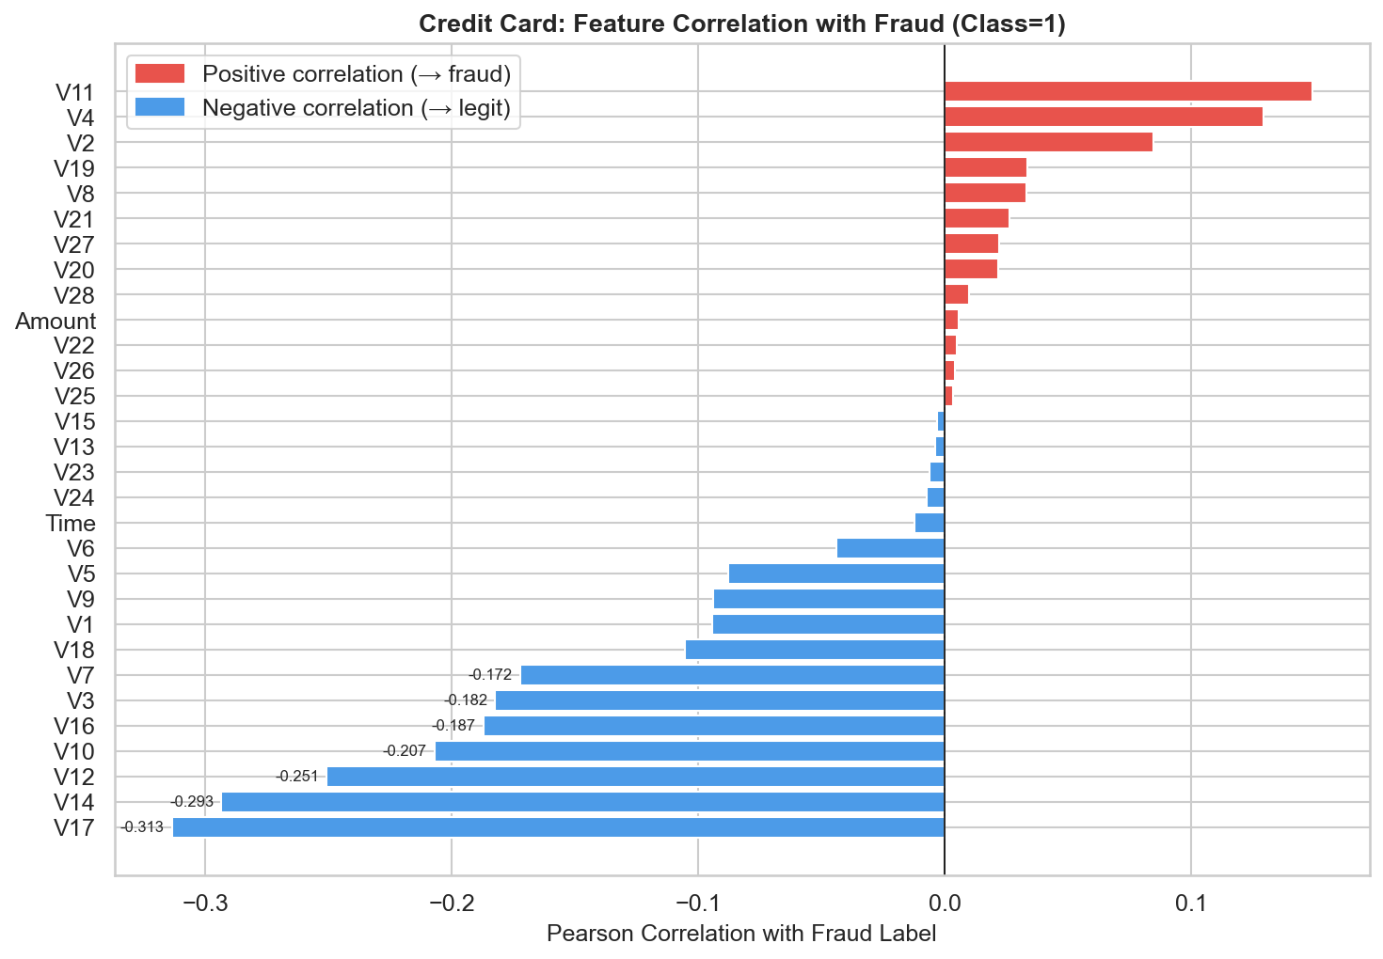
Figure 9 — Pearson correlations of all features with the fraud label. V17, V14, V12, V10 carry the strongest signal and are expected to dominate model feature importance.

Feature | |Pearson r| | Direction | Priority
V17 | 0.3135 | Positive → fraud | ★★★ Highest
V14 | 0.2934 | Negative → fraud | ★★★ Highest
V12 | 0.2507 | Negative → fraud | ★★★ High
V10 | 0.2070 | Negative → fraud | ★★ High
V16 | 0.1872 | Negative → fraud | ★★ Moderate
V3 | 0.1823 | Negative → fraud | ★★ Moderate
V7 | 0.1723 | Negative → fraud | ★ Moderate

6.6 Data Transformation Summary
Step | Action | Rationale
1. Deduplication | Drop 1,081 duplicate rows | Prevents training bias from repeated samples
2. Scaling Amount | StandardScaler → zero mean, unit var | Amount is on a very different scale to V features
3. Scaling Time | StandardScaler → zero mean, unit var | Time range (0–172,792s) dwarfs PCA features
4. V1–V28 | No scaling applied | Already PCA-transformed and normalized
5. No encoding | No categorical columns present | All features are numeric post-PCA

7. Preprocessing Pipeline — Both Datasets

7.1 The Golden Rule: Split Before Resampling
Applying SMOTE before the train/test split causes data leakage: synthetic minority samples appear in both training and test sets, making performance metrics artificially optimistic. Our strict rule: stratified 80/20 split first — test set is never touched by any resampling.

7.2 Why SMOTE?
Method | Mechanism | Weakness | Our Choice
Random Oversampling | Duplicate minority rows | Overfitting on exact copies | ✗
Random Undersampling | Remove majority rows | Discards real legitimate data | ✗
SMOTE | Interpolate new synthetic rows | Slightly slower at scale | ✓

7.3 SMOTE Results
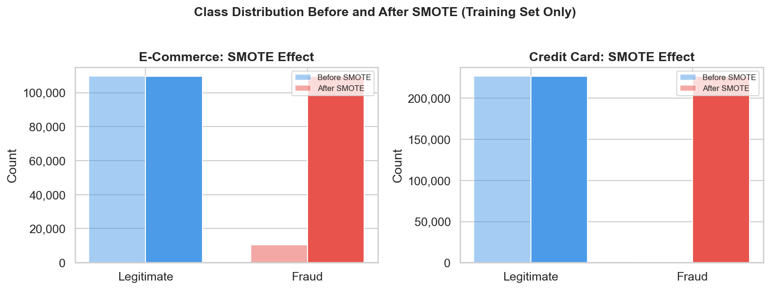
Figure 10 — Before and after SMOTE on training splits. Both datasets reach a balanced 1:1 ratio. The test sets are left untouched.

Dataset | Before SMOTE (train) | After SMOTE (train) | Test Set
E-commerce | 0: 109,568 / 1: 10,304 | 0: 109,568 / 1: 109,568 | Untouched (stratified split)
Credit card | 0: 226,602 / 1: 374 | 0: 226,602 / 1: 226,602 | Untouched (stratified split)

8. Summary of Key Findings
Finding 1 — The 1-Hour Rule (E-Commerce)
Transactions placed within 1 hour of account creation are fraudulent 99.52% of the time. Actionable immediately as a rule-based trigger requiring no model.

Finding 2 — Geographic Concentration
Luxembourg (38.9%), Ecuador (26.4%), Tunisia (26.3%), Peru (26.1%), Bolivia (24.5%) show fraud rates 2.6–4.2× the global average.

Finding 3 — Direct Traffic Anomaly
Direct-channel users commit fraud at 10.54% vs 8.93% for SEO users — consistent with automated bot traffic bypassing referral attribution.

Finding 4 — Card-Testing Signature (Credit Card)
Fraud median amount ($9.82) is far below legitimate median ($22.00), while fraud mean exceeds legitimate mean. This is the fingerprint of card-testing behavior.

Finding 5 — PCA Feature Hierarchy (Credit Card)
V17, V14, V12, V10 are the dominant fraud signals. SHAP analysis in Phase 3 will decode their behavioral interpretation.

9. Next Steps — Interim 2 & Final Submission
With clean, feature-engineered, balanced datasets in place, the pipeline moves to model building. Two key principles govern Phase 2: separate pipelines for each dataset, and evaluation metrics designed for imbalanced data.

9.1 Separate Modeling Pipelines
The e-commerce and credit card datasets have fundamentally different feature structures, imbalance ratios, and fraud mechanisms. They must be trained, tuned, and evaluated independently — a shared pipeline would mask the unique characteristics of each.
 | E-Commerce Pipeline | Credit Card Pipeline
Features | 194 (after OHE + engineering) | 30 (V1–V28, Amount, Time)
Fraud rate | 9.36% | 0.17%
SMOTE ratio | 1:1 balanced | 1:1 balanced
Primary signal | time_since_signup, country | V17, V14, V12
Baseline model | Logistic Regression | Logistic Regression
Ensemble model | XGBoost or LightGBM | XGBoost or LightGBM

9.2 Hyperparameter Tuning Strategy
We will perform systematic hyperparameter tuning on the ensemble models using RandomizedSearchCV (for efficiency on large datasets). The search space covers:
Parameter | Search Range | Why It Matters
n_estimators | 100 – 1,000 | More trees reduce variance; diminishing returns after ~500
max_depth | 3 – 10 | Controls overfitting; shallow trees generalize better on imbalanced data
learning_rate | 0.01 – 0.3 | Lower rates + more trees often outperform high-rate configurations
min_child_weight | 1 – 10 | Prevents splits on tiny fraud-minority nodes
scale_pos_weight | 1 – 600 | XGBoost's built-in class weight parameter — critical for 600:1 imbalance
subsample | 0.6 – 1.0 | Row sampling per tree — reduces overfitting on synthetic SMOTE samples
colsample_bytree | 0.6 – 1.0 | Feature sampling per tree — improves generalization

9.3 Cross-Validation Strategy
We will use Stratified K-Fold cross-validation (k=5) to get reliable, unbiased performance estimates. Standard K-Fold risks putting all fraud cases in one fold; stratification guarantees each fold preserves the class ratio.
CV Setting | Value | Rationale
Method | StratifiedKFold | Preserves fraud class ratio in every fold
k (folds) | 5 | Standard for large datasets; balances bias-variance
Scoring | average_precision | AUC-PR is the correct metric for imbalanced classification
Reported | Mean ± Std Dev | Std Dev flags instability — wide spread = unreliable model
SMOTE | Inside each fold | SMOTE applied only to training portion of each fold via Pipeline

9.4 Evaluation Metrics
Metric | Why It's Used | What Bad Looks Like
AUC-PR | Precision-Recall curve area; best metric for imbalanced classes | < 0.50 = worse than random for fraud
F1-Score | Harmonic mean of precision and recall; penalises both FP and FN | < 0.60 = too many missed fraud cases
Confusion Matrix | Shows absolute TP, FP, TN, FN counts | High FN = fraud slipping through
NOT Accuracy | Misleading — 99.83% achievable by predicting all-legitimate | Any score near 99% is a red flag

9.5 Phase Roadmap
Phase | Task | Key Deliverable
Interim 2 | Logistic Regression baseline | AUC-PR, F1, confusion matrix for both datasets
Interim 2 | XGBoost / LightGBM ensemble | Hyperparameter-tuned results, CV mean ± std
Interim 2 | Model comparison table | Justified selection of best model per dataset
Final | SHAP summary plots | Global feature importance (both datasets)
Final | SHAP force plots — 3 cases each | TP, FP, FN predictions explained individually
Final | Business recommendations | ≥3 actionable insights tied to SHAP findings

────────────────────────────────────────────────────────────────────────────────
GitHub: https://github.com/maedotamha/Fraud-Cases · Built with Python 3.11 · pandas · scikit-learn · imbalanced-learn · matplotlib · seaborn
All Task 1 notebooks are fully executed with outputs. Interim Report 1 · June 2026

