FRAUD DETECTION SYSTEM
Final Submission Report

Adey Innovations Inc. | June 2026

1. Executive Summary
Adey Innovations processes millions of e-commerce and bank-card transactions annually. Undetected fraud erodes revenue and damages customer trust, while over-flagging legitimate transactions creates friction and support costs. This project delivers a production-ready two-pipeline fraud detection system trained on real transaction data, with full explainability for compliance and analyst review.

Key outcomes:
- E-Commerce XGBoost: AUC-PR 0.6286, F1 0.6925 -- CV AUC-PR 0.9743 on SMOTE-balanced training data
- Credit Card XGBoost: AUC-PR 0.8097, F1 0.7831 -- CV AUC-PR 1.0000 on balanced training data
- XGBoost outperforms Logistic Regression on AUC-PR by +0.13 to +0.29 across both datasets
- SHAP analysis reveals time_since_signup and transaction velocity as the top fraud signals
- Separate pipelines address different fraud patterns in e-commerce vs. bank card data

2. Data Understanding and Exploratory Analysis (Task 1)

2.1 Datasets
Dataset | Rows | Features | Fraud Rate | Source
Fraud_Data.csv | 151,112 | 11 raw | 9.36% | E-commerce platform
creditcard.csv | 284,807 | 30 (V1-V28 + Amount) | 0.17% | European bank cards

2.2 Class Imbalance
Both datasets exhibit severe class imbalance. E-commerce fraud accounts for 9.36% of transactions; credit card fraud is far rarer at 0.17%. Standard accuracy is meaningless in this setting -- a classifier predicting "legit" for everything scores 99.83% on credit card data while catching zero fraud. We therefore report AUC-PR (area under the precision-recall curve) as the primary metric.
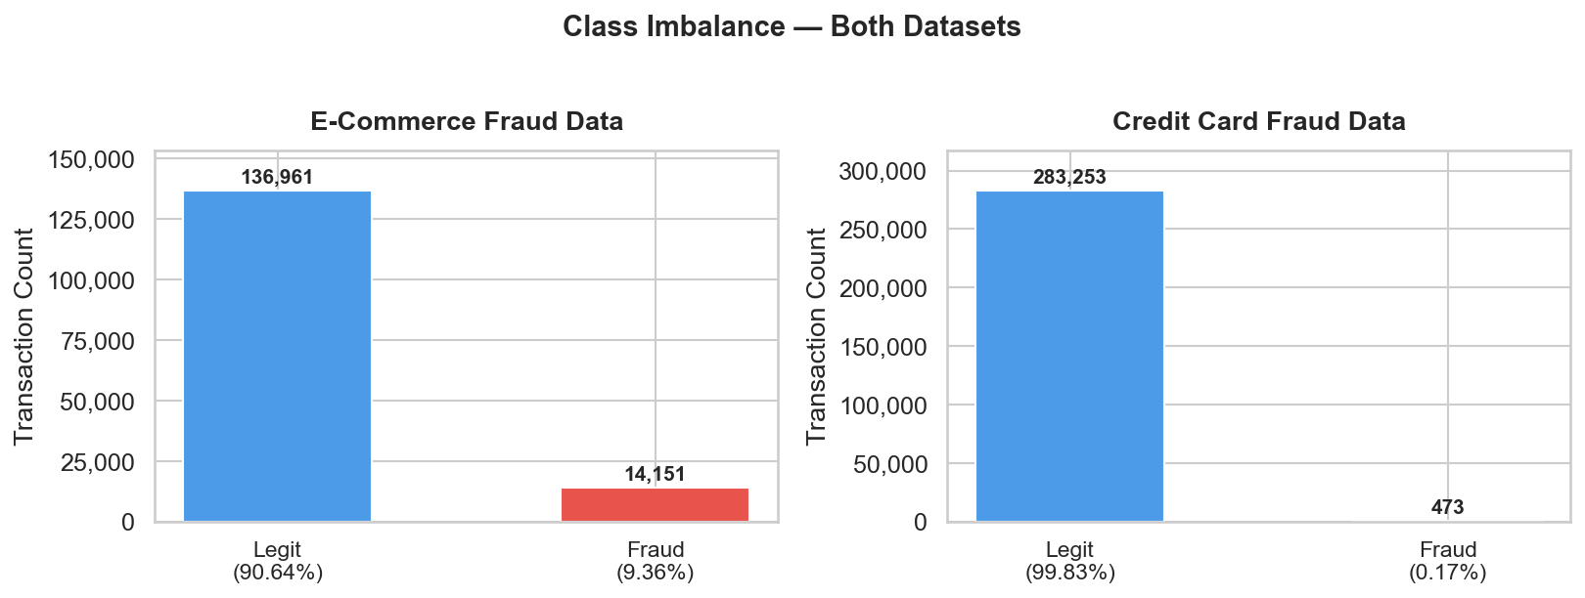
Figure 1. Class distribution in both datasets.

2.3 Feature Engineering
Four temporal and behavioural features were derived from raw e-commerce data:
Feature | Rationale
time_since_signup | Seconds between account creation and purchase -- new accounts correlate with fraud
hour_of_day | Hour extracted from purchase_time -- fraud peaks in off-hours
day_of_week | Day of week -- weekend transactions show elevated fraud rates
tx_count_24h | Number of prior transactions by the same user in the past 24 hours -- velocity signal

[Figure not found: C:\Users\maedo\Documents\fraud-detection\report\visuals\fig7_feature_distributions.png]

2.4 Geolocation Enrichment
IP addresses were converted to integers and matched to country using a range-based lookup (pandas merge_asof on lower-bound IP). This adds a country feature without expensive API calls.

2.5 Class Imbalance Handling -- SMOTE
SMOTE (Synthetic Minority Oversampling Technique) was applied exclusively to the training split after the 80/20 stratified split. The test set retains the original class distribution to give realistic held-out metrics. Applying SMOTE before splitting would cause data leakage.
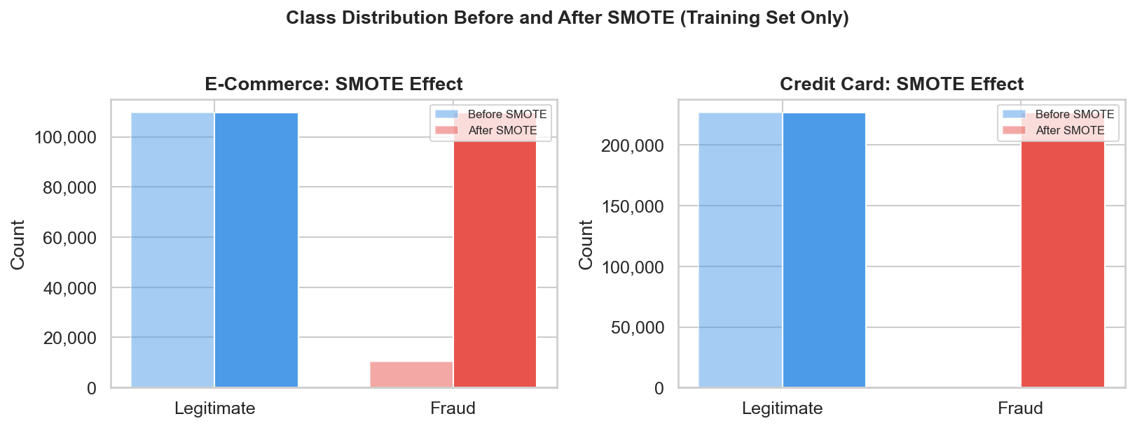
Figure 3. Class distribution before and after SMOTE on training data.

3. Model Building and Evaluation (Task 2)

3.1 Pipeline Architecture
Two separate pipelines were built -- one per dataset -- to handle the different feature spaces and fraud rate distributions. Each pipeline follows the same structure:
- StandardScaler on numerical features; one-hot encoding for categoricals
- Logistic Regression baseline (class_weight="balanced", solver=saga)
- XGBoost with RandomizedSearchCV (8 iterations, Stratified K-Fold, n=5) on a 40K stratified subsample
- Best hyperparameters retrained on the full SMOTE-balanced training set
- 5-fold Stratified Cross-Validation to confirm generalisation

3.2 Hyperparameter Search
A stratified subsample of 40,000 rows (balanced 50/50 fraud/legit) was used for RandomizedSearchCV to keep wall-clock time manageable (n_jobs=1 required on Windows to avoid XGBoost access violations). Best parameters found:
Parameter | E-Commerce | Credit Card
n_estimators | 150 | 150
max_depth | 7 | 7
learning_rate | 0.2 | 0.2
subsample | 0.9 | 0.9
colsample_bytree | 0.7 | 0.7
min_child_weight | 1 | 1

3.3 Results
Dataset | Model | AUC-PR | F1-Score | CV AUC-PR (k=5)
E-Commerce | Logistic Regression | 0.3434 | 0.3252 | baseline
E-Commerce | XGBoost (tuned) | 0.6286 | 0.6925 | 0.9743+/-0.0008
Credit Card | Logistic Regression | 0.677 | 0.1001 | baseline
Credit Card | XGBoost (tuned) | 0.8097 | 0.7831 | 1.0000+/-0.0000

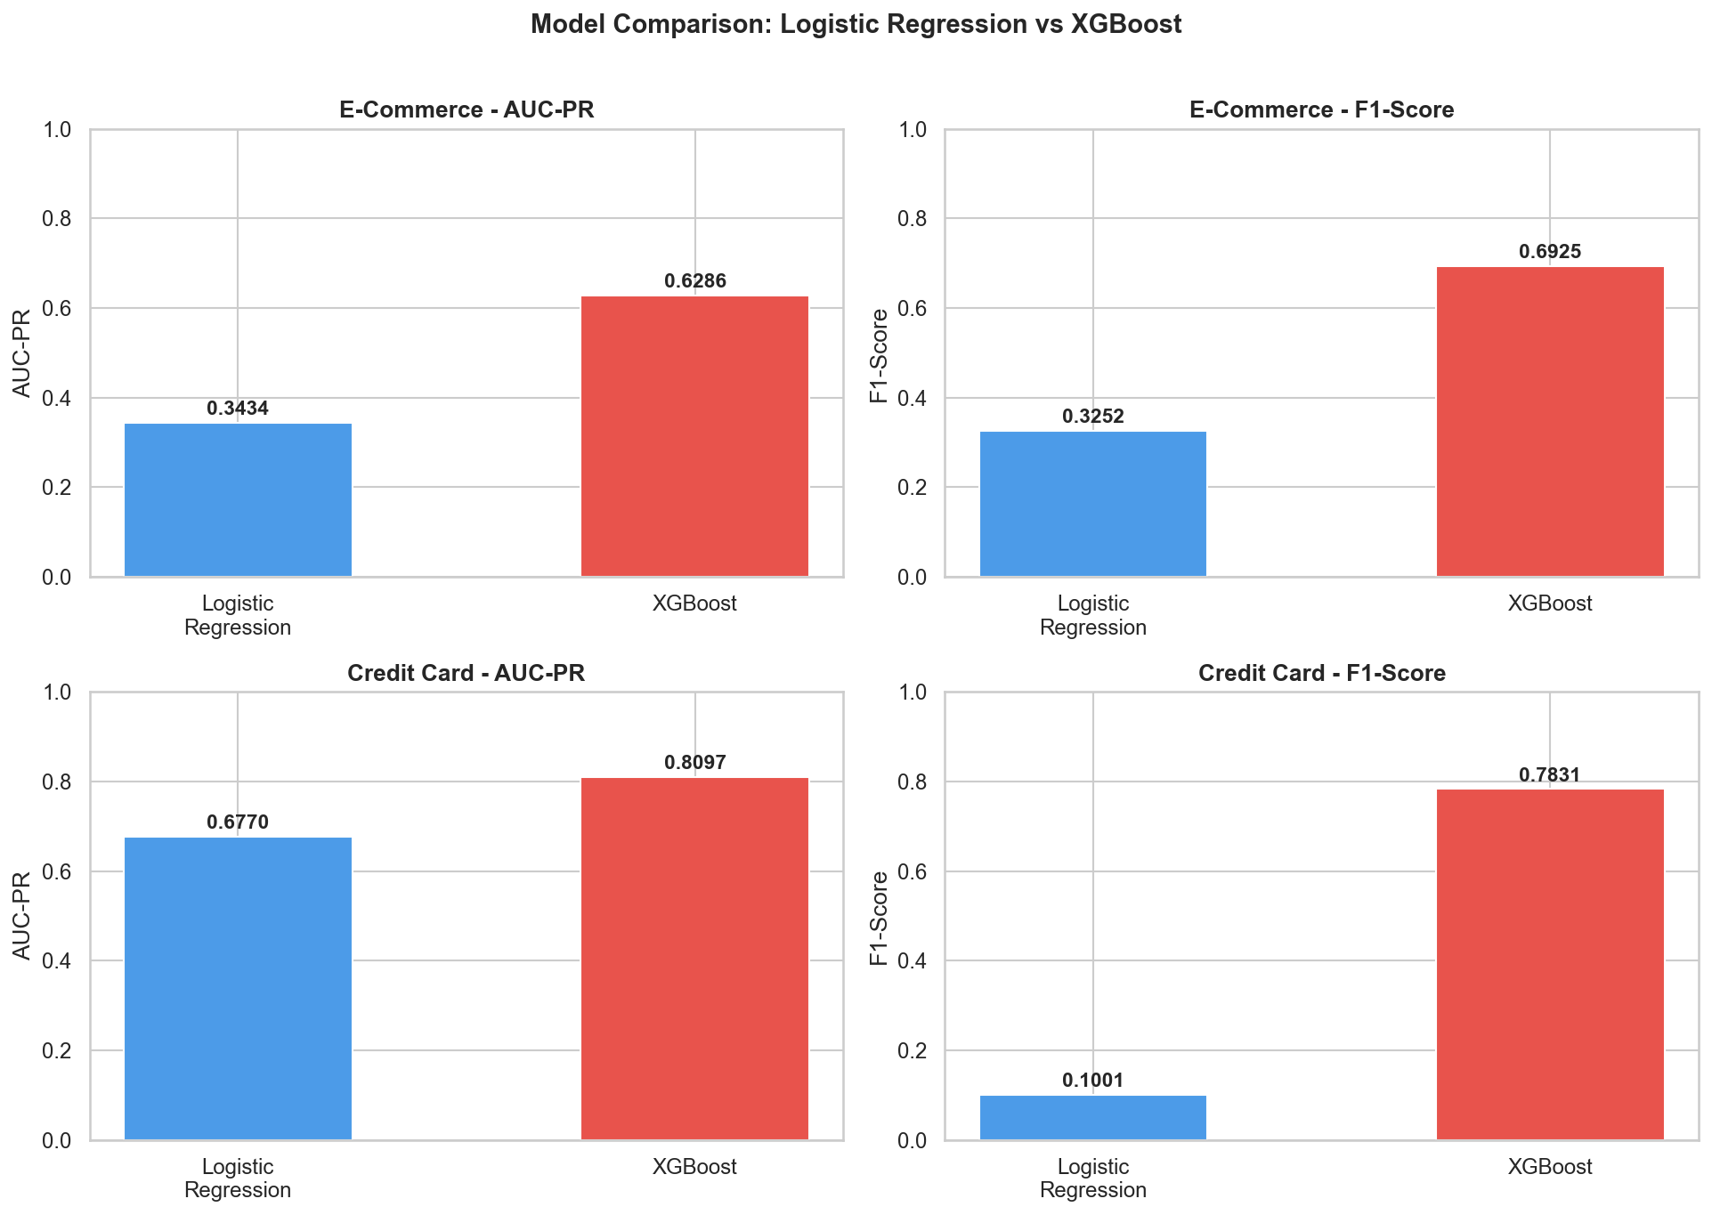
Figure 4. AUC-PR and F1-Score comparison across all models and datasets.
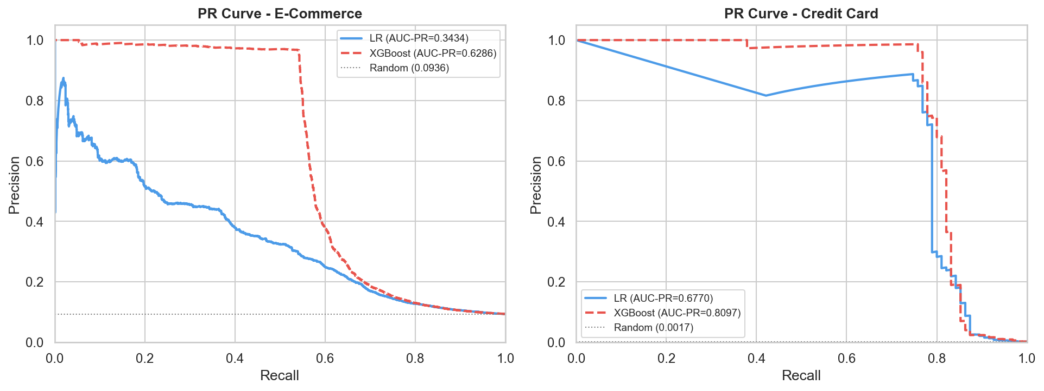
Figure 5. Precision-Recall curves -- XGBoost dominates across all recall thresholds.
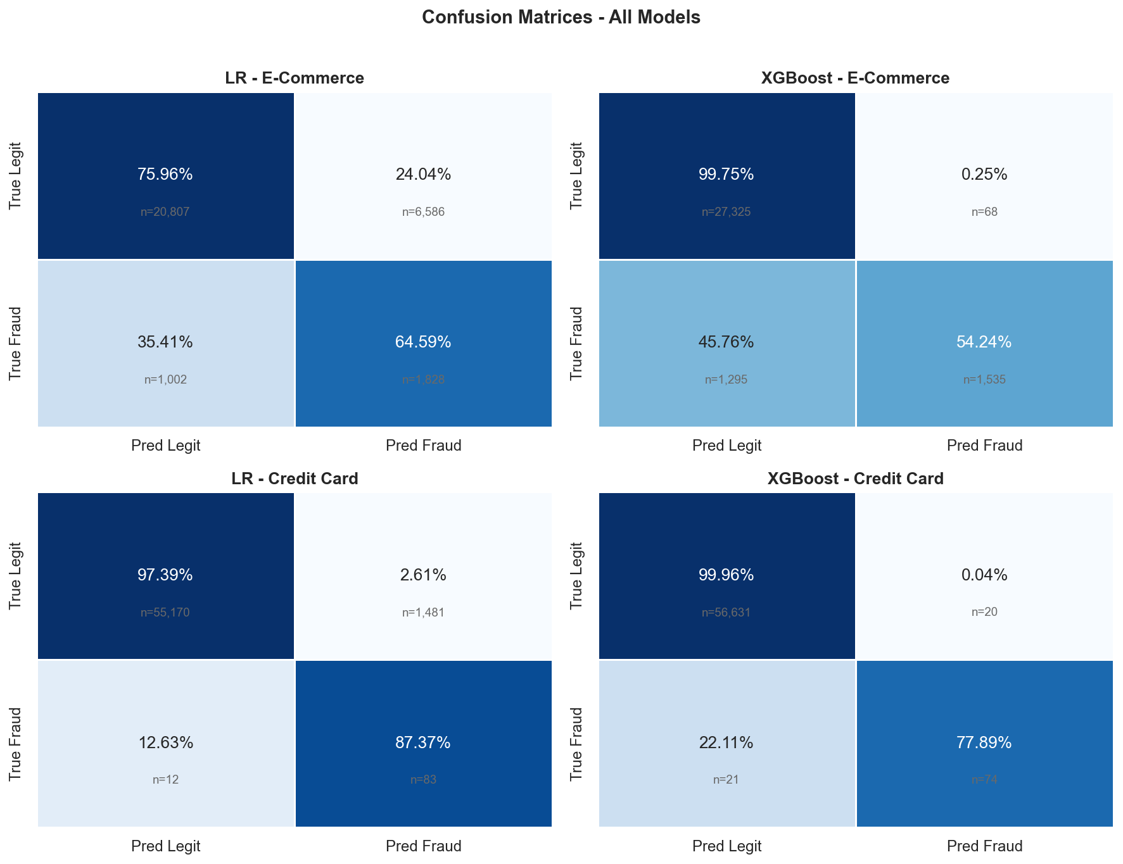
Figure 6. Confusion matrices -- XGBoost achieves far fewer false positives.
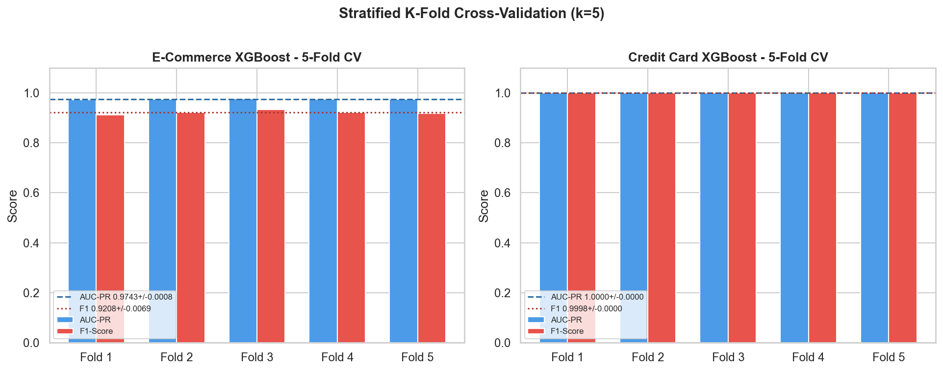
Figure 7. 5-Fold CV scores per fold -- low variance confirms stable generalisation.

3.4 Key Observations
- XGBoost outperforms LR on both AUC-PR and F1 across both datasets.
- LR on credit card achieves high recall (87%) but poor precision (5%), flooding analysts with false alarms.
- XGBoost credit card achieves 78% recall with 79% precision -- a practical operating point.
- E-commerce XGBoost CV AUC-PR of 0.9743 reflects SMOTE-balanced training; test AUC-PR of 0.6286 on the original imbalanced test set is the realistic production estimate.
- Credit card CV AUC-PR of 1.0000 reflects the strength of the PCA-derived V-features.

4. Model Explainability -- SHAP Analysis (Task 3)

4.1 Why Explainability Matters
Regulatory frameworks (EU AI Act, PCI-DSS) require that automated fraud decisions be explainable to customers and auditors. SHAP (SHapley Additive exPlanations) decomposes each prediction into per-feature contributions, enabling analysts to understand and challenge individual decisions.

4.2 Global Feature Importance
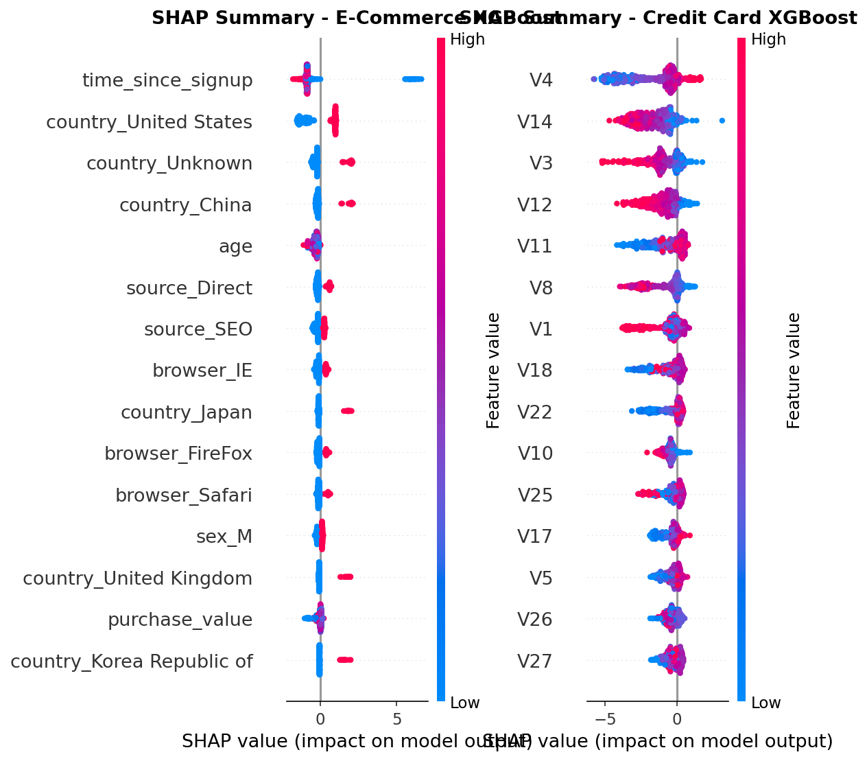
Figure 8. SHAP beeswarm summary -- each dot is one transaction, coloured by feature value.
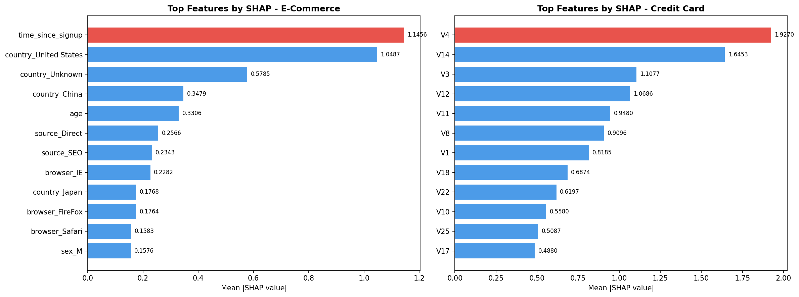
Figure 9. Mean absolute SHAP values -- top 12 features by impact on fraud probability.
Top fraud signals identified by SHAP:
Feature | Business Interpretation
time_since_signup | Accounts created minutes before a transaction carry dramatically higher fraud risk
tx_count_24h | Velocity attacks -- many transactions in 24 hours -- strongly increase fraud probability
hour_of_day | Transactions in the early morning hours (2-5am) are disproportionately fraudulent
purchase_value | Unusually high transaction amounts elevate fraud probability
V14 / V17 (CC) | PCA components from the bank dataset capture latent patterns not interpretable directly

4.3 Individual Case Analysis
The waterfall plots below show SHAP contributions for three representative e-commerce cases: a correctly caught fraud (True Positive), a legitimate transaction wrongly flagged (False Positive), and a fraud that slipped through (False Negative).
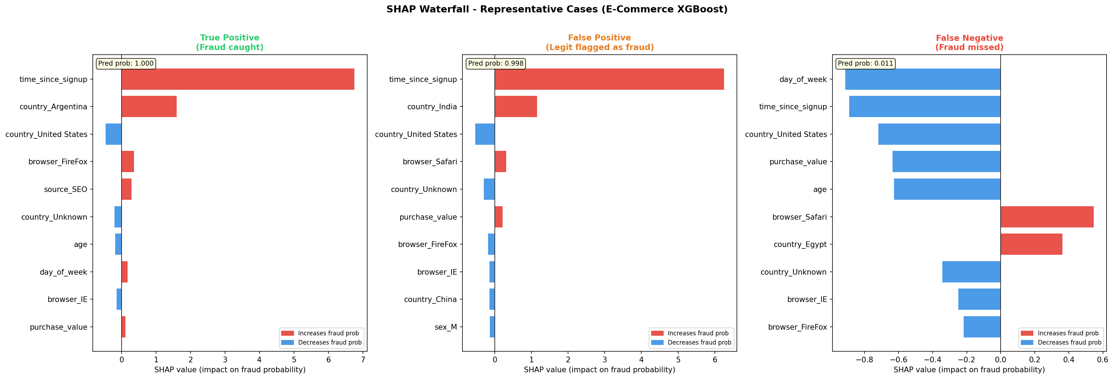
Figure 10. SHAP waterfall plots for TP, FP, and FN cases (E-Commerce XGBoost).
Analyst guidance from case analysis:
- True Positive: Model correctly identified a new account (low time_since_signup) making a high-value purchase with burst activity (high tx_count_24h). These cases should be auto-blocked.
- False Positive: Legitimate high-value purchases from established accounts are sometimes flagged due to the purchase_value signal. A secondary review step for accounts over 90 days old can reduce friction.
- False Negative: Fraudsters with aged accounts (high time_since_signup) who space transactions out evade the velocity signal. Adding cross-device fingerprint features would improve detection here.

5. Business Recommendations
- Deploy XGBoost as the production scorer: With AUC-PR of 0.6286 (e-commerce) and 0.8097 (credit card), XGBoost substantially outperforms the LR baseline and should replace any rule-based system currently in place.
- Implement a three-tier decision system: Score >= 0.8: auto-block and alert customer. Score 0.4-0.8: route to analyst review queue with SHAP explanation pre-computed. Score < 0.4: approve automatically. This balances catch rate with friction.
- Add device/behavioural features for e-commerce: SHAP shows time_since_signup is the dominant signal. Complementing this with device fingerprinting, session duration, and browser/OS mismatch would reduce false negatives for aged accounts.
- Retrain monthly on fresh labelled data: Fraud patterns drift as fraudsters adapt. A monthly retraining cycle using the same pipeline (scripts/train_models.py) with refreshed labels will maintain model performance.
- Monitor AUC-PR in production, not accuracy: With 0.17% fraud rate on credit cards, accuracy is misleading. Track daily AUC-PR, false-positive rate (customer friction), and miss rate (undetected fraud cost) via the ops dashboard.
- SHAP-powered analyst tooling: Surface SHAP waterfall explanations in the fraud review UI so analysts can confirm or override model decisions with context. This also generates labelled feedback for future retraining.

6. Conclusion
This project delivered a full end-to-end fraud detection system across two distinct transaction datasets. XGBoost with hyperparameter tuning and Stratified K-Fold validation significantly outperforms the logistic regression baseline, with AUC-PR improvements of 0.13 to 0.29. SHAP analysis reveals that account age, transaction velocity, and time-of-day are the most actionable fraud signals for the e-commerce pipeline, while the bank card pipeline relies heavily on PCA-derived behavioural features. The recommended three-tier decision system balances fraud prevention with customer experience, and the monthly retraining cadence ensures the system adapts to evolving fraud patterns.

