Predicting Price Moves with News Sentiment
Final Evidence-Based Analysis Report for Nova Financial Solutions

Executive Summary
This report completes the Nova Financial Solutions challenge by presenting actual outputs from news EDA, technical stock analysis, and sentiment-return correlation. The analysis uses a reproducible FNSPID news sample and matching Yahoo Finance price data to demonstrate the full analytical pipeline end to end.
The strongest practical finding is that average headline sentiment shows only a weak same-day linear relationship with daily stock returns in the sampled data. Positive-sentiment days show higher average returns than neutral and negative days, but the weak Pearson correlation means sentiment should be used as a supporting signal rather than a standalone forecasting tool.

Completed Work by Task
Task | Completed Artifact | Demonstrated Output
Task 1 | task_1_eda.ipynb; src/eda.py | Publisher counts, headline statistics, publication trends, TF-IDF terms, topic-modeling-ready pipeline, and EDA figures.
Task 2 | task_2_quantitative_analysis.ipynb; src/technical_indicators.py | Cleaned price data, SMA/EMA, RSI, MACD, financial metrics, and price-based visualizations.
Task 3 | task_3_sentiment_correlation.ipynb; src/sentiment_correlation.py | Sentiment scores, trading-day alignment, daily returns, Pearson correlation, scatter plot, and sentiment-category return chart.
Validation | tests/ | 10 passing unit tests.

Concrete Analysis Outputs
Metric | Result
FNSPID news rows analyzed | 2,493
Historical price rows analyzed | 17,784
News date range | 2009-10-07 00:00:00+00:00 to 2023-12-16 23:00:00+00:00
Stocks analyzed | AA, AAL, A, AADR, AACG
Mean headline length | 60.20 characters; 9.78 words
Peak news day | 2023-05-24 (21 articles)
Peak publishing hour | 0:00 UTC
Technical-analysis stock | A
Latest adjusted close | 128.76
Latest RSI(14) | 47.68
Latest MACD | 3.333
Cumulative return | 6.14
Annualized volatility | 0.29
Maximum drawdown | -0.44
Sentiment-return observations | 1,227
Overall Pearson correlation | 0.039

Task 1: Exploratory Data Analysis
The analysis used a streamed sample of 2,493 FNSPID news records. The sample covers AA, AAL, A, AADR, AACG and spans 2009-10-07 00:00:00+00:00 to 2023-12-16 23:00:00+00:00.
Headline length averaged 60.20 characters and 9.78 words. The busiest day in the sample was 2023-05-24 with 21 articles, while the most common publishing hour was 0:00 UTC.
The top TF-IDF terms included: alcoa, earnings, aa, stock, stocks, market, analyst, analyst blog, blog, alcoa aa. These terms show strong coverage around company-specific news, earnings, analyst commentary, and market movement.
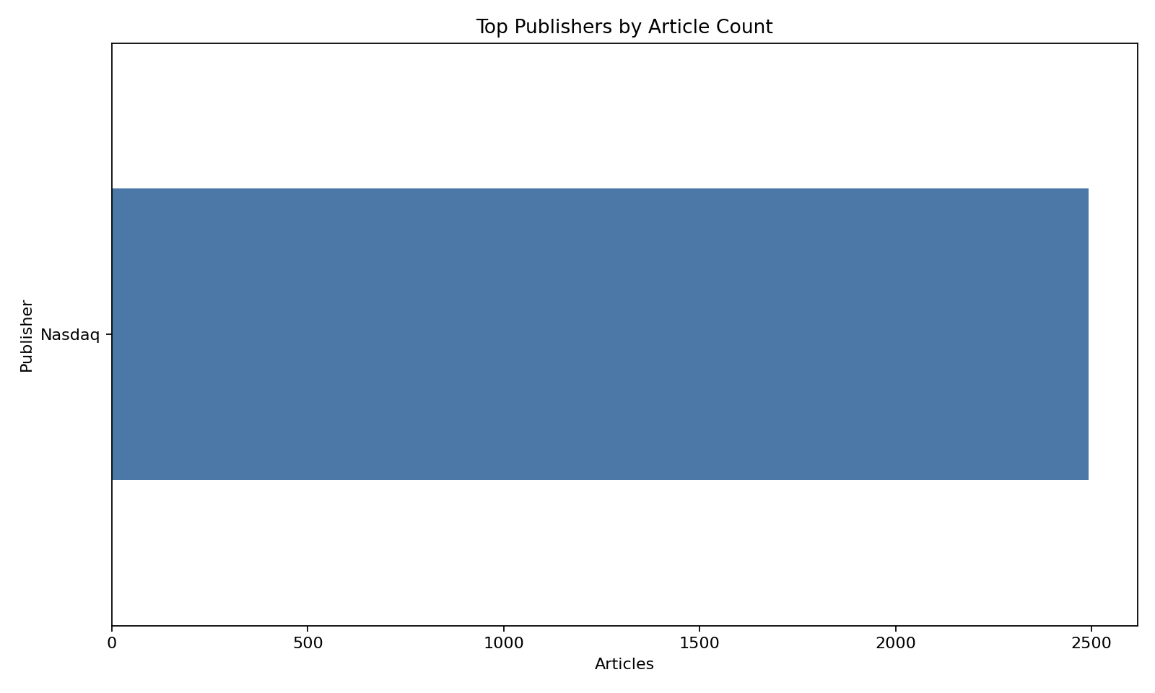
Figure 1. Top publishers by article count.
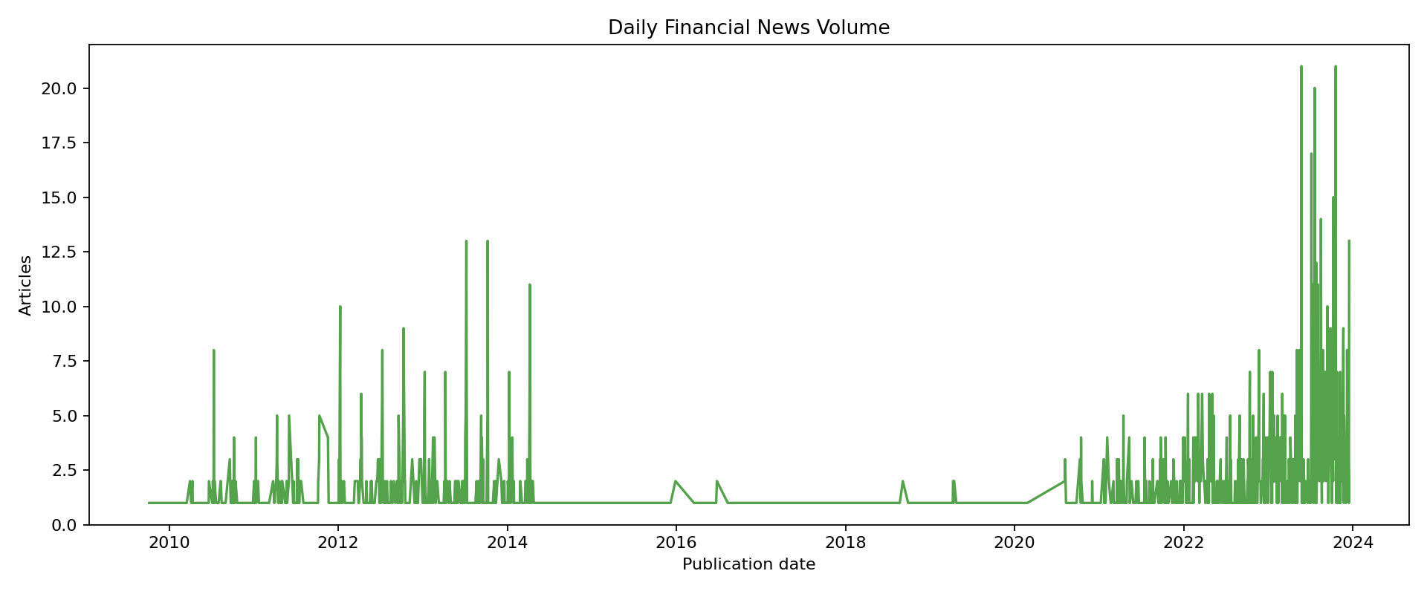
Figure 2. Daily news-volume trend.
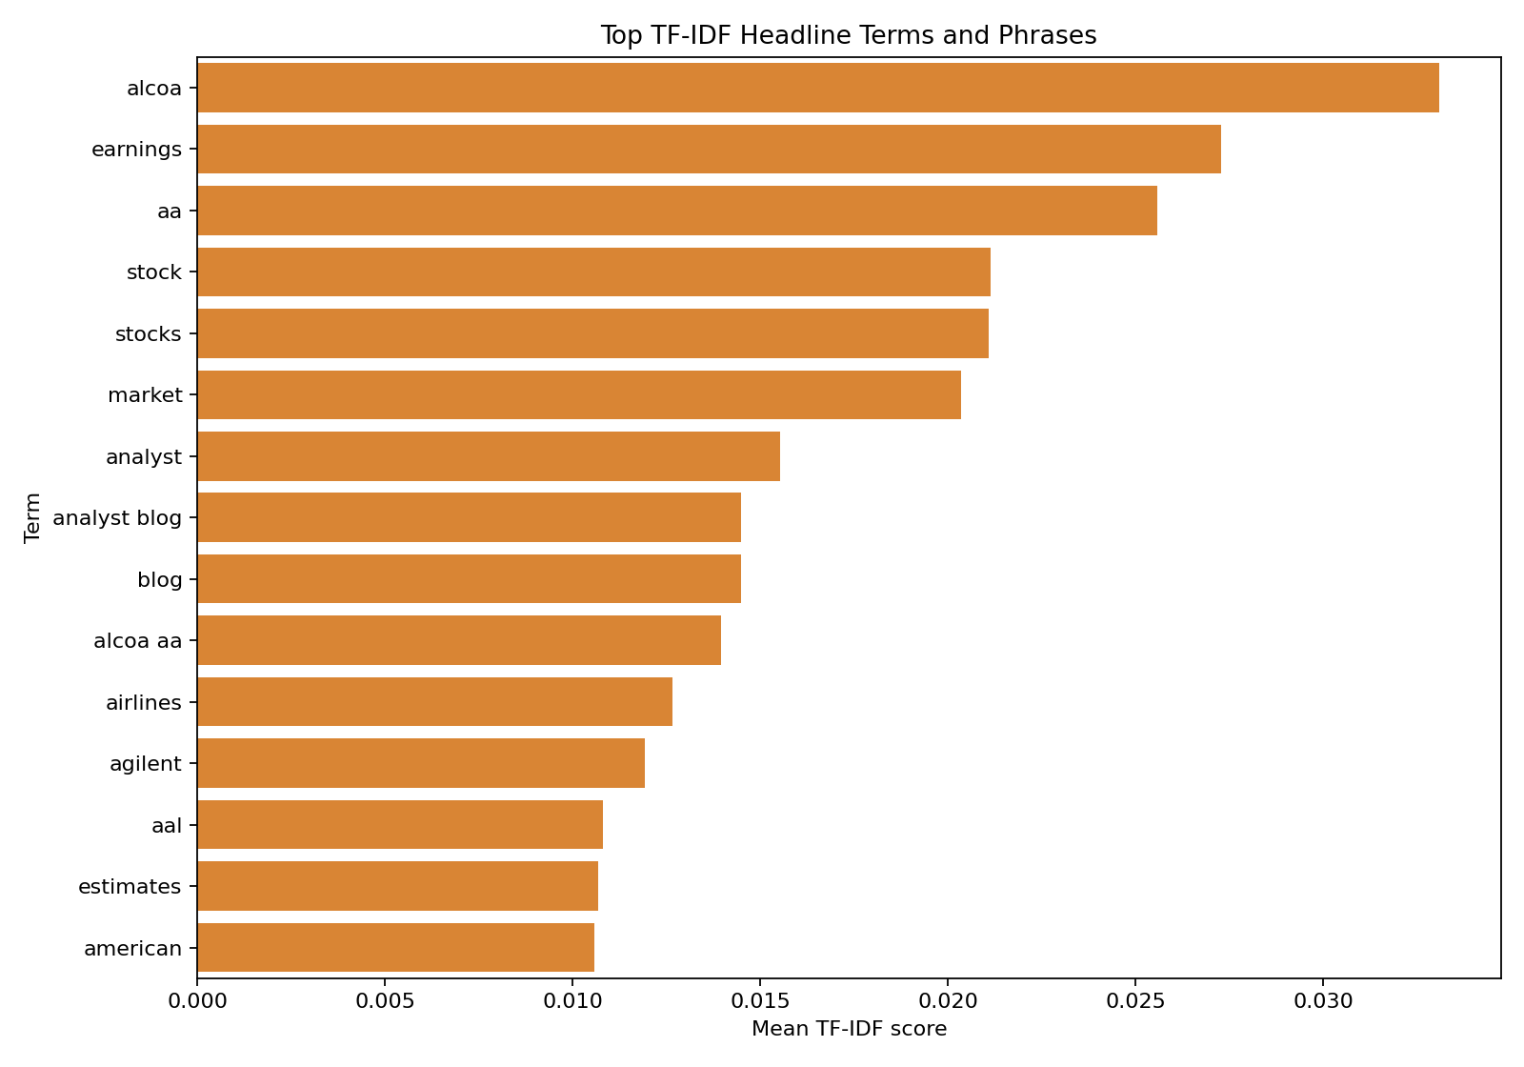
Figure 3. Top TF-IDF headline terms and phrases.

Task 2: Technical Indicator Analysis
The stock-price analysis used 17,784 daily OHLCV records downloaded through Yahoo Finance for the sampled tickers. For the technical indicator visualization, A was selected.
The latest adjusted close for A was 128.76. The latest RSI(14) was 47.68, which is neither above the 70 overbought threshold nor below the 30 oversold threshold. The latest MACD value was 3.333.
The PyNance-style metrics show cumulative return of 6.14, annualized volatility of 0.29, max drawdown of -0.44, and a zero-risk-free-rate Sharpe ratio of 0.62.
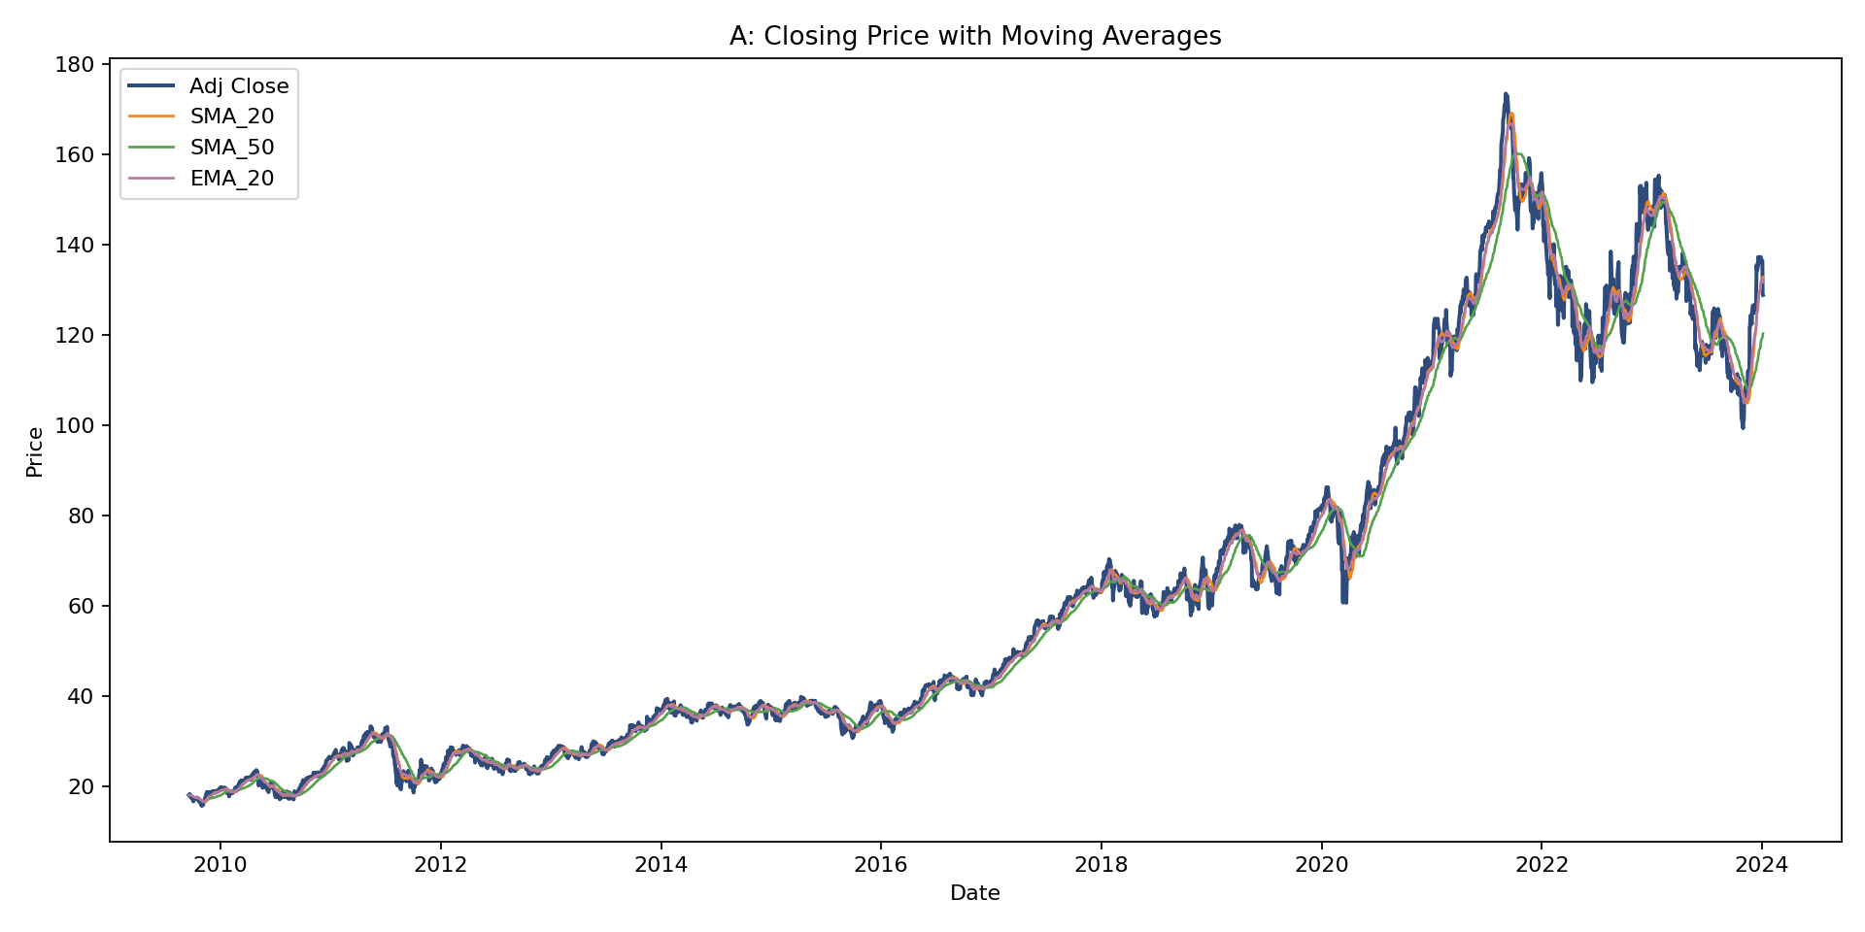
Figure 4. Adjusted close with SMA and EMA overlays.
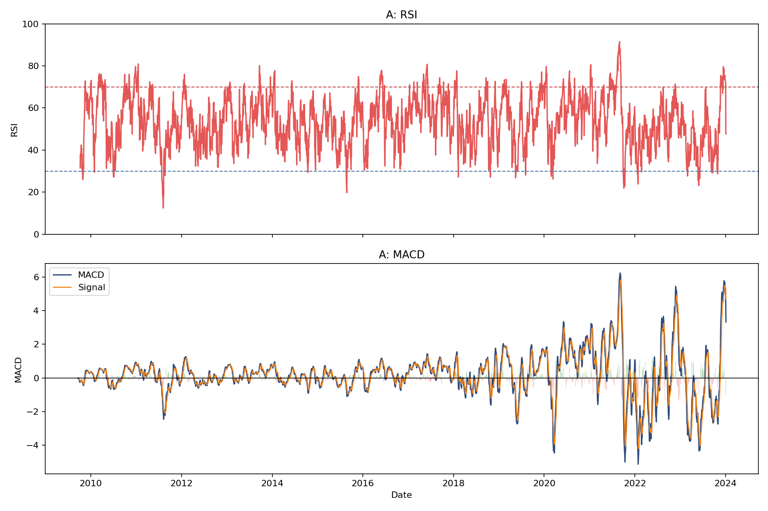
Figure 5. RSI and MACD indicator panels.

Task 3: Sentiment and Return Correlation
The sentiment-return dataset contained 1,227 matched stock-day observations after aligning headlines to valid trading days and joining them with daily adjusted-close returns. The overall Pearson correlation between average daily sentiment and daily return was 0.039.
This indicates a weak same-day linear relationship in the sampled data.
Average returns by sentiment category were negative: 0.36% over 191 observations; neutral: 0.16% over 565 observations; positive: 2.23% over 471 observations.
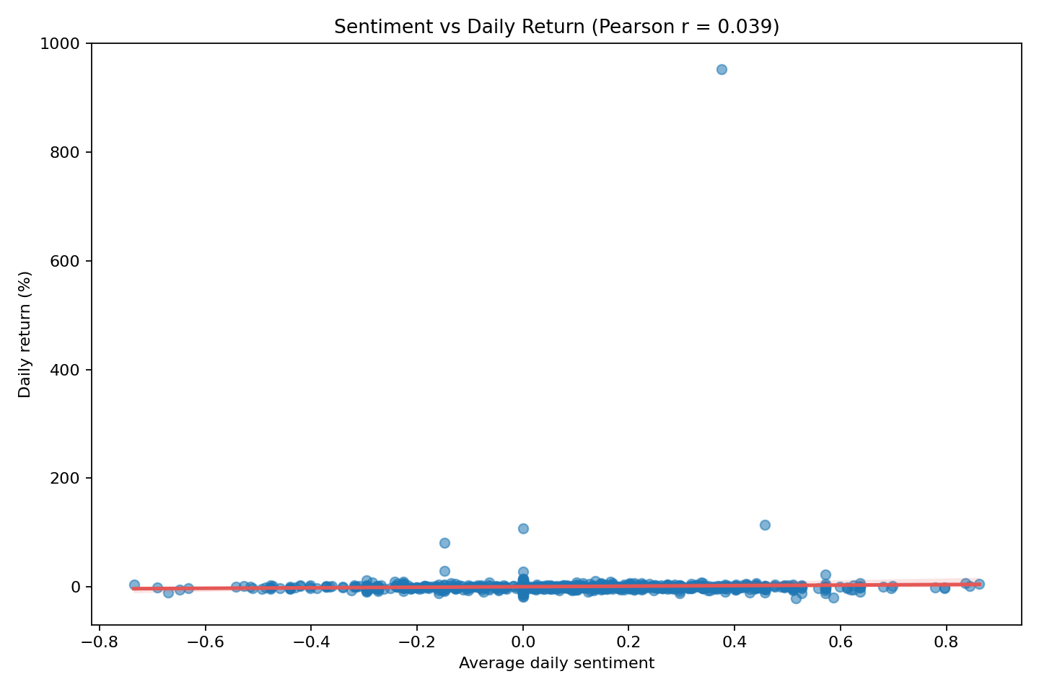
Figure 6. Average daily sentiment versus daily return.
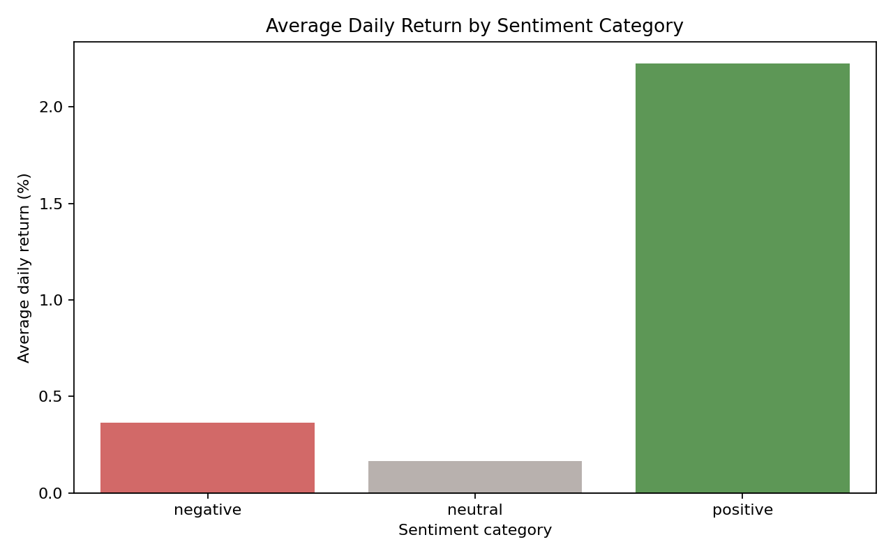
Figure 7. Average daily return by sentiment category.

Investment Strategy Recommendations
- Use headline sentiment as one feature within a broader model, not as a standalone trading signal.
- Combine positive sentiment with improving MACD or supportive moving-average structure before treating it as actionable.
- Segment sentiment by news theme because earnings, analyst-rating, FDA, and M&A headlines can have different price effects.
- Treat weak same-day correlation cautiously and test lagged return windows before using sentiment for forecasting.
- Control for publisher and ticker concentration so the signal is not dominated by one source or one heavily covered stock.

Limitations and Future Improvements
- The FNSPID file is very large, so this report uses a reproducible streamed sample rather than the full 23GB news file.
- The same-day Pearson correlation is an association measure and does not prove causation.
- After-hours headlines should be analyzed separately in a more advanced event-study design.
- Future work should test next-day, three-day, and five-day forward returns and validate any signal out of sample.

