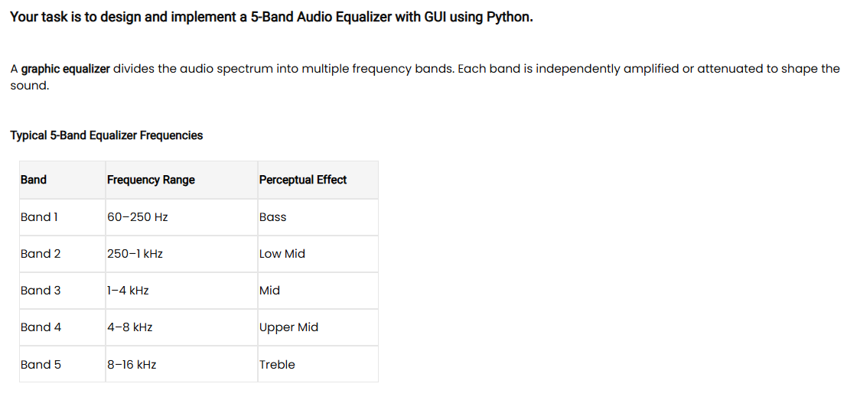
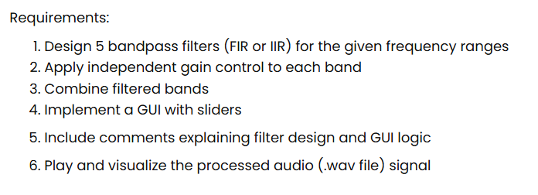
Name: Maeryl Faith P. Bobadilla CYS: CPE31 Date: May 5, 2026

F5-Band DSP Equalizer Sliders

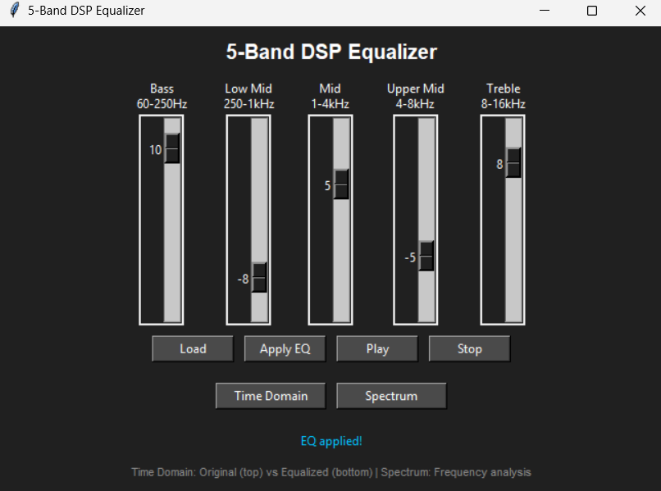

Time Domain Comparison of Original vs Equalized Audio
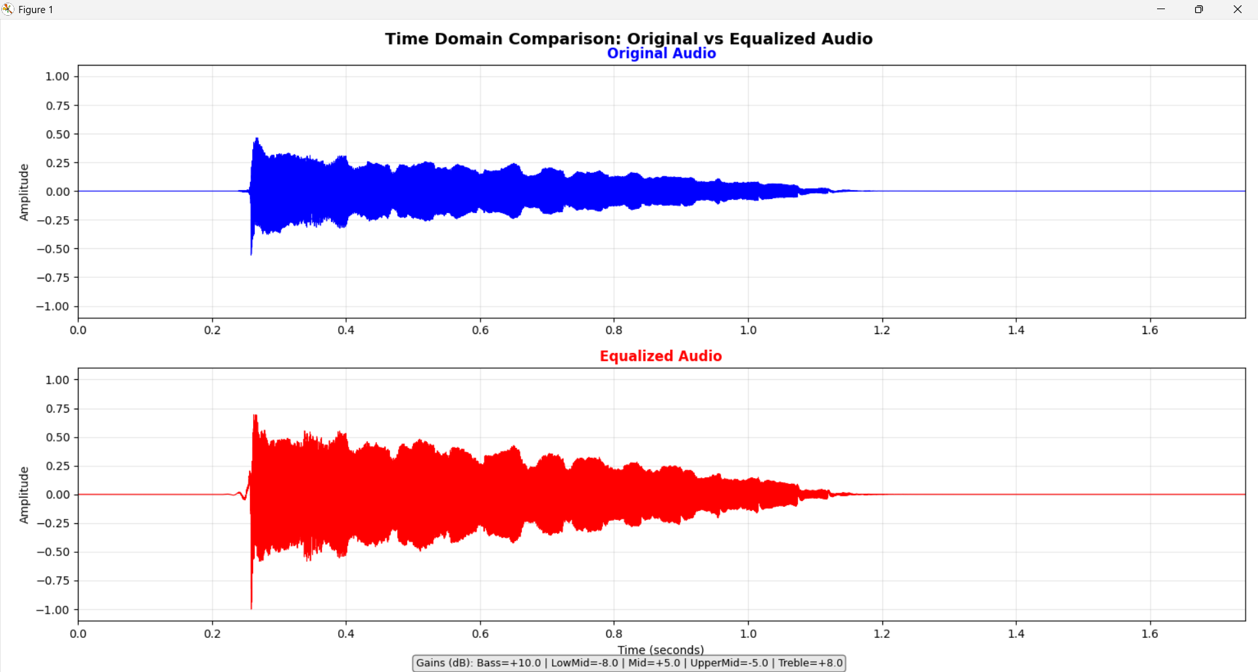
Frequency Domain Comparison of Original vs Equalized Audio
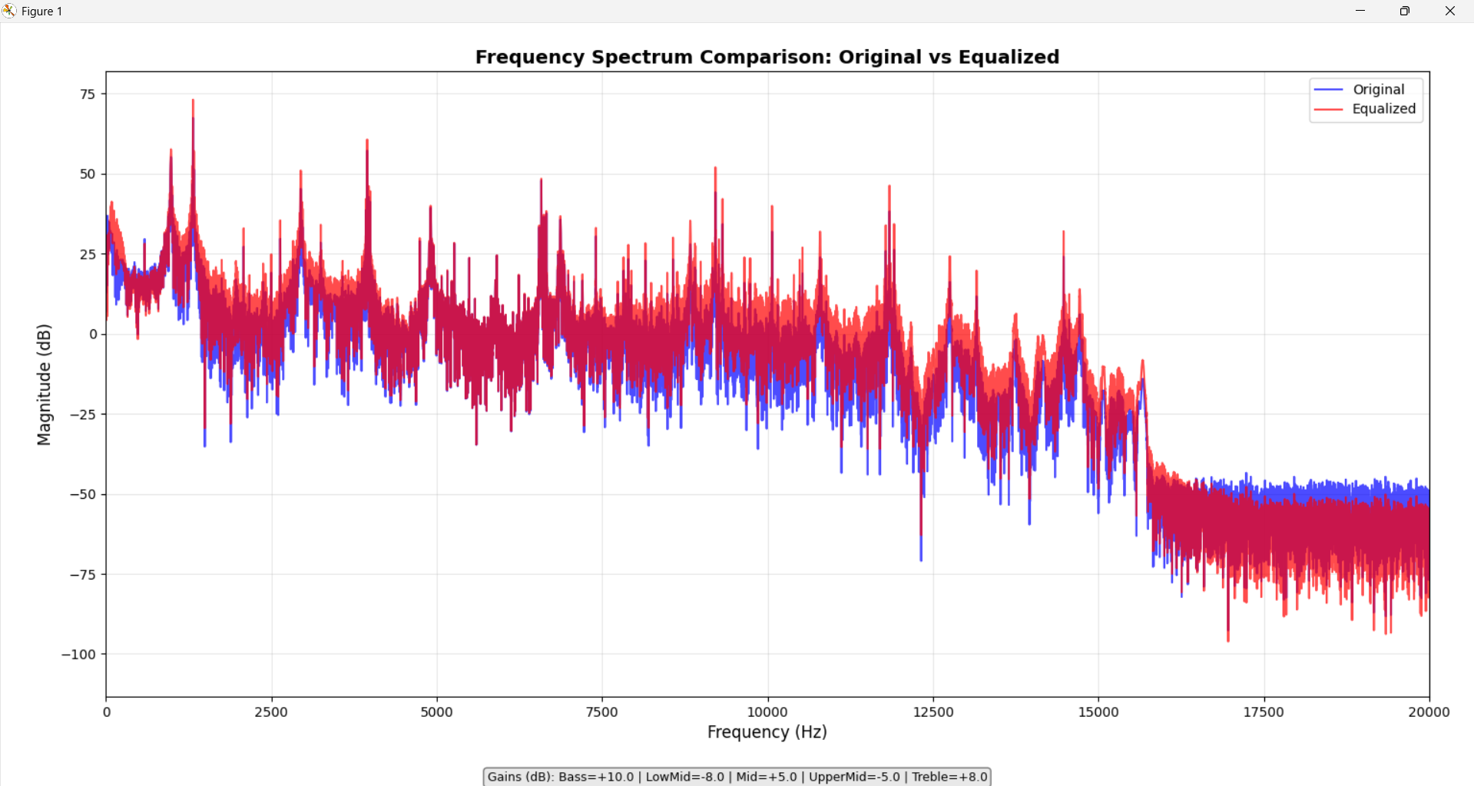

CODE:
import numpy as np
import matplotlib
matplotlib.use("TkAgg")
import matplotlib.pyplot as plt
plt.ion()
import sounddevice as sd
import soundfile as sf
import tkinter as tk
from tkinter import filedialog
from scipy.signal import butter, filtfilt

# -----------------------------
# BANDPASS FILTER
# -----------------------------
def bandpass_filter(data, lowcut, highcut, fs, order=4):
nyquist = fs / 2
highcut = min(highcut, nyquist - 1)
lowcut = max(lowcut, 1)

b, a = butter(order, [lowcut, highcut], btype="band", fs=fs)
return filtfilt(b, a, data)

# -----------------------------
# LOAD AUDIO FILE
# -----------------------------
def load_audio():
global audio, fs, bands, processed_audio, time_axis

file_path = filedialog.askopenfilename(filetypes=[("WAV files", "*.wav")])
if not file_path:
return

audio, fs = sf.read(file_path)

# convert stereo to mono
if audio.ndim > 1:
audio = np.mean(audio, axis=1)

#if no file is loaded
audio = audio.astype(np.float64)
processed_audio = None

# create time axis
time_axis = np.linspace(0, len(audio)/fs, len(audio))

# split into frequency bands
bands = [
bandpass_filter(audio, 60, 250, fs), #bass
bandpass_filter(audio, 250, 1000, fs), #low mid
bandpass_filter(audio, 1000, 4000, fs), #mid
bandpass_filter(audio, 4000, 8000, fs), #upper mid
bandpass_filter(audio, 8000, 16000, fs), #treble
]

status_label.config(text="Audio loaded successfully!")

# -----------------------------
# APPLY EQUALIZER
# -----------------------------
def apply_equalizer():
global processed_audio

if audio is None:
status_label.config(text="Load audio first.")
return

#get slider values
gains = [
bass_slider.get(),
lowmid_slider.get(),
mid_slider.get(),
uppermid_slider.get(),
treble_slider.get(),
]

processed_audio = np.zeros_like(audio, dtype=np.float64)

for i in range(5):
gain = 10 ** (gains[i] / 20)
processed_audio += bands[i] * gain

# mix original + equalizer output (stability)
processed_audio = 0.6 * processed_audio + 0.4 * audio

# normalize safely
peak = np.max(np.abs(processed_audio))
if peak > 1e-12:
processed_audio /= peak

# clamp to prevent sounddevice overflow warning
processed_audio = np.clip(processed_audio, -1.0, 1.0)

status_label.config(text="EQ applied!")

# -----------------------------
# PLAY AUDIO
# -----------------------------
def play_audio():
if processed_audio is None:
status_label.config(text="Apply EQ first.")
return

# convert to float32 for sounddevice stability
sd.play(processed_audio.astype(np.float32), fs)

# -----------------------------
# STOP AUDIO
# -----------------------------
def stop_audio():
sd.stop()

# -----------------------------
# TIME DOMAIN PLOT
# -----------------------------
def plot_time_domain():
"""Show original and equalized audio in separate plots for clear comparison"""
if processed_audio is None:
status_label.config(text="Apply Equalizer first.")
return

if audio is None or time_axis is None:
status_label.config(text="Load audio first.")
return

# Close existing plots to prevent memory issues
plt.close('all')

# Create figure with two stacked subplots
fig, (ax1, ax2) = plt.subplots(2, 1, figsize=(14, 8))

# Show first two seconds or entire audio if shorter
duration = min(2.0, len(audio)/fs)
samples_to_show = int(duration * fs)

time_segment = time_axis[:samples_to_show]
orig_segment = audio[:samples_to_show]
eq_segment = processed_audio[:samples_to_show]

# TOP PLOT: Original audio
ax1.plot(time_segment, orig_segment, color='blue', linewidth=0.8)
ax1.set_title('Original Audio', fontsize=12, fontweight='bold', color='blue')
ax1.set_ylabel('Amplitude', fontsize=10)
ax1.grid(True, alpha=0.3)
ax1.set_xlim(0, duration)
ax1.set_ylim(-1.1, 1.1)

# BOTTOM PLOT: Equalized audio
ax2.plot(time_segment, eq_segment, color='red', linewidth=0.8)
ax2.set_title('Equalized Audio', fontsize=12, fontweight='bold', color='red')
ax2.set_xlabel('Time (seconds)', fontsize=10)
ax2.set_ylabel('Amplitude', fontsize=10)
ax2.grid(True, alpha=0.3)
ax2.set_xlim(0, duration)
ax2.set_ylim(-1.1, 1.1)

fig.suptitle('Time Domain Comparison: Original vs Equalized Audio', fontsize=14, fontweight='bold', y=0.98)
# Add annotation showing gain information at the bottom
gains = [bass_slider.get(), lowmid_slider.get(), mid_slider.get(),
uppermid_slider.get(), treble_slider.get()]
gain_text = f"Gains (dB): Bass={gains[0]:+.1f} | LowMid={gains[1]:+.1f} | Mid={gains[2]:+.1f} | UpperMid={gains[3]:+.1f} | Treble={gains[4]:+.1f}"
plt.figtext(0.5, 0.01, gain_text, wrap=True, horizontalalignment='center', fontsize=9,
bbox=dict(boxstyle="round", facecolor='lightgray', alpha=0.5))

plt.tight_layout()
plt.subplots_adjust(top=0.93, bottom=0.08) # space for title and gain text
plt.show(block=False)
plt.pause(0.1)

# -----------------------------
# SPECTRUM PLOT
# -----------------------------
def plot_spectrum():
if processed_audio is None:
status_label.config(text="Apply EQ first.")
return

if audio is None:
status_label.config(text="Load audio first.")
return

# Close existing plots
plt.close('all')

freqs = np.fft.rfftfreq(len(audio), 1 / fs)

orig_fft = np.abs(np.fft.rfft(audio)) + 1e-10
eq_fft = np.abs(np.fft.rfft(processed_audio)) + 1e-10

orig_db = 20 * np.log10(orig_fft)
eq_db = 20 * np.log10(eq_fft)

plt.figure(figsize=(12, 6))
plt.plot(freqs, orig_db, label="Original", color='blue', alpha=0.7)
plt.plot(freqs, eq_db, label="Equalized", color='red', alpha=0.7)

plt.title('Frequency Spectrum Comparison: Original vs Equalized', fontsize=14, fontweight='bold')
plt.xlabel('Frequency (Hz)', fontsize=12)
plt.ylabel('Magnitude (dB)', fontsize=12)
plt.xlim(0, 20000)

# Add gain text to spectrum plot too
gains = [bass_slider.get(), lowmid_slider.get(), mid_slider.get(),
uppermid_slider.get(), treble_slider.get()]
gain_text = f"Gains (dB): Bass={gains[0]:+.1f} | LowMid={gains[1]:+.1f} | Mid={gains[2]:+.1f} | UpperMid={gains[3]:+.1f} | Treble={gains[4]:+.1f}"
plt.figtext(0.5, 0.01, gain_text, wrap=True, horizontalalignment='center', fontsize=9,
bbox=dict(boxstyle="round", facecolor='lightgray', alpha=0.5))

plt.legend(loc='upper right')
plt.grid(True, alpha=0.3)

plt.tight_layout()
plt.subplots_adjust(bottom=0.12) # Make room for gain text
plt.show(block=False)
plt.pause(0.1)

# -----------------------------
# GUI SETUP
# -----------------------------
audio = None
processed_audio = None
bands = None
fs = None
time_axis = None

root = tk.Tk()
root.title("5-Band DSP Equalizer")
root.geometry("650x550")
root.configure(bg="#202020")

# -----------------------------
# SLIDER CLASS
# -----------------------------
class EQSlider:
def __init__(self, parent, label):
self.frame = tk.Frame(parent, bg="#202020")
self.frame.pack(side="left", padx=15)

tk.Label(self.frame, text=label, fg="white", bg="#202020").pack()

self.scale = tk.Scale(
self.frame,
from_=12,
to=-12,
orient="vertical",
length=200,
bg="#202020",
fg="white"
)
self.scale.set(0)
self.scale.pack()

def get(self):
return self.scale.get()

# -----------------------------
# TITLE
# -----------------------------
tk.Label(
root,
text="5-Band DSP Equalizer",
fg="white",
bg="#202020",
font=("Arial", 15, "bold")
).pack(pady=10)

# -----------------------------
# SLIDERS
# -----------------------------
slider_frame = tk.Frame(root, bg="#202020")
slider_frame.pack()

bass_slider = EQSlider(slider_frame, "Bass\n60-250Hz")
lowmid_slider = EQSlider(slider_frame, "Low Mid\n250-1kHz")
mid_slider = EQSlider(slider_frame, "Mid\n1-4kHz")
uppermid_slider = EQSlider(slider_frame, "Upper Mid\n4-8kHz")
treble_slider = EQSlider(slider_frame, "Treble\n8-16kHz")

# -----------------------------
# BUTTONS - ROW 1 (Audio Control)
# -----------------------------
btn_frame1 = tk.Frame(root, bg="#202020")
btn_frame1.pack(pady=10)

tk.Button(btn_frame1, text="Load", command=load_audio, width=10, bg="#4a4a4a", fg="white").grid(row=0, column=0, padx=5)
tk.Button(btn_frame1, text="Apply EQ", command=apply_equalizer, width=10, bg="#4a4a4a", fg="white").grid(row=0, column=1, padx=5)
tk.Button(btn_frame1, text="Play", command=play_audio, width=10, bg="#4a4a4a", fg="white").grid(row=0, column=2, padx=5)
tk.Button(btn_frame1, text="Stop", command=stop_audio, width=10, bg="#4a4a4a", fg="white").grid(row=0, column=3, padx=5)

# -----------------------------
# BUTTONS - ROW 2 (Plots)
# -----------------------------
btn_frame2 = tk.Frame(root, bg="#202020")
btn_frame2.pack(pady=10)

tk.Button(btn_frame2, text="Time Domain", command=plot_time_domain, width=14, bg="#4a4a4a", fg="white").grid(row=0, column=0, padx=5)
tk.Button(btn_frame2, text="Spectrum", command=plot_spectrum, width=14, bg="#4a4a4a", fg="white").grid(row=0, column=1, padx=5)

# -----------------------------
# STATUS LABELS
# -----------------------------
status_label = tk.Label(
root,
text="Load a WAV file to begin.",
fg="#00bfff",
bg="#202020"
)
status_label.pack(pady=10)

info_label = tk.Label(
root,
text="Time Domain: Original (top) vs Equalized (bottom) | Spectrum: Frequency analysis",
fg="#888888",
bg="#202020",
font=("Arial", 8)
)
info_label.pack()

# -----------------------------
# CLEANUP ON CLOSE
# -----------------------------
def on_closing():
plt.close('all')
sd.stop()
root.destroy()

root.protocol("WM_DELETE_WINDOW", on_closing)

root.mainloop()

