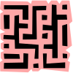
Gamemaker Challenge
The Amazing Maze!
(2 Points) Add four sprites to your game – a pacman, a wall, a star, and an ice cream cone. You can find these in the pacman folder. Add a happy sound to your game. Add four objects to your game – a pacman, a wall, a star, and an ice cream cone object. Check the solid box for each. Add a room to your game. Add instances of the wall object to form a maze. Add a few stars for pacman to find. Place pacman at his starting location. Place the ice cream cone so that it marks the end of the maze.
(3 Points) Add events and actions so that the four arrow keys move pacman through the maze.
(3 Points) Make the stars disappear and a fun sound play when pacman collides with them. When pacman collides with the ice cream cone which marks the end of the maze, play a fun sound and make pacman stop moving.
(3 Points) Add an evil ghost to the maze at a starting location of your choice. Have him move vertically or horizontally (not both) in the maze, bouncing off the walls. If the evil ghost and pacman collide, play a sad sound and jump pacman back to his starting position.
(3 Points) Make pacman use the pacman_right sprite when moving to the right, the pacman_left sprite when moving to the left, and so on for all four directions. (Hint – there is a change sprite action you can use for this.)
(3 Points) Add a collision event so that if pacman collides with a wall, he stops moving instead of going through it!

(3 Points) Add a new special object to the maze for pacman to find. You may want to use a sprite from another folder for this. Make it jump out of sight after approximately 30 seconds and then jump back 30 seconds later, and do this repeatedly. If pacman collides with this object, play a happy sound and make the special object disappear for good.
Gamemaker Tips

Adding Sprites – use the Add Sprite menu option at the top. Click the Load Sprite button and select an image. Type in a name for the sprite.

Adding Sounds - use the Add Sound menu option at the top. Click the Load Sound button and select a sound. Type in a name for the sprite. Press the play button to hear the sound.

Adding Objects – use the Add Object menu option at the top. Type in a name and pick an appropriate sprite for the object. Click the solid check box if the object should be solid.

Adding Rooms – use the Add Room menu option at the top. Add objects to the room by left clicking. Hold down the shift key and left click and drag to add many objects fast.

Adding Events and Associated Actions – On the left, double click on the Objects folder and then double click on an object. Click on the Add Event button and select an event. Then from the right click and drag actions that you want performed when the selected event occurs. Some useful events and actions are shown below.

Events
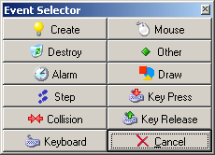
Occurs whenever the object collides with another

Occurs whenever a key on the keyboard is pressed

Occurs when the object is created (usually the start of the game)

Occurs when an alarm goes off. Set an alarm to go off using an action.

Actions
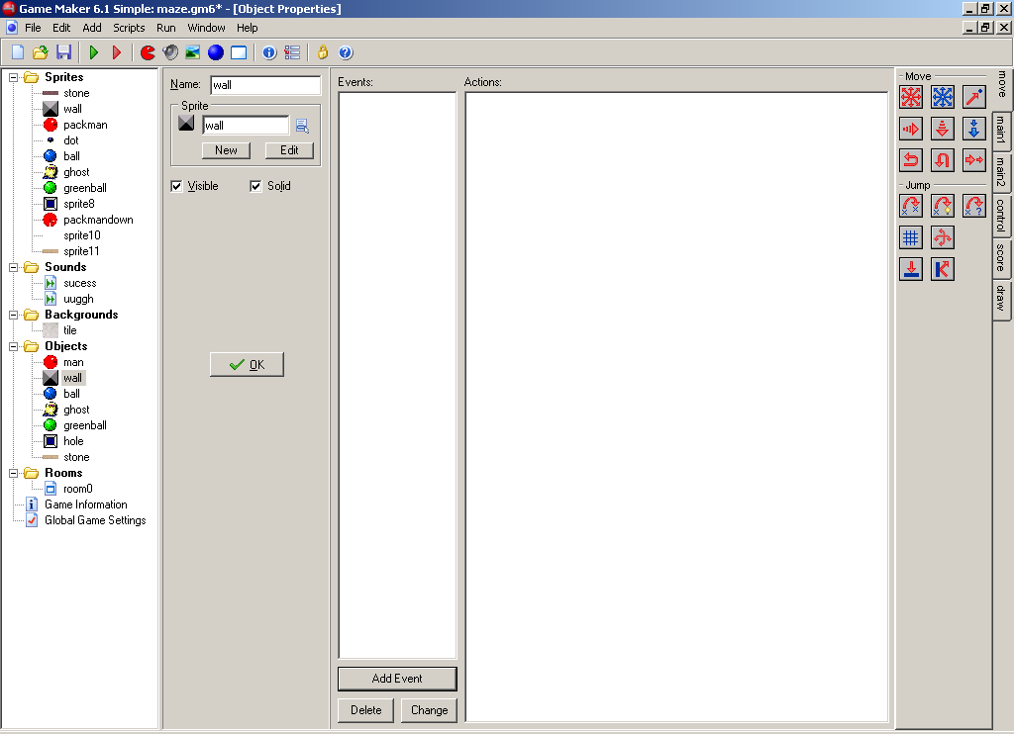
Moves the object in the selected direction. Be sure to set a speed. Select the middle square if you want the object to stop and set speed to zero. Want the object to move in a random direction? Then select all 8 directions.

Jumps the object to a particular location. Want the object to disappear? Then jump it to coordinates that are off the board, such as (-100, -100).

Plays a sound

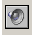

Most importantly -- have fun and enjoy the programming!

Want to do more with Game Maker? It’s available free at www.gamemaker.nl.

