2024 Physics Hackathon Welcome Session:

JavaScript:

For this workshop we’ll use [OneCompiler](https://onecompiler.com/javascript) to execute JavaScript code.

A template html file can be found [here](https://drive.google.com/file/d/1MXHt_yydsImKPDVXW693MRMw3Ds1TdJC/view?usp=sharing).

Example JavaScript can be found [here](https://drive.google.com/file/d/1997RjxBT5Gxc5o7dFe8BkBhpLOtADd4P/view?usp=sharing).

Python

For this workshop we’ll be using Google Colab to run our Python code. You’ll need a gmail account.

Python Documents:

* [Introduction to Python Notebook](https://colab.research.google.com/drive/1_9HM_WfPnCeiUGF3zUwD0xsW9poTmDHw?usp=sharing) [[Solution](https://colab.research.google.com/drive/1_d19uCQZaqO_xRFqLDU7iIXe_RDOjGsT?usp=sharing)]
* Example code: [Calculating Pi using Monte-Carlo Simulation](https://colab.research.google.com/drive/1Wmqghcjb_Bagh39MKbt78ApT76DFsisJ?usp=sharing) [[Solution](https://colab.research.google.com/drive/1MVE1svsW_F9NJT5_99_ZC3cAnMBIlRGV?usp=drive_link)]
* Example code : [N-Body Simulation](https://colab.research.google.com/drive/1vJPXAOfNGdD8uA_FfSigLyX_LDOQKKvY?usp=sharing) [[Solution](https://colab.research.google.com/drive/1_d19uCQZaqO_xRFqLDU7iIXe_RDOjGsT?usp=sharing)]

To make a copy of the code to work on first open a link and then go File-> Save a copy in Drive:

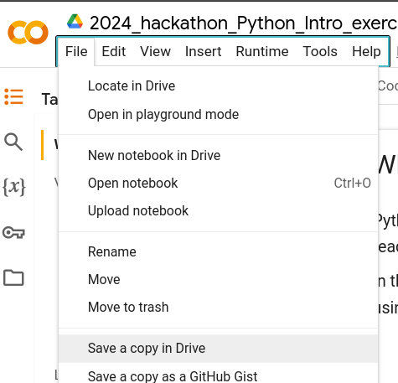

Useful links:

* [Visual Studio Code](https://code.visualstudio.com/) - Our favourite [IDE](https://aws.amazon.com/what-is/ide/)
* [Switch Statements in JavaScript](https://www.w3schools.com/js/js_switch.asp)
* [Javascript Cheatsheet](https://htmlcheatsheet.com/js/)