Exercise 2// Java Control Statements

Ma. Elaiza D. Ilagan



Answer:

X = x + 1;

X +=1;

X++;

++x;

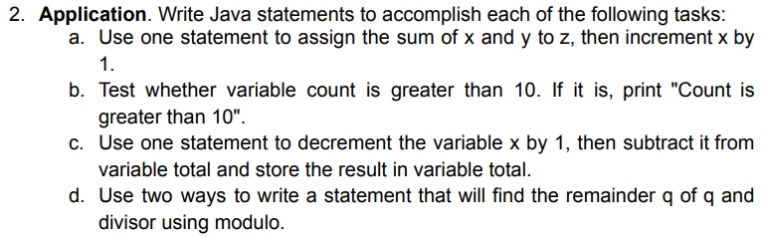

Answer:

1. z = x+y;

x++;

1. if (count > 10) {

system.out.println(“Count is greater than 10”);

}

1. total -= --x;
2. 1st q=q%divisor;

2nd q%=divisor;

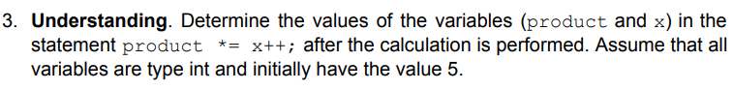

Answer :   
product = 5*5

Product = 25

X = 6

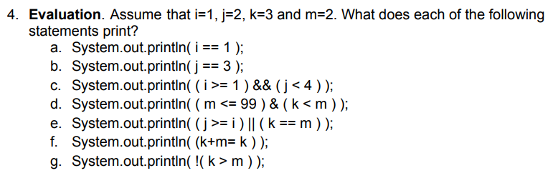

1. Output: true
2. Output: false
3. Output: true
4. Output: false
5. Output: true
6. Output: false
7. Output: true

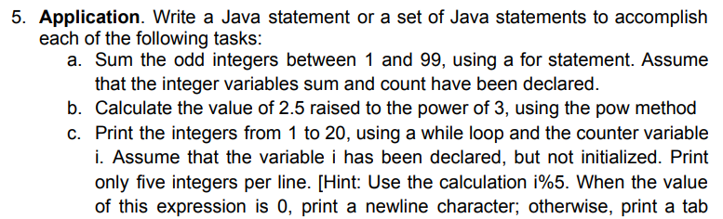

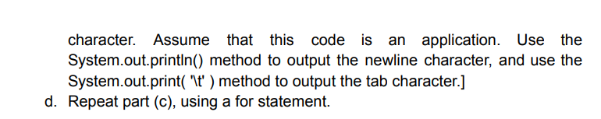

Answer:

1. Int sum = 0;

for (int i =1; i<=99; I += 2) {

sum += I;

}

1. Double result = Math.pow(2.5,3)
2. int i = 1;

while (i <= 20) {

System.out.println(i);

i++;

}

1. for (int i = 1; I <=20, i++); {

system.out.println(i);

}

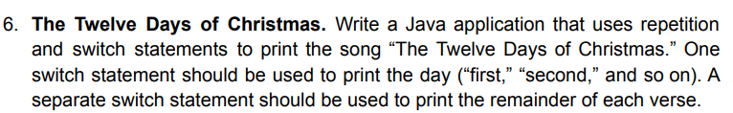

**public** **class** ilagan_exercise2 {

**public** **static** **void** main(String[] args) {

**for** (**int** day = 1; day <= 12; day ++)

{

//System.out.println("On the");

System.***out***.println();

**switch**(day){

**case** 1: System.***out***.print("On the First");

**break**;

**case** 2: System.***out***.print("On the Second");

**break**;

**case** 3: System.***out***.print("On the Third");

**break**;

**case** 4: System.***out***.print("On the Fourth");

**break**;

**case** 5: System.***out***.print("On the Fifth");

**break**;

**case** 6: System.***out***.print("On the Sixth");

**break**;

**case** 7: System.***out***.print("On the Seventh");

**break**;

**case** 8: System.***out***.print("On the Eighth");

**break**;

**case** 9: System.***out***.print("On the Ninth");

**break**;

**case** 10: System.***out***.print("On the Tenth");

**break**;

**case** 11: System.***out***.print("On the Eleventh");

**break**;

**case** 12: System.***out***.print("On the Twelfth");

**break**;

}

System.***out***.println(" day of Christmas, my true love gave to me: ");

**switch** (day){

**case** 12: System.***out***.print("twelve drummers drumming");

**break**;

**case** 11: System.***out***.print("eleven pipers piping");

**break**;

**case** 10: System.***out***.print("ten lords a-leaping");

**break**;

**case** 9: System.***out***.print("nine ladies dancing");

**break**;

**case** 8: System.***out***.print("eight maids a-milking");

**break**;

**case** 7: System.***out***.print("seven swans a-swimming");

**break**;

**case** 6: System.***out***.print("six geese a-laying");

**break**;

**case** 5: System.***out***.print("five gold rings");

**break**;

**case** 4: System.***out***.print("four calling birds");

**break**;

**case** 3: System.***out***.print("Three French hens");

**break**;

**case** 2: System.***out***.print("Two turtle doves");

**break**;

**case** 1: System.***out***.print("And a partridge in a pear tree");

**break**;

}

}

}

}