A template for writing manuscripts in Rmarkdown

Warning: package 'knitcitations' was built under R version 3.3.2

Write your abstract here.

*Keywords*: rmarkdown, reproducible science

# INTRODUCTION

Write your introduction here. You can cite bibliography like this (Yan and Gerstein 2011, Sutherland et al. 2011), if you provide a BibTeX file with references. See <http://rmarkdown.rstudio.com/authoring_bibliographies_and_citations.html> for more information. Or you could also use [knitcitations](https://cran.r-project.org/web/packages/knitcitations/index.html) or [RefManageR](https://cran.r-project.org/web/packages/RefManageR/index.html) to fetch bibliographic metadata automatically from the web. For example, citing a paper can be as easy as providing its DOI (Clark and Gelfand 2006) or even just a few keywords (Ricklefs 2008). They will then automagically appear in the list of cited references.(Yan and Gerstein 2011)

You can even specifiy the desired output format for your bibliography by including a style file for a specific journal (e.g. "ecology.csl"). Many different bibliography styles (CSL files) can be obtained at <http://citationstyles.org/> or <https://github.com/citation-style-language/styles>.

# METHODS

## Study Area

We worked in a **beautiful** place with lots of trees, like *Quercus suber* and *Laurus nobilis*.

## Data collection and analysis

We applied a linear model where

$$y_{i}=α+β*x_{i}$$

We used the statistical language R (R Core Team 2016) for all our analyses. These were implemented in dynamic rmarkdown documents using knitr (Xie 2014, 2015, 2016) and rmarkdown (Allaire et al. 2016) packages. All the multilevel models were fitted with lme4 (Bates et al. 2015).

# RESULTS

Trees in forest A grew taller than those in forest B (mean height: 25 versus 13 m). And many more cool results that get updated dynamically.

# DISCUSSION

Discuss.

# CONCLUSIONS

# ACKNOWLEDGEMENTS

# REFERENCES

Allaire, J., J. Cheng, Y. Xie, J. McPherson, W. Chang, J. Allen, H. Wickham, A. Atkins, and R. Hyndman. 2016. Rmarkdown: Dynamic documents for r.

Bates, D., M. Mächler, B. Bolker, and S. Walker. 2015. Fitting linear mixed-effects models using lme4. Journal of Statistical Software 67:1–48.

Clark, J. S., and A. E. Gelfand. 2006. A future for models and data in environmental science. Trends in Ecology & Evolution 21:375–380.

R Core Team. 2016. R: A language and environment for statistical computing. R Foundation for Statistical Computing, Vienna, Austria.

Ricklefs, R. 2008. Disintegration of the ecological community: American society of naturalists sewall wright award winner address. The American Naturalist 172:741–750.

Sutherland, W. J., D. Goulson, S. G. Potts, and L. V. Dicks. 2011. Quantifying the impact and relevance of scientific research. PLoS ONE 6:e27537.

Xie, Y. 2014. Knitr: A comprehensive tool for reproducible research in R. *in* V. Stodden, F. Leisch, and R. D. Peng, editors. Implementing reproducible computational research. Chapman; Hall/CRC.

Xie, Y. 2015. Dynamic documents with R and knitr. 2nd editions. Chapman; Hall/CRC, Boca Raton, Florida.

Xie, Y. 2016. Knitr: A general-purpose package for dynamic report generation in r.

Yan, K.-K., and M. Gerstein. 2011. The spread of scientific information: Insights from the web usage statistics in pLoS article-level metrics. PLoS ONE 6:e19917.

A glimpse of the famous *Iris* dataset.

|  |  |  |  |  |
| --- | --- | --- | --- | --- |
| Sepal.Length | Sepal.Width | Petal.Length | Petal.Width | Species |
| 5.1 | 3.5 | 1.4 | 0.2 | setosa |
| 4.9 | 3.0 | 1.4 | 0.2 | setosa |
| 4.7 | 3.2 | 1.3 | 0.2 | setosa |
| 4.6 | 3.1 | 1.5 | 0.2 | setosa |
| 5.0 | 3.6 | 1.4 | 0.2 | setosa |
| 5.4 | 3.9 | 1.7 | 0.4 | setosa |

Now a subset of mtcars dataset.

|  |  |  |  |  |  |  |  |  |  |  |  |
| --- | --- | --- | --- | --- | --- | --- | --- | --- | --- | --- | --- |
|  | mpg | cyl | disp | hp | drat | wt | qsec | vs | am | gear | carb |
| Merc 280 | 19.2 | 6 | 167.6 | 123 | 3.92 | 3.440 | 18.30 | 1 | 0 | 4 | 4 |
| Merc 280C | 17.8 | 6 | 167.6 | 123 | 3.92 | 3.440 | 18.90 | 1 | 0 | 4 | 4 |
| Merc 450SE | 16.4 | 8 | 275.8 | 180 | 3.07 | 4.070 | 17.40 | 0 | 0 | 3 | 3 |
| Merc 450SL | 17.3 | 8 | 275.8 | 180 | 3.07 | 3.730 | 17.60 | 0 | 0 | 3 | 3 |
| Merc 450SLC | 15.2 | 8 | 275.8 | 180 | 3.07 | 3.780 | 18.00 | 0 | 0 | 3 | 3 |
| Cadillac Fleetwood | 10.4 | 8 | 472.0 | 205 | 2.93 | 5.250 | 17.98 | 0 | 0 | 3 | 4 |
| Lincoln Continental | 10.4 | 8 | 460.0 | 215 | 3.00 | 5.424 | 17.82 | 0 | 0 | 3 | 4 |

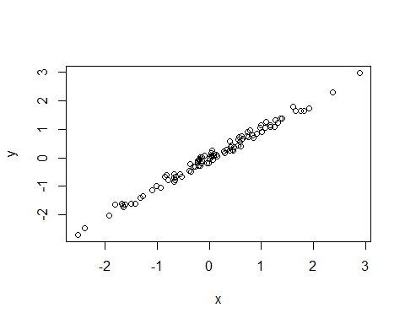

Just my first figure with a very fantastic caption.

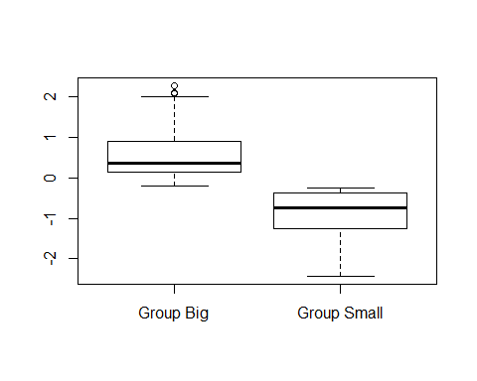

Second figure in landscape format.