How to visualize the potential of harmonization between variables related to cognitive measures: Example with tests related to **memory** in IALSA

**Goal: Create “bridge” items that can connect the different studies in IALSA**

This study is based on a list of memory scales identified by Andrea Piccinin and available in IALSA studies on the MR website. Graphs were generated using the R package sand and igraph.

**Studies are:** ACTIVE, CaPS, CFAS, CLSA, CSHA, DCS_1905, ELSA, HELIAD, HRS, LASA, LBC1936, LBLS, LGP, SydneyMAS, MCSA, MIDUS, CogUSA, OATS, OBAS, OCTO_Twin, PATH, PROSPER, SATSA, SEBAS, SNAC_K, SCS, TILDA, VETSA, WHIMS, WHISCA, WLS.

**Constructs are:**

Benton.Visual.Retention.Test (BVRT),

CERAD.Constructional.Praxis.Recall (CCPR),

CERAD.Word.List.Memory (CWLM),

Delayed.Word.Recall (DWR),

Forward.Digit.Span.Task (FDST),

Hopkins.Verbal.Learning.Test (HVLT),

Immediate.Recall.Word.List (IRWL),

Prose.Recall (PR),

Rivermead.Behavioral.Memory.Test (RBMT),

Rey.Auditory.Verbal.Learning.Test (RAVLT),

Thurstone’s.Picture.Memory.Test (TPMT),

Verbal.Learning.Test (VLT),

WAIS.Digit.Span (WDS),

Wechsler.Memory.Scale.Face.recognition (WMSFR),

Wechsler.Memory.Scale.Letter.number (WMSLN),

Wechsler.Memory.Scale.Logical.memory (WMSLM),

Wechsler.Memory.Scale.Spatial.Span (WMSSS),

Wechsler.Memory.Scale.Visual.reproduction (WMSVR),

Word.Recognition (WR),

Working.Memory.Span (WMS)

**N.B.:** For memory tests, some studies within IALSA could not be linked to other studies. Also, some constructs were utilized by only one study making them useless when linking studies to each other.

In the graph, vertices are defined as studies or constructs. Constructs serve as edges to link the studies. Constructs are displayed in blue, while studies are represented in yellow. Vertex area of each construct is proportional to the number of studies this construct could link.

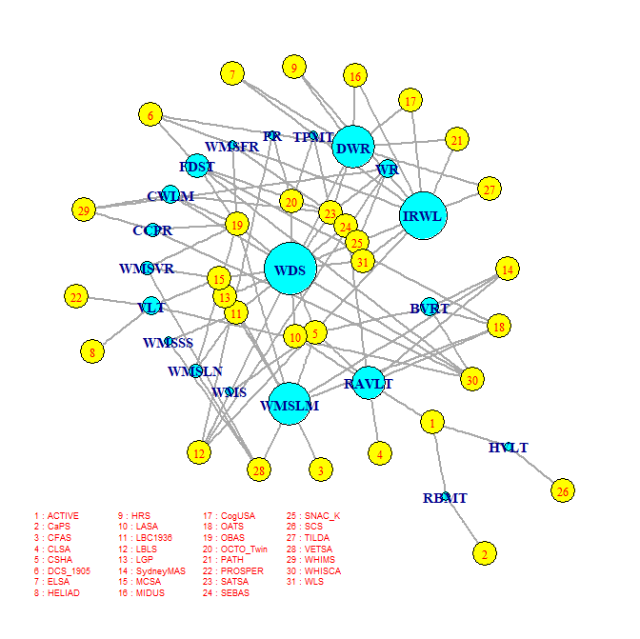

Reference:

Eric D. Kolaczyk & Gábor Csárdi: *Statistical analysis of network data with R*, Springer 2014.