Đáp án

Section 2: Dự đoán đáp án bằng ngôn ngữ chỉ dẫn

Exercise 1: Nối các cụm từ sau với các mục đích chỉ dẫn tương ứng
Câu | Câu Hỏi | Đáp án
1 | although, even though, though, but | Miêu tả sự đối nghịch
2 | before, when, then, while, after, during, immediately, whenever, as soon, Firstly/first of all, the first, the second, the last | Miêu tả trình tự, thời gian
3 | because, since, as | Miêu tả lý do
4 | also, in addition, moreover | Mở rộng ý của bài nói
5 | I’m/We’re going to tell you about… | Giới thiệu về chủ đề bài nghe
6 | So, therefore, To, in order to, so as to | Miêu tả mục đích
7 | One thing to remember is that | Nhấn mạnh thông tin quan trọng

Exercise 2: Dự đoán những ví dụ sau đây người nói đang có mục đích gì
Câu | Câu Hỏi | Đáp án
1 | They will call the restaurant to ask if they have places at the weekends. | Miêu tả mục đích/lý do
2 | Although the building is very modern, in fact a theatre has existed on this site for over two hundred years. | Miêu tả sự đối nghịch
3 | Remember that a film is really a story in pictures. | Nhấn mạnh thông tin quan trọng
4 | In addition, an extra meeting room was constructed. | Mở rộng ý của bài nói
5 | I'm going to tell you about a time when I learned something new. | Giới thiệu về chủ đề bài nghe
6 | And inside there's a present from the baby's parents. It's really fun to open it as you don't know what you'll get. | Miêu tả lý do
7 | Unlike in most countries, we fry the rice with onion in olive oil before we add any liquid. | Miêu tả trình tự

Exercise 3: Dự đoán mục đích của người nói trong từng câu dưới đây
Câu | Câu Hỏi | Đáp án
1 | Most people say that I'm similar to my father because we both have ______ | Miêu tả lý do
2 | Next, I'm now going to tell you a little about the ______ of the mountain gorilla | Giới thiệu về chủ đề bài nghe
3 | Preserving tropical rainforests isn’t Costa Rica’s only success. The government in this country also makes sure everyone has access to ______ and ______ | Mở rộng ý của bài nói
4 | Many people use social media for this purpose. First of all, social media can be a part of their job. Secondly, it can be the tool for them to ______ | Miêu tả trình tự
5 | The gift shop will be where tickets are on sale and therefore needs to be near the ______ | Miêu tả mục đích
6 | I'm afraid our main restaurant is fully booked that evening but we do have a ______ available for private hire | Miêu tả sự đối nghịch
7 | One thing is for sure, nobody is going to come to you. You have to make ______ for yourself. You have a product to sell and the product is you | Nhấn mạnh thông tin quan trọng

Exercise 4: Nghe và điền vào ô trống để hoàn thành các câu sau đây
Lưu ý: Điền không quá 2 TỪ cho mỗi ô trống
00:00:00
00:01:20
Preserving tropical rainforests isn’t Costa Rica’s only success. The government in this country also makes sure everyone has access to 1health-care//healthcare//health care and 2education.
Most people say that I'm similar to my father because we both have 3green eyes.
I'm afraid our main restaurant is fully booked that evening but we do have a 4small room available for private hire.
Many people use social media for this purpose. And the last thing I would say is, if you want to be really successful in something, you will most likely experience a certain amount of 5failure.
One thing is for sure, nobody is going to come to you. You have to make 6opportunities for yourself. You have a product to sell and the product is you.
Next, I'm now going to tell you a little about the 7diet of the mountain gorilla.
The gift shop will be where tickets are on sale and therefore needs to be near the 8entrance.

Exercise 5: Dự đoán mục đích của người nói trong từng câu được đánh dấu trong đoạn văn dưới đây
Good evening and welcome aboard the Pride of Poole. In this recorded announcement, we'll give you details of some of the facilities available on board this ship (Q1). You're currently standing in the reception area in the centre of B Deck. Next to the restaurant on A Deck in the lounge, there are reclining seats with music headphones if you want to relax. The headphones are free, but people using this area are encouraged to keep noise to a minimum so that other passengers can enjoy themselves and sleep or read if they wish (Q2)
Just beyond that on the same level, people who want a bit of fresh air or just want to see the sea can go out onto the deck, which is in the open air. Make sure you wear a jacket or coat (Q3), as it can be quite cold and windy.
Câu | Câu Hỏi | Đáp án
1 | (Q1) | Giới thiệu về chủ đề bài nghe
2 | (Q2) | Miêu tả mục đích
3 | (Q3) | Nhấn mạnh thông tin quan trọng
Mở rộng:
Có 2 kiểu cấu trúc câu được sử dụng để nhấn mạnh thông tin quan trọng:
- Nhắc nhở ai phải nhớ điều gì: "One thing to remember is that ..."
- Nhấn mạnh vào hành động: Các câu bắt đầu bằng động từ ("Make sure you wear a jacket or coat")

Exercise 6: Nghe và ghi nhãn phù hợp cho biểu đồ sau với CHỈ MỘT TỪ cho mỗi chỗ trống
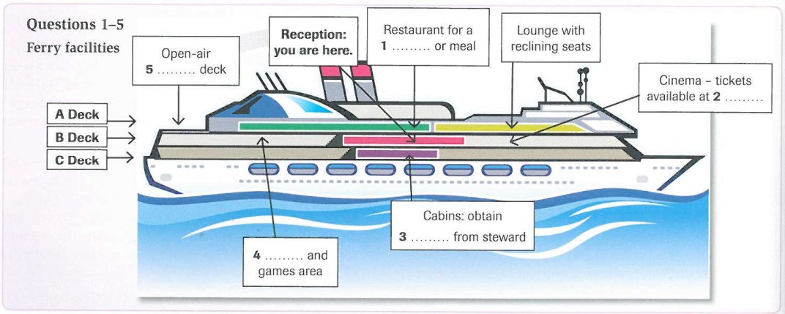
00:00:00
00:02:20
1Snack
2Entrance
3keys//key
4Shopping
5viewing
Transcript
Good evening and welcome aboard the Pride of Poole. In this recorded announcement, we'll give you details of some of the facilities available on board this ship. You're currently standing in the reception area in the centre of B Deck. If you're feeling hungry after a long day's travelling, go up the stairs to A Deck, where you'll find the restaurant. The restaurant caters for all appetites, with anything from a light snack to a full three-course meal (Q1). The restaurant will be open from the moment the ship leaves port to half an hour before arrival
Next to the restaurant on A Deck in the lounge, there are reclining seats with music headphones if you want to relax. The headphones are free, but people using this area are encouraged to keep noise to a minimum so that other passengers can enjoy themselves and sleep or read if they wish
For those of you who'd like some entertainment, just next door to us on this deck is a 40-seat cinema showing the latest full length feature films. The cinema programme is available here at reception, but you'll have to buy the tickets themselves at the cinema entrance just before you go in (Q2). Just next to the cinema is the staircase leading down to the cabins on C Deck. To access your cabin, just show your boarding pass to a steward, who will give you the key (Q3). On this deck that is B Deck, you'll also find an area where you can either play games in our special electronic games arcade or do your shopping (Q4)
Just beyond that on the same level, people who want a bit of fresh air or just want to see the sea can go out onto the viewing deck (Q5), which is in the open air. Make sure you wear a jacket or coat, as it can be quite cold and windy
Xem giải thích

