PYTHON PROGRAMMING

Lecture 1: Introduction to Python programming

Python is a high-level, interpreted, general-purpose programming language. Its count back from 1991 with its pioneer, Guido van Rossum. Python belongs to the multi-paradigm such as functional, object-oriented, structured and imperative. Worry out, you’ll understand all these concepts :)

Its a simple language to learn, with clear and logical code form and can be used for both small and large projects. The Python programming language has a wide range of syntactical constructions, standard library functions, and interactive development environment features. Fortunately, you can ignore most of that; you just need to learn enough to write some handy little programs.
Don’t hurry, I know you want to code :) But first, grasp these crucial information about the language.

Installing Python in your machine:
Note: You should first check if python is already installed in your machine before proceed with the download process. To check it, open your command-prompt or terminal (am using Ubuntu) then type:
$ python3

If you get the output like mine on the pic below, then you’re good to code. No installation required. Otherwise you need to install python.

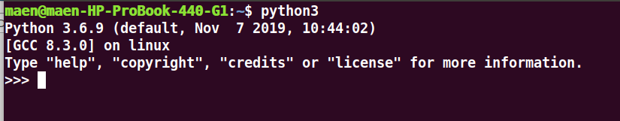

Python runs in almost all OS including Windows, Mac OS and Linux. You can easy download free from http://python.org/downloads/ the version that corresponds to your OS. In Window its a matter of few “next” clicks and you’ll be good to go.

In Ubuntu (Linux) , you install it by a a single command in a terminal. Just open the terminal ( Ctrl+Alt+T) and type the command :
$ sudo apt-get install python3.

Note: I've already installed python3 in my machine, but for you the command will work fine
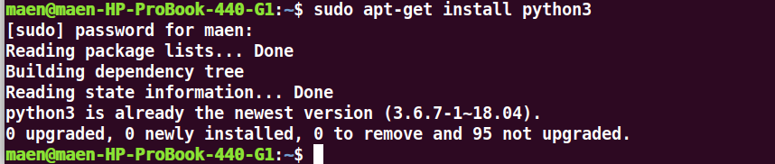
Well, we specify the version of python as version 3. Running that command without specify version you’ll download version 2 (python2) and soon or later you may encounter some errors as we proceed in coding.

Concept of IDE, Text editor and Interactive Shell:
Interactive Development Environment (IDE) and text editor are special programs (software) with which you can write and run codes. Great IDE for python is Pycharm (though there are many other) and some cool text editors are Visual Studio code, Sublime-text, etc.

No matter which system you’re running, python codes can run without all those software. Its by using Interactive Shell. You can access it from command prompt (in Windows) and from terminal (for Linux users).

Writing your first program:
Open your command prompt by pressing win+R and then type “cmd” (for Windows) and for Linux, simply open your terminal.

In there, type: python3. This command will load python interpreter so that your machine can understand what you write.

Then type: print(‘Hello, World !’) and press Enter. What happened ? Wow! That's our first program. we’ve simply tell the machine to display the word “Hello, World !” and it did ! Python is simple right ?
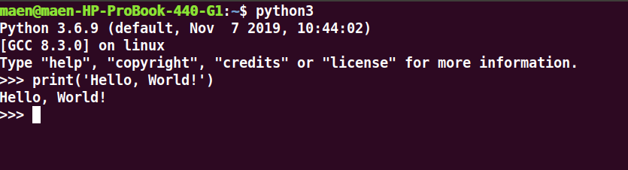

Data types:
Note that, code is just an expression formed by a particular data type. Whats data type anyway?
Simply, data type is a group or class defining a given variable. This means, every variable you write belongs to a certain data type. Got it?

For example in our English language we found that; 1,2,34,77,488839 are numbers. ‘n’, ‘H’ are letters. 0.33, 848.3349, 388.43 are decimals. That’s what it means. Computer understands these data types and when we combine them in a programmatic way that's when we get ‘code’.

Common data types:

Data type Example

Integer 3, 88, -292, 0, -992, 9292900

Float 9.0003, -0.33, 94.34,

String ‘h’, ‘hello’, ‘54’, ‘Tanzania’, ‘0.43’

Comments:
Python ignores comments, and you can use them to write notes or remind yourself what the code is trying to do. Any text for the rest of the line following a hash mark ( # ) is part of a comment. Comments never run when the program is running. Here is an example of the comment:

# this is the comment.
# you can comment many lines as you want

Sometimes you need to comment some lines of code during the test of the program, ie. making them not running at the moment. That process is very useful, and its called “commenting out”. You can remove # later to allow the code running again. We shall see more in a near future.

The two prior methods:
Programming is an art of talking to a computer. You give it some inputs and it retains some output accordingly. Its like conversation between the two people, you talk he listens and vice versa. Is that simple?

The print() function/method:
This function let the machine display for you some output depending on what you gave it (the input). For example in our first program, we wrote: print(‘Hello, World!’).
print() - the function to display
‘Hello, World!’ - our input, something we want to display

Lets try to run more examples:
print(‘Hello, friend’)
print(‘whats your name?’)

When running, python calls the function print() and display the ‘string’ passed in the function, ie our inputs. Got it?

The input() function/method:
This function helps you to fed the machine. Gives it the input to perform what you want. The input() function waits for the user to type some text on the keyboard and press enter. In the example above, from the code: print(‘whats your name?’). If our friend wants to type his/her name, that’s when we call the function input().

For example:
name = input()
print(‘Nice to meet you,’ +name)

