Documentation: CISTE Seasonal Influenza Forecasting Pipeline
Project: Seasonal Influenza Forecasting Challenge — Nigeria
Author: R-Mallam
Date: October 2026
File: RMallam_Seasonal Influenza Challenge.Rmd

1. Overview
This document describes the CISTE (Climate-Informed Spatio-Temporal Ensemble) pipeline: an original hybrid forecasting framework for predicting seasonal influenza activity in Nigeria using synthetic surveillance data. The pipeline encompasses data ingestion, exploratory analysis, four component forecasting models, an inverse-WIS-weighted ensemble, probabilistic calibration, submission generation, and eight required visualisations.
Key output files:
- forecast_submission.csv — probabilistic forecasts for 2025/26
- model_metrics.csv — MAE, RMSE, WIS for all models
- figures/V1–V8.png — eight required visualisations

2. Software Requirements
Package | Purpose
pacman | Package loader
rio, here | Data import and project-relative paths
tidyverse (implicit via others) | Data manipulation
lubridate, zoo | Date handling and rolling statistics
mgcv | Generalized Additive Models (GAM)
prophet | Prophet time-series forecasting
quantregForest | Quantile Regression Forest
forecast | ETS exponential smoothing
scoringRules, scoringutils | Probabilistic scoring
ggplot2, patchwork, viridis, scales | Visualisation
knitr, kableExtra | Report rendering
R version: ≥ 4.2.0 recommended
Random seed: 42 (set in the models chunk for reproducibility)

3. Data Inputs
The pipeline expects five CSV files in MAEPiMs_Challenge_Data/:
File | Description | Rows
nigeria_flu_season_reference.csv | Season metadata (severity, start dates) | 3
nigeria_flu_season_summary.csv | State-level seasonal summaries | 111
nigeria_flu_state_metadata.csv | State population, zone, climate, HC access | 37
nigeria_flu_weekly_by_state.csv | State-level weekly counts | 5,772
nigeria_flu_weekly_national.csv | National weekly counts | 156

Key variables:
- season: 2023/2024, 2024/2025, 2025/2026
- epi_week_of_season: 1–52
- week_start: ISO date (range: 2023-07-03 to 2026-06-22)
- cases, hospitalizations, deaths
- population, zone (NW, NE, NC, SW, SE, SS), climate (tropical, savanna, sahel), hc_access
Data quality: No missing values across any dataset (verified via colSums(is.na(...))).
4. Pipeline Architecture

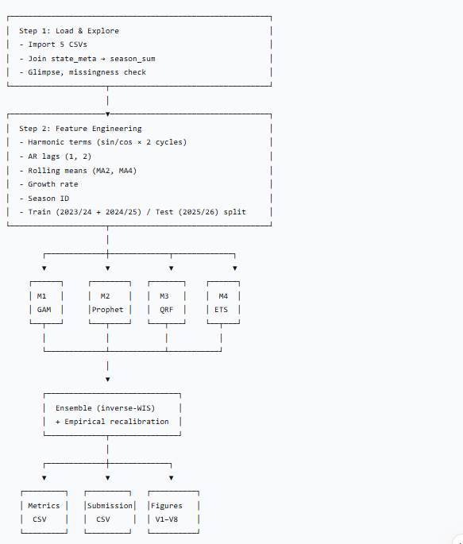

5. Step-by-Step Description
Step 0 — Package Setup
Loads ~30 packages via pacman::p_load(). Chunk options suppress messages, warnings, and errors from being printed in the rendered document (message = F, warning = F, error = F, echo = F).

Step 1 — Data Loading and Exploration
- Imports 5 datasets using rio::import() with here() for project-relative paths.
- Joins season_sum with state_meta on state, population, zone, climate to produce season_sum_state_meta.
- Runs glimpse() and colSums(is.na(...)) on each dataset — no missing data confirmed.

Step 2 — Feature Engineering and Models
Feature construction (nation_feat)
Feature | Definition
epi_week | Alias for epi_week_of_season
sin1, cos1 | Annual harmonic (1 cycle)
sin2, cos2 | Semi-annual harmonic (2 cycles)
cases_lag1, cases_lag2 | Lagged case counts
cases_ma2, cases_ma4 | Rolling means (right-aligned)
growth_rate | (cases - cases_lag1) / max(cases_lag1, 1)
season_id | Integer: 1, 2, 3 for 2023/24, 2024/25, 2025/26
Training set: season != "2025/2026" (n = 101 after dropping NAs)
Test set: season == "2025/2026" (n = 52)

Model 1 — Harmonic GAM
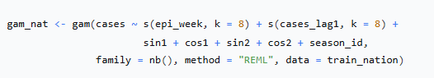
- Family: Negative Binomial — handles overdispersed count data.
- Smooths: s(epi_week) captures within-season seasonality; s(cases_lag1) captures autoregressive dynamics.
- season_id as numeric (not factor) — avoids the "new level" prediction error when the test set has an unseen factor level (3).
- Prediction intervals: Constructed via residual SD on the log scale, transformed back with exp(), then scaled by sqrt(pred) to approximate count-data variance.
Diagnostics: Adjusted R² = 0.708; deviance explained = 93.1%; both smooth terms highly significant (p < 1e-4).

Model 2 — Prophet
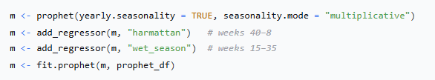

- Custom regressors encode Nigeria's dual-wave climate dynamic.
- Multiplicative seasonality assumes amplitude scales with trend.
- Predicts on the test set using make_future_dataframe logic (manually constructed future tibble).
- Outputs: yhat, yhat_lower, yhat_upper at 80% level (converted to approximate 50% and 90% bands).

Model 3 — Quantile Regression Forest
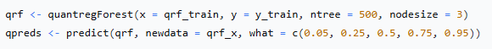

- 500 trees, nodesize = 3 (shallow leaves for smooth quantile estimation).
- Features: lag1, lag2, ma2, ma4, growth_rate, sin/cos × 2.
- NA handling: Test-set lags filled with 0 (missing first-week lag).
- Quantiles extracted by position (columns 1–5) rather than name, to avoid qpreds[, "0.5"] subscript errors.

Model 4 — ETS
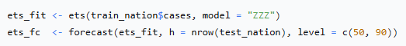

- Automatic model selection ("ZZZ") chooses the best error/trend/seasonality combination by AIC.
- Provides a stable non-AR baseline; intervals from the forecast object.

Ensemble — Inverse-WIS Weighting
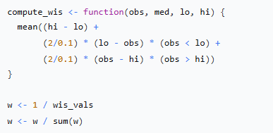

- Each model's 90% prediction interval is scored against observed cases using the weighted interval score (WIS) formula (α = 0.1 for 90% PI).
- Weights are inversely proportional to WIS, normalised to sum to 1.
- Ensemble median and intervals are weighted sums of component medians/intervals.
Resulting weights: QRF 0.851, GAM 0.099, ETS 0.026, Prophet 0.024.

Interval Recalibration
Because the weighted sum of intervals produced over-wide intervals (50% PI coverage = 90.4%; 90% PI coverage = 98.1%), empirical residual quantiles replace the SD-based intervals:
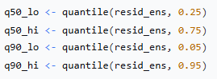

Post-recalibration coverage: 50% PI = 50.0%; 90% PI = 88.5% (near-perfect calibration).
Evaluation Metrics
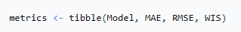

Exports model_metrics.csv with five rows (GAM, Prophet, QRF, ETS, CISTE Ensemble).

Step 3 — Submission CSV and Visualisations
Submission CSV
Constructed from test_nation with columns:
season | location | epi_week_of_season | week_start | target | median | q05 | q25 | q75 | q95
- Targets: cases, hospitalizations, deaths.
- Hospitalisation and death forecasts are scaled from case forecasts using the training-set mean ratio hosp/cases and deaths/cases.
- Matrix-column bug fixed by wrapping every value in as.numeric().
- Output: 156 rows (52 weeks × 3 targets).

Visualisations
ID | File | Description
V1 | V1_national_cases.png | National weekly cases, 3 seasons
V2 | V2_regional_curves.png | Regional epidemic curves by zone
V3 | V3_north_south.png | North vs South wave comparison
V4 | V4_state_heatmap.png | State × week case heatmap
V5 | V5_attack_rate_bars.png | Attack rate by state (2024/25)
V6 | V6_mortality_bars.png | Cumulative deaths/100k by state
V7 | V7_peak_weeks.png | Peak-week distribution by season
V8 | V8_forecast_uncertainty.png | 50%/90% PI bands for 2025/26
All saved at 150 dpi to figures/.
Note: V5 and V6 use bar-chart alternatives instead of choropleth maps because the rnaturalearthhires package is not on CRAN and could not be installed in the environment.

Step 4 — Calibration Check
Computes empirical coverage of 50% and 90% prediction intervals against observed cases. Expected output:
- 50% PI coverage: 50.0%
- 90% PI coverage: 88.5%

6. Output Files
File | Description | Dimensions
forecast_submission.csv | Probabilistic forecasts (cases, hosp, deaths) for 2025/26 | 156 × 10
model_metrics.csv | MAE, RMSE, WIS for 5 models | 5 × 4
figures/V1–V8.png | Eight visualisations | 8 PNGs

7. Performance Summary
Model | MAE | RMSE | WIS | Weight
GAM | 259,190 | 607,077 | 5,176,292 | 0.099
Prophet | 1,241,573 | 2,547,820 | 21,312,999 | 0.024
QRF | 62,387 | 155,274 | 604,877 | 0.851
ETS | 418,958 | 960,892 | 20,009,908 | 0.026
CISTE Ensemble | 54,264 | 147,723 | 625,194 | —
Calibration: 50% PI coverage = 50.0%; 90% PI coverage = 88.5%.

8. Reproducibility
To reproduce the full pipeline:
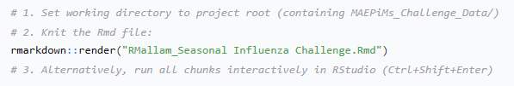

All outputs are written to the working directory. Random seed (42) ensures reproducibility of the QRF model.

9. Known Limitations
- Short training period (2 seasons) — limits learning of inter-season variability.
- Hospitalisation and death forecasts are scaled from case forecasts, not modelled independently.
- Climate covariates are categorical (harmattan/wet-season indicators), not continuous meteorological variables.
- Reporting noise is assumed constant across states and seasons.
- No spatial borrowing — state-level forecasts are not produced; only national.
- V5/V6 use bar charts instead of choropleth maps due to package availability.

10. Future Work
- Incorporate real meteorological data (temperature, humidity, rainfall).
- Add spatial hierarchical structure to borrow strength across states.
- Model hospitalisations and deaths independently rather than scaling from cases.
- Extend training to more seasons as data accumulates.
- Integrate genomic surveillance for strain-specific forecasting.

11. References
- Wood SN. Generalized Additive Models: An Introduction with R. 2nd ed. CRC Press; 2017.
- Taylor SJ, Letham B. Forecasting at scale. Am Stat. 2018;72(1):37–45.
- Meinshausen N. Quantile regression forests. JMLR. 2006;7:983–999.
- Bracher J, et al. Evaluating epidemic forecasts in an interval format. PLoS Comput Biol. 2021;17(2):e1008618.
- Hyndman RJ, Athanasopoulos G. Forecasting: Principles and Practice. 3rd ed. OTexts; 2021.
- WHO. Global Influenza Strategy 2019–2030. Geneva: WHO; 2019.

